**COMPUTER NETWORK LAB ASSIGNMENTS :**

**SUPRATIM NAG/CSE-AIM/22/57 :**

**Implementation of IPC in iterative modalities:**

**I .** Write a program to develop an iterative echo server using TCP socket.

SERVER SIDE CODE :

#include <stdio.h>

#include <stdlib.h>

#include <string.h>

#include <unistd.h>

#include <arpa/inet.h>

#define PORT 8080

#define BUFFER_SIZE 1024

int main() {

    int server_fd, client_fd;

    struct sockaddr_in address;

    int addrlen = sizeof(address);

    char buffer[BUFFER_SIZE];

    // Create socket file descriptor

    if ((server_fd = socket(AF_INET, SOCK_STREAM, 0)) == 0) {

        perror("Socket failed");

        exit(EXIT_FAILURE);

    }

    // Set up server address and port

    address.sin_family = AF_INET;

    address.sin_addr.s_addr = INADDR_ANY;

    address.sin_port = htons(PORT);

    // Bind the socket to the network address and port

    if (bind(server_fd, (struct sockaddr *)&address, sizeof(address)) < 0) {

        perror("Bind failed");

        close(server_fd);

        exit(EXIT_FAILURE);

    }

    // Listen for incoming connections

    if (listen(server_fd, 3) < 0) {

        perror("Listen failed");

        close(server_fd);

        exit(EXIT_FAILURE);

    }

    printf("Echo server is listening on port %d...\n", PORT);

    while (1) {

        // Accept a connection from a client

        if ((client_fd = accept(server_fd, (struct sockaddr *)&address, (socklen_t*)&addrlen)) < 0) {

            perror("Accept failed");

            continue;

        }

        printf("Connected to client\n");

        // Echo loop: receive message and send it back to client

        while (1) {

            memset(buffer, 0, BUFFER_SIZE);

            int bytes_received = recv(client_fd, buffer, BUFFER_SIZE, 0);

            if (bytes_received == 0) {

                printf("Client disconnected\n");

                break;

            }

            if (bytes_received < 0) {

                perror("Receive failed");

                break;

            }

            printf("Received: %s", buffer);

            // Echo the message back to the client

            send(client_fd, buffer, bytes_received, 0);

        }

        // Close the client socket

        close(client_fd);

}

    // Close the server socket

    close(server_fd);

    return 0;

}

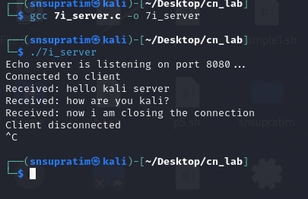

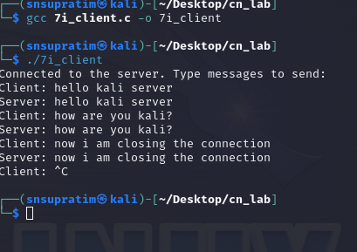

#include <stdio.h>

#include <stdlib.h>

#include <string.h>

#include <unistd.h>

#include <arpa/inet.h>

#define PORT 8080

#define BUFFER_SIZE 1024

int main() {

    int sock = 0;

    struct sockaddr_in server_address;

    char buffer[BUFFER_SIZE] = {0};

    // Create socket file descriptor

    if ((sock = socket(AF_INET, SOCK_STREAM, 0)) < 0) {

        perror("Socket creation error");

        exit(EXIT_FAILURE);

    }

    // Define server address

    server_address.sin_family = AF_INET;

    server_address.sin_port = htons(PORT);

    // Convert IPv4 address from text to binary form

    if (inet_pton(AF_INET, "127.0.0.1", &server_address.sin_addr) <= 0) {

        perror("Invalid address/Address not supported");

        close(sock);

        exit(EXIT_FAILURE);

    }

    // Connect to the server

    if (connect(sock, (struct sockaddr *)&server_address, sizeof(server_address)) < 0) {

        perror("Connection failed");

        close(sock);

        exit(EXIT_FAILURE);

    }

    printf("Connected to the server. Type messages to send:\n");

    // Send and receive messages in a loop

    while (1) {

        printf("Client: ");

        fgets(buffer, BUFFER_SIZE, stdin);

        // Send message to server

        send(sock, buffer, strlen(buffer), 0);

        // Receive echoed message from server

        int bytes_received = recv(sock, buffer, BUFFER_SIZE, 0);

        if (bytes_received <= 0) {

            printf("Server closed the connection\n");

            break;

        }

        buffer[bytes_received] = '\0';  // Null-terminate received message

        printf("Server: %s", buffer);

    }

    // Close the socket

    close(sock);

    return 0;

}

CLIENT SIDE CODE :