# Computer Network Lab Assignment 4a:

### Topic : Configuration & Simulation using CISCO Packet Tracer

## Objective

The objective of this lab assignment is to design and develop a network topology of a **100 Mbps Fast Ethernet LAN** using **two 24-port switches**. Each switch is connected to a disjoint set of **10 nodes (PCs)**, and these nodes are configured with **Class C IP addresses (192.168.4.41 - 60)**. The setup will include a **Packet Data Unit (PDU)** to check the ping and verify connectivity between the PCs. The simulation will be implemented using CISCO Packet Tracer.

## Equipment Required

* **CISCO Packet Tracer Software**
* Two (2) **24-Port Ethernet Switches**
* Twenty (20) **PCs**
* Ethernet cables (automatic in Packet Tracer)
* Class C IP address range **192.168.4.41 - 60**

## Network Topology Design

### 1. ****Setting Up the Network Components****

* **Switches:**
  + Use two **24-port Ethernet switches** to handle two groups of 10 PCs each.
  + The switches will be connected to the respective PCs forming two disjoint networks.
* **PCs:**
  + Each group will have **10 PCs** connected to their respective switches, with Class C IP addresses ranging from **192.168.4.41 to 192.168.4.60**.
  + Assign each PC a unique IP address within this range.

### 2. ****Network Connectivity****

* Ensure that all PCs are connected to their respective switches using **Fast Ethernet cables** in the **Packet Tracer** environment.
* Each switch should be assigned a common subnet mask **255.255.255.0**.

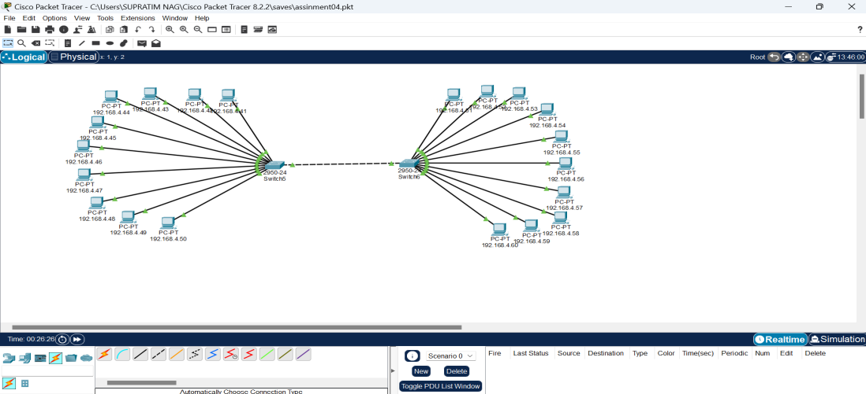

## Screenshot 2024-09-19 193945

## Screenshot 2024-09-19 194429

## Steps Involved in Configuration

### Step 1: ****Launch CISCO Packet Tracer****

* Open the **CISCO Packet Tracer** application to create and simulate the network topology.

### Step 2: ****Add Devices to Workspace****

* **Add Switches:**  
  Drag and drop **two 24-port switches** onto the workspace.
* **Add PCs:**  
  Add **20 PCs** (10 for each switch) and place them in two groups around each switch.

### Step 3: ****Connect Devices Using Ethernet Cables****

* Use the **"Connections" tool** in CISCO Packet Tracer and choose **Fast Ethernet** to connect each PC to its respective switch.
  + **Switch 1:** Connect PCs 1-10.
  + **Switch 2:** Connect PCs 11-20.

### Step 4: ****Assign IP Addresses****

* Go to each PC, open the **Desktop** tab, and configure the IP settings.
  + Set IP addresses for PCs 1-10 as **192.168.4.41 to 192.168.4.50**.
  + Set IP addresses for PCs 11-20 as **192.168.4.51 to 192.168.4.60**.
  + Use **255.255.255.0** as the subnet mask for all PCs.

### Step 5: ****Configure and Add PDU for Ping Test****

* Use the **Add Simple PDU** tool to check connectivity by initiating a ping from **PC1 to PC11** (or any other PCs across the switches).
* The PDU will simulate a ping request to ensure that the network is functioning correctly.

### Step 6: ****Run the Simulation****

* Once everything is configured, start the simulation by switching to the **Simulation Mode** in Packet Tracer.
* Observe the **ping results** between the PCs and ensure proper communication between all devices.

### Step 7: ****Verify the Results****

* The **ping test** should return successful results, indicating proper connectivity between the nodes across both switches.

## Topics Covered

### 1. ****Ethernet LAN and Switches****

* **LAN (Local Area Network)** refers to a network that connects devices within a limited area like a building or campus.
* **Switches** operate at Layer 2 (Data Link Layer) and manage communication within the LAN, using MAC addresses to forward packets to the correct destination.

### 2. ****Class C IP Addressing****

* **Class C IP Address** range is from **192.0.0.0 to 223.255.255.255**.
* A **Class C network** uses a default subnet mask of **255.255.255.0**, which allows up to **254 usable IP addresses** in a given subnet.

### 3. ****Ping and Connectivity Testing****

* **Ping** is a network utility used to test the reachability of a device on a network by sending **ICMP echo requests**.
* **Packet Data Unit (PDU)** in Packet Tracer helps in visualizing the packet flow during the simulation and testing the connectivity between the devices.

### 4. ****Simulation with CISCO Packet Tracer****

* **CISCO Packet Tracer** is a simulation tool that allows users to create, configure, and simulate network topologies.
* It enables **real-time** and **simulation mode**, where users can observe network behavior and troubleshoot issues.

## Conclusion

In this lab assignment, we successfully designed and developed a network topology of **100 Mbps Fast Ethernet LAN** using two 24-port switches, connected to **20 nodes**. The PCs were configured with **Class C IP addresses**, and the simulation was performed using **CISCO Packet Tracer**. The network was tested for connectivity using **Ping**, and the results showed successful communication between the PCs, confirming the correctness of the network setup.