**Configuration of router and configuration of DNS, FTP ..**

**1. Add a Server:**

- Under "End Devices," drag a server onto the workspace and connect it to Switch 1 using a copper straight-through cable.

2. **Configure the Server:**

- Click on the server, go to the Desktop tab, and assign it an IP address:

- IP Address: 192.168.4.55

- Subnet Mask: 255.255.255.0

- Go to Services and enable the DNS, FTP, HTTP, and Mail (SMTP/POP3) services.

**DNS Configuration:**

- Go to Services tab > DNS.

- Add entries for websites and services, e.g.,

- Name: http://mywebsite

- Address: 192.168.4.55

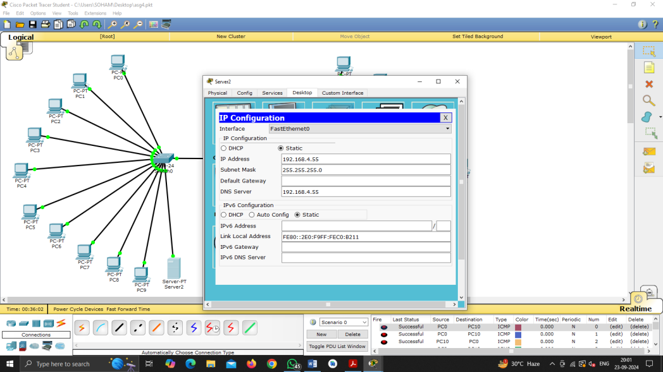

**FTP Configuration:**

**Click on the server** in Packet Tracer.

Go to the **Services** tab.

Select **FTP** from the list of available services.

**Turn On** the FTP service (it is off by default).

You can also configure the username and password for FTP access by adding them to the user list under the FTP settings.

