Sergey Timchenko

2/13/2021

Foundations Of Programming: Python

Assignment 05

Lists and Dictionaries

# Introduction

In this assignment the student learns the difference between the Lists and Dictionaries. The student modifies the program to collect the data into the dictionary, write it into .txt file and modify the list by deleting the entries.

# Creating a script

In this assignment I’m creating the program that will display the inventory of the compact disks, will add the new disk info into the inventory, or delete the previously entered CD and saves the data into the CDInventory.txt located in the same folder as the running script. Instead of lists I will be using the dictionary to store information.

## Planning the program by creating a pseudocode

In this task we will be using predefined startup file. I will modify it to work with the dictionary.

# 1. Display menu allowing the user to choose between

* load Inventory from file
* Add CD
* Display Current Inventory
* Delete CD from Inventory
* Save Inventory to file
* Exit

# 2. Load existing data from the file

# 3. Display Inventory

# 4. Add data to the table (2d-list) each time the user wants to add data

# 4 Delete line each time the user wants to delete data

# 4. Save the data to a text file CDInventory.txt if the user chooses so

# 5. Exit

After opening the starter file with pre populated code for the lists we can add TODO tasks. At this time we will be using Spider IDE.

For this program we will need to have a text file to write the user’s data. For this purpose the CDInventory.txt file has been created in the same directory where the python program is saved.

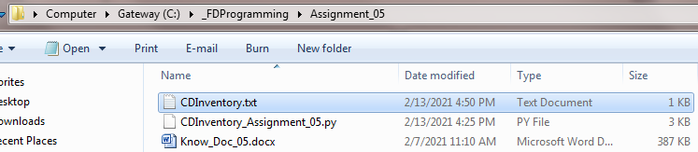

Figure 1 –Creation of CDInventory.txt file

At the beginning of the program I’m replacing *lstRow* list with dictionary *dictRow.*

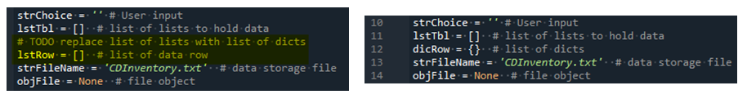

Figure 2 –Replacement of the list with the dictionary

To run different user’s choice operations we are using the *while if elif* loop

Choice 1 (x) is easy – if user wants to exit we are breaking the process at the user sees the main menu



Figure 3 –Exit choice

For choice 2 we are clearing *lstTbl* from memory and loading the data from the *CDInventory.txt* file with read only option.

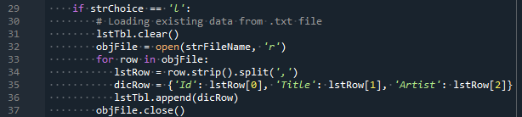

*Figure 4 –Printing the inventory in a for loop*

To add the new disc (choice (a)) we are requesting the information from the user and it is stored in computer’s memory in a dictionary format. The new information is added to the dictionary stored in memory if we have anything. Otherwise it will be first row to be added to the inventory.

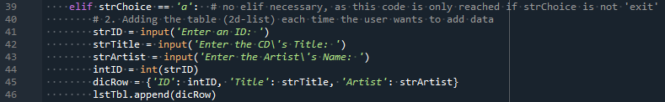

Figure 5 –Requesting the new disk information

For the choice (*i*) we are printing the top row on the screen and then requesting values of the dictionary stored in the computer’s memory.

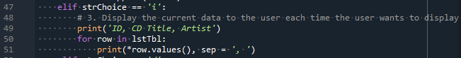

Figure 6 –Displaying the values of the dictionary

To delete the disc info in choice (d) we are loading the stored in memory information about all the discs and requesting from the user the disc number to be deleted. Then deleting the key from the dictionary with the position -1 because the computer starts to count the keys from 0, people start to count the positions from 1.

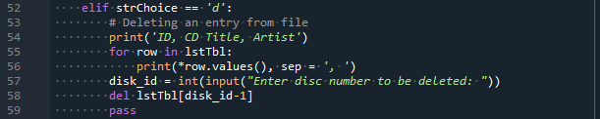

Figure 7 –Displaying the disk from the dictionary loaded into computer memory

To save the disc info into the text file (choice (s)) we are opening the file with option w and writing all disk data from memory of the computer.

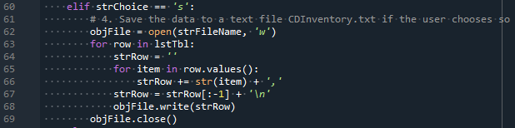

Figure 8 –Writing the list into the text file

The last portion of the program returns the user to the beginning of the program if he or she didn’t enter the one of the predefined choices.



Figure 9 –Exiting from the while loop

# The result of the program run

After the code is written we test the program in Spider sub window.

1. First we are loading the info from the file and displaying the inventory

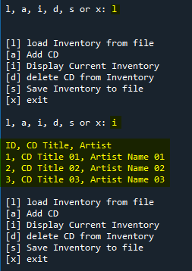

Figure 10 –Choice [l] and [i] demonstration

1. Then loading the new disk info and saving the file

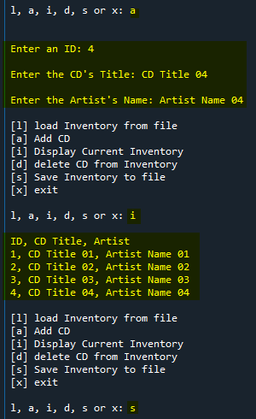

Figure 11 –Choice [a] and [s] demonstration

1. Lastly we are choosing deletion CD from the file (choice(d))

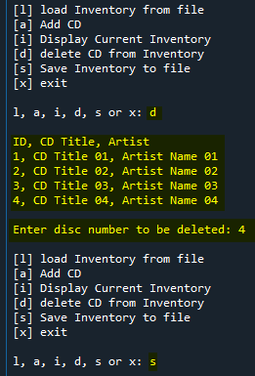

Figure 12 –Choice [d] demonstration

1. After saving the file we are loading the data from the file and checking if the disk info was deleted correctly. Disk 4 was deleted from the list in the text file as requested.

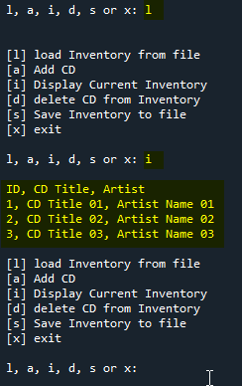

Figure 13 –Demonstration of disk 4 deletion

After running the program we are opening the text file and checking the results.

Disk 4 was added to the file and then deleted.

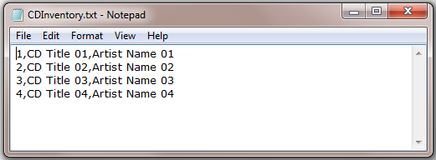

Figure 14 – Deletion of the disk 4 from the text file

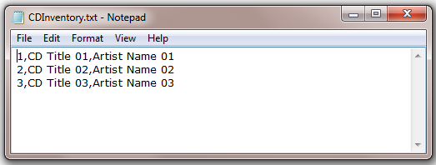

Figure 15 – Deletion of the disk 4 from the text file

Now we want to check if the program runs correctly in Anaconda command line window.

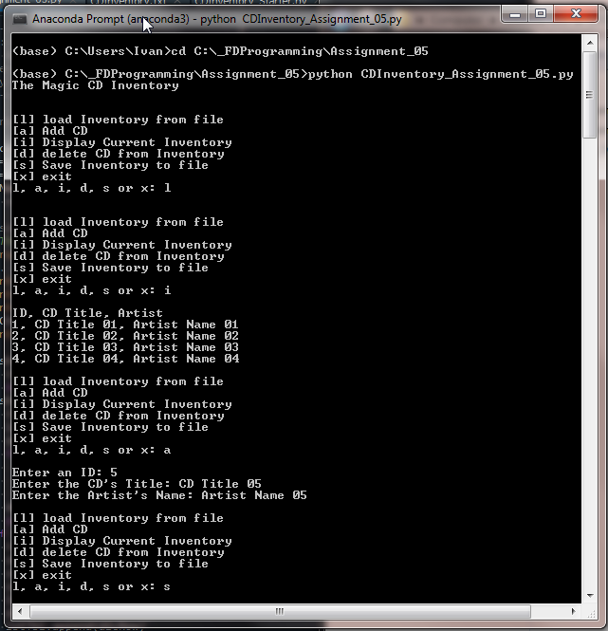

Figure 16 – Adding disk 5 in Anaconda Prompt window

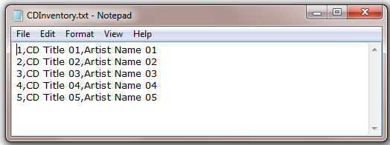

Figure 17 – CDInventory text file after running the script in Anaconda Prompt window

# Summary

In this Assignment I used the 2 dimensional *dictionary,* learned how to delete data from the text file, used *for* and *while* loops.

Areas of improvement:

This program doesn’t renumber the disks if the user chooses to delete the disc from the middle of the list.