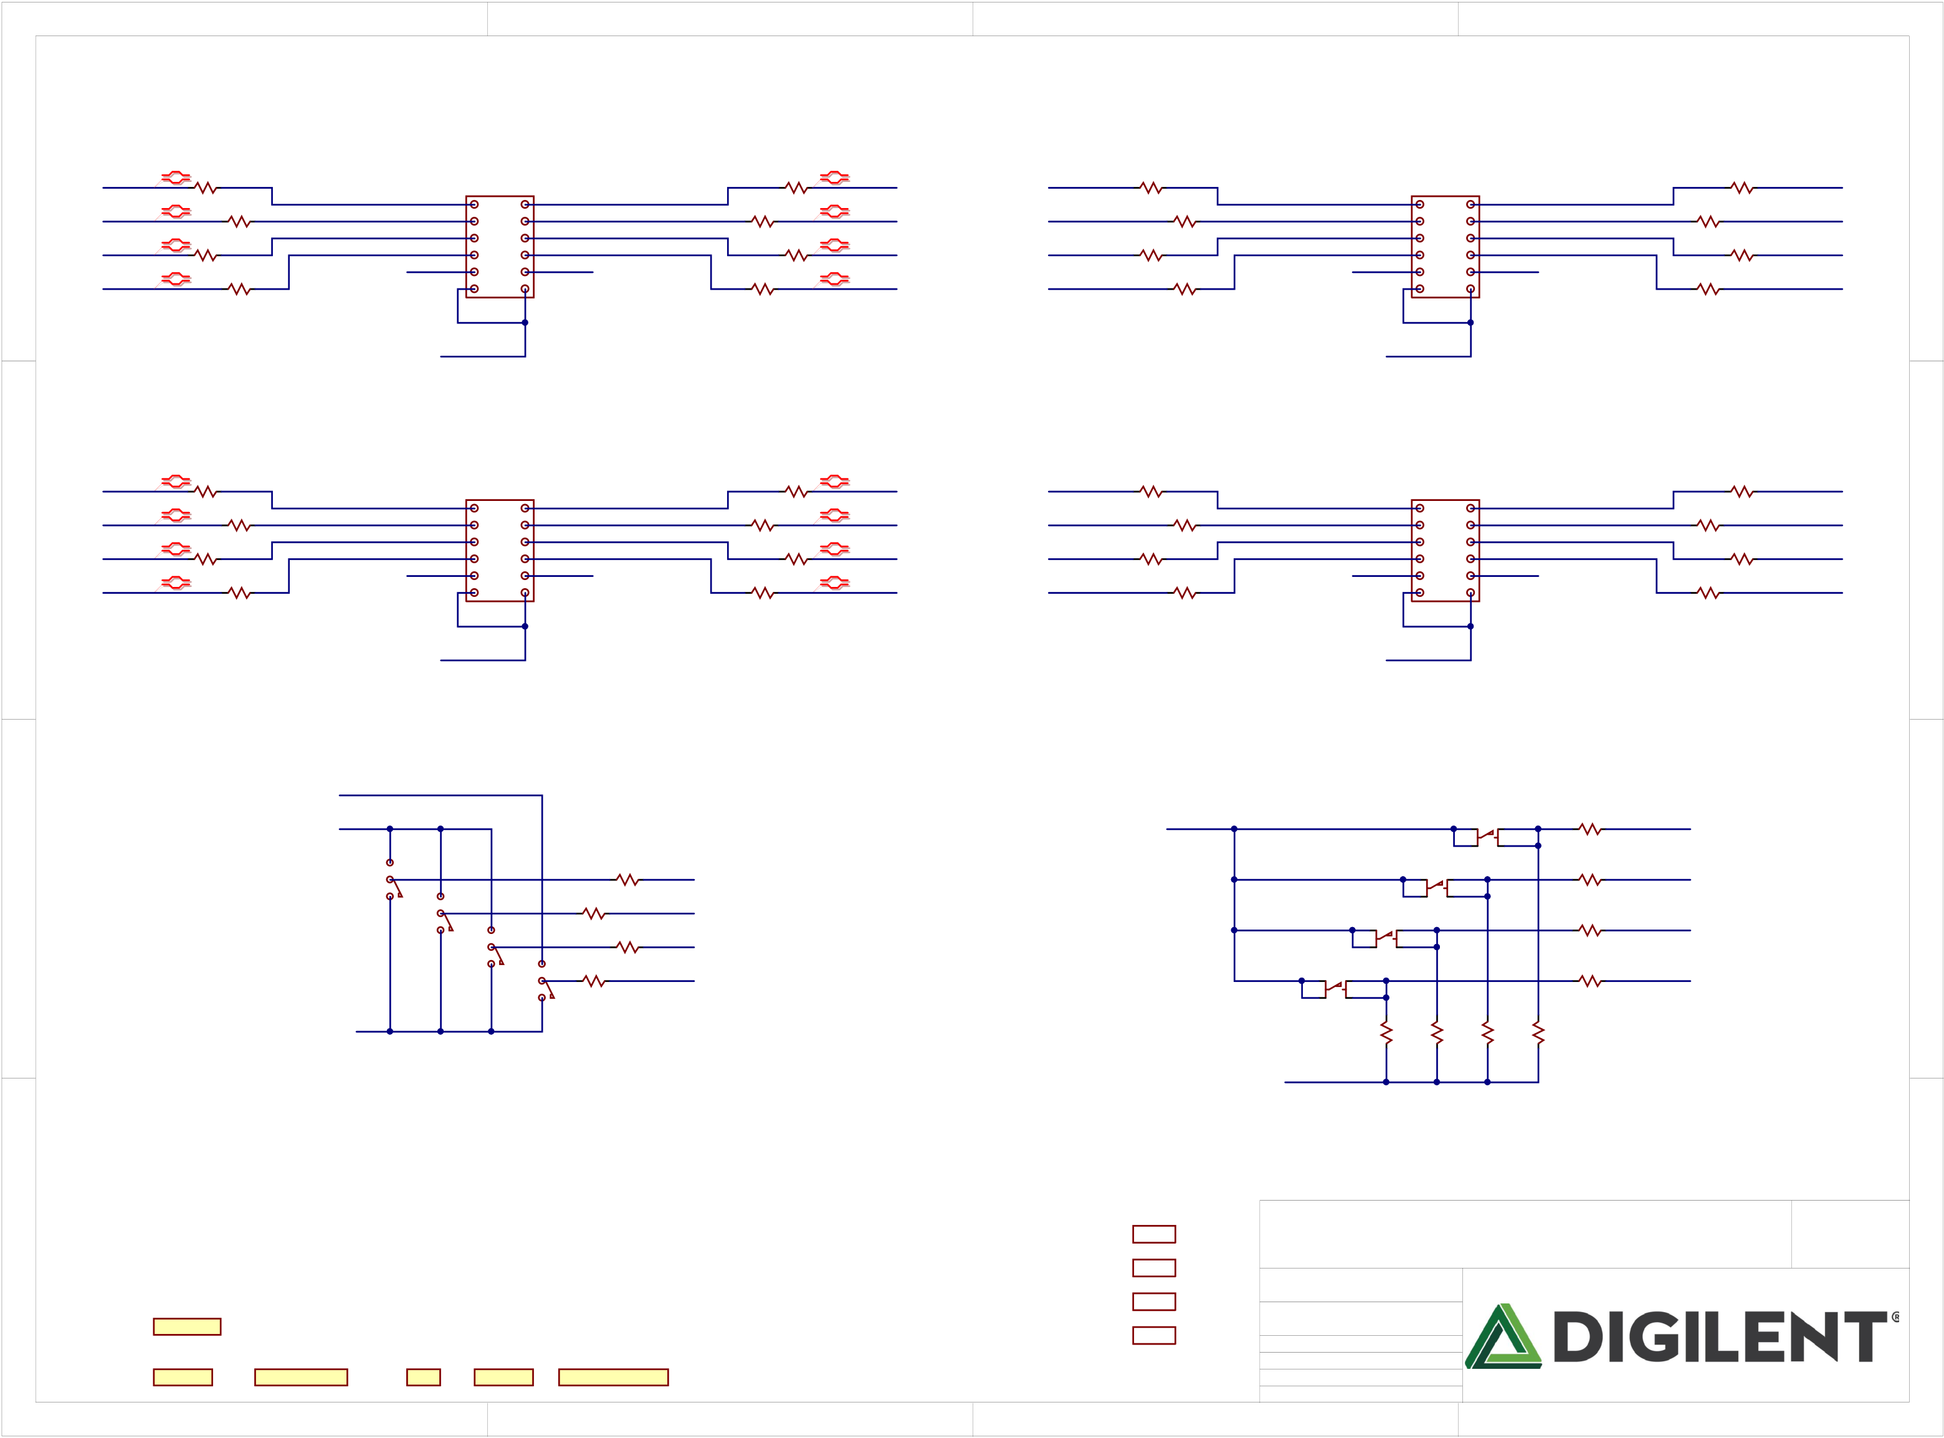

|  |  |  |  |  |  |  |  |  |  |  |  |  |  |  |  |  |  |  |  |  |  |  |  |  |
| --- | --- | --- | --- | --- | --- | --- | --- | --- | --- | --- | --- | --- | --- | --- | --- | --- | --- | --- | --- | --- | --- | --- | --- | --- |
| A | NLJA10P | 1 | | | GND | Pmod 2x6  PIJA01 1 7 PIJA07  2 8  3 9  4 10  5 11  6 12  COJA | GND | 2 | COR2 R2  PIR202 PIR201 | | | NLJA30P | NLJC10CK0IO41 PIR302 R3 COR3 | | PIR301 | | 3 | GND | Pmod 2x6  PIJC01 1 7 PIJC07  2 8  3 9  4 10 PIJC010  5 11  6 12  COJC | GND | 4 | | | A |
| R1 PIR102 | PIR101 | | PIR402 R4 COR4 PIR401 NLJC70CK0IO37 | | |
| NLJA10N | 0 | COR5 | | COR6 | 0 | | NLJA30N | NLJC20CK0IO40 200  PIR702  COR7  PIR701  NLJC30CK0IO39 PIR1102 COR11  PIR1101   200 | | | | PIR802  R8 COR8  PIR801 200 NLJC80CK0IO36  200  PIR1202 COR12 PIR1201 NLJC90CK0IO35 | | |
| PIR502 COR9 0 PIR902 PIR901 | | PIR501 | PIR602 0 | PIR601  COR10 PIR1002 PIR1001 | |
| NLJA20P | NLJA40P |
| NLJA20N | 0 | COR13 | | COR14 | | 0 | NLJA40N | NLJC40CK0IO38 | 200 | COR15 | | R16 COR16  PIR1602 PIR1601 | 200 | NLJC100CK0IO34 |
| PIR1302 | | PIR1301 | PIR1402 | PIR1401 | | PIR1502 | PIR1501 |
| 0 | | | 0 | | | 200 | | | | 200 | | |

|  |  |  |  |  |  |  |  |  |  |  |  |  |  |  |  |  |  |  |  |  |  |  |
| --- | --- | --- | --- | --- | --- | --- | --- | --- | --- | --- | --- | --- | --- | --- | --- | --- | --- | --- | --- | --- | --- | --- |
| B | NLJB10P | COR17 | | | GND | VCC3V3 | GND | COR18 | | | | NLJB30P | NLJD10CK0IO33 PIR1902 R19 COR19  PIR1901 | | | GND | VCC3V3 | GND | PIR2002 R20 COR20 PIR2001 NLJD70CK0IO29 | | | B |
| PIR1702 | PIR1701 | | Pmod 2x6  PIJB01 1 7 PIJB07  2 8  3 9  4 10  5 11  6 12  COJB | PIR1802 | | | PIR1801 | Pmod 2x6  PIJD01 1 7 PIJD07  2 8  3 9  4 10 PIJD010  5 11  6 12  COJD |
| NLJB10N | 0 | COR21 | | COR22 | | 0 | | NLJB30N | NLJD20CK0IO32 200  PIR2302  COR23  PIR2301  NLJD30CK0IO31 PIR2702 COR27  PIR2701   200 | | | PIR2402  R24 COR24  PIR2401 200 NLJD80CK0IO28  200  PIR2802 COR28 PIR2801 NLJD90CK0IO27 | | |
| PIR2102 COR25 0 PIR2502 PIR2501 | | PIR2101 | PIR2202  0 | PIR2201  COR26 PIR2602 PIR2601 | | |
| NLJB20P | NLJB40P |
| NLJB20N | 0 | COR29 | | COR30 | | 0 | | NLJB40N | NLJD40CK0IO30 | 200 | COR31 | R32 COR32  PIR3202 PIR3201  200 | 200 | NLJD100CK0IO26 |
| PIR2902  0 | | PIR2901 | PIR3002  0 | PIR3001 | | | PIR3102 PIR3101  200 |
| VCC3V3 | VCC3V3 |

NLDDR1V35

|  |  |  |  |  |  |  |  |  |  |  |  |
| --- | --- | --- | --- | --- | --- | --- | --- | --- | --- | --- | --- |
| C | NLVCC3V3 | COSW1 PISW103 | PISW201 | PISW301 | COR34 | | NLSW0 | VCC3V3 | COBTN0 COR33  PIBTN001 PIBTN003 PIR3302 PIR3301  10K  BTN1 PTA-142 R35 COR35  PIR3502 PIR3501  10K  COBTN2 PTA-142 COR37  PIBTN201 PIBTN203 PIR3702 PIR3701  10K  COBTN3 PTA-142 COR40  PIBTN301 PIBTN303 PIR4002 PIR4001  10K  PTA-142 PIR4102 COR41 PIR4402  COR44 PIR4202 COR42 PIR4302 COR43  PIR4101 10K PIR4401 10K PIR4201 10K PIR4301 10K | NLBTN0 | C |
| PISW001 | NLBTN1 |
| SW0 | PIR3402 PIR3401  COR36 10K | |
| NLSW1 |
| NLBTN2 |
| PIR3602 PIR3601  10K COR38  PIR3802 PIR3801 | |
| NLSW2 |
| NLGND | SW2 | NLBTN3 |
| COR39 | 10K | NLSW3 |
| SW3 | PIR3902 PIR3901  10K | |

GND

|  |  |  |  |  |  |  |  |  |  |  |  |  |  |  |  |
| --- | --- | --- | --- | --- | --- | --- | --- | --- | --- | --- | --- | --- | --- | --- | --- |
| D | Arty S7 | 1 | Digilent Inc. | CE | ROHS | Chinese ROHS | 2 | Foot | 3 | Title   Arty S7  Circuit  PMOD, BTN, SWTs  Doc# 500-352 | | | 4 | Rev  Copyright B.0 2017 | D |
| COF1  Foot  F2  Foot |
| F3  Foot  F4 |
| Engineer Author  Date  Sheet# 1 | MTA  GMA  4/7/2017 out of | 11 |
| Xilinx |

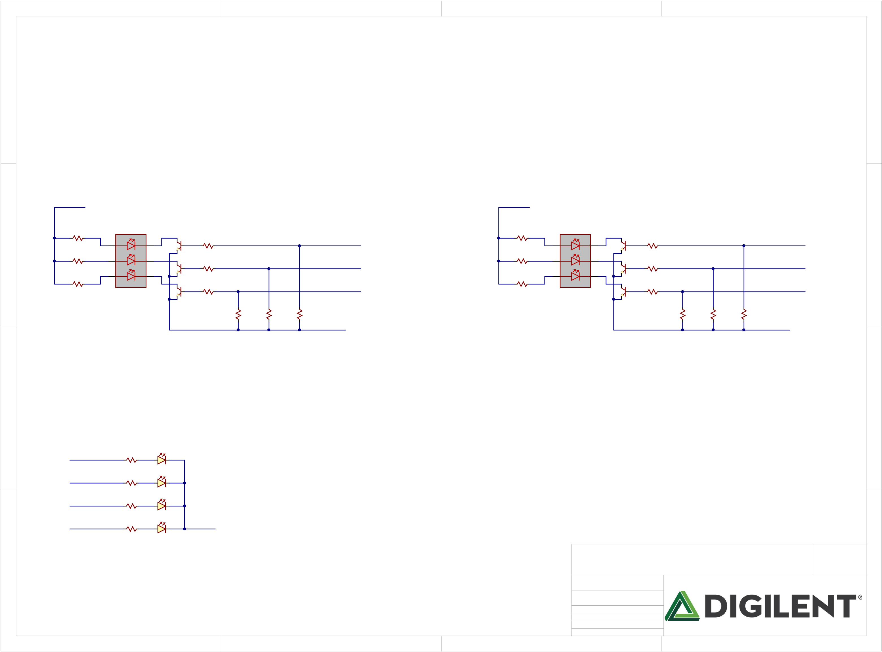

|  |  |  |  |  |  |
| --- | --- | --- | --- | --- | --- |
| A | 1 | 2 | 3 | 4 | A |

NLVCC5V0 VCC5V0

|  |  |  |  |  |  |  |  |  |  |  |  |  |  |  |  |  |  |  |  |  |  |  |  |  |
| --- | --- | --- | --- | --- | --- | --- | --- | --- | --- | --- | --- | --- | --- | --- | --- | --- | --- | --- | --- | --- | --- | --- | --- | --- |
| B | COR45 | 4 | COLD0 | 1 | COQ1B | R47 | 2.2K | PIR5701 | COR57  2.2K | PIR5801  COR58  PIR5802 2.2K | PIR5901  COR59  PIR5902 2.2K | LED0_B | COR46 | 4 | LD1 | 1 | Q1B | R48 | PIR4801 2.2K | PIR6001  COR60  PIR6002 2.2K | PIR6101  COR61  PIR6102 2.2K | PIR6201  COR62  PIR6202 2.2K | NLLED10B | B |
| PIR4502 PIR4501  86.6  R49 | PIR4602 PIR4601  86.6  R50 |
| B | Q2A | R51 | B | Q2B | R52 |
| 5 | 2 | 5 | 2 | NLLED10R |
| C | 150  R53 | R | 2.2K | LED0_R | 150  R54 | R | PIR5201  2.2K | C |
| 6 | 3 | 6 | 3 |
| Q3A | Q3B |
| G | R55 | G | R56 |
| LED0_G | NLLED10G |
| 75 | VS NRD8 | 2.2K | 75 | VS NRD8 | PIR5601  2.2K |
| GND | GND |
| PIR5702 |

|  |  |  |  |  |  |  |  |  |  |  |  |  |  |  |
| --- | --- | --- | --- | --- | --- | --- | --- | --- | --- | --- | --- | --- | --- | --- |
| D | NLLED2 | 1 | COR63  PIR6302 PIR6301 | PILD20A | PILD20K | NLGND | 2 | 3 | Title   Arty S7  Circuit  LEDs  Doc# 500-352 | | | 4 | Rev  Copyright B.0 2017 | D |
| NLLED3 | 330 | LD2 | |
| COR64 |
| PIR6402 PIR6401  330 | PILD30A | |
| NLLED4 | COLD3 | |
| R65  PIR6502 PIR6501 330 |
| PILD40A | |
| NLLED5 | COLD4 | |
| COR66 |
| PIR6602 PIR6601  330 | PILD50A | |
| COLD5 | |
| Engineer Author  Date  Sheet# 2 | MTA  GMA  4/7/2017 out of | 11 |

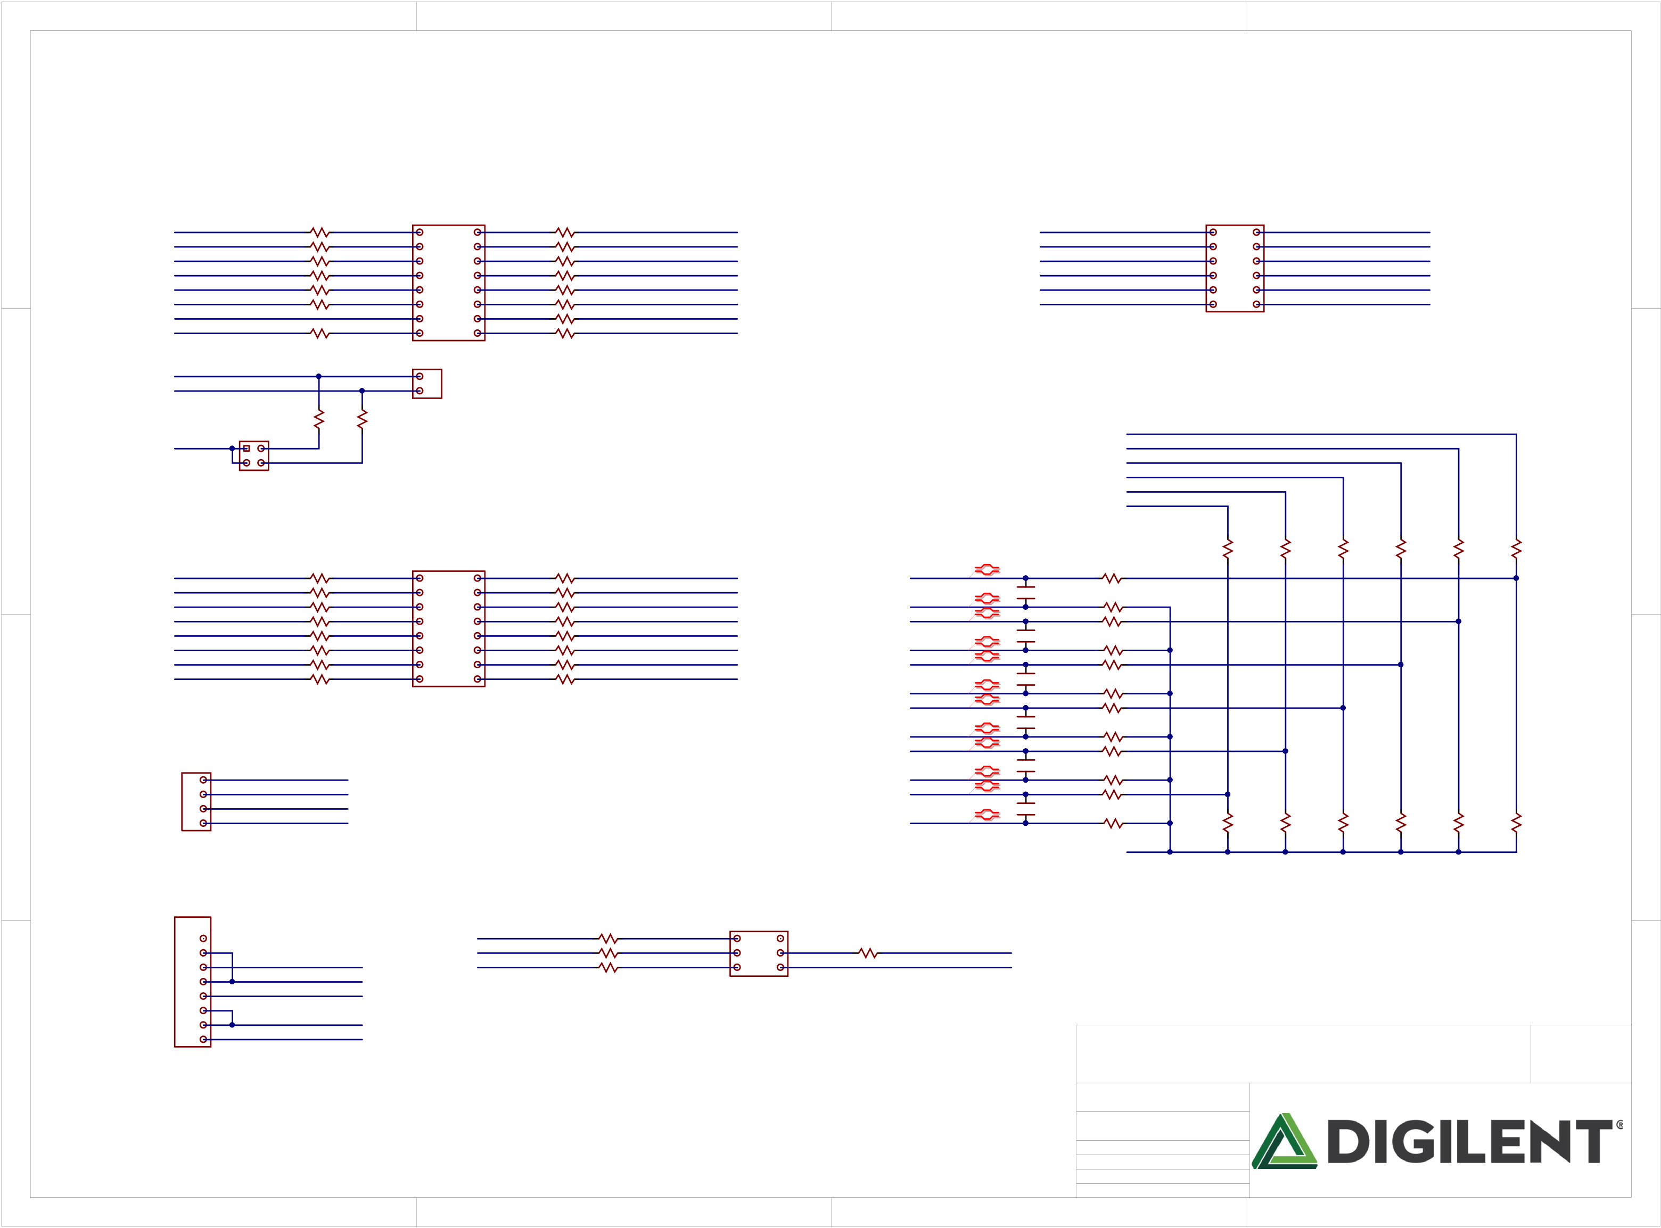

|  |  |  |  |  |  |
| --- | --- | --- | --- | --- | --- |
| A | 1 | 2 | 3 | 4 | A |

|  |  |  |  |  |  |  |  |  |  |  |  |  |  |  |  |  |  |  |  |  |  |  |  |  |  |  |  |  |  |  |  |  |  |  |  |  |  |
| --- | --- | --- | --- | --- | --- | --- | --- | --- | --- | --- | --- | --- | --- | --- | --- | --- | --- | --- | --- | --- | --- | --- | --- | --- | --- | --- | --- | --- | --- | --- | --- | --- | --- | --- | --- | --- | --- |
| B | NLCK0IO8  NLCK0IO9  NLCK0IO100SS  CK_IO11_MOSI  CK_IO12_MISO  NLCK0IO130SCK  GND  NLCK0IOA | | | 200 PIR6702 200 PIR6902 200 PIR7102 200 PIR7302 200 PIR7502 200 PIR7702 | PIR6701 COR67  PIR6901 COR69  PIR7101 COR71    PIR7301  PIR7501  COR73  COR75  R73  PIR7701 COR77 | | | 8  9  10  11  12  13  G  A | IOH | | PIJ202 | 34  35  36  37  38  39  40  41 | 200 PIR6802 200 PIR7002 200 PIR7202 200 PIR7402 200 PIR7602 200 PIR7802 200 PIR7902 200 PIR8102 | PIR6801 COR68  PIR7001 COR70  PIR7201 COR72  PIR7401  PIR7601  COR74  COR76  R74  PIR7801 COR78  PIR7901 COR79  PIR8101 COR81 R81 | NLJC100CK0IO34  NLJC90CK0IO35  NLJC80CK0IO36  NLJC70CK0IO37  NLJC40CK0IO38  NLJC30CK0IO39  NLJC20CK0IO40  NLJC10CK0IO41 | NLCK0AN00P | PIC101 | NLCK0A0 NLCK0A1 NLCK0A2  CK_A3 NLCK0A3  NLCK0A4 NLCK0A5 | COR92 PIR9201 | CK_A0 CK_A1 CK_A2 CK_A3 CK_A4 CK_A5 | A0 A1 A2 A3 A4 A5 | ANALOG | | | | | | | | | | | | | | COR89  2.32K  1% | B |
| 2x8  PIJ201 1 2  3 4  PIJ205 5 6  7 8  PIJ209 9 10  11 12  13 14  15 16  COJ2  PIJ301  1x2  1  2   SDA  SCL  COJ3 | | PIJ101 | 2x6  1 2 3 4 5 6 7 8 9 10 11 12 | | PIJ102 | A6  A7  A8  A9  A10  A11 | | | NLCK0A6  NLCK0A7  NLCK0A8  NLCK0A9  NLCK0A10  NLCK0A11 | | | | | | |
| PIJ206 | PIJ103 | PIJ104 |
| PIJ105 | PIJ106 |
| PIJ2010 | PIJ107 | PIJ108 |
| PIJ109 | PIJ1010 |
| PIJ1011 | PIJ1012 |
| 200 PIR8002 | PIR8001 COR80 R80 | | | J1 | NOTE: CK_A10 and CK_A11 are Digital I/O only! | | | | | | | | | |
| NLCK0SDA  NLCK0SCL | | | | | | | |
| VCC3V3 | 2x2 | | | PIR8201 | COR82 R82  2.2K | PIR8301  COR83 R83  2.2K | |
| PIJ401 | PIJ402 | |
| COJ4 | | I2C JUMPER | | | | | |
| C | NLCK0IO0  NLCK0IO1  NLCK0IO2  NLCK0IO3  NLCK0IO4  NLCK0IO5  NLCK0IO6  NLCK0IO7 | | 200 PIR9002  200 PIR9302  200 PIR9502  200 PIR9802  200 PIR10102  200 PIR10302  200 PIR10602  200 PIR10902 | | PIR9001 COR90  PIR9301 COR93    PIR9501  PIR9801  COR95  COR98  PIR10101 COR101  PIR10301 COR103  COR106    PIR10601  PIR10901 COR109 | | | 0  1  2  3  4  5  6  7 | IOL | | PIJ502 | 26  27  28  29  30  31  32  33 | 200 PIR9102 200 PIR9402 200 PIR9602 200 PIR9902 200 PIR10202 200 PIR10402 200 PIR10702 200 PIR11002 | PIR9101 COR91  PIR9401 COR94  PIR9601  PIR9901  COR96  COR99  PIR10201 COR102  PIR10401 COR104  COR107  PIR10701  PIR11001 COR110 | NLJD100CK0IO26  NLJD90CK0IO27  NLJD80CK0IO28  NLJD70CK0IO29  NLJD40CK0IO30  NLJD30CK0IO31  NLJD20CK0IO32  NLJD10CK0IO33 | COC1  1nF | PIR9202 140 1%  PIR9701 845  PIR10002 140 1%  PIR10501 845 140 1% 845 140 1% 845 140 1% 845  PIR11602 140 1%  PIR12301 845 | 1% | PIR8401 | | COR84  2.32K  1% | | | PIR8501 | 2.32K COR85  1% | PIR8601 | COR86  2.32K 1% | PIR8701 | 2.32K COR87  1% | PIR8801 | 2.32K COR88  1% | PIR8901 | C |
| PIJ501  PIJ503  PIJ507  COJ5 | 2x8  1 2  3 4  5 6  7 8  9 10  11 12  13 14  15 16 |
| PIJ504 | CK_AN0_N  NLCK0AN10P | R97 COR97  COR100 PIR9702  PIR10001 |
| PIJ508 | PIC201 |
| C2 COC2  1nF |
| 1% |
| CK_AN1_N  NLCK0AN20P | COR105 PIR10502  R108 PIR10801 |
| PIC301 |
| C3 COC3  1nF |
| 1% |
| CK_AN2_N  NLCK0AN30P | R111 R112 PIR11201 |
| PIC302 |
| PIC401 | COC4  1nF |
| 1% |
| 1x4  1 PIJ601  2  3  4  COJ6 | | NLXADC0V0P  XADC_V_N  XADCGND  XADCVREF | | | | | | CK_AN3_N  NLCK0AN40P | R113 R114 PIR11401 |
| PIC501 |
| COC5  1nF |
| 1% |
| CK_AN4_N  NLCK0AN50P | R115  COR116 PIR11601 |
| PIC601 | C6 COC6  1nF | 1% | PIR11701 | | COR117 1K  1% | | | PIR11801 | R118 COR118  1K  1% | PIR11901 | R119 COR119  1K  1% | PIR12001 | R120 COR120  1K  1% | PIR12101 | R121 COR121  1K  1% | PIR12201 | R122 COR122  1K  1% |
| CK_AN5_N | COR123 PIR12302 |
| GND |

Note: Terminate N signals next to Analog Header

|  |  |  |  |  |  |  |  |  |  |  |  |  |  |  |  |  |  |  |  |  |
| --- | --- | --- | --- | --- | --- | --- | --- | --- | --- | --- | --- | --- | --- | --- | --- | --- | --- | --- | --- | --- |
| D | POWER | CK_RST  VCC3V3  VCC5V0 | CK_IO12_MISO  CK_IO13_SCK  CK_IO10_SS | 200 200 PIR12402  PIR12502 200 PIR12702 | PIR12401 PIR12501 COR124 COR125  PIR12701 COR127 | MISO SCK  SS | PIJ701 | SPI | PIJ702 | MOSI GND | 200 PIR12602 | PIR12601 COR126 | CK_IO11_MOSI GND | 3 | Title   Arty S7  Circuit  CHipKIT IO  Doc# 500-352 | | | 4 | Rev  Copyright B.0 2017 | D |
| 1x8  1 PIJ801  2 PIJ802  3  4  5  6  7  8  COJ8 | 2x3 1 2 3 4 5 6 |
| PIJ703 | PIJ704 |
| COJ7 |
| NLGND  VU |
| 1 | 2 | Engineer Author  Date  Sheet# 3 | MTA  GMA  4/7/2017 out of | 11 |

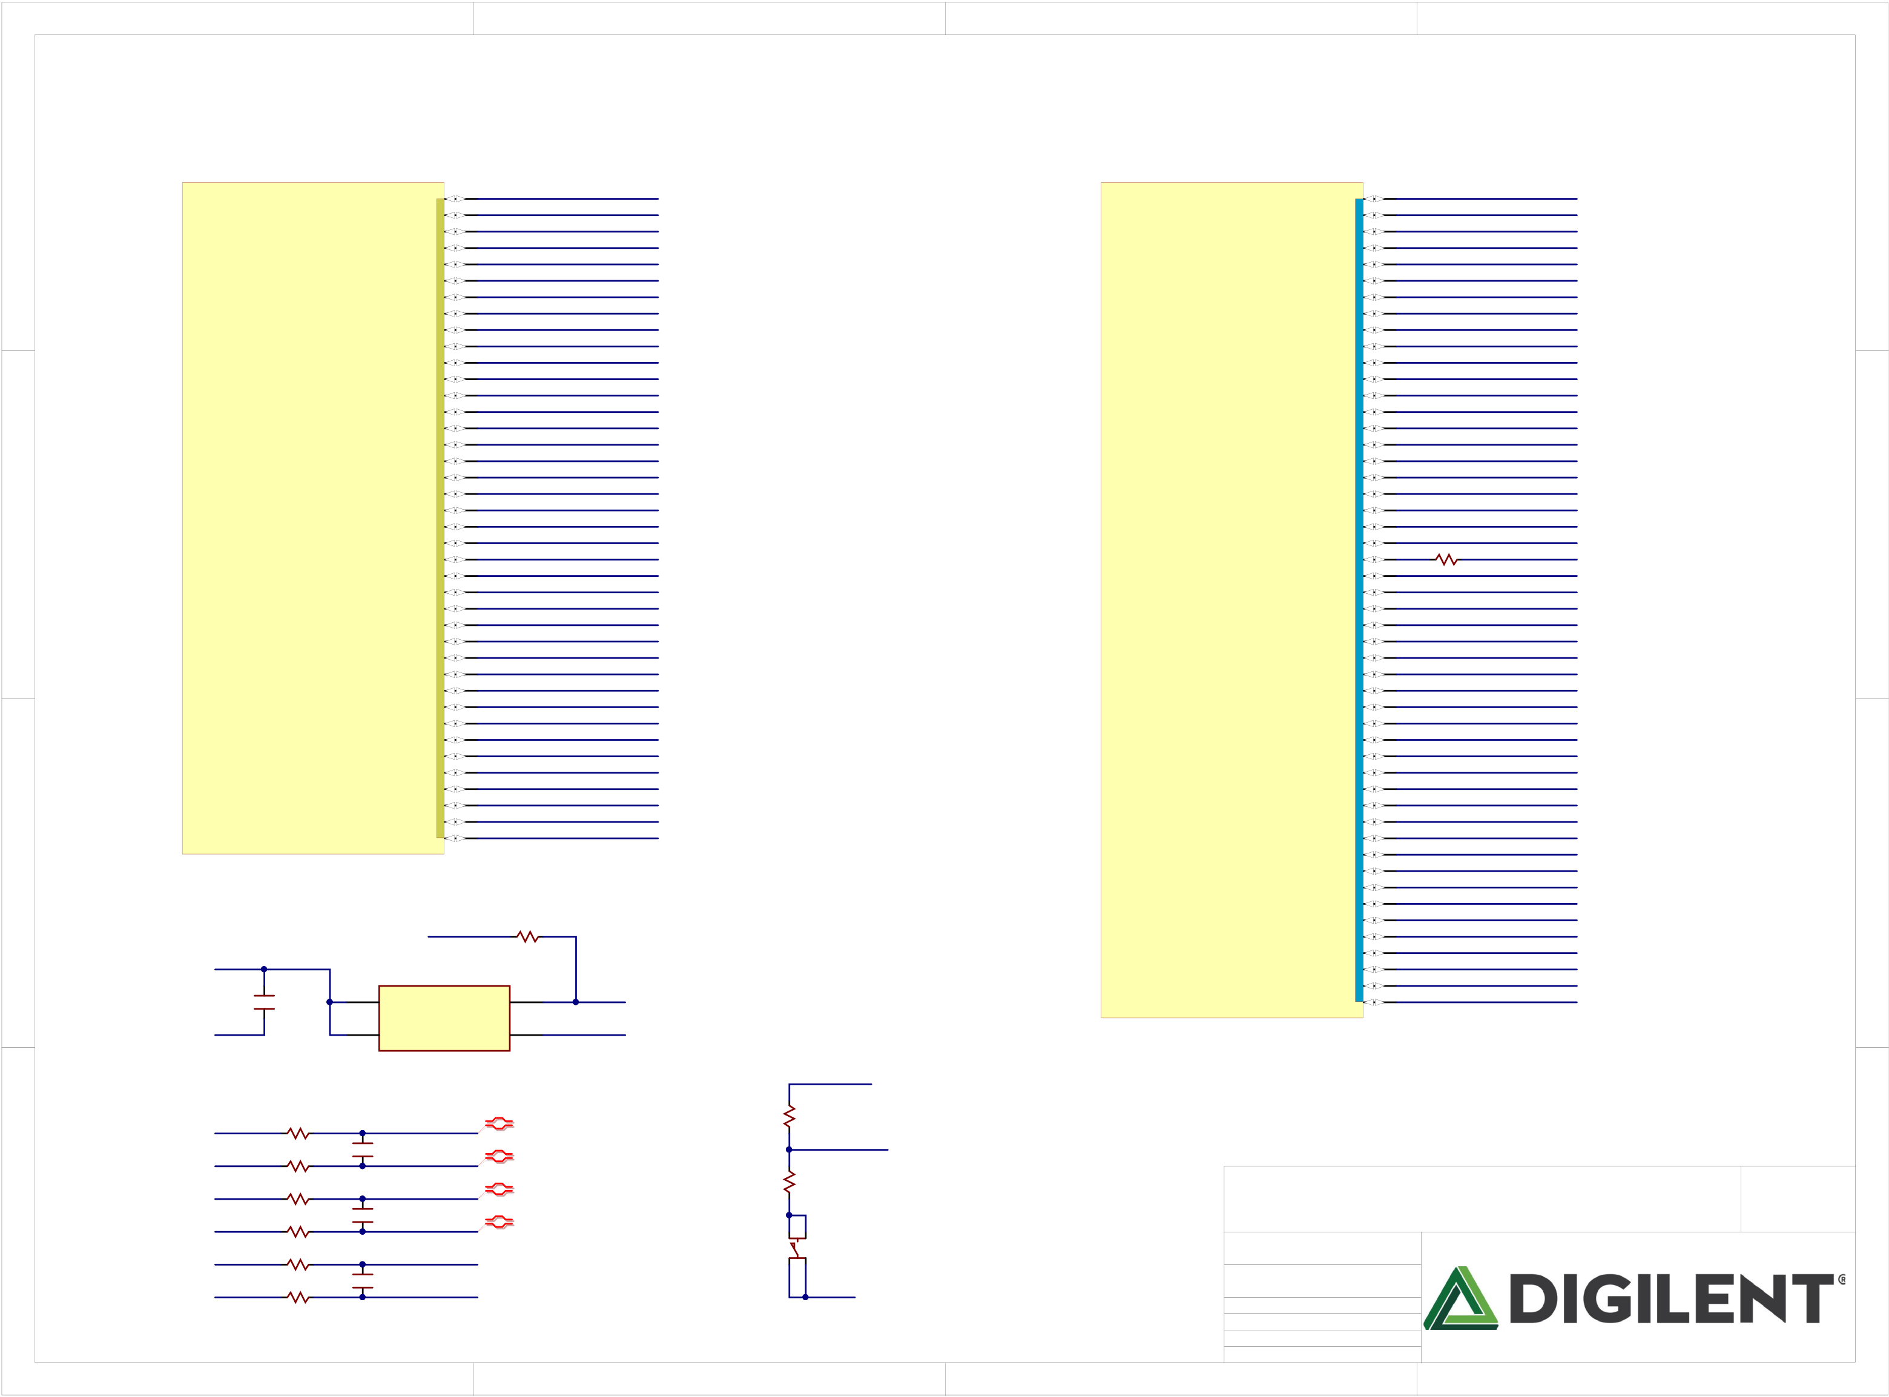

|  |  |  |  |  |  |  |  |  |  |  |  |  |  |  |  |  |  |  |
| --- | --- | --- | --- | --- | --- | --- | --- | --- | --- | --- | --- | --- | --- | --- | --- | --- | --- | --- |
| A | 1 | | | | | | | | | CK_IO0  JA1_P  JA1_N  JA2_P  JA2_N  CK_IO1  JA3_P  JA3_N  JA4_P  JA4_N  JB1_P  JB1_N  JB2_P  JB2_N  JB3_P  JB3_N  JB4_P  JB4_N  CK_IO3  CK_IO4  CK_IO5  CK_IO6  CK_IO7  CK_IO8  CK_IO9  JC1/CK_IO41  JC2/CK_IO40  JC8/CK_IO36  JC9/CK_IO35  JC10/CK_IO34  JD1/CK_IO33  JD2/CK_IO32  JD3/CK_IO31  JD4/CK_IO30  JD7/CK_IO29  JD8/CK_IO28  JD9/CK_IO27  JD10/CK_IO26  UART_TXD_IN  UART_RXD_OUT | 2 | **BANK 15** | 3 | G13 B13 A13 B14 A14 B15 A15 B16 A16 E12 D12 C13 C14 B17 A17 C17 B18 D16 D17 E16 E17 D18 C18 D14 D15 F14  F15  G16 G17 E14 E15 F18  E18 F13  E13 H15 G15 K16 J16  H13 H14 H18 G18 H16 H17 K14 J15  J13  J14  K13 | 200 PIR12802 | CK_A0  CK_AN0_P  CK_AN0_N  AD8_P  AD8_N  CK_AN1_P  CK_AN1_N  CK_A1  CK_A2  CK_AN2_P  CK_AN2_N  CK_A3  CK_A4  CK_AN3_P  CK_AN3_N  CK_AN4_P  CK_AN4_N  AD3_P  AD3_N  CK_AN5_P  CK_AN5_N  CK_A5  PIR12801 COR128 CK_RST CK_A10_R   CK_A11_R  UCLK  LED0_B  CK_IO13_SCK  LED0_G  LED1_B  LED1_R  LED1_G  LED2  LED3  LED4  LED5  BTN0  BTN1  BTN2  BTN3  SW0  SW1  SW2  CK_IO10_SS  CK_IO11_MOSI CK_IO12_MISO LED0_R  CK_SDA  CK_SCL  CK_IOA | 4 | A |
| **BANK 14** | IO_0_14  IO_L4P_T0_D04_14  IO_L4N_T0_D05_14  IO_L5P_T0_D06_14  IO_L5N_T0_D07_14  IO_L6N_T0_D08_VREF_14  IO_L7P_T1_D09_14  IO_L7N_T1_D10_14  IO_L8P_T1_D11_14  IO_L8N_T1_D12_14  IO_L9P_T1_DQS_14  IO_L9N_T1_DQS_D13_14  IO_L10P_T1_D14_14  IO_L10N_T1_D15_14  IO_L11P_T1_SRCC_14  IO_L11N_T1_SRCC_14  IO_L12P_T1_MRCC_14  IO_L12N_T1_MRCC_14  IO_L13P_T2_MRCC_14  IO_L13N_T2_MRCC_14  IO_L14P_T2_SRCC_14  IO_L14N_T2_SRCC_14  IO_L16N_T2_A15_D31_14  IO_L17P_T2_A14_D30_14  IO_L17N_T2_A13_D29_14  IO_L18P_T2_A12_D28_14  IO_L18N_T2_A11_D27_14  IO_L19P_T3_A10_D26_14  IO_L19N_T3_A09_D25_VREF_14 IO_L20P_T3_A08_D24_14  IO_L20N_T3_A07_D23_14  IO_L21P_T3_DQS_14  IO_L21N_T3_DQS_A06_D22_14 IO_L22P_T3_A05_D21_14  IO_L22N_T3_A04_D20_14  IO_L23P_T3_A03_D19_14  IO_L23N_T3_A02_D18_14  IO_L24P_T3_A01_D17_14  IO_L24N_T3_A00_D16_14  IO_25_14 | | | | | L13  L17  L18  M14  N14  N13  M16  M17  M18  N18  P17  P18  R18  T18  P14  P15  N15  P16  R14  T14  R16  R17  V17  R15  T15  U15  V16  P13  R13  V14  V15  U12  V13  T12  T13  R11  T11  U11  V12  R12 | | | IO_0_15  IO_L1P_T0_AD0P_15  IO_L1N_T0_AD0N_15  IO_L2P_T0_AD8P_15  IO_L2N_T0_AD8N_15  IO_L3P_T0_DQS_AD1P_15  IO_L3N_T0_DQS_AD1N_15 IO_L4P_T0_15  IO_L4N_T0_15  IO_L5P_T0_AD9P_15  IO_L5N_T0_AD9N_15  IO_L6P_T0_15  IO_L6N_T0_VREF_15  IO_L7P_T1_AD2P_15  IO_L7N_T1_AD2N_15  IO_L8P_T1_AD10P_15  IO_L8N_T1_AD10N_15  IO_L9P_T1_DQS_AD3P_15  IO_L9N_T1_DQS_AD3N_15 IO_L10P_T1_AD11P_15  IO_L10N_T1_AD11N_15  IO_L11P_T1_SRCC_15  IO_L11N_T1_SRCC_15  IO_L12P_T1_MRCC_15  IO_L12N_T1_MRCC_15  IO_L13P_T2_MRCC_15  IO_L13N_T2_MRCC_15  IO_L14P_T2_SRCC_15  IO_L14N_T2_SRCC_15  IO_L15P_T2_DQS_15  IO_L15N_T2_DQS_ADV_B_15 IO_L16P_T2_A28_15  IO_L16N_T2_A27_15  IO_L17P_T2_A26_15  IO_L17N_T2_A25_15  IO_L18P_T2_A24_15  IO_L18N_T2_A23_15  IO_L19P_T3_A22_15  IO_L19N_T3_A21_VREF_15 IO_L20P_T3_A20_15  IO_L20N_T3_A19_15  IO_L21P_T3_DQS_15  IO_L21N_T3_DQS_A18_15  IO_L22P_T3_A17_15  IO_L22N_T3_A16_15  IO_L23P_T3_FOE_B_15  IO_L23N_T3_FWE_B_15  IO_L24P_T3_RS1_15  IO_L24N_T3_RS0_15  IO_25_15 |
| B | B |
| C | C |
| COIC1C | | | | | | | | |
| 12MHZ/UCLK PIR12902 COR129  PIR12901 | | | | | | | | |
| NLUCLK |
| NLVCC3V3 | | | COC7  100nF | 4 | COIC2 | No Load | 0 | 3 |
| PIC701 | | |
| VDD | OUT |
| GND | | PIC702 |
| 1 | EN | GND | 2 | GND | IC1C |

|  |  |  |  |  |  |  |  |  |  |  |  |  |  |  |  |  |
| --- | --- | --- | --- | --- | --- | --- | --- | --- | --- | --- | --- | --- | --- | --- | --- | --- |
| D | NLCK0A6 | PIR13102 | COR131  PIR13101  140  PIR13201 COR132  140  PIR13401 COR134  140  PIR13501 COR135 R135  140  PIR13601 COR136  140  PIR13701 COR137  140 | PIC801 | ASEM1-100.000MHZ-LC-T | 2 | VCC3V3 | | | 3 | Title   Arty S7  Circuit  FPGA Banks  Doc# 500-352 | | | 4 | Rev  Copyright B.0 2017 | D |
| NLAD80P  COC8  1nF NLAD80N  No Load   NLAD30P  COC9  1nF   NLAD30N No Load   NLCK0A100R  COC142  1nF NLCK0A110R  No Load | PIR13001 | COR130  10K | NLCK0RST |
| PIR13002 |
| NLCK0A7 | PIR13202 | PIC802 |
| PIR13301 | COR133  200 | |
| NLCK0A8 | PIR13402 | PIC901 |
| NLCK0A9 | PIR13502 | PIBTNR03 PIBTNR04   BTNR  PIBTNR01 PIBTNR02 PTA-142 Red Knob | | |
| NLCK0A10 | PIC14201 |
| PIR13602 |
| NLCK0A11 | PIR13702 | PIC14202 | GND | | |
| Engineer Author  Date  Sheet# 4 | MTA  GMA  4/7/2017 out of | 11 |
| 1 |

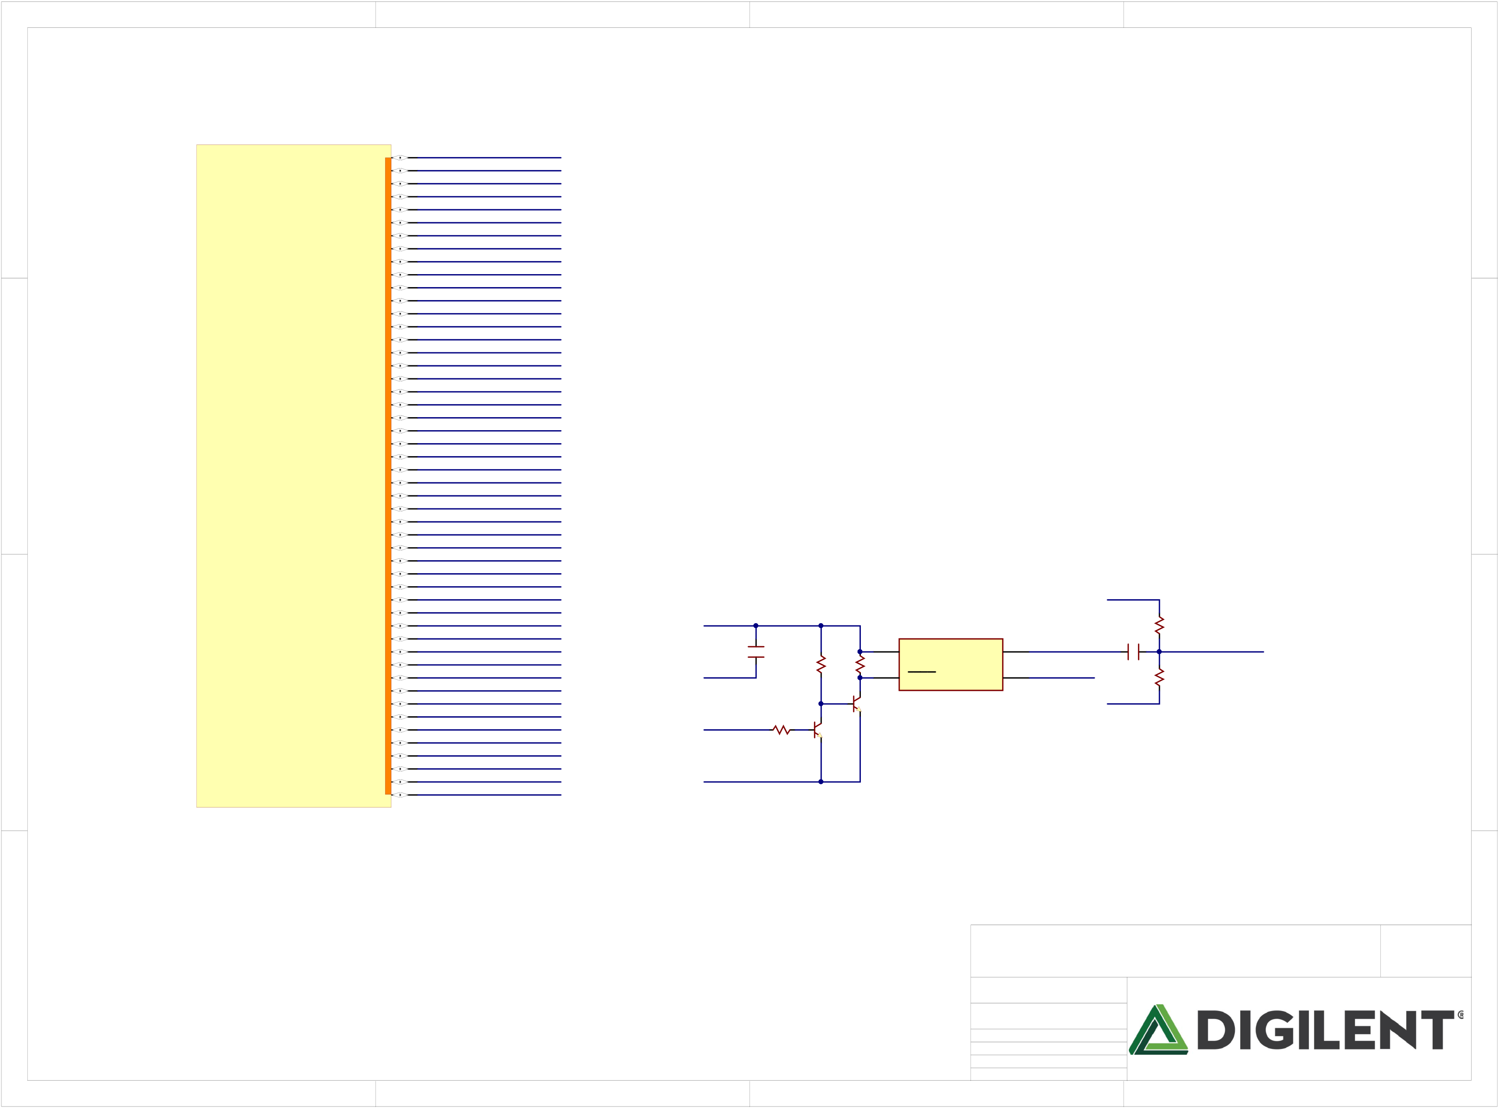

|  |  |  |  |  |  |  |  |  |  |  |  |  |  |  |  |  |  |  |  |  |
| --- | --- | --- | --- | --- | --- | --- | --- | --- | --- | --- | --- | --- | --- | --- | --- | --- | --- | --- | --- | --- |
| A | 1 | **BANK 34** | IO_0_34  IO_L1P_T0_34  IO_L1N_T0_34  IO_L2P_T0_34  IO_L2N_T0_34  IO_L3P_T0_DQS_34  IO_L3N_T0_DQS_34  IO_L4P_T0_34  IO_L4N_T0_34  IO_L5P_T0_34  IO_L5N_T0_34  IO_L6P_T0_34  IO_L6N_T0_VREF_34 IO_L7P_T1_34  IO_L7N_T1_34  IO_L8P_T1_34  IO_L8N_T1_34  IO_L9P_T1_DQS_34  IO_L9N_T1_DQS_34  IO_L10P_T1_34  IO_L10N_T1_34  IO_L11P_T1_SRCC_34 IO_L11N_T1_SRCC_34 IO_L12P_T1_MRCC_34 IO_L12N_T1_MRCC_34 IO_L13P_T2_MRCC_34 IO_L13N_T2_MRCC_34 IO_L14P_T2_SRCC_34 IO_L14N_T2_SRCC_34 IO_L15P_T2_DQS_34  IO_L15N_T2_DQS_34 IO_L16P_T2_34  IO_L16N_T2_34  IO_L17P_T2_34  IO_L17N_T2_34  IO_L18P_T2_34  IO_L18N_T2_34  IO_L19P_T3_34  IO_L19N_T3_VREF_34 IO_L20P_T3_34  IO_L20N_T3_34  IO_L21P_T3_DQS_34  IO_L21N_T3_DQS_34 IO_L22P_T3_34  IO_L22N_T3_34  IO_L23P_T3_34  IO_L23N_T3_34  IO_L24P_T3_34  IO_L24N_T3_34  IO_25_34 | J6  K4  L4  K3  K2  K1  L1  K6  L6  L5  M4  M6  M5  M3  M2  M1  N1  N3  N2  N5  N4  P2  P1  R2  R1  R3  T2  T1  U1  U3  U2  V3  V2  V5  V4  R4  T3  P6  P5  V7  V6  R5  T4  T6  T5  R7  R6  U7  U6  P7 | DDR3_RESET  DDR3_DM0  DDR3_DQ2  DDR3_DQ1  DDR3_DQ0  DDR3_DQS0_P DDR3_DQS0_N DDR3_DQ4  DDR3_DQ7  DDR3_DQ6  DDR3_DQ5  DDR3_DQ3   SW3  DDR3_DM1  DDR3_DQ12 DDR3_DQ14 DDR3_DQ10 DDR3_DQS1_P DDR3_DQS1_N DDR3_DQ11 DDR3_DQ8  DDR3_DQ15 DDR3_DQ13 NLDDR30CLK100 DDR3_DQ9  DDR3_CS  DDR3_CKE0  DDR3_BA1  DDR3_RAS  DDR3_BA2  DDR3_A0  DDR3_CAS  DDR3_A2  DDR3_BA0  DDR3_A3  DDR3_A1  DDR3_A4  DDR3_A10   DDR3_ODT DDR3_A9  DDR3_A6  DDR3_CLK0_P DDR3_CLK0_N DDR3_A7  DDR3_A11  DDR3_A5  DDR3_A12  DDR3_A8  DDR3_A13  DDR3_WE | 2 | NLVCC1V8 | PIC1101 | COC11  100nF | PIR23701  R237  10K | PIR24201 | 6  R242  10K 1 | 3 | | | GND | DDR1V35 | COR240  300  1% DDR3_CLK100 | 4 | A |
| B | COIC3 | OUT | 4 | B |
| PIR24001 |
| COC10 |
| NLGND | VDD | PIC1001 PIC1002 |
| STBY | GND | 3 | 100nF | R241  300  1% |
| C | DDR1V35 | COR238 PIR23801 PIR23802 | PIQ706  PIQ702  PIQ703 PIQ701 COQ7B  PIQ705   PIQ704 Q7B | | | ASFLMB-100.000MHZ-LR-T | | | GND | C |
| GND | 2.2K |

COIC1E

|  |  |  |  |
| --- | --- | --- | --- |
| D | Title   Arty S7  Circuit  FPGA Banks  Doc# 500-352 | Rev  Copyright B.0 2017 | D |

|  |  |  |  |  |  |  |
| --- | --- | --- | --- | --- | --- | --- |
| 1 | 2 | 3 | Engineer Author  Date  Sheet# 5 | MTA  GMA  4/7/2017 out of | 11 | 4 |

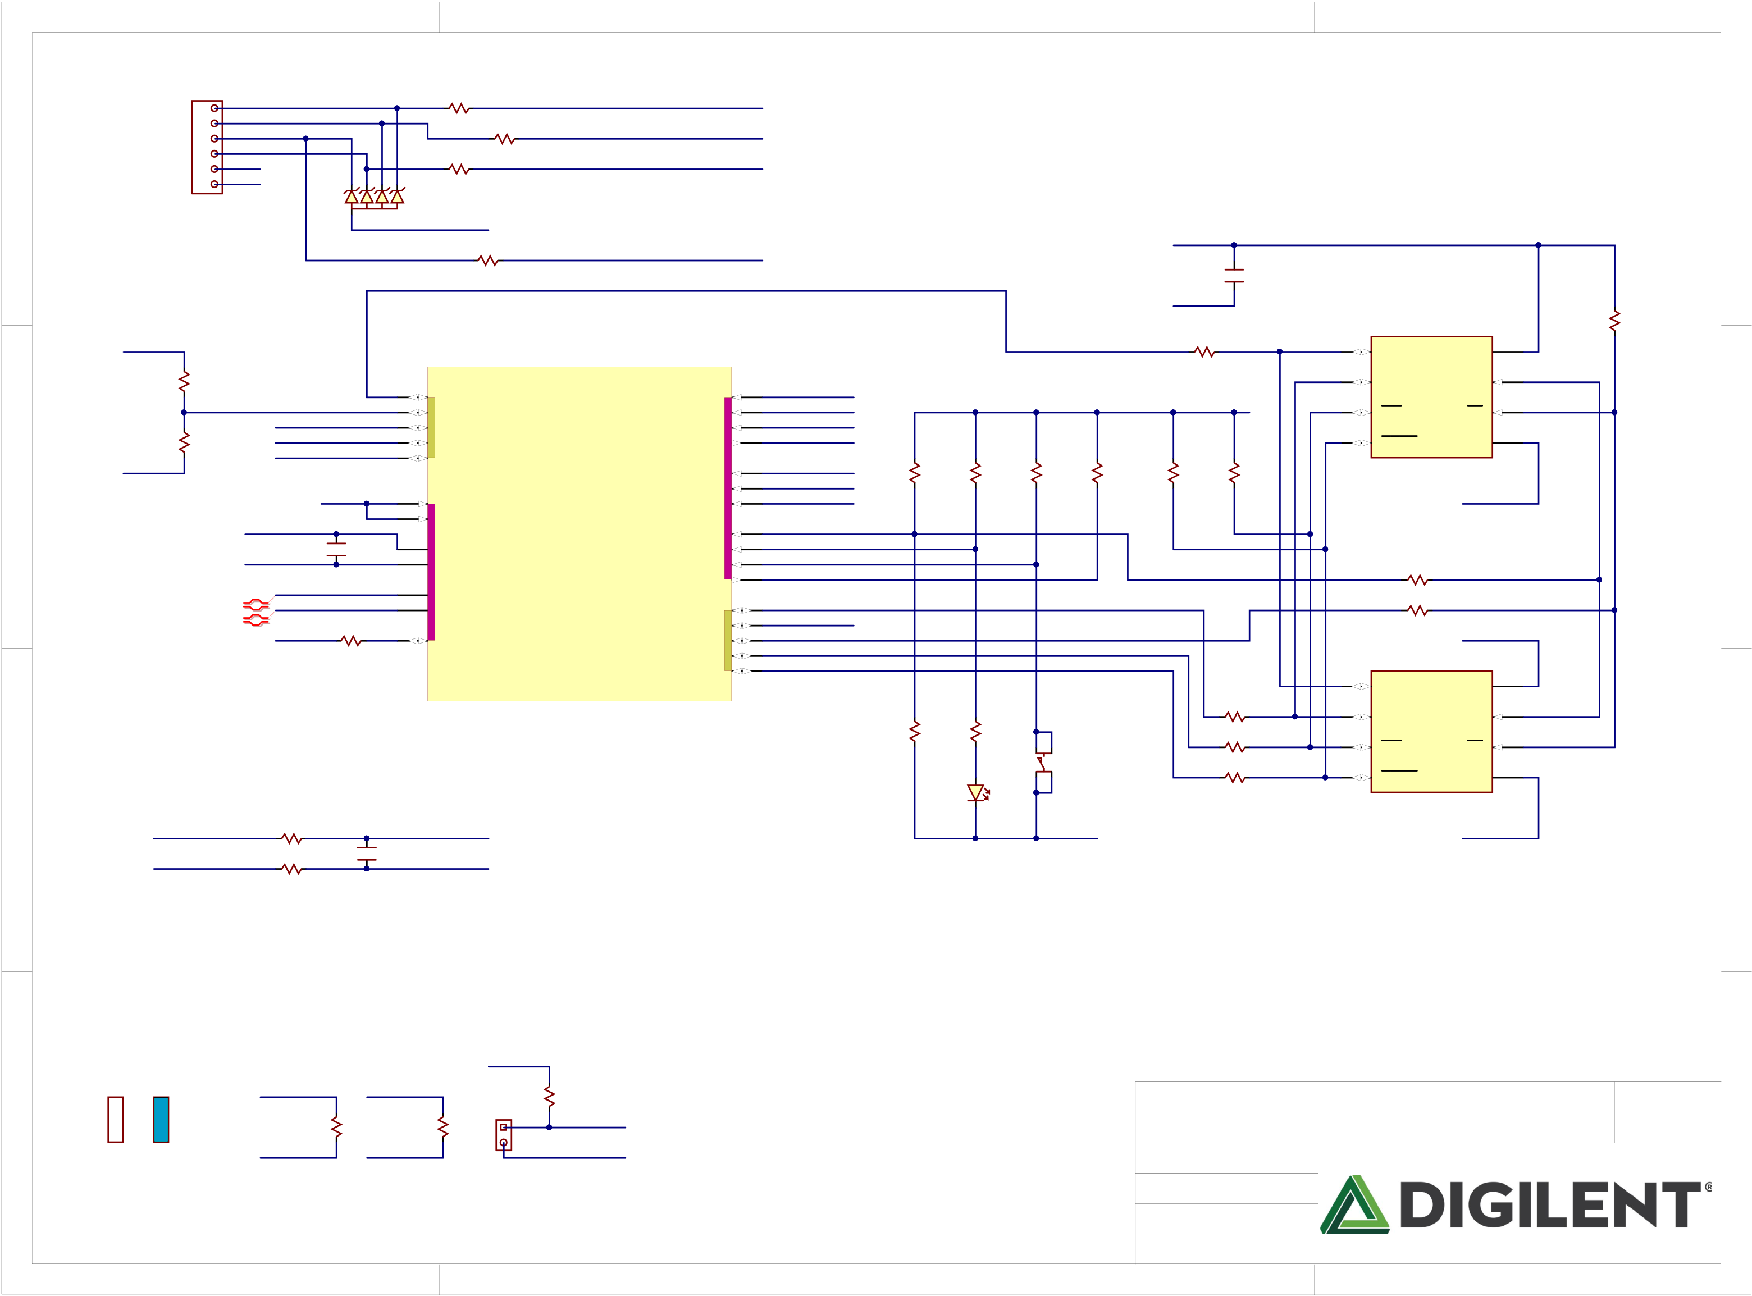

|  |  |  |  |  |  |  |  |  |  |  |  |  |  |  |  |  |  |  |  |  |  |  |  |  |  |  |  |  |  |  |  |  |  |  |  |  |  |  |  |  |
| --- | --- | --- | --- | --- | --- | --- | --- | --- | --- | --- | --- | --- | --- | --- | --- | --- | --- | --- | --- | --- | --- | --- | --- | --- | --- | --- | --- | --- | --- | --- | --- | --- | --- | --- | --- | --- | --- | --- | --- | --- |
| A | 1 | | | | | | | | | | | | 2 | | | | | TMS  TCK  TDI_FPGA TDO_FPGA | PIR14601 | PIR14701  COR146  100 PIR14702  No Load | COR147  200 | PIR14801 | 3 | | VCC3V3 | | | | | | 5 | COIC6 | No Load | | | 8 | | 4 | PIR14201  R142 COR142  PIR14202 4.7K | A |
| 1x6  1 PIJ901  2  3  4  5  6 | | | NLTMS0JTAG NLTDI0JTAG  NLTDO0JTAG TDO_JTAG  NLTCK0JTAG | | | PID101 | | | PID103 | PID104 PID105 | | COR138 R138  PIR13802 PIR13801 | | | NLTMS | |
| 100 | COR139 | | NLTDI0FPGA TDI_FPGA | |
| PIR13902 PIR13901  100 | |
| COR140 R140  PIR14002 PIR14001 |
| NLTCK | |
| GND  VCC3V3 | | |
| 100 | | | | |
| COJ9 J9 | | | | | PID102 | | | | | COD1 | |
| GND | | | | |
| No Load | | | | |
| COR141 | | | NLTDO0FPGA | |
| GND | | | PIC1201 | | C12  100nF |
| PIR14101 | | PIR14102 |
| 100 | | | NLQSPI0DQ0 | |
| NLVCC3V3 | | | | | | | | | | | |
| 0 | | PIR14302 | PIR14301 R143 COR143 | | |
| SDI/DQ0 | | | VCC |
| B | NLGND | PIR14401 | COR144 1K | | NLPUDC  CK_IO2  JC3/CK_IO39 JC7/CK_IO37 | | | | | | K17 L15 L16 U17 U16 | | IO_L1P_T0_D00_MOSI_14 TMS_0 IO_L3P_T0_DQS_PUDC_B_14 TCK_0 IO_L3N_T0_DQS_EMCCLK_14 TDI_0 IO_L15P_T2_DQS_RDWR_B_14 TDO_0 IO_L16P_T2_CSI_B_14   M0_0 M1_0 DXP_0 M2_0 DXN_0 **CONFIG**  CCLK_0 VREFP_0 DONE_0 VREFN_0 PROGRAM_B_0 INIT_B_0 VP_0  VN_0 IO_L1N_T0_D01_DIN_14 IO_L15N_T2_DQS_DOUT_CSO_B_14 CFGBVS_0 IO_L6P_T0_FCS_B_14 IO_L2P_T0_D02_14 IO_L2N_T0_D03_14 | | | | T9  D9  R9  T8  T10 U10 U9  C8  V8  R8  U8  K18  U18  M13 L14  M15 | VCC3V3 | | PIR15001 | COR150  1.8K | | | PIR15101  COR151  PIR15102 1.8K | | B |
| 2 | SDO/DQ1 | | | SCK | | 6 |
| 3 | WP/DQ2 | | | CS | 1 | |
| COR145  1K  No Load | |
| 7 | HOLD/DQ3 | | | VSS | 4 | |
| COR148  4.7K | PIR14901  COR149  PIR14902 4.7K |
| MODE0  MODE1  MODE2 | S25FL128SAGNFx00 | | | | | | |
| PIR14602 | PIR14802 | PIR15002 |
| NLXADCVREF | | | | | | GND | | COC13  10nF | | | L10 L9 | GND | | | | | | |
| C | PIC1301 | | NLQSPI0SCK NLDONE  NLPROG  NLINIT | PIR15601 | R156 COR156  100  No Load | COR157 100 | BTNP  PTA-142 Red Knob | | 0 | | | PIR15502 | | PIR15501 COR155 | Load either the MLP8 or the SOIC16 package, not both. | | | | | | | C |
| K10 J9 |
| XADCGND | | | | | |
| PIC1302 | |
| 0 | | PIR15202 | PIR15201 R152 COR152 | | | |
| V_P  V_N | | | | | | | | | | J10  K9 | |
| NLQSPI0DQ1  JC4/CK_IO38 NLQSPI0CS  NLQSPI0DQ2  NLQSPI0DQ3 | 0 | | PIR15302 | PIR15301 COR153 | | | |
| VCC3V3 | | | | | | | COR154 PIR15401 PIR15402 4.7K | | | V9 | |
| VCC3V3 | | | | | | |
| 15 | COIC7 | | | VCC | 2 | |
| SDI/DQ0 | | |
| COIC1A | | | | |
| 8 | SDO/DQ1 | | | SCK | | 16 |
| 0 | | | PIR15802 | | PIR15801 COR158 | 9 | WP/DQ2 | | | CS | 7 | |
| 0 | | | PIR15902 | | PIR15901 COR159 | 1 | HOLD/DQ3 | | | VSS | 10 | |
| PILD60A | LD6 |
| S25FL128SAGMFx00 | | | | | | |
| NLXADC0V0P | | | PIR16002 | | PIR16001 COR160  140  PIR16101 COR161  140 | | | PIC1401 | | COC14 1nF | | NLV0P | | | | | GND | | GND | | | | | | |
| XADC_V_N | | | PIR16102 | | NLV0N | | | | |

VCC3V3

|  |  |  |  |  |  |  |  |  |  |  |  |  |  |  |  |  |  |  |  |
| --- | --- | --- | --- | --- | --- | --- | --- | --- | --- | --- | --- | --- | --- | --- | --- | --- | --- | --- | --- |
| D | JTAG | Master SPI | 1 | VCC3V3 | PIR16302 | MODE1 | PIR16402 | COR164 1K | JP1 | PIR16201 | COR162  1K  MODE2 | 2 | 3 | Title   Arty S7  Circuit  CONFIG, SPI FLASH  Doc# 500-352 | | | 4 | Rev  Copyright B.0 2017 | D |
| MODE0 | COR163   1K   GND | PIJP101 |
| GND |
| Engineer Author  Date  Sheet# 6 | MTA  GMA  4/7/2017 out of | 11 |

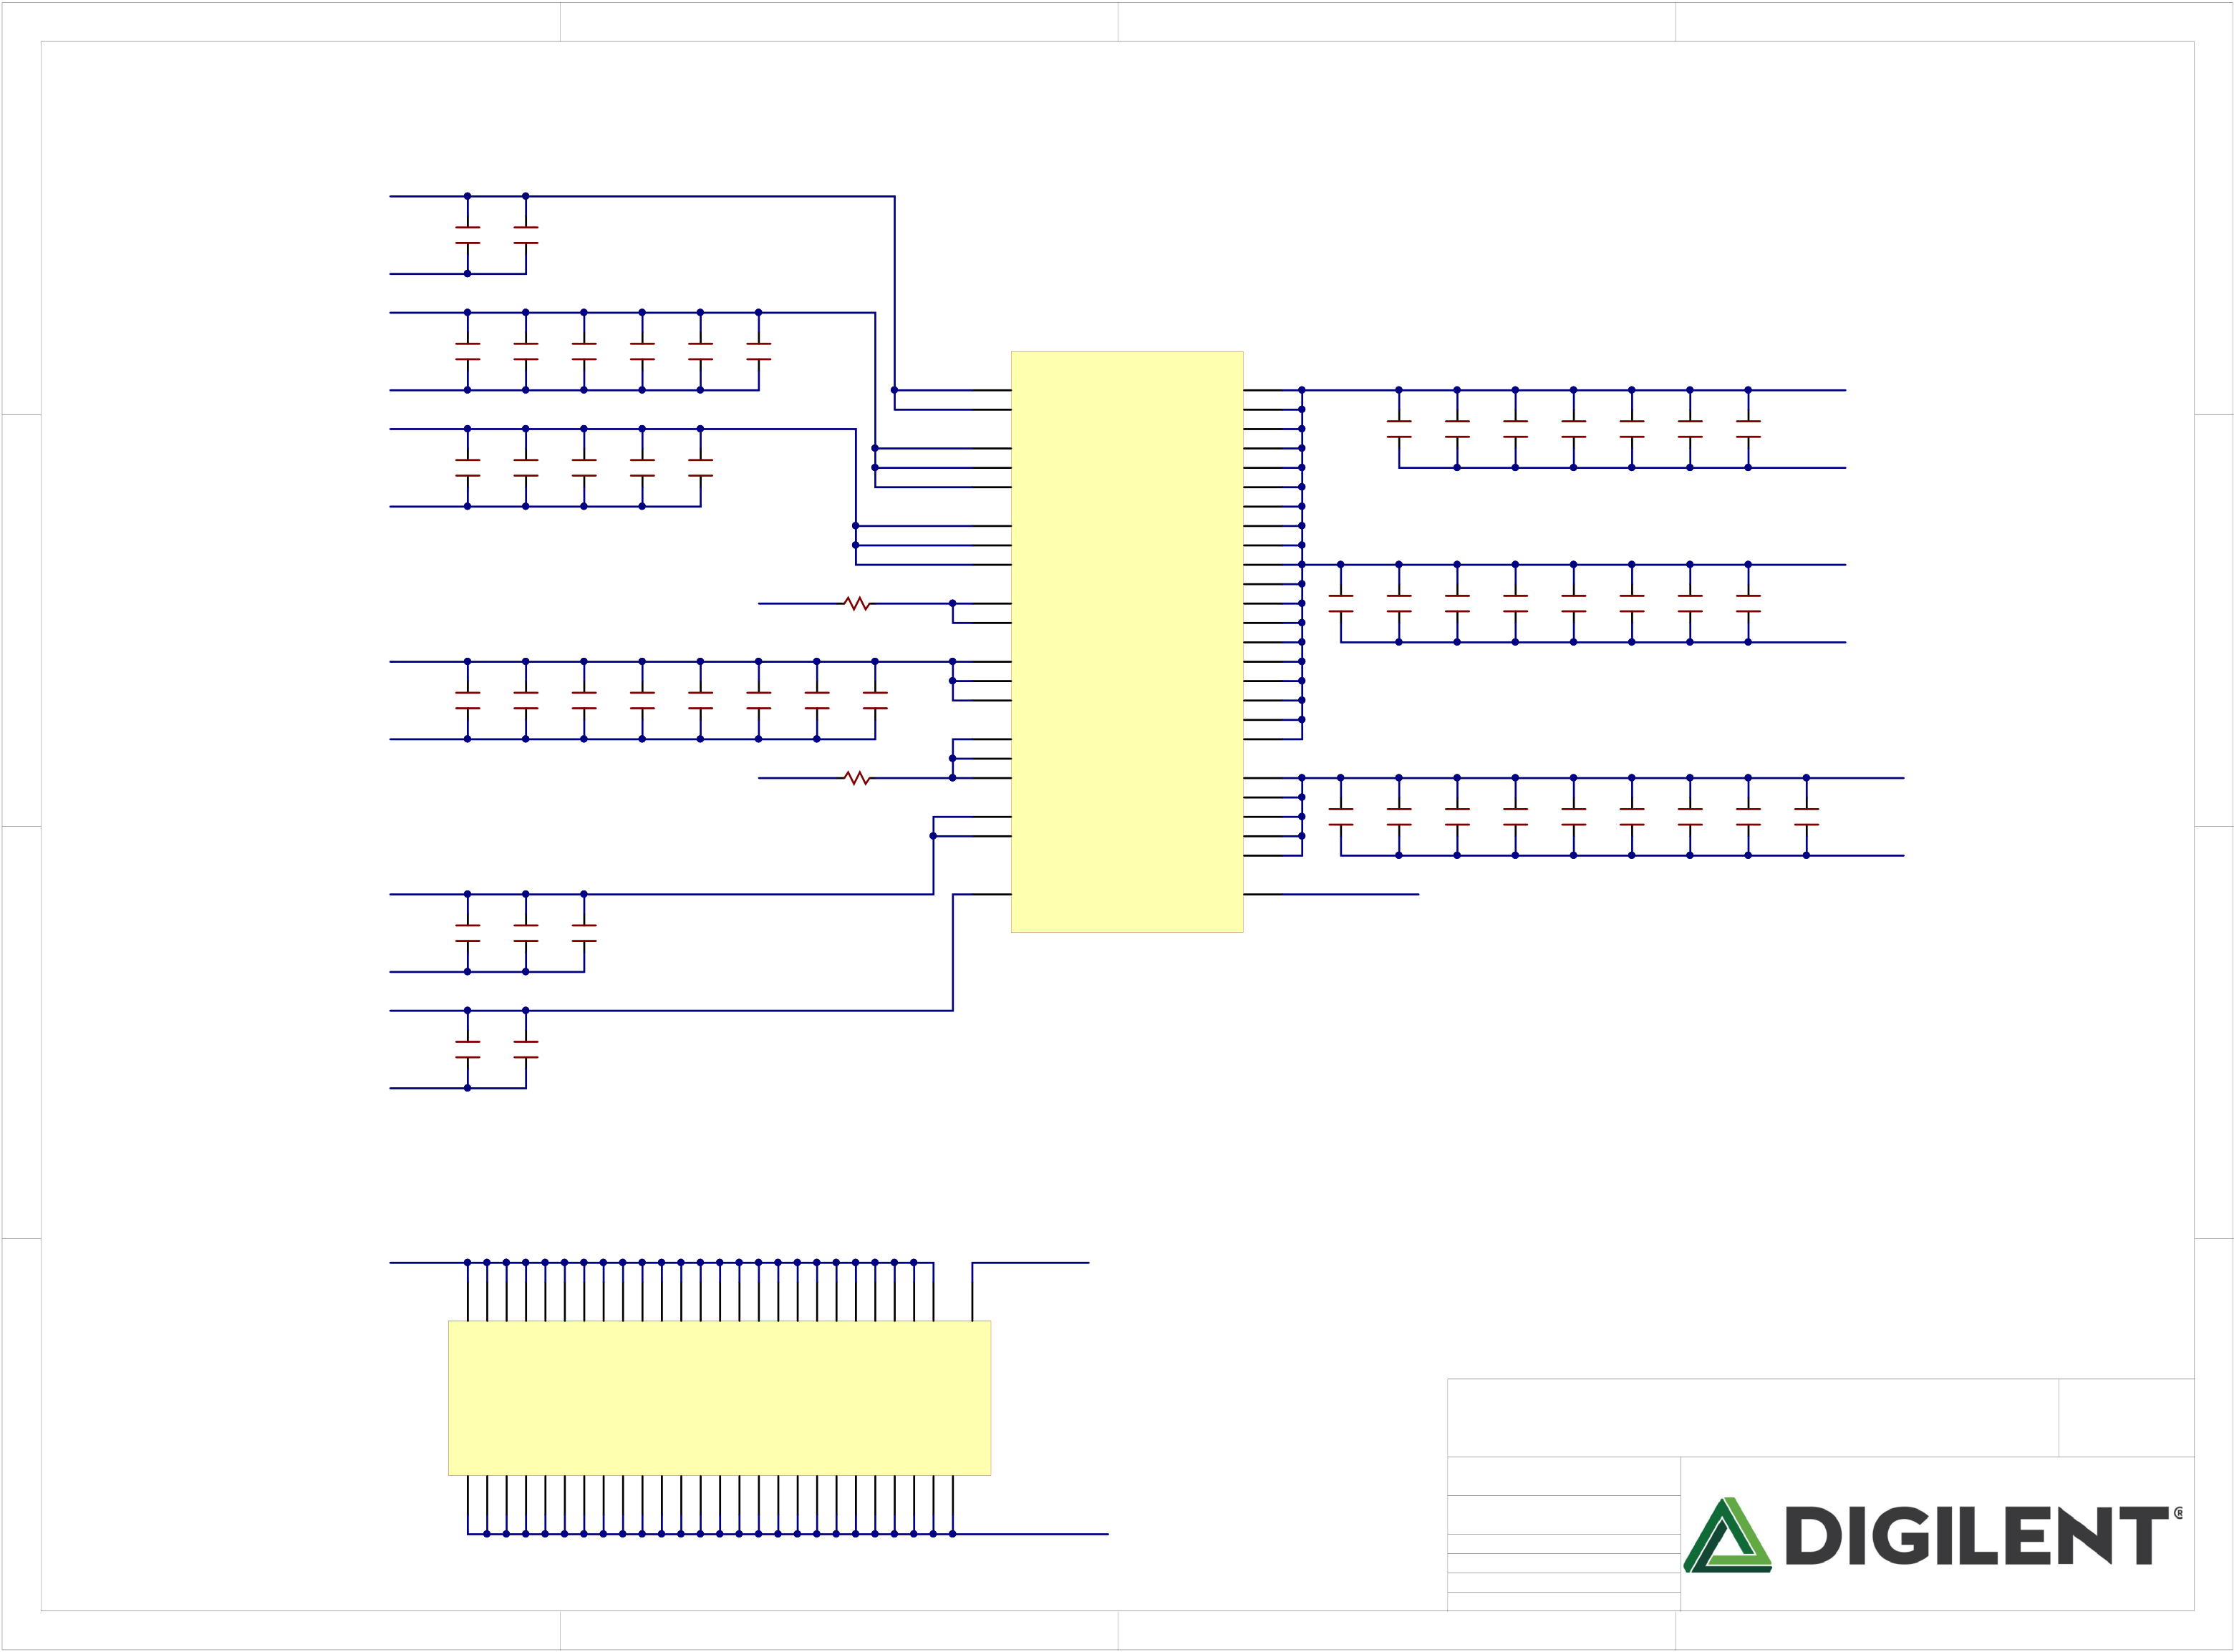

|  |  |  |  |
| --- | --- | --- | --- |
| 1 | 2 | 3 | 4 |

VCC3V3

|  |  |  |  |  |  |  |
| --- | --- | --- | --- | --- | --- | --- |
| A | GND | PIC1501 | C15  47uF | PIC1601 | C16  470nF | A |

VCC3V3

|  |  |  |  |  |  |  |  |  |  |  |  |  |  |  |  |  |  |  |  |  |  |  |  |  |  |  |  |  |  |  |  |  |  |  |  |  |
| --- | --- | --- | --- | --- | --- | --- | --- | --- | --- | --- | --- | --- | --- | --- | --- | --- | --- | --- | --- | --- | --- | --- | --- | --- | --- | --- | --- | --- | --- | --- | --- | --- | --- | --- | --- | --- |
| B | GND | | C17  100uF | C18  4.7uF | C19  470nF | C20  470nF | | C21  47nF | | C22  47nF | | | D8 V10 | VCCO_0 VCCO_0 | VCCINT VCCINT VCCINT VCCINT VCCINT VCCINT VCCINT VCCINT VCCINT VCCINT VCCINT VCCINT VCCINT VCCINT VCCINT VCCINT VCCINT VCCINT VCCINT | E7  E9  E11  F8  F10  G7  G9  G11  H8  J7  J11  K8  L11  M8  M10  N9  N11  P8  P10 | PIC3501 | PIC2301  PIC2302 | | PIC2401 COC23  470nF PIC2402 | | PIC2501 COC24  470nF PIC2502 | | PIC2601 COC25  470nF PIC2602 | | PIC2701 COC26  470nF PIC2702 | | PIC2801 C27  4.7uF COC27 PIC2802 | | PIC2901 COC28  4.7uF PIC2902 | | VCC1V0 | | | | B |
| VCC3V3 | | COC30  4.7uF PIC3102 | COC31  470nF PIC3202 | COC32  470nF PIC3302 | COC33  47nF | PIC3402 | | COC34  47nF | | | | COC29  100uF GND | | | |
| N17 T16 U13 |
| VCCO_14 VCCO_14 VCCO_14 |
| GND | PIC3002 |
| C43  100uF | C44  4.7uF | C45  470nF | GND | | | | | 0 | R165 | C15 F16 J17 | VCCO_15 VCCO_15 VCCO_15 | C35  47nF | PIC3601 | C36  47nF | PIC3701 | C37  47nF | PIC3801 | C38  47nF | PIC3901 | C39  47nF | PIC4001 | C40  47nF | PIC4101 | C41  47nF | PIC4201 | VCC1V0 | | | |
| NLDDR1V35 | | B10 B12 | C42  47nF | GND | | |
| VCCO_16 VCCO_16 |
| Note: R165-166 No Load on XC7S25 | | | | | | |
| L3  P4  U5 |
| VCCO_34 VCCO_34 VCCO_34 |
| C46  470nF | | C47  47nF | | C48  47nF | C49  10nF | C50  10nF |
| GND | |
| B6  D4  G3 |
| VCCO_35 VCCO_35 VCCO_35 |
| NLVCC1V0 | | C60  47nF | C61  470nF | C62  47uF | GND | | | | | 0 | R166 | VCCAUX VCCAUX VCCAUX VCCAUX VCCAUX | F12  H12  K12  M12  P12 | C51  47uF | | C52  4.7uF | | C53  4.7uF | | C54  470nF | | C55  470nF | | C56  470nF | | C57  470nF | | NLVCC1V8 | | | |
| L7  N7 | C58  47nF | PIC5901 | C59  47nF | GND |
| VCCBRAM VCCBRAM |
| H10 | VCC1V8 | | | |
| VCCADC_0 | B8 |
| VCCBATT_0 |
| GND | | IC1G |

NLXADC1V8

|  |  |  |  |  |  |
| --- | --- | --- | --- | --- | --- |
| C | PIC6301 | PIC6401 C63  100nF | C64  10nF | XADCGND | C |
| XADCGND |
| NLGND |

|  |  |  |  |  |  |  |  |  |  |  |  |  |
| --- | --- | --- | --- | --- | --- | --- | --- | --- | --- | --- | --- | --- |
| D | 1 | PIIC10K7 PIIC10K11 PIIC10K15 PIIC10L2 PIIC10L8 PIIC10L12 PIIC10M7 PIIC10M9 PIIC10M11 PIIC10N6 PIIC10N8 PIIC10N10 PIIC10N12 PIIC10N16 PIIC10P3 PIIC10P9 PIIC10P11 PIIC10R10 PIIC10T7 PIIC10T17 PIIC10U4 PIIC10U14 PIIC10V1 PIIC10V11 PIIC10V18 K7 | PIIC10H9 H9 | IC1H | GND | 3 | Title   Arty S7  Circuit  FPGA Power  Doc# 500-352 | | | 4 | Rev  Copyright B.0 2017 | D |
| GND  GND  GND  GND  GND  GND  GND  GND  GND  GND  GND  GND  GND  GND  GND  GND  GND  GND  GND  GND  GND  GND  GND  GND  GND | GNDADC_0 |
| GND  GND  GND  GND  GND  GND  GND  GND  GND  GND  GND  GND  GND  GND  GND  GND  GND  GND  GND  GND  GND  GND  GND  GND  GND  GND | |
| A1  A12  A18  B9  C6  C16  D3  D13  E8  E10  F7  F9  F11  F17  G4  G8  G10  G12  G14  H1  H7  H11  J8  J12  J18  K5 | |
| 2 | | Engineer Author  Date  Sheet# 7 | MTA  GMA  4/7/2017 out of | 11 |

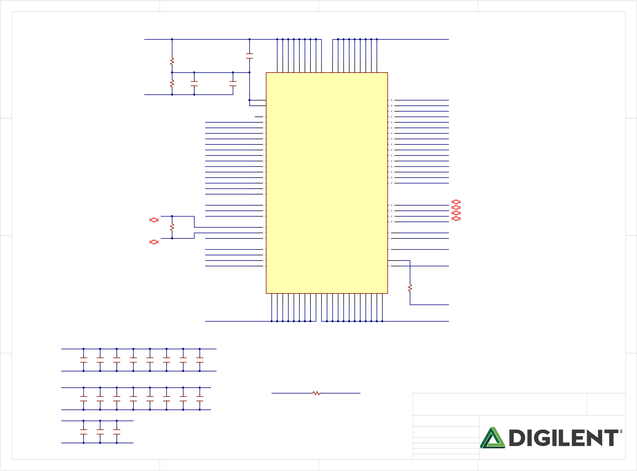

|  |  |  |  |  |  |  |  |  |  |  |  |  |  |  |  |  |
| --- | --- | --- | --- | --- | --- | --- | --- | --- | --- | --- | --- | --- | --- | --- | --- | --- |
| A | 1 | DDR1V35 | COR167 1K  1% | 2 | | | COC65 | PIIC80A1 PIIC80A8 PIIC80C1 PIIC80C9 PIIC80D2 PIIC80E9 PIIC80F1 PIIC80H2 PIIC80H9  A1  H2  C1  E9 | | PIIC80B2 PIIC80D9 PIIC80G7 PIIC80K2 PIIC80K8 PIIC80N1 PIIC80N9 PIIC80R1 PIIC80R9  D9  K2  G7  B2 | | 3 | DDR1V35 | | 4 | A |
| PIC6502 | | |
| CA Byp | | |
| 10nF |
| DDRVREF | | |
| R168  1K  1% |
| B | GND | C66 1uF | DQ Byp | C67  10nF | M8 H1 | A3  B8  A2  A7  C2  C8  C3  D7  H7  G2  H8  H3  F8  F2  F7  E3 | DDR3_DQ15  DDR3_DQ14  DDR3_DQ13  DDR3_DQ12  DDR3_DQ11  DDR3_DQ10  DDR3_DQ9  DDR3_DQ8  DDR3_DQ7  DDR3_DQ6  DDR3_DQ5  DDR3_DQ4  DDR3_DQ3  DDR3_DQ2  DDR3_DQ1  DDR3_DQ0 | | B |
| VDDQ  VDDQ  VDDQ  VDDQ  VDDQ  VDDQ  VDDQ  VDDQ  VDDQ | | VDD  VDD  VDD  VDD  VDD  VDD  VDD  VDD  VDD | |
| VrefCA VrefDQ | MT41K128M16JT-125:K | | DQ15 DQ14 DQ13 DQ12 DQ11 DQ10 DQ9 DQ8 DQ7 DQ6 DQ5 DQ4 DQ3 DQ2 DQ1 DQ0 |
| DDR3_A13  DDR3_A12  DDR3_A11  DDR3_A10  DDR3_A9  DDR3_A8  DDR3_A7  DDR3_A6  DDR3_A5  DDR3_A4  DDR3_A3  DDR3_A2  DDR3_A1  DDR3_A0 | | |
| T7  T3  N7  R7  L7  R3  T8  R2  R8  P2  P8  N2  P3  P7  N3 |
| A14  A13  A12/BC# A11  A10/AP  A9  A8  A7  A6  A5  A4  A3  A2  A1  A0 |
| DDR3 | |
| C | R169  80.6 | DDR3_BA0  DDR3_BA1  DDR3_BA2 | | | M2 N8 M3 | BA0  BA1  BA2  CK  CK#  CKE | | UDQS  UDQS#  LDQS  LDQS#  LDM  UDM | | C7  B7  F3  G3 | DDR3_DQS1_P  DDR3_DQS1_N  DDR3_DQS0_P  DDR3_DQS0_N | | C |
| DDR3_CLK0_P DDR3_CLK0_N DDR3_CKE0 | | | J7  K7  K9 |
| E7  D3 | DDR3_DM0  DDR3_DM1 | |
| DDR3_CS  DDR3_RAS  DDR3_CAS  DDR3_WE | | | L2  J3  K3  L3 | K1 | DDR3_ODT | |
| CS#  RAS#  CAS#  WE# | | ODT  ZQ  RESET# | |
| L8  T2 |
| DDR3_RESET | |
| VSSQ  VSSQ  VSSQ  VSSQ  VSSQ  VSSQ  VSSQ  VSSQ  VSSQ  VSS  VSS  VSS  VSS  VSS  VSS  VSS  VSS  VSS  VSS  VSS  VSS | | | | R170  1%  240 | GND |
| IC8 |
| PIIC80J8 PIIC80M1 PIIC80T9  J2  J8  M1  M9  P1  P9  T1  T9  B3  E1  B1  B9  D1  D8  E2  E8  F9  G1  G9  G8  A9 | | | |
| GND | | | GND | |

NLDDR1V35

|  |  |  |  |  |  |  |  |  |  |  |  |  |  |  |  |  |  |  |  |  |
| --- | --- | --- | --- | --- | --- | --- | --- | --- | --- | --- | --- | --- | --- | --- | --- | --- | --- | --- | --- | --- |
| D | NLGND | C68 | C69 | C70 | C71 | C72 | C73 | C74 | C75 | 2 | DDR3_RESET | COR171 | GND | 3 | Title   Arty S7  Circuit  DDR3  Doc# 500-352 | | | 4 | Rev  Copyright B.0 2017 | D |
| 47nF | 47nF | 47nF | 47nF | 47nF | 47nF | 47nF | 47nF |
| DDR1V35 | C76 | C77 | C78 | C79 | C80 | C81 | C82 | COC83 |
| PIR17102 PIR17101  4.7K |
| GND | 47nF | 47nF | 47nF | 47nF | 47nF | 47nF | 47nF |
| 47nF |
| DDR1V35 | C84 | C85 | C86 |
| GND | 470nF | 470nF | 4.7uF |
| Engineer Author  Date  Sheet# 8 | MTA  GMA  4/7/2017 out of | 11 |
| 1 |

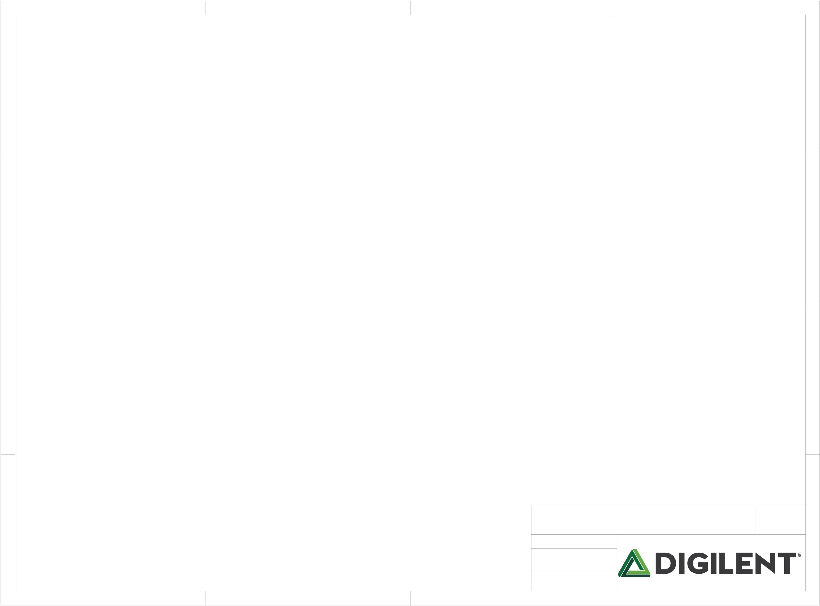

|  |  |  |  |  |  |  |  |  |  |  |  |  |  |  |  |  |  |  |  |  |  |  |  |  |  |  |  |  |  |  |  |  |
| --- | --- | --- | --- | --- | --- | --- | --- | --- | --- | --- | --- | --- | --- | --- | --- | --- | --- | --- | --- | --- | --- | --- | --- | --- | --- | --- | --- | --- | --- | --- | --- | --- |
| A | 1 | COFB1 | PIFB102 | NLVPLL | PIC8701 | COC87 | PIC8801 | COC88 | 2 | COC89 | PIIC904 | PIIC909 | PIIC9012 PIIC9037 PIIC9064 | PIIC9020 PIIC9031 PIIC9042 PIIC9056 | PIC9001 | COC90 | PIC9101 | COC91 | PIC9201 | COC92 | 3 | PIIC505 | PIIC504 | | | | PIIC5013 | PIR17201 | 4 | PIR17601 | COR176 | A |
| NLVCC1V8 |
| PIC8901 |
| PIIC506 | | | |
| COFB2 | PIFB202 | NLVPHY | PIC8702 | PIC8802 | PIC8902 | PIC9002 | PIC9102 | PIC9202 | PIC9901 | COIC5E | PIIC501 | PIIC503 | | PIIC5012 | COR174 |
| PIC9301 | PIC9401 | PIC9501 | PIC9601 | PIC9701 | PIC9801 |
| PIIC502 |
| COR175  PIR17501 PIR17502 | | | PIIC5011 |
| PIR17402 |
| COIC9 |

COR180

B B

NLVBUS

|  |  |  |  |  |
| --- | --- | --- | --- | --- |
| NLSHIELD | COJ10 | COIC10 | PIR18501 | COR182 |
| COR185 This page intentionally left blank. |
| PIR18502 |

PIC10101

C C

NLGND

|  |  |  |  |  |  |  |  |  |  |  |  |  |  |  |  |  |
| --- | --- | --- | --- | --- | --- | --- | --- | --- | --- | --- | --- | --- | --- | --- | --- | --- |
| D | 1 | COC104 | | PIR19401 | COR194 | PIC10501 | PIQ401  COQ4 | 3 | Title   Arty S7  Circuit | | | | 4 | PIIC507 | Rev  Copyright B.0 2017 | D |
| PIC10401 | PIC10402 |
| COR193 | |
| PIR19302 | PIR19301 | PIR19402 |
| PIR19501 | COR195 |
| PIR19502 | Doc# | 500-352 | | |
| 2 | Engineer Author  Date  Sheet# 9 | | MTA  GMA  4/7/2017 out of | 11 |

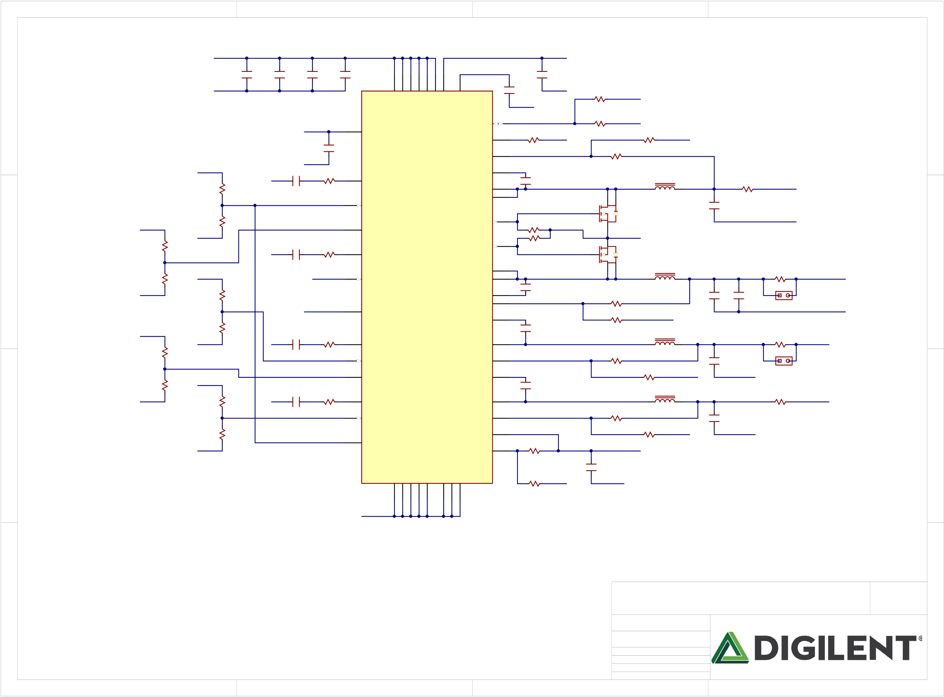

|  |  |  |  |  |  |  |  |  |  |  |  |  |  |  |  |  |  |  |  |  |  |  |  |  |  |  |  |  |  |  |  |  |  |  |  |  |  |  |  |  |  |  |  |  |  |  |  |  |  |  |  |  |  |
| --- | --- | --- | --- | --- | --- | --- | --- | --- | --- | --- | --- | --- | --- | --- | --- | --- | --- | --- | --- | --- | --- | --- | --- | --- | --- | --- | --- | --- | --- | --- | --- | --- | --- | --- | --- | --- | --- | --- | --- | --- | --- | --- | --- | --- | --- | --- | --- | --- | --- | --- | --- | --- | --- |
| A | 1 | NLVREG | PIR20601 | 1% | NLVCC5V0 | | | | | PIC10601 | COC106 10uF  10V | PIC10701 PIC10702 | 2 | | | | | | | | | | | | | | | 43 | NLVCC3V3 | | | | | | 3 | | | | | | | | | PIC11801 | COR203   PIR20302 | | | PIR20301 0 | 2.2A  VCC3V3 | | | 4 | A |
| COC107 10uF  10V | | PIC10801 | COC108 10uF  10V | PIC10901 | COC109 10uF  10V | | PIIC12036 PIIC12035 PIIC12025 PIIC12024 PIIC1204 PIIC1209 PIIC1208  35  36  4  8 | | | | | PIIC12042  42 | | |
| PIR19602  COR196  PIR19601 VREG  0  R197  PIR19701 GND  0 No Load | | | | COR199 | | | | GND |
| COC111 1uF | | | PIC11001 | COC110  1uF | |
| GND | | | | |
| PIC10602 | PIC10802 | PIC10902 | PIC11002 |
| GND | |
| PVIN1  PVIN1  PVIN2  PVIN2  PVIN3  PVIN4  PVIN5 | | | | | | | | | | | | VDD | | | GND | | | | | |
| VREG | | | | 44 | | VREG | | | SYNC/MODE | | | | | | R198  31.6K | | | | | GND  1% |
| NLDDR1V35 | | | | | 41 |
| GND | | RT | | | | | |
| GND COC113 | | | C112  1uF  10V | | | COR200  PIR20002 PIR20001  31.6K | | | PIR19902 PIR19901  10.2K | | | | 1% |
| IC12  ADP5052ACPZ-R7 | | | | FB1 | | 40 |
| COMP1 | | | 1% | | | |
| 32 | 10V | PIC11401 | COC114  100nF | | | |
| COR201 PIR20102 PIR20101 56.2K | 39 | | BST1 | | | | | |
| COL1 | | | | | | SRN6045-2R2Y | | |
| COR202 4.64K | | PIR20201 | | 1% | PIC11301 | PIC11302 | | 33 34 |
| SW1  SW1 | | | | | | PIC11402 |
| 2.7nF | | | 6  5 | | | | | PIL101 PIL102  2.2uH | | | |
| PIR20202 | |
| 37 | | | EN1 | | | C115  100uF | | | | | GND | |
| No Load | | | | | |
| 4 | | Q5A  FDS9926A | | | | | | |
| COR204 10K  GND | | PIR20401 | | 1% | 31 |
| GND | | SS12 | | | | 38 | | SS12 | | | | | | DL1 | | | R205 | | | | 47K | |
| PIR20402 | |
| 3 1 | | GND | | | | | | |
| COR206  9.53K  No Load | 29 | R208 | | | | 47K | |
| C116 | | R207 | | 22 | | COMP2 | | | | | | DL2 | | |
| 2 | Q5B   FDS9926A  PIQ508 PIQ507 COL2 PIL201 SRN6028-3R3M  PIL202 7  8  3.3uH | | | | | | | |
| PIC11601 | |
| B | 1% | NLVCC1V0 | | | | | GND | | 5.6nF | | 7.15K | | 23 | | SW2  SW2 | | | 26 27 | 10V | PIC11701 | COC117  100nF | | | | COR210 PIR21002 | | | | | PIR21001 0.01 | | 1A  VCC1V0 | B |
| COR209 0  NLGND | EN2 | | | | | |
| VCC5V0 | |
| R211 820 | 1% | | | | 28 21 | COC118 PIC11901  22uF PIC11902 | | COC119 22uF | | | PIJP301 PIJP302 | | COJP3  No Load   GND |
| PG_ALL | | | | 20 | | PWRGD | | | | | | BST2  FB2 | | |
| PIR21202 COR212 | | PIR21201 1%  8.25K  PIR21401 1%  33K   COL3 | | | | GND | | |
| PIC11802 |
| 1 | 10V | PIC12001 | COC120  100nF | | | |
| VREG | R213 10K  GND | 1% | | | | BST3 | | |
| R214 | |
| COR216 PIR21602 | | | | | PIR21601 0.01 | | 1A  VCC1V8 |
| COC121 COR215  PIC12101 PIC12102 PIR21502 PIR21501  1.8nF 9.31K | | | | 46 | | COMP3 | | | | | | SW3 | | | SRN5040-4R7M | | |
| 3 | PIC12002 |
| COR217 402K | COR218 | | 12.7K | 1% | | PIL301 PIL302  4.7uH | | | |
| C | NLVCC1V8 | | | | | GND | | 48 | | 45 | 10V | PIC12301 | COC123  100nF | | | | PIC12201 | C122 10uF | GND | | | | PIJP401 | PIJP402 | COJP4  No Load | C |
| EN3 | | | | | | FB3 | | |
| PIR21802 | | PIR21801  R219 10.2K | | | | | 1% | GND |
| COR220 301K  GND | 1% | SS34 | | | | 47 | | SS34 | | | | | | BST4 | | | 12 |
| PIR21901 | | | | | 1A  DDR1V35 |
| PIC12401  COC124  PIC12402 1.8nF PIR22102   COR221  PIR22101 15K 15  14 | | | | | | COMP4 | | | | | | SW4 | | | 10 | PIC12302 | COL4 | | | | | | SRN5040-4R7M | | | PIC12501 | COR223 PIR22302 | | | | | PIR22301 0 | |
| COR222 9.53K | | PIR22201 | | 1% |
| COR224 | | 7.87K | 1% | | PIL401 PIL402  4.7uH | | | |
| 16 | COC125 22uF | GND | | | | | |
| EN4 | | | | | | FB4 | | |
| COR226 10K  GND | | | 1% | | PIR22402 | | PIR22401  R225 11.5K | | | | | 1% GND | | PIC12502 |
| 7 |
| 5 | | | | | | EN5 | | GND  GND  GND  GND  AGND | | | VOUT5 | | | |
| PIR22501 | | | | |
| 6 | COR227 | | | | | | NLAVCC1V8 | | | | | | | | |
| PGND  PGND3  PGND4 | | | FB5 |
| PIR22702 PIR22701  4.99K | | | | 1% | |
| PIC12601  PIC12602 | COC126  1uF   GND | | | | | | | |
| R228  PIR22801  1.91K | | | | GND 1% | |
| PIIC12013 PIIC12017 PIIC12018 PIIC12019 PIIC120P  P  13 | | | | | | | | | | PIIC12030 PIIC1202 PIIC12011  2  30 | | | | |

GND

|  |  |  |  |
| --- | --- | --- | --- |
| D | Title   Arty S7  Circuit  Power Regulation  Doc# 500-352 | Rev  Copyright B.0 2017 | D |

|  |  |  |  |  |  |  |
| --- | --- | --- | --- | --- | --- | --- |
| 1 | 2 | 3 | Engineer  Author  Date  Sheet# 10 | MTA  GMA  4/7/2017 out of | 11 | 4 |

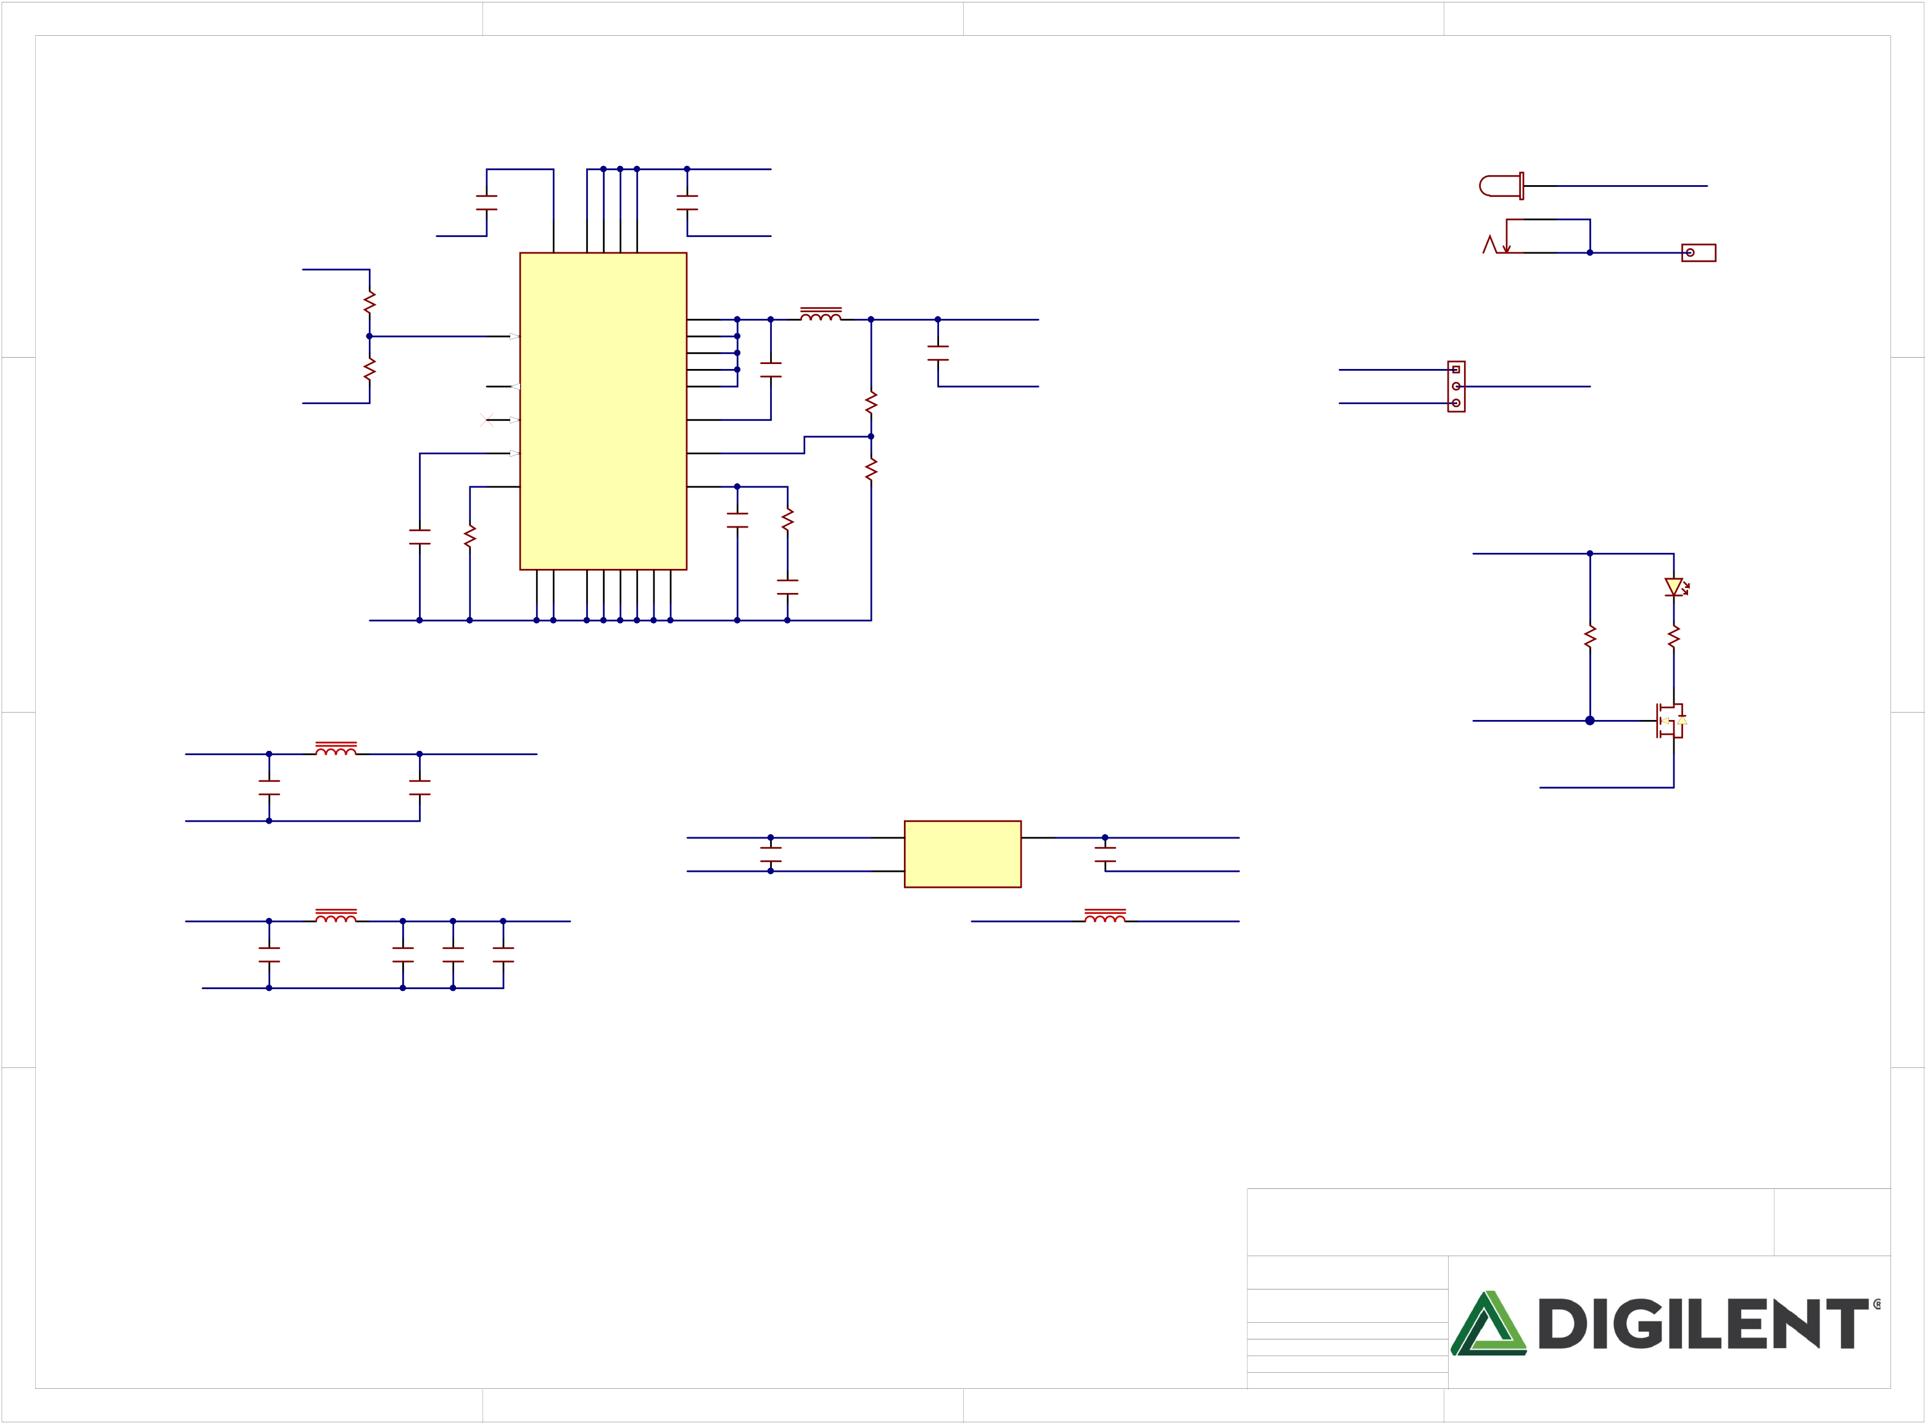

|  |  |  |  |  |  |  |  |  |  |  |  |  |  |  |  |  |  |  |  |  |  |  |  |  |  |  |  |  |  |  |  |  |  |  |  |  |  |  |  |
| --- | --- | --- | --- | --- | --- | --- | --- | --- | --- | --- | --- | --- | --- | --- | --- | --- | --- | --- | --- | --- | --- | --- | --- | --- | --- | --- | --- | --- | --- | --- | --- | --- | --- | --- | --- | --- | --- | --- | --- |
| A | 1 | PIC13401 | 16V | | | | | | | | | PIC12701 | C127 1uF | | 3 | 16  17  18  19 | 25V | 2 | | | | | | SRP7028A-3R3M | | 3.5A  NLREG5V0 | | | PIC13702 | COC137 10uF | 3 | 4 | | | | | | Rev  Copyright B.0 2017 | A |
| Note: Input Voltage 7-15V. | | | | | |
| VU | | | | | |
| VU | | | | | |
| PIC12801 | C128 10uF | GND | | | |
| COJ12 | | GND | COJ11 | | No Load |
| GND | | | | | | | | |
| NLVU | 1% | | PIR22901 | COR229  43.2K | | | | | 20 | | VREG | | PVIN  PVIN  PVIN  PVIN | SW SW SW SW SW | ADP2384ACPZN-R7 | | | | | | PIJ1101 1  1x1 | |
| 5  6  7  14  26  15 | | L5  3.3uH  C130  100nF  35V | | | |
| PIR22902 |
| EN | | |
| B | NLAVCC1V8 | GND | 1% | | PIR23001 | COR230  10K | | | | | 21 | | PGOOD | | | 10V | | C129 47uF | GND | | XADCVREF | REG5V0 | PIJP1301 | VCC5V0 | | | | B |
| PIR23002 |
| VUSB |
| R231  1%  86.6K | | | | |
| 23 | |
| SYNC | | | BST | COJP13 | | | | | |
| 24 | | | | | | | | | | | SS | | FB | | 2 | | | | | | Power Select | | | | | |
| R232  1%  11.8K | | | | |
| 22 | | | | | | | | | | | RT | | COMP | | 1 | | | | | |
| 16V | | C131 3.9pF | | | R233  1%  60.4K | VCC3V3 | | | | | |
| No Load | | | | | | C132 0 | | | R234 1%  100K | | GND  GND | | PGND  PGND  PGND  PGND  PGND  PGND | |
| PILD90A | | | | | |
| IC13 | | 16V | | | C133 1.2nF |
| 4  25 | | | | | | | | | | | | | 13  12  11  10  9  8 | |
| PIR23501   R235  100K | | | LD9  PIR23601  R236  680 | | |
| GND | | | | | | | | | | | | | | |
| 1 | COIC14 | OUT | | 2 |
| COFB3 | | | | | PIC13501 | | COC135  470nF | | NLXADC1V8 | | | | | | NLPG0ALL | | 1 | PIQ603 3 | COQ6  FDV301N | |
| AVCC3V3 | | | PIC13601 | C136  100nF | | PIQ602 2 |
| PIFB301 PIFB302  600Ohm/100MHz | | | | |
| GND | | | | | |
| NLGND | COC134  1uF | | | | |
| PIC13402 | PIC13502 | |
| IN |
| C | NLVCC3V3 | FB4 | | MLZ2012N100LT000 | | | | | | | | | AVCC3V3 | | | | XADCGND | | | 3 | GND | | | | XADCGND | Title   Arty S7  Circuit  Power Regulation  Doc# 500-352 | | | | | | C |
| REF3012AIDBZ   GND | | | | | COFB5 | | XADCGND |
| 10uH | | PIFB501 PIFB502  600Ohm/100MHz | |
| GND | C138  10uF | | C139  10uF | | | | | | C140 1uF | | | C141  470nF | | | |
| D | D |

|  |  |  |  |  |  |  |
| --- | --- | --- | --- | --- | --- | --- |
| 1 | 2 | 3 | Engineer  Author  Date  Sheet# 11 | MTA  GMA  4/7/2017 out of | 11 | 4 |