심리학석사 학위논문

Associations between Neurocognitive Functions and Early Life Stress in Children: Evidence from a Large-scale Longitudinal Study
생애초기스트레스와 신경인지기능 간 관련성: 아동기
대규모 종단 연구

2025 년 2 월

서울대학교 대학원
심리학과 계산임상심리학 전공
신 정 연

Associations between Neurocognitive Functions and Early Life Stress in Children: Evidence from a Large-scale Longitudinal Study
생애초기스트레스와 신경인지기능 간 관련성: 아동기
대규모 종단 연구

지도교수 안 우 영
이 논문을 심리학석사 학위논문으로 제출함
2024 년 12 월

서울대학교 대학원 심리학과 계산임상심리학 전공 신 정 연
신정연의 심리학석사 학위논문을 인준함
2024 년 12 월

위 원 장 김 향 숙 (인) 부위원장 차 지 욱 (인) 위 원 안 우 영 (인)

Abstract

Early life stress (ELS), encompassing adverse childhood experiences such as abuse, neglect, and household dysfunction, has been widely studied for its impact on brain development, cognitive and emotional functions, and mental health. Investigating its effects on neurocognitive functions—such as reward processing, emotion processing, working memory, and impulsivity—is critical, as these functions serve as key risk factors for psychiatric disorders. Growing evidence indicates that threat and deprivation, the core dimensions of ELS, distinctly affect neurocognitive functions, despite inconsistent neural findings. These inconsistencies may stem from small sample sizes, varied ELS definitions, and reliance on cross-sectional analyses with retrospective measures of ELS, underscoring the need for investigations using large-scale longitudinal data.
This study examines how threat and deprivation uniquely associate with multiple neurocognitive functions. Using data from the Adolescent Brain Cogni-tive Development (ABCD) study, task-based fMRI, behavioral measures, and survey measures were employed. The analyses included 3,568 children aged 9–10 years at baseline for cross-sectional analyses and 2,222 children for longitudinal analyses at the two-year follow-up. Generalized Linear Models (GLM) and binomial Least Absolute Shrinkage and Selection Operator (LASSO) regression were applied to identify unique and multivariate associations.
Findings revealed that threat and deprivation broadly influenced reward

and emotion-related neural activation. Deprivation was more clearly linked to reduced working memory performance and heightened trait impulsivity, whereas threat showed minimal or no associations. Multivariate patterns suggested that, in cross-sectional analyses, threat was linked to emotion processing, while longi-tudinal analyses revealed associations across multiple neurocognitive domains. Deprivation was associated with reduced brain activation in regions involved in reward processing, emotion processing, and working memory. Longitudinally, increased brain activation was observed in regions related to reward processing. These results highlight the importance of differentiating threat and depriva-tion to better understand their neurocognitive impacts. The study demonstrates the value of dimensional frameworks and large-scale longitudinal data in clari-fying these relationships and emphasizes the need for tailored interventions to
address their distinct mechanisms.

Keywords: Early life stress, Threat, Deprivation, Neurocognitive functions, Longitudinal analysis
Student Number: 2023-23572

Contents
Abstract i

Introduction 1
Early life stress and neurocognitive functions 3
Reward processing 3
Emotion processing 9
Working memory 16
Impulsivity 20
Research gap and objectives 26
Methods 29
Participants 29
Measurement 30
Early life stress 30
Neurocognitive functions 33
Covariates 39
MRI acquisition 41
Analysis 41
Generalized linear model (GLM) 41
Binomial LASSO regression 43
Results 45
Participants characteristics 45
Generalized linear model results 55
Reward processing 55
Emotion processing 57
Working memory 59
Impulsivity 61
LASSO results 64
Threat 64
Deprivation 72
Additional analysis results 80
Discussion 81
Distinct neurocognitive effects of threat and deprivation 81
Reward processing 81
Emotion processing 83
Working memory 85
Impulsivity 86
Multivariate patterns of threat and deprivation 88
Implications and limitations 90
Appendix A: Early life stress measurement 118
Appendix B: Significant coefficients from GLM analysis 121
Appendix C: Significant standardized coefficients from binomial LASSO regression 123
Appendix D: Additional GLM results for continuous threat and deprivation 128
Abstract in Korean 131
Acknowledgement 133

List of Figures
Figure 1 Monetary Incentive Delay Task, Adapted from Casey
et al. (2018) 34
Figure 2 Emotional N-Back Task, Adapted from Casey et al. (2018) 36 Figure 3 Stop Signal Task, Adapted from Casey et al. (2018) 38
Figure 4 Results of the cross-sectional binomial LASSO regression
(low threat vs. high threat) 65
Figure 5 Results of the cross-sectional binomial LASSO regres-sion (low threat vs. high threat): significant standardized
coefficients 66
Figure 6 Results of the longitudinal binomial LASSO regression (low threat vs. high threat): significant standardized co-
efficients 68
Figure 7 Results of the longitudinal binomial LASSO regression
(low threat vs. high threat) 71
Figure 8 Results of the cross-sectional binomial LASSO regres-sion (low deprivation vs. high deprivation): significant
standardized coefficients 73
Figure 9 Results of the cross-sectional binomial LASSO regression
(low deprivation vs. high deprivation) 75
Figure 10 Results of the longitudinal binomial LASSO regression (low deprivation vs. high deprivation): significant stan-
dardized coefficients 77

Figure 11 Results of the longitudinal binomial LASSO regression
(low deprivation vs. high deprivation) 79

List of Tables
Table 1 Summary of previous results: early life stress and reward processing 6
Table 2 Summary of previous results: early life stress and emotion processing 12
Table 3 Summary of previous results: early life stress and working memory 18
Table 4 Summary of previous results: early life stress and impulsivity 22 Table 5 Summary of previous results on the impact of early life
stress and neurocognitive functions 28
Table 6 Descriptive statistics for demographics and socioeconomic status 46
Table 7 Descriptive statistics for adversity before birth, parental psychopathology and child behavior 47
Table 8 Distribution of threat and deprivation 48
Table 9 Overlap of Threat and Deprivation Groups 49
Table 10 Descriptive statistics and group comparison (high vs. low threat) at Y0 (mean age = 9.96) 50
Table 11 Descriptive statistics and group comparison (high vs. low deprivation) at Y0 (mean age = 9.96) 51
Table 12 Descriptive statistics and group comparison (high vs. low threat) at Y2 (mean age = 11.94) 53

Table 13 | Descriptive statistics and group comparison (high vs. low
 | deprivation) at Y2 (mean age = 11.94) . . . . . . . . . . . | 54
Table 14 | Summary of GLM results for reward processing . . . . . . | 57
Table 15 | Summary of GLM results for emotion processing . . . . . | 59
Table 16 | Summary of GLM results for working memory . . . . . . | 61
Table 17 | Summary of GLM results for impulsivity . . . . . . . . . . | 63
Table A1 Details of threat measurement and scoring 118
Table A2 Details of deprivation measurement and scoring 119
Table B1 Significant coefficients from cross-sectional GLM analysis 121
Table B2 Significant coefficients from longitudinal GLM analysis 122
Table C1 Significant standardized coefficients from cross-sectional LASSO analysis (low threat vs. high threat) 123
Table C2 Significant standardized coefficients from longitudinal LASSO analysis (low threat vs. high threat) 124
Table C3 Significant standardized coefficients from cross-sectional LASSO analysis (low deprivation vs. low deprivation) 125
Table C4 Significant standardized coefficients from longitudinal LASSO analysis (low deprivation vs. high deprivation) 126
Table D1 Summary of additional analyses: continuous GLM results 128
Table D2 Significant coefficients from cross-sectional GLM analysis
with continuous scores 129
Table D3 Significant coefficients from longitudinal GLM analysis
with continuous scores 130

Introduction
Early life stress (ELS) encompasses adverse childhood experiences such as abuse, neglect, and household adversity. The impact of ELS on brain develop-ment, cognitive and affective functions, and mental health outcomes has been extensively investigated (Carr et al., 2013; Y. Chen & Baram, 2016; McLaughlin et al., 2019; Pechtel & Pizzagalli, 2011). Investigating its effects on neurocog-nitive functions is particularly critical for preventive interventions, as these functions represent key risk factors for psychiatric disorders.
Childhood and adolescence are critical periods for neurocognitive devel-opment, during which various systems interact and influence each other as they mature. Notably, the development of top-down and bottom-up processes progresses along distinct trajectories, and these patterns may be further in-fluenced by heightened emotional reactivity (Casey et al., 2008). To better understand these complex dynamics, it is crucial to consider how ELS influences both bottom-up processes (e.g., reward and emotion processing) and top-down processes (e.g., impulsivity and working memory) at the same time, as these systems are interdependent rather than isolated.
The Dimensional Model of Adversity and Psychopathology (DMAP; McLaugh-lin & Sheridan, 2016; Sheridan & McLaughlin, 2014) posits that threat and deprivation, the core dimensions of ELS, have distinct neural mechanisms. Threat involves experiences of actual or potential harm, whereas deprivation is characterized by the absence of critical developmental inputs from the envi-ronment (McLaughlin et al., 2014; Sheridan & McLaughlin, 2014). Behavioral

evidence suggests that threat is linked to negative emotion processing, while deprivation is associated with poor executive function (D. Johnson et al., 2021; Machlin et al., 2019; Schäfer et al., 2023). However, findings on brain function remain inconsistent. A systematic review noted non-significant or inconclusive results, despite the differing effects of threat, deprivation, and mixed exposure (McLaughlin et al., 2019).
This inconsistency may stem from small sample sizes and cross-sectional study designs with retrospective ELS measurement (McLaughlin et al., 2019). Small sample sizes, in particular, contribute to the replication crisis (Turner et al., 2018). To address this, recent studies have leveraged the large-scale longitudinal Adolescent Brain Cognitive Development (ABCD) study to examine ELS and brain function (D. Beck et al., 2024; Jeong et al., 2024; Russell et al., 2025; Stinson et al., 2024; Vedechkina et al., 2024; A. Yang et al., 2024).
Nevertheless, many of these studies employed data-driven approaches (D. Beck et al., 2024; Jeong et al., 2024; Russell et al., 2025; Vedechkina et al., 2024) or relied on cumulative Adverse Childhood Experience (ACE) scores (Stinson et al., 2024), complicating comparisons with earlier findings. One study applied the dimensional model, focusing on unpredictability and its relationship with resting-state functional connectivity and psychopathology (A. Yang et al., 2024). Task-based functional Magnetic Resonance Imaging (fMRI) is particularly well-suited for identifying neural correlates of cognitive processes (J. E. Chen & Glover, 2015) and holds promise for investigating the neural distinctions between threat and deprivation. To my knowledge, among studies utilizing large-scale data, only two have employed task-based fMRI: one examined network

efficiency using graph theory with data-driven ELS (Jeong et al., 2024), and the other explored impulsivity in relation to cumulative ELS (Stinson et al., 2024). However, these studies did not differentiate between threat and deprivation, limiting their applicability to dimensional frameworks.
Therefore, this study aims to investigate the distinct impacts of threat and deprivation on multiple neurocognitive functions during childhood, using task-based fMRI measures within a large-scale longitudinal dataset.

Early life stress and neurocognitive functions
The subsequent section will explore the impact of ELS on reward processing, emotion processing, working memory, and impulsivity, focusing on inconsistent findings in the field. Given the extensive research in this field, this discussion will primarily draw on evidence from task-based fMRI studies and behavioral outcomes. Notably, much of the existing research has assessed ELS without explicitly distinguishing between its specific dimensions, such as threat and deprivation. Such studies have been categorized as mixed exposure to facilitate comparison.

Reward processing

Reward processing encompasses the cognitive and neural mechanisms in-volved in recognizing, responding to, and learning from stimuli associated with rewards. Key brain regions implicated in the reward system include the anterior cingulate cortex (ACC), orbital prefrontal cortex, ventral striatum, and ventral pallidum (Haber & Knutson, 2010). Altered reward processing is commonly

observed in psychiatric disorders such as depression (Baskin-Sommers & Foti, 2015; Forbes & Dahl, 2012; Pizzagalli et al., 2009) and Substance Use Disorder (SUD; Baskin-Sommers & Foti, 2015; A. Beck et al., 2009; Joyner et al., 2018). Evidence suggests that early life stress (ELS) disrupts ventral striatum-related functions, including reward responsiveness and approach motivation (Novick et al., 2018). A meta-analysis revealed medium associations between ELS and reward learning, with small associations in reward valuation and
responsiveness (Oltean et al., 2022).
Studies using the Behavioral Activation System (BAS; Carver & White, 1994), a self-reported measure of reward processing, have shown mixed findings. While most reported no significant relationships between ELS and BAS subscales (DelDonno et al., 2019; Dragan et al., 2019; S. L. Johnson et al., 2016; Marusak et al., 2015, 2017; Miu et al., 2017; Rosenman & Rodgers, 2009), some studies found reduced reward responsiveness (Babad et al., 2021; Dragan et al., 2019) and decreased drive, which reflects motivation for pursuing goals (Babad et al., 2021; Miu et al., 2017).
Behavioral assessments of the Monetary Incentive Delay (MID) task also yield diverse results. For threat, reaction time (RT) to reward-related stimuli varies, showing increases (Dillon et al., 2009), decreases (Dennison et al., 2016), or no significant differences (Mehta et al., 2010) compared to healthy controls. Similarly, for deprivation, RT has been reported to increase (Mueller et al., 2012) or show no significant differences (Mehta et al., 2010). Few studies have investigated accuracy, generally reporting no significant differences (Dennison et al., 2019; Mehta et al., 2010; Mueller et al., 2012), except for reduced performance

linked to food insecurity (Dennison et al., 2019).
Systematic reviews have demonstrated that reduced striatal activation during reward processing is related to ELS, particularly deprivation (Gerin et al., 2019; McCrory et al., 2017). Specifically, during reward anticipation, ELS is consistently associated with reduced activation in the ventral striatum (Boecker et al., 2014; Boecker-Schlier et al., 2016; Mehta et al., 2010), putamen, pallidum (Boecker-Schlier et al., 2016; Dillon et al., 2009) and anterior cingulate cortex (Boecker et al., 2014; Boecker-Schlier et al., 2016). In reward feedback, however, the results are less consistent. Most studies focus on mixed exposures, reporting heightened activation in the insula, pallidum, and putamen (Boecker et al., 2014; Boecker-Schlier et al., 2016), while others observe no differences (Birn et al., 2017; Mehta et al., 2010). Findings on ventral striatum activation during feedback show inconsistency (Boecker-Schlier et al., 2016; Hanson et al., 2015). (Please refer to Table 1 for further details of the results in reward processing.)

Table 1

Summary of previous results: early life stress and reward processing

ELS
Study
dimension

Participants (N) Age: mean (SD) Design Measurement Behavioral results Neural results

Dennison et al., 2016

Threat

ELS (21) 16.95 (1.44)

Cross- MID task RT ↓ (at the trend level) -
sectional

Dillon et al., 2009

Threat

ELS (13)
HC (38)
HC (31)

ELS 24.58 (.88)
HC 37.08 (13.77)

Cross- MID task RT ↑ (at the trend level)

- Abuse: reward performance
sectional

Reward anticipation: left putamen and left pallidus ↓

Dennison et al., 2019

Threat/ 94 participants 13.57 (3.47)
deprivation

Cross-sectional
Reward Processing task
not significant
- Food insecurity: reward performance (lower rewards) ↓
- Neglect: reward performance not significant

-

- Threat: right nucleus accumbens
survivors
-

Liuzzi et al., 2024

Hanson

Threat/ deprivation

169 trauma 32.2 (10.3)

Cross-sectional
Resting state-functional connectivity

Card
connectivity with temporal fusiform gyrus/parahippocampal gyrus ↑, not significant amygdala
- Deprivation: nucleus accumbens, amygdala not significant

Reward feedback: ventral striatum

et al., 2015
sectional
Deprivation 106 participants 13.67 Longitudinal
guessing paradigm
- development ↓

Mehta et al., 2010

Deprivation

ELS (12)
HC (11)

ELS 16.1 (.77)
HC 16.0 (.85)

Cross- MID Task Accuracy, RT: not significant

Reward anticipation: ventral striatum and caudate nucleus ↓

Mueller et al., 2012

Birn

Deprivation

ELS (17)
HC (29)

ELS (23)

ELS 11.3 (1.9)
HC 11.9 (2.4)

Cross-sectional
Monetary Incentive Saccade task

- RT ↑
- Error: not significant (reward
& neutral condition)

-

- Reward anticipation: posterior cin-

et al., 2017

Boecker
Mixed

HC (19)
20.5 Longitudinal MID task -
gulate/precuneus, middle temporal gyrus, lingual gyrus, right middle frontal gyrus, and cerebellum ↓
- Reward anticipation (monetary vs. verbal): left ventral striatum, putamen, left thalamus, left insula,

et al., 2014
Mixed 162 participants 24.4 Longitudinal MID task RT ↑
left anterior cingulate cortex and right anterior hippocampus ↓ in ROI analysis
- Reward feedback (win vs. no win): bilateral insula, right pallidum, and bilater putamen ↑ in ROI analysis

6

Table 1

(Continued)
Study ELS | Participants (N) | Age: mean (SD) | Design | Measurement |  | Behavioral results Neural results
Boecker-  Schlier Mixed | 168 participants | 24.5 (.59) | Longitudinal | MID task | RT ↑ | - Reward anticipation (monetary vs. verbal): left middle frontal gyrus,  left and right anterior cingulate cortex, left ventral striatum, left and right putamen, left anterior

dimension

et al., 2016

Holz et al., 2017

Babad

Mixed 171 participants 25 Longitudinal

Cross-

Reward task
- Reward responsiveness: ↓ emotional neglect, physical neglect, domestic violence, age,
-
-

insula and left pallidum ↓ in ROI analysis
- Reward feedback (win vs. no win): not significant
Reward anticipation: left caudate, putamen, dorsal striatum ↓ in ROI analysis

et al., 2021
Mixed 436 participants 19.73 (1.83)
sectional BAS
and being male
- Drive: ↓ (emotional neglect, substance use, mental illness, and cumulative ACEs)
- Fun seeking: not reported
BAS

DelDonno et al., 2019

Dragan

Mixed

Mixed
sectional

MDD (23)
HC (27)

MDD 25.09 (3.32)
HC 29.15 (9.00)

Cross-sectional
- Reward responsiveness: not significant
- Drive: not significant
-
- Fun seeking: not reported
- Reward responsiveness: ↓
-

et al., 2019
(cumulative ELS)
48 participants 25.1 (5.36) Cross-
BAS
(significant only in female)
- Drive: not significant
- Fun seeking: not significant
BAS

Marusak et al., 2015

Marusak et al., 2017

Miu

Mixed

Threat (26%
reported neglect)

ELS (14)
HC (19)

ELS (43)
HC (43)

ELS 12.61 (2.11)
HC 12.06 (2.66)

ELS 12.28 (2.65)
HC 11.51 (2.29)

Cross-sectional

Cross-sectional
- Reward responsiveness: not significant
- Drive: not significant
-
- Fun seeking: not significant
- Reward responsiveness: not significant
-
- Drive: not reported
- Fun seeking: not reported
- Reward responsiveness: not significant
BAS
sectional
-

et al., 2017
Mixed 375 participants 21.33 (4.40) Cross-
BAS
- Drive: ↓ interpersonal trauma (than HC/non-interpersonal trauma)
- Fun seeking: not significant

7

Table 1

(Continued)
ELS
Study
dimension

Rosenman

Participants (N) Age: mean (SD) Design Measurement Behavioral results Neural results

Not significant in any subscale
60-64

& Rodgers, 2009

S. L.
Mixed 7485 participants 20-24, 40-44,
Cross-sectional
BAS
(reward responsiveness, drive, - fun seeking)

- Reward responsiveness: not

Johnson et al., 2016
sectional
Mixed 343 participants 18.79 (1.93) åå Cross-

BAS
significant (only interaction
effect of specific gene and ELS) -
- Drive: not significant
- Fun seeking: not significant

8

Note. The criteria for distinguishing between cross-sectional and longitudinal designs were based on the timing of the administration of ELS and neurocognitive function measures.
Abbreviations. ELS, Early Life Stress; HC, Healthy Control; ROI, Regions of Interest; MID, Monetary Incentive Delay; RT, Reaction Time; BAS, Behavioral Activation System

Emotion processing

Emotion processing involves the identification of emotional stimuli and the regulation of emotional responses. The amygdala, insula, anterior cingulate cortex (ACC), occipital cortex, and medial prefrontal cortex (mPFC) are critical brain regions involved in this process (Phan et al., 2002). Studies on emotion regulation and ELS reveal atypical neural activation in regulatory areas such as the ventral ACC and inferior prefrontal cortex, with altered frontal-subcortical connectivity (McCrory et al., 2017). Threat is associated with fear learning (Machlin et al., 2019), biases toward angry faces (Schäfer et al., 2023), but not deprivation.
Task-based fMRI studies commonly reveal amygdala hyperactivation to negative emotional stimuli such as fear and anger in children exposed to threats (McCrory et al., 2011; McLaughlin et al., 2015; Suzuki et al., 2014). However, one study found reduced amygdala activation to angry faces and no significant difference to fearful faces (Hein et al., 2020). In cases of mixed ELS or deprivation, a systematic review revealed that the amygdala’s responses to negative emotional stimuli yield inconsistent results (McLaughlin et al., 2019). For deprivation, three studies reported amygdala hyperactivation to fearful faces (Gee et al., 2013; Maheu et al., 2010; Tottenham et al., 2011). However, studies have reported lower amygdala discrimination between parent and stranger faces (Callaghan et al., 2019; Olsavsky et al., 2013) and between trustworthy and untrustworthy faces (Green et al., 2016). For mixed exposure, most studies reported hyperactivation (Bellis & Hooper, 2012; Dannlowski et al., 2012, 2013; Harmelen et al., 2013;

McCrory et al., 2013), but some studies reported hypoactivation (Holz et al., 2017; Taylor et al., 2006) or no significant findings (Fonzo et al., 2016).
Furthermore, behavioral measures on negative emotion processing show varied results. Reaction time (RT) to negative emotional stimuli is sometimes faster (Maheu et al., 2010; Tottenham et al., 2010), but often, no significant difference is observed compared to controls (Harmelen et al., 2013; McCrory et al., 2011; Metz et al., 2018; Taylor et al., 2006; Tottenham et al., 2011). Accuracy in identifying negative emotional stimuli in children with ELS varies, being reported as higher (Metz et al., 2018), lower (McCrory et al., 2011; Tottenham et al., 2010), or equivalent to those without ELS (Dannlowski et al., 2012; Fonzo et al., 2016; McCrory et al., 2013; Taylor et al., 2006).
In contrast to negative emotional stimuli, positive emotional stimuli remain underexplored, despite their importance as social rewards. Behavioral measures, such as accuracy and RT to positive stimuli, have mostly shown no significant differences between individuals with ELS and healthy controls (Goff et al., 2013; Maheu et al., 2010; Olsavsky et al., 2013).
In terms of neural activation, limited studies have found that threat is associated with hyperactivation in striatal regions, while deprivation is linked to deactivation in the ventral striatum. However, some studies have also reported no significant differences. Specifically, for threat, hyperactivation has been observed in striatal regions, including the nucleus accumbens and putamen (Dennison et al., 2016), as well as in the amygdala and pallidum (Suzuki et al., 2014). Conversely, other studies found no significant differences when participants viewed happy emotional stimuli (McLaughlin et al., 2015; Schweizer et al., 2016;

Suzuki et al., 2014).
For deprivation, studies reported no significant differences in response to happy emotional stimuli compared to healthy controls (Gee et al., 2013; Maheu et al., 2010). However, some findings have suggested deactivation in the ventral striatum in response to positive emotional stimuli (Goff et al., 2013; Hein et al., 2020). In cases of mixed ELS, one study reported hyperactivation in the amygdala, thalamus, and pallidum in response to positive emotional stimuli (McCrory et al., 2013). (Please refer to Table 2 for further details of the results in emotion processing.)

Table 2

Summary of previous results: early life stress and emotion processing

ELS
Study
dimension

Participants (N) Age: mean (SD) Design Measurement Behavioral results Neural results

Dennison et al., 2016

Threat

ELS (21) 16.95 (1.44)

Cross-sectional
Emotional images viewing
Rated images more emotionally intense independent of image type

Positive vs. neutral stimuli: left nucleus accumbens, left putamen ↑

McCrory
HC (38)

ELS (20)

ELS 12.05 (1.41)

Cross-

Face-
- Accuracy: angry, sad, neutral ↓ - Angry vs. neutral face: right

et al., 2011

McLaughlin et al.,
2015

Schweizer et al., 2016

Suzuki et al., 2014

Hein
Threat

Threat

Threat

Threat

Threat/

HC (23)

ELS (21)
HC (21)

ELS (23)
HC (30)

MDD (42)
HC (51)
Other psychiatric disorders (22)

HC 12.57 (1.18)

ELS 16.26 (1.43)
HC 16.89 (1.35)

ELS 20.13 (.64)
HC 20.07 (.74)

MDD 9.81 (1.23)
Healthy 9.8 (1.36) Other psychiatric disorders 10.18
(1.47)

ELS assessment

sectional

Cross-sectional

Longitudinal

Longitudinal
Viewing paradigm

Emotion Regula-tion task

Emotional Regula-tion task

Facial emotion-processing task

Emotional
- RT: not significant

No differences in self-reported emotional intensity

Positive, Negative: emotional regulation ↑

-
amygdala, anterior insula ↑
- Sad vs. neutral face: not significant
- Negative vs. neutral (look): amygdala, putamen, thalamus, anterior insula ↑
- Positive vs. neutral (look): not significant
- Negative emotion downregulation (regulation vs. look): middle frontal gyrus, middle temporal gyrus, amygdala ↓
- Positive (regulation vs. look): not significant
Traumatic events
- Sad face: amygdala, left posterior entorhinal cortex, subgenual anterior cingulate cortex and pregenual anterior cingulate cortex↑
- Fearful face & happy face: not significant
Stressful events
- Fearful face: right amygdala/posterior entorhinal cortex and lateral globus pallidus ↑
- sad face: left amygdala ↑
- happy face: right amygdala, left medial globus pallidus ↑
- Angry vs. baseline: left amygdala activation ↓, right amygdala habituation ↓ (threat)

et al., 2020
deprivation 167 participants
1, 3, 5, 9, 15
fMRI: 15
Longitudinal
Faces task -
- Fearful vs. baseline: not significant (threat)
- Happy vs. baseline: ventral striatum ↓ (deprivation)

12

Table 2

(Continued)
ELS
Study
dimension

Participants (N) Age: mean (SD) Design Measurement Behavioral results Neural results

- Threat: adaptation to

Lambert et al., 2017

Callaghan
Threat/ 287 participants 16-17
ELS (45)
deprivation
Cross-sectional
Emotional Stroop task
Parent/
emotional conflict ↓, inhibition not significant
- Deprivation: adaptation to emotional conflict not significant, inhibition ↓
-
- Lower amygdala discrimination in

et al., 2019
Deprivation
HC (57) 10.25 Longitudinal
stranger fMRI task
-
RT to correct hits to neutral
parent vs. stranger faces (not reduced amygdala to parent)
- Fearful face: amygdala, right superior temporal gyrus, inferior frontal gyrus ↑, not significant in medial prefrontal cortex activation

Gee et al., 2013

Green et al., 2016

Goff et al., 2013

Maheu et al., 2010

Deprivation

Deprivation

Deprivation

Deprivation
ELS (41)
HC (48)

Behavior: ELS (42) HC (45)
fMRI: ELS (33)
HC (41)

5-10 years old:
ELS (24) HC (15)
11-15 years old:
ELS (14) HC (16)

ELS (11)
HC (19)
ELS 10.8 (2.7)
HC 12.1 (3.3)

Behavior: ELS 10.26 (2.5)
HC 9.43 (2.4) fMRI:
ELS 10.6 (2.3)
HC 10.51 (2.7)

ELS 9.9 (2.6)
HC 9.7 (3.1)

ELS 13.75 (2.32)
HC 13.41 (2.70)
Cross-sectional

Longitudinal

Cross-sectional

Cross-sectional
Emotional Faces task

Face Processing task

Emotional Faces task

Face-Viewing Paradigm
faces in fear run: faster with increased age in HC, not significant in ELS

RT: not significant difference in untrust vs. trust

- RT to correct hits to neutral faces in fear/happy run: not significant
- Accuracy (d-prime) in
fear/happy run: not significant

RT: angry face ↓, fear/happy/neutral face not significant
/ negative amygdala-medial prefrontal cortex coupling ↑ (mature amygdala-medial prefrontal
cortex connectivity),
- Happy face: not significant in amygdala & age-related change in connectivity

Lower amygdala discrimination in trust vs. untrust faces (trust faces: amygdala ↑)

Fearful and happy face: nucleus accumbens ↓ in adolescent (no age difference in ELS)

- Fearful face vs. neutral face: amygdala, left anterior hippocampus ↑
Angry face vs. neutral face: left amygdala, left anterior hippocampus ↑
- Happy face vs. neutral face: not significant

13

Table 2

(Continued)
ELS
Study
dimension

Participants (N) Age: mean (SD) Design Measurement Behavioral results Neural results

Olsavsky et al., 2013

Tottenham et al., 2010

Tottenham

Deprivation

Deprivation

ELS (33)
HC (34)

ELS (19)
HC (27)

ELS (22)

ELS 11 (±4)
HC 10 (±3)

ELS 101.5 (20)
HC 115.3 (26.7)
(in months)

ELS 9.3 (2.2)

Cross-sectional

Cross-sectional

Cross-

Parent/ stranger fMRI task

Emotional GNG task

Emotional

Correct hits (to happy), errors of commission (to neutral), RT (correct trials): not significant

- Accuracy ↓: negative face
- RT ↑: to neutral face (positive distractor)
- RT ↓: to neutral face (negative distractor)

- Lower amygdala discrimination in parent vs. stranger faces (not higher amygdala for mother)
- Mother: not significant
- Stranger: amygdala ↑

-

Fearful face vs. baseline: right

et al., 2011

Bellis &
Deprivation

HC (22)

ELS (5)

HC 10.9 (2.4)

ELS 15.5 (2.3)

sectional

Cross-
GNG task Accuracy, RT: not significant

Emotional
amygdala, left medial temporal gyrus, rostral anterior cingulate cortex ↑
Sad vs. neutral (sad distractor):

Hooper, 2012

Dannlowski
Mixed
HC (11)
HC 12.8 (3.3)
sectional

Cross-
Oddball task

Face-
Accuracy & RT: Not significant
bilateral amygdala, left subgenual cingulate, left inferior frontal gyrus, right middle temporal gyrus ↑
- Fearful & angry face: right amygdala ↑

et al., 2012

Dannlowski et al.,
2013
Mixed 145 participants 33.8 (± 10.4)

Mixed 134 participants 34.5 (± 10.6)

PTSD & ELS
sectional

Cross-sectional
Matching paradigm

Subliminal affective priming paradigm
Not significant
- Emotional abuse and emotional neglect were the strongest predictors for amygdala responsiveness

- Sad vs. neutral face: amygdala ↑

Fonzo et al., 2016

Harmelen

Mixed
PTSD & ELS 22 PTSD 20
HC & ELS 20

ELS (60)
39.71 (10.8) PTSD
37.09 (10.37) HC & ELS
32.48 (12.45)

ELS 38.22 (1.32)

Cross-sectional

Cross-
Emotional Conflict task

The Faces

Not significant in both ROI analysis and whole-brain analysis

Angry, fearful, sad, happy, neutral
Accuracy & RT: Not significant

et al., 2013
Holz
Mixed
HC (75)
HC 34.91 (1.22)
sectional
task RT: not significant

Face
face: amygdala ↑

et al., 2017
Mixed 171 participants 25 Longitudinal
Matching task
- Fearful/angry faces: amygdala ↓

14

Table 2

(Continued)
ELS
Study
dimension

Participants (N) Age: mean (SD) Design Measurement Behavioral results Neural results

McCrory et al., 2013

Metz

Mixed

ELS (18)
HC (23)

ELS 12.17 (1.43)
HC 12.55 (1.22)

ELS 42.13

Cross-sectional

Masked dot-probe paradigm (angry, happy and neutral)

Emotional
Mixed

Accuracy, RT: not significant

- Accuracy ↓ (across all targets)

- Angry vs. neutral face: right amygdala, cerebellum ↑
- Happy vs. neutral face: right amygdala, thalamus, pallidum ↑, temporal pole/middle temporal
gyrus, temporal pole/superior temporal gyrus ↓
- Not significant in dorsolateral prefrontal cortex
- neutral than negative: left

et al., 2018

Taylor
ELS (15)
HC (16)

30 participants

(± 11.04)
HC 34.38
(± 11.33)
Cross-sectional

Cross-
(word) N-Back task

Observation
- Negative vs. positive accuracy
↑ in ELS group
- RT: not significant
posterior cingulate cortex, precuneus ↓ only in ELS group
- negative than positive, negative than neutral: rostral anterior cingulate cortex ↓ only in ELS group

et al., 2006
(observation): amygdala ↓
Mixed
(ELS low/ high by median)
18 - 36
sectional (2-6 weeks after)
and labeling task
Accuracy, RT: not significant Fearful and angry face

15
Note. The criteria for distinguishing between cross-sectional and longitudinal designs were based on the timing of the administration of ELS and neurocognitive function measures.
Abbreviations. ELS, Early Life Stress; HC, Healthy Control; emotional GNG task, emotional go-nogo task; RT, Reaction Time

Working memory

Working memory is a critical component of cognitive processes and is impli-cated in a range of psychiatric disorders, including attention-deficit/hyperactivity disorder (ADHD) and schizophrenia (Lee & Park, 2005; Martinussen et al., 2005). A substantial body of research highlights the negative effects of ELS on working memory (Goodman et al., 2019). Successful working memory performance in-volves increased activity in the central executive network (CEN) and decreased activity in the default mode network (DMN) (Satterthwaite et al., 2013).
Most previous studies employing the N-Back task to assess working memory have utilized mixed ELS samples, yielding inconsistent neuroimaging findings. For example, one study reported greater DMN deactivation, particularly in the posterior cingulate cortex (PCC), middle temporal gyrus (MTG), and inferior parietal lobe (IPL), in individuals with ELS compared to healthy controls (Philip et al., 2013). However, these findings were not replicated in a subsequent study with a slightly larger sample size (Philip et al., 2016), and one study reported increased left IPL activation in a non-clinical ELS group (Quidé et al., 2017). Notably, the IPL is also considered part of CEN, thus reduced IPL activation might reflect poorer working memory performance. Regarding other CEN regions, such as the dorsolateral prefrontal cortex (dlPFC) and middle frontal gyrus (MFG), one study reported reduced caudal MFG activation in mixed ELS samples (Hallowell et al., 2019), while another study found no significant results in the dlPFC (Metz et al., 2018).
Behavioral assessments typically reveal diminished working memory perfor-

mance in individuals with ELS (Danese et al., 2017; Fuge et al., 2014; Majer et al., 2010; Metz et al., 2018; Philip et al., 2016; Quidé et al., 2017; Viola et al., 2013). Nonetheless, some studies report no significant differences compared to healthy controls (Philip et al., 2013; Üçok et al., 2015). However, recent studies revealed that deprivation is more associated with poor working memory or executive function than threat (D. Johnson et al., 2021; Schäfer et al., 2023).
Findings regarding ELS and working memory remain inconsistent, with limited studies distinguishing the effects of threat and deprivation. Further research is needed to clarify how these distinct dimensions of ELS influence brain activation and performance. (Please refer to Table 3 for further details on the results of working memory.)

Table 3

Summary of previous results: early life stress and working memory

ELS
Study
dimension
D.

Participants (N) Age: mean (SD) Design Measurement Behavioral results Neural results

Johnson et al., 2021
Review - - -
Threat/ Deprivation
Working memory ↓ (deprivation <threat)

- Threat: double errors ↑ in emotional abuse, physical
deprivation
-

Majer et al., 2010
Threat/ 47 participants 51.51 (1.22)
Cross-sectional
CANTAB
Spatial WM task
abuse, not significant sexual
abuse -
- Deprivation: double errors ↑ physical neglect, not significant emotional neglect
21.1 (4.8)

Üçok et al., 2015
Wolf & Sun-theimer, 2019

Threat/ Deprivation

Threat/ deprivation

Ultra-high risk for psychosis (53)

18200
participants

Cross-sectional

Cross-sectional
N-Back task (alphabet)

Numbers reversed task

Accuracy: not significant in all category

- Threat, deprivation: not
-
significant -
- Cumulative deprivation: ↓

Viola et al., 2013

Bücker et al., 2013

Danese

Deprivation

Mixed

Female substance abuser: ELS (37)
nonELS (48)

Bipolar-ELS (26) Bipolar-nonELS (38)
HC-ELS (9)
HC-nonELS (19)

ELS 31.51 (7.83)
5.6
nonELS
28.89 (8.72)

Bipolar-ELS
22.57 (± 1.91)
Bipolar-nonELS
23.10 (± 5.05) HC
22.78 (± 4.90)

Cross-sectional

Cross-sectional
Auditory N-Back task (number)
Letter-number sequencing, CANTAB
Spatial WM task
CANTAB
Spatial WM

Accuracy: not significant in
1back, -
↓ in 2back, 3back

- Letter-number sequencing: not significant
-
- Spatial WM ↓ only in bipolar group

et al., 2017
Mixed 2044 participants 18, 38 Longitudinal
task, Digit span forward, Digit span backward
Working memory ↓ -

Fuge et al., 2014

Mixed

541 participants
No ELS (96)
Low ELS (109)
Moderate ELS (128)
Severe ELS (118)
No ELS 36 (± 17)
Low ELS
41.6 (± 19.4)
Moderate ELS
41.3 (± 19.1)
Severe ELS
43.5 (± 17.2)

Cross-sectional

N-Back task (Word)

Accuracy↓ in 2 back -

18

Table 3

(Continued)
ELS
Study
dimension

Participants (N) Age: mean (SD) Design Measurement Behavioral results Neural results

Hallowell et al., 2019

Metz

Mixed ELS (30) 20.63 (2.2)

ELS 42.13
Mixed

Cross-sectional

N-Back task (alphabet)

Emotional

Accuracy: ↓ in 2 back

2back vs. 0back: posterior parietal lobule, left caudal middle frontal gyrus ↓
- Not significant in dorsolateral prefrontal cortex
- Neutral than negative: left

et al., 2018

Philip et al., 2013
Mixed

Philip et al., 2016
Mixed

Quidé
ELS (15)
HC (16)

ELS (10)
HC (9)

ELS (13)
HC (13)

Clinical-ELS (56) Clinical-nonELS

(± 11.04)
HC 34.38
(± 11.33)

ELS 37.4 (12)
HC 39.7 (15)

ELS 38 (9)
HC 30 (9)

Clinical-ELS 37.4
(12.1)
Cross-sectional

Cross-sectional

Cross-sectional
(word) N-Back task

N-Back task (alphabet)

N-Back task (alphabet)

N-Back
- Accuracy ↓ (across all targets)
- RT: not significant

Accuracy. RT: not significant

- Accuracy: ↓ in 2 back, not significant in 0 back
- RT: not significant in 0 back, 2 back

- Accuracy: ↓ in 2back as ELS
posterior cingulate cortex, precuneus ↓ only in ELS group
- Negative than positive, negative than neutral: rostral anterior cingulate cortex ↓ only in ELS group
2back: right posterior cingulate cortex, medial prefrontal cortex, left middle frontal gyrus, right middle temporal region ↓ (greater default mode network deactivation in ELS)
- 2back: right inferior frontal gyrus, right inferior parietal lobule, left superior temporal gyrus/inferior parietal lobule, left posterior cingulate cortex/precuneus ↑ (ELS
vs. nonELS); right inferior frontal gyrus, left middle temporal gyrus/inferior parietal lobule ↑ as
ELS severity ↑ (not significant between subtype severity)
- Not significant in ROI analysis
- 2back vs 0back: left Inferior parietal lobule ↑ (ELS vs. nonELS),

et al., 2017
Mixed
(36)
non-clinical ELS (17)
HC (30)
Clinical-nonELS
38.3 (12)
ELS-HC 44 (12.5)
HC 35.5 (8.4)
Cross-sectional
task (number)
severity ↑ regardless of clinical status
- RT: not significant
cuneus, calcarine sulcus, lingual gyrus cuneus ↑ (clinical ELS vs. clinical-nonELS), calcarine sulcus,
lingual gyrus ↓ (non-clinical ELS vs. HC)

19
Note. The criteria for distinguishing between cross-sectional and longitudinal designs were based on the timing of the administration of ELS and neurocognitive function measures.
Abbreviations. ELS, Early Life Stress; HC, Healthy Control; ROI, Regions of Interest; RT, Reaction Time

Impulsivity

Impulsivity has been proposed as a potential mechanism linking ELS and psychopathology, such as alcohol dependence (S. T. Kim et al., 2018; Liu, 2019). Previous studies on impulsivity and ELS have primarily utilized mixed ELS measures, making it difficult to separately review the effects of threat and deprivation. Impulsivity manifests in various dimensions: impulsive action (motor impulsivity), impulsive choice (cognitive impulsivity, including delay discounting), and impulsive personality traits (MacKillop et al., 2016). This section reviews the findings in terms of impulsivity dimensions.
In the context of impulsive actions (e.g., Stop Signal Task; SST), inconsistent findings have been reported. Some studies observed longer reaction time (RT), which are indicative of compromised inhibitory control in individuals with ELS (Lim et al., 2015; Merz et al., 2013; Mueller et al., 2010). However, others found no significant differences in RT or stop accuracy when comparing individuals with ELS to controls (Carrion et al., 2008; Elton et al., 2014; Hamilton et al., 2013; Hart & Rubia, 2012; Lim et al., 2015; Mezzacappa et al., 2001).
As for the neural correlates of impulsive action (e.g., during successful inhibition), research shows mixed results. Hyperactivation in inhibitory regions of the brain, such as the inferior frontal gyrus (IFG), anterior cingulate cortex (ACC), and striatum, has been observed during successful inhibition (Mueller et al., 2010). In contrast, other studies have reported no significant neural differences (Elton et al., 2014; Liu, 2019), while some have found decreased activation in these regions (Bruce et al., 2013).

Regarding choice impulsivity, a majority of studies report an elevated dis-counting rate in individuals with ELS (Acheson et al., 2019; Oshri et al., 2018; Simmen-Janevska et al., 2015). However, one study found no significant cor-relation between discounting rate and the severity of ELS (Hamilton et al., 2013).
Trait impulsivity, as assessed through self-report measures, consistently appears elevated in individuals with ELS across studies (Hallowell et al., 2019; Liu, 2019; A. Yang et al., 2024). Among its subscales, negative urgency—defined as the tendency to act impulsively under distress—has been consistently reported as increased. Findings for other subscales, however, remain inconsistent (Gagnon et al., 2013; Liu, 2019; Shin et al., 2018; Weiss et al., 2023). (Please refer to Table 4 for further details on the results related to impulsivity.)

Table 4

Summary of previous results: early life stress and impulsivity

ELS
Study
dimension
Participants (N) Age: mean (SD) Design Impulsivity

Measurement Behavioral results Neural results

Auerbach et al., 2014

Threat 194 participants 15.53 (1.34)

Cross-sectional

Impulsive action
dimension
Continuous performance Task

Commission error: not significant
-

Nogo vs. go (stop vs. go): left
13.7

Carrion et al., 2008

Mezzacappa

Threat
ELS (16)
HC (14)

ELS (25)
(therapeutic
10.5 (2.1)
Cross-sectional
Impulsive action
Go/Nogo task (alphabet)
Accuracy, RT: not significant
cuneus, left inferior occipital, left inferior temporal gyri, medial frontal gyrus, anterior cingulate cortex ↑

et al., 2001

Lambert
Threat

Threat/
school/abused) therapeutic/ non abused (52)
HC (48)
Cross-sectional

Cross-
Impulsive action

Impulsive
Stop signal task

The arrows
Stop accuracy: ↓ -

- Threat: not significant
-

et al., 2017

Wolf &
deprivation 287 participants 16-17
Threat/
5.6
sectional
action
task
teacher
inhibition or switching
- Deprivation: ↓ inhibition and switching
-

Sun-theimer, 2019
18200
deprivation participants

ELS (41 adopted
Cross-sectional
inhibitory control
reported survey
Threat, deprivation: inhibitory control ↓

Merz et al., 2013

Deprivation
≤9 months 34 adopted
≥ 14 months)
HC (133)
ELS 12.97 (3.03)
HC 12.26 (2.75)
Cross-sectional
Impulsive action
Stop signal task
SSRT: ↑ (adopted after 14 months >before 9 months)

- Correct no go vs. correct go: right anterior cingulate cortex,
-
HC (11)

Bruce et al., 2013

Elton

Mixed
ELS (11) 10.91 (0.90)

Cross-sectional

Cross-

Impulsive action

Impulsive

Go/Nogo task

Stop signal

No-go accuracy, go accuracy: not significant

Stop accuracy, SSRT: not
right middle frontal, right lingual, cuneus ↓
- Incorrect no go vs. correct no go: left inferior parietal lobule, right precunues, right cuneus, right lingual gyrus ↓
Successful stop vs go (not following a stop trials): inferior

et al., 2014
Mixed 40 participants 29.6 (7.9)
sectional
action
task
significant
frontal gyrus, dorsal anterior cingulate cortex, middle cingulate, supramarginal not significant

22

Table 4

(Continued)
ELS
Study
dimension

Participants (N) Age: mean (SD) Design Impulsivity

Measurement Behavioral results Neural results

Hamilton et al., 2013

Mixed ELS (192) 30.42 (9.3)

Cross-sectional

Impulsive action
dimension

Go/Nogo task

Nogo accuracy: not significant
Unsuccessful stop vs. go: ↓ connectivity right putamen
-

Hart et al., 2018

Mixed

ELS (23)
HC (27)

ELS 17.2 (2.44)
HC 17.5 (1.63)

Cross-sectional

Impulsive action

Stop signal task
- Stop accuracy: not significant
- Stop signal reaction time (SSRT): not significant
- Mean RT, post-error RT↑
between caudate, right anterior cingulate cortex, left putamen,
↓ connectivity right supplementary motor area between right dorsomedial prefrontal cortex, right dorsolateral prefrontal cortex, right inferior frontal gyrus
Mixed

Li et al., 2013

Lim
PVP (53)
PVnP (64)
nPV (68)
nV (74)

ELS (23)
PVP 19.66 (0.85)
PVnP 19.55 (0.78)
nPV 19.68 (0.80)
nV 19.74 (0.84)

ELS 17.2 (2.44)
HC 17.5 (1.63)

Cross-sectional

Cross-

Impulsive action

Impulsive

Stop signal task

Stop signal
- Stop accuracy (last half):
↓ (PVP <nV)
- SSRT: not significant

- Stop accuracy: not

-

- Correct stop vs. correct go: not significant
- Incorrect stop vs. correct

et al., 2015

Mueller
Mixed
HC (27)
Psychiatric-nonELS (20)

ELS (12)
Psychiatric-nonELS
17.0 (2.42)

sectional

Cross-

action

Impulsive

task

Change task
significant
- SSRT: ↑

Change signal reaction
go:presupplementary motor area, supplementary motor area, dorsal anterior cingulate cortex, superior frontal gyri, left paracentral lobule ↑
- Correct change vs. correct go: left inferior prefrontal gyrus, right dorsal anterior cingulate cortex, left anterior cingulate cortex, left putamen, left caudate, precentral, right post

et al., 2010
Mixed
HC (21) 13.16 (2.58)
sectional
action
(variant of stop signal task)
time (CSRT) ↑
central, left claustrum/insula, primary motor and sensorimotor cortex ↑
- Correct change vs. incorrect change: left inferior prefrontal gyrus, left precentral/inferior frontal gyrus, left claustrum/insula ↑

23

Table 4

(Continued)
ELS
Study
dimension

Participants (N) Age: mean (SD) Design Impulsivity

Measurement Behavioral results Neural results
dimension

Correct stop vs. correct go: pre-supplementary motor area, right inferior frontal gyrus ↓, not significant in left inferior
Mixed
action

Stinson et al., 2024

Y0 (7895)
Y2 (4973)
Y0
approximately 10 Y2
approximately 12

Longitudinal Impulsive

Stop signal task
-Stop accuracy: ↓ both 0, 2year (ACE)
SSRT: ↑ only in 2 year (ACE)
frontal gyrus, anterior cingulate cortex, dorsolateral prefrontal cortex, anterior insula (ACE correlation) / anterior insula, left
pre-supplementary motor area
↑ (family conflict)
(both 0, 2 year)

Acheson et al., 2019
Hamilton

Mixed ELS (1192) 23.6 (3.5)

Cross-sectional

Cross-

Impulsive choice

Impulsive
Delay discounting task
Experiential

Discounting rate ↑ -

Discounting rate: no

et al., 2013
Oshri
Mixed ELS (192) 30.42 (9.3)
sectional

Longitudinal
choice

Impulsive
discounting task

Monetary
significant association with - severity

et al., 2018
Mixed 225 participants 21.56 (2.24)
(9 - 12 months)
choice
Choice Questionnaire
Discounting rate ↑ -

Simmen-Janevska et al., 2015

Weiss

Mixed

ELS (103)
HC (50)

11872

ELS 76.75 (5.23)
HC 75.16 (5.66)

9.83 (0.61)

Cross-sectional

Impulsive choice

Trait

Delay discounting task

UPPS-P
positive

Discounting rate: no
significant association with - severity

- UPPS positive urgency: ↑

et al., 2023

Gagnon
Threat
participants
at baseline Longitudinal

Cross-
impulsivity

Trait
urgency, negative urgency
- UPPS negative urgency: ↑ -

- UPPS negative urgency ↑
- UPPS lack of planning ↑
- UPPS lack of

et al., 2013

Hallowell
Mixed 122 participants 23.05 (3.72)
sectional

Cross-
impulsivity UPPS

Trait
perseverance: not -
significant
- UPPS sensation seeking: not significant

et al., 2019
Mixed ELS (30) 20.63 (2.2)
sectional
impulsivity UPPS-P UPPS-P ↑ -

24

Table 4

(Continued)
ELS
Study
dimension

Participants (N) Age: mean (SD) Design Impulsivity

Measurement Behavioral results Neural results
dimension

- General trait impulsivity
↑
impulsivity

Liu, 2019

Mixed 55 publications - - Trait
General trait impulsivity (BIS, ICS, SNAP-IV, EIS, CCQ)
(21 studies), UPPS
(9 studies)
- UPPS; lack of perseverance/ negative urgency ↑, lack of planning, sensation
seeking: not significant -
- Negative urgency ↑ - sexual abuse, physical abuse, physical neglect
+ motor impulsivity ↑: mixed, physical abuse, emotional abuse
- UPPS negative urgency ↑ (emotional ACEs, high/multiple ACEs >low
ACEs), not significant
UPPS

Shin et al., 2018

A. Yang

Mixed 335 participants 21.7 (2.1)
Cross-sectional
Trait impulsivity

Trait
(house/community ACEs)
- UPPS sensation seeking ↑ - (house/community ACEs
>emotional ACEs)
- UPPS lack of planning, lack of perseverance: not significant
UPPS: ↑ (neighborhood violence, adverse life

et al., 2024
Mixed 2925 participants 9.52 (0.50) Longitudinal
impulsivity UPPS-P
events, SES disadvantage), - not significant (area
poverty) (correlation)

25
Note. The criteria for distinguishing between cross-sectional and longitudinal designs were based on the timing of the adminis-tration of ELS and neurocognitive function measures.
Abbreviations. ELS, Early Life Stress; HC, Healthy Control; PVP, Poly-victimization with PTSD; PVnP, Poly-victimization with-out PTSD; nPV, Non-PV nV, Non-victimization; ROI, Regions of Interest; RT, Reaction Time; UPPS, Urgency-Premeditation-Perseverance-Sensation Seeking; UPPS-P, Urgency-Premeditation-Perseverance-Sensation Seeking-Positive Urgency; ACE, Adverse Childhood Experience; SES, Socio-economic Status; BIS, Barratt Impulsiveness Scale; ICS, Impulsivity Control Scale; SNAP-IV, Swanson, Nolan, and Pelham Rating Scale; EIS, Eysenck Impulsivity Scale; CCQ, California Child Q-Set

Research gap and objectives
Previous studies on ELS and neurocognitive functions using task-based fMRI have yielded mixed findings. Such inconsistencies may stem from varied defini-tions of ELS, with limited studies distinguishing between threat and deprivation, and small sample sizes, often fewer than 100 participants. Additionally, many studies have focused on adults with retrospective measures of ELS or have been cross-sectional when involving children, limiting insights into developmental impacts.
To address these gaps, this thesis leverages a large-scale longitudinal dataset to examine how threat and deprivation uniquely affect neurocognitive functions. This approach aims to clarify the distinct pathways associated with each dimen-sion and provide deeper insights into their developmental impacts. Furthermore, previous studies have rarely accounted for interactions among neurocognitive functions. By considering these interactions, this thesis seeks to identify multi-variate patterns of neurocognitive functions related to threat and deprivation, providing valuable information for interventions.
The primary objectives of this study are 1) to replicate and extend findings on the relationships between ELS and neurocognitive functions, focusing on the unique effects of threat and deprivation, and 2) to explore multivariate patterns of neurocognitive functions associated with threat and deprivation, using both cross-sectional and longitudinal analyses to capture developmental trajectories.
This thesis proposes the following hypotheses based on prior findings:
Reward processing Threat and deprivation are associated with decreased

striatal activation during reward anticipation, especially in deprivation.
Emotion processing Positive emotional stimuli: Threat is associated with hyperactivation in emotion-related regions (e.g., amygdala, striatum), while deprivation is linked to reduced activation.
Negative emotional stimuli: threat and deprivation are linked to amygdala hyperactivation, with a stronger effect observed in threat.
Working memory Deprivation is associated with poorer working memory
performance and reduced activation in key neural correlates of working memory.
Impulsivity Trait impulsivity: Threat and deprivation are associated with heightened trait impulsivity, particularly negative urgency.
Impulsive choice: Threat and deprivation are linked to increased impulsive choice.
While some hypotheses focus on well-established directional associations, others remain exploratory due to inconsistent findings in the literature. A summary of previous findings is presented in Table 5.

Table 5

Summary of previous results on the impact of early life stress and neurocognitive functions
Domain Task or measurement Threat Deprivation

fMRI Reward anticipation (reward vs. neutral) Reward feedback

Striatal activation ↓ especially in deprivation (ACC, insula, pallidum ↓)
Inconsistent
Reward processing  fMRI  Behavior BAS | positive vs. negative Accuracy (reward) Reaction Time (reward)  Reward responsiveness | N.S. (↓ in food insecurity)  (↑ ↓ N.S.) (↑ N.S.)
 | Drive | (N.S.)
 | Fun seeking
fMRI | Positive vs neutral | Striatum, amygdala, pallidum ↑ N.S.
 |  | N.S. (ventral striatum ↓)
 | Negative vs neutral | Amygdala ↑ Amygdala ↑ (some inconsistency)
Emotion processing |  | (striatum, insula, pallidum, ACC ↑) (NAc ↓, hippocampus, ACC ↑)
fMRI | Accuracy (positive) | N.S.
Behavior | Accuracy (negative)  Reaction Time (positive) | N.S. (↑ ↓)  N.S.
 | Reaction Time (negative) | N.S. (↓)
fMRI | 2 back vs. 0 back | Inconsistent
fMRI Behavior | Accuracy (2 back)  Reaction Time (2 back) | ↓ (N.S.)  N.S.
Behavioral tasks | Total score | ↓ especially in deprivation
fMRI | Correct stop vs correct go | Inconsistent
fMRI Behavior | Reaction Time  Stop Accuracy | N.S. (↑ especially in deprivation)  N.S. (threat ↓)
Choice impulsivity |  | ↑ (N.S.)
Impulsivity UPPS-P | Positive urgency | Inconsistent (N.S. ↑)
 | Negative urgency | ↑
 | Lack of perseverance | Inconsistent (N.S. ↑)
 | Sensation seeking | Inconsistent (N.S. ↑)
 | Lack of planning | Inconsistent (N.S. ↑)

Working memory

Note. Results in parentheses represent limited evidence.
Abbreviations. N.S., Not significant; BAS, Behavioral Activation System; UPPS-P, Urgency-Premeditation-Perseverance-Sensation Seeking-Positive Urgency; ACC, ante-rior cingulate cortex; NAc, nucleus accumbens.

Methods

Participants

The dataset used in this thesis originates from the Adolescent Brain Cognitive Development (ABCD) study, a large-scale longitudinal dataset. The ABCD study recruited 11,878 children aged 9–10 years and their parents or guardians across 21 research sites in the United States (Garavan et al., 2018). Data collection began in September 2016, with annual follow-ups planned for ten years. Further details regarding the recruitment process and study design can be found in (Garavan et al., 2018).
This thesis used ABCD release 5.0, which includes complete data from baseline through the three-year follow-up, as well as a subset of data from the four-year follow-up. Cross-sectional analyses used baseline data, while longitudinal analyses incorporated data from the baseline and two-year follow-up.
Of the 11,878 participants, individuals with missing data on any variables of interest were excluded. Additionally, fMRI data with poor imaging quality were removed based on the recommended image inclusion criteria (Hagler et al., 2019). To minimize biases arising from shared genetic factors or familial environments, only one participant per family was randomly selected for inclusion. The final sample sizes were 3,568 for cross-sectional analyses at baseline (Y0; mean age = 9.96 years) and 2,222 for longitudinal analyses at the two-year follow-up (Y2; mean age = 11.94 years).

Measurement

Early life stress

ELS measures were derived from baseline data and divided into two di-mensions—threat and deprivation—based on the theoretical model of ELS (McLaughlin et al., 2014).
Threat Threat measures included sexual abuse, physical abuse, domestic
violence, non-interpersonal trauma, and community violence/safety. These sub-domains were assessed using items from parent and youth reported ABCD Family Environment Scale-Family Conflict Subscale Modified from PhenX, parent re-ported ABCD Neighborhood Safety/Crime Survey-Safety from Crime Subscale Modified from PhenX, parent reported ABCD KSADS - Post-Traumatic Stress Disorder. All items were binary coded (1 = ELS present, 0 = ELS absent).
Sexual abuse was assessed with three items, including: "A grown-up in the home touched your child in their privates, had your child touch their privates, or did other sexual things to your child." Physical abuse included five items, such as: "Shot, stabbed, or beaten brutally by a non-family member" and "A family member threatened to kill your child." Domestic violence, distinct from physical abuse that directly targets the child, was measured using both youth and parent-reported items, such as: "Family members sometimes hit each other."
Non-interpersonal trauma was assessed with six items, including experiencing a car accident, witnessing a natural disaster, or war. Community violence/safety was evaluated with four items, such as: "Witnessed someone shot or stabbed in the community" and "I feel safe walking in my neighborhood, day or night."

Deprivation Deprivation measures included emotional neglect, physical neglect, parental separation, previous institutionalization, food insecurity, utility insecurity, household poverty, and neighborhood poverty.
Emotional neglect was assessed using ten items from the ABCD Children’s Report of Parental Behavioral Inventory. These items evaluated relationships with the first and second caregivers, such as: "First caregiver makes me feel better after talking over my worries with him/her." Physical neglect was measured using five items related to parental monitoring from ABCD Parental Monitoring Survey, including: "In an average week, how many times do you and your parents/guardians eat dinner together?"
Parental separation was defined as parents reporting being "separated" or "divorced," or if the current partner was not the child’s biological or adoptive parent. Previous institutionalization was identified if the parent answered "yes" to the question: "Is your partner the child’s adoptive parent?"
Food insecurity was assessed with an item such as: "In the past 12 months, has there been a time when you and your immediate family experienced any of the following: Needed food but couldn’t afford to buy it or couldn’t afford to go out to get it?" Utility insecurity was measured using six items about the affordability of housing or essential services, such as telephone or medical care, in the past year.
Neighborhood poverty was assessed using the Area Deprivation Index (ADI; Kind et al., 2014), with higher national percentiles indicating greater deprivation. Consistent with prior research, a national percentile of 85 or higher was classified as poverty (Kind et al., 2014). Household poverty was derived using the income-

to-needs ratio (INR), as described in a previous study (H. H. Kim et al., 2022). Since income was reported in ranges, the median value of each range was used for calculations. The INR was calculated by dividing household income by the poverty line based on family size provided by the 2017 Poverty Guidelines (U.S. Department of Health and Human Services, 2017). An INR below 1 was defined as household poverty (H. H. Kim et al., 2022).
To calculate scores for each dimension, composite scores were created by counting the subdomains associated with each dimension as dichotomous vari-ables. A subdomain was considered present if at least one item within it was marked. The threat score ranged from 0 to 5, and the deprivation score ranged from 0 to 8. Participants scoring within the top 10% were assigned to the high-threat or high-deprivation groups. Specifically, the high-threat group in-cluded those with threat scores of 2 or higher (≥87th percentile), while the high-deprivation group included those with deprivation scores of 3 or higher (≥90th percentile).
Alternative thresholds were tested but were found to be less suitable, leading to the selection of the 10% threshold for group classification. For threat, the top 20% cut-off included nearly half of the sample (up to the 50th percentile), making it unsuitable for meaningful group distinctions. Similarly, the top 5% cut-off produced the same group classifications as the 10% threshold, limiting its utility.
For a detailed description of the measures, refer to Appendix A.

Neurocognitive functions

Neurocognitive functions are divided into four domains: reward processing, emotion processing, working memory, and impulsivity.
These constructs were measured through a combination of self-report surveys, behavioral tasks, and behavioral/neural measures from fMRI tasks. Behavioral tasks, two for working memory and one for impulsivity, were available only at baseline and therefore limited to cross-sectional analyses.
For neural measures, spatial regions of interest (ROIs) for each task were primarily defined based on prior findings, which have reported inconsistent results. Additionally, core regions associated with the corresponding neurocognitive functions were included. The fMRI beta weights for each ROI, derived from first-level GLM analyses, were used as provided by the ABCD dataset.
Reward processing The Monetary Incentive Delay (MID) task (Knutson
et al., 2001; Figure 1) was used for reward processing. Participants saw one of five incentive cues: win $5, win $0.2, lose $0.2, lose $5, or $0 (no win or lose). They then responded to a target and received feedback on winning a reward or avoiding a loss. The task consisted of 100 trials: 40 reward trials, 40 loss trials, and 20 no-money trials, with accuracy maintained at 60% across all trials (Casey et al., 2018).
Behavioral measures included the accuracy of reward trials and the average reaction time for successful reward trials. For fMRI analysis, two contrasts were used: the "reward versus neutral" contrast at cue onset, reflecting reward anticipation, and the "positive feedback versus negative feedback" contrast in

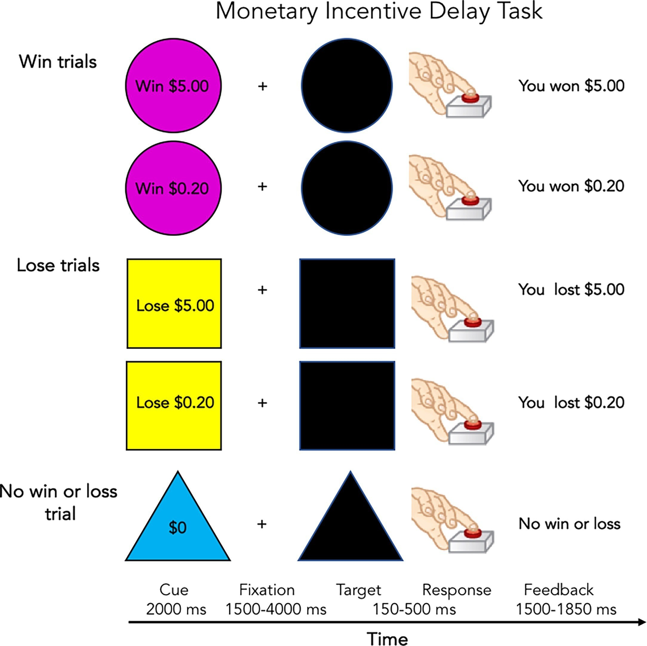

Figure 1

Monetary Incentive Delay Task, Adapted from Casey et al. (2018)

reward trials, reflecting reward feedback. The ROIs included the rostral and caudal anterior cingulate cortex (rACC, cACC), the insula, the striatum (caudate nucleus, putamen, and nucleus accumbens [NAc]), and the pallidum.
The ABCD Youth Behavior Inhibition/Behavioral Activation System (BIS/BAS; Carver & White, 1994), modified from PhenX, was used to as-sess reward sensitivity and motivation for goal-directed behavior. Participants rated each item on a 4-point Likert scale, ranging from 0 (very true) to 3 (very false). The analysis focused on three BAS subscales: Reward Responsiveness,

capturing positive reactions to anticipated or received rewards; Drive, reflect-ing motivation to pursue goals; and Fun Seeking, assessing the desire for new rewards.
Emotion processing The behavioral measures and fMRI beta weights
from Emotional N-Back (EN-back) task (Cohen et al., 2015; Figure 2) were used to assess emotion processing. In this task, participants responded when the current stimulus matched a target (0-back) or when it matched the stimulus from two previous trials (2-back). The task included two runs, each consisting of four 2-back blocks and four 0-back blocks. The stimuli were happy, fearful, and neutral faces, as well as places, presented in separate blocks. Each stimulus type included 40 trials, resulting in 160 trials in total (Casey et al., 2018).
Behavioral measures included the accuracy for positive faces (positive ac-curacy), accuracy for negative faces (negative accuracy), average reaction time for correct responses to positive faces (positive RT), and average reaction time for correct responses to negative faces (negative RT). For fMRI analysis, beta weights were derived from two contrasts: "positive face versus neutral face’ and "negative face versus neutral face". The ROIs included the rostral and caudal anterior cingulate cortex (rACC, cACC), insula, amygdala, striatum (caudate nu-cleus, putamen, and nucleus accumbens [NAc]), pallidum, and thalamic regions (thalamus, ventral diencephalon, and hippocampus).
Working memory The EN-Back task(Cohen et al., 2015; Figure 2) was
employed to assess working memory. For neural measures, the "2-back versus 0-back" contrast was utilized, as the 2-back condition required greater working memory capacity compared to the 0-back condition. The ROIs were defined

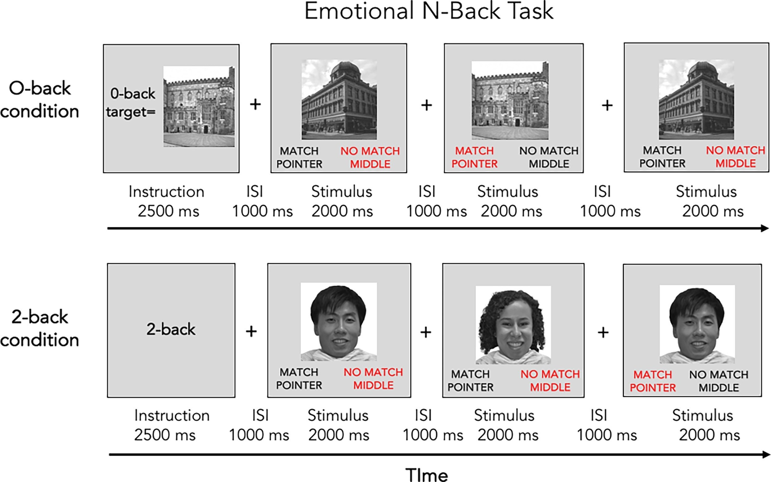
Figure 2

Emotional N-Back Task, Adapted from Casey et al. (2018)

based on the involvement of the Default Mode Network (DMN) and the Central Executive Network (CEN). DMN regions included the posterior cingulate cortex (PCC), precuneus, medial prefrontal cortex (mPFC; rostral anterior cingulate cortex [rACC] and medial orbitofrontal cortex [mOFC]), and inferior parietal lobule (IPL). CEN regions included dorsolateral prefrontal cortex (dlPFC; rostral and caudal middle frontal gyrus [rMFG, cMFG]) and the posterior parietal cortex (PPC; superior and inferior parietal lobule [SPL, IPL]). Behavioral measures included accuracy and average reaction time from the 2-back trials.
List Sorting Working Memory Test (list sorting test; Tulsky et al., 2013) and Dimensional Change Card Sort Test (card sort test; Tulsky et al., 2013) from

NIH Toolbox were also included as the behavioral measures of working memory. The list sorting test asked participants to sequence items in a specific order. Card sort test required participants to sort cards based on either their color or shape. Age-corrected scores for both tasks were included. However, these tasks were limited to cross-sectional analyses due to their lack of administration at the 2-year follow-up.
Impulsivity Impulsive action, trait impulsivity, and impulsive choice were
assessed using the Stop Signal Task (SST), the modified UPPS-P Impulsive Behavior Scale for Children, and the Cash Choice Task, respectively.
Stop Signal Task (SST; Logan et al., 1984; Figure 3) assessed neural and behavioral aspects of impulsive action. In this task, participants responded to a left or right arrow by pressing a corresponding button as quickly and accurately as possible during "Go" trials. In "Stop" trials, participants were required to inhibit their response when an unpredictable "Stop signal" (up-right arrow) appeared. Stop trials made up 16.67% of all trials. The task consisted of 360 trials in total, divided equally into two runs. The stop signal delay (SSD) was dynamically adjusted to maintain approximately 50% accuracy for stop trials (Casey et al., 2018).
Behavioral measures included Stop Signal Reaction Time (SSRT) and accu-racy in stop trials (stop accuracy). For fMRI analysis, the "correct stop versus correct go" contrast was used to examine successful inhibition. The ROIs in-cluded the inferior frontal gyrus (IFG; pars triangularis and pars orbitalis), rostral and caudal anterior cingulate cortex (rACC, cACC), and the striatum (caudate nucleus, putamen, and nucleus accumbens [NAc]).

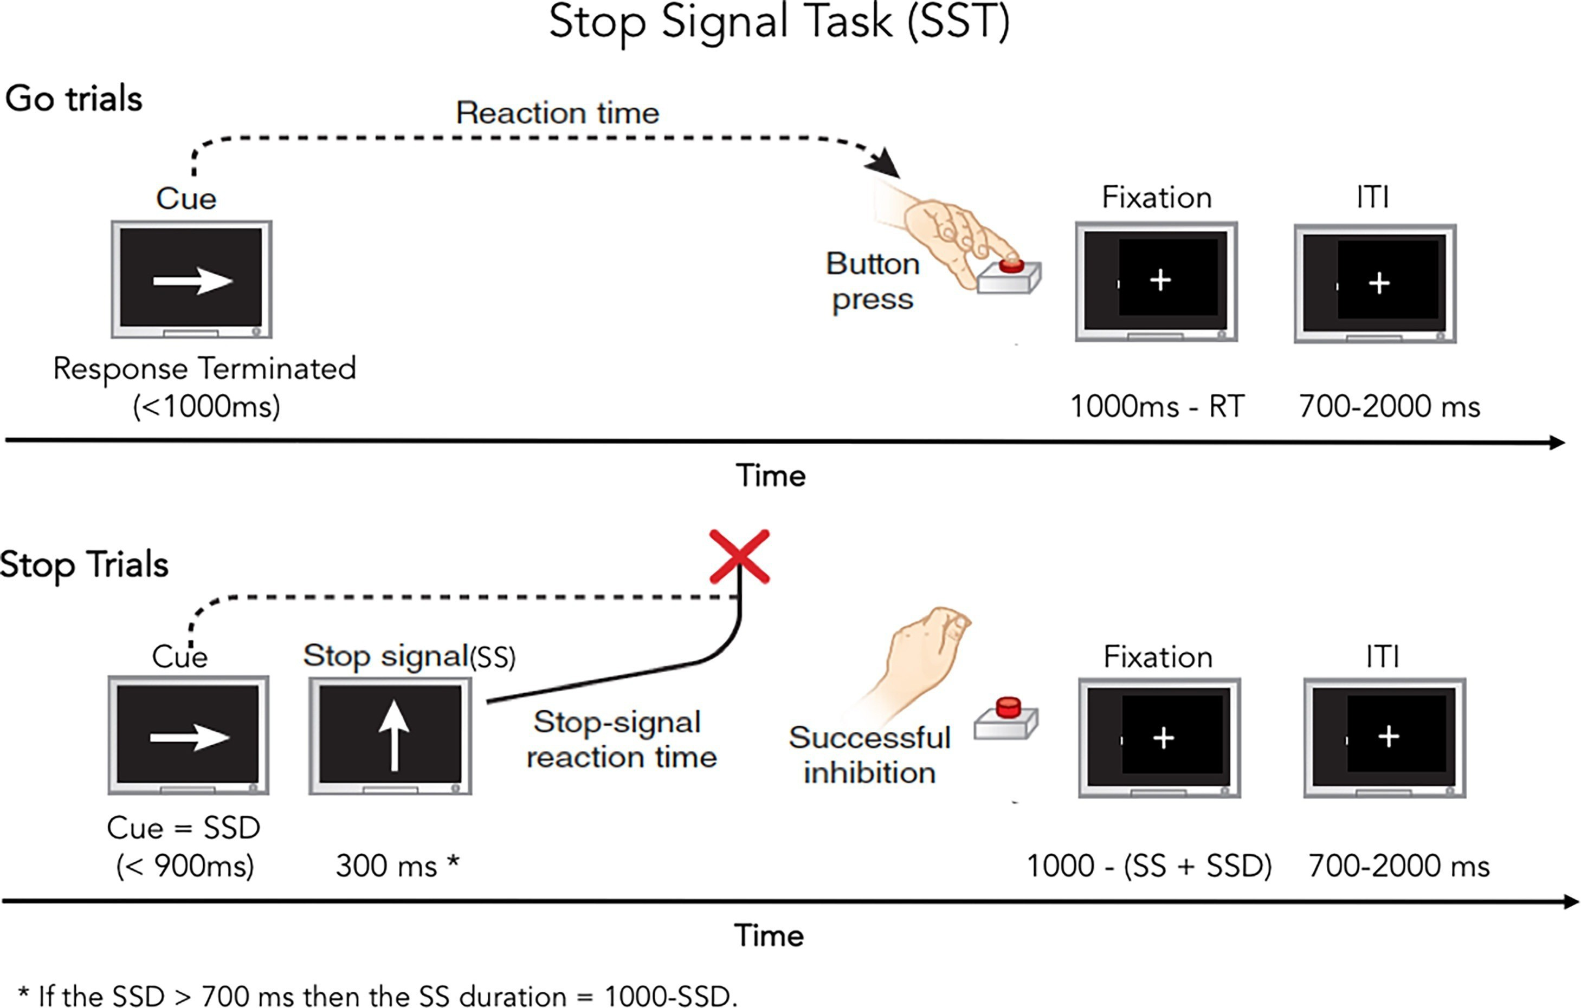
Figure 3

Stop Signal Task, Adapted from Casey et al. (2018)

To measure trait impulsivity, the modified Urgency, Premeditation, Perse-verance, Sensation Seeking, and Positive Urgency Impulsive Behavior Scale for Children (UPPS-P; Barch et al., 2018) was used. This 20-item questionnaire, designed for youth, included five subscale scores: lack of planning, lack of perse-verance, sensation seeking, positive urgency, and negative urgency. Participants rated each item on a 4-point Likert scale, ranging from 1 (not at all like me) to 4 (very much like me).
Impulsive choice was assessed using the Cash Choice Task (Luciana et al., 2018), which was included only in cross-sectional analyses. The task involved a single-item: "Let’s pretend a kind person wanted to give you some money.

Would you rather have $75 in 3 days or $115 in months?” Choosing the smaller, immediate reward ($75) reflects greater impulsivity, while selecting the larger, delayed reward ($115) indicates lower impulsivity.

Covariates
Demographics and Socioenocomic status (SES) Socio-demographic variables included the child’s age at interview, gender, race/ethnicity, parental education level, and maternal age at the child’s birth, all measured at baseline. Analyses included only children recorded as male or female. Race/ethnicity was categorized as "Hispanic" if the respondent identified as such. For those who did not identify as "Hispanic", the categories were "Black", "White", "Asian", and "Others". The "Others" category included participants reporting multiple races. Race/ethnicity was included based on prior findings suggesting that structural inequalities may influence variability in neurophysiological responses across racial/ethnic groups (Harnett et al., 2023). Parental education level was defined as the highest degree received, ranging from 0 (Never attended/Kindergarten only) to 21 (Doctoral degree). This measure reflects the education level of a single parent (mother or father), who participated in the study. Household income was excluded, because it was already part of the deprivation measure. When analyzing the effect of threat, the deprivation score was included in the model to indirectly account for the effects of income.
Data acquisition site The 21 ABCD study sites were included as a control variable to account for site-related variability, such as differences in scanner hardware and data collection protocols. This inclusion helps reduce measurement

bias.
Adversity exposure before birth Adversity exposure before birth was included as a covariate due to its potential influence on neurocognitive function. Variables included birth weight (measured as a continuous variable), premature birth, cyanosis (blue at birth), and maternal smoking or alcohol consumption during pregnancy.
Parental psychopathology and drug problem Parental psychopathology and substance use are often considered subcategories of ELS but were treated as covariates due to difficulties in clearly distinguishing between threat and deprivation.
Parental psychopathology was assessed at baseline using the Adult Self-Report from the Achenbach System of Empirically Based Assessment (ASEBA; Achenbach, 2009). The assessment included T-scores for scales oriented to the Diagnostic and Statistical Manual of Mental Disorders, Fifth Edition (DSM-5). Anxiety, somatic problems, depressive symptoms, avoidant personality prob-lems, attention deficit/hyperactivity problems (inattention and hyperactiv-ity/impulsivity subscales), and antisocial personality problems were included in the analyses. Note that only one parent (mother or father) completed the assessment, so these psychopathology measures may reflect data from a single parental source.
Parental substance use was assessed separately for mothers and fathers by determining whether they had problems with alcohol or drug use. Maternal and paternal substance use were analyzed separately to capture potential distinct pathways. For instance, maternal use may more directly impact daily caregiving

if the mother is the primary caregiver, while paternal use may influence the broader home environment or family stability. Moreover, because data were collected separately for mothers and fathers, combining them into a single ‘parental use’ measure could conceal parent-specific differences and obscure potential differential effects on the child’s neurodevelopment.
Children behavior checklist The parent-reported Child Behavior Check-
list (CBCL; Achenbach, 2009) was used to assess the child’s behavior over the past six months. T-scores for internalizing and externalizing problems were included as control variables due to their potential impact on neurocognitive functions. Baseline data were used for cross-sectional analyses, while 2-year follow-up data were utilized for longitudinal analyses.

MRI acquisition
The ABCD fMRI data (release 5.0) were used, which include pre-extracted task-related fMRI features. These features represent the averaged beta estimates for each brain region. Brain regions were parcellated using a surface-based method: cortical regions were defined by the Desikan–Killiany Atlas (Desikan et al., 2006), and subcortical regions by the Aseg Atlas (Fischl et al., 2002).

Analysis

Generalized linear model (GLM)

Generalized linear regression analyses were conducted to investigate the relationship between ELS and neurocognitive functions cross-sectionally and

longitudinally. Threat and deprivation were treated as binary variables (e.g., low threat = 0, high threat = 1, based on a cut-off score) and entered as independent variables. This mass-univariate approach provides a clear interpretation by analyzing each neurocognitive outcome independently, clarifying how threat or deprivation relates to each specific domain. The analyses were performed using the "glm" function in R, comparing the following two models:
Model 1. A model including only covariates
Model 2. A model including covariates, threat, and deprivation
Results were considered significant only if the Akaike Information Criterion (AIC) of Model 2 was lower than that of Model 1, indicating better model fit. Baseline neurocognitive functions (N = 3,568) were used for cross-sectional analyses, while 2-year follow-up neurocognitive functions (N = 2,222) were used for longitudinal analyses.
Multicollinearity among predictors was evaluated using Variance Inflation Factor (VIF) and no variables exceeded the threshold of 5. Neurocognitive functions (reward processing, emotion processing, working memory, and im-pulsivity) were treated as dependent variables, resulting in 123 models for cross-sectional data and 120 models for longitudinal data. Because testing multi-ple outcomes can inflate the risk of false positives, p-values were adjusted using the false discovery rate (FDR) method, implemented in the stats R package (https://www.rdocumentation.org/packages/stats).
While the GLM approach is valuable for examining each outcome separately, this mass-univariate strategy may still heighten the risk of multiple comparisons and may fail to capture the complex, joint impacts of predictors. Therefore,

to further mitigate these issues and explore multivariate patterns, LASSO regression was also employed.

Binomial LASSO regression

To explore multivariate patterns of neurocognitive functions associated with ELS, binomial LASSO (Least Absolute Shrinkage and Selection Operator; Tibshi-rani, 1996) regression was applied. LASSO is a regression method that performs both variable selection and regularization to enhance the interpretability and accuracy of statistical models. Threat and deprivation were separately set as outcome variables, while covariates and neurocognitive functions were included as predictors. Four models were constructed:
Model 1. Cross-sectional analysis with threat as the outcome variable: low
threat group (coded as 0), high threat group (coded as 1)
Model 2. Cross-sectional analysis with deprivation as the outcome variable: low deprivation group (coded as 0), high deprivation group (coded as 1) Model 3. Longitudinal analysis with threat as the outcome variable: low threat group (coded as 0), high threat group (coded as 1)
Model 4. Longitudinal analysis with deprivation as the outcome variable: low deprivation group (coded as 0), high deprivation group (coded as 1)
To control for the influence of threat and deprivation, threat scores were included as continuous variables in models examining deprivation, and vice versa. Since ELS occurs before measuring neurocognitive functions, these analyses are not predictive in nature. However, this approach enables the identification of variables associated with ELS while accounting for the effects of other variables.

The analysis was performed using the "glmnet" and "easyml" (v0.1.1) R packages. The easyml package provides a framework for building and evaluating machine learning models with the "glmnet" package (Ahn et al., 2017). The dataset was divided into 80% training set and 20% test set. The data was randomly split a hundred times, to ensure the robustness of the results. The model performance was averaged for every train-test split (Ahn et al., 2017).
The integration of findings from the mass-univariate (GLM) and multivari-ate (LASSO) approaches provides complementary insights: GLM elucidates how threat or deprivation relates to each neurocognitive outcome individually, whereas LASSO highlights which combinations of variables best characterize ELS exposure. I focused on results that emerged consistently across both methods, enhancing the clarity and robustness of conclusions.

Results

Participants characteristics
Descriptive statistics for participants’ demographics and covariates are pre-sented in Table 6 and Table 7. The sample size was 3,568 at Y0 (mean age = 9.96, SD = 0.63) and 2,222 at Y2 (mean age = 11.94, SD = 0.63).
Table 8 presents the distribution of threat and deprivation at Y0 and Y2. There were no significant differences in the distribution of threat (p = 1.000) or deprivation (p = 1.000) scores between Y0 and Y2, allowing for direct comparisons between cross-sectional and longitudinal analyses. Since nearly half of the participants scored zero, categorical groups were used instead of continuous scores. At both Y0 and Y2, 13% of participants were classified in the high-threat group, and 9.2% were in the high-deprivation group.
The overlap between high threat and high deprivation groups is an important consideration, as it reflects individuals with mixed exposure. As shown in Table 9, at Y0, 2.92% of participants (N = 104) belonged to both high-threat and high-deprivation groups, a proportion that remained similar at Y2 (N = 56, 2.51%). Conversely, the majority of participants were classified as low threat and low deprivation, comprising 80.49% (N = 2,872) at Y0 and 80.02% (N = 1,778) at Y2.
To address the overlap, statistical controls were applied to account for the effects of each dimension while retaining participants with mixed exposure. This approach ensured a sufficient number of participants for analysis while disentangling the unique contributions of threat and deprivation.

Table 6

Descriptive statistics for demographics and socioeconomic status

Y0 (N = 3,568) Y2 (N = 2,222)

N (%) Mean (SD) N (%) Mean (SD)

Child age (years) |  | 9.96 (0.63) |  | 11.94 (0.63)
Gender
Male | 1,823 (51%) |  | 1,150 (52%)
Female | 1,745 (49%) |  | 1,072 (48%)
Race and Ethnicity
White | 2,248 (63%) |  | 1,464 (66%)
Black | 259 (7.3%) |  | 142 (6.4%)
Hispanic | 603 (17%) |  | 364 (16%)
Asian | 65 (1.8%) |  | 36 (1.6%)
Other | 393 (11%) |  | 216 (9.7%)
Maternal age at child’s birth |  | 30.3 (5.8) |  | 30.3 (5.8)
Parental education |  | 17.25 (2.35) |  | 17.24 (2.34)
Data acquisition site
Site 1 | 88 (2.5%) |  | 35 (1.6%)
Site 2 | 190 (5.3%) |  | 126 (5.7%)
Site 3 | 159 (4.5%) |  | 83 (3.7%)
Site 4 | 231 (6.5%) |  | 184 (8.3%)
Site 5 | 118 (3.3%) |  | 85 (3.8%)
Site 6 | 229 (6.4%) |  | 155 (7.0%)
Site 7 | 79 (2.2%) |  | 32 (1.4%)
Site 8 | 110 (3.1%) |  | 50 (2.3%)
Site 9 | 152 (4.3%) |  | 77 (3.5%)
Site 10 | 175 (4.9%) |  | 114 (5.1%)
Site 11 | 151 (4.2%) |  | 76 (3.4%)
Site 12 | 161 (4.5%) |  | 92 (4.1%)
Site 13 | 223 (6.3%) |  | 120 (5.4%)
Site 14 | 191 (5.4%) |  | 133 (6.0%)
Site 15 | 65 (1.8%) |  | 44 (2.0%)
Site 16 | 453 (13%) |  | 294 (13%)
Site 17 | 203 (5.7%) |  | 132 (5.9%)
Site 18 | 146 (4.1%) |  | 72 (3.2%)
Site 19 | 81 (2.3%) |  | 51 (2.3%)
Site 20 | 203 (5.7%) |  | 144 (6.5%)
Site 21 | 148 (4.1%) |  | 119 (5.4%)
Site 22 | 12 (0.3%) |  | 4 (0.2%)
Note. Mean age: Y0 (cross-sectional) = 9.96 years, Y2 (longitudinal) = 11.94 years

Table 7

Descriptive statistics for adversity before birth, parental psychopathology and child behavior
Y0 (N = 3,568) Y2 (N = 2,222)

N (%) Mean (SD) N (%) Mean (SD)

Birth weight (pound) 6.73 (1.41) 6.74 (1.41) Premature birth
Yes 607 (17%) 385 (17%)
No 2,961 (83%) 1,837 (83%)

Cyanosis (blue at birth)
Yes | 124 (3.5%) | 80 (3.6%)
No | 3,444 (97%) | 2,142 (96%)
Pregnant alcohol use/smoking Yes | 210 (5.9%) |  | 114 (5.1%)
No  Parent anxiety problems | 3,358 (94%) | 53.3 (5.2) | 2,108 (95%) | 53.2 (5.0)
Parent somatic problems |  | 54.3 (5.9) |  | 54.4 (6.0)
Parent depressive problems |  | 53.8 (5.7) |  | 53.8 (5.8)
Parent avoidant personality problems |  | 53.0 (5.1) |  | 53.1 (5.2)
Parent AD/H problems |  | 53.0 (5.3) |  | 53.1 (5.4)
Parent antisocial personality problems Father drug problem  Yes | 524 (15%) | 52.8 (4.4) | 317 (14%) | 52.8 (4.4)
No | 3,044 (85%) |  | 1,905 (86%)
Mother drug problem
Yes | 160 (4.5%) |  | 93 (4.2%)
No  Child externalizing problems | 3,408 (96%) | 44 (9) | 2,129 (96%) | 44 (9)
Child internalizing problems |  | 48 (10) |  | 48 (10)
Note. Mean age: Y0 (cross-sectional) = 9.96 years, Y2 (longitudinal) = 11.94 years

Table 8

Distribution of threat and deprivation

Y0 (N = 3,568) Y2 (N = 2,222)
p
N (%) Score N (%) N (%) Score N (%)

Threat 1.000

Low threat group | 3,096 (87%) | 0 | 1,670 (47%) | 1,927 (87%) | 0 | 1,044 (47%)
 |  | 1 | 1,426 (40%) |  | 1 | 883 (40%)
High threat group | 472 (13%) | 2 | 410 (11%) | 295 (13%) | 2 | 251 (11%)
 |  | 3 | 49 (1.4%) |  | 3 | 35 (1.6%)
 |  | 4 | 9 (0.3%) |  | 4 | 4 (0.2%)
Deprivation |  | 5 | 4 (0.1%) |  | 5 | 5 (0.2%)  1.000
Low deprivation group | 3,240 (91%) | 0 | 1,805 (51%) | 2,017 (91%) | 0 | 1,107 (50%)
 |  | 1 | 955 (27%) |  | 1 | 576 (26%)
 |  | 2 | 480 (13%) |  | 2 | 334 (15%)
High deprivation group | 328 (9.2%) | 3 | 206 (5.8%) | 205 (9.2%) | 3 | 121 (5.4%)
 |  | 4 | 83 (2.3%) |  | 4 | 61 (2.7%)
 |  | 5 | 31 (0.9%) |  | 5 | 17 (0.8%)
 |  | 6 | 8 (0.2%) |  | 6 | 6 (0.3%)
Note. A Mann-Whitney test was performed to compare the scores of Y0 and Y2. Mean age: Y0 (cross-sectional) = 9.96 years, Y2 (longitudinal) = 11.94 years

Table 9

Overlap of Threat and Deprivation Groups

 |  | Y0 [N (%)] |  |  | Y2 [N (%)]
 | Low deprivation | High deprivation | Total | Low deprivation | High deprivation | Total
Low threat | 2,872 (80.49%) | 224 (6.28%) | 3,096 (86.77%) | 1,778 (80.02%) | 149 (6.71%) | 1,927 (86.73%)
High threat | 368 (10.31%) | 104 (2.92%) | 472 (13.23%) | 239 (10.76%) | 56 (2.51%) | 295 (13.27%)
Total | 3,240 (90.80%) | 328 (9.20%) | 3,568 (100%) | 2,017 (90.78) | 205 (9.22%) | 2,222 (100%)
Note. Mean age: Y0 (cross-sectional) = 9.96 years, Y2 (longitudinal) = 11.94 years

Table 10 and Table 11 summarize the demographics and covariates for high-threat and low-threat groups and for high-deprivation and low-deprivation groups at Y0. Age and gender did not significantly differ between high-threat and low-threat groups (t(624.24) = -1.92, p = .056 for age; p = .882 for gender) or between high-deprivation and low-deprivation groups (t(394.11) = -1.97, p =
.050 for age; p = 1.000 for gender).

Table 10

Descriptive statistics and group comparison (high vs. low threat) at Y0 (mean age = 9.96)
Y0 (N = 3,568)
 | N (%) | Mean (SD) | N (%) | Mean (SD)
Child age (years) |  | 9.91 (0.62) |  | 9.97 (0.63) | -1.92 .056
Gender |  |  |  |  | .882
Male | 243 (51%) |  | 1,580 (51%)
Female | 229 (49%) |  | 1,516 (49%)
Race and Ethnicity |  |  |  |  | <.001 ***
White | 255 (54%) |  | 1,993 (64%)
Black | 70 (15%) |  | 189 (6.1%)
Hispanic | 88 (19%) |  | 515 (17%)
Asian | 7 (1.5%) |  | 58 (1.9%)
Other | 52 (11%) |  | 341 (11%)
Maternal age at child’s birth |  | 28.49 (5.97) |  | 30.60 (5.69) | 7.22 <.001 ***
Parental education |  | 16.42 (2.71) |  | 17.38 (2.27) | 7.32 <.001 ***
Birth weight (pound) |  | 6.69 (1.40) |  | 6.74 (1.41) | 0.72 .047 *
Premature birth |  |  |  |  | .599
Yes | 76 (16%) |  | 531 (17%)
No | 396 (84%) |  | 2,565 (83%)
Cyanosis (blue at birth) |  |  |  |  | .892
Yes | 17 (3.6%) |  | 107 (3.5%)
No | 455 (96%) |  | 2,989 (97%)
Pregnant alcohol use/smoking |  |  |  |  | <.001 ***
Yes | 51 (11%) |  | 159 (5.1%)
No | 421 (89%) |  | 2,937 (95%)
Parent anxiety problems |  | 54.72 (6.04) |  | 53.07 (5.01) | 5.62 <.001 ***
Parent somatic problems |  | 56.97 (7.57) |  | 53.91 (5.52) | 8.43 <.001 ***
Parent depressive problems |  | 56.26 (7.22) |  | 53.43 (5.33) | 8.18 <.001 ***
Parent avoidant personality problems |  | 54.79 (6.92) |  | 52.72 (4.71) | 6.26 <.001 ***
Parent AD/H problems |  | 54.88 (6.90) |  | 52.69 (4.90) | 6.64 <.001 ***
Parent antisocial personality problems |  | 54.64 (5.80) |  | 52.55 (4.05) | 7.54 <.001 ***
Father drug problem |  |  |  |  | <.001 ***
Yes | 114 (24%) |  | 410 (13%)
No | 358 (76%) |  | 2,686 (87%)
Mother drug problem |  |  |  |  | <.001 ***
Yes | 42 (8.9%) |  | 118 (3.8%)
No | 430 (91%) |  | 2,978 (96%)
Child externalizing problems |  | 48.99 (10.87) |  | 43.54 (9.00) | 10.37 <.001 ***
Child internalizing problems |  | 51.79 (11.26) |  | 47.31 (9.80) | 8.20 <.001 ***

High threat group (N = 472) Low threat group (N = 3,096) t p

Note. * p < .05, ** p < .01, *** p < .001
A Fisher’s exact test was performed to assess group differences in categorical variables. A Welch’s t-test was used for continuous variables.

Table 11

Descriptive statistics and group comparison (high vs. low deprivation) at Y0 (mean age = 9.96)
Y0 (N = 3,568)
 | N (%) | Mean (SD) | N (%) | Mean (SD)
Child age (years) |  | 9.90 (0.63) |  | 9.97 (0.62) | 1.97 .050
Gender |  |  |  |  | 1.000
Male | 168 (51%) |  | 1,655 (51%)
Female | 160 (49%) |  | 1,585 (49%)
Race and Ethnicity |  |  |  |  | <.001 ***
White | 119 (36%) |  | 2,129 (66%)
Black | 71 (22%) |  | 188 (5.8%)
Hispanic | 89 (27%) |  | 514 (16%)
Asian | 2 (0.6%) |  | 63 (1.9%)
Other | 47 (14%) |  | 346 (11%)
Maternal age at child’s birth |  | 26.72 (5.96) |  | 30.69 (5.63) | 11.56 <.001 ***
Parental education |  | 15.13 (2.77) |  | 17.46 (2.20) | 14.76 <.001 ***
Birth weight (pound) |  | 6.56 (1.38) |  | 6.75 (1.41) | 2.33 .020 *
Premature birth |  |  |  |  | .397
Yes | 50 (15%) |  | 557 (17%)
No | 278 (85%) |  | 2,683 (83%)
Cyanosis (blue at birth) |  |  |  |  | .204
Yes | 7 (2.1%) |  | 117 (3.6%)
No | 321 (98%) |  | 3,123 (96%)
Pregnant alcohol use/smoking |  |  |  |  | <.001 ***
Yes | 42 (13%) |  | 168 (5.2%)
No | 286 (87%) |  | 3,072 (95%)
Parent anxiety problems |  | 55.25 (6.91) |  | 53.09 (4.93) | 5.51 <.001 ***
Parent somatic problems |  | 57.20 (8.23) |  | 54.03 (5.56) | 6.82 <.001 ***
Parent depressive problems |  | 56.15 (7.76) |  | 53.57 (5.38) | 5.89 <.001 ***
Parent avoidant personality problems |  | 54.14 (6.57) |  | 52.88 (4.92) | 3.38 <.001 ***
Parent AD/H problems |  | 54.73 (7.57) |  | 52.80 (4.94) | 4.52 <.001 ***
Parent antisocial personality problems |  | 54.61 (5.74) |  | 52.64 (4.18) | 6.04 <.001 ***
Father drug problem |  |  |  |  | <.001 ***
Yes | 121 (37%) |  | 403 (12%)
No | 207 (63%) |  | 2,837 (88%)
Mother drug problem |  |  |  |  | <.001 ***
Yes | 39 (12%) |  | 121 (3.7%)
No | 289 (88%) |  | 3,119 (96%)
Child externalizing problems |  | 48.53 (11.83) |  | 43.83 (9.07) | 6.99 <.001 ***
Child internalizing problems |  | 50.15 (11.16) |  | 47.67 (9.98) | 3.86 <.001 ***

High deprivation group (N = 328) Low deprivation group (N = 3,240) t p

Note. * p < .05, ** p < .01, *** p < .001
A Fisher’s exact test was performed to assess group differences in categorical variables. A Welch’s t-test was used for continuous variables.

For Y2, refer to Table 12 and Table 13. Age and gender did not significantly differ between the high-threat and low-threat groups (t(394.86) = -1.47, p =
.435 for age; p = .348 for gender). However, a significant age difference was
observed between high-deprivation and low-deprivation groups (t(242.65) =
-2.21, p = .028), although gender differences were not significant (p = .077).
Adversity before birth and parental psychopathologies significantly differed across both threat and deprivation groups, indicating that these factors cannot be easily categorized as exclusively threat- or deprivation-related. Similarly, child externalizing and internalizing problems showed significant differences across both groups. These factors were therefore included as covariates to control for potential confounding effects and to isolate the unique effects of threat and deprivation on neurocognitive functions.

Table 12

Descriptive statistics and group comparison (high vs. low threat) at Y2 (mean age = 11.94)
Y2 (N = 2,222)
 | N (%) | Mean (SD) | N (%) | Mean (SD)
Child age (years) |  | 11.89 (0.62) |  | 11.95 (0.63) | 1.47 1.435
Gender |  |  |  |  | .348
Male | 145 (49%) |  | 1,005 (52%)
Female | 150 (51%) |  | 922 (48%)
Race and Ethnicity |  |  |  |  | <.001 ***
White | 162 (55%) |  | 1,302 (68%)
Black | 43 (15%) |  | 99 (5.1%)
Hispanic | 48 (16%) |  | 316 (16%)
Asian | 4 (1.4%) |  | 32 (1.7%)
Other | 38 (13%) |  | 178 (9.2%)
Maternal age at child’s birth |  | 28.54 (6.03) |  | 30.61 (5.66) | 5.55 <.001 ***
Parental education |  | 16.47 (2.65) |  | 17.35 (2.27) | 5.39 <.001 ***
Birth weight (pound) |  | 6.68 (1.39) |  | 6.75 (1.42) | 0.75 .452
Premature birth |  |  |  |  | .187
Yes | 43 (15%) |  | 342 (18%)
No | 252 (85%) |  | 1,585 (82%)
Cyanosis (blue at birth) |  |  |  |  | .737
Yes | 9 (3.1%) |  | 71 (3.7%)
No | 286 (97%) |  | 1,856 (96%)
Pregnant alcohol use/smoking |  |  |  |  | .004 **
Yes | 26 (8.8%) |  | 88 (4.6%)
No | 269 (91%) |  | 1,839 (95%)
Parent anxiety problems |  | 54.86 (5.80) |  | 52.92 (4.87) | 5.46 <.001 ***
Parent somatic problems |  | 56.55 (7.55) |  | 54.09 (5.71) | 5.36 <.001 ***
Parent depressive problems |  | 56.34 (7.23) |  | 53.44 (5.40) | 6.6 <.001 ***
Parent avoidant personality problems |  | 55.03 (6.87) |  | 52.80 (4.79) | 5.39 <.001 ***
Parent AD/H problems |  | 55.21 (6.97) |  | 52.78 (5.01) | 5.77 <.001 ***
Parent antisocial personality problems |  | 54.64 (5.90) |  | 52.54 (4.01) | 5.89 <.001 ***
Father drug problem |  |  |  |  | <.001 ***
Yes | 68 (23%) |  | 249 (13%)
No | 227 (77%) |  | 1,678 (87%)
Mother drug problem |  |  |  |  | .027 *
Yes | 20 (6.8%) |  | 73 (3.8%)
No | 275 (93%) |  | 1,854 (96%)
Child externalizing problems |  | 46.49 (10.32) |  | 43.18 (8.84) | 5.22 <.001 ***
Child internalizing problems |  | 50.91 (11.16) |  | 47.01 (9.98) | 5.66 <.001 ***

High threat group (N = 295) Low threat group (N = 1,927) t p

Note. * p < .05, ** p < .01, *** p < .001
A Fisher’s exact test was performed to assess group differences in categorical variables. A Welch’s t-test was used for continuous variables.

Table 13

Descriptive statistics and group comparison (high vs. low deprivation) at Y2 (mean age = 11.94)
Y2 (N = 2,222)
 | N (%) | Mean (SD) | N (%) | Mean (SD)
Child age (years) |  | 11.84 (0.66) |  | 11.95 (0.63) | 2.21 .028 *
Gender |  |  |  |  | .077
Male | 104 (51%) |  | 1,046 (52%)
Female
Race and Ethnicity |  |  |  |  | <.001 ***
White | 84 (41%) |  | 1,380 (68%)
Black | 42 (20%) |  | 100 (5.0%)
Hispanic | 48 (23%) |  | 316 (16%)
Asian | 0 (0%) |  | 36 (1.8%)
Other | 31 (15%) |  | 185 (9.2%)
Maternal age at child’s birth |  | 26.88 (6.42) |  | 30.69 (5.56) | 8.19
Parental education |  | 15.22 (3.07) |  | 17.44 (2.15) | 10.12
Birth weight (pound) |  | 6.67 (1.42) |  | 6.74 (1.41) | 0.69 .492
Premature birth |  |  |  |  | .561
Yes | 32 (16%) |  | 353 (18%)
No | 173 (84%) |  | 1,664 (82%)
Cyanosis (blue at birth) |  |  |  |  | .237
Yes | 4 (2.0%) |  | 76 (3.8%)
No | 201 (98%) |  | 1,941 (96%)
Pregnant alcohol use/smoking |  |  |  |  | <.001 ***
Yes | 28 (14%) |  | 86 (4.3%)
No | 177 (86%) |  | 1,931 (96%)
Parent anxiety problems |  | 54.73 (6.22) |  | 53.02 (4.89) | 3.82 <.001 ***
Parent somatic problems |  | 57.03 (8.15) |  | 54.15 (5.73) | 4.93 <.001 ***
Parent depressive problems |  | 55.94 (7.57) |  | 53.61 (5.50) | 4.29 <.001 ***
Parent avoidant personality problems |  | 54.18 (6.18) |  | 52.98 (5.04) | 2.68 .008 **
Parent AD/H problems |  | 54.62 (7.35) |  | 52.94 (5.11) | 3.19 .002 **
Parent antisocial personality problems |  | 54.32 (5.59) |  | 52.67 (4.20) | 4.11 <.001 ***
Father drug problem |  |  |  |  | <.001 ***
Yes | 79 (39%) |  | 238 (12%)
No | 126 (61%) |  | 1,779 (88%)
Mother drug problem, n (%) |  |  |  |  | <.001 ***
Yes | 22 (11%) |  | 71 (3.5%)
No | 183 (89%) |  | 1,946 (96%)
Child externalizing problems |  | 47.25 (10.67) |  | 43.25 (8.86) | 5.19 <.001 ***
Child internalizing problems |  | 49.74 (10.75) |  | 47.30 (10.15) | 3.11 .002 **

High deprivation group (N = 205) Low deprivation group (N = 2,017) t p

Note. * p < .05, ** p < .01, *** p < .001
A Fisher’s exact test was performed to assess group differences in categorical variables. A Welch’s t-test was used for continuous variables.

Generalized linear model results

Reward processing

Threat Cross-sectional analyses revealed no significant neural activation during either reward anticipation or reward feedback. However, in the longitudi-nal analyses, threat was associated with deactivation in the left caudate (b =
-0.030, SE = 0.014, p = .029) and the left rACC (b = -0.028, SE = 0.013, p
= .031) during reward anticipation. For reward feedback, threat was positively related to activation in the left putamen (b = 0.027, SE = 0.013, p = .046), right insula (b = 0.028, SE = 0.012, p = .019), and left cACC (b = 0.029, SE
= 0.014, p = .032). None of these results, however, remained significant after
FDR correction.
Additionally, no behavioral or survey measures showed significant associations with threat.
Deprivation No significant brain activation was observed during reward
anticipation. However, during the reward feedback phase, deprivation was cross-sectionally associated with deactivation in several striatal and cortical regions, including the bilateral caudate (left: b = -0.051, SE = 0.017, p = .003; right: b = -0.039, SE = 0.017, p = .024), bilateral putamen (left: b = -0.034, SE = 0.015, p = .021; right: b = -0.042, SE = 0.015, p = .004), left NAc (b = -0.066, SE = 0.020, p = .043), left insula (b = -0.030, SE = 0.013, p = .022), left rACC
(b = -0.039, SE = 0.018, p = .028), and bilateral cACC (left: b = -0.049, SE = 0.016, p = .002; right: b = -0.043, SE = 0.015, p = .005). After FDR correction, only deactivation in the left NAc remained significant (p-FDR = .043).

Longitudinally, deprivation was linked to hyperactivation in the bilateral NAc (left: b = 0.085, SE = 0.029, p = .004; right: b = 0.078, SE = 0.030, p =
.009), right pallidum (b = 0.032, SE = 0.015, p = .033), and left cACC (b =
0.041, SE = 0.017, p = .014) during reward feedback.
For behavioral and survey measures, only the BAS Drive subscale was positively associated with deprivation (b = 0.369, SE = 0.175, p = .034) in the cross-sectional analysis.
Summary of findings Reduced striatal activation during reward antici-pation, as hypothesized, was observed for threat only in longitudinal analyses.
During reward feedback, threat was associated with hyperactivation in cortical regions (insula, cACC) and the striatum (putamen). In contrast, deprivation showed no significant association with reward anticipation. Cross-sectionally, during reward feedback, deprivation was linked to hypoactivation in striatal and cortical regions, particularly in the ventral striatum (NAc), with this finding remaining significant after FDR correction. Longitudinally, deprivation was associated with increased activation in the striatum (NAc, pallidum) and cACC, demonstrating a pattern opposite to the cross-sectional findings. Among be-havioral measures, only the BAS Drive subscale showed a significant positive association with deprivation. A summary of results for reward processing is provided in Table 14.

Table 14

Summary of GLM results for reward processing

Domain Task or measurement ROI Threat Deprivation
 |  |  | Y0 | Y2 | Y0 | Y2
MID fMRI | Reward anticipation | ACC (rACC/cACC) | N.S. | left caudate ↓ | N.S. | N.S.
 | (reward vs. neutral) | Insula |  | left rACC ↓
 | Reward feedback | Striatum | N.S. | left putamen ↑ | bilateral caudate ↓ | bilateral NAc ↑
 | positive vs. negative | (caudate/putamen/NAc) |  | right insula ↑ | bilateral putamen ↓ | right pallidum ↑
 |  | Pallidum |  | left cACC ↑ | left NAc ↓ | left cACC ↑
Reward processing |  |  |  |  | left insula ↓
 |  |  |  |  | left rACC ↓
 |  |  |  |  | bilateral cACC ↓
MID fMRI | Accuracy (reward) |  | N.S. | N.S. | N.S. | N.S.
Behavior | RT (Successful reward) |  | N.S. | N.S. | N.S. | N.S.
BAS | Reward responsiveness |  | N.S. | N.S. | N.S. | N.S.
 | Drive |  | N.S. | N.S. | ↑ | N.S.
 | Fun seeking |  | N.S. | N.S. | N.S. | N.S.
Note. Written in bold means significance after FDR correction. Mean age: Y0 (cross-sectional) = 9.96 years, Y2 (longitudinal) = 11.94 years.
Abbreviations. N.S., Not significant; ROI, Regions of Interest; MID, Monetary Incentive Delay task; BAS, Behavioral Activation System; RT, Reaction Time; ACC, anterior cingulate cortex; rACC, rostral anterior cingulate cortex; cACC, caudal anterior cingulate cortex; NAc, nucleus accumbens

Emotion processing

Threat Cross-sectional analyses indicated that threat was associated with deactivation in the left putamen (b = -0.040, SE = 0.017, p = .020) and bilateral hippocampus (left: b = -0.037, SE = 0.016, p = .026; right: b = -0.038, SE = 0.017, p = .023) in the positive vs. neutral contrast. Longitudinally, threat was associated with deactivation in the left putamen (b = -0.056, SE = 0.027, p =
.035).
For the negative vs. neutral contrast, no significant activation was observed cross-sectionally. Longitudinal analyses revealed hyperactivation in the right NAc related to threat (b = 0.094, SE = 0.046, p = .043). However, none of

these findings remained significant after FDR correction.
Reaction time (RT) and accuracy showed no significant associations with threat in either cross-sectional or longitudinal analyses.
Deprivation Cross-sectionally, deprivation was associated with deactivation
in the left pallidum for positive faces (b = -0.060, SE = 0.021, p = .005). For negative faces, deprivation was linked to deactivation in the left pallidum (b =
-0.044, SE = 0.021, p = .035) and right hippocampus (b = -0.041, SE = 0.020,
p = .041). Longitudinally, no significant brain activation was observed.
For behavioral measures, deprivation was related to lower accuracy for positive faces (b = -0.017, SE = 0.005, p = .001) and negative faces (b = -0.017, SE = 0.005, p = .001). Longitudinal analyses revealed similar results, with lower accuracy for positive faces (b = -0.022, SE = 0.006, p < .001) and negative faces (b = -0.024, SE = 0.006, p < .001) in the deprivation group.
Furthermore, longer reaction times were observed for positive faces (b = 27.191, SE = 9.322, p = .004) and negative faces (b = 28.501, SE = 9.553, p
= .003) in the longitudinal analysis. After FDR correction, only longitudinal associations with positive and negative accuracy remained significant.
Summary of findings For positive emotional stimuli, threat was related
to reduced brain activation, contrary to the hypothesis. No significant associ-ations were found between threat and behavioral measures such as reaction time or accuracy for positive stimuli. Deprivation was linked to cross-sectional deactivation in the pallidum, consistent with the hypothesis.
For negative emotional stimuli, the hypothesized amygdala hyperactivation associated with threat and deprivation was not observed. Instead, longitudinal

Table 15

Summary of GLM results for emotion processing

Domain Task or measurement ROI Threat Deprivation
Y0 Y2 Y0 Y2

EN-Back fMRI Positive vs neutral Amygdala
ACC (rACC/cACC)
Insula
Striatum (caudate/putamen/NAc)
left putamen ↓ bilateral hippocampus ↓
right insula ↓
left putamen ↓ left pallidum ↓
N.S.

Emotion processing
Negative vs neutral
Pallidum Thalamic regions
(thalamus/ventral diencephalon/
N.S. right NAc ↑
left pallidum ↓ right hippocampus ↓
N.S.

EN-Back fMRI Accuracy (positive)
hippocampus)
N.S. N.S. ↓ ↓

Behavior Accuracy (negative) N.S. N.S. ↓ ↓
RT (positive) N.S. N.S. N.S. ↑
RT (negative) N.S. N.S. N.S. ↑
Note. Written in bold means significance after FDR correction. Mean age: Y0 (cross-sectional) = 9.96 years, Y2 (longitudinal) = 11.94 years.
Abbreviations. N.S., Not significant; ROI, Regions of Interest; EN-Back, emotional N-back task; RT, Reaction Time; ACC, anterior cingulate cortex; rACC, rostral anterior cingulate cortex; cACC, caudal anterior cingulate cortex; NAc, nucleus accumbens

analyses indicated that threat was associated with hyperactivation in the ventral striatum (NAc), while no significant behavioral associations (reaction time or accuracy) were found for threat. Deprivation was related with deactivation in the pallidum and hippocampus cross-sectionally. See Table 15 for a summary of results for emotion processing.

Working memory Threat
No significant relationships were observed between threat and any working memory measures in either cross-sectional or longitudinal analyses.
Deprivation Deprivation was related to decreased activation in CEN regions
only in cross-sectional analyses (left rMFG: b = -0.047, SE = 0.020, p = .017; right IPL: b = -0.032, SE = 0.016, p = .048). However, these associations did

not survive after FDR correction. For behavioral measures, deprivation was related to lower 2-back accuracy (b = -0.017, SE = 0.005, p = .001), list sorting test score (b = -1.786, SE = 0.870, p = .040), and card sort test score (b =
-2.264, SE = 0.949, p = .017) cross-sectionally. Longitudinal analyses revealed
that only lower 2-back accuracy was related to deprivation (b = -0.022, SE = 0.006, p < .001). After FDR correction, only the 2-back accuracy across years remained significant (cross-sectional: p-fdr = .043, longitudinal: p-fdr = .009).
Summary of findings As hypothesized, deprivation was consistently linked to poorer working memory performance, particularly in 2-back accuracy across
cross-sectional and longitudinal analyses. While cross-sectional analyses also suggested reduced activation in CEN regions, such as the left rMFG and right IPL, these findings did not survive FDR correction. In contrast, no significant as-sociations were found between threat and any working memory-related measures. See Table 16 for a summary of results for working memory.

Table 16

Summary of GLM results for working memory

Domain Task or measurement ROI Threat Deprivation Y0 Y2 Y0 Y2

Working memory
↓
left rMFG ↓
right IPL ↓
EN-Back fMRI 2-back vs. 0-back DMN regions
(PCC, precuneus,
IPL, mPFC: rACC/mOFC)
CEN regions
(dlPFC: rMFG/cMFG, PPC: SPL/IPL)
N.S. N.S.
N.S.

EN-Back fMRI Behavior Accuracy (2-back) N.S. N.S. ↓
RT (2-back) N.S. N.S. N.S. N.S.
List sorting test Total score N.S. - -
↓
↓
Card sort test Total score N.S. - -

Note. Written in bold means significance after FDR correction. Mean age: Y0 (cross-sectional) = 9.96 years, Y2 (longitudinal) = 11.94 years.
Abbreviations. N.S., Not significant; ROI, Regions of Interest; EN-Back, emotional N-back task; RT, Reaction Time; DMN, default mode network; PCC, posterior cingulate cortex; IPL, inferior parietal lobule,; mPFC, medial prefrontal cortex; rACC, rostral anterior cinculate cortex; mOFC, medial orbitofrontal cortex; CEN, central executive network; dlPFC, dorsolateral prefrontal cortex; rMFG, rostral middle frontal gyrus; cMFG, caudal middle frontal gyrus; PPC, posterior parietal cortex; SPL, superior parietal lobule

Impulsivity

Threat No significant brain activation was associated with threat in the correct stop versus correct go contrast in cross-sectional analyses. However, stop accuracy was negatively associated with threat in cross-sectional analyses (b =
-0.006, SE = 0.003, p = .038). Longitudinal analyses showed that threat was
associated with hyperactivation in the left NAc (b = 0.028, SE = 0.013, p =
.037). However, these results did not survive after FDR correction. No significant findings were observed in the cash choice task or UPPS-P for threat.
Deprivation Deprivation showed no association with brain activation in

either cross-sectional or longitudinal analyses. Additionally, no significant asso-ciations were found in the cash choice task. However, higher UPPS-P positive
urgency (b = 0.792, SE = 0.175, p < .001, p-fdr = .001), lack of perseverance
(b = 0.459, SE = 0.133, p = .001, p-fdr = .043), and lack of planning (b = 0.607, SE = 0.003, p = .038, p-fdr = .001) were associated with deprivation in cross-sectional analyses. These associations were not consistently found in longi-tudinal analyses, although higher lack of perseverance was modestly associated with deprivation (b = 0.394, SE = 0.170, p = .021, p-fdr = .499).
Summary of findings The hypothesized associations with UPPS-P negative urgency and increased impulsive choice were not observed for either threat or deprivation. Instead, deprivation was linked to higher positive urgency, lack of perseverance, and lack of planning in cross-sectional analyses. However, these associations were not consistent longitudinally and did not extend to brain activation or impulsive choice. Threat was associated with hyperactivation in the left ventral striatum in longitudinal analyses. However, this result did not survive FDR correction, and no significant findings were observed in impulsive choice or trait impulsivity. See Table 17 for a summary of results for impulsivity.

Table 17

Summary of GLM results for impulsivity

Domain Task or measurement ROI Threat Deprivation Y0 Y2 Y0 Y2

SST fMRI Correct stop vs correct go IFG (pars triangularis/
pars orbitalis)
ACC (rACC/cACC)
Striatum (caudate/putamen/NAc)
left NAc ↑
N.S.
N.S. N.S.

Impulsivity
SST fMRI Behavior SSRT N.S. N.S. N.S. N.S.
Stop Accuracy ↓ N.S. N.S. N.S. Cash Choice Task N.S. N.S. - -
UPPS-P Positive urgency N.S. N.S. ↑ N.S.
Negative urgency N.S. N.S. N.S. N.S.

Lack of perseverance | N.S. | N.S. | ↑ ↑
Sensation seeking | N.S. | N.S. | N.S. N.S.
Lack of planning | N.S. | N.S. | ↑ N.S.
Note. N.S. Not significant; Written in bold means significance after FDR correction. Mean age: Y0 (cross-sectional) = 9.96 years, Y2 (longitudinal) = 11.94 years.
Abbreviations. N.S., Not significant; ROI, Regions of Interest; SST, Stop Signal Task; SSRT, Stop Signal Reaction Time; UPPS-P, Urgency-Premeditation-Perseverance-Sensation Seeking-Positive Urgency; ACC, anterior cingulate cortex; rACC, rostral anterior cingulate cortex; cACC, caudal anterior cingulate cortex; NAc, nucleus accum-bens

LASSO results

Threat

Cross-sectional results
Figure 4a presents a receiver-operating characteristic (ROC) curve and mean area under the curve (AUC) for classifying high threat and low threat groups:
0.73 for the training set and 0.71 for the test set.
Figure 5 shows the significant variables for classifying the high and low threat groups. Among the neurocognitive functions, only emotion processing was significantly associated with threat. Specifically, lower accuracy to negative faces (standardized coefficient β = -0.021, 95% confidence interval (CI) = [-0.038,
-0.004]). For neural measures, lower left putamen activation to positive faces was associated with high threat, which is consistent with the GLM results (β =
-0.035, 95% CI = [-0.045, -0.025]; Figure 4b).
Participants who identified as Black (β = 0.435, 95% CI = [0.362, 0.507]), and those with higher deprivation scores (β = 0.266, 95% CI = [0.264, 0.507]) were strongly related to the high threat group. Child externalizing problems (β = 0.259, 95% CI = [0.255, 0.263]), and internalizing problems (β = 0.043, 95% CI = [0.030, 0.056]) also showed positive associations with the high threat group.
Parent-related variables were also significantly associated with threat: mater-nal smoking/alcohol use during pregnancy (β = 0.146, 95% CI = [0.079, 0.214]),
father’s drug problem (β = 0.119, 95% CI = [0.075, 0.163]) were positively related to high threat. Additionally, high parent somatic problems (β = 0.106,

Figure 4

Results of the cross-sectional binomial LASSO regression (low threat vs. high threat)
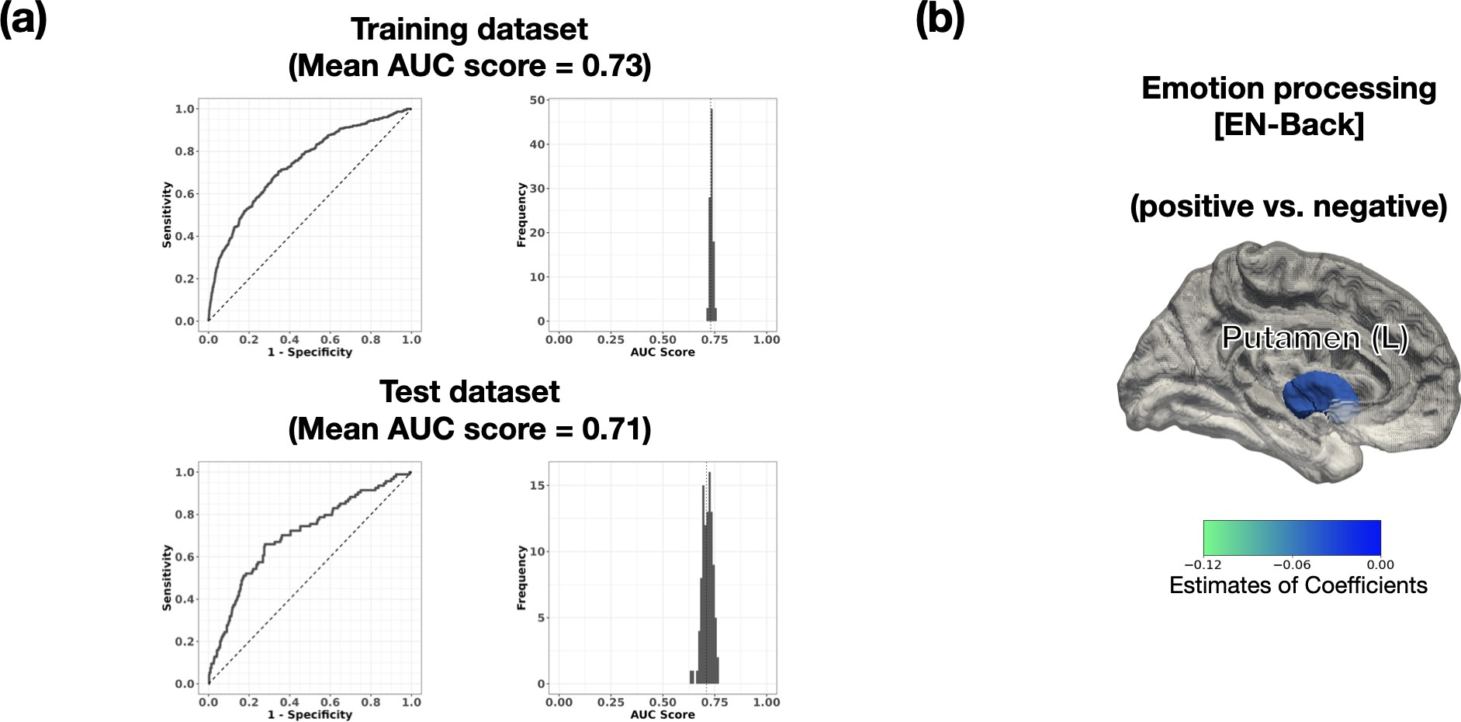

Note. (a) a representative receiver-operation curve (ROC) (left) and the distribution of the area under the curve (AUC) scores (right) for the training and test datasets. (b) Regions of Interest (ROIs) with significant coefficients during the emotional N-back task, consistently significant in LASSO and GLM

95% CI = [0.104, 0.109]), antisocial personality problems (β = 0.078, 95% CI =
[0.072, 0.084]), depressive problems (β = 0.053, 95% CI = [0.052, 0.084]), and
avoidant personality problems (β = 0.040, 95% CI = [0.031, 0.049]) showed pos-itive associations with threat. Furthermore, younger maternal age at childbirth (β = -0.077, 95% CI = [-0.089, -0.066]) and lower parental education level (β =
-0.078, 95% CI = [-0.084, -0.072]) were related to higher threat levels. The mean significant coefficients and 95% CI are presented in Table C1.

Figure 5

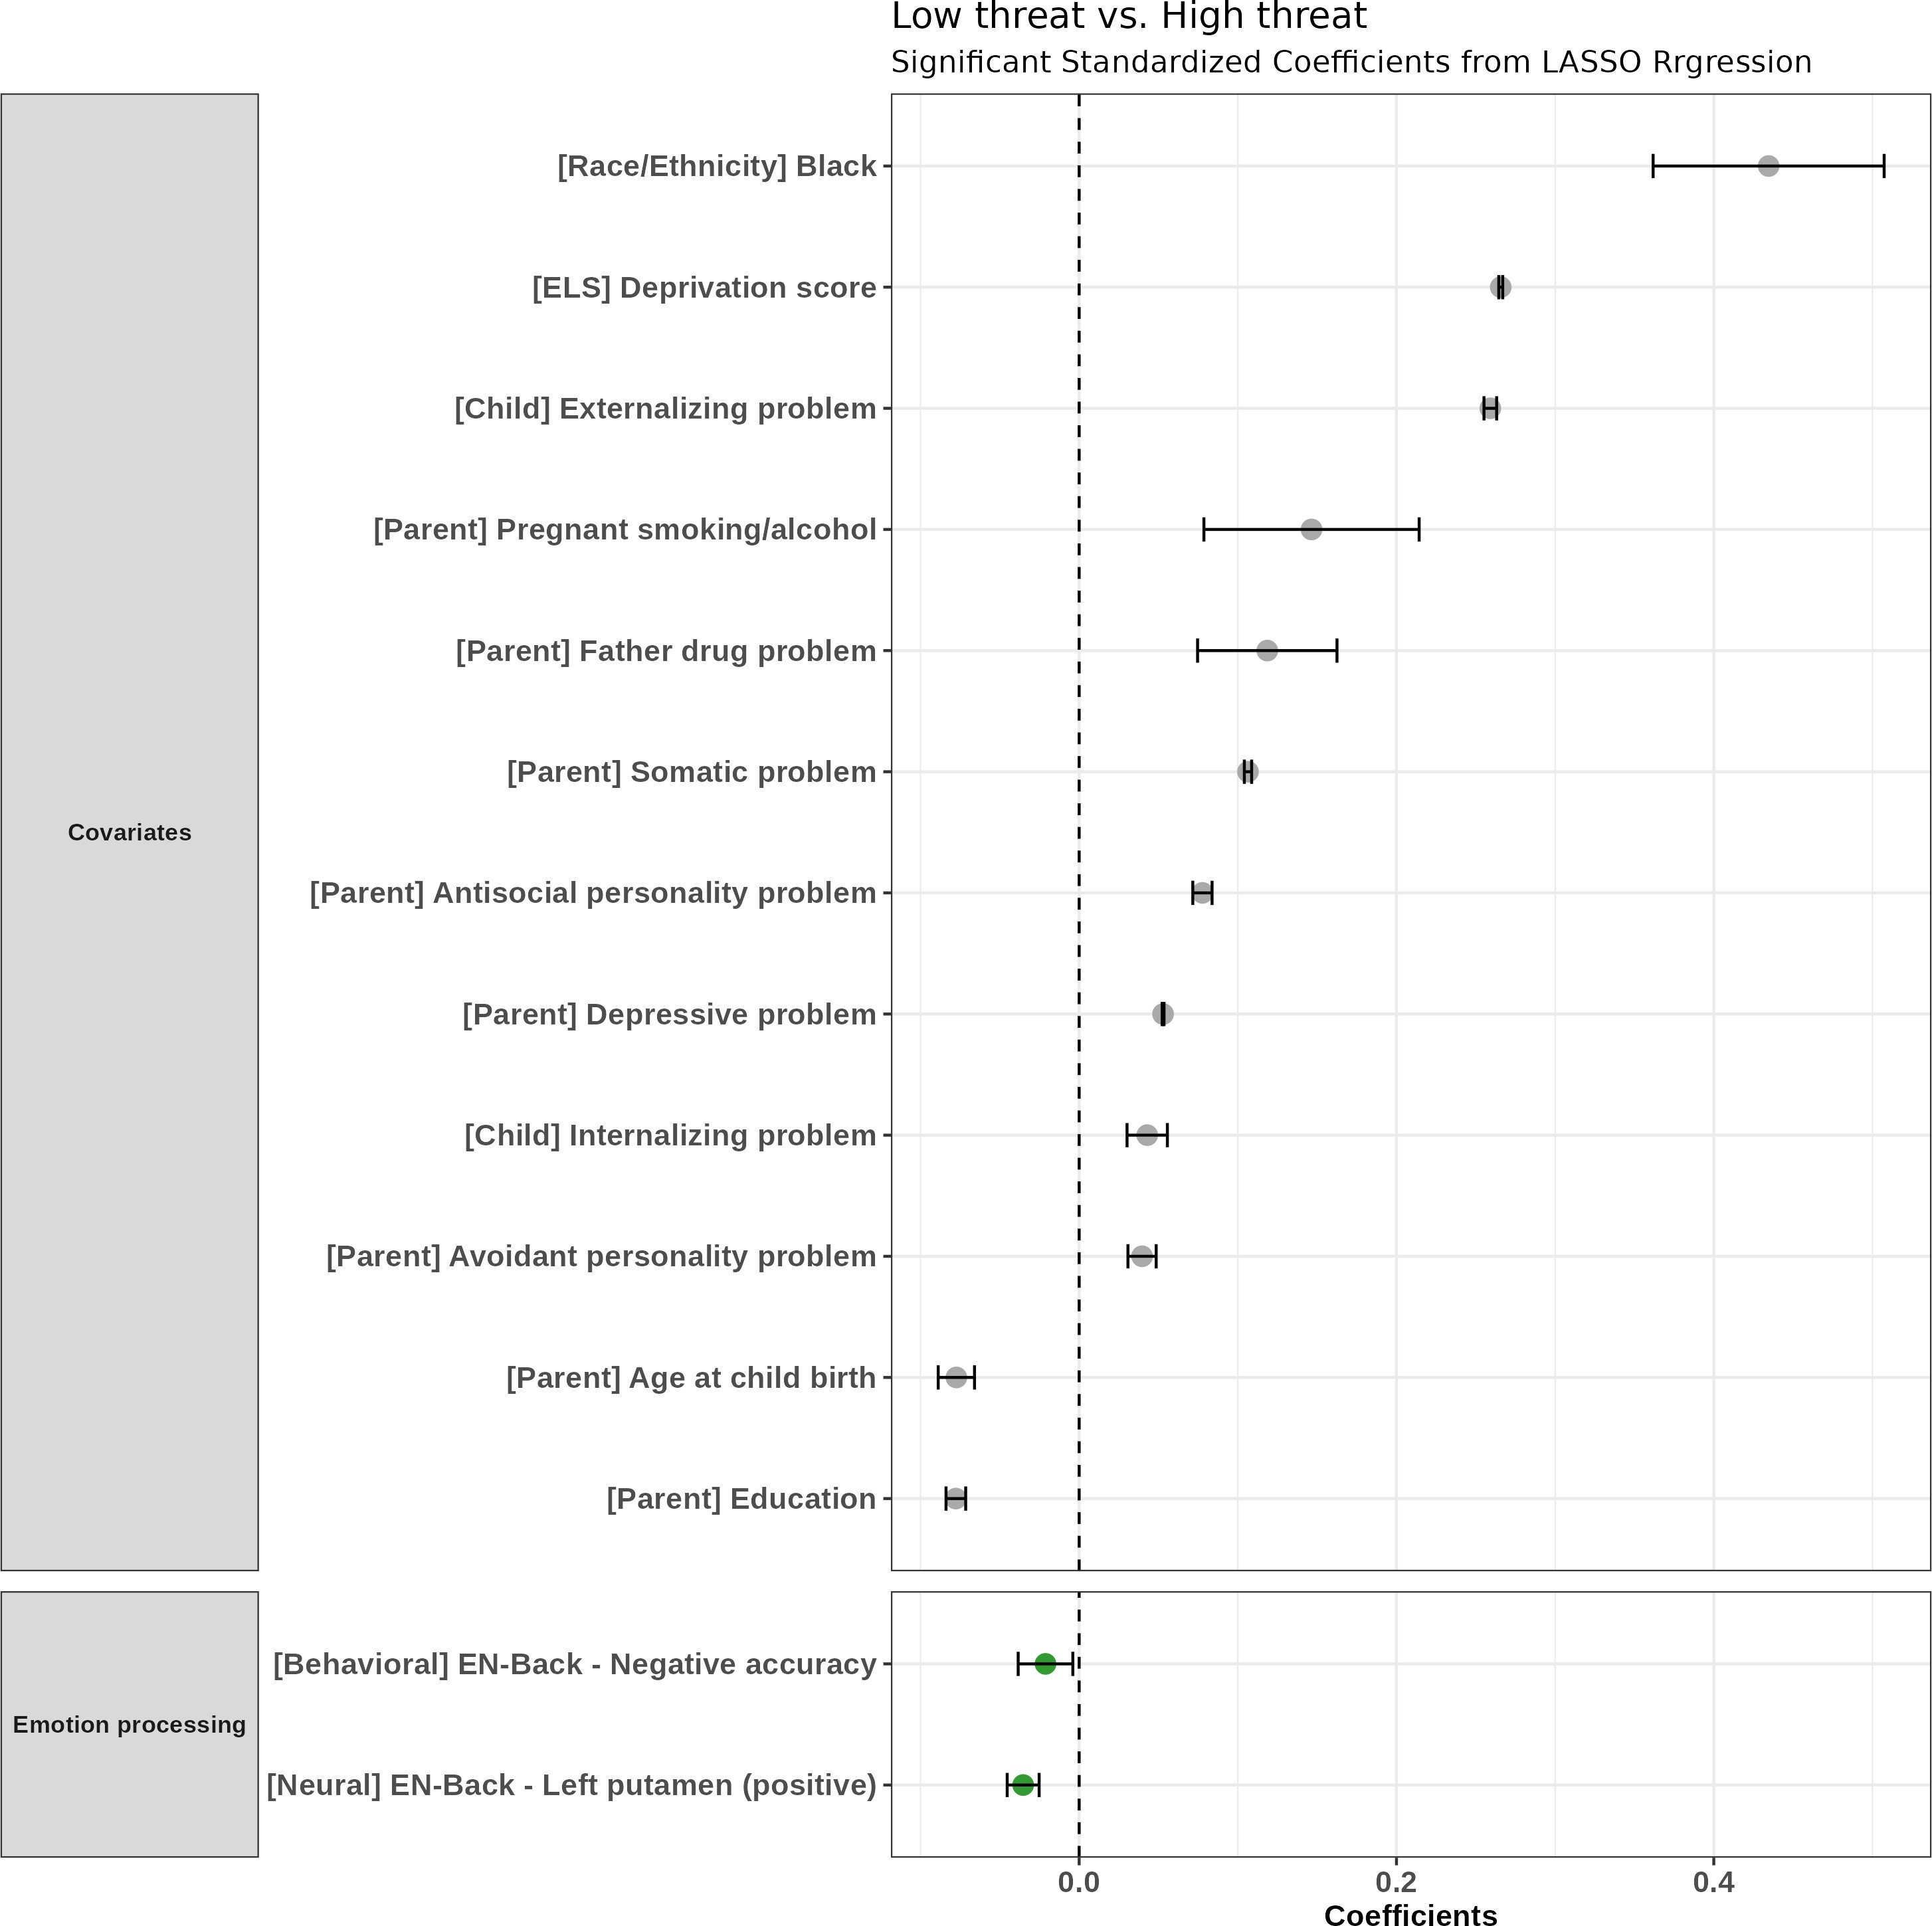
Results of the cross-sectional binomial LASSO regression (low threat vs. high threat): significant standardized coefficients

Note. Data acquisition sites were removed for clarification. The error bar represents the 95% confidence interval.
Abbreviations. LASSO, Least Absolute Shrinkage and Selection Operator; EN-Back, emotional N-Back task

Longitudinal results
Figure 6 shows the significant variables used to classify the high threat and low threat groups. Deprivation score was positively related to the high threat group (β = 0.173, 95% CI = [0.171, 0.174]). Demographic information was significantly associated with the high threat group: younger age when the child reported ELS was associated with high threat (β = -0.039, 95% CI = [-0.065,
-0.013]). Participants who identified as Black (β = 0.732, 95% CI = [0.679,
0.785]) and "Other" (β = 0.037, 95% CI = [0.004, 0.071]) were more likely to belong to the high threat group compared to White participants. High child internalizing problems (β = 0.133, 95% CI = [0.122, 0.145]) and externalizing problems (β = 0.042, 95% CI = [0.032, 0.051]) were also associated with the high threat group. Younger maternal age at childbirth (β = -0.131, 95% CI
= [-0.146, -0.116]) and lower parental education level (β = -0.095, 95% CI = [-0.109, -0.081]) were also related to high threat.
High parental psychopathology scores were also linked to the high threat group, including parent antisocial personality problems (β = 0.164, 95% CI = [0.146, 0.181]), parent depressive problems (β = 0.106, 95% CI = [0.103, 0.109]),
parent avoidant personality problems (β = 0.079, 95% CI = [0.074, 0.084]), and
parent AD/H problems (β = 0.035, 95% CI = [0.032, 0.038]).
Figure 7a presents a ROC curve and mean AUC for classifying high threat and low threat groups: 0.75 for the training set and 0.68 for the test set.
Unlike the cross-sectional results, threat was related to all four neurocognitive functions longitudinally. Regarding reward processing, hyperactivation in the right insula (β = 0.035, 95% CI = [0.032, 0.038]) and left cACC (β = 0.035,

Figure 6

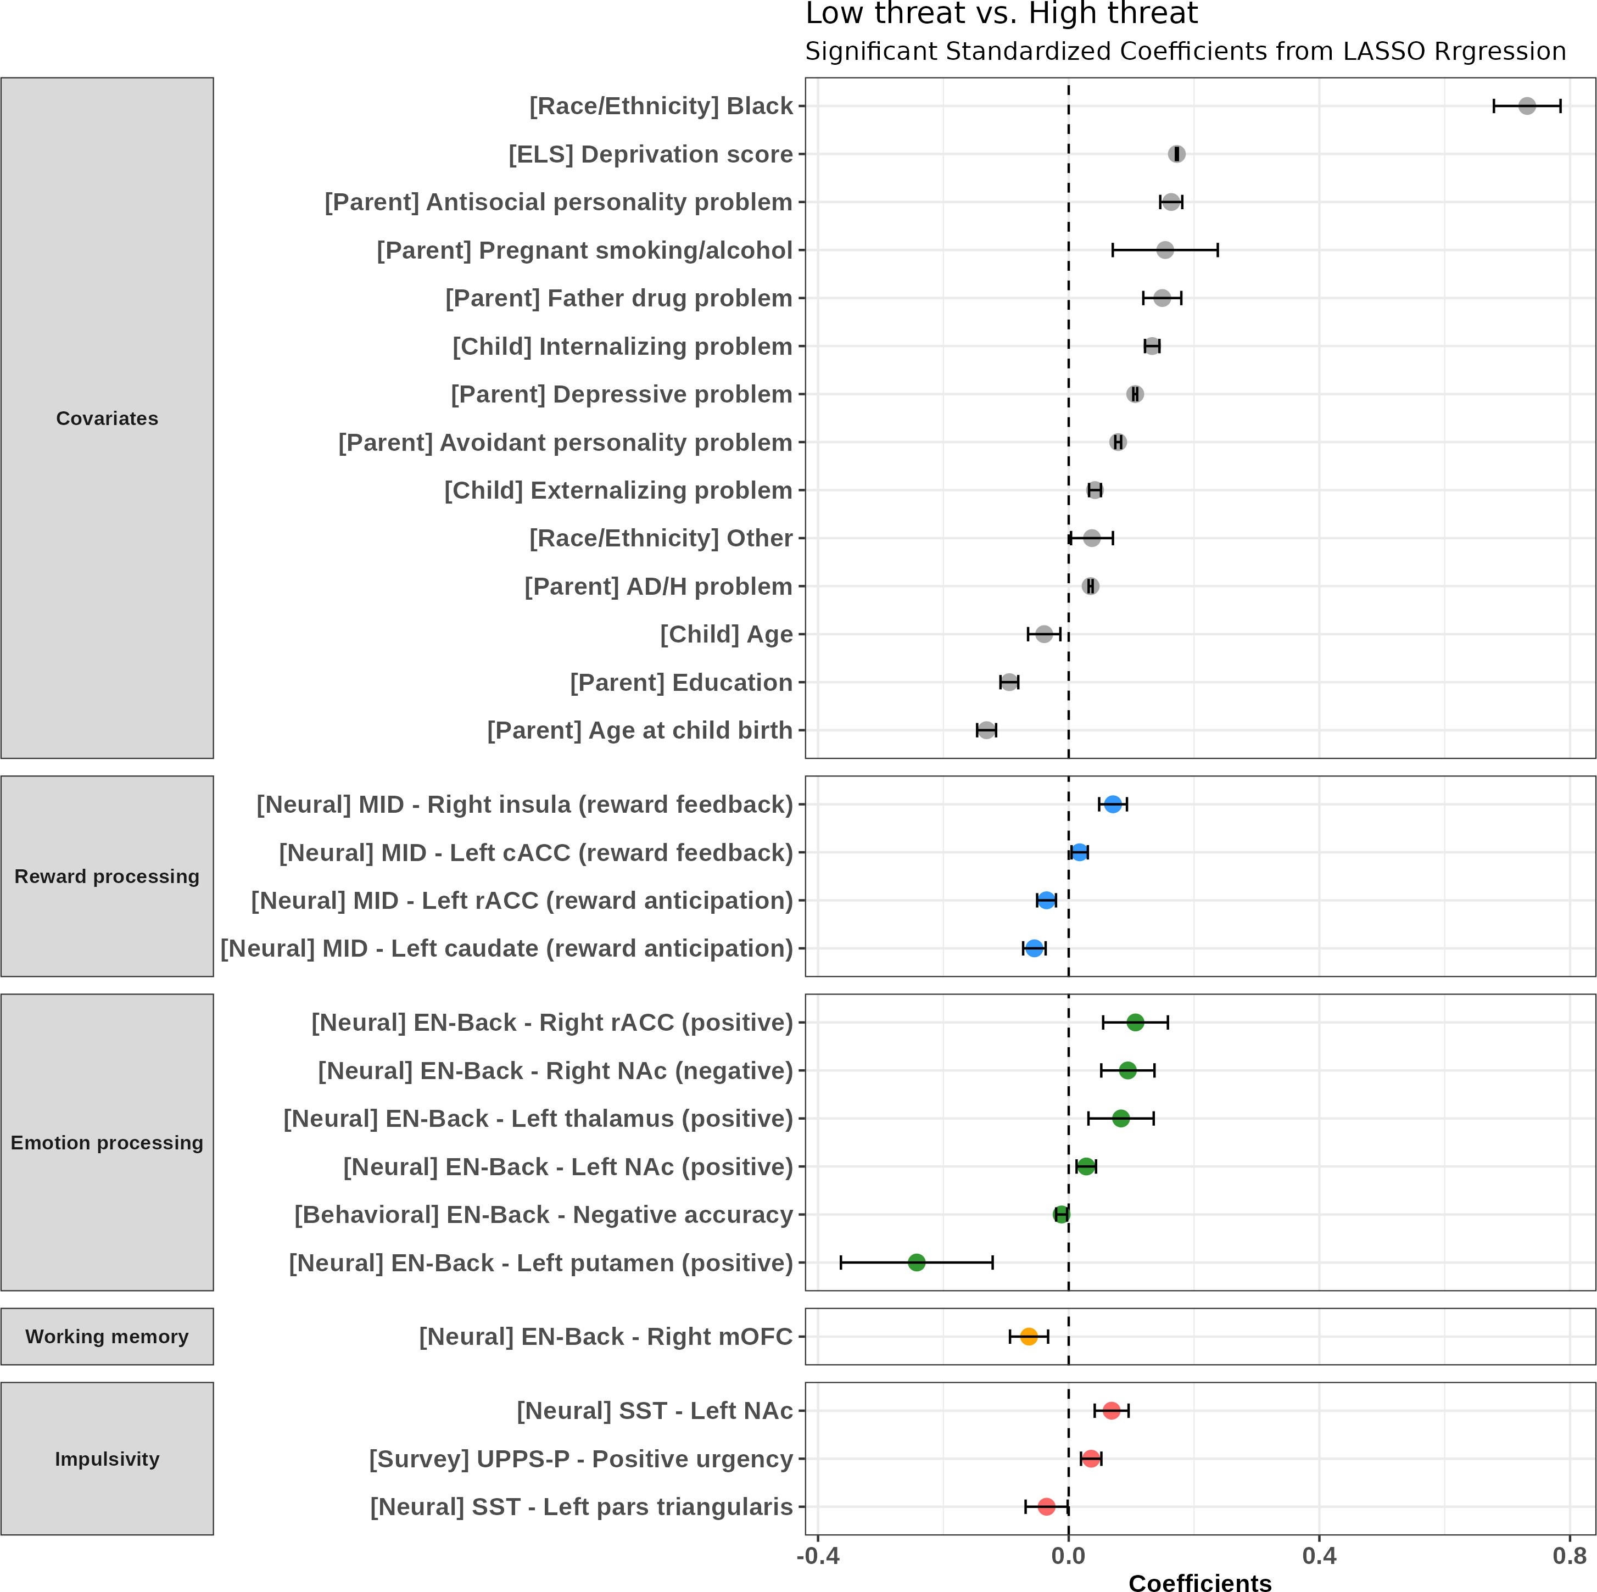
Results of the longitudinal binomial LASSO regression (low threat vs. high threat): significant standardized coefficients

Note. Data acquisition sites were removed for clarification. The error bar represents the 95% confidence interval.
Abbreviations. LASSO, Least Absolute Shrinkage and Selection Operator; MID, Mone-tary Incentive Delay task; EN-Back, emotional N-Back task; SST, Stop Signal Task; cACC, caudal anterior cingulate cortex; rACC, rostral anterior cingulate cortex; NAc, nucleus accumbens; mOFC, medial orbitofrontal cortex

95% CI = [0.032, 0.038]) during reward feedback was related to the high threat group, while reduced activation in left ACC (β = -0.035, 95% CI = [-0.045,
-0.025]) and left caudate (β = -0.035, 95% CI = [-0.045, -0.025]) during reward anticipation were associated with threat. The brain regions consistently related to threat in GLM and LASSO results are presented in Figure 7b.
For emotion processing, consistent with cross-sectional results, deactivation in the left putamen to positive faces was related to the high threat group (β
= -0.242, 95% CI = [-0.364, -0.121]). Hyperactivation in the right rACC (β = 0.107, 95% CI = [0.055, 0.158]), left thalamus (β = 0.084, 95% CI = [0.032,
0.136]), and left NAc (β = 0.028, 95% CI = [0.013, 0.044]) to positive faces were associated with the high threat group. For negative faces, increased activation in the right NAc (β = 0.094, 95% CI = [0.052, 0.137]) and lower accuracy (β =
-0.011, 95% CI = [-0.020, -0.003]) were related to the high threat group. The brain regions consistently related to threat in GLM and LASSO results are presented in Figure 7c.
For working memory, deactivation in the mOFC, which is part of the DMN, was related to the high threat group (β = -0.063, 95% CI = [-0.094, -0.033]). However, this result was not significant in the previous GLM analysis.
Regarding impulsivity, increased left NAc activation (β = 0.069, 95% CI
= [0.041, 0.096]) was associated with the high threat group, consistent with previous GLM analysis (Figure 7d). LASSO results exclusively revealed decreased activation in the pars triangularis of the IFG (β = -0.035, 95% CI = [-0.069,
-0.002]) during response inhibition. Additionally, a positive association was found between the UPPS-P positive urgency subscale and high threat (β = 0.036, 95%

CI = [0.020, 0.052]).
Summary of findings The cross-sectional analysis revealed that high threat was associated with reduced striatal activation (left putamen) to positive faces and lower accuracy for negative faces. In the longitudinal analysis, significant differences between high-threat and low-threat groups emerged in brain acti-vation related to reward processing, emotion processing, working memory, and impulsivity.

Figure 7

Results of the longitudinal binomial LASSO regression (low threat vs. high threat)
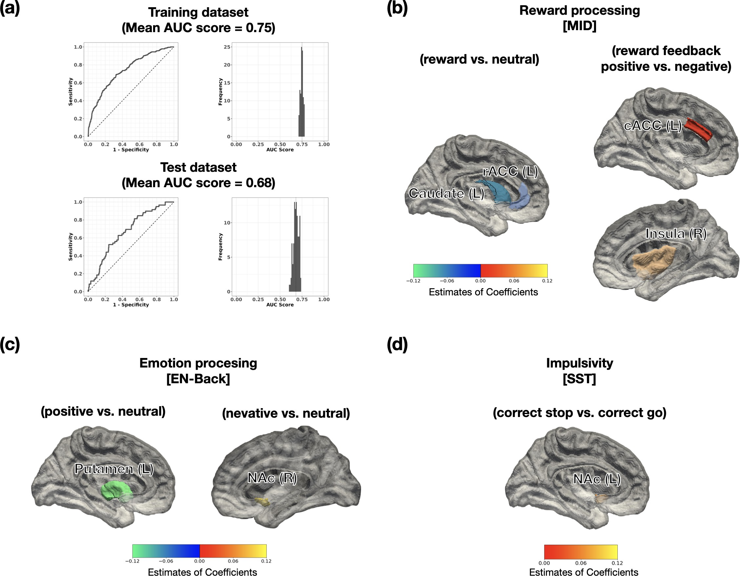
Note. (a) a representative receiver-operation curve (ROC) (left) and the distribution of the area under the curve (AUC) scores (right) for the training and test datasets. (b) Regions of Interest (ROIs) with significant coefficients during the Monatery Incentive Delay task, consistently significant in LASSO and GLM (c) Regions of Interest (ROIs) with significant coefficients during the emotional N-back task, consistently significant in LASSO and GLM (d) Regions of Interest (ROIs) with significant coefficients during the Stop Signal Task, consistently significant in LASSO and GLM

Deprivation

Cross-sectional results Deprivation was related to more variables than threat (Figure 8). The threat score was positively related to the high deprivation group (β = 0.268, 95% CI = [0.266, 0.270]). Father drug problem (β = 0.908,
95% CI = [0.895, 0.921]), mother drug problem (β = 0.085, 95% CI = [0.074,
0.097]), and pregnant smoking/alcohol use (β = 0.127, 95% CI = [0.116, 0.138]) were positively associated with high deprivation. Race/ethnicity was associated with high deprivation: Black (β = 0.796, 95% CI = [0.774, 0.818]), Hispanic
(β = 0.178, 95% CI = [0.149, 0.208]), Other (β = 0.177, 95% CI = [0.142,
0.211]). Also, child externalizing behavior problems (β = 0.080, 95% CI = [0.078, 0.082]) and parental psychopathologies were related to high deprivation (anxiety problem: β = 0.098, 95% CI = [0.096, 0.101]; antisocial personality problem:
β = 0.051, 95% CI = [0.051, 0.051]; depressive problem: β = 0.034, 95% CI =
[0.031, 0.037]; somatic problem: β = 0.022, 95% CI = [0.021, 0.022]).
Conversely, lower parental education level was related to high deprivation (β
= -0.473, 95% CI = [-0.473, -0.473]). Child age (β = -0.031, 95% CI = [-0.039,
-0.022]) and maternal age at childbirth (β = -0.234, 95% CI = [-0.238, -0.231]) were negatively related to high deprivation. Also, children who had cyanosis (blue at birth) were more likely to be classified in the low deprivation group (β
= -0.200, 95% CI = [-0.262, -0.231]).
Figure 9a presents a ROC curve and mean AUC for classifying high depriva-tion and low deprivation groups. The mean AUC scores were 0.87, 0.84 for the training set and test set, respectively.

Figure 8

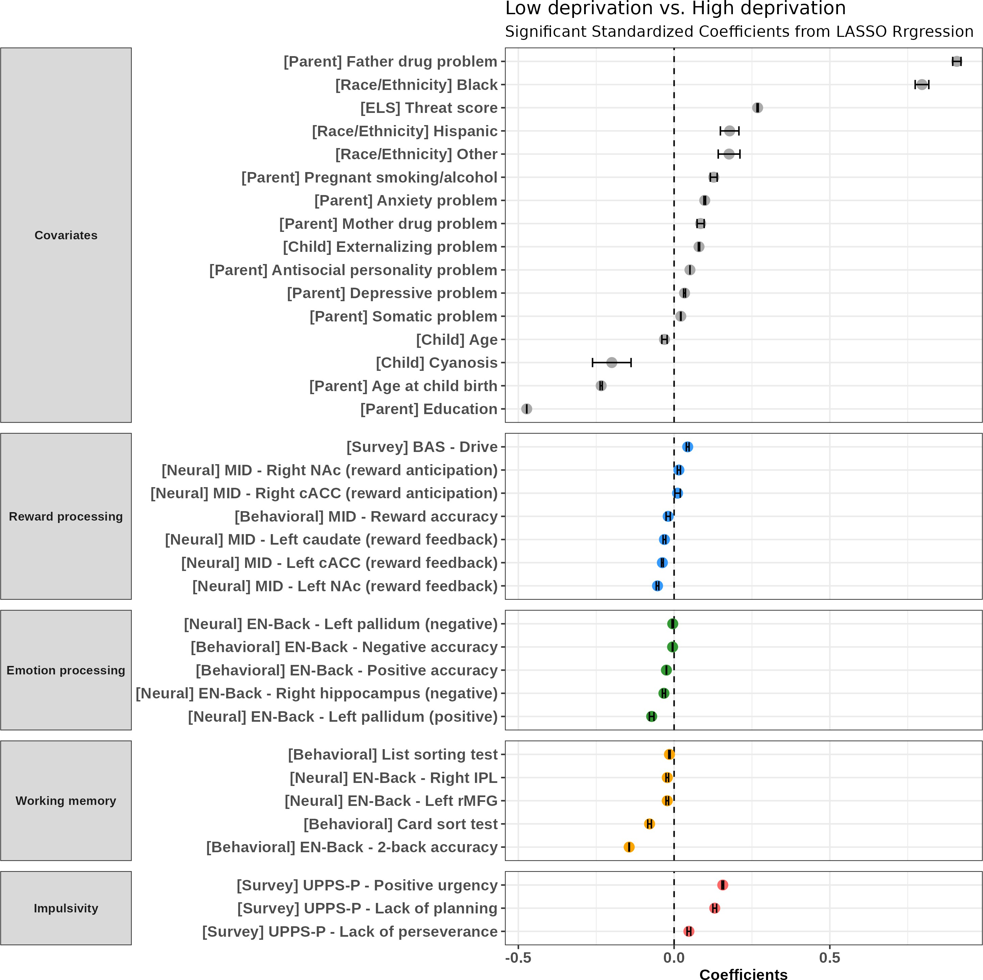
Results of the cross-sectional binomial LASSO regression (low deprivation vs. high deprivation): significant standardized coefficients

Note. Data acquisition sites were removed for clarification. The error bar represents the 95% confidence interval.
Abbreviations. LASSO, Least Absolute Shrinkage and Selection Operator; BAS, Be-havioral Activation System; MID, Monetary Incentive Delay task; EN-Back, emotional N-Back task; SST, Stop Signal Task; UPPS-P, Urgency-Premeditation-Perseverance-Sensation Seeking-Positive Urgency; NAc, nucleus accumbens; cACC, caudal anterior cingulate cortex; rACC, rostral anterior cingulate cortex; IPL, inferior parietal lobule; rMFG, rostral middle frontal gyrus

For the behavioral measures of reward processing, higher BAS Drive subscale was associated with high deprivation (β = 0.044, 95% CI = [0.039, 0.048]). Lower accuracy in reward trials in the MID task was related to high deprivation (β = -0.019, 95% CI = [-0.026, -0.012]). During reward anticipation, increased activation in the right NAc of the ventral striatum (β = 0.015, 95% CI = [0.010, 0.020]) and cACC (β = 0.011, 95% CI = [0.002, 0.020]) were associated with high deprivation. During reward feedback, deactivation in striatum (left NAc: β
= -0.053, 95% CI = [-0.057, -0.049]; left caudate: β = -0.031, 95% CI = [-0.035,
-0.027]), and left cACC (β = -0.038, 95% CI = [-0.040, -0.035]) was related to high deprivation. The brain regions consistently related to threat in GLM and LASSO results are presented in Figure 9b.
Regarding emotion processing, lower accuracy to positive (β = -0.025, 95% CI = [-0.025, -0.024]) and negative (β = -0.005, 95% CI = [-0.006, -0.004]) faces
were related to high deprivation. Deactivation in the left pallidum to positive faces was related to high deprivation (β = -0.004, 95% CI = [-0.007, -0.002]). For negative faces, deactivation in the left pallidum (β = -0.072, 95% CI = [-0.079, -0.065]), and right hippocampus (β = -0.033, 95% CI = [-0.038, -0.028])
were associated with high deprivation. The brain regions consistently related to deprivation in GLM and LASSO results are presented in Figure 9c.
For working memory, poor behavioral working memory performance was related to high deprivation (list sorting test: β = -0.015, 95% CI = [-0.017,
-0.013]; card sort test: β = -0.079, 95% CI = [-0.085, -0.073]; 2-back accuracy: β
= -0.144, 95% CI = [-0.145, -0.143]). For neural measures, deactivation in the
left rMFG (β = -0.022, 95% CI = [-0.026, -0.018]) and right IPL (β = -0.022,

Figure 9

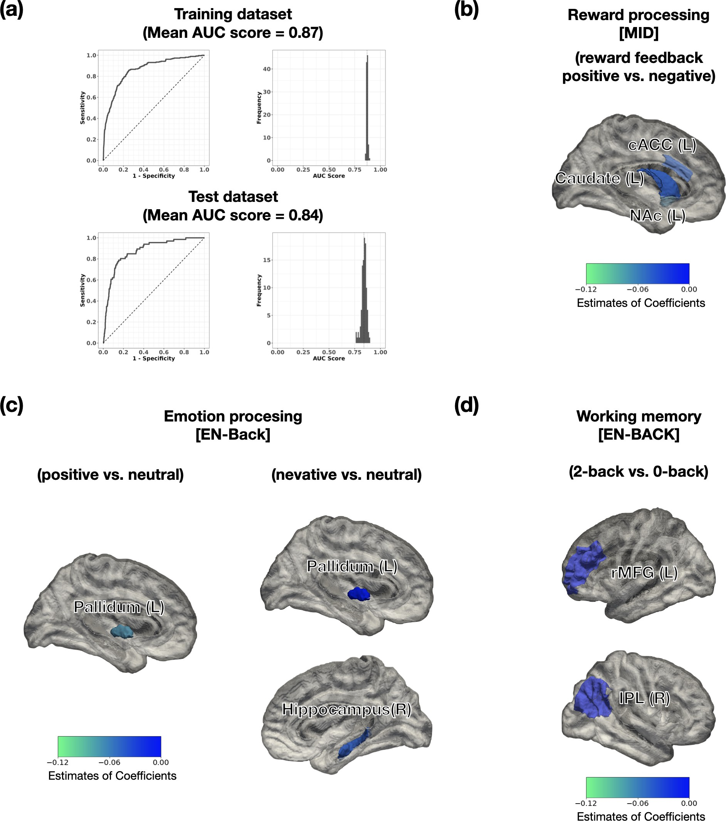
Results of the cross-sectional binomial LASSO regression (low deprivation vs. high deprivation)
Note. (a) a representative receiver-operation curve (ROC) (left) and the distribution of the area under the curve (AUC) scores (right) for the training and test datasets. (b) Regions of Interest (ROIs) with significant coefficients during the Monatery Incentive Delay task, consistently significant in LASSO and GLM (c) Regions of Interest (ROIs) associated with emotion processing during the emotional N-back task, consistently significant in LASSO and GLM. (d) Regions of Interest (ROIs) associated with working memory during the emotional N-back task, consistently significant in LASSO and GLM

95% CI = [-0.026, -0.018]), which are part of CEN, were associated with high deprivation (Figure 9d), consistent with previous GLM analysis.
In impulsivity, only trait impulsivity was significantly associated with high deprivation: high positive urgency (β = 0.156, 95% CI = [0.154, 0.159]), high lack of planning (β = 0.130, 95% CI = [0.124, 0.136]), high lack of perseverance (β = 0.048, 95% CI = [0.042, 0.053]).

Longitudinal results
Figure 10 shows the results from the longitudinal analysis to find multivari-ate patterns related to the high/low deprivation group. The threat score was positively related to the deprivation group (β = 0.150, 95% CI = [0.142, 0.158]). Race/ethnicity was related to the high deprivation group: Black (β = 0.927, 95% CI = [0.918, 0.937]), Other (β = 0.351, 95% CI = [0.338, 0.364]). Father drug
problem (β = 0.973, 95% CI = [0.958, 0.988]) and pregnant smoking/alcohol use (β = 0.351, 95% CI = [0.338, 0.364]) were positively associated with high deprivation. Also, higher child externalizing behavior problems (β = 0.128, 95% CI = [0.118, 0.137]) and parental psychopathologies were related to high deprivation: antisocial personality problem (β = 0.072, 95% CI = [0.067, 0.077]), somatic problem (β = 0.071, 95% CI = [0.068, 0.073]), anxiety problem (β = 0.009, 95% CI = [0.002, 0.017]), depressive problem (β = 0.008, 95% CI = [0.005,
0.011]).
Conversely, lower parental education level was related to high deprivation (β
= -0.412, 95% CI = [-0.416, -0.409]). Younger child age (β = -0.061, 95% CI =
[-0.080, -0.041]) and maternal age at childbirth (β = -0.234, 95% CI = [-0.244,
-0.255]) were related to high deprivation.

Figure 10

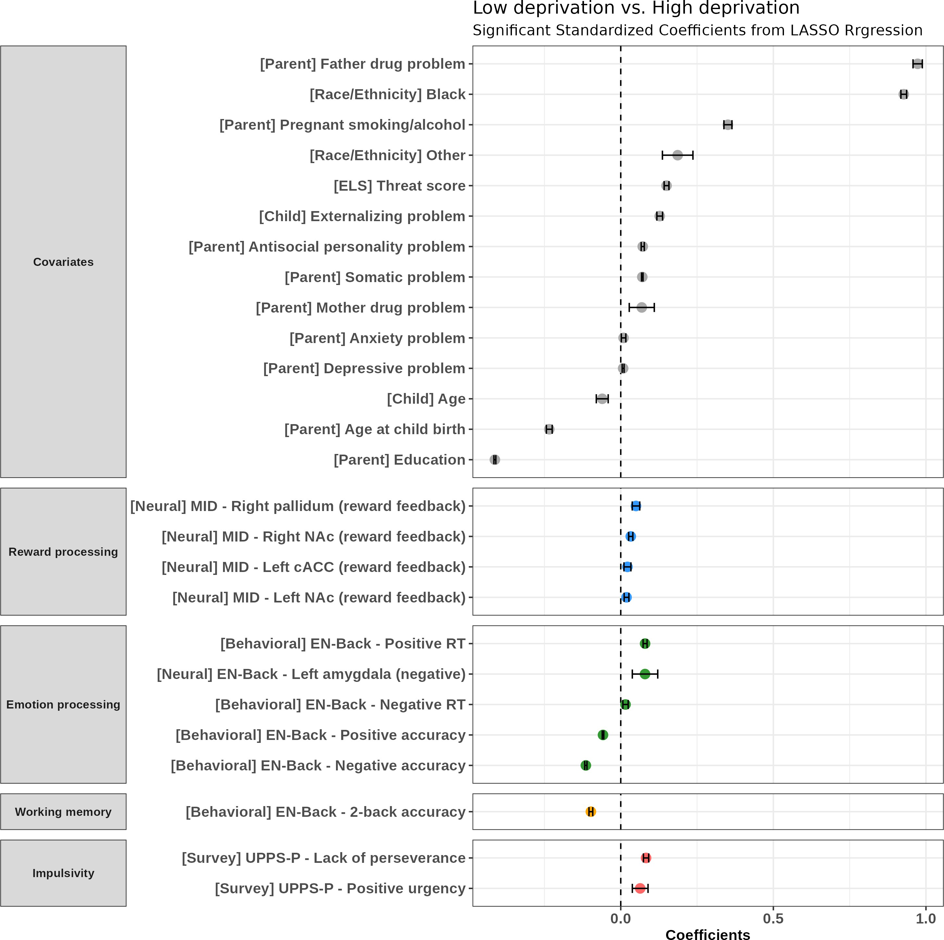
Results of the longitudinal binomial LASSO regression (low deprivation vs. high deprivation): significant standardized coefficients

Note. Data acquisition sites were removed for clarification. The error bar represents the 95% confidence interval.
Abbreviations. LASSO, Least Absolute Shrinkage and Selection Operator; BAS, Be-havioral Activation System; MID, Monetary Incentive Delay task; EN-Back, emotional N-Back task; UPPS-P, Urgency-Premeditation-Perseverance-Sensation Seeking-Positive Urgency; RT, Reaction Time; NAc, nucleus accumbens; cACC, caudal anterior cingulate cortex

Reversing the findings from the cross-sectional analysis, increased brain activation during reward feedback was observed. Hyperactivation in the right pallidum (β = 0.050, 95% CI = [0.038, 0.062]), bilateral NAc (left: β = 0.019,
95% CI = [0.011, 0.027]; right: β = 0.033, 95% CI = [0.026, 0.040]), and
left cACC (β = 0.022, 95% CI = [0.011, 0.033]) were associated with the high deprivation group in the reward feedback positive vs. negative contrast. However, brain activation during reward anticipation and behavioral measures show no significant association with deprivation in the longitudinal analysis.
For emotion processing, hyperactivation in the amygdala to negative stimuli was associated with high deprivation (β = 0.080, 95% CI = [0.073, 0.086]), consistent with the hypothesis. Slower RT to positive (β = 0.080, 95% CI = [0.073, 0.086]) and negative (β = 0.016, 95% CI = [0.007, 0.024]) faces, and lower accuracy to positive (β = -0.058, 95% CI = [-0.061, -0.056]) and negative faces (β = -0.114, 95% CI = [-0.118, -0.111]) were also significantly related to high deprivation.
Regarding working memory, lower 2-back accuracy was consistently associ-ated with high deprivation (β = -0.098, 95% CI = [-0.104, -0.092]), while no significant association in brain activation.
For impulsivity, no significant associations regarding brain activation. How-ever, consistent with the cross-sectional analysis, high trait impulsivity was related to high deprivation: UPPS-P lack of perseverance (β = 0.083, 95% CI = [0.074, 0.092]), positive urgency (β = 0.064, 95% CI = [0.038, 0.089]).
Figure 11a presents a ROC curve and mean AUC for classifying high depri-vation and low deprivation groups with longitudinal neurocognitive functions.

Figure 11

Results of the longitudinal binomial LASSO regression (low deprivation vs. high deprivation)
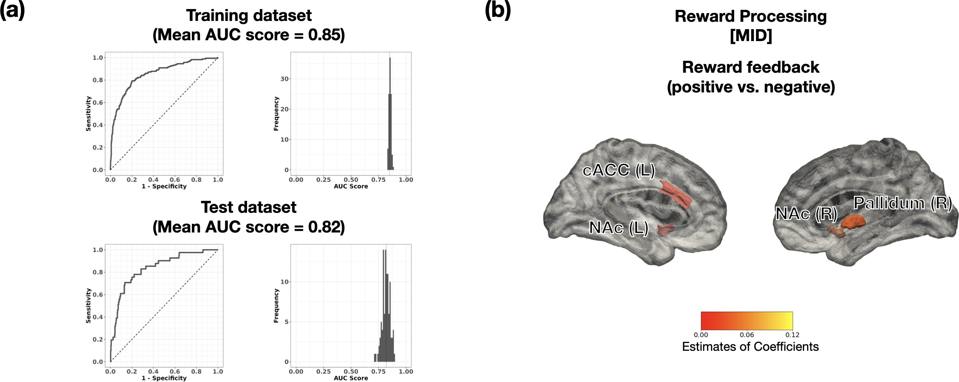
Note. (a) a representative receiver-operation curve (ROC) (left) and the distribution of the area under the curve (AUC) scores (right) for the training and test datasets. (b) Regions of Interest (ROIs) with significant coefficients during the Monatery Incentive Delay task, consistently significant in LASSO and GLM

The mean AUC scores for the training set was 0.85, and 0.82 for the test set. Figure 11b shows the brain activation consistent with previous GLM results.
Summary of findings Cross-sectionally, reduced brain activation in reward
processing, emotion processing, and working memory were significantly related to high deprivation, after controlling for covariates and the level of threat. However, longitudinally, hyperactivation in brain regions related to reward processing and emotion processing was associated with high deprivation.

Additional analysis results
In the main analyses, participants were categorized into low and high threat or deprivation groups based on approximately the 10th percentile (13% for threat and 9.2% for deprivation). While this approach facilitated group-based comparisons, the threshold was somewhat arbitrary. To address this limitation, additional analyses were conducted treating threat and deprivation as continuous variables. Generalized linear regression (GLM) was used for this purpose, as it allows for the direct analysis of continuous variables. The results showed generally consistent patterns with the binary classification analyses, although some differences were observed in the specific brain regions associated with threat and deprivation. For example, continuous threat scores were positively associated with striatal and insula activation during reward feedback, consistent with the binary results. Similarly, continuous deprivation scores revealed signifi-cant positive relationships with self-reported impulsivity, although the specific subcategories showed some variability. Detailed summaries of the continuous threat and deprivation results, along with significant coefficients, are provided in Appendix D.

Discussion
This study aimed to resolve prior inconsistencies in research on early life stress (ELS) and neurocognitive functions by investigating the distinct impacts of threat and deprivation within a large-scale dataset. Using both cross-sectional and longitudinal analyses, this study provided a nuanced understanding of how these ELS dimensions influence reward processing, emotion processing, working memory, and impulsivity.
Generalized linear model (GLM) analyses were performed to explore the effects of threat and deprivation while controlling for demographic and covariate factors. In addition, binomial LASSO regression was employed to identify multi-variate patterns uniquely related to each ELS dimension. These complementary methods enabled a robust interpretation, with a focus on results significant in both approaches.
The findings revealed distinct patterns of impact, highlighting the importance of considering threat and deprivation as separate dimensions in future research and intervention strategies.

Distinct neurocognitive effects of threat and deprivation

Reward processing

This study hypothesized that threat and deprivation, particularly depri-vation, would be associated with reduced striatal activation during reward anticipation. Longitudinal analyses partially supported this hypothesis, as threat was associated with reduced activation in the left caudate and rACC. However,

deprivation did not show significant effects during reward anticipation in either analysis, diverging from some previous reports (Hanson et al., 2015; Mehta et al., 2010; Novick et al., 2018). These discrepancies may stem from differences in participant age. While this study focused on younger participants aged 9–12 years, previous studies predominantly included older samples (over 11 years), as noted in Table 1.
Regarding reward feedback phase, both threat and deprivation were associ-ated with longitudinal hyperactivation in ACC and striatal regions, although the specific regions differed. This is consistent with previous findings reporting hyperactivation in the striatum (Boecker et al., 2014) and the ACC under specific genetic influences (Boecker-Schlier et al., 2016). Cross-sectionally, only deprivation was related to reduced activation in the striatum, including NAc. These results suggest that the inconsistent findings in reward feedback from previous studies might stem from variability in participant age.
Note that deprivation was associated with ventral striatum deactivation during reward feedback in cross-sectional analyses and hyperactivation in longi-tudinal analyses. This can reflect neural adaptations to reward scarcity. Initial deactivation may indicate a blunted reward response due to limited exposure to rewarding stimuli. Over time, deprivation heightens sensitivity to rare rewards as an adaptive response to prolonged stress and reward scarcity.
For accuracy and reaction time, no significant effects were observed for either threat or deprivation. This aligns with previous studies that reported no significant behavioral differences related to threat (Dennison et al., 2019) and deprivation (Dennison et al., 2019; Mehta et al., 2010; Mueller et al., 2012).

Regarding self-reported reward processing (BAS subscales), no significant results were observed after FDR correction, consistent with prior studies in mixed ELS (DelDonno et al., 2019; Dragan et al., 2019; Rosenman & Rodgers, 2009). However, deprivation was cross-sectionally associated with increased BAS Drive, potentially reflecting an adaptive response to reward scarcity during childhood. Children experiencing deprivation may initially demonstrate height-ened motivation for rewards, which could diminish over time as environmental constraints persist.

Emotion processing

For positive emotional stimuli, the hypothesis that threat would be associated with hyperactivation in emotion-related regions (e.g., amygdala, striatum) was not supported. Instead, threat was linked to deactivation in the putamen across years, potentially indicating reduced emotional reactivity as an adjustment to ongoing stress. Longitudinal LASSO analysis revealed some evidence of hyperactivation in regions involved in emotional processing and regulation, including the ventral striatum, rACC, and thalamus, suggesting that the effects of threat on these regions could develop gradually over time. Deprivation, in contrast, was associated with reduced activation in the left pallidum during positive emotion processing, consistent with prior findings of ventral striatum deactivation (Goff et al., 2013; Hein et al., 2020).
For negative emotional stimuli, the hypothesis that both threat and depriva-tion would be linked to amygdala hyperactivation was only partially supported. No amygdala alteration was observed for threat, contrary to the hypothesis.This

discrepancy may stem from differences in participant age. While this study focused on children aged 9–12 years, previous studies predominantly included older samples (Table 2). Supporting this, one longitudinal study in adolescents found no significant association between threat and amygdala activation to fear-ful faces (Hein et al., 2020). Another study reported that traumatic events were unrelated to amygdala activation, whereas less intense stressors were linked to hyperactivation (Suzuki et al., 2014). These findings suggest that the amygdala’s response may depend on the intensity of stress, with severe threats potentially leading to reduced sensitivity to fear-related stimuli. Deprivation, however, was linked to delayed amygdala hyperactivation in longitudinal LASSO analysis, partially supporting the hypothesis. This delayed effect may reflect the prolonged impact of deprivation on neural responses to negative stimuli.
Beyond the amygdala, threat was linked to longitudinally increased acti-vation in the ventral striatum. While limited prior research has documented hyperactivation in striatal regions, such as the pallidum, in response to emotional stimuli (McLaughlin et al., 2015; Suzuki et al., 2014), the findings highlight the ventral striatum’s potential role in processing emotional salience under threat, warranting further investigation. For deprivation, cross-sectional analyses revealed deactivation in the left pallidum and right hippocampus, potentially reflecting an adaptive reduction in emotional reactivity to negative stimuli. This adaptation may temporarily buffer stress responses and promote resilience.
In terms of behavioral measures, only deprivation was consistently related to impaired processing of both negative and positive emotional stimuli. This may be explained by a lack of opportunities to observe emotional expressions,

leading to difficulties in processing emotions.

Working memory

Deprivation was robustly associated with poorer working memory perfor-mance across both cross-sectional and longitudinal analyses. Neural correlates, specifically reduced activation in the rMFG and IPL (CEN regions), were ob-served cross-sectionally. CEN activation is known to be crucial for successful working memory performance (Satterthwaite et al., 2013), and thus the deacti-vation observed in these regions may imply reduced working memory capacity in children exposed to deprivation. However, in the longitudinal analysis, the deactivation of neural correlates for working memory was not significant. This may indicate that the effects of deprivation on working memory are not absolute and could diminish over time.
Threat was associated with reduced mOFC activation only in the cross-sectional LASSO analysis, and this finding should be interpreted with caution as it was observed in a single analysis. Given the mOFC’s role in emotional decision-making (Bechara et al., 2000; Rolls, 2023) and the emotional stimuli in our task, this may indicate difficulties in processing emotional stimuli rather than impaired working memory performance.
These findings align with previous studies suggesting that reduced execu-tive function is specifically associated with deprivation rather than threat (D. Johnson et al., 2021; Wolf & Suntheimer, 2019). This distinction underscores the importance of considering the unique mechanisms underlying threat and deprivation when investigating their impact on working memory.

Impulsivity

The hypothesis for impulsivity proposed that threat and deprivation would be associated with increased choice impulsivity. However, choice impulsivity was not significant in this study, consistent with prior findings (Hamilton et al., 2013). Notably, while previous studies often calculated discounting rates using multiple items (Acheson et al., 2019; Hamilton et al., 2013; Oshri et al., 2018; Simmen-Janevska et al., 2015), this study measured choice impulsivity with a single item, which may account for the nonsignificant results.
The hypothesis also suggested that threat and deprivation would be linked to heightened trait impulsivity, particularly negative urgency. For trait impulsivity, deprivation was associated with increased positive urgency, lack of perseverance, and lack of planning. These findings align with studies reporting heightened positive urgency (Weiss et al., 2023), lack of perseverance (Liu, 2019), and lack of planning (Gagnon et al., 2013) in mixed ELS. This suggests that deprivation, rather than threat, may be more strongly linked to trait impulsivity. Children exposed to deprivation may encounter fewer opportunities for positive rewards, potentially leading to impulsive reactions toward positive stimuli and challenges in developing long-term planning skills.
Negative urgency, however, was not significant. Given that previous studies linking ELS to increased negative urgency were conducted on adults with mixed ELS (Gagnon et al., 2013; Hallowell et al., 2019; Shin et al., 2018), these effects may emerge later. As negative urgency reflects immediate responses to negative emotions, children accustomed to deprivation may exhibit reduced reactivity.

Further research is needed to investigate these effects in older participants, as this study’s sample consisted of children aged 9–12 years.
In terms of impulsive action, only threat was associated with neural alter-ations. Longitudinal hyperactivation in the ventral striatum (NAc) and reduced activation in the left IFG were observed. The NAc, a key region involved in reward processing and impulsivity, exhibited hyperactivation that may reflect heightened sensitivity to motivational salience or increased emotional arousal triggered by threat. This finding aligns with prior studies linking striatal hyper-activation to impaired inhibitory control (Mueller et al., 2010).
Reduced left IFG activation was observed only in the LASSO analysis, which warrants cautious interpretation. While recent studies, such as the ABCD dataset (Stinson et al., 2024), reported similar findings under mixed ELS conditions, other studies have found nonsignificant results in this region (Elton et al., 2014; Lim et al., 2015). Further research is needed to clarify the role of the left IFG in relation to ELS.
The limited neural activation observed in impulsive action, compared to reward processing and emotion processing, may be attributed to the delayed development of top-down regulatory regions relative to the bottom-up system (Casey et al., 2008). This developmental delay highlights the need for further research to better understand the trajectory of these processes.
Behavioral measures of impulsive action were largely nonsignificant, aligning with prior studies (Carrion et al., 2008; Elton et al., 2014; Hamilton et al., 2013; Hart & Rubia, 2012; Lim et al., 2015; Mezzacappa et al., 2001). Only one study reported reduced stop accuracy in threat (Mezzacappa et al., 2001),

which was partially replicated in the cross-sectional analysis. A recent ABCD study examining mixed ELS exposure consistently found reduced stop accuracy and longer SSRT at year 0 and year 2 (Stinson et al., 2024), but these effects were not observed here. This highlights potential differences in the impacts of mixed ELS compared to threat or deprivation separately.
Overall, the findings suggest that trait impulsivity is more strongly associated with deprivation, while impulsive action shows potential links to threat, war-ranting further investigation. This underscores the importance of differentiating between dimensions of ELS and impulsivity when studying their relationships.

Multivariate patterns of threat and deprivation
Multivariate analyses revealed that threat and deprivation displayed distinct associations with neurocognitive functions. Cross-sectional analyses indicated that threat was primarily linked to emotion processing, while longitudinal analyses suggested its associations extended to multiple neurocognitive domains as children developed.
In contrast, deprivation was associated with reduced brain activation in regions involved in reward processing, emotion regulation, and working memory in cross-sectional analyses. Longitudinally, some regions exhibited increased activation related to reward processing, possibly reflecting compensatory or adaptive neural responses during development.
These findings suggest that the influence of ELS may vary across developmen-tal stages, underscoring the need for further investigation into how these impacts evolve. Furthermore, neurocognitive functions and their neural correlates are

still maturing during this critical developmental period (Casey et al., 2008; S. Yang & Tseng, 2021). This indicates that the observed patterns may not solely reflect the influence of ELS but rather a combination of developmental processes and other interacting factors.
Notably, associations between ELS dimensions and neurocognitive functions were relatively small compared to the contributions of covariates like adversity before birth. This suggests that the relationship between ELS and neurocog-nitive functions may be influenced by interactions with other factors rather than being direct or isolated effects. Covariates such as prenatal adversity and parental psychopathology are particularly relevant, as they encompass both genetic and environmental influences that may shape neurocognitive outcomes. Prior research has demonstrated that early life stress can modulate the genetic influence on brain structure and cognitive function (Wang et al., 2024). Building on these findings, future studies should incorporate these factors into compre-hensive multivariate models, enabling a deeper understanding of the mechanisms underlying ELS-related outcomes.
Additionally, the observed associations of both threat and deprivation with socio-demographic variables like race/ethnicity and parental education level highlight the role of structural inequalities in shaping ELS outcomes. These findings emphasize the importance of addressing systemic disparities through early interventions.
Taken together, these results demonstrate distinct cross-sectional and lon-gitudinal patterns for threat and deprivation. This emphasizes the need for tailored approaches that account for the specific neurocognitive mechanisms

associated with each dimension of ELS. Addressing pre-ELS factors such as SES disparities and systemic inequities will be critical for reducing the prevalence and impact of ELS, ultimately supporting better developmental outcomes for at-risk populations.

Implications and limitations
This study highlights the distinct effects of threat and deprivation on neu-rocognitive functions, addressing inconsistencies in prior research. By examining multiple neurocognitive domains within a single large-scale sample, it provides a more comprehensive perspective compared to studies focusing on individual domains. The findings remained significant even after accounting for various demographic and covariate factors, including socio-demographic variables and adversity before birth. Additionally, replicating results from task-based fMRI studies within a longitudinal dataset reinforces evidence for the unique impacts of these ELS dimensions. The study underscores the value of longitudinal designs in capturing the evolving effects of ELS, providing insights into these dynamic processes.
The results suggest distinct patterns of associations for threat and deprivation, which could guide the design of tailored strategies to address each dimension of ELS. Moreover, addressing systemic disparities, such as socio-economic and educational inequalities, could help mitigate the prevalence and impact of ELS, ultimately improving developmental outcomes for at-risk populations. These findings emphasize the importance of both research and policy-level efforts in reducing the negative effects of ELS.

However, several limitations should be acknowledged. First, the prevalence of both threat and deprivation in the sample was relatively low, with half of the participants experiencing no threat or deprivation. This may limit the general-izability of the findings to broader or more diverse populations. Additionally, although the results reported in this study were statistically significant, the effect sizes were marginal, suggesting that ELS-related outcomes may be influenced by broader systemic factors or interactions with other variables. This necessitates cautious interpretation and highlights the importance of multivariate approaches in future research.
Second, while statistical controls were applied to account for mixed effects, ELS rarely occurs in isolation. The observed effects may not represent "pure" dimensions of threat and deprivation but rather the interplay of overlapping experiences. Future studies should incorporate data-driven approaches to better capture the multifaceted nature of ELS, as employed by recent studies (D. Beck et al., 2024; Jeong et al., 2024; Russell et al., 2025; Vedechkina et al., 2024).
Third, ELS was measured at a single time point in this study. As the timing of ELS exposure is known to influence its effects (Novick et al., 2018), future research should investigate how exposure at different developmental stages interacts with neurocognitive outcomes.
Finally, the relatively young age of participants in this study limits conclu-sions about long-term developmental trajectories, underscoring the need for research involving older populations and extended follow-up periods.

References
Achenbach, T. (2009). Achenbach system of empirically based assessment (aseba): Development, findings, theory, and applications. University of Vermont, Research Center of Children, Youth & Families. https://books.google.co. kr/books?id=JMsdcgAACAAJ
Acheson, A., Vincent, A. S., Cohoon, A., & Lovallo, W. R. (2019). Early Life Adversity and Increased Delay Discounting: Findings From the Family Health Patterns Project [SUD 2 more ELA]. Experimental and Clinical Psychopharmacology, 27 (2), 153–159. https://doi.org/10.1037/ pha0000241
Ahn, W.-Y., Hendricks, P., & Haines, N. (2017). Easyml: Easily Build and Evaluate Machine Learning Models. bioRxiv, 137240. https://doi.org/10. 1101/137240
Auerbach, R. P., Kim, J. C., Chango, J. M., Spiro, W. J., Cha, C., Gold, J., Esterman, M., & Nock, M. K. (2014). Adolescent nonsuicidal self-injury: Examining the role of child abuse, comorbidity, and disinhibition.
Psychiatry Research, 220 (1-2), 579–584. https://doi.org/10.1016/j.
psychres.2014.07.027
Babad, S., Zwilling, A., Carson, K. W., Fairchild, V., Razak, S., Robinson, G., & Nikulina, V. (2021). Risk-Taking Propensity and Sensation Seeking in Survivors of Adverse Childhood Experiences. Journal of Interpersonal Violence, 36 (19-20), NP10670–NP10687. https: // doi .org/10 .1177 / 0886260519876035

Barch, D. M., Albaugh, M. D., Avenevoli, S., Chang, L., Clark, D. B., Glantz,
M. D., Hudziak, J. J., Jernigan, T. L., Tapert, S. F., Yurgelun-Todd, D., Alia-Klein, N., Potter, A. S., Paulus, M. P., Prouty, D., Zucker,
R. A., & Sher, K. J. (2018). Demographic, physical and mental health
assessments in the adolescent brain and cognitive development study: Rationale and description. Developmental Cognitive Neuroscience, 32, 55–66. https://doi.org/10.1016/j.dcn.2017.10.010
Baskin-Sommers, A. R., & Foti, D. (2015). Abnormal reward functioning across substance use disorders and major depressive disorder: Considering
reward as a transdiagnostic mechanism [transdiagnistic model]. Interna-
tional Journal of Psychophysiology, 98 (2), 227–239. https://doi.org/10. 1016/j.ijpsycho.2015.01.011
Bechara, A., Damasio, H., & Damasio, A. R. (2000). Emotion, Decision Making and the Orbitofrontal Cortex. Cerebral Cortex, 10 (3), 295–307. https:
//doi.org/10.1093/cercor/10.3.295
Beck, A., Schlagenhauf, F., Wüstenberg, T., Hein, J., Kienast, T., Kahnt, T., Schmack, K., Hägele, C., Knutson, B., Heinz, A., & Wrase, J. (2009). Ventral Striatal Activation During Reward Anticipation Correlates with Impulsivity in Alcoholics. Biological Psychiatry, 66 (8), 734–742. https:
//doi.org/10.1016/j.biopsych.2009.04.035
Beck, D., Whitmore, L., MacSweeney, N., Brieant, A., Karl, V., Lange, A.-M. G. d., Westlye, L. T., Mills, K. L., & Tamnes, C. K. (2024). Dimensions of early life adversity are differentially associated with patterns of de-

layed and accelerated brain maturation. Biological Psychiatry. https:
//doi.org/10.1016/j.biopsych.2024.07.019
Bellis, M. D. D., & Hooper, S. R. (2012). Neural substrates for processing task-irrelevant emotional distracters in maltreated adolescents with depressive disorders: A pilot study. Journal of Traumatic Stress, 25 (2), 198–202. https://doi.org/10.1002/jts.21682
Birn, R. M., Roeber, B. J., & Pollak, S. D. (2017). Early childhood stress exposure, reward pathways, and adult decision making. Proceedings of the National Academy of Sciences, 114 (51), 13549–13554. https :
//doi.org/10.1073/pnas.1708791114
Boecker, R., Holz, N. E., Buchmann, A. F., Blomeyer, D., Plichta, M. M., Wolf, I., Baumeister, S., Meyer-Lindenberg, A., Banaschewski, T., Brandeis, D., & Laucht, M. (2014). Impact of Early Life Adversity on Reward Processing in Young Adults: EEG-fMRI Results from a Prospective Study over 25 Years. PLoS ONE, 9 (8), e104185. https://doi.org/10. 1371/journal.pone.0104185
Boecker-Schlier, R., Holz, N. E., Buchmann, A. F., Blomeyer, D., Plichta, M. M., Jennen-Steinmetz, C., Wolf, I., Baumeister, S., Treutlein, J., Rietschel, M., Meyer-Lindenberg, A., Banaschewski, T., Brandeis, D., & Laucht,
M. (2016). Interaction between COMT Val158Met polymorphism and childhood adversity affects reward processing in adulthood. NeuroImage, 132, 556–570. https://doi.org/10.1016/j.neuroimage.2016.02.006
Bruce, J., Fisher, P. A., Graham, A. M., Moore, W. E., Peake, S. J., & Man-nering, A. M. (2013). Patterns of brain activation in foster children and

nonmaltreated children during an inhibitory control task. Development and Psychopathology, 25 (4pt1), 931–941. https:// doi .org/10.1017/ s095457941300028x
Bücker, J., Kozicky, J., Torres, I., Kauer-Sant’anna, M., Silveira, L., Bond, D., Lam, R., & Yatham, L. (2013). The impact of childhood trauma on cognitive functioning in patients recently recovered from a first manic
episode: Data from the Systematic Treatment Optimization Program for Early Mania (STOP-EM). Journal of Affective Disorders, 148 (2-3), 424–430. https://doi.org/10.1016/j.jad.2012.11.022
Callaghan, B. L., Gee, D. G., Gabard-Durnam, L., Telzer, E. H., Humphreys,
K. L., Goff, B., Shapiro, M., Flannery, J., Lumian, D. S., Fareri, D. S., Caldera, C., & Tottenham, N. (2019). Decreased Amygdala Reactivity to Parent Cues Protects Against Anxiety Following Early Adversity: An Examination Across 3 Years. Biological Psychiatry: Cognitive Neuro-science and Neuroimaging, 4 (7), 664–671. https://doi.org/10.1016/j. bpsc.2019.02.001
Carr, C. P., Martins, C. M. S., Stingel, A. M., Lemgruber, V. B., & Juruena,
M. F. (2013). The Role of Early Life Stress in Adult Psychiatric Disorders.
The Journal of Nervous and Mental Disease, 201 (12), 1007–1020. https:
//doi.org/10.1097/nmd.0000000000000049
Carrion, V. G., Garrett, A., Menon, V., Weems, C. F., & Reiss, A. L. (2008). Posttraumatic stress symptoms and brain function during a response-inhibition task: an fMRI study in youth. Depression and Anxiety, 25 (6), 514–526. https://doi.org/10.1002/da.20346

Carver, C. S., & White, T. L. (1994). Behavioral Inhibition, Behavioral Activa-tion, and Affective Responses to Impending Reward and Punishment:
The BIS/BAS Scales. Journal of Personality and Social Psychology,
67 (2), 319–333. https://doi.org/10.1037/0022-3514.67.2.319
Casey, B., Cannonier, T., Conley, M. I., Cohen, A. O., Barch, D. M., Heitzeg,
M. M., Soules, M. E., Teslovich, T., Dellarco, D. V., Garavan, H., Orr,
C. A., Wager, T. D., Banich, M. T., Speer, N. K., Sutherland, M. T.,
Riedel, M. C., Dick, A. S., Bjork, J. M., Thomas, K. M., . . . Workgroup,
t. A. I. A. (2018). The Adolescent Brain Cognitive Development (ABCD) study: Imaging acquisition across 21 sites. Developmental Cognitive Neuroscience, 32, 43–54. https://doi.org/10.1016/j.dcn.2018.03.001
Casey, B., Jones, R. M., & Hare, T. A. (2008). The Adolescent Brain. Annals
of the New York Academy of Sciences, 1124 (1), 111–126. https://doi. org/10.1196/annals.1440.010
Chen, J. E., & Glover, G. H. (2015). Functional Magnetic Resonance Imaging Methods. Neuropsychology Review, 25 (3), 289–313. https://doi.org/10. 1007/s11065-015-9294-9
Chen, Y., & Baram, T. Z. (2016). Toward Understanding How Early-Life Stress Reprograms Cognitive and Emotional Brain Networks. Neuropsychophar-macology, 41 (1), 197–206. https://doi.org/10.1038/npp.2015.181
Cohen, A. O., Breiner, K., Steinberg, L., Bonnie, R. J., Scott, E. S., Taylor-Thompson, K., Rudolph, M. D., Chein, J., Richeson, J. A., Heller, A. S., Silverman, M. R., Dellarco, D. V., Fair, D. A., Galván, A., & Casey, B. J. (2015). When Is an Adolescent an Adult? Assessing Cognitive Control

in Emotional and Nonemotional Contexts. Psychological Science, 27 (4), 549–562. https://doi.org/10.1177/0956797615627625
Danese, A., Moffitt, T. E., Arseneault, L., Bleiberg, B. A., Dinardo, P. B., Gandelman, S. B., Houts, R., Ambler, A., Fisher, H. L., Poulton, R., & Caspi, A. (2017). The Origins of Cognitive Deficits in Victimized
Children: Implications for Neuroscientists and Clinicians. American
Journal of Psychiatry, 174 (4), 349–361. https://doi.org/10.1176/appi. ajp.2016.16030333
Dannlowski, U., Kugel, H., Huber, F., Stuhrmann, A., Redlich, R., Grotegerd, D., Dohm, K., Sehlmeyer, C., Konrad, C., Baune, B. T., Arolt, V., Heindel, W., Zwitserlood, P., & Suslow, T. (2013). Childhood maltreatment is
associated with an automatic negative emotion processing bias in the amygdala. Human Brain Mapping, 34 (11), 2899–2909. https://doi.org/ 10.1002/hbm.22112
Dannlowski, U., Stuhrmann, A., Beutelmann, V., Zwanzger, P., Lenzen, T., Grotegerd, D., Domschke, K., Hohoff, C., Ohrmann, P., Bauer, J., Lind-ner, C., Postert, C., Konrad, C., Arolt, V., Heindel, W., Suslow, T., & Kugel, H. (2012). Limbic Scars: Long-Term Consequences of Childhood Maltreatment Revealed by Functional and Structural Magnetic Reso-
nance Imaging. Biological Psychiatry, 71 (4), 286–293. https://doi.org/
10.1016/j.biopsych.2011.10.021
DelDonno, S. R., Mickey, B. J., Pruitt, P. J., Stange, J. P., Hsu, D. T., Weldon,
A. L., Zubieta, J.-K., & Langenecker, S. A. (2019). Influence of childhood adversity, approach motivation traits, and depression on individual

differences in brain activation during reward anticipation. Biological Psychology, 146, 107709. https://doi.org/10.1016/j.biopsycho.2019.05.
009
Dennison, M. J., Rosen, M. L., Sambrook, K. A., Jenness, J. L., Sheridan,
M. A., & McLaughlin, K. A. (2019). Differential Associations of Distinct Forms of Childhood Adversity With Neurobehavioral Measures of Reward Processing: A Developmental Pathway to Depression. Child Development, 90 (1), e96–e113. https://doi.org/10.1111/cdev.13011
Dennison, M. J., Sheridan, M. A., Busso, D. S., Jenness, J. L., Peverill, M., Rosen, M. L., & McLaughlin, K. A. (2016). Neurobehavioral Markers of Resilience to Depression Amongst Adolescents Exposed to Child Abuse. Journal of Abnormal Psychology, 125 (8), 1201–1212. https://doi.org/10. 1037/abn0000215
Desikan, R. S., Ségonne, F., Fischl, B., Quinn, B. T., Dickerson, B. C., Blacker, D., Buckner, R. L., Dale, A. M., Maguire, R. P., Hyman, B. T., Albert,
M. S., & Killiany, R. J. (2006). An automated labeling system for
subdividing the human cerebral cortex on MRI scans into gyral based regions of interest. NeuroImage, 31 (3), 968–980. https://doi.org/10. 1016/j.neuroimage.2006.01.021
Dillon, D. G., Holmes, A. J., Birk, J. L., Brooks, N., Lyons-Ruth, K., & Pizzagalli,
D. A. (2009). Childhood Adversity Is Associated with Left Basal Ganglia Dysfunction During Reward Anticipation in Adulthood. Biological Psy-chiatry, 66 (3), 206–213. https://doi.org/10.1016/j.biopsych.2009.02.019

Dragan, W. Ł., Jednoróg, K., & Marchewka, A. (2019). Sex-Specific Relationship of Childhood Adversity With Gray Matter Volume and Temperament.
Frontiers in Behavioral Neuroscience, 13, 71. https://doi.org/10.3389/
fnbeh.2019.00071
Elton, A., Tripathi, S. P., Mletzko, T., Young, J., Cisler, J. M., James, G. A., & Kilts, C. D. (2014). Childhood maltreatment is associated with a sex-dependent functional reorganization of a brain inhibitory control network. Human Brain Mapping, 35 (4), 1654–1667. https://doi.org/10. 1002/hbm.22280
Fischl, B., Salat, D. H., Busa, E., Albert, M., Dieterich, M., Haselgrove, C., Kouwe, A. v. d., Killiany, R., Kennedy, D., Klaveness, S., Montillo, A., Makris, N., Rosen, B., & Dale, A. M. (2002). Whole Brain Segmentation Automated Labeling of Neuroanatomical Structures in the Human Brain. Neuron, 33 (3), 341–355. https://doi.org/10.1016/s0896-6273(02)00569-x
Fonzo, G. A., Huemer, J., & Etkin, A. (2016). History of childhood maltreatment augments dorsolateral prefrontal processing of emotional valence in PTSD. Journal of Psychiatric Research, 74, 45–54. https://doi.org/10. 1016/j.jpsychires.2015.12.015
Forbes, E. E., & Dahl, R. E. (2012). Research Review: Altered reward function in adolescent depression: what, when and how? Journal of Child Psychology and Psychiatry, 53 (1), 3–15. https://doi.org/10.1111/j.1469-7610.2011. 02477.x
Fuge, P., Aust, S., Fan, Y., Weigand, A., Gärtner, M., Feeser, M., Bajbouj, M., & Grimm, S. (2014). Interaction of Early Life Stress and Corticotropin-

Releasing Hormone Receptor Gene: Effects on Working Memory. Biolog-ical Psychiatry, 76 (11), 888–894. https://doi.org/10.1016/j.biopsych.
2014.04.016
Gagnon, J., Daelman, S., McDuff, P., & Kocka, A. (2013). UPPS Dimensions of Impulsivity: Relationships with Cognitive Distortions and Childhood Maltreatment. Journal of Individual Differences, 34 (1), 48–55. https:
//doi.org/10.1027/1614-0001/a000099
Garavan, H., Bartsch, H., Conway, K., Decastro, A., Goldstein, R., Heeringa, S., Jernigan, T., Potter, A., Thompson, W., & Zahs, D. (2018). Recruiting the ABCD sample: Design considerations and procedures. Developmental Cognitive Neuroscience, 32, 16–22. https://doi.org/10.1016/j.dcn.2018.
04.004
Gee, D. G., Gabard-Durnam, L. J., Flannery, J., Goff, B., Humphreys, K. L., Telzer, E. H., Hare, T. A., Bookheimer, S. Y., & Tottenham, N. (2013). Early developmental emergence of human amygdala–prefrontal connec-tivity after maternal deprivation. Proceedings of the National Academy of Sciences, 110 (39), 15638–15643. https:// doi .org/10.1073/ pnas .
1307893110
Gerin, M. I., Hanson, E., Viding, E., & McCrory, E. J. (2019). A review of childhood maltreatment, latent vulnerability and the brain: implications for clinical practice and prevention. Adoption & Fostering, 43 (3), 310–
328. https://doi.org/10.1177/0308575919865356
Goff, B., Gee, D., Telzer, E., Humphreys, K., Gabard-Durnam, L., Flannery, J., & Tottenham, N. (2013). Reduced nucleus accumbens reactivity and

adolescent depression following early-life stress. Neuroscience, 249, 129–
138. https://doi.org/10.1016/j.neuroscience.2012.12.010
Goodman, J. B., Freeman, E. E., & Chalmers, K. A. (2019). The relationship between early life stress and working memory in adulthood: A systematic review and meta-analysis [working memory meta paper peer violence?!]. Memory, 27 (6), 868–880. https:// doi .org/10.1080/09658211.2018 .
1561897
Green, S. A., Goff, B., Gee, D. G., Gabard-Durnam, L., Flannery, J., Telzer, E. H., Humphreys, K. L., Louie, J., & Tottenham, N. (2016). Discrimination of amygdala response predicts future separation anxiety in youth with early deprivation. Journal of Child Psychology and Psychiatry, 57 (10), 1135–1144. https://doi.org/10.1111/jcpp.12578
Haber, S. N., & Knutson, B. (2010). The Reward Circuit: Linking Primate Anatomy and Human Imaging. Neuropsychopharmacology, 35 (1), 4–26. https://doi.org/10.1038/npp.2009.129
Hagler, D. J., Hatton, S., Cornejo, M. D., Makowski, C., Fair, D. A., Dick,
A. S., Sutherland, M. T., Casey, B., Barch, D. M., Harms, M. P., Watts,
R., Bjork, J. M., Garavan, H. P., Hilmer, L., Pung, C. J., Sicat, C. S.,
Kuperman, J., Bartsch, H., Xue, F., . . . Dale, A. M. (2019). Image processing and analysis methods for the Adolescent Brain Cognitive Development Study. NeuroImage, 202, 116091. https://doi.org/10.1016/ j.neuroimage.2019.116091
Hallowell, E. S., Oshri, A., Liebel, S. W., Liu, S., Duda, B., Clark, U. S., & Sweet,
L. H. (2019). The Mediating Role of Neural Activity on the Relationship

Between Childhood Maltreatment and Impulsivity. Child Maltreatment, 24 (4), 389–399. https://doi.org/10.1177/1077559519835975
Hamilton, K. R., Ansell, E. B., Reynolds, B., Potenza, M. N., & Sinha, R. (2013). Self-reported impulsivity, but not behavioral choice or response impulsivity, partially mediates the effect of stress on drinking behavior [alcohol use only self reported impulsivity mediates ELS and AUD (not
choice / response impulsivity)]. Stress, 16 (1), 3–15. https://doi.org/10.
3109/10253890.2012.671397
Hanson, J. L., Hariri, A. R., & Williamson, D. E. (2015). Blunted Ventral Striatum Development in Adolescence Reflects Emotional Neglect and Predicts Depressive Symptoms. Biological Psychiatry, 78 (9), 598–605. https://doi.org/10.1016/j.biopsych.2015.05.010
Harmelen, A.-L. v., Tol, M.-J. v., Demenescu, L. R., Wee, N. J. A. v. d., Veltman, D. J., Aleman, A., Buchem, M. A. v., Spinhoven, P., Penninx,
B. W. J. H., & Elzinga, B. M. (2013). Enhanced amygdala reactivity to emotional faces in adults reporting childhood emotional maltreatment.
Social Cognitive and Affective Neuroscience, 8 (4), 362–369. https://doi.
org/10.1093/scan/nss007
Harnett, N. G., Fani, N., Carter, S., Sanchez, L. D., Rowland, G. E., Davie,
W. M., Guzman, C., Lebois, L. A. M., Ely, T. D., Rooij, S. J. H. v., Seligowski, A. V., Winters, S., Grasser, L. R., Musey, P. I., Seamon,
M. J., House, S. L., Beaudoin, F. L., An, X., Zeng, D., . . . Ressler, K. J. (2023). Structural inequities contribute to racial/ethnic differences in neurophysiological tone, but not threat reactivity, after trauma exposure

[black and els]. Molecular Psychiatry, 28 (7), 2975–2984. https://doi.org/ 10.1038/s41380-023-01971-x
Hart, H., Lim, L., Mehta, M. A., Curtis, C., Xu, X., Breen, G., Simmons, A., Mirza, K., & Rubia, K. (2018). Altered Functional Connectivity of Fronto-Cingulo-Striatal Circuits during Error Monitoring in Adolescents
with a History of Childhood Abuse. Frontiers in Human Neuroscience,
12, 7. https://doi.org/10.3389/fnhum.2018.00007
Hart, H., & Rubia, K. (2012). Neuroimaging of child abuse: a critical review. Frontiers in Human Neuroscience, 6, 52. https://doi.org/10.3389/fnhum. 2012.00052
Hein, T. C., Goetschius, L. G., McLoyd, V. C., Brooks-Gunn, J., McLanahan,
S. S., Mitchell, C., Lopez-Duran, N. L., Hyde, L. W., & Monk, C. S. (2020). Childhood violence exposure and social deprivation are linked to adolescent threat and reward neural function. Social Cognitive and Affective Neuroscience, 15 (11), 1252–1259. https://doi.org/10.1093/ scan/nsaa144
Holz, N. E., Boecker-Schlier, R., Buchmann, A. F., Blomeyer, D., Jennen-Steinmetz, C., Baumeister, S., Plichta, M. M., Cattrell, A., Schumann, G., Esser, G., Schmidt, M., Buitelaar, J., Meyer-Lindenberg, A., Ba-naschewski, T., Brandeis, D., & Laucht, M. (2017). Ventral striatum and amygdala activity as convergence sites for early adversity and conduct disorder. Social Cognitive and Affective Neuroscience, 12 (2), 261–272. https://doi.org/10.1093/scan/nsw120

Jeong, H. J., Reimann, G. E., Durham, E. L., Archer, C., Stier, A. J., Moore,
T. M., Pines, J. R., Berman, M. G., & Kaczkurkin, A. N. (2024). Early life stress and functional network topology in children. Developmental Cognitive Neuroscience, 66, 101367. https://doi.org/10.1016/j.dcn.2024.
101367
Johnson, D., Policelli, J., Li, M., Dharamsi, A., Hu, Q., Sheridan, M. A., McLaughlin, K. A., & Wade, M. (2021). Associations of Early-Life Threat and Deprivation With Executive Functioning in Childhood and Adolescence. JAMA Pediatrics, 175 (11), e212511. https://doi.org/10. 1001/jamapediatrics.2021.2511
Johnson, S. L., Carver, C. S., Joormann, J., & Cuccaro, M. L. (2016). Genetic polymorphisms related to behavioral approach and behavioral inhibition scales. Personality and Individual Differences, 88, 251–255. https://doi. org/10.1016/j.paid.2015.09.024
Joyner, K. J., Bowyer, C. B., Yancey, J. R., Venables, N. C., Foell, J., Worthy,
D. A., Hajcak, G., Bartholow, B. D., & Patrick, C. J. (2018). Blunted Reward Sensitivity and Trait Disinhibition Interact to Predict Substance Use Problems. Clinical Psychological Science, 7 (5), 1109–1124. https:
//doi.org/10.1177/2167702619838480
Kim, H. H., McLaughlin, K. A., Chibnik, L. B., Koenen, K. C., & Tiemeier, H. (2022). Poverty, Cortical Structure, and Psychopathologic Characteristics in Adolescence [poverty criteria]. JAMA Network Open, 5 (11), e2244049. https://doi.org/10.1001/jamanetworkopen.2022.44049

Kim, S. T., Hwang, S. S., Kim, H. W., Hwang, E. H., Cho, J., Kang, J. I.,
& Kim, S. J. (2018). Multidimensional impulsivity as a mediator of early life stress and alcohol dependence. Scientific Reports, 8 (1), 4104. https://doi.org/10.1038/s41598-018-22474-8
Kind, A. J. H., Jencks, S., Brock, J., Yu, M., Bartels, C., Ehlenbach, W., Green-berg, C., & Smith, M. (2014). Neighborhood Socioeconomic Disadvantage
and 30-Day Rehospitalization: A Retrospective Cohort Study. Annals
of Internal Medicine, 161 (11), 765. https://doi.org/10.7326/m13-2946 Knutson, B., Adams, C. M., Fong, G. W., & Hommer, D. (2001). Anticipation
of Increasing Monetary Reward Selectively Recruits Nucleus Accumbens [MID task]. The Journal of Neuroscience, 21 (16), RC159–RC159. https:
//doi.org/10.1523/jneurosci.21-16-j0002.2001
Lambert, H. K., King, K. M., Monahan, K. C., & McLaughlin, K. A. (2017). Dif-ferential associations of threat and deprivation with emotion regulation and cognitive control in adolescence. Development and Psychopathology, 29 (3), 929–940. https://doi.org/10.1017/s0954579416000584
Lee, J., & Park, S. (2005). Working Memory Impairments in Schizophrenia: A Meta-Analysis. Journal of Abnormal Psychology, 114 (4), 599–611. https://doi.org/10.1037/0021-843x.114.4.599
Li, Y., Dong, F., Cao, F., Cui, N., Li, J., & Long, Z. (2013). Poly-victimization and executive functions in junior college students. Scandinavian Journal of Psychology, 54 (6), 485–492. https://doi.org/10.1111/sjop.12083
Lim, L., Hart, H., Mehta, M. A., Simmons, A., Mirza, K., & Rubia, K. (2015). Neural Correlates of Error Processing in Young People With a History

of Severe Childhood Abuse: An fMRI Study. American Journal of Psychiatry, 172 (9), 892–900. https://doi.org/10.1176/appi.ajp.2015.
14081042
Liu, R. T. (2019). Childhood Maltreatment and Impulsivity: A Meta-Analysis and Recommendations for Future Study [intro: impulsivity as a mediator]. Journal of Abnormal Child Psychology, 47 (2), 221–243. https://doi.org/ 10.1007/s10802-018-0445-3
Liuzzi, M. T., Harb, F., Petranu, K., Huggins, A. A., Webb, E. K., Fitzgerald,
J. M., Krukowski, J. L., Miskovich, T. A., deRoon-Cassini, T. A., & Larson, C. L. (2024). The Dichotomy of Threat and Deprivation as Sub-types of Childhood Maltreatment: Differential Functional Connectivity Patterns of Threat and Reward Circuits in an Adult Trauma Sample. Biological Psychiatry: Cognitive Neuroscience and Neuroimaging, 9 (2), 227–234. https://doi.org/10.1016/j.bpsc.2023.10.001
Logan, G. D., Cowan, W. B., & Davis, K. A. (1984). On the ability to inhibit simple and choice reaction time responses: A model and a method. Jour-nal of Experimental Psychology: Human Perception and Performance, 10 (2), 276–291. https://doi.org/10.1037//0096-1523.10.2.276
Luciana, M., Bjork, J., Nagel, B., Barch, D., Gonzalez, R., Nixon, S., & Banich, M. (2018). Adolescent neurocognitive development and impacts of substance use: Overview of the adolescent brain cognitive development (ABCD) baseline neurocognition battery. Developmental Cognitive Neuroscience, 32, 67–79. https://doi.org/10.1016/j.dcn.2018.02.006

Machlin, L., Miller, A. B., Snyder, J., McLaughlin, K. A., & Sheridan, M. A. (2019). Differential Associations of Deprivation and Threat With Cogni-
tive Control and Fear Conditioning in Early Childhood. Frontiers in Be-
havioral Neuroscience, 13, 80. https://doi.org/10.3389/fnbeh.2019.00080 MacKillop, J., Weafer, J., Gray, J. C., Oshri, A., Palmer, A., & Wit, H. d. (2016). The latent structure of impulsivity: impulsive choice, impulsive
action, and impulsive personality traits. Psychopharmacology, 233 (18), 3361–3370. https://doi.org/10.1007/s00213-016-4372-0
Maheu, F. S., Dozier, M., Guyer, A. E., Mandell, D., Peloso, E., Poeth, K.,
Jenness, J., Lau, J. Y. F., Ackerman, J. P., Pine, D. S., & Ernst, M. (2010). A preliminary study of medial temporal lobe function in youths with a history of caregiver deprivation and emotional neglect. Cognitive, Affective, & Behavioral Neuroscience, 10 (1), 34–49. https://doi.org/10. 3758/cabn.10.1.34
Majer, M., Nater, U. M., Lin, J.-M. S., Capuron, L., & Reeves, W. C. (2010). Association of childhood trauma with cognitive function in healthy adults: a pilot study. BMC Neurology, 10 (1), 61. https://doi.org/10.1186/1471-
2377-10-61
Martinussen, R., Hayden, J., Hogg-Johnson, S., & Tannock, R. (2005). A Meta-Analysis of Working Memory Impairments in Children With Attention-Deficit/Hyperactivity Disorder. Journal of the American Academy of Child & Adolescent Psychiatry, 44 (4), 377–384. https://doi.org/10.1097/ 01.chi.0000153228.72591.73

Marusak, H. A., Etkin, A., & Thomason, M. E. (2015). Disrupted insula-based neural circuit organization and conflict interference in trauma-exposed
youth. NeuroImage: Clinical, 8, 516–525. https://doi.org/10.1016/j.nicl.
2015.04.007
Marusak, H. A., Hatfield, J. R., Thomason, M. E., & Rabinak, C. A. (2017). Reduced Ventral Tegmental Area–Hippocampal Connectivity in Chil-dren and Adolescents Exposed to Early Threat. Biological Psychia-try: Cognitive Neuroscience and Neuroimaging, 2 (2), 130–137. https:
//doi.org/10.1016/j.bpsc.2016.11.002
McCrory, E. J., Brito, S. A. D., Kelly, P. A., Bird, G., Sebastian, C. L., Mechelli, A., Samuel, S., & Viding, E. (2013). Amygdala activation in maltreated children during pre-attentive emotional processing. British Journal of Psychiatry, 202 (4), 269–276. https://doi.org/10.1192/bjp.bp.112.116624 McCrory, E. J., Brito, S. A. D., Sebastian, C. L., Mechelli, A., Bird, G., Kelly,
P. A., & Viding, E. (2011). Heightened neural reactivity to threat in child victims of family violence. Current Biology, 21 (23), R947–R948. https://doi.org/10.1016/j.cub.2011.10.015
McCrory, E. J., Gerin, M. I., & Viding, E. (2017). Annual Research Review: Childhood maltreatment, latent vulnerability and the shift to preventa-
tive psychiatry – the contribution of functional brain imaging. Journal
of Child Psychology and Psychiatry, 58 (4), 338–357. https://doi.org/10. 1111/jcpp.12713
McLaughlin, K. A., Peverill, M., Gold, A. L., Alves, S., & Sheridan, M. A. (2015). Child Maltreatment and Neural Systems Underlying Emotion

Regulation. Journal of the American Academy of Child & Adolescent Psychiatry, 54 (9), 753–762. https://doi.org/10.1016/j.jaac.2015.06.010 McLaughlin, K. A., & Sheridan, M. A. (2016). Beyond Cumulative Risk. Current Directions in Psychological Science, 25 (4), 239–245. https://doi.org/10.
1177/0963721416655883
McLaughlin, K. A., Sheridan, M. A., & Lambert, H. K. (2014). Childhood adversity and neural development: Deprivation and threat as distinct dimensions of early experience. Neuroscience & Biobehavioral Reviews, 47, 578–591. https://doi.org/10.1016/j.neubiorev.2014.10.012
McLaughlin, K. A., Weissman, D., & Bitrán, D. (2019). Childhood Adversity and Neural Development: A Systematic Review. Annual Review of Developmental Psychology, 1 (1), 1–36. https://doi.org/10.1146/annurev-devpsych-121318-084950
Mehta, M. A., Gore-Langton, E., Golembo, N., Colvert, E., Williams, S. C. R., & Sonuga-Barke, E. (2010). Hyporesponsive Reward Anticipation in the Basal Ganglia following Severe Institutional Deprivation Early in Life.
Journal of Cognitive Neuroscience, 22 (10), 2316–2325. https://doi.org/
10.1162/jocn.2009.21394
Merz, E. C., McCall, R. B., Wright, A. J., & Luna, B. (2013). Inhibitory Control and Working Memory in Post-Institutionalized Children. Journal of Abnormal Child Psychology, 41 (6), 879–890. https://doi.org/10.1007/ s10802-013-9737-9
Metz, S., Aust, S., Fan, Y., Bönke, L., Harki, Z., Gärtner, M., Bajbouj, M., & Grimm, S. (2018). The influence of early life stress on the integration of

emotion and working memory. Behavioural Brain Research, 339, 179–185. https://doi.org/10.1016/j.bbr.2017.11.022
Mezzacappa, E., Kindlon, D., & Earls, F. (2001). Child Abuse and Performance Task Assessments of Executive Functions in Boys. Journal of Child Psychology and Psychiatry, 42 (8), 1041–1048. https://doi.org/10.1111/
1469-7610.00803
Miu, A. C., Bîlc, M. I., Bunea, I., & Szentágotai-Tătar, A. (2017). Childhood trauma and sensitivity to reward and punishment: Implications for depressive and anxiety symptoms. Personality and Individual Differences, 119, 134–140. https://doi.org/10.1016/j.paid.2017.07.015
Mueller, S. C., Hardin, M. G., Korelitz, K., Daniele, T., Bemis, J., Dozier, M., Peloso, E., Maheu, F. S., Pine, D. S., & Ernst, M. (2012). Incentive effect on inhibitory control in adolescents with early-life stress: An antisaccade study. Child Abuse & Neglect, 36 (3), 217–225. https://doi.org/10.1016/ j.chiabu.2011.10.010
Mueller, S. C., Maheu, F. S., Dozier, M., Peloso, E., Mandell, D., Leibenluft, E., Pine, D. S., & Ernst, M. (2010). Early-life stress is associated with impairment in cognitive control in adolescence: An fMRI study. Neuropsy-chologia, 48 (10), 3037–3044. https://doi.org/10.1016/j.neuropsychologia.
2010.06.013
Novick, A. M., Levandowski, M. L., Laumann, L. E., Philip, N. S., Price, L. H., & Tyrka, A. R. (2018). The effects of early life stress on reward processing. Journal of Psychiatric Research, 101, 80–103. https://doi.org/10.1016/j. jpsychires.2018.02.002

Olsavsky, A. K., Telzer, E. H., Shapiro, M., Humphreys, K. L., Flannery, J., Goff, B., & Tottenham, N. (2013). Indiscriminate Amygdala Response
to Mothers and Strangers After Early Maternal Deprivation. Biological
Psychiatry, 74 (11), 853–860. https://doi.org/10.1016/j.biopsych.2013.05.
025
Oltean, L.-E., S, oflău, R., Miu, A. C., & Szentágotai-Tătar, A. (2022). Childhood adversity and impaired reward processing: A meta-analysis. Child Abuse & Neglect, 105596. https://doi.org/10.1016/j.chiabu.2022.105596
Oshri, A., Liu, S., Duprey, E. B., & MacKillop, J. (2018). Child Maltreatment,
Delayed Reward Discounting, and Alcohol and Other Drug Use Problems: The Moderating Role of Heart Rate Variability. Alcoholism: Clinical and Experimental Research, 42 (10), 2033–2046. https://doi.org/10.1111/ acer.13858
Pechtel, P., & Pizzagalli, D. A. (2011). Effects of early life stress on cognitive and affective function: an integrated review of human literature. Psychophar-macology, 214 (1), 55–70. https://doi.org/10.1007/s00213-010-2009-2
Phan, K., Wager, T., Taylor, S. F., & Liberzon, I. (2002). Functional Neu-roanatomy of Emotion: A Meta-Analysis of Emotion Activation Studies
in PET and fMRI. NeuroImage, 16 (2), 331–348. https://doi.org/10.
1006/nimg.2002.1087
Philip, N. S., Sweet, L. H., Tyrka, A. R., Carpenter, S. L., Albright, S. E., Price, L. H., & Carpenter, L. L. (2016). Exposure to childhood trauma is associated with altered n-back activation and performance in healthy adults: implications for a commonly used working memory task. Brain

Imaging and Behavior, 10 (1), 124–135. https://doi.org/10.1007/s11682-
015-9373-9
Philip, N. S., Sweet, L. H., Tyrka, A. R., Price, L. H., Carpenter, L. L., Kuras,
Y. I., Clark, U. S., & Niaura, R. S. (2013). Early life stress is associated with greater default network deactivation during working memory in healthy controls: a preliminary report. Brain Imaging and Behavior, 7 (2), 204–212. https://doi.org/10.1007/s11682-012-9216-x
Pizzagalli, D. A., Holmes, A. J., Dillon, D. G., Goetz, E. L., Birk, J. L., Bogdan,
R., Dougherty, D. D., Iosifescu, D. V., Rauch, S. L., & Fava, M. (2009). Reduced Caudate and Nucleus Accumbens Response to Rewards in Unmedicated Individuals With Major Depressive Disorder. American Journal of Psychiatry, 166 (6), 702–710. https://doi.org/10.1176/appi. ajp.2008.08081201
Quidé, Y., O’Reilly, N., Rowland, J. E., Carr, V. J., Elzinga, B. M., & Green, M. J. (2017). Effects of childhood trauma on working memory in affective and non-affective psychotic disorders. Brain Imaging and Behavior, 11 (3), 722–735. https://doi.org/10.1007/s11682-016-9548-z
Rolls, E. T. (2023, July). 475the orbitofrontal cortex, amygdala, reward value, emotion, and decision-making. In Brain computations and connectivity. Oxford University Press. https://doi.org/10.1093/oso/9780198887911. 003.0011
Rosenman, S., & Rodgers, B. (2009). Childhood adversity and adult personality. Australian and New Zealand Journal of Psychiatry, 40 (5), 482–490. https://doi.org/10.1080/j.1440-1614.2006.01826.x

Russell, J. D., Heyn, S. A., Peverill, M., DiMaio, S., & Herringa, R. J. (2025). Traumatic and Adverse Childhood Experiences and Developmental Dif-
ferences in Psychiatric Risk. JAMA Psychiatry, 82 (1). https://doi.org/
10.1001/jamapsychiatry.2024.3231
Satterthwaite, T. D., Wolf, D. H., Erus, G., Ruparel, K., Elliott, M. A., Gennatas,
E. D., Hopson, R., Jackson, C., Prabhakaran, K., Bilker, W. B., Calkins,
M. E., Loughead, J., Smith, A., Roalf, D. R., Hakonarson, H., Verma, R., Davatzikos, C., Gur, R. C., & Gur, R. E. (2013). Functional Maturation of the Executive System during Adolescence. The Journal of Neuroscience, 33 (41), 16249–16261. https://doi.org/10.1523/jneurosci.2345-13.2013
Schäfer, J. L., McLaughlin, K. A., Manfro, G. G., Pan, P., Rohde, L. A.,
Miguel, E. C., Simioni, A., Hoffmann, M. S., & Salum, G. A. (2023). Threat and deprivation are associated with distinct aspects of cognition, emotional processing, and psychopathology in children and adolescents [read]. Developmental Science, 26 (1), e13267. https://doi.org/10.1111/ desc.13267
Schweizer, S., Walsh, N. D., Stretton, J., Dunn, V. J., Goodyer, I. M., & Dalgleish, T. (2016). Enhanced emotion regulation capacity and its neural substrates in those exposed to moderate childhood adversity. Social Cognitive and Affective Neuroscience, 11 (2), 272–281. https :
//doi.org/10.1093/scan/nsv109
Sheridan, M. A., & McLaughlin, K. A. (2014). Dimensions of early experience and neural development: deprivation and threat. Trends in Cognitive Sciences, 18 (11), 580–585. https://doi.org/10.1016/j.tics.2014.09.001

Shin, S. H., McDonald, S. E., & Conley, D. (2018). Profiles of adverse childhood experiences and impulsivity. Child Abuse & Neglect, 85, 118–126. https:
//doi.org/10.1016/j.chiabu.2018.07.028
Simmen-Janevska, K., Forstmeier, S., Krammer, S., & Maercker, A. (2015). Does Trauma Impair Self-Control? Differences in Delaying Gratification Be-tween Former Indentured Child Laborers and Nontraumatized Controls. Violence and Victims, 30 (6), 1068–1081. https://doi.org/10.1891/0886-6708.vv-d-13-00174
Stinson, E. A., Sullivan, R. M., Navarro, G. Y., Wallace, A. L., Larson, C. L., & Lisdahl, K. M. (2024). Childhood Adversity is Associated with Reduced BOLD Response in Inhibitory Control Regions Amongst Preadolescents from the ABCD Study. Developmental Cognitive Neuroscience, 101378. https://doi.org/10.1016/j.dcn.2024.101378
Suzuki, H., Luby, J. L., Botteron, K. N., Dietrich, R., McAvoy, M. P., & Barch,
D. M. (2014). Early Life Stress and Trauma and Enhanced Limbic Activation to Emotionally Valenced Faces in Depressed and Healthy Children. Journal of the American Academy of Child & Adolescent Psychiatry, 53 (7), 800–813.e10. https://doi.org/10.1016/j.jaac.2014.04.
013
Taylor, S. E., Eisenberger, N. I., Saxbe, D., Lehman, B. J., & Lieberman,
M. D. (2006). Neural Responses to Emotional Stimuli Are Associated with Childhood Family Stress. Biological Psychiatry, 60 (3), 296–301. https://doi.org/10.1016/j.biopsych.2005.09.027

Tibshirani, R. (1996). Regression Shrinkage and Selection Via the Lasso. Journal of the Royal Statistical Society: Series B (Methodological), 58 (1), 267–
288. https://doi.org/10.1111/j.2517-6161.1996.tb02080.x
Tottenham, N., Hare, T., Millner, A., Gilhooly, T., Zevin, J., & Casey, B. (2011). Elevated amygdala response to faces following early deprivation. Developmental Science, 14 (2), 190–204. https://doi.org/10.1111/j.1467-7687.2010.00971.x
Tottenham, N., Hare, T. A., Quinn, B. T., McCarry, T. W., Nurse, M., Gilhooly, T., Millner, A., Galvan, A., Davidson, M. C., Eigsti, I.-M., Thomas,
K. M., Freed, P. J., Booma, E. S., Gunnar, M. R., Altemus, M., Aronson, J., & Casey, B. (2010). Prolonged institutional rearing is associated with atypically large amygdala volume and difficulties in emotion regulation.
Developmental Science, 13 (1), 46–61. https://doi.org/10.1111/j.1467-
7687.2009.00852.x
Tulsky, D. S., Carlozzi, N. E., Chevalier, N., Espy, K. A., Beaumont, J. L., & Mungas, D. (2013). V. NIH TOOLBOX COGNITION BATTERY (CB):
MEASURING WORKING MEMORY. Monographs of the Society for
Research in Child Development, 78 (4), 70–87. https://doi.org/10.1111/ mono.12035
Turner, B. O., Paul, E. J., Miller, M. B., & Barbey, A. K. (2018). Small sample sizes reduce the replicability of task-based fMRI studies. Communications Biology, 1 (1), 62. https://doi.org/10.1038/s42003-018-0073-z
Üçok, A., Kaya, H., Uğurpala, C., Çıkrıkçılı, U., Ergül, C., Yokuşoğlu, Ç., Bülbül, Ö., & Direk, N. (2015). History of childhood physical trauma is related

to cognitive decline in individuals with ultra-high risk for psychosis. Schizophrenia Research, 169 (1-3), 199–203. https://doi.org/10.1016/j. schres.2015.08.038
U.S. Department of Health and Human Services. (2017). Annual update of the hhs poverty guidelines. Federal Register, 82 (19), 8831–8832. https:
//www.federalregister.gov/documents/2017/01/31/2017-02076/annual-
update-of-the-hhs-poverty-guidelines
Vedechkina, M., Astle, D. E., & Holmes, J. (2024). Dimensions of early life ad-versity and their associations with functional brain organisation [ABCD]. Imaging Neuroscience, 2, 1–25. https://doi.org/10.1162/imag\_a\
_00145
Viola, T. W., Tractenberg, S. G., Pezzi, J. C., Kristensen, C. H., & Grassi-Oliveira, R. (2013). Childhood physical neglect associated with executive functions impairments in crack cocaine-dependent women. Drug and Alcohol Dependence, 132 (1-2), 271–276. https://doi.org/10 .1016/j. drugalcdep.2013.02.014
Wang, H.-H., Moon, S.-Y., Kim, H., Kim, G., Ahn, W.-Y., Joo, Y. Y., & Cha,
J. (2024). Early life stress modulates the genetic influence on brain structure and cognitive function in children. Heliyon, 10 (1), e23345. https://doi.org/10.1016/j.heliyon.2023.e23345
Weiss, N. H., Goncharenko, S., Forkus, S. R., Ferguson, J. J., & Yang, M. (2023). Longitudinal Investigation of Bidirectional Relations Between Childhood Trauma and Emotion-Driven Impulsivity in the Adolescent

Brain Cognitive Development Study. Journal of Adolescent Health, 73 (4), 731–738. https://doi.org/10.1016/j.jadohealth.2023.05.027
Wolf, S., & Suntheimer, N. M. (2019). A dimensional risk approach to assessing early adversity in a national sample. Journal of Applied Developmental Psychology, 62. https://doi.org/10.1016/j.appdev.2019.03.004
Yang, A., Lu, H. J., & Chang, L. (2024). The impacts of early environmental
adversity on cognitive functioning, body mass, and life-history behavioral profiles. Brain and Cognition, 177, 106159. https://doi.org/10.1016/j. bandc.2024.106159
Yang, S., & Tseng, K. Y. (2021). Sensitive Periods of Brain Development and Preventive Interventions. Current Topics in Behavioral Neurosciences, 53, 37–53. https://doi.org/10.1007/7854\_2021\_239

Appendix A
Early life stress measurement

Table A1

Details of threat measurement and scoring
subdomain

ABCD 5.0
Subdomain
table name

ABCD 5.0
variable name
Contents Response Coding Presence of A grown up in the home touched your child in

Total score

Sexual abuse
mh_p_ksads_ptsd ksads_ptsd_raw_767_p

mh_p_ksads_ptsd ksads_ptsd_raw_768_p
their privates, had your child touch their privates, or did other sexual things to your child
An adult outside your family touched your child in their privates, had your child touch their privates or did other sexual things to your child

1 = Yes;
0 = No

1 = Yes;
0 = No

1 if any of variable is 1

Physical abuse

mh_p_ksads_ptsd ksads_ptsd_raw_769_p A peer forced your child to do something sexually mh_p_ksads_ptsd ksads_ptsd_raw_761_p Shot, stabbed, or beaten brutally by a non-family
member

mh_p_ksads_ptsd ksads_ptsd_raw_762_p Shot, stabbed, or beaten brutally by a grown up mh_p_ksads_ptsd ksads_ptsd_raw_763_p Beaten to the point of having bruises by a grown
in the home
up in the home
mh_p_ksads_ptsd ksads_ptsd_raw_764_p A non-family member threatened to kill your child mh_p_ksads_ptsd ksads_ptsd_raw_765_p A family member threatened to kill your child

1 = Yes;
0 = No

1 = Yes;
0 = No

1 if any of variable is 1

0∼5

mh_p_ksads_ptsd ksads_ptsd_raw_766_p Witness the grownups in the home push, shove or 1 = Yes;
1 = Yes;

hit one another
Domestic | ce_y_fes | fes_youth_q3 | Family members sometimes get so angry they throw things. |  |  | 1 if any of
violence | ce_y_fes | fes_youth_q6 | Family members sometimes hit each other. | 1 = True; | 1 = True; | variable is 1

0 = No
0 = No

ce_p_fes fam_enviro3_p Family members sometimes get so angry they ce_p_fes fam_enviro6_p Family members sometimes hit each other.
throw things.
A car accident in which your child or another
0 = False
0 = False

mh_p_ksads_ptsd ksads_ptsd_raw_754_p

mh_p_ksads_ptsd ksads_ptsd_raw_755_p
mh_p_ksads_ptsd ksads_ptsd_raw_756_p
person in the car was hurt bad enough to require medical attention
Another significant accident for which your child needed specialized and intensive medical treatment

Non-interpersonal trauma
Witnessed or caught in a fire that caused significant property damage or personal injury
Witnessed or caught in a natural disaster that

1 = Yes;
0 = No

1 = Yes;
0 = No

1 if any of variable is 1

mh_p_ksads_ptsd ksads_ptsd_raw_757_p
caused significant property damage or personal injury

Community violence/safety

mh_p_ksads_ptsd ksads_ptsd_raw_758_p Witnessed or present during an act of terrorism
(e.g., Boston marathon bombing)

mh_p_ksads_ptsd ksads_ptsd_raw_759_p Witnessed death or mass destruction in a war zone mh_p_ksads_ptsd ksads_ptsd_raw_760_p Witnessed someone shot or stabbed in the

I feel safe walking in my neighborhood, day or
community
ce_p_nsc neighborhood1r_p night.

ce_p_nsc neighborhood2r_p Violence is not a problem in my neighborhood.

ce_p_nsc neighborhood3r_p My neighborhood is safe from crime.

1 = Yes;
0 = No

1 = Strongly Disagree;
2 = Disagree;
3 = Neutral (neither agree nor disagree);
4 = Agree;
5 = Strongly Agree

1 = Yes;
0 = No

1 = Strongly Disagree, Disagree,
0 = Neutral, Agree, Strongly Agree

1 if any of variable is 1

Table A2

Details of deprivation measurement and scoring
subdomain

ABCD 5.0
Subdomain
table name

ABCD 5.0
variable name
Contents Response Coding Presence of First caregiver (caregiver participating in

Total score

Emotional
ce_y_crpbi crpbi_parent1_y

ce_y_crpbi crpbi_parent2_y

ce_y_crpbi crpbi_parent3_y
study/completing protocol). Makes me feel better after talking over my worries with him/her
First caregiver (caregiver participating in study/completing protocol). Smiles at me very often.
First caregiver (caregiver participating in study/completing protocol). Is able to make me feel better when I am upset.
First caregiver (caregiver participating in

1 = Not like him/her;

1 = Not like him/her ;

neglect
ce_y_crpbi crpbi_parent4_y
study/completing protocol). Believes in showing
2 = Somewhat like 0 = Somewhat like 1 if any of

his/her love for me.

study/completing protocol). Is easy to talk to.
him/her;
3 = A lot like
 | ce_y_crpbi | crpbi_parent5_y | First caregiver (caregiver participating in | him/her him/her
 | ce_y_crpbi | crpbi_caregiver12_y | Second caregiver. Makes me feel better after
 | ce_y_crpbi | crpbi_caregiver13_y | Second caregiver. Smiles at me very often.
 | ce_y_crpbi | crpbi_caregiver14_y | Second caregiver. Is able to make me feel better
 | ce_y_crpbi | crpbi_caregiver15_y | Second caregiver. Believes in showing his/her love
 | ce_y_crpbi | crpbi_caregiver16_y | Second caregiver. Is easy to talk to.
 | ce_y_pm | parent_monitor_q1_y | How often do your parents/guardians know where
 | ce_y_pm | parent_monitor_q2_y | How often do your parents know who you are with when you are not at school and away from home?

him/her, A lot like
variable is 1

talking over my worries with him/her.

when I am upset. for me.

you are?

If you are at home when your parents or

1 = Never;

1 = Never,

0∼8

Physical
ce_y_pm parent_monitor_q3_y
guardians are not, how often do you know how to 2 = Almost Never; Almost Never ;

neglect

ce_y_pm parent_monitor_q4_y
get in touch with them?
How often do you talk to your mom/dad or guardian about your plans for the coming day, such as your plans about what will happen at school or what you are going to do with friends?
3 = Sometimes;
4 = Often;
5 = Always or Almost Always
0 = Sometimes, Often,
Always or Almost Always
1 if any of variable is 1

In an average week, how many times do you and your parents/guardians, eat dinner together?
ce_y_pm parent_monitor_q5_y

abcd_p_demo demo_prnt_marital_v2 Are you now married, widowed, divorced,

1 = Married;
2 = Widowed;
3 = Divorced;
4 = Separated;

1 = Divorced, Separated

separated, never married or living with a partner? 5 = Never married; 0 = Other

Parental separation (single parent)

abcd_p_demo

demo_prnt_prtnr_v2 demo_prnt_prtnr_bio demo_prnt_prtnr_adopt

demo_prnt_prtnr_v2 Do you have a partner?
== 1
→ demo_prnt_prtnr_bio == 2 # not biological parent
6 = Living with partner;
777 = Refused to answer

1 = Yes;
2 = No;
777 = Refuse to
options

1 = Having not biological/ adoptive parent

1 if any of variable is 1

Previous institutionaliza-tion
→ demo_prnt_prtnr_adopt == 0 # not adopted answer
parent

abcd_p_demo demo_prnt_prtnr_adopt Is your partner the child’s adoptive parent? 1 = Yes
0 = No

1 = Yes
0 = No

1 = Yes
0 = No

Table A2

(Continued)
ABCD 5.0
Subdomain
table name

ABCD 5.0
variable name

Contents Response Coding Presence of In the past 12 months, has there been a time when 1 = Yes;
subdomain

Total score

Food insecurity abcd_p_demo demo_fam_exp1_v2
you and your immediate family experienced any of 0 = No;
1 = Yes;
1 = Yes

abcd_p_demo demo_fam_exp2_v2

abcd_p_demo demo_fam_exp3_v2

abcd_p_demo demo_fam_exp4_v2
the following: Needed food but couldn’t afford to buy it or couldn’t afford to go out to get it?
In the past 12 months, has there been a time when you and your immediate family experienced any of the following: Were without telephone service because you could not afford it?
In the past 12 months, has there been a time when you and your immediate family experienced any of the following: Didn’t pay the full amount of the rent or mortgage because you could not afford it?
In the past 12 months, has there been a time when you and your immediate family experienced any of the following: Were evicted from your home for not paying the rent or mortgage?
777 = Refuse to answer

1 = Yes;
0 = No
0 = No

Utility insecurity
In the past 12 months, has there been a time when 0 = No;
you and your immediate family experienced any of 777 = Refuse to
1 = Yes;
0 = No
1 if any of variable is 1

abcd_p_demo demo_fam_exp5_v2

abcd_p_demo demo_fam_exp6_v2

abcd_p_demo demo_fam_exp7_v2
the following: Had services turned off by the gas or electric company, or the oil company wouldn’t deliver oil because payments were not made?
In the past 12 months, has there been a time when you and your immediate family experienced any of the following: Had someone who needed to see a doctor or go to the hospital but didn’t go because you could not afford it?
In the past 12 months, has there been a time when you and your immediate family experienced any of the following: Had someone who needed a dentist but couldn’t go because you could not afford it?
Percentile
answer

0∼8

Neighborhood poverty
Residential history derived - Area Deprivation led_l_adi reshist_addr1_adi_perc Index: national percentiles, higher means higher
value of ADI 1
How many people are living at your address?

1 = (ADI ≥85)
(Kind et al., 2014)

1= (ADI ≥85)
0 = (ADI <85)

demo_roster_v2
INCLUDE everyone who is living or staying at your address for more than 2 months.

What is your TOTAL COMBINED FAMILY INCOME for the past 12 months? This should
Numeric

1= Less than
$5,000;
2=$5,000 through
$11,999;
3=$12,000 through
$15,999;
4=$16,000 through

Household
include income (before taxes and deductions) from $24,999;

1 = (INR <1)

1 = (INR <1)

poverty (derived)
abcd_p_demo
all sources, wages, rent from properties, social security, disability and/or veteran’s benefits,
5=$25,000 through
$34,999; (H. H. Kim et al., 20202=) (INR >= 1)

demo_comb_income_v2
unemployment benefits, workman’s compensation, 6=$35,000 through

help from relative (include child payments and alimony), and so on.
INR (income-toneed ratio) = (Median income) / (poverty line by the number of family)
(H. H. Kim et al., 2022)
$49,999;
7=$50,000 through
$74,999;
8= $75,000 through
$99,999;
9=$100,000 through
$199,999;
10=$200,000 and
greater.
999 = Don’t know; 777 = Refuse to answer

Appendix B
Significant coefficients from GLM analysis

Table B1

Significant coefficients from cross-sectional GLM analysis

Domain | Target variable | ELS | Coefficient | SE | t | p | p-fdr
Reward processing | [Neural] MID - Left caudate (reward feedback) | Deprivation | -0.051 | 0.017 | -2.972 | .003 | .081
Reward processing | [Neural] MID - Right caudate (reward feedback) | Deprivation | -0.039 | 0.017 | -2.260 | .024 | .309
Reward processing | [Neural] MID - Left putamen (reward feedback) | Deprivation | -0.034 | 0.015 | -2.303 | .021 | .309
Reward processing | [Neural] MID - Right putamen (reward feedback) | Deprivation | -0.042 | 0.015 | -2.875 | .004 | .100
Reward processing | [Neural] MID - Left NAc (reward feedback) | Deprivation | -0.066 | 0.020 | -3.307 | .001 | .043 | *
Reward processing | [Neural] MID - Left insula (reward feedback) | Deprivation | -0.030 | 0.013 | -2.292 | .022 | .309
Reward processing | [Neural] MID - Left rACC (reward feedback) | Deprivation | -0.039 | 0.018 | -2.192 | .028 | .333
Reward processing | [Neural] MID - Left cACC (reward feedback) | Deprivation | -0.049 | 0.016 | -3.119 | .002 | .056
Reward processing | [Neural] MID - Right cACC (reward feedback) | Deprivation | -0.043 | 0.015 | -2.818 | .005 | .100
Reward processing | [Survey] BAS - Drive | Deprivation | 0.369 | 0.175 | 2.115 | .034 | .375
Emotion processing | [Neural] EN-Back - Left putamen (positive) | Threat | -0.040 | 0.017 | -2.325 | .020 | .309
Emotion processing | [Neural] EN-Back - Left hippocampus (positive) | Threat | -0.037 | 0.016 | -2.233 | .026 | .315
Emotion processing | [Neural] EN-Back - Right hippocampus (positive) | Threat | -0.038 | 0.017 | -2.273 | .023 | .309
Emotion processing | [Neural] EN-Back - Right insula (positive) | Threat | -0.032 | 0.016 | -1.995 | .046 | .418
Emotion processing | [Neural] EN-Back - Left pallidum (positive) | Deprivation | -0.060 | 0.021 | -2.829 | .005 | .100
Emotion processing | [Neural] EN-Back - Left pallidum (negative) | Deprivation | -0.044 | 0.021 | -2.108 | .035 | .375
Emotion processing | [Neural] EN-Back - Right hippocampus (negative) | Deprivation | -0.041 | 0.020 | -2.042 | .041 | .390
Emotion processing | [Behavioral] EN-Back - Positive accuracy | Deprivation | -0.017 | 0.005 | -3.191 | .001 | .050
Emotion processing | [Behavioral] EN-Back - Negative accuracy | Deprivation | -0.017 | 0.005 | -3.280 | .001 | .043 | *
Working memory | [Neural] EN-Back - Left rMFG | Deprivation | -0.047 | 0.020 | -2.378 | .017 | .307
Working memory | [Neural] EN-Back - Right IPL | Deprivation | -0.032 | 0.016 | -1.982 | .048 | .418
Working memory | [Behavioral] List sorting test | Deprivation | -1.786 | 0.870 | -2.054 | .040 | .390
Working memory | [Behavioral] Card sort test | Deprivation | -2.264 | 0.949 | -2.387 | .017 | .307
Working memory | [Behavioral] EN-Back - 2-back accuracy | Deprivation | -0.017 | 0.005 | -3.363 | .001 | .043 | *
Impulsivity | [Behavioral] SST - Stop accuracy | Threat | -0.006 | 0.003 | -2.074 | .038 | .390
Impulsivity | [Survey] UPPS-P - Lack of planning | Deprivation | 0.607 | 0.138 | 4.397 | .000 | .001 | *
Impulsivity | [Survey] UPPS-P - Lack of perseverance | Deprivation | 0.459 | 0.133 | 3.440 | .001 | .043 | *
Impulsivity | [Survey] UPPS-P - Positive urgency | Deprivation | 0.792 | 0.175 | 4.533 | .000 | .001 | *
Note. The reported coefficients are derived from different models, as the target variable was the dependent variable in each model. Only models with a lower AIC compared to the covariate-only models were reported.
Abbreviations. MID, Monetary Incentive Delay task; BAS, Behavioral Activation Sys-
tem; EN-Back, emotional N-Back task; SST, Stop Signal Task; UPPS-P, Urgency-Premeditation-Perseverance-Sensation Seeking-Positive Urgency; NAc, nucleus accum-bens; rACC, rostral anterior cingulate cortex; cACC, caudal anterior cingulate cortex; rMFG, rostral middle frontal gyrus; IPL, inferior parietal lobule

Table B2

Significant coefficients from longitudinal GLM analysis

Domain | Target variable | ELS | Coefficient | SE | t | p | p-fdr
Reward processing | [Neural] MID - Left caudate (reward anticipation) | Threat | -0.030 | 0.014 | -2.188 | .029 | .552
Reward processing | [Neural] MID - Left rACC (reward anticipation) | Threat | -0.028 | 0.013 | -2.155 | .031 | .552
Reward processing | [Neural] MID - Left putamen (reward feedback) | Threat | 0.027 | 0.013 | 1.992 | .046 | .618
Reward processing | [Neural] MID - Right insula (reward feedback) | Threat | 0.028 | 0.012 | 2.343 | .019 | .499
Reward processing | [Neural] MID - Left cACC (reward feedback) | Threat | 0.029 | 0.014 | 2.143 | .032 | .552
Reward processing | [Neural] MID - Left NAc (reward feedback) | Deprivation | 0.085 | 0.029 | 2.911 | .004 | .145
Reward processing | [Neural] MID - Right NAc (reward feedback) | Deprivation | 0.078 | 0.030 | 2.621 | .009 | .303
Reward processing | [Neural] MID - Right pallidum (reward feedback) | Deprivation | 0.032 | 0.015 | 2.130 | .033 | .552
Reward processing | [Neural] MID - Left cACC (reward feedback) | Deprivation | 0.041 | 0.017 | 2.471 | .014 | .407
Emotion processing | [Neural] EN-Back - Left putamen (positive) | Threat | -0.056 | 0.027 | -2.105 | .035 | .552
Emotion processing | [Neural] EN-Back - Right NAc (negative) | Threat | 0.094 | 0.046 | 2.023 | .043 | .610
Emotion processing | [Behavioral] EN-Back - Positive accuracy | Deprivation | -0.022 | 0.006 | -3.998 | .000 | .008 | *
Emotion processing | [Behavioral] EN-Back - Positive RT | Deprivation | 27.191 | 9.322 | 2.917 | .004 | .145
Emotion processing | [Behavioral] EN-Back - Negative accuracy | Deprivation | -0.024 | 0.006 | -4.263 | .000 | .005 | *
Emotion processing | [Behavioral] EN-Back - Negative RT | Deprivation | 28.501 | 9.553 | 2.984 | .003 | .145
Working memory | [Behavioral] EN-Back - 2-back accuracy | Deprivation | -0.022 | 0.006 | -3.881 | .000 | .009 | *
Impulsivity | [Neural] SST - Left NAc | Threat | 0.028 | 0.013 | 2.089 | .037 | .552
Impulsivity | [Survey] UPPS-P - Lack of perseverance | Deprivation | 0.394 | 0.170 | 2.313 | .021 | .499
Note. The reported coefficients are derived from different models, as the target variable was the dependent variable in each model. Only models with a lower AIC compared to the covariate-only models were reported.
Abbreviations. MID, Monetary Incentive Delay task; EN-Back, emotional N-Back
task; SST, Stop Signal Task; UPPS-P, Urgency-Premeditation-Perseverance-Sensation Seeking-Positive Urgency; rACC, rostral anterior cingulate cortex; cACC, caudal anterior cingulate cortex; NAc, nucleus accumbens

Appendix C
Significant standardized coefficients from binomial LASSO regression

Table C1

Significant standardized coefficients from cross-sectional LASSO analysis (low threat vs. high threat)

Domain Variable Mean
 |  |  | Lower bound | Upper bound
Covariates | Site 22 | 0.767 | 0.421 | 1.114
Covariates | [Race/Ethnicity] Black | 0.435 | 0.362 | 0.507
Covariates | [ELS] Deprivation score | 0.266 | 0.264 | 0.267
Covariates | [Child] Externalizing problem | 0.259 | 0.255 | 0.263
Covariates | [Parent] Pregnant smoking/alcohol | 0.146 | 0.079 | 0.214
Covariates | [Parent] Father drug problem | 0.119 | 0.075 | 0.163
Covariates | [Parent] Somatic problem | 0.106 | 0.104 | 0.109
Covariates | [Parent] Antisocial personality problem | 0.078 | 0.072 | 0.084
Covariates | [Parent] Depressive problem | 0.053 | 0.052 | 0.053
Covariates | [Child] Internalizing problem | 0.043 | 0.030 | 0.056
Covariates | [Parent] Avoidant personality problem | 0.040 | 0.031 | 0.049
Covariates | [Parent] Age at child birth | -0.077 | -0.089 | -0.066
Covariates | [Parent] Education | -0.078 | -0.084 | -0.072
Emotion processing | [Behavioral] EN-Back - Negative accuracy | -0.021 | -0.038 | -0.004
Emotion processing | [Neural] EN-Back - Left putamen (positive) | -0.035 | -0.045 | -0.025

95% CI

Note. The lower and upper bounds indicate the 95% confidence interval (CI) for each coefficient.

Table C2

Significant standardized coefficients from longitudinal LASSO analysis (low threat vs. high threat)
Domain Variable Mean 95% CI
 |  |  | Lower bound | Upper bound
Covariates | Site 22 | 1.322 | 0.919 | 1.725
Covariates | [Race/Ethnicity] Black | 0.732 | 0.679 | 0.785
Covariates | Site 15 | 0.273 | 0.190 | 0.355
Covariates | Site 20 | 0.207 | 0.098 | 0.316
Covariates | [ELS] Deprivation score | 0.173 | 0.171 | 0.174
Covariates | [Parent] Antisocial personality problem | 0.164 | 0.146 | 0.181
Covariates | [Parent] Pregnant smoking/alcohol | 0.154 | 0.070 | 0.238
Covariates | [Parent] Father drug problem | 0.149 | 0.119 | 0.180
Covariates | [Child] Internalizing problem | 0.133 | 0.122 | 0.145
Covariates | [Parent] Depressive problem | 0.106 | 0.103 | 0.109
Covariates | Site 16 | 0.104 | 0.051 | 0.157
Covariates | [Parent] Avoidant personality problem | 0.079 | 0.074 | 0.084
Covariates | [Child] Externalizing problem | 0.042 | 0.032 | 0.051
Covariates | [Race/Ethnicity] Other | 0.037 | 0.004 | 0.071
Covariates | [Parent] AD/H problem | 0.035 | 0.032 | 0.038
Covariates | [Child] Age | -0.039 | -0.065 | -0.013
Covariates | [Parent] Education | -0.095 | -0.109 | -0.081
Covariates | Site 3 | -0.126 | -0.220 | -0.031
Covariates | [Parent] Age at child birth | -0.131 | -0.146 | -0.116
Covariates | Site 13 | -0.133 | -0.224 | -0.042
Covariates | Site 17 | -0.199 | -0.314 | -0.083
Covariates | Site 11 | -0.202 | -0.337 | -0.067
Covariates | Site 2 | -0.269 | -0.397 | -0.140
Reward processing | [Neural] MID - Right insula (reward feedback) | 0.071 | 0.049 | 0.093
Reward processing | [Neural] MID - Left cACC (reward feedback) | 0.018 | 0.005 | 0.030
Reward processing | [Neural] MID - Left rACC (reward anticipation) | -0.035 | -0.050 | -0.020
Reward processing | [Neural] MID - Left caudate (reward anticipation) | -0.055 | -0.073 | -0.037
Emotion processing | [Neural] EN-Back - Right rACC (positive) | 0.107 | 0.055 | 0.158
Emotion processing | [Neural] EN-Back - Right NAc (negative) | 0.094 | 0.052 | 0.137
Emotion processing | [Neural] EN-Back - Left thalamus (positive) | 0.084 | 0.032 | 0.136
Emotion processing | [Neural] EN-Back - Left NAc (positive) | 0.028 | 0.013 | 0.044
Emotion processing | [Behavioral] EN-Back - Negative accuracy | -0.011 | -0.020 | -0.003
Emotion processing | [Neural] EN-Back - Left putamen (positive) | -0.242 | -0.364 | -0.121
Working memory | [Neural] EN-Back - Right mOFC | -0.063 | -0.094 | -0.033
Impulsivity | [Neural] SST - Left NAc | 0.069 | 0.041 | 0.096
Impulsivity | [Survey] UPPS-P - Positive urgency | 0.036 | 0.020 | 0.052
Impulsivity | [Neural] SST - Left pars triangularis | -0.035 | -0.069 | -0.002

Table C3

Significant standardized coefficients from cross-sectional LASSO analysis (low deprivation vs. low deprivation)
Domain Variable Mean 95% CI
 |  |  | Lower bound | Upper bound
Covariates | [Parent] Father drug problem | 0.908 | 0.895 | 0.921
Covariates | [Race/Ethnicity] Black | 0.796 | 0.774 | 0.818
Covariates | Site 4 | 0.701 | 0.679 | 0.723
Covariates | Site 20 | 0.506 | 0.467 | 0.545
Covariates | Site 15 | 0.501 | 0.458 | 0.544
Covariates | Site 11 | 0.338 | 0.305 | 0.372
Covariates | Site 3 | 0.297 | 0.264 | 0.329
Covariates | [ELS] Threat score | 0.268 | 0.266 | 0.270
Covariates | [Race/Ethnicity] Hispanic | 0.178 | 0.149 | 0.208
Covariates | [Race/Ethnicity] Other | 0.177 | 0.142 | 0.211
Covariates | [Parent] Pregnant smoking/alcohol | 0.127 | 0.116 | 0.138
Covariates | [Parent] Anxiety problem | 0.098 | 0.096 | 0.101
Covariates | [Parent] Mother drug problem | 0.085 | 0.074 | 0.097
Covariates | [Child] Externalizing problem | 0.080 | 0.078 | 0.082
Covariates | [Parent] Antisocial personality problem | 0.051 | 0.051 | 0.051
Covariates | [Parent] Depressive problem | 0.034 | 0.031 | 0.037
Covariates | [Parent] Somatic problem | 0.022 | 0.021 | 0.022
Covariates | [Child] Age | -0.031 | -0.039 | -0.022
Covariates | [Child] Cyanosis | -0.200 | -0.262 | -0.138
Covariates | [Parent] Age at child birth | -0.234 | -0.238 | -0.231
Covariates | Site 14 | -0.259 | -0.309 | -0.209
Covariates | [Parent] Education | -0.473 | -0.473 | -0.473
Reward processing | [Survey] BAS - Drive | 0.044 | 0.039 | 0.048
Reward processing | [Neural] MID - Right NAc (reward anticipation) | 0.015 | 0.010 | 0.020
Reward processing | [Neural] MID - Right cACC (reward anticipation) | 0.011 | 0.002 | 0.020
Reward processing | [Behavioral] MID - Reward accuracy | -0.019 | -0.026 | -0.012
Reward processing | [Neural] MID - Left caudate (reward feedback) | -0.031 | -0.035 | -0.027
Reward processing | [Neural] MID - Left cACC (reward feedback) | -0.038 | -0.040 | -0.035
Reward processing | [Neural] MID - Left NAc (reward feedback) | -0.053 | -0.057 | -0.049
Emotion processing | [Neural] EN-Back - Left pallidum (negative) | -0.004 | -0.007 | -0.002
Emotion processing | [Behavioral] EN-Back - Negative accuracy | -0.005 | -0.006 | -0.004
Emotion processing | [Behavioral] EN-Back - Positive accuracy | -0.025 | -0.025 | -0.024
Emotion processing | [Neural] EN-Back - Right hippocampus (negative) | -0.033 | -0.038 | -0.028
Emotion processing | [Neural] EN-Back - Left pallidum (positive) | -0.072 | -0.079 | -0.065
Working memory | [Behavioral] List sorting test | -0.015 | -0.017 | -0.013
Working memory | [Neural] EN-Back - Right IPL | -0.022 | -0.026 | -0.018
Working memory | [Neural] EN-Back - Left rMFG | -0.022 | -0.026 | -0.018
Working memory | [Behavioral] Card sort test | -0.079 | -0.085 | -0.073
Working memory | [Behavioral] EN-Back - 2-back accuracy | -0.144 | -0.145 | -0.143
Impulsivity | [Survey] UPPS-P - Positive urgency | 0.156 | 0.154 | 0.159
Impulsivity | [Survey] UPPS-P - Lack of planning | 0.130 | 0.124 | 0.136
Impulsivity | [Survey] UPPS-P - Lack of perseverance | 0.048 | 0.042 | 0.053

Table C4

Significant standardized coefficients from longitudinal LASSO analysis (low deprivation vs. high deprivation)
Domain Variable Mean 95% CI
 |  |  | Lower bound | Upper bound
Covariates | Site 3 | 1.095 | 1.003 | 1.187
Covariates | [Parent] Father drug problem | 0.973 | 0.958 | 0.988
Covariates | [Race/Ethnicity] Black | 0.927 | 0.918 | 0.937
Covariates | Site 11 | 0.613 | 0.545 | 0.682
Covariates | Site 4 | 0.538 | 0.493 | 0.583
Covariates | Site 20 | 0.422 | 0.342 | 0.503
Covariates | [Parent] Pregnant smoking/alcohol | 0.351 | 0.338 | 0.364
Covariates | [Race/Ethnicity] Other | 0.187 | 0.137 | 0.237
Covariates | Site 15 | 0.161 | 0.099 | 0.222
Covariates | [ELS] Threat score | 0.150 | 0.142 | 0.158
Covariates | [Child] Externalizing problem | 0.128 | 0.118 | 0.137
Covariates | [Parent] Antisocial personality problem | 0.072 | 0.067 | 0.077
Covariates | [Parent] Somatic problem | 0.071 | 0.068 | 0.073
Covariates | [Parent] Mother drug problem | 0.069 | 0.028 | 0.110
Covariates | [Parent] Anxiety problem | 0.009 | 0.002 | 0.017
Covariates | [Parent] Depressive problem | 0.008 | 0.005 | 0.011
Covariates | [Child] Age | -0.061 | -0.080 | -0.041
Covariates | [Parent] Age at child birth | -0.234 | -0.244 | -0.225
Covariates | [Parent] Education | -0.412 | -0.416 | -0.409
Reward processing | [Neural] MID - Right pallidum (reward feedback) | 0.050 | 0.038 | 0.062
Reward processing | [Neural] MID - Right NAc (reward feedback) | 0.033 | 0.026 | 0.040
Reward processing | [Neural] MID - Left cACC (reward feedback) | 0.022 | 0.011 | 0.033
Reward processing | [Neural] MID - Left NAc (reward feedback) | 0.019 | 0.011 | 0.027
Emotion processing | [Behavioral] EN-Back - Positive RT | 0.080 | 0.073 | 0.086
Emotion processing | [Neural] EN-Back - Left amygdala (negative) | 0.080 | 0.038 | 0.121
Emotion processing | [Behavioral] EN-Back - Negative RT | 0.016 | 0.007 | 0.024
Emotion processing | [Behavioral] EN-Back - Positive accuracy | -0.058 | -0.061 | -0.056
Emotion processing | [Behavioral] EN-Back - Negative accuracy | -0.114 | -0.118 | -0.111
Working memory | [Behavioral] EN-Back - 2-back accuracy | -0.098 | -0.104 | -0.092
Impulsivity | [Survey] UPPS-P - Lack of perseverance | 0.083 | 0.074 | 0.092
Impulsivity | [Survey] UPPS-P - Positive urgency | 0.064 | 0.038 | 0.089

Note. The lower and upper bounds indicate the 95% confidence interval (CI) for each coefficient.

Appendix D
Additional GLM results for continuous threat and deprivation

Table D1

Summary of additional analyses: continuous GLM results

Domain Task or measurement ROI Threat Deprivation
Y0 Y2 Y0 Y2
right putamen ↓
bilateral insula ↑
left putamen ↑
bilateral caudate ↓ bilateral cACC ↓

↓
right caudate ↑

Reward
MID fMRI
Reward anticipation (reward vs. neutral)
Reward feedback positive vs. negative
ACC (rACC/cACC)
Insula
Striatum (caudate/putamen/NAc) Pallidum
N.S. N.S.

N.S.
N.S.

bilateral NAc ↑ pallidum ↑

processing
MID fMRI
Accuracy (reward) N.S. N.S.
N.S.

Behavior RT (Successful reward) N.S. N.S. N.S.
↓
↑

BAS
Reward responsiveness N.S. N.S. N.S.
Drive N.S. N.S. ↑ N.S.
Fun seeking N.S. N.S. N.S. N.S.

EN-Back fMRI
Positive vs neutral
Amygdala
ACC (rACC/cACC)
Insula
Striatum (caudate/putamen/NAc)
N.S. N.S.
.
left pallidum ↓
N.S.

Emotion processing
Negative vs neutral
Pallidum Thalamic regions
(thalamus/ventral diencephalon/ hippocampus)
N.S. N.S. N.S. N.S.

EN-Back fMRI  Behavior | Accuracy (positive)  Accuracy (negative) RT (positive) | N.S.  N.S.  N.S. | N.S.  N.S.  N.S. | ↓  ↓ N.S. | ↓  ↓  ↑
 | RT (negative) | N.S. |  | N.S. | ↑
EN-Back fMRI | 2-back vs. 0-back DMN regions | N.S. | N.S. | N.S. | N.S.
 | (PCC, precuneus, IPL,
 | mPFC: rACC/mOFC)
 | CEN regions
Working | (dlPFC: rMFG/cMFG,
memory | PPC: SPL/IPL)
EN-Back fMRI | Accuracy (2-back) | N.S. | N.S. | ↓ | ↓
Behavior | RT (2-back) | N.S. | N.S. | ↓ | ↑
List sorting test | Total score | N.S. | - | ↓ | -
Card sort test | Total score | N.S. | - | ↓ | -
SST fMRI | Correct stop vs correct go IFG (pars triangularis/  pars orbitalis) | N.S. | N.S. | N.S. | N.S.
 | ACC (rACC/cACC)
 | Striatum (caudate/putamen/NAc)
SST fMRI Behavior | SSRT | N.S. | N.S. | N.S. | ↑
 | Stop Accuracy | N.S. | N.S. | N.S. | N.S.
Impulsivity Cash Choice Task |  | N.S. | N.S. | - | -
UPPS-P | Positive urgency | N.S. | N.S. | ↑ | ↑
 | Negative urgency | N.S. | N.S. | ↑ | N.S.
 | Lack of perseverance | N.S. | N.S. | ↑ | ↑
 | Sensation seeking | N.S. | ↑ | N.S. | N.S.
 | Lack of planning | N.S. | N.S. | ↑ | ↑
Note. Written in bold means significance after FDR correction. Mean age: Y0 (cross-sectional) = 9.96 years, Y2 (longitudinal) = 11.94 years.
Abbreviations. N.S., Not significant; ROI, Regions of Interest; MID, Monetary Incentive Delay task; BAS, Behavioral Activation System; RT, Reaction Time; rACC, rostral anterior cingulate cortex; cACC, caudal anterior cingulate cortex; NAc, nucleus accumbens; EN-Back, emotional N-back task;
DMN, default mode network; PCC, posterior cingulate cortex; IPL, inferior parietal lobule; mPFC, medial prefrontal cortex; mOFC, medial orbitofrontal cortex; CEN, central executive network; dlPFC, dorsolateral prefrontal cortex; rMFG, rostral middle frontal gyrus; cMFG, caudal middle frontal gyrus; PPC, posterior parietal cortex; SPL, superior parietal lobule; SST, Stop Signal Task; SSRT, Stop Signal Reaction Time; UPPS-P, Urgency-Premeditation-Perseverance-Sensation Seeking-Positive Urgency.

Table D2

Significant coefficients from cross-sectional GLM analysis with continuous scores
Domain | Target variable | ELS | Coefficient | SE | t | p | p-fdr
Reward processing | [Neural] MID - Right putamen (reward anticipation) | Deprivation | -0.007 | 0.003 | -2.249 | .025 | .378
Reward processing | [Neural] MID - Left caudate (reward feedback) | Deprivation | -0.013 | 0.005 | -2.604 | .009 | .289
Reward processing | [Neural] MID - Right caudate (reward feedback) | Deprivation | -0.012 | 0.005 | -2.416 | .016 | .337
Reward processing | [Neural] MID - Left cACC (reward feedback) | Deprivation | -0.010 | 0.004 | -2.284 | .022 | .368
Reward processing | [Neural] MID - Right cACC (reward feedback) | Deprivation | -0.010 | 0.004 | -2.404 | .016 | .337
Reward processing | [Behavioral] MID - Reward accuracy | Deprivation | -0.002 | 0.001 | -1.977 | .048 | .610
Reward processing | [Behavioral] MID - Reward RT | Deprivation | 1.233 | 0.538 | 2.291 | .022 | .368
Reward processing | [Survey] BAS - Drive | Deprivation | 0.101 | 0.049 | 2.070 | .039 | .527
Emotion processing | [Neural] NBACK - Left pallidum (positive) | Threat | -0.019 | 0.008 | -2.400 | .016 | .337
Emotion processing | [Behavioral] EN-Back - Positive accuracy | Deprivation | -0.005 | 0.002 | -3.402 | .001 | .033 | *
Emotion processing | [Behavioral] EN-Back - Negative accuracy | Deprivation | -0.006 | 0.001 | -3.743 | .000 | .011 | *
Working memory | [Behavioral] List sorting test | Deprivation | -0.624 | 0.243 | -2.564 | .010 | .289
Working memory | [Behavioral] Card sort test | Deprivation | -0.679 | 0.266 | -2.557 | .011 | .289
Working memory | [Behavioral] EN-Back - 2-back accuracy | Deprivation | -0.004 | 0.001 | -3.198 | .001 | .057
Working memory | [Behavioral] EN-Back - 2-back RT | Deprivation | -4.420 | 2.047 | -2.160 | .031 | .447
Impulsivity | [Survey] UPPS-P - Lack of planning | Deprivation | 0.322 | 0.038 | 8.396 | .000 | .000 | *
Impulsivity | [Survey] UPPS-P - Negative urgency | Deprivation | 0.101 | 0.044 | 2.299 | .022 | .368
Impulsivity | [Survey] UPPS-P - Lack of perseverance | Deprivation | 0.268 | 0.037 | 7.204 | .000 | .000 | *
Impulsivity | [Survey] UPPS-P - Positive urgency | Deprivation | 0.227 | 0.049 | 4.654 | .000 | .000 | *

Note. The reported coefficients are derived from different models, as the target variable was the dependent variable in each model. Only models with a lower AIC compared to the covariate-only models were reported. Abbreviations. MID, Monetary Incentive Delay task; BAS, Behavioral Activation System; EN-Back, emotional N-Back task; SST, Stop Signal Task; UPPS-P, Urgency-Premeditation-Perseverance-Sensation Seeking-Positive Urgency; cACC, caudal anterior cingulate cortex

Table D3

Significant coefficients from longitudinal GLM analysis with continuous scores

Domain | Target variable | ELS | Coefficient | SE | t | p | p-fdr
Reward processing | [Neural] MID - Right caudate (reward feedback) | Threat | 0.016 | 0.007 | 2.326 | .020 | .371
Reward processing | [Neural] MID - Left putamen (reward feedback) | Threat | 0.013 | 0.006 | 2.253 | .024 | .412
Reward processing | [Neural] MID - Right putamen (reward feedback) | Threat | 0.015 | 0.006 | 2.633 | .009 | .255
Reward processing | [Neural] MID - Left insula (reward feedback) | Threat | 0.011 | 0.005 | 2.080 | .038 | .501
Reward processing | [Neural] MID - Right insula (reward feedback) | Threat | 0.011 | 0.005 | 2.173 | .030 | .441
Reward processing | [Neural] MID - Left NAc (reward feedback) | Deprivation | 0.019 | 0.008 | 2.403 | .016 | .336
Reward processing | [Neural] MID - Right NAc (reward feedback) | Deprivation | 0.016 | 0.008 | 2.013 | .044 | .531
Reward processing | [Neural] MID - Left pallidum (reward feedback) | Deprivation | 0.011 | 0.004 | 2.464 | .014 | .332
Reward processing | [Survey] BAS - Reward responsiveness | Deprivation | -0.132 | 0.067 | -1.980 | .048 | .546
Emotion processing | [Behavioral] EN-Back - Positive accuracy | Deprivation | -0.005 | 0.002 | -3.239 | .001 | .049 | *
Emotion processing | [Behavioral] EN-Back - Positive RT | Deprivation | 8.316 | 2.567 | 3.240 | .001 | .049 | *
Emotion processing | [Behavioral] EN-Back - Negative accuracy | Deprivation | -0.006 | 0.002 | -3.647 | .000 | .016 | *
Emotion processing | [Behavioral] EN-Back - Negative RT | Deprivation | 7.718 | 2.632 | 2.932 | .003 | .117
Working memory | [Behavioral] EN-Back - 2-back accuracy | Deprivation | -0.006 | 0.002 | -4.083 | .000 | .004 | *
Working memory | [Behavioral] EN-Back - 2-back RT | Deprivation | 6.094 | 2.731 | 2.231 | .026 | .412
Impulsivity | [Behavioral] SST - SSRT | Deprivation | 2.634 | 1.222 | 2.156 | .031 | .441
Impulsivity | [Survey] UPPS-P - Sensation seeking | Threat | 0.180 | 0.075 | 2.393 | .017 | .336
Impulsivity | [Survey] UPPS-P - Lack of planning | Deprivation | 0.202 | 0.046 | 4.365 | .000 | .002 | *
Impulsivity | [Survey] UPPS-P - Sensation seeking | Deprivation | -0.118 | 0.058 | -2.048 | .041 | .514
Impulsivity | [Survey] UPPS-P - Lack of perseverance | Deprivation | 0.284 | 0.047 | 6.096 | .000 | .000 | *
Impulsivity | [Survey] UPPS-P - Positive urgency | Deprivation | 0.139 | 0.056 | 2.474 | .013 | .332
Note. The reported coefficients are derived from different models, as the target variable was the dependent variable in each model. Only models with a lower AIC compared to the covariate-only models were reported. Abbreviations. MID, Monetary Incen-tive Delay task; EN-Back, emotional N-Back task; SST, Stop Signal Task; UPPS-P, Urgency-Premeditation-Perseverance-Sensation Seeking-Positive Urgency; NAc, nucleus accumbens

Abstract in Korean

생애초기스트레스는 학대, 방임, 가정 내 역기능과 같은 아동기 역경 경험을 포함하며, 이는 뇌 발달, 인지 및 정서적 기능, 정신 건강에 미치는 영향을 중심으 로 폭넓게 연구되어 왔다. 특히, 보상 처리, 정서 처리, 작업 기억, 충동성과 같은 신경인지기능은 정신장애의 주요 위험요인으로 작용하기 때문에, 신경인지기능 에 생애초기스트레스가 미치는 영향을 연구하는 것이 중요하다. 최근 연구들은 생애초기스트레스의 핵심 차원인 위협 (threat)과 결핍 (deprivation)이 신경인 지 기능에 독특한 영향을 미친다는 것을 밝히고 있지만, 뇌 활성화에서는 여전히 일관되지 않은 결과가 보고되었다. 이러한 불일치는 표본 크기가 작고, 생애초기 스트레스의 정의가 다양하며, 생애초기스트레스를 회상적으로 측정하는 횡단적 연구가 대부분이라는 것에 기인하며, 이는 대규모 종단 자료를 활용한 연구의 필 요성을 강조한다.
본 연구는 신경인지기능에 대한 위협과 결핍의 고유한 관련성을 확인하고자 하였다. Adolescent Brain Cognitive Development (ABCD) 연구 자료를 활용하여 과제 기반 fMRI와 행동 측정을 통해 횡단적 및 종단적 분석을 실시하였다. 횡단적 분석을 위해 9-10세 아동 3,568명이 포함되었으며, 종단적 분석에는 2년차 후속 자료에서 2,222명이 포함되었다. 일반화 선형 모델 (GLM)과 이항 LASSO (Least Absolute Shrinkage and Selection Operator) 회귀 분석을 적용하여 독특하고 다차원적인 연관성을 확인하였다.
연구 결과, 위협과 결핍이 보상 및 정서 처리와 관련된 뇌 활성화에 광범위한
영향을 미치는 것으로 나타났다. 결핍은 위협에 비해 작업 기억 수행의 감소와

충동적 성향의 증가와 더 밀접한 관련이 있었다. 다변량 패턴 분석 결과, 위협은 횡단적 분석에서 정서 처리와 관련이 있는 것으로 나타났으며, 종단적 분석에서는 다양한 신경인지기능과의 연관성이 발견되었다. 한편, 결핍은 횡단적 분석에서 보 상 처리, 정서 처리, 작업 기억과 관련된 뇌 영역의 활성화 감소와 연관이 있었으며, 종단적으로는 보상 처리와 관련된 일부 뇌 영역의 활성화 증가와 관련이 있었다.
이러한 결과는 생애초기스트레스의 신경인지적 영향을 이해하는 데 있어 위 협과 결핍을 구분하는 것이 중요함을 보여준다. 본 연구는 이러한 관계를 밝히는 것에 대한 차원적 접근과 대규모 종단 자료의 가치를 입증하며, 위협과 결핍의 메커니즘에 따른 맞춤형 개입의 필요성을 강조한다.

주요어: 생애초기스트레스, 위협, 결핍, 신경인지기능, 종단적 분석
학번: 2023-23572

Acknowledgement

짧다면 짧고, 길다면 길었던 2년간의 석사 과정을 마치게 되었습니다. 이 길을 걸을 수 있도록 허락하시고 끝까지 견딜 힘을 주신 하나님께 감사드립니다. 또한, 함께해 주시고 도와주신 모든 분들께 감사의 인사를 전합니다.
먼저, 아낌없는 지도와 조언을 해주신 안우영 교수님께 깊이 감사드립니다. 제 가능성을 믿어주시고, 불안해할 때 따뜻하게 지지해주시며 방향을 제시해주신 덕 분에 무사히 석사 과정을 마칠 수 있었습니다. 믿어주신 만큼 더 좋은 연구자로 성장해 나가겠습니다.
논문 심사를 맡아주신 김향숙 교수님과 차지욱 교수님께 감사드립니다. 바쁘신 와중에도 제 발표를 주의 깊게 들어주시고, 세심한 피드백을 주셔서 논문을 한층 더 발전시킬 수 있었습니다.
함께 연구실에서 고민을 나누며 힘이 되어주신 동료 선생님들께도 감사의 마 음을 전합니다. 연구를 시작할 수 있도록 자료를 제공해 주시고 조언과 격려를 아끼지 않으신 김현진 선생님께 감사드립니다. 고민을 안고 찾아가면 "할 수 있다" 를 외쳐주신 권민아 선생님, 제 단점도 장점으로 봐주시고 늘 따뜻하게 격려해주신 이정현 선생님, 언제든 찾아가면 엄마처럼 반갑게 맞아주시고 위로해주신 임주연 박사님께도 감사드립니다.
석사 과정 내내 옆자리에서 함께해 주며 저를 위로하는 방법까지 터득해주신 이은휘 선생님, 포기하고 싶었던 순간마다 옆에서 잡아주신 송수연 선생님께도 감 사를 드립니다. 늘 동그란 눈으로 고민을 들어주시고 지지해 주신 정예린 선생님, 무조건적으로 응원해주시고 보기만 해도 기분이 좋아졌던 이현민 선생님, 갑작스

럽게 고민을 나누어도 함께 깊이 생각해주신 정채윤 선생님께 감사를 전합니다. 감정이 앞서는 저에게 이성적인 해결책을 제시해 주신 이상호 박사님, 오른쪽 짝 꿍으로 늘 언니처럼 응원해 주신 오유주 선생님, 좋아하는 간식을 기억하고 선물해 주신 오유진 선생님께도 감사드립니다. 또한, 선행연구 리뷰를 함께해주신 김민수, 차민경, 권세은 선생님께도 고마운 마음을 전합니다.
그리고 늘 곁에서 힘이 되어준 가족들에게도 감사합니다. 힘든 상황 속에서도 묵묵히 지지해 주신 어머니, 논문이 언제 끝나는지 물어보시며 제 컨디션을 걱정 해 주신 아버지, 언제 연락해도 재미있는 이야기로 웃음을 주고 선물을 건네주던 언니에게도 고마움을 전합니다.
미처 다 적지 못한 분들이 많습니다. 제 삶에 머물러주신 모든 분들께 감사 드립니다. 제게 위로가 되어주시고 함께해주신 덕분에 이 과정을 무사히 마칠 수 있었습니다. 세상에 도움이 되는 연구를 하며 사랑을 전하는 사람으로 살아가겠습 니다.

