Classification trees - assignment 1 report

In this report we will present the results of our analysis of a simple classification tree algorithm. In our assignment we have focused only on the task of binary classification. We have tested our algorithm on the data provided in text and also on an additional data set obtained from the UCL Machine Learning repository.

Data set description

We have used the Adult data set available at http://archive.ics.uci.edu/ml/datasets/Adult. It consists of ~30.000 instances, each containing 14 attributes. The data is about predicting the income of individuals from the 1994 Census database. Task is to determine, whether the income of an individual will exceed the amount of 50k per year.

Data consists of common information such as age, education, work class, marital-status and so on. Some constraints on the data are the minimum on the minimum age of individuals which is sixteen and the amount of actual work hours per week exceeding zero. There are no missing values in the data. Data is both categorical and numerical.

Our algorithm

In addition to what was required in the assignment we have implemented additional features. Our algorithm is able to handle categorical data. We have used the approach presented in class. Because of a relatively large data set we also implemented the optimization where we can skip values in all the instances with that value have the same class label. With this optimization we were able to extensively test our algorithm and observe the effect of different parameters on the error rate.

We have represented the tree using the list data type. Each node is a list with three values, first one contains the left subtree and third one contains the right subtree. In the middle is another list that contains the column to split on and the actual splitting value. In the case of a category, splitting value is replaced with the all the categories that go into the left subtree.

Results

Our task was to test the error rates of the algorithm in relationship to the nmin and minleaf parameters. For this purpose we have randomly split the data in a train and test set, sized 70 and 30 percent of the whole data. We have then tested the algorithm on a large set of different nmin and minleaf pairs. We have grown each tree on the train set and measured its performance on the test set. As a measure of performance we have used the accuracy of the results. It is the percent of the data that got correctly classified.

Figure one shows the the accuracy scores plotted against their NMin and MinLeaf parameters. Note that white tiles indicate pairs of arguments that had no sense ( NMin value must be at least twice the size of MinLeaf otherwise no split can be made). Our results indicate that the best results are obtained using a NMin value of 400 and MinLeaf of 10. This is interesting, since one could assume that lowering the NMin value would produce better results. Our conclusion is that in the case of a to small NMin parameter the algorithm is over-fitting.

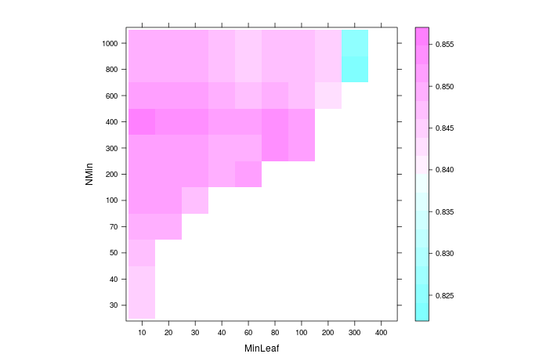Figure 1: Level plot containing the accuracy score of a different combination of NMin and MinLeaf pairs.

We have also compared our algorithm to the rpart algorithm.

