- Dioxane in Ann Arbor (12)
In the middle of the last century, there was a young startup making microporous fibers, a factory called Pall Gellman located near the intersection of Liberty and Wagner. At the latest, in 1980, it became evident that dioxane, a solvent released in the process and dumped in an open lagoon, shown below, was getting into the groundwater below.
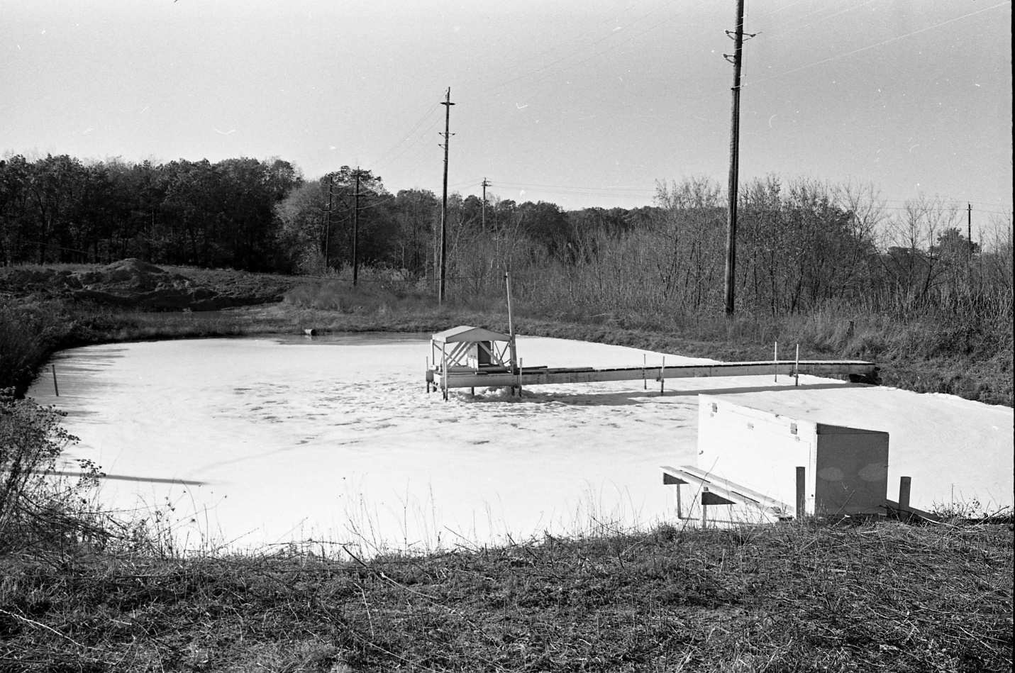
Over the last 40 years, the ‘plume’ has traveled some distance, as shown in the map below, and has reached approximately the intersection of Dexter Rd and Jackson Rd in Ann Arbor. Since it took me a few minutes (using my running app) to obtain the difference in elevation (about 35 m), you can figure out the distance between the two points (plumes don’t really care about roads, they go more like the crow flies). Now you have the distance and a time in days (about 40 years) from which you can calculate an ‘actual velocity’ in m/day. Using a porosity of about 0.5 will allow you to convert the actual velocity to a Darcy velocity. Using Darcy’s law (height and distance for the slope have been determined above) gives you most of the variables for Darcy’s law except for the hydraulic conductivity K, which you can get by solving the equation for K. Now, you can convert the conductivity to ft/day and use the table at the bottom to find out what the soil texture in that part of Ann Arbor might be.
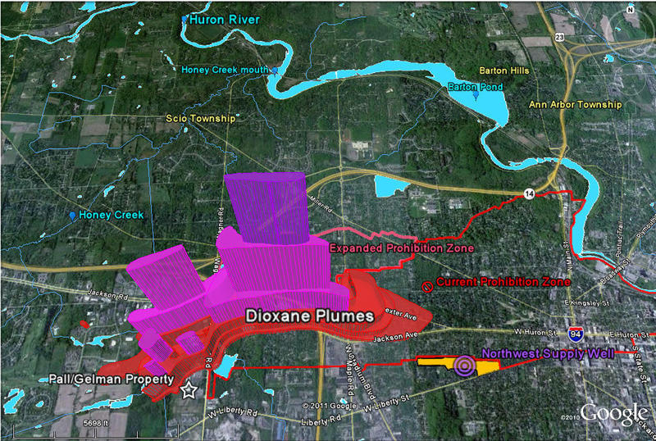

- Distance Pall-Gellman factory -> Dexter/Jackson: (3)
The distance from the Pall-Gellman factory -> Dexter/Jackson is about 2 miles if we are using the blue arrow as reference. In kilometers, this is 2*1.6 = 3.21. The distance is about 3.21 km.
- Actual velocity in m/day: (3)
The actual velocity should be in m/day (meters per day). The distance is about 3.21 km or 3210 meters. And the distance difference in elevation is about 35 meters. The time for the plume is about 40 years. Actual velocity is horizontal distance traveled divided by the time. In this case, it is 3210 m / 40 years = 80.25 m/yr. To convert this into m/day we can do 80.25 m/yrs * 1 yr / 365 days. This amounts to 0.22 m/day as the actual velocity.
- Convert actual velocity to Darcy velocity, what additional info is necessary to do that (4)
Darcy velocity can be computed with the relation being v_Darcy = v_actual * porosity. Using this relational formula, the Darcy velocity can be computed by: 0.22 m/day * 0.5 = 0.11 m/day. Using the actual formula for Darcy’s law, we have v_Darcy = k * change in height / change in distance. We need the change in height and the value of k to calculate Darcy velocity with this equation.
- Write down Darcy’s law, first with variables that you would have to define, then plug in numbers for all variables that you have so far: (3)
Darcy’s law is v_Darcy = k * change in height / change in distance. Therefore, we have to define what k is, what the change in height is, and what the change in distance is. With the information we have already, we know that change is height = 35 m. We also know that the change in distance = 3210 m. Additionally, from the relational equation we know that the Darcy velocity is about 0.11 m/day. Having all of these variables defined, the equation becomes 0.11 m/day = k * 35 m / 3210 m.
- Solve for hydraulic conductivity K: (3)
To solve for hydraulic conductivity, we can rewrite the equation from the last part by dividing by the change in hehight and multiplying by the change in distance on both sides of the equation. By doing this, we get v_Darcy * change in distance / change in height = k. Plugging in the values, we get 0.11 m/day *3210 m / 35 m = k. Therefore K is equal to about 10.08 m/ day.
- Estimated soil texture using the table below and compare with info that you can find about soils in AA. (4)
From the table below, I can convert the K from above to ft/day. There are about 3.28 feet in a meter. The conversion is 3.28 ft / 1 m * 10.08 m/day = 33.06 ft/day. This falls in the 100 - 10 range in the table for the second column (ft/day). With this information, the soil texture is semi-pervious – pervious, is a good aquifier, is well sorted sand or sand and gravel, may be peat, ad may contain oil reservoir rocks.
(Remember to show your work in all steps above)

