Understanding and being able to derive what effort would be needed if all transportation would be electrified.
Lately, there have been a lot of discussions suggesting that we should all drive electric cars to fight climate change and related water issues (directly as in water consumption of power plants and indirectly by as in the increase of hurricanes and droughts, and sea level rise), but the electric energy should come from somewhere that is ideally not coal, and not even any other carbohydrates, but from alternative resources that don’t emit carbon dioxide. But do we know, or can we make an estimate, how much effort would be required if we went all nuclear or all wind to produce the electricity or energy needed to electrify transportation?
Unfortunately, the confusion starts with a zoo of units used for total primary energy consumption (quadrillion British thermal units or quads) and electrical energy units (kWh, MWh, GWh, TWh …).
To make things a little easier, we are providing you with a spreadsheet template where you start with seven pieces of raw information first:
- Total amount of energy consumed in the US per year (the energy given here is most likely in quads or quadrillion British Thermal Units, VTU)
100 quads/year
- Percentage of (1) that is used in transportation
28%
- Total annual electricity currently produced in the US
4000 TWh/year
- Total annual nuclear energy currently produced in the US
800 TWh/year
- Total annual wind energy currently produced in the US
300 TWh/year
- Power of 1 nuclear reactor
1 GW = 0.001 TW
- Power of 1 big wind turbine. (you would have to multiply the nominal value of a big wind turbine by about 0.25 because lots of times the wind is not blowing at the right speed).
2.5 MW × 0.25 = 0.625 MW convert to GW then to TW: 0.625 MW = 0.000625 GW = 0.000000625 TW

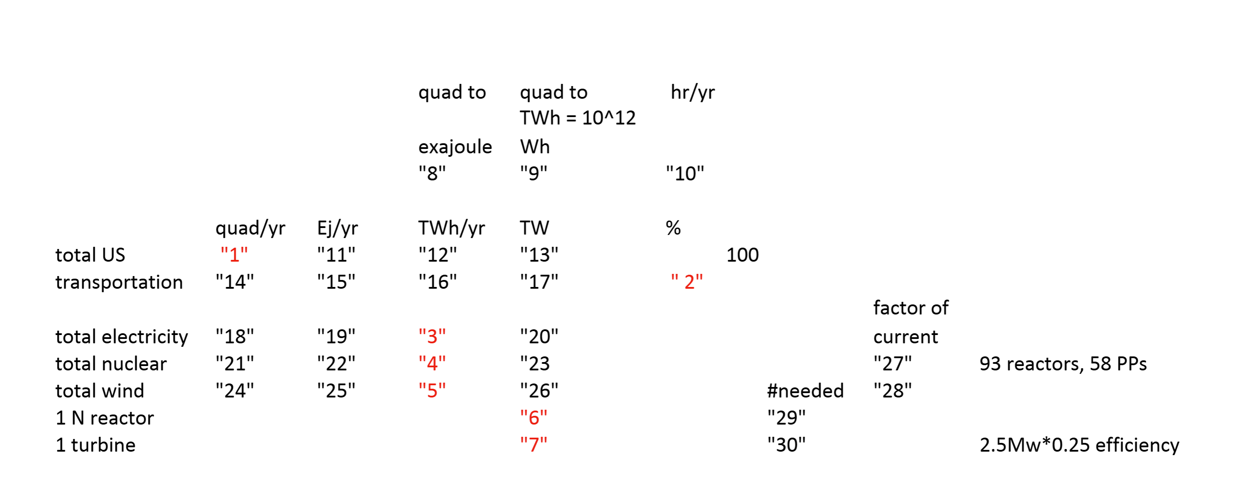
While the items above go into the red boxes 1-7, we need three conversion factors for units in placeholders 8-10. Since you slowly develop into Excel wizards, you can calculate (maybe with a little help) the values for the remaining fields and answer the following questions.
- In order to obtain numbers 27 and 28, the total TW for transportation has to be divided by the total nuclear and the total wind, respectively, to obtain the factors by which factors nuclear and wind would have to be increased.
Calculate other values using the table:
8: 1 quad = 1.055 EJ
9: 1 quad = 293.1 TWh
10: 365 days × 24 hours = 8760 hours
11: 100 quads × 1.055 EJ/quad
12: 100 quads × 293.1 TWh/quad = 29,310 TWh
13: 29,310 TWh / 8760 hr = 3.344 TW
14: 28% of 100 quads = 28%
15: 28 quads × 1.055 EJ/quad = 29.54 EJ
16: 28 quads × 293.1 TWh/quad = 8206.8 TWh
17: 8206.8 TWh / 8760 hr = 0.9372 TW
18: 4000 TWh / 293.1 TWh/quad = 13.64 quads
19: 13.64 quads × 1.055 EJ/quad = 14.39 EJ
20: 4000 TWh / 8760 hr = 0.456 TW
21: 800 TWh / 293.1 = 2.73 quads
22: 2.73 × 1.055 = 2.88 EJ
23: 800 TWh / 8760 hr = 0.0913 TW
24: 300 TWh / 293.1 = 1.023 quads
25: 1.023 × 1.055 = 1.08 EJ
26: 300 TWh / 8760 hr = 0.03425 TW

Now to get 27 and 28:
For 27: Transportation energy in TW / Nuclear in TW so 0.9372 / 0.0913 = roughly 10.27
For 28: Transportation energy in TW / Wind in TW so 0.9372 / 0.03425 = roughly 27.37

- For the numbers of reactors needed to electrify all transportation you need to divide the TW for transportation by the power of one reactor or the power of one big wind turbine (times its efficiency for the latter), in order to obtain the # of reactors or turbines needed. Please comment on these two numbers, specifically look up how many nuclear reactors have been built in the last 40 years?
To electrify all U.S. transportation, we calculated Transportation energy use: 0.9372 TW and power per nuclear reactor: 1 GW = 0.001 TW and power per wind turbine: 0.625 MW × 0.25 capacity factor = 0.000000625 TW so
Number of nuclear reactors needed = 0.9372 / 0.001 = 937 reactors and number of wind turbines needed = 0.9372 / 0.000000625 ≈ 1.5 million turbines
Looking up online only two reactors have been completed in the past 40 years. Most recently, Vogtle Units 3 and 4 in Georgia were finished in 2023 and 2024, after decades of delay and billions over budget. According to the World Nuclear Association about 100–110 reactors have been completed worldwide in the last 40 years and many are in China, Russia, India, and South Korea.
Building only 2 reactors in 40 years shows the extreme political, regulatory, and financial challenges in scaling nuclear for the U.S, as compared to the rest of the world.
In contrast, wind turbines are being built rapidly: The U.S. has installed around 70,000 wind turbines so far and is probably more feasible because of construction, faster installation time (months vs. decades for nuclear), and not as many regulations.
Questions not from the spreadsheet: Answers found from online sources as well as lecture references.
- What types of transportation are not easily electrified using battery-driven engines?
Heavy-duty transportation like airplanes, long-haul trucks, cargo ships, and trains (especially in remote areas) are not easily electrified with batteries. This is because batteries are too heavy or don't store enough energy for the long distances and high power needed.

- What type of transportation can be electrified without the use of batteries?
Trains can be electrified without batteries if they are powered by overhead electric lines or third rails. This is common in many cities and countries. It avoids the need to carry heavy batteries onboard.

- Since we are treating hydropower plants in lecture, how does the total electricity produced by hydropower in the US compare to nuclear and wind?
In the U.S., hydropower produces less electricity than both nuclear and wind. Nuclear is the biggest non-carbon source, followed by wind, then hydropower. So while hydro is important, it's not the largest.

- Since we are discussing different hydropower plants with very different sizes:
What is the power of the Argo plant in AA using the following data for this year in Feb
Date Dam Flow (cfs) Pond Level Tail Level Hydro Flow (cfs) Hydro kW
Feb 9 746 797 774 543 845.7
Dam flow is the water that passes by the plant and Hydro flow is the water going through the plant. The sum of the two is what’s coming from the river or reservoir.
- What percentage of the total flow was going through the plant?
Hydro flow = 543 cfs; Total river flow = Dam flow + Hydro flow = 746 + 543 = 1289 cfs
Percentage through the plant = 543 / 1289 ≈ 42.1%

- Using the equation in the lecture slide and an efficiency of one, what nominal power of the Argo plant would you obtain? The Argo plant is listed with a power of 846 kW, what is the efficiency that you have to use to get to that value?
P=ρ*g*Q*h
Where: ρ=1000\rho = 1000ρ=1000 kg/m³ (density of water), g=9.81g = 9.81g=9.81 m/s², Q=543 cfs=15.38Q = 543 cfs = 15.38Q=543 cfs=15.38 m³/s, h=797−774=23h = 797 - 774 = 23h=797−774=23 ft = 7.01 m
So P=1000*9.81*15.38*7.01≈1,057,397 W=1057 kWP = 1000 * 9.81 * 15.38 * 7.01 P=1000⋅9.81⋅15.38⋅7.01≈1,057,397 W=1057 kW
Efficiency = Actual output / Ideal output = 846 / 1057 ≈ 0.80 or 80%
- how does that compare with the power produced by a full-scale wind turbine?
A typical full-scale wind turbine produces 1.5 to 3 MW (1500–3000 kW). Argo only produces 846 kW, so it's about 1/2 to 1/4 the size of a single wind turbine.
- What is the power of the three gorges plant in China?
From online: The Three Gorges Dam produces 22,500 MW, or 22.5 GW. It's the largest hydroelectric plant in the world.
- What is the power of the Niagara plant?
From online: Niagara produces about 2,500 MW, or 2.5 GW from both the U.S. and Canadian sides combined.
- How do these last two values compare with the one for one nuclear reactor?
From online: A typical nuclear reactor is 1 GW. Three Gorges = 22.5× more powerful
Niagara = 2.5× more powerful
So large hydro plants can rival or exceed nuclear reactor output—but there are very few sites left to build more of them.

