MEMO
From: Suhaib Nur
Date: November 3, 2026
Subject: Leak detection simulator (compensated volume balance): summary of results
Code and full results: github.com/snur1981-dev/leak-detection-sim

Purpose
I built this as a self-study project to learn how computational pipeline monitoring (CPM) works. I did not have CPM work experience, so I wrote a compensated volume balance in Python and tested it against the four performance measures in API RP 1130: sensitivity, reliability, accuracy and robustness. All data is synthetic, generated by my own simplified model of a made-up pipeline. The results show how the method behaves under my assumptions, not a validation of a real system.

Setup
- Pipeline: 100 km, NPS 16 (390.6 mm ID), flat, crude oil at 850 kg/m³, normal flow 0.20 m³/s (720 m³/h). Flow meters at both ends, pressure at 0, 50 and 100 km, temperature at both ends.
- Hand checks first: friction loss 6.10 MPa at full flow, line pack 11.52 m³ per MPa (about 74% oil compression, 26% pipe stretch) and 9.59 m³ per °C, wave speed 1,106 m/s.
- Test data: 1-minute SCADA-style readings with meter bias and noise, leaks, pump starts, valve moves and data faults. The true values are kept separately to score the detector, which only reads the tags.
- Detector: imbalance = flow in − flow out − change in line pack, over 5 minute, 1 hour and 24 hour windows. An alarm needs 3 minutes in a row over the threshold. Alarms are held for 15 minutes after a pump or valve status change, and data quality checks run before the balance.
- Thresholds: a bias allowance (0.1% of flow, assumed after meter proving) plus 3 times the noise, with the noise measured from a 7 day no-leak tuning run, the way an operator would tune from historian data.

Results
1. Line pack correction removes pump-start false alarms. A pump start from 0.10 to 0.20 m³/s raises average pressure by about 2.2 MPa and packs about 25 m³ into the line. A plain in minus out balance counted that as missing oil: it reached 25.2 m³ and alarmed at 06:04. The compensated balance stayed under 0.7 m³. Both caught the real 1% leak at 10:28 (Figure 1, using a 3 m³ placeholder threshold).
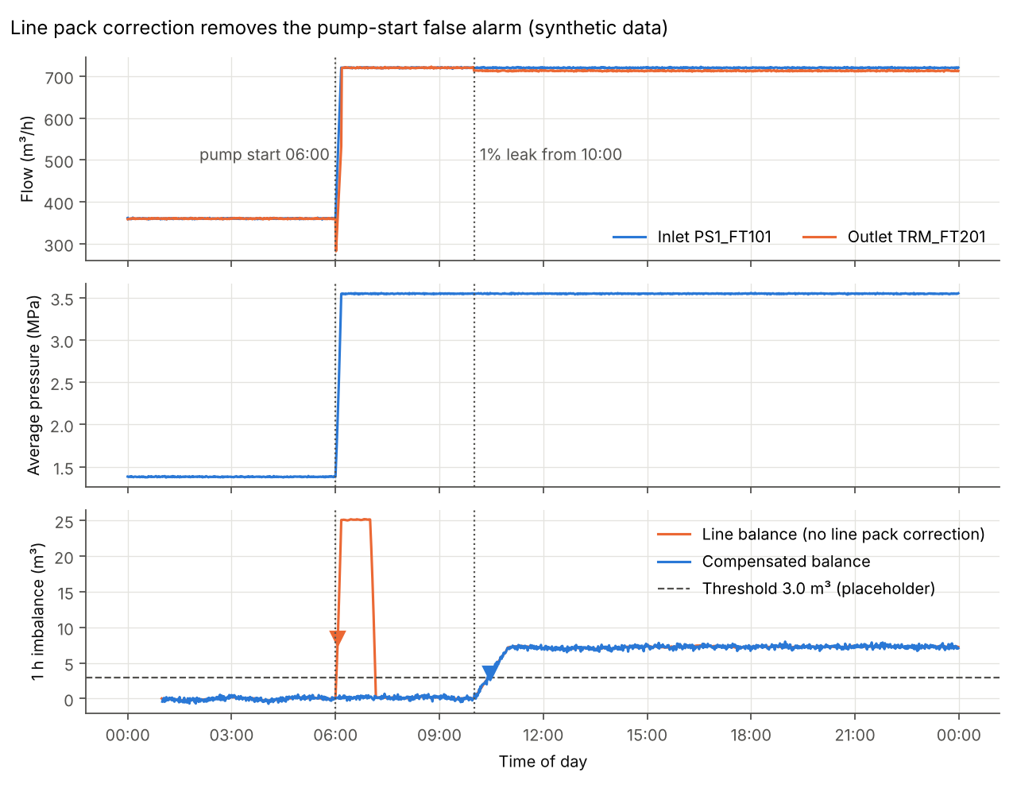
Figure 1. One simulated day with a pump start at 06:00 and a 1% leak at 10:00 (synthetic data).
2. Thresholds and sensitivity. With the tuned thresholds, the 1 hour window caught a 1% leak in a median of 8 minutes and caught every 0.5% leak. The 24 hour window was slower on these sizes because it already holds a full day of meter bias, so a leak has to add more volume to cross its threshold. Its job is leaks below about 0.2%, which my test matrix did not include.
Median of 5 seeds | 5 min window | 1 h window | 24 h window
Threshold (m³) | 0.67 | 1.44 | 18.93
Smallest leak it can see (% of flow) | 1.11% | 0.20% | 0.11%
Median time to alarm, 0.5% leak | 2 of 5 caught | 18 min | 89 min
Median time to alarm, 1% leak | 11 min | 8 min | 47 min
Median time to alarm, 2% leak | 4 min | 5 min | 25 min
Median time to alarm, 5% leak | 3 min | 3 min | 10 min

3. Meter bias sets the floor. Noise averages out over longer windows but bias does not, because it adds the same volume every minute, just like a leak. Most of the 24 hour threshold (17.3 of 18.9 m³) is the bias allowance, and the smallest detectable leak levels off near 0.1% of flow. Bias also made every leak rate estimate about 0.6 m³/h too high (20% error at 0.5%, 2% at 5%). Only better meters or regular proving lower this floor.
4. Reliability. Over 7 days with no leak, 6 pump stop and start pairs and 2 valve moves (5 seeds), the plain balance averaged 1.14 false alarms per day in the 5 minute and 1 hour windows, one for every time flow went up. The compensated balance had none. The 15 minute inhibit made no difference here, because my model has no pressure waves, so compensation left nothing for it to catch.
5. Robustness (clock skew and deadband). An outlet clock running a few seconds late (up to 10 s) caused no false alarms. False alarms started around 30 s, once the added imbalance approached the 1 hour threshold. A 0.5 m³/h reporting deadband on the flow meters did nothing, but 2 m³/h, larger than the meter noise, caused 76 false alarms in the 1 hour window over 21 days: stuck values act like a temporary bias (Figure 2).
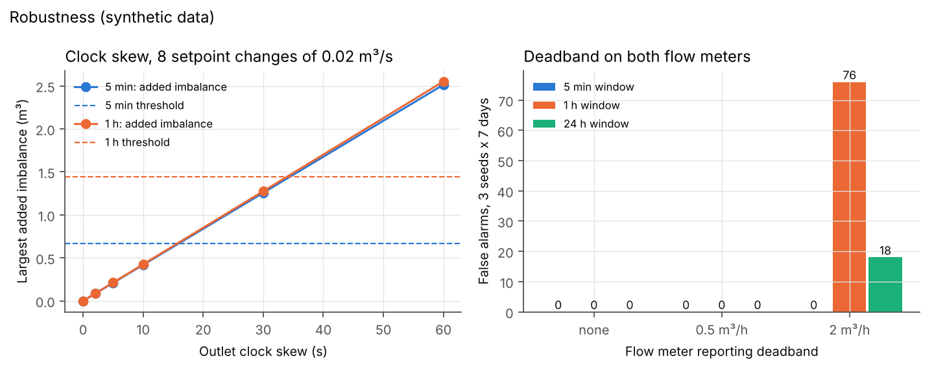
Figure 2. Effect of outlet clock skew (left) and flow meter reporting deadband (right) on false alarms (synthetic data).
6. Data quality checks. The checks caught a frozen outlet reading and stopped its false alarms, but did not catch slow meter drift (0.02% per day), which looks the same as a growing leak. During a 30 minute outlet dropout, suppressing the bad data delayed alarming on a real 2% leak (82 minutes instead of 25 in the 1 hour window). The CPM should tell the controller detection is degraded rather than go quiet.

Limitations
What the model simplifies: flat line with no elevation or slack line; one crude with fixed properties and no batches; each minute treated as settled, so no pressure waves (about 90 s to cross the line); meter errors as constant bias plus clean random noise; the leak does not change the pressures; a 7 day tuning run is short.
What a real system also has to handle: batch tracking, slack line and shut-in conditions, meter proving and maintenance, SCADA communications and time sync across many sites, alarm management and controller response procedures, and leak location, which a two-meter balance cannot provide.
Next steps: test leaks below 0.2% of flow to show what the 24 hour window adds, add pressure waves and elevation and retest the inhibit, and run the method on real historian data with a senior advisor.
Notes: Python (numpy, pandas, matplotlib), built with an AI tutor. I did the hand calculations, ran every test and checked the results against them. Standards studied from public summaries of API RP 1130, API TR 1149 and CSA Z662 Annex E. Every number here comes from results/summary.md in the repository.

