HW3 - Writeup

Computer Science and Engineering

2017-18538

Hwang Sunyoung

Part 1

**H = compute_h(p1, p2)**

p1 and p2 is N×2 matrices of corresponded (x,y)T coordinates between two images.

Suppose p1 is ($x_{1}$, $y_{1}$), ($x_{2}$, $y_{2}$), ($x_{3}$, $y_{3}$), ($x_{4}$, $y_{4}$) and p2 is ($x_{1}^{'}$, $y_{1}^{'})$, ($x_{2}^{'}$, $y_{2}^{'})$, ($x_{3}^{'}$, $y_{3}^{'})$, ($x_{4}^{'}$, $y_{4}^{'})$

for each correspondence point, we can write 2×9 matrices such as

To compute PH = 0, we can matrix multiplication like that:

To get H, compute SVD $P=USV^{T}$ and get last singular vector of $V^{T}$ as H. Then reshape H to 3×3 matrix.

**H = compute_h_norm(p1, p2)**

I expressed normalization as a matrix. A shape of normalization matrix is equal to that of p1. p1 is divided by 1600 and p2 is divided by 1200. Then compute H with normalized p1 and p2.

Part 2

**p_in, p_ref = set_cor_mosaic()**

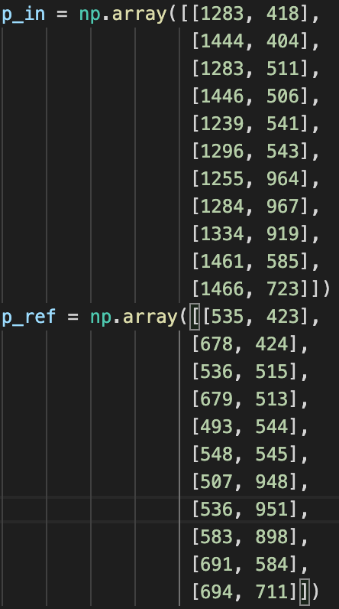

p_in and p_ref is N by 2 matrices of corresponded ${(x, y)}^{T}$ coordinates between two images.

**igs_warp, igs_merge = warp_image(igs_in, igs_ref, H)**

This function warp igs_in to view of igs_ref. First, compute corresponding coordinate in igs_in to view of igs_ref. And for each pixel, compute np.linalg.solve(A, b) to get t matrix for affine transformation. Then we can get igs_warp image. Then arrange igs_warp and igs_ref to igs_merge in proper position for panorama image.

Part 3

**c_in, c_ref = set_cor_rec()**

c_in and c_ref is N by 2 matrices of corresponded ${(x, y)}^{T}$ coordinates between two images.

**igs_rec = rectify(igs, p1, p2)**

To normalize and compute H, normalize p1 and p2 and apply compute_h function. Then produce igs_rec, this method is equal to **warp_image.** Difference is normalizing factor, 1920 and 1056, that is size of igs.