# Polymer

## Concepts:

* Component creation
* Creating properties
* Property Observers
* Routing
  + iron-selector
  + iron-pages
  + _routePageChanged observer (app-route observer)
  + [_pageChanged observer (component observer)](#__pageChanged_observer_(component)
* Navigation from components
* Component communication
  + Parent to child communication
  + Child to parent communication
  + Event triggering from child component to parent component
* If condition using dom-if
* Loop array items using dom-repeat
* Lifecycle callback’s
* Global variables
* Loading External css globally

## Component creation, Creating properties, Property observers:

* Go to src/ folder
* Create new js file. Example:
  + example-element.js
* **Create component properties at properties function:**
* 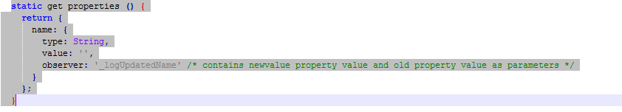
* **Create html tags inside template:**
* 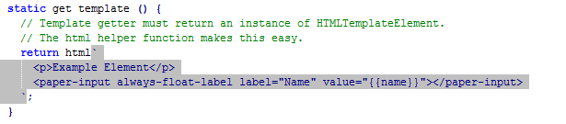
* **Component property simple observer:**
* 
* **Total example component looks like this with html, properties, simple observer, import statements:**

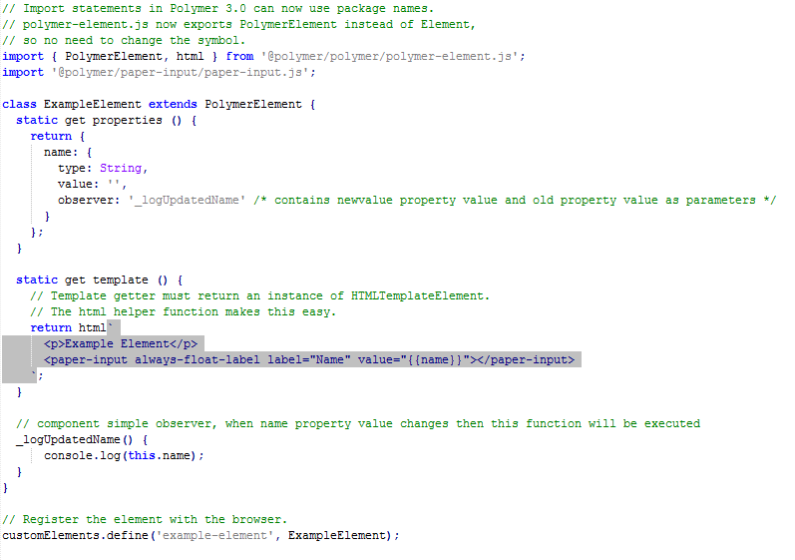

## Routing:

As example of myapp.js routing

### Import related js files in my-app.js and set RoutePath:

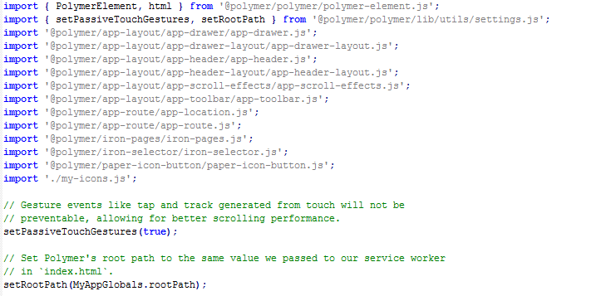

### <app-route> and <app-location> elements:

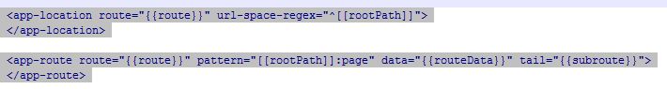

### iron-selector:

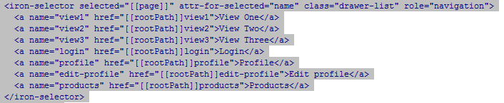

### iron-pages:

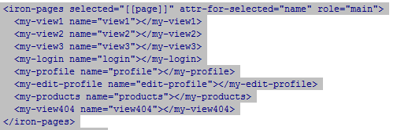

### _ routePageChanged observer (app-route observer):

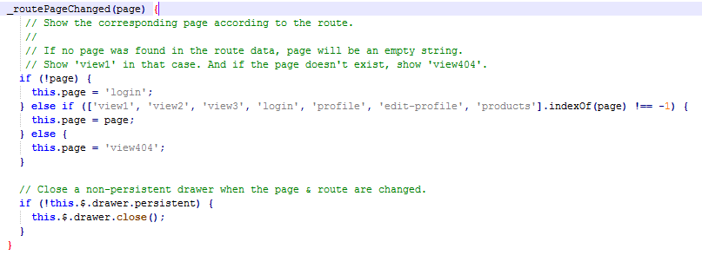

### _pageChanged observer (component property observer):

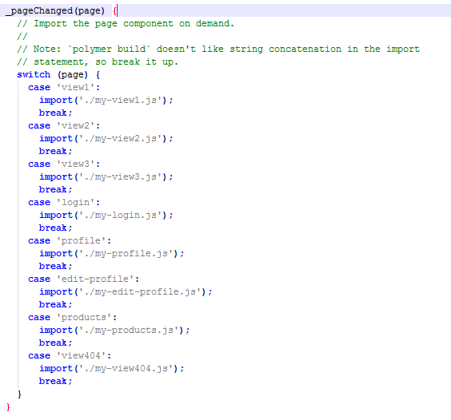

## Navigation from components:

### Import app-route component:

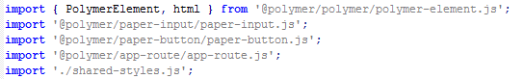

### Set app-location:



### Set route-path:



## Component communication:

Example of components communication with **myUsername** property.

### Parent to Child communication:

Inside parent component, we are setting **my-username = {{mName}}** at child component element.

Whatever we set data to **myName** property will be passed to **myUsername** property inside my-edit-profile component.

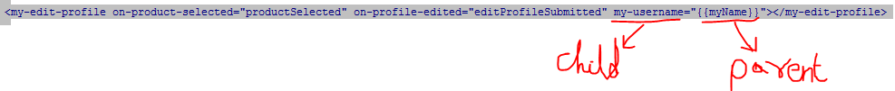



### Child to Parent communication:

Inside child component property, use **notify: true** inside property to set updated data to parent component

Whatever we change data to **myUsername** property at child component will be updated at **myName** property inside parent component. (Two way binding)

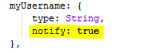



### Event triggering from child component to parent component:

Inside parent component:



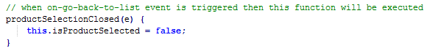

From child component, trigger event to parent component:

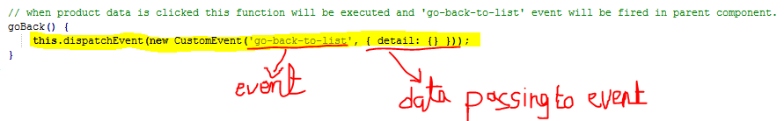

## If condition using dom-if:

### Import dom-if js file and set if condition using template tag:



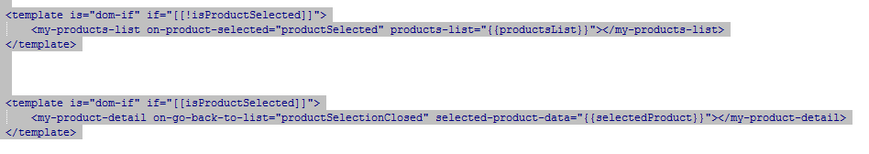

## Loop array items using dom-repeat:

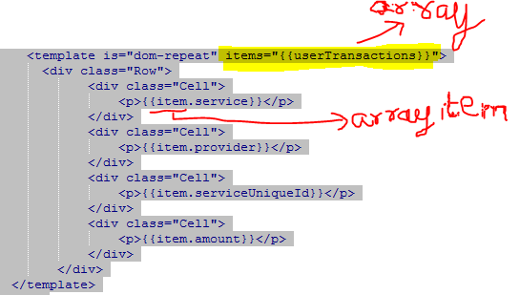

## Lifecycle callback’s:

### Ready Callback:

ready(){

super.ready();

}

### Constructor:

constructor() {

super();

}

## Global variables:

Don’t know how to set global variables.

## Loading External css globally:

Don’t know how to set external css file.