# **Operational Concept Description (OCD)**

**Hangry Mobile Food Truck Locator**

**<Team Number>**

**Team Members and Roles**

John Humlick ------------------------------------------------ Architect

Amir Radman ----------------------------------------------- Project Manager/UI Designer

Aaron Escoto ------------------------------------------------ UI Designer

Daniel Tam ------------------------------------------------ Back-End Engineer

Natalia Zarubin --------------------------------------------- Back-End Engineer

**<Date>**

# **Version History**

|  |  |  |  |  |
| --- | --- | --- | --- | --- |
| **Date** | **Author** | **Version** | **Changes made** | **Rationale** |
| 08/20/05 | PP | 1.0 | * Original template for use with LeanMBASE v1.0 | * Initial draft for use with LeanMBASE v1.0 |
| 08/28/05 | PP | 1.1 | * Added section 3.2 | * Section 3.2 was added to provide traceability for the outcome in the Benefits Chain |
| 08/30/06 | SK, RT | 1.6 | * Added Template for Tables and Figures | * Consistent format |
| 10/04/06 | SK | 1.61 | * Added section 3.3.1 | * Section 3.3.4 |
| 09/14/07 | SK | 1.9 | * Updated Section 2.4, 3.3.1, 3.3.2, 3.3.3 | * Consistent with LeanMBASE V1.9 |
| 08/25/08 | PA | 2.0 | * Swapped sections 3.4 and 3.5. * Renamed section 2.4 title from “Benefits Chain (Initiatives, Expected Outcomes, and Assumptions)” to “Benefits Chain” * Replaced References section (1.2) with “Status of the OCD” * Edited Table 1 structure to be consistent with the Instructional ICM-Sw OCD Guideline. * Added Figure 2, Figure 3, and Figure 4 * Edited Table 2 to be consistent with the Instructional ICM-Sw OCD Guideline | * Initial draft for use with Instructional ICM-Sw v2.0 modified from LeanMBASE v1.9 |
| 05/22/09 | SK | 2.1 | * Embedded description in each Table * Removed section 3.5 Prototype * Moved all goals to the Section 3.1 * Removed Section 4. WikiWinWin Result * Added Section 3.1.4 Constraints * Added Section 3.1 Current System | * To be consistent with ICM EPG template set standard V2.1 * To leanify and rearrange data presentation * Moved Prototype information to Prototype report * To document information about current system |
| 08/15/12 | TK | 2.2 | * Added Program Model * Updated index of subsections in section 2 Shared Vision | * To be consistent with ICSM EPG |

# **Table of Contents**

**Operational Concept Description (OCD) i**

**Version History ii**

**Table of Contents iii**

**Table of Tables iv**

**Table of Figures v**

**1.** **Introduction 1**

**1.1** **Purpose of the OCD 1**

**1.2** **Status of the OCD 1**

**2.** **Shared Vision 2**

**2.1** **Benefits Chain 3**

**2.2** **System Capability Description 4**

**2.3** **System Boundary and Environment 4**

**3.** **System Transformation 6**

**3.1** **Information on Current System 6**

**3.2** **System Objectives, Constraints and Priorities 6**

**3.3** **Proposed New Operational Concept 8**

**3.4** **Organizational and Operational Implications 12**

# **Table of Tables**

*Table 1: The Program Model 2*

*Table 2: Level of Service Goals 7*

*Table 3: Relation to Current System 8*

# **Table of Figures**

*Figure 1: Benefits Chain Diagram of Volunteer Tracking System 3*

*Figure 2: Benefits Chain Diagram 4*

*Figure 3: System Boundary and Environment Diagram of Volunteer Tracking System 5*

*Figure 4: System Boundary and Environment Diagram 5*

*Figure 5: Element Relationship Diagram of Transportation Grant Fund system (NDI-intensive project) 9*

*Figure 6: Element Relationship Diagram of the Los Angeles Community Garden Inventory and Locator (Architected agile project) 9*

*Figure 7: Element Relationship Diagram 10*

*Figure 8: Business Workflow Diagram of Volunteer Tracking System 11*

*Figure 9: Business Workflows Diagram 12*

### **Introduction**

#### **Purpose** **of the OCD**

This document provides, in detail, the shared visions and goals of team team Neon in San Jose State University’s CS 161 Software Project course. The success-critical stakeholders of the project are Aaron Escoto, John Humlick, Amir Radman, Daniel Tam, and Natalia Zarubin.

#### **Status of the OCD**

4/13/17: The status of the OCD is currently in its first design phase version 1.0.0.

5/13/17: The OCD is now finalized.

### **Shared Vision**

<< In order to understand or know what projects or related initiatives are required for program management we create a Program Model as shown below. The model helps in designing and managing programs. Understanding the concept of a program – how it is different from traditional projects and what it brings to them – is the first major step to embarking on the route to effective, proactive benefits management.

The Program Model starts out with five components as shown in the table below >>

**Table 1: The Program Model**

|  |  |  |  |
| --- | --- | --- | --- |
| **Assumptions** (Under what *Business* *assumptions* will this *‘model’* be true) | | | |
| **Stakeholders** (Who is accountable for the initiatives) | **Initiatives**  (What to do to realize benefits) | **Value Propositions**  (Benefits i.e Why) | **Beneficiaries**  (Who derives value) |
| * Amazon AWS with Dynamo DB and Lambda | * Create an Amazon AWS account * Create middleware messaging service on AWS * Create an android app | * This software solves the problem of not knowing where a particular food truck will be and also allows users to find a list of nearby food trucks | * Hungry app users * Mobile food truck owners looking for more business and advertising |

**Legend:**



#### **Benefits Chain**

<< The benefits chain diagram illustrates the following information

* **Stakeholder(s):** What are the success critical stakeholders who create and receive benefits from the developing system? E.g. Development team, Volunteer, Manager
* **Initiative**: What are the actions that stakeholder(s) performs that could contribute benefit to the system. Initiative should be represented in Verb-form. E.g. Develop automatic report generation module, fill out online application, Analyze volunteer performance
* **Contribution**: What are the results of the initiative that will add to the benefits to the system? E.g. automated report generation process, paperless application, insightful volunteer performance analysis
* **Outcome**: Benefits that is contributed by the system such as improved volunteer management performance, faster application processing
* **Assumption**: What are the conditions that have to be true in order to make this benefit chain to be true.

Below is an example and a template of Benefit Chain Diagram: >>

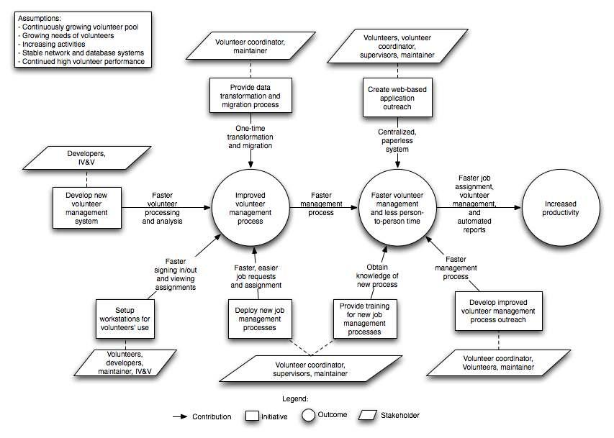

**Figure 1: Benefits Chain Diagram of Volunteer Tracking System**

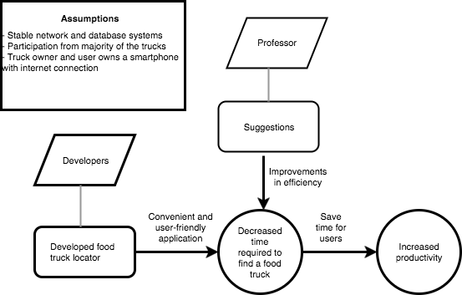

**Figure 2: Benefits Chain Diagram**

#### **System Capability Description**

The phone application will be for the Android platform, which consists of approximately 50% of the smartphone used out there today. This application will allow hungry Android users to locate mobile food trucks in real time nearby. This application will be needed because everyone gets hungry and mobile food trucks are getting more popular in cities. Our competitor are other similar mobile truck locators, however, our application will be more unique since we potentially will allow crowdsourcing and online orders.

<< Provide an “elevator test” summary of the project's expected benefits, i.e., a short executive summary that could convince a potential funder (venture capitalist) “during the course of a short elevator ride.” (See Geoffrey Moore's Crossing the Chasm (Harper Collins, 1991, p.161)). Such an “elevator test” summary includes:

* The type of system to be built
* The target customer(s) for the system
* The need or opportunity that will be satisfied by the system
* A compelling reason for the customer to buy/use the system
* The closest competitor of the system
* The system's primary differentiation from, or benefit over, the closest competitor or alternative approach, if there are competitors or alternatives ah the time >>

#### **System Boundary and Environment**

<< The system boundary and environment diagram contains a list of services and functions that the project team will be responsible for developing and delivering, as well as the system environment showing the stakeholders' organizations and other systems for which the project has no authority or responsibility, but with which the delivered system must interface in order to deliver the desired benefits. The figure below shows the basic structure context diagram used to define the system boundary. Below is an example and a template of a system boundary and environment diagram.>>

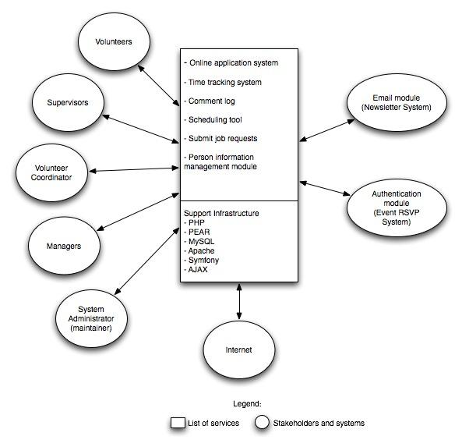

**Figure 3: System Boundary and Environment Diagram of Volunteer Tracking System**

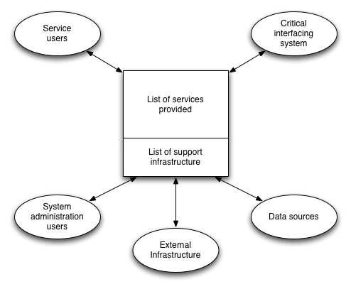

**Figure 4: System Boundary and Environment Diagram**

### System Boundary.png**System Transformation**

#### **Information on Current System**

##### **Infrastructure**

This Android project will consist of two parts: a driver side and an user side. Both side of the app uses Amazon DynamoDB to create,read and write to and from the database. Google Sign-In is used as the login system for our application and is used to associate each user as either a truck owner or customer.

##### **Artifacts**

<< List the artifacts used by the system or by the users in operating the system. Provide a brief description about each artifact. >>

##### **Current Business Workflow**

<< Sketch the overview of business workflows around the current system. Use an activity diagram to describe business workflow. >>

#### **System Objectives, Constraints and Priorities**

##### **Capability Goals**

<< Provide a brief enumeration of the most important operational capability goals. A “capability” is simply a function or set of functions that the system performs or enables users to perform. To facilitate traceability between capability goals listed in the OCD and references to them from other artifacts (WinWin Agreements, SSAD, LCP, and FED), assign each capability a unique designation (e.g. OC-1) and a short descriptive name.

|  |  |
| --- | --- |
| **Capability Goals** | **Priority Level** |
| **<< OC-1 Automated Report Generation:** The system is capable of generating the report in PDF format. >> | << Must have>> |
|  |  |
|  |  |
|  |  |

##### **Level of Service Goals**

<< Identify in a table the desired and acceptable goals for the proposed new system's important levels of service. Example can be found in ICSM EPG. >>

**Table 2: Level of Service Goals**

|  |  |  |
| --- | --- | --- |
| **Level of Service Goals** | **Priority Level** | **Referred WinWin Agreements** |
|  |  |  |
|  |  |  |
|  |  |  |
|  |  |  |

##### **Organizational Goals**

<< List briefly the broad, high-level objectives and aspirations of the sponsoring organization(s) and any organizations that will be using and maintaining the new system. The goals should be expressed in terms of (or referenced to) the Value Propositions, and should only include the goals that indicate what the organization wishes to achieve by having the proposed system (e.g., increase sales, profits, and customer satisfaction). Each goal in this section should relate to one or more of the Value Propositions.

Provide a brief enumerated list of goals. To facilitate traceability, assign each goal a unique number (e.g. OG-1).

For example:  
OG-1: Increase sales and profits via more efficient order processing.  
OG-2: Improve speed via faster order entry.

More examples can be found in ICSM EPG. >>

**OG-1:** <Goal>

##### **Constraints**

<< Identify constraints of the project. Constraints will be derived from your WinWin negotiation and/or client’s meeting. Constraint is a limitation condition that you have to satisfy for your development project. Examples of Constraints are:

**CO-1:** **Windows as an Operating System**: The new system must be able to run on Windows platform.

**CO-2: Zero Monetary Budget:** The selected NDI/NCS should be free or no monetary cost.

**CO-3: Java as a Development Language**: Java will be used as a development language. >>

##### **Relation to Current System**

<< Summarize the relations between the current and new systems in a table. Include key differences between the current and new roles, responsibilities, user interactions, infrastructure, stakeholder essentials, etc. Example of Relation to Current System can be found in ICSM EPG.>>

**Table 3: Relation to Current System**

|  |  |  |
| --- | --- | --- |
| **Capabilities** | **Current System** | **New System** |
| Roles and Responsibilities |  |  |
| User Interactions |  |  |
| Infrastructure |  |  |
| Stakeholder Essentials and Amenities |  |  |
| Future Capabilities |  |  |

#### **Proposed New Operational Concept**

<< This section contains information about the transformation of new operational concept that will be introduced to the system. >>

##### **Element Relationship Diagram**

<< The element relationship diagram summarizes the major relationships among the primary elements and external entities involved in the proposed new system. The entities include actors or users as well as external systems and components that interface with the system. The dashed box represents your proposed system, the boxes outside the dashed box represent external element that your system has to communicate with.

Note that the example is more in the style of a data flow diagram than in the style of Chen's ER diagram or of an EER diagram; any of these notations is fine, as the content is far more important than the style. The followings are an example and a template for Element Relationship diagram. >>

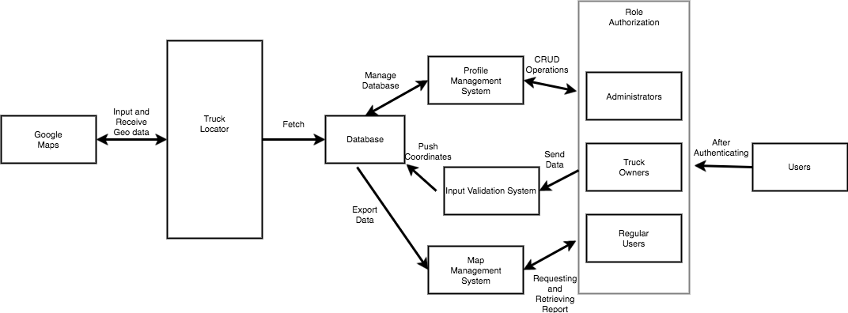

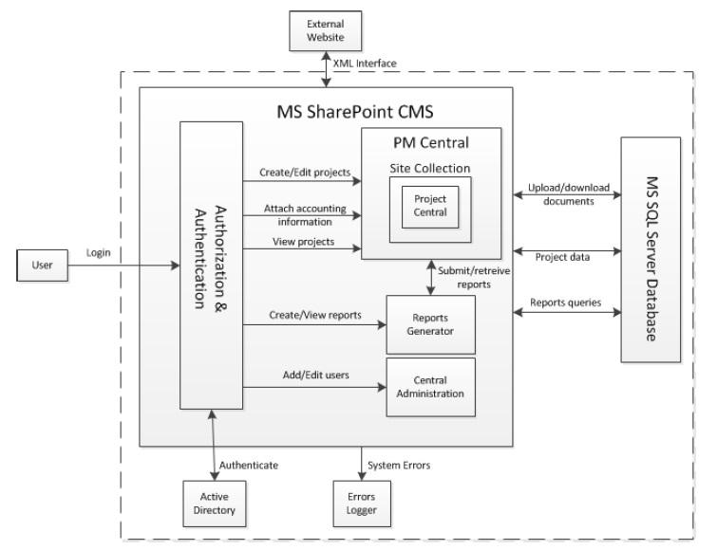

**Figure 5: Element Relationship Diagram of Transportation Grant Fund system   
(NDI-intensive project)**

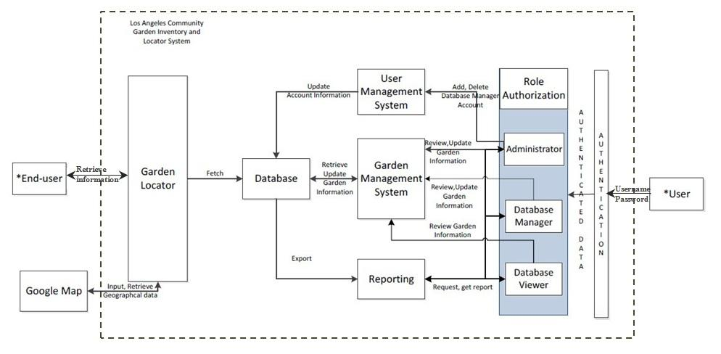

**Figure 6: Element Relationship Diagram of   
the Los Angeles Community Garden Inventory and Locator (Architected agile project)**

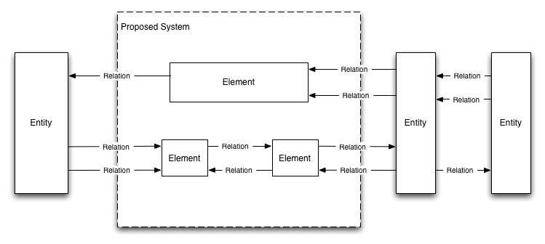

**Figure 7: Element Relationship Diagram**

##### **Business Workflows**

<< Characterize the new operational concept in terms of the flow of works through the proposed new system. The workflows will be illustrated in the form of business activity diagram(s). It will show the overview of the business activities flowing in proposed new system. As appropriate, indicate future capabilities of the new system or major differences from the current system as well. >>

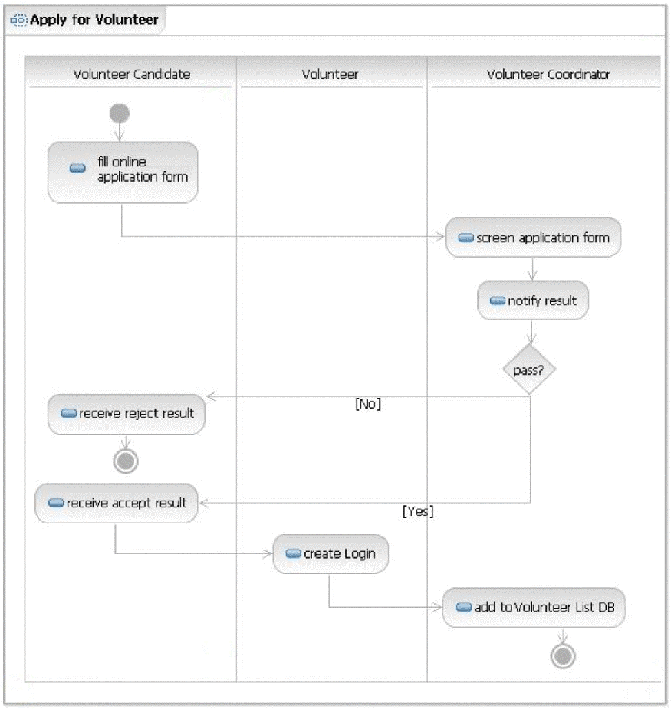

**Figure 8: Business Workflow Diagram of Volunteer Tracking System**

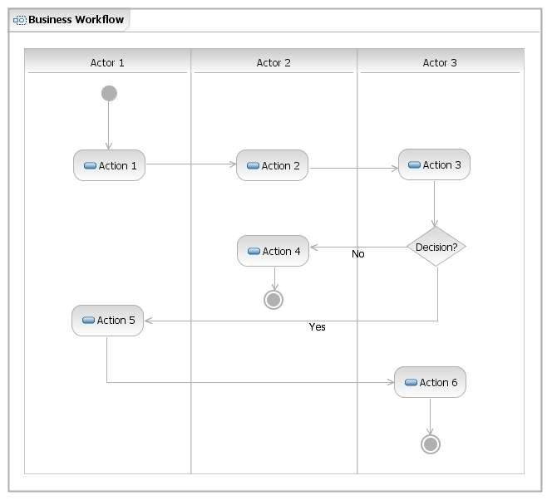

**Figure 9: Business Workflows Diagram**

#### **Organizational and Operational Implications**

##### **Organizational Transformations**

If there are any requirement changes, it could affect the delivery timeline.

If there are any changes in external resources(database, google services, etc), it could affect the the project and possibly delay the final due date.

##### **Operational Transformations**

<< Identify any significant changes in operational procedures and workflows that will result from transitioning to the new system. Identify major operational stakeholders affected by the changes, and indicate their concurrence with the changes.

Examples of operational transformations:

* Having the financial, delivery, and administrative processing concurrently progress rather than sequentially to decrease response time, subject to the check for payment validity before shipping an order.
* The option for new potential volunteers to fill out the applications online, or on paper and submitted in person. >>