# **Prototype Report**

**Hangry Mobile Food Truck Locator**

**<Team Number>**

**Team Members and Roles**

John Humlick ------------------------------------------------ Architect

Amir Radman ----------------------------------------------- Project Manager/UI Designer

Aaron Escoto ------------------------------------------------ UI Designer

Daniel Tam ------------------------------------------------ Back-End Engineer

Natalia Zarubin --------------------------------------------- Back-End Engineer

# **Version History**

|  |  |  |  |  |  |  |  |  |  |  |
| --- | --- | --- | --- | --- | --- | --- | --- | --- | --- | --- |
| **Date** | | | **Author** | | **Version** | | **Changes made** | | **Rationale** | |
| 08/20/12 | | SK | | 1.0 | | * Original for CSCI477; Tailored from ICSM OCD Template | | * To fit CS477 course content | | |
|  | | |  | |  | |  | |  | |
|  | | |  | |  | |  | |  | |

# **Table of Contents**

**Prototype Report i**

**Version History ii**

**Table of Contents iii**

**Table of Tables iv**

**Table of Figures v**

**1.** **Introduction 1**

**1.1** **Purpose of the prototype report 1**

**1.2** **Status of the prototype 1**

**2.** **Navigation Flow 2**

**3.** **Prototype 3**

# **Table of Tables**

*Table 1: Screenshot name-1 3*

*Table 2: Volunteer Clock Out Page 4*

# **Table of Figures**

*Figure 1: Navigation Flow of Volunteer Tracking System 2*

*Figure 2: screenshot name 1 3*

*Figure 3: Clock-out page 4*

### **Introduction**

The purpose of this document is to create a prototype of our application to demonstrate the intended functionality.

### **Navigation Flow**

<< This section should show presents the prototype navigation flow. By end of csci477a, all core capabilities screenshot should be included in this document and presented to client. All other non-core capabilities screenshot may be included later in csci477b. The screenshots presented in this document should follow the same order as the navigation flow.

In the first version or early round of prototyping, if the navigation flow is not the critical point of your project, you can skip this section with rationale provided.

The following is an example navigation flow: >>

Navigation Flow Diagram.png

**Figure 1: Navigation Flow of Hangry Eats**

### **Prototype**

<< Most students think about prototype as sample screenshots of system’s graphical user interface (GUI). It is not always true. With the risk-driven approach, you should select the riskiest module or the functionalities that you are uncertain about to develop a prototype. The prototype, especially the initial version, does not have to be in the form of GUI. It could be in the form of algorithm prototyping, interoperability prototyping, performance testing and etc. Again, if you select to prototype on GUI in order to model the story telling, or look and feel, it would be much better NOT to pick the easy one such as login page. >>

<< Use the following table to describe what this screenshot/figure is about, what capability requirement/goal it relates to. >>

**Table 1: Food truck owner screen**

|  |  |
| --- | --- |
| Description | This is the screen seen by mobile food truck owners when they open the app. |
| Related Capability | CR-2 |
| Pre-condition | A mobile food truck owner has opened the app. |
| Post condition | The location of the truck will be stored on AWS depending on whether the operator clicks enable or disable. |

|  |  |
| --- | --- |
| FoodTruck-UI.PNG | FoodTruck-UI2.PNG |

**Figure 2: Mobile Food Truck Owner app screen**

<< The following is an example of the screen shot and its description. >>

**Table 2: Customer home screen**

|  |  |
| --- | --- |
| Description | This image shows the customer interface shown when a user opens the app. |
| Related Capability | CR-2 |
| Pre-condition | A user has opened the app. |
| Post condition | All nearby food trucks are drawn on a map. |

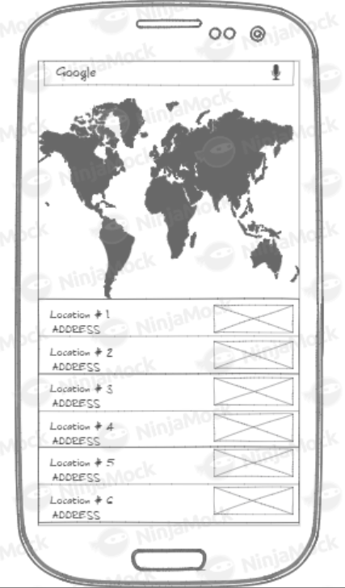

**Figure 3: Customer home ui screen**