可实现功能：数码管显示，最右侧的一位数码管以1Hz变化由0-9循环往复
分频+计数+显示整合之后
(请注意改名后使用）100%成功：
library ieee;
use ieee.std_logic_1164.all;
USE IEEE.STD_LOGIC_UNSIGNED.ALL;
entity zhengti28 is
port(clk:in std_logic;
zhengti28:out std_logic;
cp,clear:IN STD_LOGIC;
q:OUT STD_LOGIC_VECTOR(3 DOWNTO 0);
A:IN STD_LOGIC_VECTOR(3 DOWNTO 0);
LED7S:OUT STD_LOGIC_VECTOR(6 DOWNTO 0);
cat:OUT STD_LOGIC_VECTOR(5 DOWNTO 0)
);
end;
architecture one of zhengti28 is
signal cnt:std_logic_vector(2 downto 0);
signal clk_temp:std_logic;
SIGNAL temp:STD_LOGIC_VECTOR(3 DOWNTO 0);
SIGNAL tmp: INTEGER RANGE 0 TO 49999999;
SIGNAL clk_out: STD_LOGIC;
constant m:integer:=5;
begin
process(clk)
begin
if clk'event and clk='1' then
if cnt=m then
clk_temp<=not clk_temp;
cnt<="000";
else
cnt<=cnt+1;
end if;
end if;
end process;
zhengti28<=clk_temp;

P1:PROCESS(cp)
BEGIN
IF cp'event AND cp='1' THEN
IF tmp=49999999 THEN
tmp<=0;
ELSE
tmp<=tmp+1;
END IF;
IF tmp<=24999999 THEN
clk_out<='0';
ELSE
clk_out<='1';
END IF;
END IF;
END PROCESS P1;
P2:PROCESS(clear,clk_out)
BEGIN
IF clear='1' THEN temp<="0000";
ELSIF (clk_out'event and clk_out='1') THEN
IF temp="1001"THEN
temp<="0000";
ELSE
temp<=temp+1;
END IF;
END IF;
END PROCESS P2;
q<=temp;

PROCESS(temp)
BEGIN
CASE temp IS
WHEN "0000"=>LED7S<="0111111";--X"3F"->0
WHEN "0001"=>LED7S<="0000110";--X"06"->1
WHEN "0010"=>LED7S<="1011011";--X"5B"->2
WHEN "0011"=>LED7S<="1001111";--X"4F"->3
WHEN "0100"=>LED7S<="1100110";--X"66"->4
WHEN "0101"=>LED7S<="1101101";--X"6D"->5
WHEN "0110"=>LED7S<="1111101";--X"7D"->6
WHEN "0111"=>LED7S<="0000111";--X"07"->7
WHEN "1000"=>LED7S<="1111111";--X"7F"->8
WHEN "1001"=>LED7S<="1101111";--X"6F"->9
WHEN OTHERS=>LED7S<="0000000";--X"6F"->null
END CASE;
cat<="111110";
END PROCESS;
END;

其管脚设置：
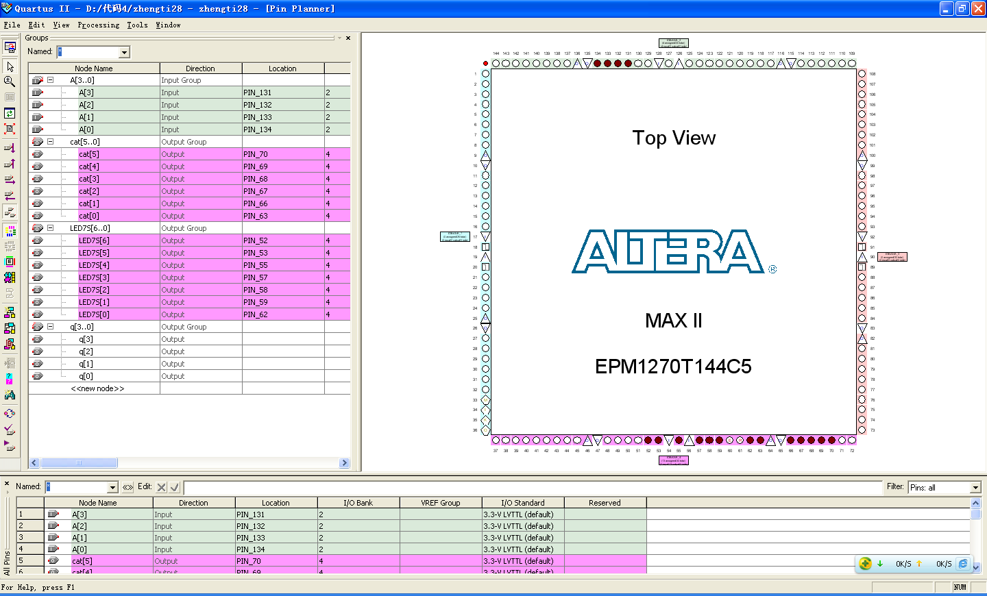
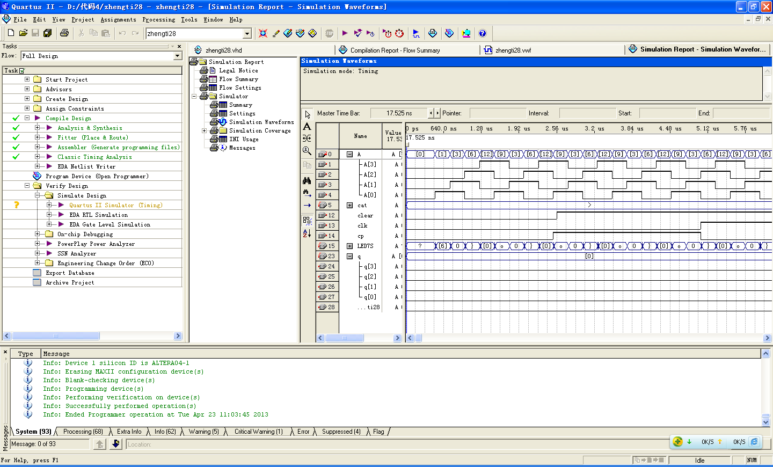
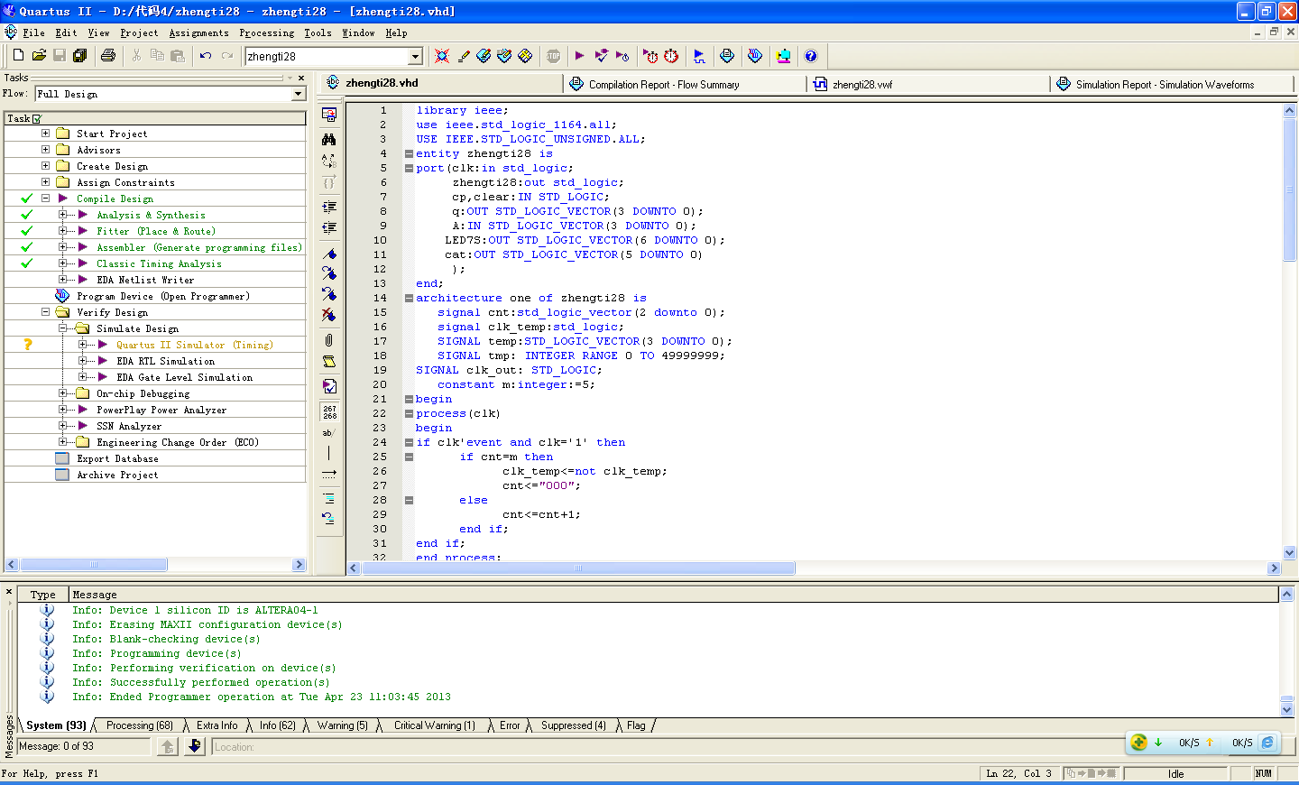

异步复位8421码十进制计数器：
LIBRARY IEEE;
USE IEEE.STD_LOGIC_1164.ALL;
USE IEEE.STD_LOGIC_UNSIGNED.ALL;

ENTITY BCDcoder IS
PORT(
cp,clear:IN STD_LOGIC;
q:OUT STD_LOGIC_VECTOR(3 DOWNTO 0));
END BCDcoder;

ARCHITECTURE a OF BCDcoder IS
SIGNAL temp:STD_LOGIC_VECTOR(3 DOWNTO 0);
SIGNAL tmp: INTEGER RANGE 0 TO 49999999;
SIGNAL clk_out: STD_LOGIC;
BEGIN
P1:PROCESS(cp)
BEGIN
IF cp'event AND cp='1' THEN
IF tmp=49999999 THEN
tmp<=0;
ELSE
tmp<=tmp+1;
END IF;
IF tmp<=24999999 THEN
clk_out<='0';
ELSE
clk_out<='1';
END IF;
END IF;
END PROCESS P1;
P2:PROCESS(clear,clk_out)
BEGIN
IF clear='1' THEN temp<="0000";
ELSIF (clk_out'event and clk_out='1') THEN
IF temp="1001"THEN
temp<="0000";
ELSE
temp<=temp+1;
END IF;
END IF;
END PROCESS P2;
q<=temp;
END a;
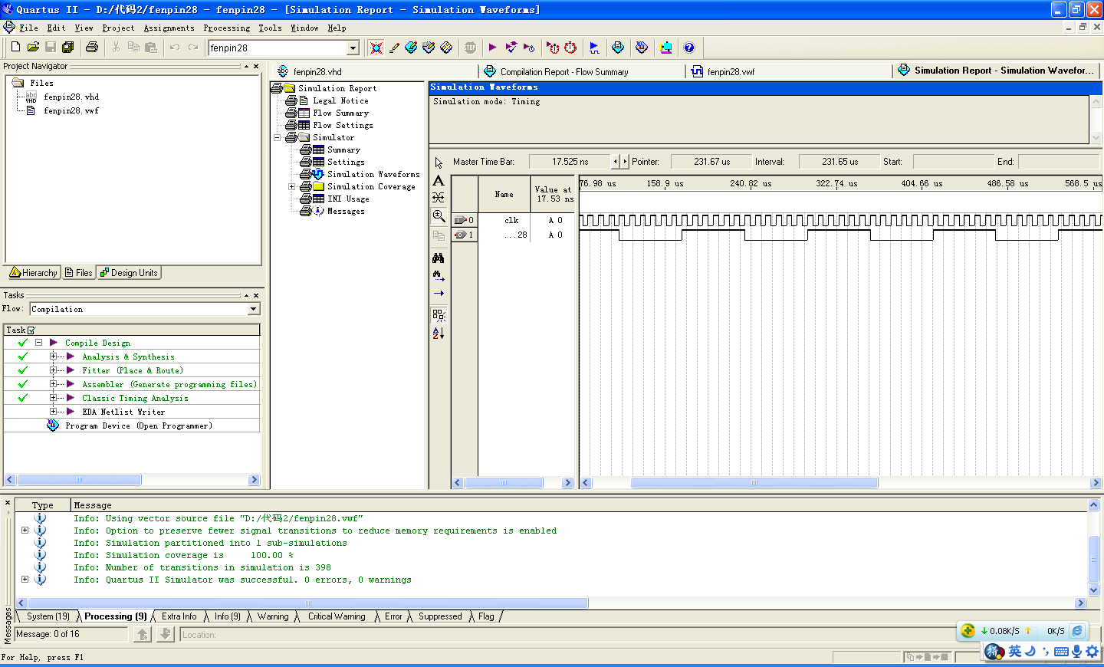分频器（上图为分频结果）
library ieee;
use ieee.std_logic_1164.all;
USE IEEE.STD_LOGIC_UNSIGNED.ALL;
entity fenpin28 is
port(clk:in std_logic;
fenpin28:out std_logic);
end;
architecture one of fenpin28 is
signal cnt:std_logic_vector(2 downto 0);
signal clk_temp:std_logic;
constant m:integer:=5;
begin
process(clk)
begin
if clk'event and clk='1' then
if cnt=m then
clk_temp<=not clk_temp;
cnt<="000";
else
cnt<=cnt+1;
end if;
end if;
end process;
fenpin28<=clk_temp;
end;

计数器：
LIBRARY IEEE;
USE IEEE.STD_LOGIC_1164.ALL;
USE IEEE.STD_LOGIC_UNSIGNED.ALL;

ENTITY jishu28 IS
PORT(
cp,clear:IN STD_LOGIC;
q:OUT STD_LOGIC_VECTOR(3 DOWNTO 0));
END jishu28;

ARCHITECTURE a OF jishu28 IS
SIGNAL temp:STD_LOGIC_VECTOR(3 DOWNTO 0);
SIGNAL tmp: INTEGER RANGE 0 TO 49999999;
SIGNAL clk_out: STD_LOGIC;
BEGIN
P1:PROCESS(cp)
BEGIN
IF cp'event AND cp='1' THEN
IF tmp=49999999 THEN
tmp<=0;
ELSE
tmp<=tmp+1;
END IF;
IF tmp<=24999999 THEN
clk_out<='0';
ELSE
clk_out<='1';
END IF;
END IF;
END PROCESS P1;
P2:PROCESS(clear,clk_out)
BEGIN
IF clear='1' THEN temp<="0000";
ELSIF (clk_out'event and clk_out='1') THEN
IF temp="1001"THEN
temp<="0000";
ELSE
temp<=temp+1;
END IF;
END IF;
END PROCESS P2;
q<=temp;
END a;

数码管：
LIBRARY IEEE;
USE IEEE.STD_LOGIC_1164.ALL;
USE IEEE.STD_LOGIC_UNSIGNED.ALL;
ENTITY shuma28 IS
PORT(A:IN STD_LOGIC_VECTOR(3 DOWNTO 0);
LED7S:OUT STD_LOGIC_VECTOR(6 DOWNTO 0);
cat:OUT STD_LOGIC_VECTOR(5 DOWNTO 0)
);
END;
ARCHITECTURE ONE OF shuma28 IS
BEGIN
PROCESS(A)
BEGIN
CASE A IS
WHEN "0000"=>LED7S<="0111111";--X"3F"->0
WHEN "0001"=>LED7S<="0000110";--X"06"->1
WHEN "0010"=>LED7S<="1011011";--X"5B"->2
WHEN "0011"=>LED7S<="1001111";--X"4F"->3
WHEN "0100"=>LED7S<="1100110";--X"66"->4
WHEN "0101"=>LED7S<="1101101";--X"6D"->5
WHEN "0110"=>LED7S<="1111101";--X"7D"->6
WHEN "0111"=>LED7S<="0000111";--X"07"->7
WHEN "1000"=>LED7S<="1111111";--X"7F"->8
WHEN "1001"=>LED7S<="1101111";--X"6F"->9

WHEN OTHERS=>LED7S<="0000000";--X"6F"->null
END CASE;
cat<="111110";
END PROCESS;
END;

一个有很多vhdl代码的网址：
http://download.csdn.net/download/shaoqso111/1901736

