# Mini-game 1: Avatar

Screen mockup

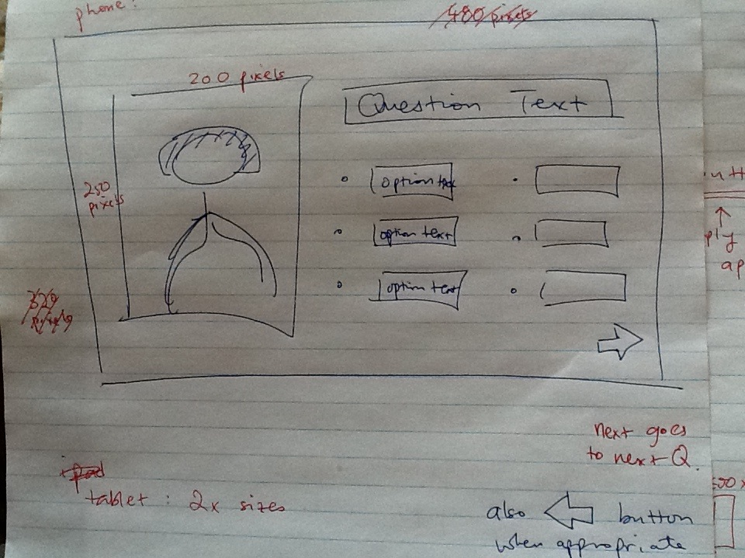

Question Text: this is where the instructions text goes

e.g., “Pick a hair colour”

Option Text: this is where possible options will go

e.g., “Red”

For this game, the question **texts** we need are (you can vary the wording as you see fit):

* Pick a hair style (or hair length)
* Pick a hair colour
* Pick a country

For this game, the option **texts** we need are:

* Short, long
* Red, black, blonde, brown
* Canada, Japan, China, Korea, France, Brazil

**Audio**: All text will need corresponding audio

**Images**: the avatar image will need to be broken up into several pieces that can be cut and paste together seamlessly. We need:

* A skeleton upper body with a person’s face (neutral gender), shaved hair, wearing a white tank top

Corresponding to each of the option texts above, we need **images** for:

* Short red hair, short brown hair, short black hair, short blonde hair – ALL MUST HAVE THE SAME HAIR STYLE
* Long red hair, long brown hair, long black hair, long blonde hair – ALL MUST HAVE THE SAME HAIR STYLE
* T-shirt over the skeleton body showing a Canada flag, T-shirt over the skeleton body showing a Japan flag, T-shirt over the skeleton body showing a China flag, T-shirt over the skeleton body showing a Korea flag, T-shirt over the skeleton body showing a France flag – ALL MUST HAVE THE SAME SHIRT SIZE AND COLOUR

Note for **images**: the avatar on the screen must fit in 200 pixels x 250 pixels for a phone layout and 400 pixels x 500 pixels for a tablet layout. So the sizes for the images for hair, t-shirt, face, etc. must be drawn up accordingly. It will be easier to draw the big versions first and then scale down for the smaller versions. All images will be in .PNG with transparent backgrounds.

# Mini-game 2: School Supplies Vocab

Screen mockup

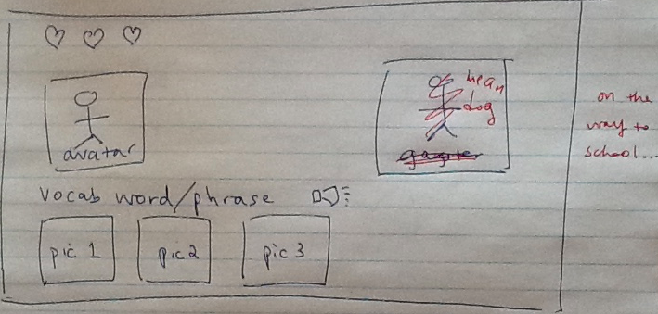

Vocab word or phrase: this is where the instructions text goes

e.g., “What is pencil?”

Pic1: this is where the first picture for an option will go

e.g., picture for pencil

For this game, the question **texts** we need are (you can vary the wording as you see fit):

* What is … ? (hopefully the … can be plugged in with a noun vocab)

For this game, the option **texts** we need are:

* A list of school supplies vocabulary

**Audio**: All text will need corresponding audio

Character **Images**: there are two characters in the mockup. These will need to be 150 pixels by 200 pixels. We need:

* The avatar image will be a generic looking person (we can customize it later if desired)
* The gangster image will be a yakuza character (see Nina’s text for reference)

Vocab **Images**: these will be displayed at the bottom with the size of 125 pixels by 125 pixels. We need:

* An image for each school supply vocab

Note for **images**: the image sizes given are for phone layouts, you will need the same images that are twice as big.

# Mini-game 3: Food Vocab

Screen mockup

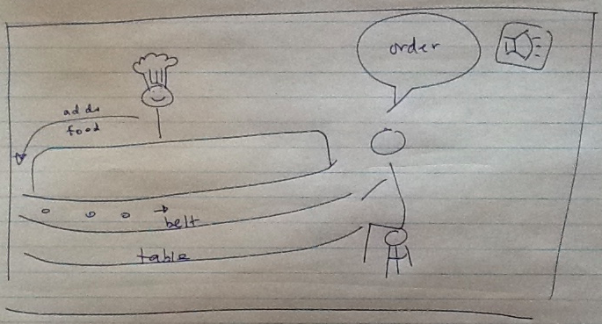

Order: this is where the instructions for the customer to order food goes

e.g., “Sake maki please”

For this game, the order **texts** we need are (you can vary the wording as you see fit):

* “… please” (hopefully the … can be plugged in with a food vocab)

**Audio**: All text will need corresponding audio

Background **Image**: most of what is on the mockup appears in the background of size 320 pixels by 480 pixels. On this background, we need:

* A restaurant scene that has an empty conveyor belt and a table, with the chef behind the food counter

Character **Image**: a customer sitting at the table is needed. The size of this customer should be relative to the background so it looks right. For this customer, we need:

* A customer sitting on a chair with a happy expression
* A customer sitting on a chair with a neutral expression – this is the same person, in the same sitting pose, only the facial expression is changed
* A customer sitting on a chair with an angry expression – this is the same person, in the same sitting pose, only the facial expression is changed

Vocab **Images**: all the food items will need to be placed on the conveyor belt in the game. These images need to be 100 pixels by 100 pixels. We need:

* An image for each food vocab

Note for **images**: the image sizes given are for phone layouts, you will need the same images that are twice as big.

# General Assets Needs

For some/all the mini-games, we also need the following buttons:

* **Image**: An audio icon (that looks like a speaker)
* **Image**: A left arrow (going forward to the next screen)
* **Image**: A right arrow (going back to the previous screen)
* **Image**: A filled heart (showing a life is available)
* **Image**: A faded heart (showing a life has been used) – THIS MUST BE THE SAME HEART WITH ONLY THE INSIDE COLOUR CHANGED

Additional items needed to polish up the games:

* **Audio**: A short positive feedback sound when the user gets something right
* **Audio**: A short negative feedback sound when the user gets something wrong
* **Audio**: A short game over sound when the user is done with the game
* Splash page to introduce the game
* Consent page to ask for agreement to have data collected for educational purposes
* Instructions or teaching support material
* Credits page
* Game over page, possibly showing game statistics
* Dealing with data logging – details may need to be flushed out