|  |  |  |  |  |  |
| --- | --- | --- | --- | --- | --- |
| № | SD адаптер | № | PWC10-6 (X9) | № | J1 XMEGA |
| 1 | CS | 1 | CS | 1 | SDA |
| 2 | DI | 2 | MOSI | 6 | MOSI |
| 4 | Vdd | 3 | +3.3v | 10 | P3V3 |
| 5 | SCLK | 4 | CLK | 8 | SCK |
| 6 | GND | 5 | GND | 9 | GND |
| 7 | DO | 6 | MISO | 7 | MISO |

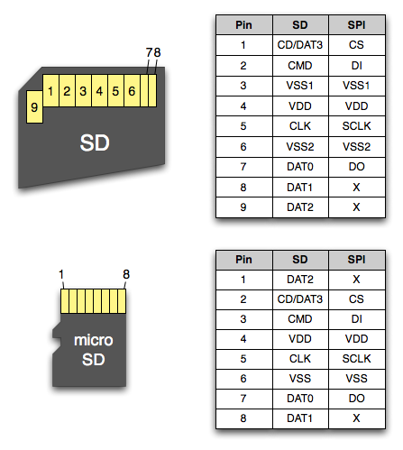

|  |  |  |  |  |  |
| --- | --- | --- | --- | --- | --- |
| № | microSD | № | PWC10-6 (X9) | № | J1 XMEGA |
| 2 | CS | 1 | CS | 1 | SDA |
| 3 | DI | 2 | MOSI | 6 | MOSI |
| 4 | Vdd | 3 | +3.3v | 10 | P3V3 |
| 5 | SCLK | 4 | CLK | 8 | SCK |
| 6 | GND | 5 | GND | 9 | GND |
| 7 | DO | 6 | MISO | 7 | MISO |