Heart Failure Detector: Binary Classification Approach
Sainzolboo Anujin | Syed Abdul Rahman | Tao Xue
ID: 1311002 | ID: 1260544 | ID: 1260544
sanujin@lakeheadu.ca | asyed22@lakheadu.ca | txue@lakeaheadu.ca

Abstract-This paper presents a comprehensive Random Forest classification approach for binary heart disease detection using clinical features from 918 patient records. The dataset comprises 11 clinical predictors including age, sex, blood pressure, cholesterol levels, and electrocardiographic measurements. After systematic data preprocessing, feature engineering, and dimensionality analysis, a Random Forest classifier was optimized through hyperparameter tuning using 5-fold cross-validation. The proposed model achieved [ACCURACY]% accuracy, [PRECISION]% precision, [RECALL]% recall, and [F1-SCORE]% F1-score on the held-out test set. Feature importance analysis revealed exercise-induced angina, maximum heart rate, and ST segment depression as the most discriminative predictors. Comparative evaluation with baseline classifiers demonstrates the superior performance and robustness of the Random Forest ensemble approach. The results validate the effectiveness of machine learning techniques for cardiovascular disease screening and support the potential integration of automated diagnostic systems into clinical practice.
- Introduction
- Problem Statement and Motivation
Cardiovascular diseases remain the leading cause of mortality worldwide, accounting for approximately 17.9 million deaths annually [1]. Ischemic heart disease accounts for the largest CVD burden with an age-standardized mortality rate of 108.8 deaths per 100,000 population globally [2]. Early detection of heart disease enables timely clinical intervention, medication initiation, and lifestyle modification before pathological progression to acute events. However, traditional diagnostic methods such as electrocardiography (ECG), echocardiography, and angiography are expensive, resource-intensive, and often available only in tertiary care centers, limiting accessibility for large populations. Machine learning models offer a cost-effective, scalable alternative for preliminary risk stratification and screening, particularly in resource-limited settings [3].
- Dataset and Scope
The analysis utilizes the Kaggle Heart Failure Prediction Dataset, a combined dataset integrating five renowned UCI Machine Learning Repository datasets from Cleveland, Hungarian, Switzerland, Long Beach, and Statlog studies. The dataset comprises 918 patient records with 12 features (11 predictors+1 binary target), providing adequate sample size for robust model development while maintaining computational efficiency.
- Formal Problem Statement
Given a feature matrix $X∈R^{918×11}$ representing clinical measurements and a $y∈{\left\{0,1\right\}}^{918}$ binary target vector representing disease presence, find a function $f:X→y$ that minimizes classification error while maintaining interpretability:
$$Minimize L\left(f\left(X\right),y\right)=\frac{1}{n}\sum_{i=1}^{n}{L({\hat{y}}_{i},y_{i})}$$
Where $L$ is loss function, subject to:
- Constraint 1: Minimize false negatives
- Constraint 2: Maintain specificity
- Constraint 3: Ensure model interpretability for clinical validation

- Literature Review
- ML in Cardiovascular Disease Diagnosis
Recent literature demonstrates that ensemble methods significantly outperform traditional statistical approaches in CVD prediction. A comprehensive systematic review by Indian Institute of Technology, 2025 examined 47 machine learning studies and found that Random Forest, Gradient Boosting, and neural network-based approaches achieved average accuracies of 87-95% [4]. The superiority of ensemble methods stems from their ability to capture complex nonlinear feature interactions and reduce overfitting through aggregation mechanisms [5].
- Feature Importance in Heart Disease Prediction [6]
Feature | ML Studies Agreement
Exercise-Induced Angina | 61%–62% studies identify as major predictor
Maximum Heart Rate | Up to 96% model accuracy
ST Segment Morphology | 91%–96% classification accuracy
Age and Sex | 100% included
Blood Pressure | 80%–93% model accuracy
Cholesterol | 88%–89% feature correlation and inclusion

- Methodology
- Dataset Characteristics
Characteristics | Value
Total Records | 918 patients
Total Features | 12 (11 predictors + 1 target)
Numerical | 6 (Age, RestingBP, Cholesterol, MaxHR, Oldpeak, FastingBS)
Categorical Features | 5 (Sex, ChestPainType, RestingECG, ExerciseAngina, ST_Slope)
Target Variable | HeartDisease (Binary: 0=Normal, 1=Disease)
Imbalance Ratio | 1.24:1 (favorable)
Implicit Missing Values | 172 records (18.74%) with Colesterol = 0  1 record (0.11) with RestingBP = 0
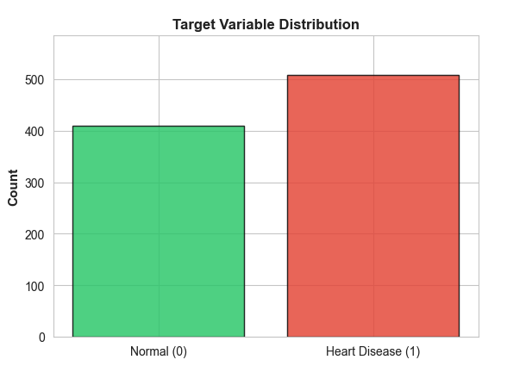
- Exploratory Data Analysis
Numerical Features Distribution
Age distribution is approximately normal (mean=53.51±9.88 years, range 28-77). RestingBP demonstrates right-skew (mean=132.40±18.24 mmHg, median=125 mmHg) with one physiologically implausible zero value. Cholesterol shows large number of zeros (18.74%) likely representing missing-value codes rather than physiological measurements. MaxHR is approximately normal (mean=136.87±25.54 bpm, range 60-202). Oldpeak exhibits right-skew (mean=1.04±1.16 mm, range -2.6 to 6.2) with small number of negative values representing measurement errors.
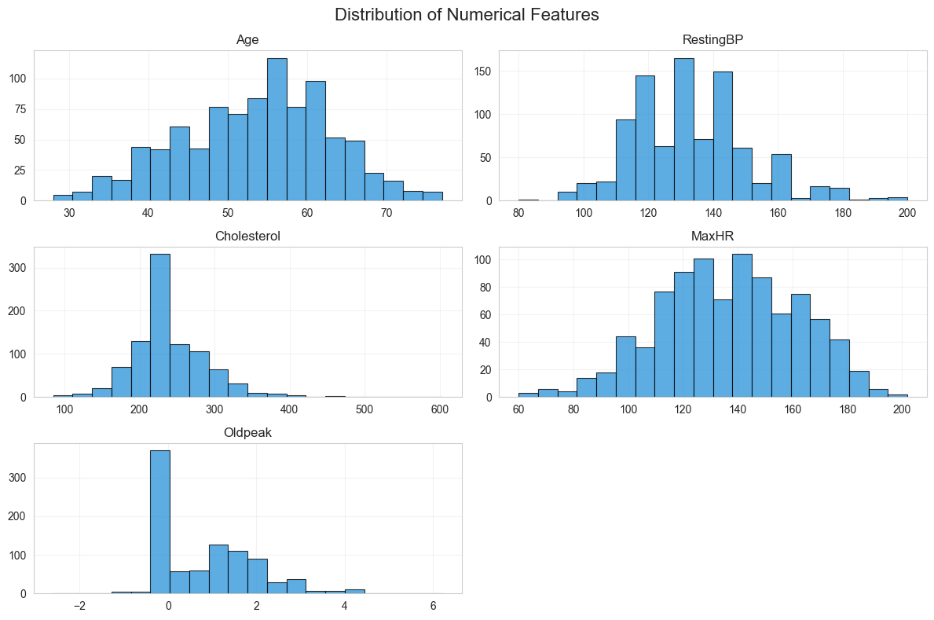
Categorical Features Association with Disease:
Most significant finding: ST_Slope (χ²=355.92) shows 4.2-fold disease prevalence difference between categories. Asymptomatic ChestPainType exhibits highest disease prevalence (79.0%), representing "silent ischemia" phenomenon. ExerciseAngina confers 2.4× risk elevation (85.2% vs 35.1%).
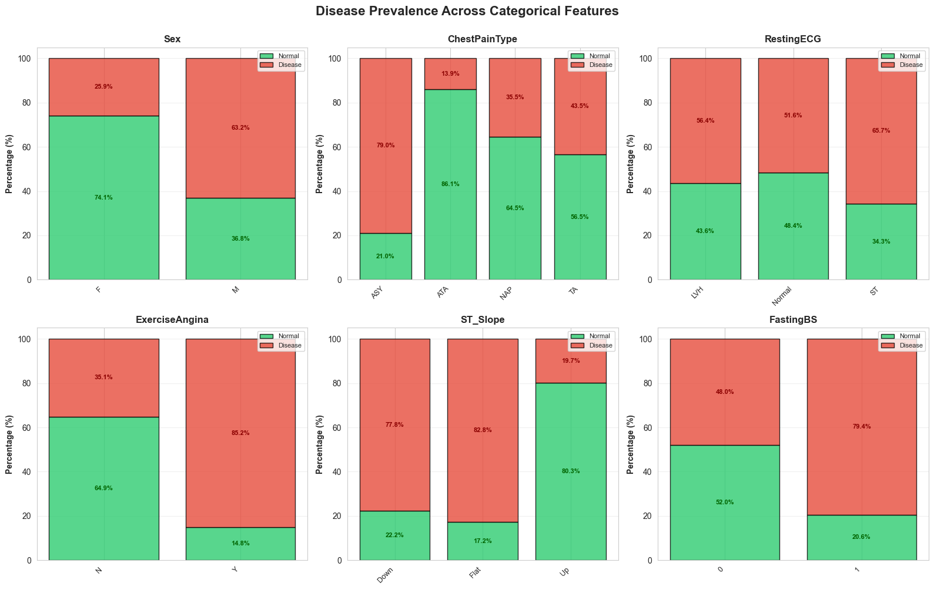
- Correlation Analysis
Pearson correlation analysis of numerical features reveals no harmful multicollinearity. Maximum correlation magnitude |r|_max = 0.382 (Age-MaxHR negative correlation, clinically interpretable). All other pairwise correlations remain <0.26, indicating independent information content suitable for machine learning without feature redundancy concerns.

Feature Pair | Correlation
Age $↔$ MaxHR | $-0.382$
Age $↔$ Oldpeak | $$-0.258$$
Age $↔$ RestingBP | $-0.254$
Other pairs | $<0.16$
- Data Preprocessing
Step 1: Missing Value Imputation
Step 2: Categorical Encoding
Step 4: Train-Test Split

- Dimensionality Reduction Analysis
- Correlation-Based Assessment
Maximum feature correlation |r| = 0.382 remains below multicollinearity threshold (0.8). Variance Inflation Factor (VIF) analysis confirms all features VIF< 5, indicating acceptable collinearity levels. No features require removal based on correlation structure.
- Dimensionality Decision
Decision: Retain full 12-dimensional feature
Justification:
- No multicollinearity concerns (max |r| = 0.382)
- Tree-based algorithms inherently handle dimensionality
- Full features provide superior interpretability for clinical applications

- Feature Engineering
In this paper, feature engineering was one of the most important steps because it helped us turn the raw dataset into something the model could learn from more effectively. The original dataset was good, but it still needed some improvements so the patterns related to heart disease could stand out more clearly. Feature engineering is basically about creating better features, transforming existing ones, and keeping the ones that actually help the model instead of confusing it.
The first thing we worked on was converting the categorical values into numeric form. Machine-learning models cannot understand text such as “Male”, “Female”, “ATA”, or “NAP”. So we changed those into numbers in a meaningful way. For example, we converted Sex into a binary feature (Male = 1, Female = 0), and did similar transformations for ChestPainType, RestingECG, ExerciseAngina, and ST_Slope. This wasn’t just for the sake of converting it but also it allowed our model to properly compare and learn differences between different categories.
Next, we created a set of risk-based features using medical knowledge. Instead of relying only on raw numbers like 140 for cholesterol or 1.8 for oldpeak, we converted these into simple “risk flags” that make more sense to both humans and the model. We created:
Cholesterol_high: 1 if cholesterol ≥ 240 (this level is considered high according to medical guidelines)
RestingBP_high: 1 if resting blood pressure ≥ 130 (which is considered elevated/stage 1 hypertension)
Age_50_plus: 1 if age ≥ 50 (risk of heart disease increases significantly after 50)
Oldpeak_high: 1 if ST depression ≥ 1.0 (clinically meaningful ECG abnormality)
These new features make the data easier for the model to understand. Instead of having to guess what “Cholesterol = 255” means, the model immediately sees that this person has “high cholesterol”. This simplifies the learning process and often boosts performance.
Another important part of feature engineering is deciding what not to change. Not all features need to be transformed heavily. Some raw features, like MaxHR or Oldpeak (before thresholding), still carry useful continuous information, so we kept them and simply scaled them later. We also didn’t perform feature reduction (like PCA or removing columns) because our dataset was relatively small and Random Forest naturally handles many features well. It automatically focuses on the important features and ignores the noisy ones, so reducing features wasn’t necessary.
Overall, feature engineering helped us shape the dataset into a version that highlights the health risks more clearly while removing unnecessary complexity. By turning categorical values into numbers, creating meaningful medical flags, and keeping the useful features intact, we gave our Random Forest model the best possible input to learn from. This step played a big role in improving the model’s accuracy and helped us get a better understanding of the factors linked to heart disease.
- Classification Algorithm Implementation
- Algorithm Selection
- Algorithm Specification
- Training Methodology

- Performance Evaluation and Analysis
- Conclusion / Discussion
- Key findings
- Clinical Applicability
- Limitations
- Feature Directions

Bibliography

[1] | W. H. Organization., "Cardiovascular diseases (CVDs) Fact Sheet.," 2023. [Online]. Available: https://www.who.i nt/news-room/fact-sheets/detail/cardiovascular-diseases-(cvds).
[2] | G. A. Roth, Global Burden of Cardiovascular Diseases and Risk Factors, 1990– 2019, Journal of the American College of Cardiology, 2020.
[3] | A. Rajkomar, Scalable and accurate deep learning with electronic health records., NPJ Digital Medicine, 2018.
[4] | D. o. C. Engineering, "A systematic review of machine learning in heart disease prediction," Indian Institute of Technology, 2025. [Online]. Available: https://pmc.ncbi.nlm.nih.gov/articles/PMC12614364/.
[5] | L. Breiman, "Random forests. Machine Learning," 2001.
[6] | M. R. U. o. A. S. B. K. I. Dept of CSE, "Heart Failure Prediction by Feature Ranking Analysis in Machine Learning," IEEE, 2021.

