Size of baffle for 90” PFC
Jim Burge
March 12, 2002

We need a baffle that blocks incoming light before it hits the filter mechanism. This baffle has been specified to be located at a position 3 mm behind the shutter. From the David’s I-deas model, this surface is 111 mm from the flat side of L4.
Filter

L3
baffle
L4

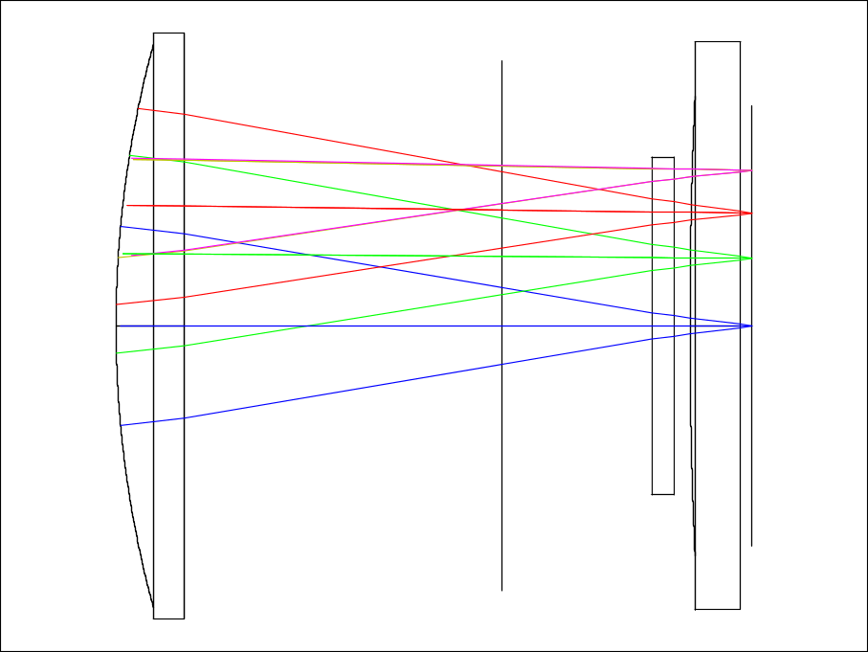
111 mm
(141 mm nom)

I have assumed 10 mm thick filters, 150 x 150 mm.

The size of the baffle must be larger than 220 mm diameter, since the baffle will be directly illuminated with light up to 110 mm off axis.
The square aperture should be 170 mm on a side. This matches the aperture defined by the filters. The corners should not be sharp. The radius should be 20 mm +/- 3 mm.

This will size will reject stray light, but will not block any light from the science images.
The figure below shows the beam footprints on the baffle.

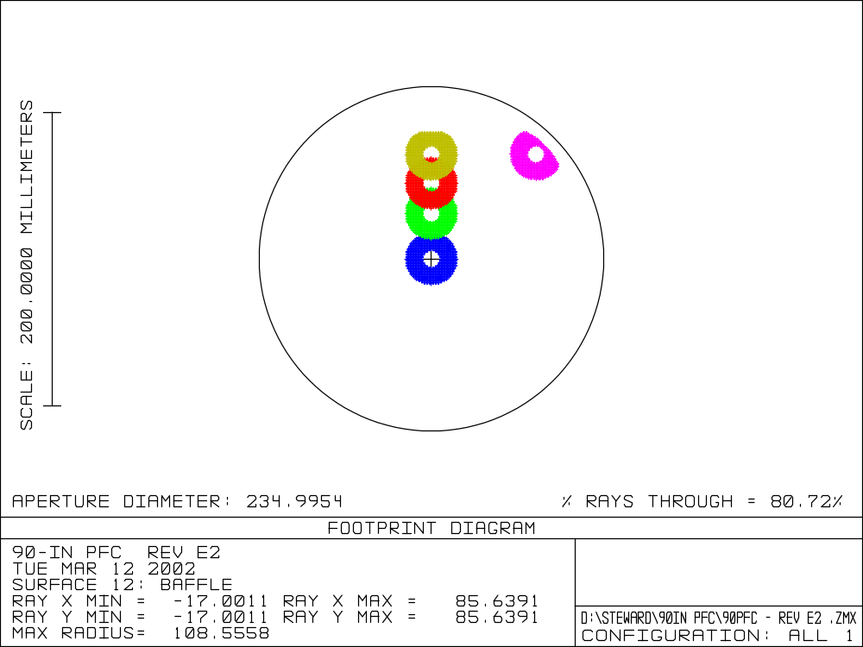
Corner beamprint defined by lens apertures
Square aperture of baffle

