Optical Design and specifications for the 90-in Prime Focus Corrector

Part 1: specifications and tolerances

Revision D

Jim Burge and Gordon Tang

April 20, 2000

This memo summarizes the optical design for the 90-in Prime Focus Corrector. The final specifications and tolerances for the individual lenses and for the mounting are given. Part 2 of this memo gives the analysis of the performance of the optical system.

Design revisions:
Rev. A Sept. 1, 1999 – original memo
Rev. B Sept. 9, 1999
Filter moved 28 mm towards the CCD
(spacing from filter to lens 4 changed from 44 to 16 mm
spacing from lens 3 to filter changed from 172 to 200 mm)
Drawing and tables modified to reflect this change
This does not affect performance
Rev. C Oct. 25, 1999
Incorporated measurements of the primary mirror from Sarlot et al.
Some lens spacings were changed
The figure on the aspheric surface was changed (Lens 2, concave surface)
The overall performance and the tolerances are not affected

Rev D April 20, 2000
Accommodated radius change for L2 for available test plate
Incorporated as-built dimensions for L3, L4 (they were within spec)
Slight re-spacing of elements to re-optimize

System specifications

Primary mirror (from Sarlot et al.)
Radius of curvature R 12281 ± 4 mm
Conic constant K -1.0646 ± 0.001
Clear aperture D 90” ± 0.06”
Central obscuration 33.5 ± 0.1”

Spacings (in mm)
 | Rev. D | Rev D change | Rev. C | Rev B
Primary mirror – Lens1 spacing | 5010.4 ± 1 | ✓ | 5009.4 ± 1 | 4958.2 ± 1
Lens1 thickness | 45 ± 0.1 |  | 45 ± 0.1 | 45 ± 0.1
Lens1 – Lens2 spacing | 429.9 ± 0.3 | ✓ | 430.5 ± 0.3 | 434.8 ± 0.3
Lens2 thickness | 14 ± 0.1 |  | 14 ± 0.1 | 14 ± 0.1
Lens2 – Lens3 spacing | 441.6 ± 0.3 | ✓ | 442.3 ± 0.3 | 450.8 ± 0.3
Lens3 thickness | 30.21 ± 0.005 | ✓ | 30 ± 0.3 | 30 ± 0.3
Lens3 – filter spacing  (focus adjust for system) | 204.4 ± 5 | ✓ | 204.9 ± 5 | 200.± 5
Filter thickness | 8 ± 4 |  | 8 ± 4 | 8 ± 4
Filter – Lens4 spacing | 16 ± 3 |  | 16 ± 3 | 16 ± 3
Lens4 thickness | 17.75 ± 0.005 | ✓ | 17.3 ± 0.5 | 17.3 ± 0.5
Lens4 – focal plane spacing | 5 ± 1 |  | 5 ± 1 | 5 ± 1
Overall length Lens 1 to FP | 1212 | ✓ | 1213 | 1221

The overall design is shown below. We have divided the system into two parts – Can 1 and Can 2. Can 1 which holds the filter mechanism, Lens 4 (which is the dewar window) and the focal plane array. Can 2 holds Lens1, Lens 2, and Lens 3. The entire unit is supported by a spider, which is bolted to the telescope.

The requirements for the systems are

Overall system, supported by spider
Held with Lens1 – PM distance of 5010.4 ± 5. (Must maintain this to ±1 mm.)
Centered to telescope axis to 0.1 mm
Aligned in rotation to 0.05 mrad (about middle of system)

Can 1, Focal plane assembly  Driven axially for focus adjustment  10 µm resolution and stability for axial motion  0.2 mrad rotation about interface to Can 2  0.5 mm centration | Can 2, Lens housing  50 µm stability for axial motion  0.1 mrad rotation about interface to Can 1  - mm centration

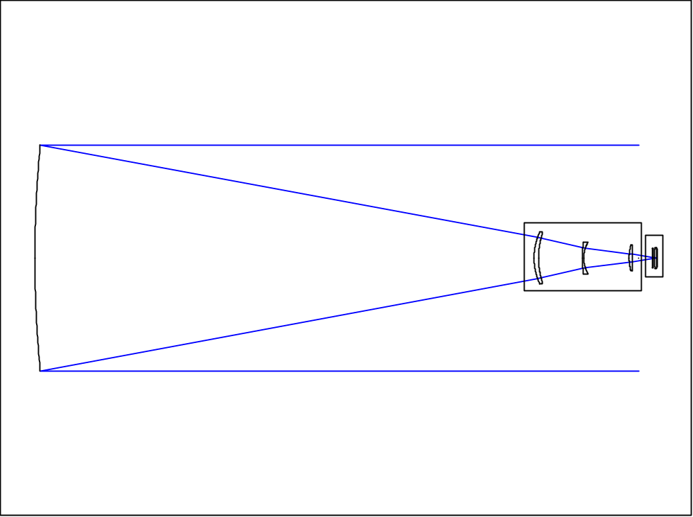
Primary mirror
Can 1
Can 2

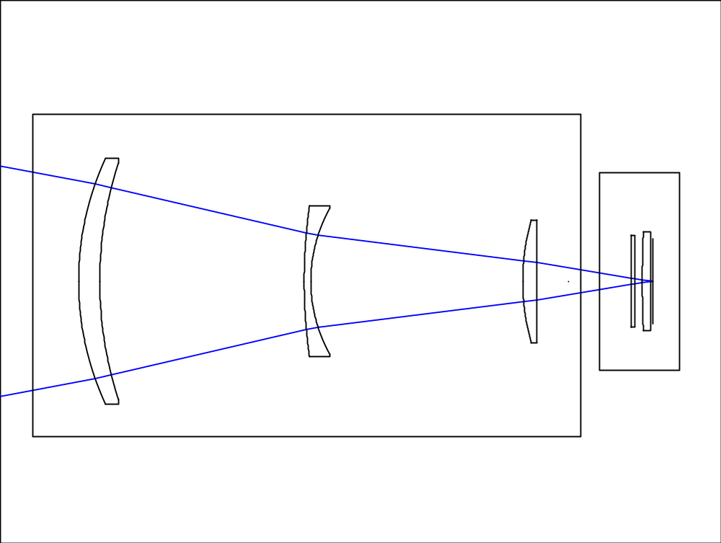
Can 2
Lens 1
Can 1
Lens 3
Lens 4
Filter
Focal plane
Lens 2

Lens mounting specifications

Focal plane
decenter | ?
Tilt | < 0.2 mrad

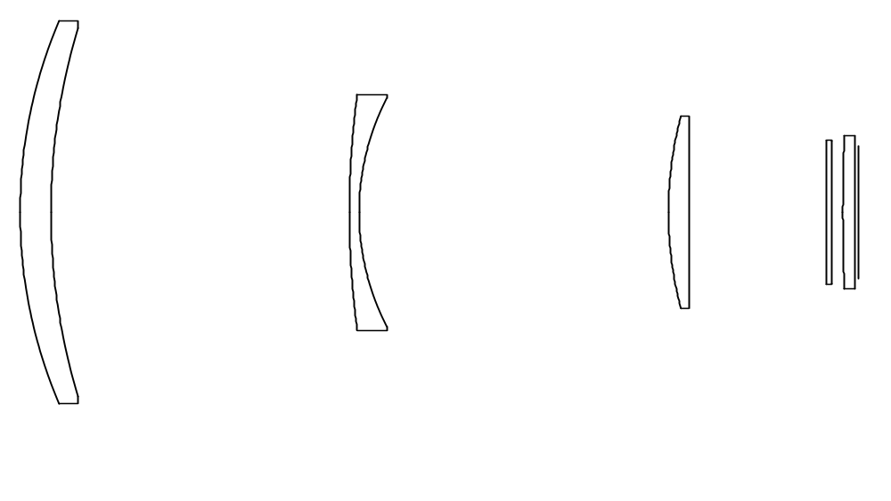

Lens 1
Diameter | 520
CA1 | 495
CA2 | 480
CT | 45.0 ± 0.1
(ET | 27.4 )
Wedge | < 0.05 mm
decenter | < 0.1 mm
Tilt | < 0.05 mm
 | (0.1 mrad)

Lens 2
Diameter | 320.65
CA1 | 296
CA2 | 276
CT | 14.0 ± 0.1
(ET | 43 )
Wedge | < 0.05 mm
decenter | < 0.1 mm
Tilt | < 0.05 mm
 | (0.16 mrad)

Lens 3
Diameter | 260
CA1 | 240
CA2 | 240
CT | 30.21± 0.005
(ET | 12.2 )
Wedge | < 0.05 mm
decenter | < 0.1 mm
Tilt | < 0.05 mm
 | (0.2 mrad)

Lens 4
Diameter | 208
CA1 | 188
CA2 | 188
CT | 17.75 ± 0.005
(ET | 15.5 )
Wedge | < 0.05 mm
decenter | < 0.2 mm
Tilt | < 0.2 mm
 | (1 mrad)

5 ± 1
CCD – L4
5010.4 ±1
to primary
Vertex spacings shown
429.9 ± 0.3
16 ± 3
204.4
441.6 ± 0.3

Lens 1 Rev D.
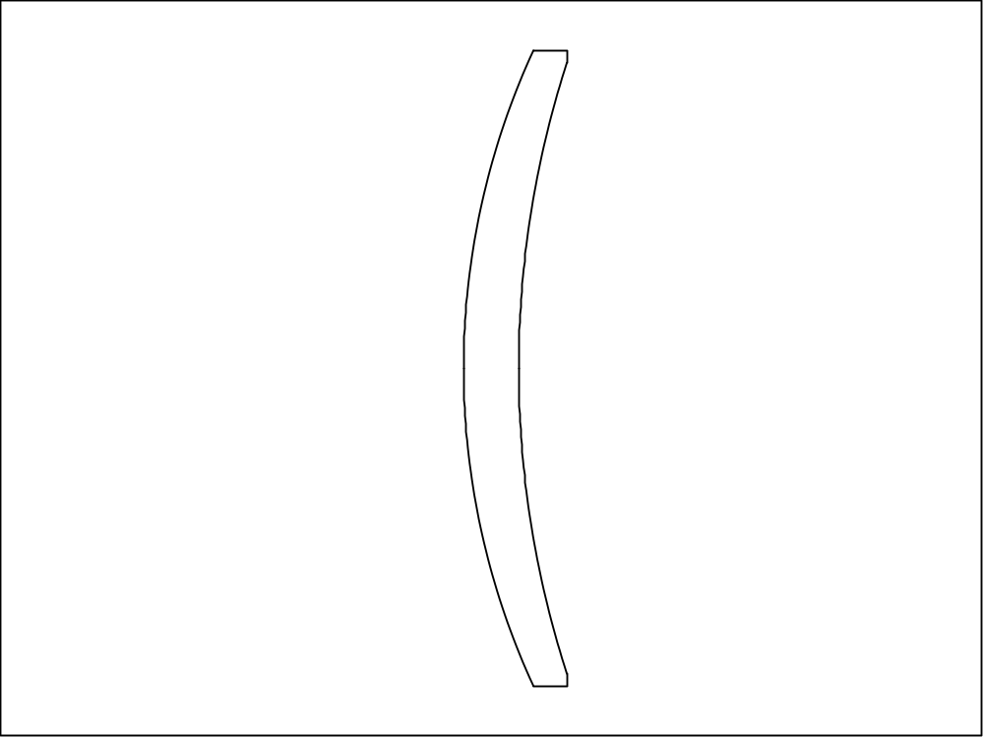

Surface 1
CA1 | 495
R1 | 622.0 ± 0.15 (cvx)
Figure | Measured by custom 250 mm test plate
 | 0.5 fringes power
 | 0.25 fringes irregularity

Surface 2
Diam | 500
CA2 | 480
R2 | 813 ± 0.3 (ccv)
Figure | Measured by PSI
 | Rms slopes < 0.025 waves/cm

Outside diameter | 520
Center thickness | 45.0 ± 0.1 mm
(Edge thickness | 27.4 mm)
Wedge | < 0.05 mm

Material
Fused silica (equivalent with Amersil Grade 4000 or Hereaus Herasil 3)
Refractive index inhomogeneity < 1e-5 P-V
Birefringence < 10 nm/cm
Total inclusion cross section < 1 mm/100 cc
Maximum inclusion 1 mm
Lens 2 – Rev. D.
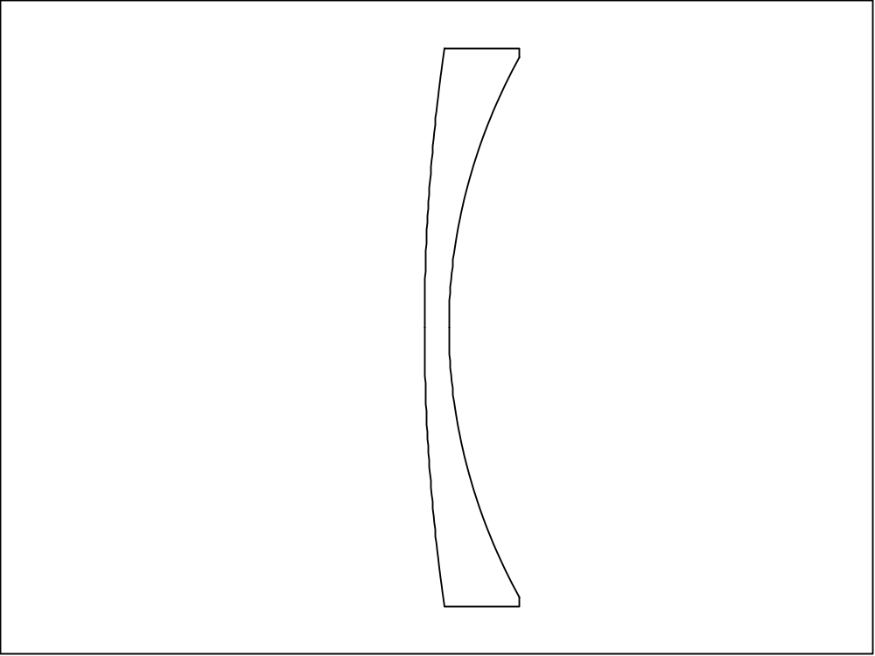
Outside diameter | 320.65 as built
Center thickness | 14.0 ± 0.1 mm
(Edge thickness | 43 mm)
Wedge | < 0.05 mm

Surface 1
CA1 | 296
R1 | 1128.1 ± 1 (cvx)
Figure | Measured by Kreisher 150 mm test plate
 | 0.5 fringes power
 | 0.25 fringes irregularity

Surface 2, asphere
Diam | 310
CA2 | 276
R2 | 312.58
K2 | -0.249
Figure | Measured by PSI
 | Using ellipse test
 | 0.2 waves/cm

Material
Fused silica (equivalent with Amersil Grade 4000 or Hereaus Herasil 3)
Refractive index inhomogeneity < 1e-5 P-V
Birefringence < 10 nm/cm
Total inclusion cross section < 1 mm/100 cc
Maximum inclusion 0.76 mm

Ellipse test – Rev. D
Measure interferometrically using natural conjugate points for the ellipse  Aspheric surface  R = 312.58 mm  K = -0.249  623.9 ± 0.3 mm  208.5 ± 0.1 mm  The radius of curvature and conic constant tolerances follow from the tolerances defined for the test conjugates.  C1 = 623.9 ± 0.3 mm  C2 = 208.5 ± 0.1 mm  Rms surface slopes < 0.2 waves/cm | 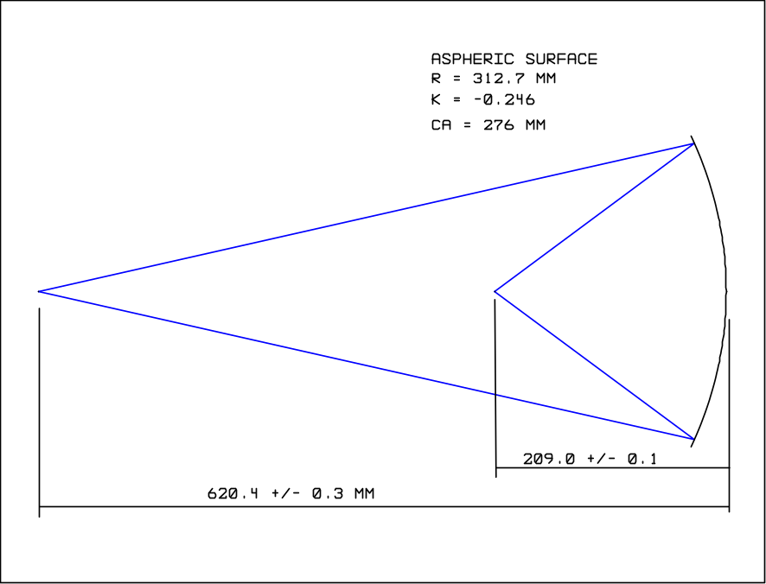

Lens 3 Rev D

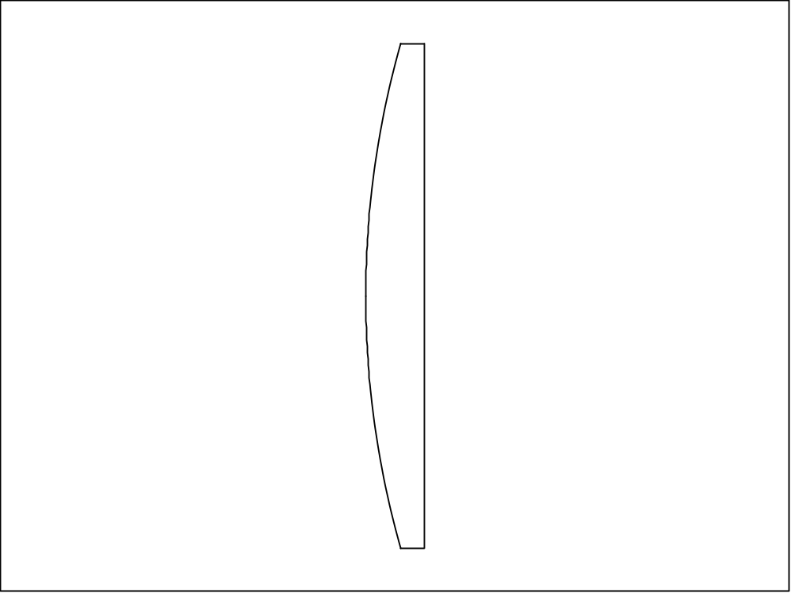
Outside diameter | 260
Center thickness | 30.21 as built
(Edge thickness | 12.2 mm)
Wedge | < 0.05 mm

Surface 1
CA1 | 240
R1 | 478.54 as built
Figure | Measured by Kreisher 100 mm test plate
 | 1 fringes power
 | 0.5 fringes irregularity

Surface 2
CA2 | 240
R2 | Flat (1 fringe convex/25cm TP)
Power | < 9 fringes / 100 mm
Figure | Measured with 100 mm test plate
 | 1 fringes power
 | 0.5 fringes irregularity

Material
Fused silica (equivalent with Amersil Grade 4000 or Hereaus Herasil 3)
Refractive index inhomogeneity < 1e-5 P-V
Birefringence < 10 nm/cm
Total inclusion cross section < 1 mm/100 cc
Maximum inclusion 0.76 mm

Lens 4 Rev D

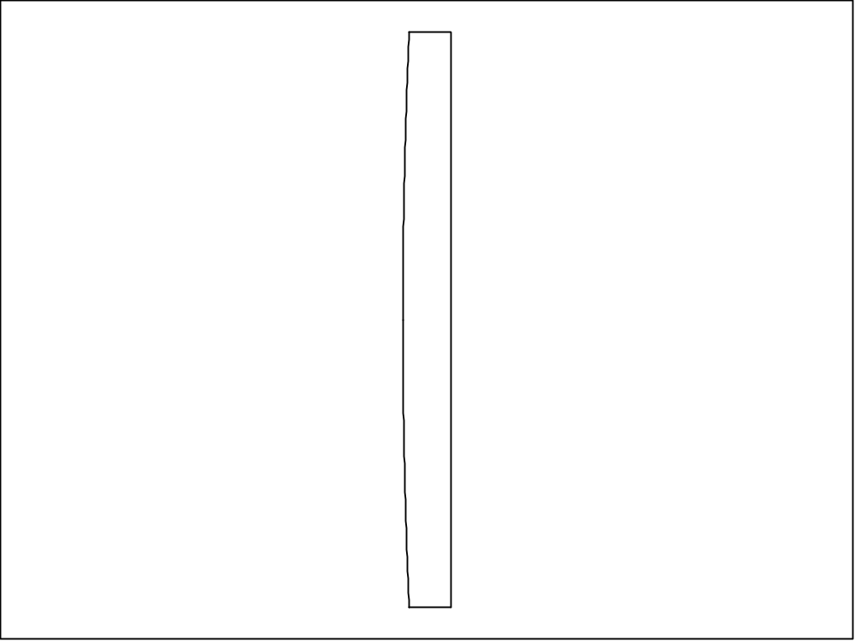
Outside diameter | 208
Center thickness | 17.75 as built
(Edge thickness | 15.5 mm)
Wedge | < 0.05 mm

Surface 1
CA1 | 188
R1 | 2370.5 as built)
Figure | Measured by Kreisher 100 mm test plate
 | 4 fringes power
 | 2 fringes irregularity

Surface 2
CA2 | 188
R2 | Flat (1 fringe concave over full aperture))
Power | < 10 fringes / 100 mm
Figure | Measured with 100 mm test plate
 | 4 fringes power
 | 2 fringes irregularity

Material
Fused silica (Amersil Grade 4100 or Hereaus Herasil 2)
Refractive index inhomogeneity < 6e-6 P-V
Birefringence < 10 nm/cm
Total inclusion cross section < .1 mm/100 cc
Maximum inclusion 0.3 mm

