Optical Design and specifications for the 90-in Prime Focus Corrector

Part 2: Analysis of system performance

Jim Burge and Gordon Tang

Sept. 1, 1999

Optical design
The wide field imager, placed at prime focus of the Steward 90-in uses 4 fused silica lenses to image 1.07° onto a focal plane paved with 4 4k x 4k CCD arrays. The basic telescope parameters are

Telescope diameter | 2287 mm
Primary mirror | R = 12192 mm  K = -1.06 (needs to be measured)
Primary to Corrector distance | 4958 mm
Diameter of largest element | 520 mm
System focal length | 6821 mm
Plate scale | 30.2 arc seconds/mm  (33 µm/arc second)
Focal ratio | F/2.98
Pixel size | 15 µm  (0.45 arc seconds on sky)
Array size | 128 x 128 mm  (1.07 x 1.07° on sky)
Wavelength range | Optimized for 0.35 – 0.9 µm  Performs to 2.2 µm
Image quality – ideal system | 3.57 µm rms image radius, average over field and wavelength
Image quality – with manufacturing tolerances | 7.43 µm rms image radius, average over field and wavelength

The plots below show image performance for the system focused for particular wavelength bands.
The encircled energy plots show 4 curves, corresponding to images on-axis, 45 mm from the axis, 64 mm from axis (at edge of array), and 90 mm from axis (at corners of array)

0.35 – 0.4 µm

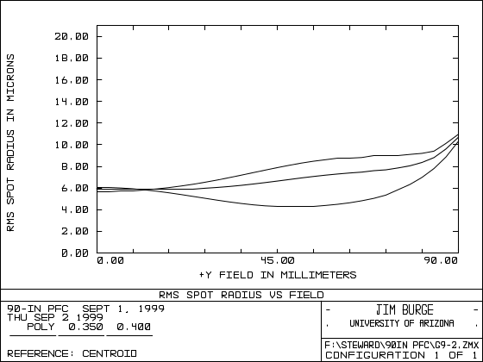 | 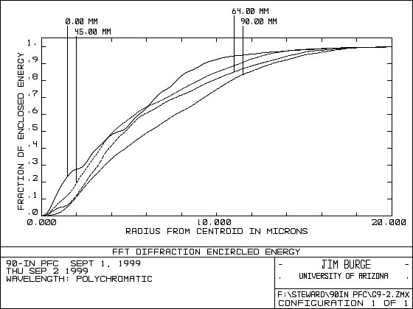
0.45 – 0.55 µm

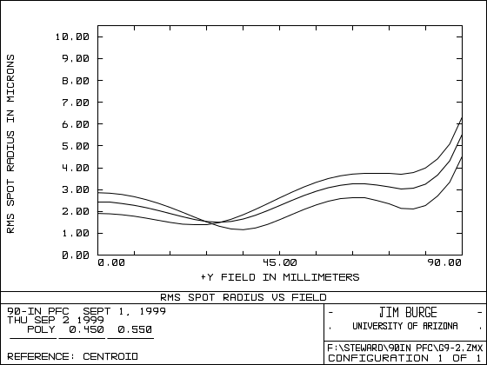 | 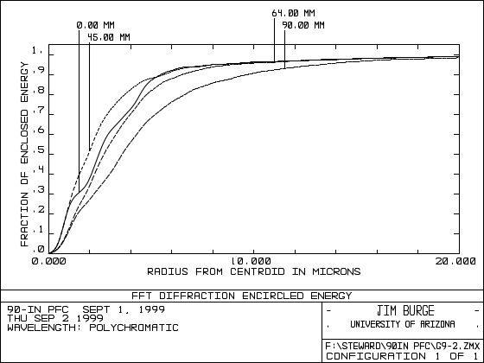

0.55 – 0.7 µm

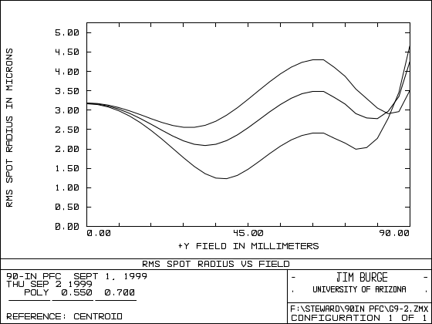 | 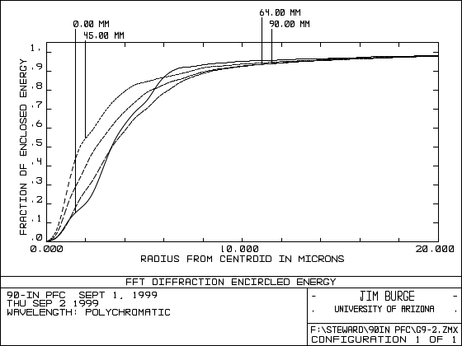
0.7 – 0.9 µm

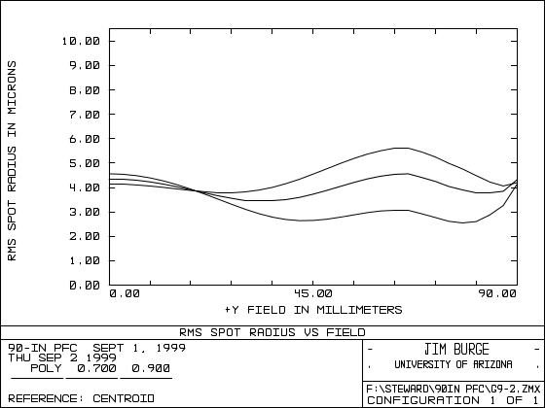 | 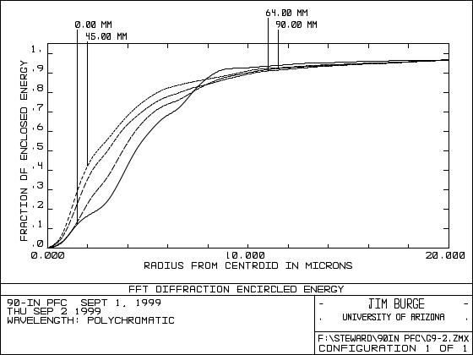

Vignetting
The system is made to intentionally vignet, or clip some of for the corners of the field. A limit of 70% was imposed for this effect at the corner of the field, and no vignetting was allowed at the edge of the square field. A plot of the blocked light vs. field is shown below.

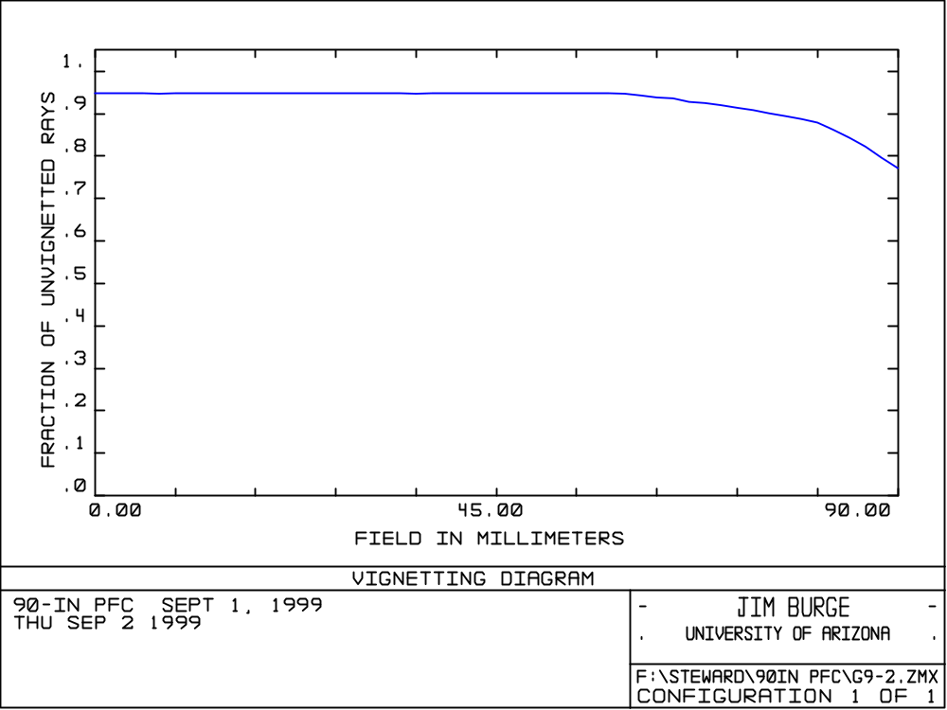
Edge of field
Corner of field

The system will work out to 2.2 µm, although performance degrades.
For the system focused to get this full range, a plot of rms spot size vs wavelength is given below. Note that the “sweet spot” can be moved by adjusting focus.

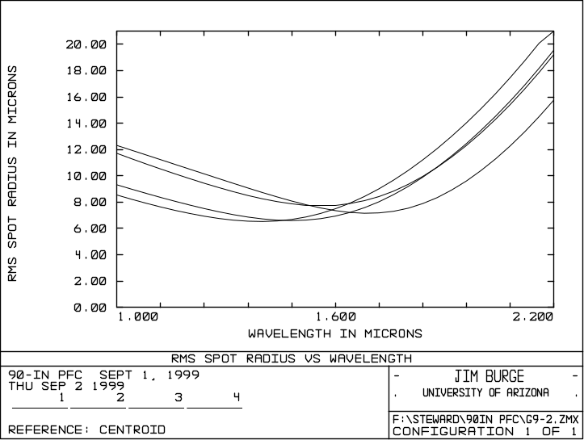
Tolerances

The effect of manufacturing errors was simulated and a budget was assigned to allow the system to be built economically, yet perform adequately.

The system parameters are given fully in Part 1 of this report.

The Excel spreadsheet given on the following pages shows the system tolerances and the effects on image quality. The net effect of all of the terms is estimated in the usual way by taking a root sum square (RSS) of the individual terms.

The effect of things like radius of curvature and spacing errors were determined by direct simulation of the optical system. The parameters were perturbed the appropriate amount and we recorded the image degradation. For all of these, we assume a final adjustment for focus.

The effect of refractive index variation and surface figure errors were estimated with some basic assumptions about the statistics of these. Gordon wrote a memo detailing the calculations. The basic assumptions were, for figure specs,
Power can vary by a given amount for the sub-aperture test plate
Irregularity is typically 2 cycles across the test plate

For refractive index inhomogeneity, we assume spatial scale of the index variations of 1/3 the lens diameter.

Glass quality
For this application, the quality of glass was driven by both the inclusions and the refractive index variation, or homogeneity within the glass. We decided that the low-grade optical quality fused silica is adequate for Lens1, Lens2, and Lens3. The next better grade is preferable for Lens 4, which is near the focal plane.

 | Typical glass |  | Index inhomogeneity |  | inclusions |  | Largest bubble
 | Heraeus | Amersil | spec | image | spec | Incl x-section | spec | Ratio bubble to beam area
Lens 1 | Herasil3 | 4000 | 1e-5 P-V | 1.027 µm rms | 1 mm²/cc | 0.04% | 1 mm | 5 ppm
Lens 2 | Herasil3 | 4000 | 1e-5 P-V | 0.67 µm rms | 1 mm²/cc | 0.02% | 0.76 mm | 13 ppm
Lens 3 | Herasil3 | 4000 | 1e-5 P-V | 0.22 µm rms | 1 mm²/cc | 0.01% | 0.76 mm | 74 ppm
Lens 4 | Herasil2 | 4100 | 6e-6 P-V | 0.007 µm rms | 0.1 mm²/cc | 0.001% | 0.3 mm | 0.6%

Optical design
A print out of the optical design is given at the end of this report.

