Vignetting effects of increasing the array separation

Jim Burge
September 27, 2000

I looked at the effect of increasing the gap between the detector arrays to 15.7 mm. In summary, the result is not really significant. The outer edges of the detector will be vignetted but only by a 30% at worst and nearly all of the area is unvignetted.

The very corners are vignetted, but this can be greatly improved by allowing the clear aperture for L4 to increase from 188 to 196 mm. The overall lens diameter is 208 mm.

Vignetting from filter
The dominant effect is from the 5.75” filter, and only the outer few pixels will be affected.
For the CCD, the edges go from – 69 to + 69 mm

The figure below shows a slice from center to edge of the field, showing the effect of the filter.

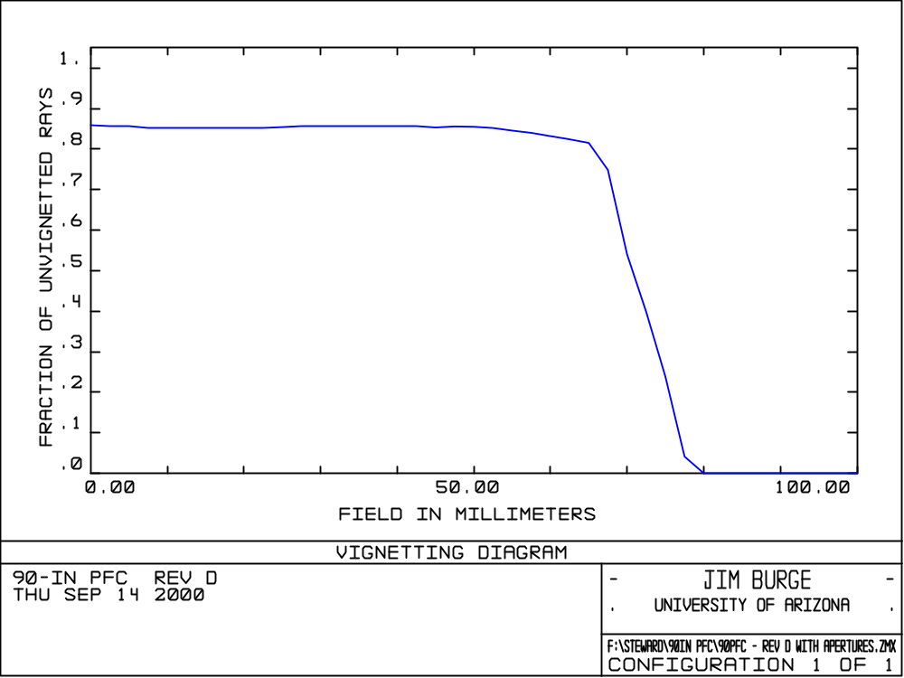

The illumination at the very edge falls off from 85% to 60% (relative to a filled 90” telescope)
Inside 65 mm, there is no additional vignetting effect.

A plot of the beam footprint at the filter is shown below to show roughly how the beam for each field point is blocked. Locations in image plane are given for each.

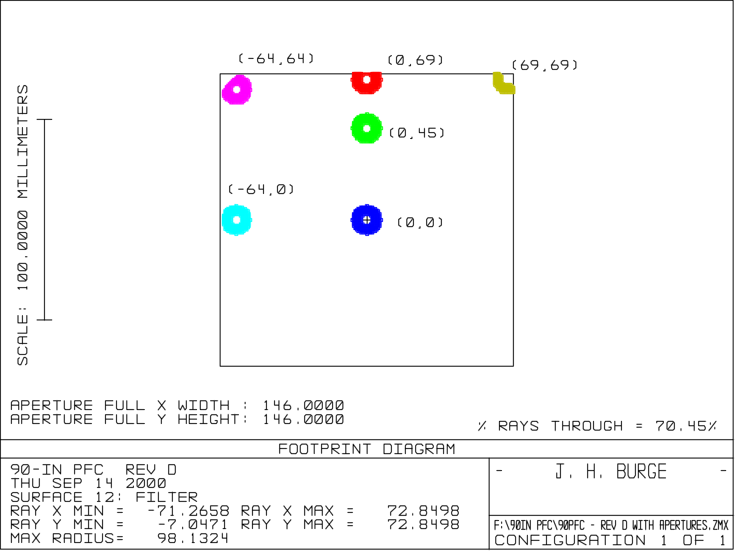
Effects of lens apertures
The effects of the lenses are only at the very corners of the field.
The corners go from –98 to 98 mm in the focal plane.

The clear aperture for L4 is specified to be 188 mm diameter, which provides the vignetting at the corner.

In the diagonal direction, the vignetting is shown below for the case where L4 is limited to 188 mm.

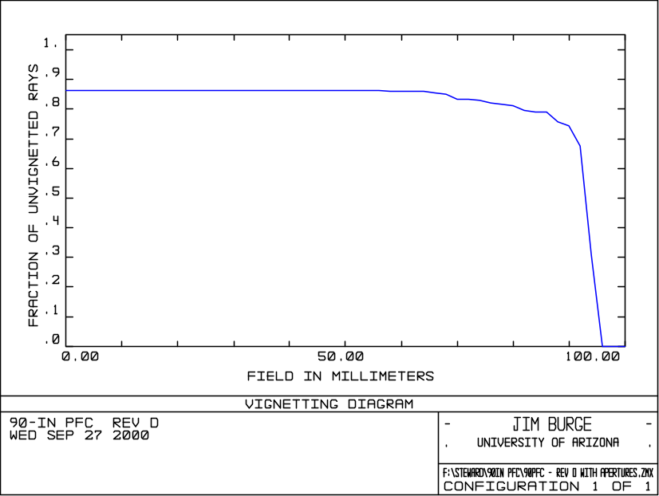

If we increase the aperture to 196 mm, we pick up the corners, as shown in the plot below.
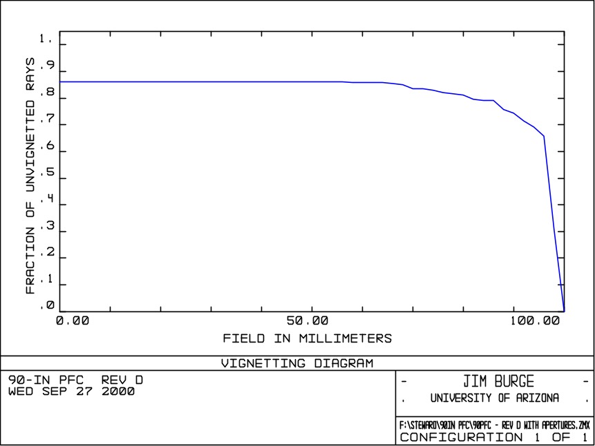
The very corners are nearly blocked, but in fact very little area on the array is affected. I recommend that we increase the clear aperture to 196 mm

