Tor Network

Technical Analysis



Prepared by:
Simon Owens

Date: April 26, 2018
Course Number: CS-415

Summary

Objective and Scope
This paper will cover the technical aspects of what the Tor Network is, how it works, and why it is considered secure. Threats to the Tor Network will be briefly covered, but just minor speculation. The moral and ethical implications of humans using the Tor Network should be covered in an entirely different paper. For more information on the design of the Tor Network, visit the following page.

Executive Summary
- What its good for

- What it cannot do

- Where it might have some security weaknesses

- How you should follow best practices and be aware that there is some risk to thinking you are completely anonymous

Tor Overview

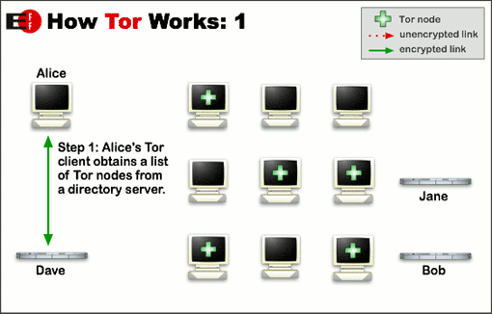
The Tor Network was founded by Roger Dingledine and Nick Mathewson. The Tor Project is a collection of open source tools to use the Tor Network. The Tor Network is an open network that attempts to keep users uncensored and anonymous from others they interact with with on the Internet. This means that anyone listening to your network traffic doesn’t know what information is being sent or received, where it is going, and how much is being sent or received. A users traffic is bounced around to various places on the Internet before being directed to the requested site. The Tor browser is an application that allows users use standard websites as well as onion websites, it hides all of the complexity of bouncing around traffic to remain uncensored and anonymous. Onion Services are like standard websites, but only only the Tor browser can access the information.
Tor users are able to “bounce their traffic around the Internet” by connecting to various virtual tunnels called Tor Nodes. These nodes are a virtual machine that acts as a router for the Tor Network. Below is an illustration of Internet traffic routing through the Tor Network. First the Tor Browser obtains a list of Entry Nodes from the Tor Database.

Tor Searches for Entry Nodes [1]
A connection with the first node is established. Then that node looks for other Relay Nodes. Each Relay Node only knows its next and previous node. The Middle Relay only knows which node sent it traffic, and which node it should forward the traffic.
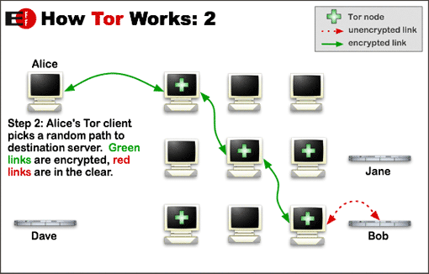

Tor Incrementally Builds Circuit [1]
If the user wants to browse another site, they will have to restart the process. They will look for another entry node, and incrementally build a circuit. Anyone analyzing all of this network traffic does not get any indication where Alice is browsing.
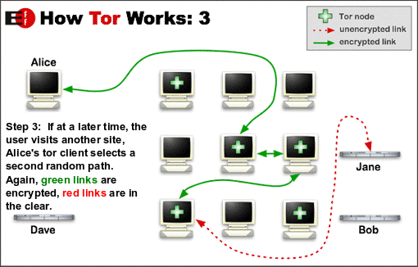

Circuit Rebuild Each Connection [1]

There are four different types of Tor Nodes: Guard Node, Middle Node, Exit relay, and a Bridge.
Guard(Entry) Node: This is the first connection the Tor browser will make when attempting to browse the web. Those nodes are stored in the Tor Database so the browser knows what it can start it’s connection with. Middle Node: This acts as the second connection in a Tor circuit. It neither knows the address of the original user, or what the user is attempting to connect to. This node only knows the entry and exit nodes. Exit Node: This is the final node in the Tor circuit. This node makes the request to whatever the user originally requested. The sites they are requesting will see this IP address, instead of the user’s. Bridge Node: All Tor nodes are publicly available except for bridge nodes. The addresses of these nodes stay secret. Some Governments, ISPs, and websites block connections coming or going to Tor nodes, but Tor bridges stops this. I downloaded the Guard Node from the Tor Website, uploaded it to my home server, started an Ubuntu docker container, configured system settings, and opened network ports on my firewall in under 30 minutes. Traffic immediately starting routing in and out of my Tor Node! Analyzing the traffic with Wire Shark did not real any information on what type of traffic was going through the Tor Node.
Insert Packet capture of Tor Guard
Only the Source of the information was visible to me.
I then downloaded and ran the Tor Bridge. Again, I could only tell where the traffic was coming from, and where it was being sent.
Insert Packet capture of Tor Bridge
I did not run an exit relay. There are legal implications for running an exit relay. If a user were to download copyrighted information through my Tor Exit Node, the IP address would be associated with my home.
Hosting Tor nodes is not required at all to use the Tor browser, many people do not host nodes but use the Tor browser. The Tor browser is just a fork of Mozilla’s Firefox, so it is extremely easy to use. To visit normal sites, just search for them like a normal web browser. Sniffing the firewall’s traffic on my local network I can see a normal HTTPS key exchange when attempting to browse facebook.
Insert Packet capture Tor browser here
Insert explanation of searching DNS, key exchange, large prime number, and tor encapsulation
Accessing Onion services is different. Onion pages, that can only be accessed through a tor browser, do not have an associated IP address with them.
Insert explanation of how Tor DNS works

ISP and Surveillance Overview
- How does my data get transferred around the Internet?
To truly understand how Tor works as well as why it is used the Internet must be understood.

- People monitor, block, and throttle my connections? And they sell that information?
Some countries and Internet Service Providers (ISPs) block and throttle connections to certain websites and services.

- What is Metadata?

- What can they see? What if I have TLS or HTTPS?

- What does the Tor Network Look like?

- Example of browsing facebook

Technical Analysis

Onion Layers
- Multiple layers of encryption

- How does it know where to go next

- Cryptography behind the key exchanges

Entry and Exit Nodes
- How does it know where to enter?

- How does it know where to stop?

- What if someone was being malicious with entry or exit?

- What if ISP had control over entry and exit?

DNS and Key Management
- How does it know how to establish a connection with facebook

- How does it know how to establish a connection with a .onion site

- How does it get its database of Entry/exit nodes? Ways to attack this?

- Where does it keep these certs?

Key Exchanges (Asymmetric Encryption)
- How does it establish a secure connection with each node? How secure?

- How does it establish connection with DB? DNS? Hashes?

- Why not NIST curves?

Symmetric Encryption
- Once connection has been established, how secure is it?

Traffic Obfuscation
- So what does ISP see? Speed, size, data within

- How does it do this?

- What if they decide to block certain ports?

Attack Vectors and Threats

Deep Packet Inspection

Timing Attacks

Browser Exploitation

Decryption

DNS Spoofing or Poisoning

Best Practice for Usage

Connection Setup

Tor Nodes

Browsing

Conclusion
- Security and development behind tor

- Would I use it?

- How easy is it to use?

Appendix A: Sources and References
- Inc. “Tor.” Tor Project: Overview, www.torproject.org/about/overview.html.en.

