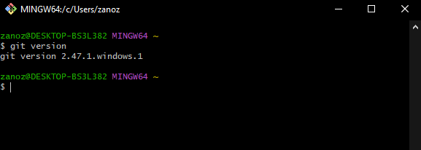

**5) usage: git [-v | --version] [-h | --help] [-C <path>] [-c <name>=<value>]**

**[--exec-path[=<path>]] [--html-path] [--man-path] [--info-path]**

**[-p | --paginate | -P | --no-pager] [--no-replace-objects] [--no-lazy-fetch]**

[--no-**optional-locks] [--no-advice] [--bare] [--git-dir=<path>]**

**[--work-tree=<path>] [--namespace=<name>] [--config-env=<name>=<envvar>]**

**<command> [<args>]**

**These are common Git commands used in various situations:**

**start a working area (see also: git help tutorial)**

**clone Clone a repository into a new directory**

**init Create an empty Git repository or reinitialize an existing one**

**work on the current change (see also: git help everyday)**

**add Add file contents to the index**

**mv Move or rename a file, a directory, or a symlink**

**restore Restore working tree files**

**rm Remove files from the working tree and from the index**

**examine the history and state (see also: git help revisions)**

**bisect Use binary search to find the commit that introduced a bu**g

**diff Show changes between commits, commit and working tree, etc**

**grep Print lines matching a pattern**

**log Show commit logs**

**show Show various types of objects**

**status Show the working tree status**

**grow, mark and tweak your common history**

**branch List, create, or delete branches**

**commit Record changes to the repository**

**merge Join two or more development histories together**

**rebase Reapply commits on top of another base tip**

**reset Reset current HEAD to the specified state**

**switch Switch branches**

**tag Create, list, delete or verify a tag object signed with GPG**

**collaborate (see also: git help workflows)**

**fetch Download objects and refs from another repository**

**pull Fetch from and integrate with another repository or a local branch**

push Update remote refs along with associated objects

**6)Создать директорию**

**Открыть в ней консоль**

**Прописать команду git init**

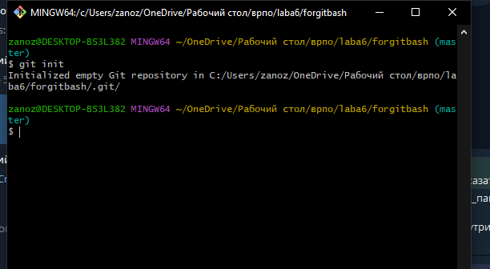

9)не заметил изменений

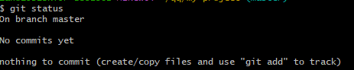

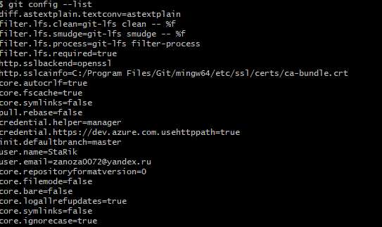

11)текущая ветка

Отсутствие предыдущих коммитов

Неотслеживаемые файлы

12)

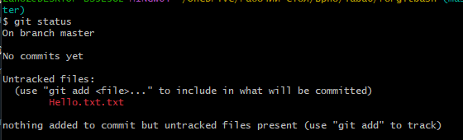



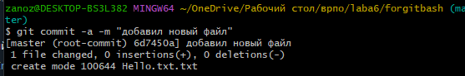

13)

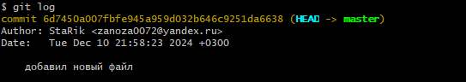

14)

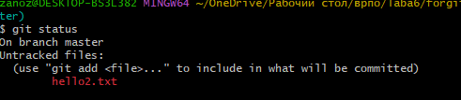

15) 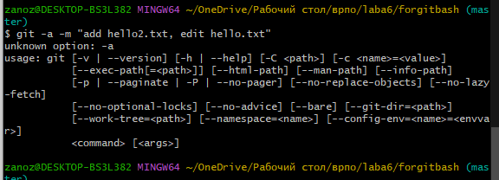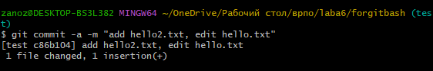

16)

17) 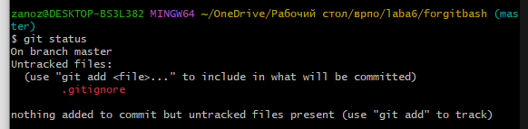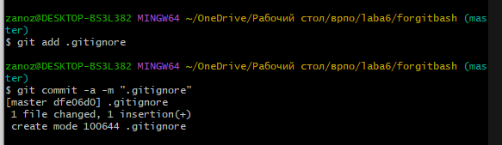

18)

