An overview of the C2C business model and how it can be used to create an online 2-sided marketplace.

C2C (Consumer-To-Consumer), or peer-to-peer (P2P), is an e-commerce model in which consumers sell their products or services directly to other consumers. It differs from business-to-consumer, where the primary objective of the business is to provide items or services to individual consumers. The C2C model is highly favoured in e-commerce because it expands business owners' consumer base and reaches a broader audience.

The C2C (Consumer-To-Consumer) e-commerce market was valued at USD 1,670.90 billion in 2023. The market is anticipated to grow from USD 2,061.22 billion in 2024 to USD 11,216.30 billion by 2032. (Polaris Market Research, 2023)
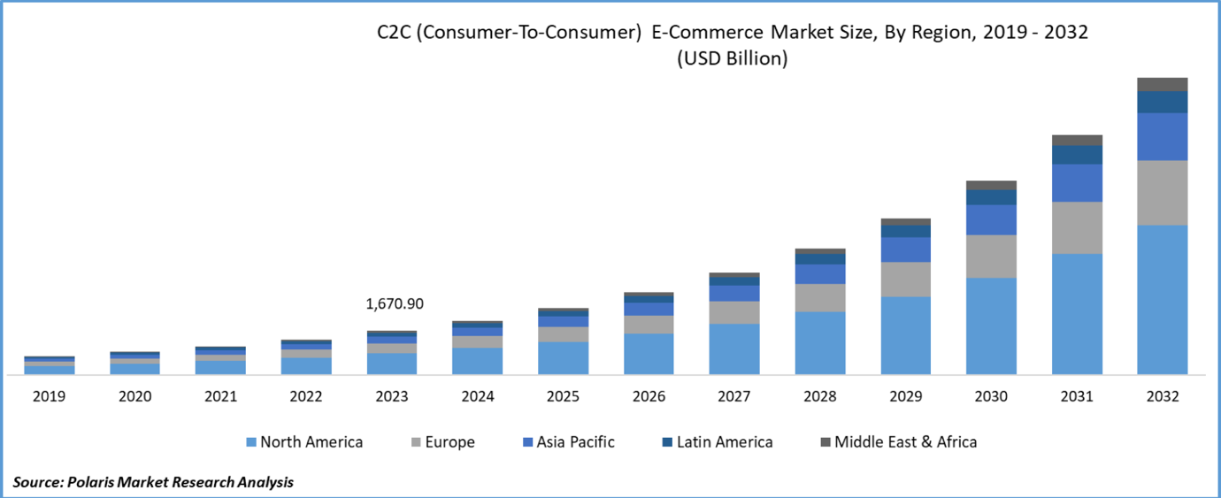
Figure 1. C2C market trend 2019/2032 (Polaris Market Research, 2023)
C2C websites are commonly known as P2P selling platforms. The notion strongly resembles classified advertisements locally within a neighbourhood or community. (Staff, B. and Taylor, J. 2021)
In C2C eCommerce business model, individual consumers serve as both buyers and sellers, offering goods or services to one another without the intervention of traditional corporations or intermediaries. C2C platforms provide a virtual marketplace where users can create listings, negotiate prices, and complete transactions securely. Common examples of C2C platforms include online auction sites, classified marketing websites, and peer-to-peer renting platforms.
The growing adoption of online payment methods will likely stimulate the market, empowering consumers with multiple options from various sellers. This enables smooth comparison of items and pricing and even bargaining for the best deal, boosting customer happiness and responding to the pursuit of value for money. Consequently, the expansion of the C2C e-commerce sector is triggered. C2C e-commerce operates within loose standards, primarily focusing on data security, financial protection, and seller eligibility checks. This increasing need for online transactions and variations will increase the C2C market size in the next few years.
However, the absence of severe laws encourages an environment where word-of-mouth marketing, notably popular on social media platforms, and the sense of community within C2C marketplaces flourish. Platforms like Facebook contribute to forming internal C2C marketplaces, facilitating product marketing through pre-existing user bases. As a result, the C2C e-commerce market is primed for a tremendous increase.

A well-known example of a P2P or C2C services marketplace is Uber. Most people who book an Uber can also be an Uber Driver, making this a P2P or C2C marketplace rather than a B2C Marketplace. An example of a P2P product marketplace is Etsy. Airbnb is also another excellent example of a P2P rental marketplace. There are many types of P2P marketplaces depending on the types of users that participate in them and the unique needs that each industry presents.

Many P2P marketplaces in different industries exist, such as Airbnb, Viator (Formerly TripAdvisor Experiences), Etsy, Uber, and Airtasker.
Therefore, there are already many competitors and alternatives in the market segment.
If we consider a real-world scenario, when a user is abroad and requires a specific service, they must use several programs to receive the requested service.
If we analyse the different platforms described above, we may notice both user and service provider perspectives:

User | User / Service Provider
Airbnb to book accommodation before their departure | Hosts other users (Guest) through Airbnb
Viator to arrange experiences connected to their vacation itinerary | Provides tours, excursions and other services on Viator (Former TripAdvisor experience)
Purchases things from Etsy | Sells items on Etsy
Uber to book a ride or book a planned ride at a greater cost | Provide rides through Uber (In this context, the driver must be online)
Airtasker to hire freelance labour | Selects the sort of job they wish to perform
It is apparent that for all these activities, the user would need to sign up on all these platforms and book the desired activities separately. Considering a scenario where somebody is abroad and wants to schedule this type of service, it becomes fairly challenging for several reasons.

The requirement of a platform that allows the user to book or request all these services in one place is the notion behind YouWander (The proposed platform in this project).

Main competitors and examples of C2C marketplaces

Airbnb: The pioneering platform for short-term rentals, Airbnb connects travellers with hosts who offer unique accommodations worldwide, ranging from cosy apartments to exotic treehouses.
Viator: Online travel agent (OTA) and online marketplaces where tour and activity suppliers worldwide can list their services.
Etsy: Catering to artisans and creatives, Etsy provides a marketplace for handmade and vintage goods. It allows independent sellers to showcase their unique products and connect with buyers who appreciate craftsmanship and creativity.
Uber: These ride-sharing giants connect passengers with drivers who provide transportation services on-demand, offering a convenient and cost-effective alternative to traditional taxis or public transit.
Airtasker: An online and mobile marketplace where users can outsource various tasks.
Main competitors’ analysis – Companies using different P2P/C2C business models
Criteria | Airbnb | Viator (Former TripAdvisor Experiences) | Etsy | Uber | Airtasker
Key Information | Founded in 2007, Airbnb launched experiences in 2016.  -Airbnb is estimated to have over 150 million users, with over 45 million users in the U.S.  -Airbnb has over 7 million active listings in over 220 countries. | Founded in 1995  Operates in more than 1,300 destinations worldwide  Direct access to more than 100,000 bookable activities  9m visits per month | Founded in 2005  500 million visitors every month.  97.3 million active buyers worldwide in 2023.  7.47 million sellers in 2022 | Founded in 2009  150 million users monthly  Operates in 90 countries  9.4 billion trips carried out in 2023  Available in 900 cities | Launched in 2012  Operates in 6 major countries  Paid out over 1 billions to taskers  More than 500,000 taskers
Services | Online marketplace for short and long term stay and experiences. | Online marketplace party that sells tours and activities operated by other companies. | E-commerce company focused on handmade or vintage items and craft supplies. | Ride sharing company providing a range of services such as deliveries, rental, etc. | Online marketplace that matches freelance labor with local demand, allowing people to find help with tasks.
Key features | Airbnb hosts list many kinds of experiences.  User don't have to pay to list their properties. Listings can include written descriptions, photos with captions, and a user profile in which potential guests can get to know a bit about the hosts.  User set the price  User can search the Airbnb database—not only by date and location, but by price, type of experience, host info. , and review the experiences.  Airbnb provide extensive coverage for both host and user. | Provides travelers with trusted reviews and a wealth of travel-related information.  Creates a sense of community among travelers worldwide.  Offers booking services for convenience and a seamless travel experience.  Facilitates price comparison for cost-conscious travelers.  Attracts a global user base seeking reliable travel information and services. | It allows to sell vintage products but they categorize a product as vintage if it is 20 years old or higher.  Sellers have a rating system which helps buyers make their decision.  It offers various payment methods.  Sellers have the flexibility to create a shop within the app itself. | Real time journey tracking  Easily split the fare  Include multiple drop-off locations.  Scheduled Rides allow you to plan ahead.  Ride-hailing: Users can request a ride from their current location to a desired destination, and track the arrival of their driver in real-time.  Price estimation: The app provides estimated fares for trips based on distance and time. | Tasker set the price  Booking and scheduling system  Bidding System
Business Model | Sharing economy platform  These marketplaces enable individuals to share assets or resources with each other.  (Accommodation sharing) | When a provider sells tours and activities on Viator, they’re automatically distributed 3,500 partner network, too.  This means the services may also appear on partners’ sites like TripAdvisor, as well as airlines, hotels, travel publications, and more. One Viator listing gives the service providers access to millions of travellers around the world via Viator, TripAdvisor, and the  vast network of partners.  P2P travel marketplace | Product Marketplaces:  These platforms facilitate the buying and selling of physical goods between individuals. | Sharing economy platform  Uber is a P2P ride sharing application | Service-based P2P marketplaces connect individuals seeking services with those offering them.

The Advantages of C2C Marketplaces
Empowerment: C2C marketplaces allow individuals to capitalise on their assets, talents, and knowledge. These platforms provide an equal opportunity for homeowners to rent a room and for creative entrepreneurs to showcase their handcrafted products, allowing everyone to participate in the economy.
Enhanced accessibility: Peer-to-peer C2C markets facilitate seamless connections between buyers and sellers. By just clicking, customers can conveniently access a wide array of items and services from various parts of the globe, thereby eliminating geographical limitations and enhancing trade prospects.
Flexibility: C2C marketplaces provide flexibility and independence that is not seen in traditional retail models, benefiting both customers and sellers. Sellers have the autonomy to determine their prices, oversee their inventory, and dictate the conditions of the sale. On the other hand, buyers benefit from the ease of exploring, comparing, and acquiring goods or services according to their own preferences.
P2P markets promote community building by facilitating connections between users who frequently possess similar interests, values, or requirements. Features such as ratings, reviews, and forums enhance communication and foster trust, establishing a friendly environment where users can gain knowledge from one another and establish significant relationships.

A lot of travellers desire to experience a city like a local would.
People are looking for unusual features and go away from the busy attractions that everyone knows about. They want to feel a city's mood and vibe to create a truly memorable experience.
After all, that’s the fundamental premise behind companies like Airbnb.
And we’ve known this for a while. It’s no secret that people are yearning for tailored local experiences.

E-business categorization

An electronic business (e-business) is one in which ICT is crucial to supporting its internal value chain and external value network. The internal value chain comprises the set of activity systems via which the business delivers a product or service to its consumers. The external value network includes the activities, relationships and flows of value between the organisation and actors in its external environment.
(Beynon-Davies, 2020)

Since the platform has not been on the market or performed in any competitive environment, YouWander will face intense rivalry. YouWander’s primary competitors have positives and cons. Still, researching the biggest ones is worth discovering how YouWander wants to obtain a competitive advantage and place itself in the market.

(This can also be of project objective)
To accomplish this, we will strongly utilise techniques thoroughly discussed in the Strategic Management of Information Systems and Information Driven Entrepreneurship and Enterprise modules. These tools will enable us to conduct a series of strategic analyses to comprehend the factors, actors, and conditions that will impact the firm's progression.
(Beynon-Davies, 2020)
- Form of Operation: dot com
The proposed business idea is e-commerce, as all operations would be conducted exclusively online. The company will serve as an intermediary between customers.
The choice of operating as a DOT com is due to the absence of a tangible product that needs to be sold or delivered. All the services a consumer requests or a service provider is ready to provide will be catalogued on the website, eliminating the need for physical inventory as the business will operate only online.
- Dimension: Pure E-Commerce (Digital product, Digital process, Physical and digital delivery)

Our business operates entirely in the E-commerce industry, without any physical presence. Users can book or request services online through our platform, and the service provider will deliver the requested service (This can be both physical and digital).
The sole activities that our platform will do are:
-List the customer's requests
-List the services provided by the service provider
-Handle the customer reservations
-Process the booking payments
-Solve disputes.
Business classification: C2C service marketplace
Service marketplaces offer a place for service providers and their customers to meet and cooperate under beneficial conditions. Our business will be classified as a C2C as the customers will interact with other customers to request services and offers.
Hoffman and Novak (1996) suggested that C2C interactions are a vital characteristic of the Internet that is important for companies to consider. Still, these have become so popular in recent years, with the growth of always-on broadband connections and mobile access to the web. (Chaffey et al., 2019)

Horizontal vs vertical portal | Product vs service marketplace | Local vs global operations
GoWander has vertical portal-type marketplaces allowing users to request or book numerous services and service providers to list the same without sticking to a specific niche. | GoWander is a service marketplace that acts as an intermediary between users. | GoWander operates globally

E-Commerce business model: 2-sided marketplace (Consumer to Consumer)
We generally consider a two-sided market to be one in which at least two distinct sets of agents (or sides) interact through an intermediary—the platform—and in which the behaviour of each set of agents directly impacts the utility or the profit of the other set of agents. (Rysman, 2009)
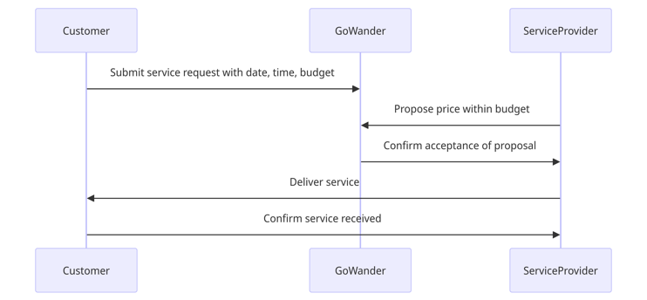
Figure. Example diagram of 2-sided marketplace

Business Model Canvas

A business model is a way of expressing the core design for some value-creating system.
(Jullien et al., 2021)

Figure. GoWander Business Model Canvas

Customer Segments: | Value Propositions: | Channels: | Customer Relationships: | Key partners | Revenue Streams: | Key Resources: | Key Activities: | Cost Structure:
Travellers: Users seeking authentic travel experiences and local services abroad  Service providers: Local offering services and experiences in their respective regions. | Access to Authentic Experiences:  Users can explore local culture and book services and activities not typically available through traditional channels.  Personalised Services:  Tailored recommendations and services based on travellers' preferences and interests.  Community Engagement  Facilitating connections between travellers and locals, fostering cultural exchange and mutual understanding.  (Prebensen, Nina, 2010) | Online Platform:  Website for browsing and booking services.  Social media:  Leveraging social networks for user engagement, reviews, and marketing.  Partnerships:  Collaborating with travel bloggers, influencers, and tourism boards for promotion.  (Buhalis, Dimitrios, Simon 2011) | Community Building: Establishing a vibrant online community through forums, user-generated content, and events.  Customer Support: Aiding and resolving issues promptly to ensure a positive user experience.  Review Mechanism: Gathering feedback and reviews to improve services and maintain trust.  (McCabe, Scott,Buhalis 2003) | Collaborations with trusted payment gateways for payment processing.  Collaboration with insurance providers for insurance covering both the traveller and service provider.  Background verification provider to verify the user’s identity.  Collaboration with cloud services providers to maintain the platform's performance and security.  Partnerships with influencers or brands that can enhance visibility and user trust.  Partnership with the brand to promote the platform usage and brand awareness. | Service Fees:  Charging a percentage of transactions made through the platform on both users’ side.  Premium Features: Offering subscription-based access to advanced search filters or priority support.  Advertising: Partnering with local businesses for targeted advertising on the platform.  (Tussyadiah, Iis, Zheng 2017) | Technology Infrastructure: Reliable servers, databases, and security measures to support the online platform.  Network of Locals: Recruiting and vetting locals offering services in various destinations.  Marketing Expertise: Skilled personnel for digital marketing, content creation, and community management.  (Zott, Christoph, Amit 2010) | Platform Development: Continuous improvement and maintenance of the website.  User Acquisition: Marketing campaigns, SEO optimisation, and referral programs to attract both travellers and locals.  Quality Assurance: Ensuring the authenticity and reliability of services through reviews, ratings, and verification processes.  (Chesbrough, Henry, Rosenbloom 2002) | Technology Costs: The online platform's development, maintenance, and hosting fees.  Marketing Expenses: Advertising, content creation, and promotional activities.  Operational Costs: Customer support, administration, and legal expenses.  (Osterwalder, Alexander, Yves Pigneur 2005)

The beginning point of any digital business and/or e-commerce strategy should be to assess the environment, i.e. the marketplace, in which a business works. Generally, an organisation has two environments (Chaffey et al., 2019) :

- Macro-environment - things outside of the organisation that indirectly influence its activities.
- Micro-environment - internal elements directly influencing the business, such as suppliers, competitors, and customers. (Chaffey et al., 2019)

Microenvironment Analysis

Porter's Five Forces model is an effective tool for understanding the competitive landscape. GoWander's case is helpful because it analyses various forces, such as competitive power in the sector, industry structure, and the bargaining power of customers and suppliers.
Porter's Five Forces analysis is a conceptual framework devised by Michael E. Porter for evaluating a company's competitive landscape. An organisation operates inside a specific industry, and to thrive, it must effectively manage the competitive dynamics present in that industry. (Ward and Peppard , 2011)
Porter 5 forces diagram

 | GoWander
Threat of New Entrants – High | - Low barriers to entry: Technology-based platforms can be relatively easy to start, requiring moderate initial investment and technical knowledge. (Ex: No code platform builders)  - Saturated distribution channels and platforms (Ex: AI tools)  - Brand loyalty: While significant players might have strong brand recognition, new entrants can quickly gain traction if they offer unique features, better prices, or enhanced user experiences.  - Differentiation: New entrants can quickly differentiate themselves by targeting niche markets or offering innovative features that improve the user experience, making the sector more competitive.
Bargaining Power of Suppliers –  Moderate to High | In a consumer-to-consumer (C2C) framework, suppliers are individuals who also act as consumers and offer their services by listing them. They possess a substantial ownership interest and exert considerable control, as they directly contribute to the nature and diversity of the marketplace.  - Diverse supply base: In a e-marketplace available globally, suppliers would be service providers from various countries with different offerings. Their power varies by exclusivity and the uniqueness of their services.  - Switching costs: For standard services (like tour offering, ride offering, etc.), switching costs for the marketplace might be low; however, for specialized or unique services, suppliers may wield more power.
Bargaining Power of Buyers - High | - Price sensitivity: Travelers often compare options across multiple platforms looking for the best deals, which increases their bargaining power.  - Availability of alternatives: Numerous alternatives like direct booking through provider sites or other competitive platforms enhance buyer power.  - No loyalty programs: Unlike traditional B2C models, C2C platforms often lack extensive loyalty programs, which reduces barriers for buyers to switch platforms.
Threat of Substitute Products or Services - High | - Variety of choices: Buyers and sellers might opt for self-organizing their travel plans or using other forms of collaborative consumption that bypass marketplaces entirely, such as social media groups.  - Technology advancements: The ease of finding and booking services directly or through new apps and platforms serves as a potential substitute.
Rivalry Among Existing Competitors – Very high | - Fragmented industry: Many players exist, from large platforms like Airbnb and Booking.com to niche sites like Air tasker to provide specific types of services.  - Price competition: Heavy price competition due to low switching costs for users and high transparency of offerings.  - Competition includes not only price, but also performance, user experience, and reduced transaction fees.  - Market growth: Many players are in this sector from a long time with more experience and resources. This can delay the growth process of a business shifting constantly its focus from market growth to competitiveness.
(Rysman, 2009)

Macroenvironment Analysis

As a business, GoWander aspires to operate internationally in a broadly defined external environment. Many elements of this environment need to be thoroughly examined, comprehended, and interpreted early in the business planning stage.

These environmental aspects are generally evaluated together in the early phases of strategic thinking, utilising a PEST (Political, Economic, Social and Technological) analysis method where legal factors are typically included with political and ecological ones with social ones.
(Ward and Peppard, 2011)
These are essential because of their evolving speed and effect on an increasingly ‘global’ economic sector. Careful monitoring of these elements may lead to significant business opportunities or finding possible threats in time to take measures to prevent the effects. (Ward and Peppard, 2011)

 |  | Impact Analysis
Category | Factor | Issue | Opportunities
Political | Regulatory environment | Different countries across the globe have limited the operating power of big technological firm. | This creates opportunities for small businesses like GoWander to enter the market and compete against big player in a fair way.
Political | Political instability | War in Ukraine, Palestine, Sudan, etc.  Operating in these countries is becoming extremely hard due to technological restrictions. | This can foster engagement between local users in those specific countries, improving social networking and promoting local businesses among the residents.
Economical | Global economic trends | High inflation rate and continuous increase in cost of living. | Rising costs may create an increase in userbase because promoting C2C transactions.
Economical | Brexit | Our platform is UK based but to operate in Europe and worldwide we will need to comply to different legislations. | Operating in some countries might be cheaper.
Economical | Currency exchange rates | They affect pricing and affordability, particularly in a platform operating across numerous nations.  Krugman, P., Obstfeld, M., & Melitz, M. (2015).
Economical | Rising unemployment rate | Users may spend more time to seek a job. This can lead to inactivity in the platform. | Potential increase in users willing to provide their time/ services as freelancer.
Economical | Current player market dominance | Big tech companies integrating e-commerce in their platform. | This can have both a positive and negative outcome. (See key findings)
Social | Cultural factors | Understanding and honouring local customs and etiquette is vital in a global marketplace.  Hofstede, G. (2001)
Social | Travel trends | The popularity of various travel trends, such as adventure tourism, eco-tourism, or cultural tourism, affects the types of services in demand.  Buckley, R. (2012) | (See key findings)
Technological | Innovation in E-commerce: | Rising in AI | AI features can be implemented to boost user experience and operational efficiency.
Technological | Innovation in E-commerce: | Rising in AI | These approaches are innovative ways to build algorithms that can recognize pattern and predict behaviours.
Technological | Data security | Government | Machine learning algorithms can be monitor users’ activities.
Technological | Data security | Government | Ensuring comprehensive cybersecurity measures to protect user data.
Technological | Online censorship | More than 50 countries across the globe are increasing the internet censorship in their countries.  Freedom on the net (2021)
Legal | Data protection regulations | In at least 38 of the 70 countries assessed this year, governments initiated legal or administrative reforms affecting companies’ management of user data.  Freedom on the net (2021) | Implement a strong Data management and security system.
Legal | Data protection regulations | Laws like GDPR in Europe define how firms must manage and secure personal data.  Kuner, C., Bygrave, L. A., & Docksey, C. (2020) | Implement a strong Data management and security system.
Legal | Tax | Tax policies across the globe | (See key findings)
Legal | New legislations | Authorities in at least 24 countries passed or announced new laws or rules governing how platforms treat content.  Freedom on the net (2021) | Robust safeguards against the potential responsibility of intermediaries
Environmental | Sustainability practices | Promoting environmentally responsible processes | The platform would allow users to outsource short-term works.
Environmental | Sustainability practices | Promoting environmentally responsible processes | All the processes will be happening online, allowing the business to be paperless.
Environmental | Sustainability practices | Promoting environmentally responsible processes | The platform could implement virtual machines that run in one server, reducing energy consumption.
Environmental | Local environment | The impact on local businesses and environment | Ensuring the services listed do not lead to over-tourism and local environmental deterioration.

The key finding from the analysis and opportunities:

- [KF1] Different countries have distinct policies impacting e-commerce and tourism. Compliance with these laws is necessary for operation.

- [KF2] Political instability can dramatically damage tourism-related activities and the willingness of users to seek services in certain places.

- [KF3] Economic changes can influence consumer spending power on travel and services.

- [KF4] Taxes in the digital economy

- [KF5] The popularity of various travel trends, such as adventure tourism, eco-tourism, or cultural tourism, affects the types of services in demand.
- [KF6] Big tech companies are held accountable for their worldwide influence and impact. (Loe, 2023)
  - Japan shows increasing concern that the domestic units of tech companies are undermining fair competition. (Loe, 2023)
  - Indonesian officials say that small businesses need protection from big tech companies, and banning e-commerce on social media will support offline businesses. (Loe, 2023)

Opportunities:

- [OP1] GoWander can foster partnerships with different government bodies, such as local councils and tourism bodies, to operate in different countries. This would allow local businesses, as well as freelancers, to promote their services on the platform.
- [OP2] The platform can also allow residents and users who know a specific city to pre-plan.
- [OP3] Different demands mean a chance to operate in a ‘niche’ market share by allowing the residents to offer tailored services matching the users' needs.
- [OP4] Operating in some countries might be cheaper than others. The platform can maintain its presence worldwide while keeping its physical offices and infrastructures in a country with a low cost of living.
- [OP5] Unlike traditional companies, whose profits are taxed at value creation, digital technology companies conduct most transactions electronically. This is an advantage for GoWander due to the virtual nature of its business, as companies are taxed through permanent establishment rules primarily based on physical presence. So, while GoWander will operate virtually all over the globe, its profits will be taxed only in the state with a physical establishment. (Moskowitz, 2023)
- [OP6] Users can outsource short-term jobs to other users, creating employment and promoting freelance labour.

SWOT Analysis
GoWander | Strength – S  [S1]: 2-sided marketplace focus GoWander concentrates on offering an open platform to anyone who is willing to offer a service. This has the potential to attract a certain group of users.  [S2] GoWander differentiates itself from competitors by offering customised experiences through direct engagement between user and service providers, showcasing flexibility and customisation.  [S3] Reduced prices: The service fees that are lower than those of competitors may appeal to a larger user base, including both service providers and consumers.  [S4] Scalability: The open market paradigm enables swift expansion into new geographies and user categories. | Weakness – W  [L1] Brand awareness: It would be difficult to compete with well-known brands such as AirTasker, TaskRabbit, Airbnb and similar platform because they have gained extensive awareness and trust.  [L2] Acquiring a substantial number of users in the early phases of a start-up is challenging because the platform need to expand at the same time.  [L3] Technical infrastructure: The process of creating and maintaining a reliable and easy-to-use system requires significant investment in technology and human resources.
Opportunities – O  [O1] Personalization of Services: Focus on highly tailored services unavailable on larger platforms, targeting a wide user base.  [O2] Global Expansion: Potential to expand into regions with less saturation of entrusted companies, capturing unexplored markets.  [O3] Collaborations: Partnering with travel companies, airlines, or local governments could generate new customer bases and increase trust.  [O4] Local Expertise: Leveraging local expertise to give unique experiences that established platforms might not offer. | SO Strategies  [S2,O1] A 2 sided marketplace will allows user create specific demand for certain services based on personal needs.  [S3,O2] Cheap service fee would enable user to maximise their cost-opportunity. At the same time service providers would be able to list their services and pay no listing fees.  =Attacking strategy
Threats – T

[T1] Competition: The presence of established players makes it tough to win market share.
[T2] Regulation & Compliance: Navigating the differing requirements for online marketplaces across different locations can be complex and costly.
[T3] Trust and Safety: Ensuring user safety and resolving disputes is vital in the C2C sector, especially in the tourism sector.

Business Model Paradigm and Revenue Models

To be profitable and competitive, GoWander needs to work with a specific commercial framework that goes over the traditional outlook of doing business. C2C is the leading commercial structure in an open market.

Open-Market Paradigm
An “open market” is defined as a marketplace where many people (individuals and businesses) can sell their products/services for a minor cost (Jung, 2006).

During the past 10 years, ordinary people have produced, distributed, and reviewed products and services through the Web. While an open market provides goods and services at competitive costs, the value proposition remains the same. The vendor or service provider sells their product and services to buyers. These transactions, facilitated by the individual participation of people, bring improvements to the economy, industry, and organisation (Kwon et al., 2007). In an open market setting, customers' needs become more noticeable and accessible, which can be quickly addressed. GoWander intends to leverage this opportunity and operate as an intermediary platform to list supply and demand.
Advertising and consumers' purchasing impact are especially significant in a C2C open market. For our platform, user acquisition and engagement are the essential activities the firm needs to focus on.

In an open market, it also became more accessible to reach economies of scale as no intermediaries are involved. Buyer and seller can change their role; the buyer can become a customer and vice versa.

After deciding on the commercial structure, one essential point to consider as a business is how to generate revenue. As the platform acts as an intermediary between 2 agents, the business aims to change the service fee for the user and service provider. This fee is charged to the user when they book a service from a service provider and charged to the service provider when they provide a service to a specific user request. This strategy encompasses the essence of a 2-sided marketplace where both agents can set their price for a designated service.

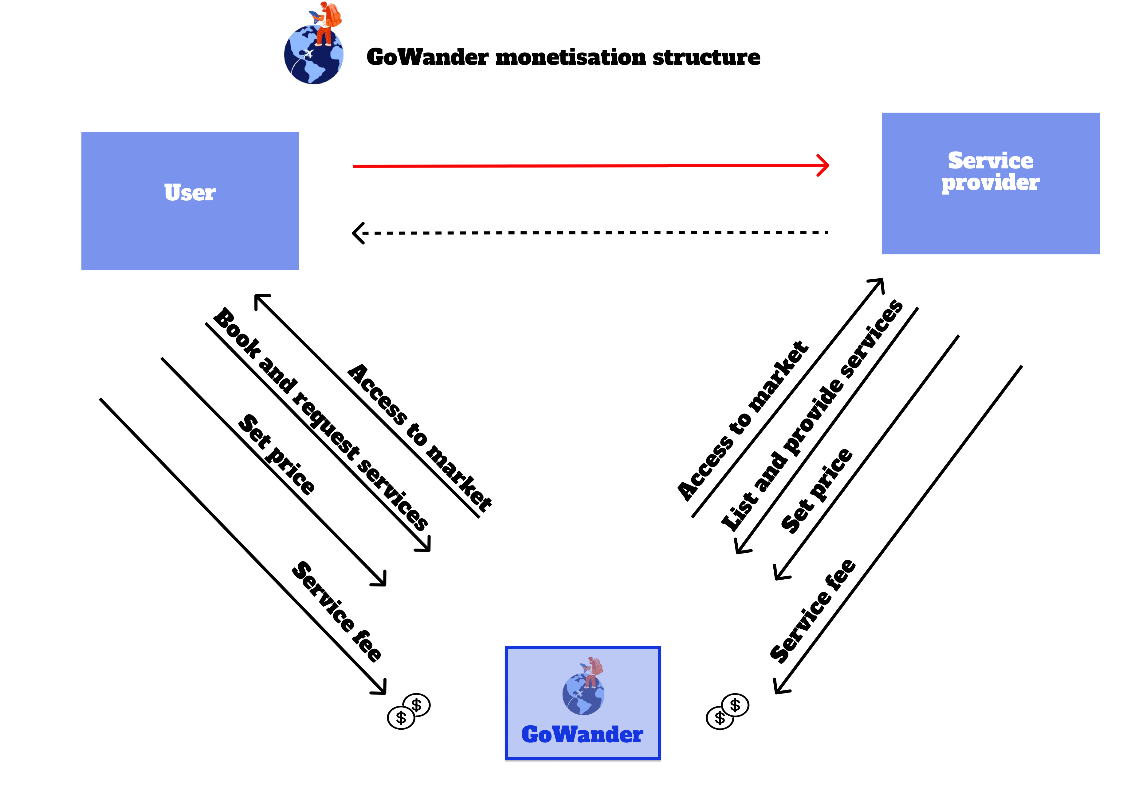

Request Service – Provide Service

Travellers have the option to request a service from GoWander using two different methods:
Traditional method:
The process can be described as follows: (1) A user submits a request for a service that must be delivered on a particular date, time, and budget; (2) A service provider or user proposes a price within the specified budget for that particular service request, and (3) The customer selects a user or provider to fulfil the service.
The listings model: Enables service providers to bundle a pre-packaged service and present it at a set price. When customers travellers look through the listings on GoWander, they may come across one of these service packages and buy it directly from the service provider without any customisation.

Advantages for service providers

- Minimal entrance barrier - When choosing where to sell their services, merchants or service providers have two alternatives: creating their e-commerce store or joining an established platform. As e-commerce websites may cost tens of thousands of dollars, joining an online marketplace is more affordable.
- A significant number of possible customers - Coming to a marketplace, service providers don’t need to spend time hunting for buyers as they would be already looking for services in the platform.
- No analytic hassle - Service providers don’t need to track their sales. C2C marketplaces frequently contain technology that automates standard processes for hassle-free operations.

Advantages for users

- Ability to choose from many sellers - A 2-sided marketplace is where one side draws the other. While service providers have access to a huge target audience, purchasers have a vast range of services. Thanks to this choice, every user of a C2C marketplace can select the finest solutions in terms of quality and price.
- Quality control – GoWander would ensure a compliant listing of platform services. For this aim, GoWander will create reviews and rating features that would allow purchasers to be sure about the quality of the services by verifying every user.
- Convenience and speed of purchasing - One of the features of C2C marketplaces is a short checkout process that encourages users to make transactions immediately. Buyers or consumers can pay immediately on the website to make the purchasing process even faster and secure.
- Security of purchasing – A secure payment method that accepts and retains a customer’s payment until the goods or service is appropriately provided. After that, the system transfers money to the service provider.

The Prospects of C2C Marketplaces
The prospects of C2C or P2P markets seem promising, contingent upon the alignment of client demands and technical improvements. Artificial intelligence, augmented reality or virtual reality, and blockchain technology are examples of breakthroughs that can improve the user experience even more, boost security and trust, and open up possibilities for development.
Conclusion
P2P marketplaces substantially change how we interact with business. These platforms are revolutionising how we shop, sell, and engage in the digital age by developing connections, empowering individuals, and fostering diversity. P2P markets serve as a metaphor for the ability of technology to empower trade and generate a more interconnected, cooperative, and dynamic global marketplace as we welcome the future of commerce.

A lot of travellers desire to experience a city like a local would.
People are looking for unusual features and go away from the busy attractions that everyone knows about. They want to feel a city's mood and vibe to create a truly memorable experience.
After all, that’s the fundamental premise behind companies like Airbnb.
And we’ve known this for a while. It’s no secret that people are yearning for tailored local experiences.

References

- Bennett, S., McRobb, S. and Farmer, R., 2005. Object-oriented systems analysis and design using UML. McGraw Hill Higher Education. (pp.67, pp 132-133).
- Staff, B. and Taylor, J. (2021) The 4 main e-commerce business models for building a successful online store: Beprofit - profit analytics blog, BeProfit. Available at: https://beprofit.co/a/blog/what-are-the-four-main-types-of-e-commerce-business-models (Accessed: 16 April 2024).
- What is a P2P or c2c marketplace? Tangram. Available at: https://www.tangram.co/blog-post/what-is-a-p2p-or-c2c-marketplace (Accessed: 16 April 2024).
- Gretzel, Ulrike, and Daniel R. Fesenmaier. "Reconceptualizing destination image in an online world." In Information and communication technologies in tourism 2009, pp. 25-36. Springer, Vienna, 2009.
- Prebensen, Nina K., and John S. G. Wells. "Creating value for the tourist: exploring the use of value propositions in tourism firms." Tourism management 31, no. 6 (2010): 733-743.
- Buhalis, Dimitrios, and Simon Darcy. "eTourism: information technology for strategic tourism management." Pearson education, 2011.
- McCabe, Scott, and Dimitrios Buhalis. "Conceptual framework for tourism destination competitiveness." International Journal of Contemporary Hospitality Management 15, no. 3 (2003): 186-198.
- Tussyadiah, Iis P., and Zheng Xiang. "Tourism analytics with big data: progress and possibilities." Tourism Management 58 (2017): 186-202.
- Zott, Christoph, and Raphael Amit. "Business model design: An activity system perspective." Long range planning 43, no. 2-3 (2010): 216-226.
- Chesbrough, Henry, and Richard S. Rosenbloom. "The role of the business model in capturing value from innovation: evidence from Xerox Corporation's technology spin‐off companies." Industrial and corporate change 11, no. 3 (2002): 529-555.
- Osterwalder, Alexander, and Yves Pigneur. "Clarifying business models: Origins, present, and future of the concept." Communications of the association for Information Systems 16, no. 1 (2005): 1-25.
- Zheng Qin. (2009). Introduction to E-commerce. Tsinghua University Press, Beijing and Springer-Verlag GmbH Berlin Heidelberg.
- Jones, K. and Leonard, L.N.K. (2008). Trust in consumer-to-consumer electronic commerce. Information & Management, 45(2), pp.88–95. doi:https://doi.org/10.1016/j.im.2007.12.002.
- Krishna, V. (2014). Auction Theory. Burlington: Elsevier Science.
- Statista.com. (n.d.). Statista - The Statistics Portal. [online] Available at: https://www.statista.com/markets/413/topic/983/c2c-e-commerce/#overview.

