**普元PAAS平台服务扩展开发手册**

第201507版

**普元软件**

**二〇一五年七月五日**

版本控制信息

|  |  |  |  |
| --- | --- | --- | --- |
| 版本 | 日期 | 拟稿和修改 | 说明 |
| 1.0.0 | 2015-07-04 | 李中文 |  |
|  |  |  |  |
|  |  |  |  |
|  |  |  |  |

|  |
| --- |
| 本文档中的所有内容为普元信息技术股份有限公司的机密和专属所有。未经普元信息技术股份有限公司的明确书面许可，任何组织或个人不得以任何目的、任何形式及任何手段复制或传播本文档部分或全部内容。 |

文档安全控制信息

|  |  |  |  |  |
| --- | --- | --- | --- | --- |
| **机密等级** | | 国密商密一级商密二级商密三级内部使用公开 | | |
| **机密性期限** | | 永久 | | |
| **授权访问/分发范围** | | 普元信息技术股份有限公司 | | |
|  | |  | | |
|  | |  | | |
|  | |  | | |
|  | |  | | |
| **备注** | |  | | |
| **文档操作方式** | | | | |
| **复制** | 禁止 | | **打印** | 禁止 |
| **复印** | 禁止 | |  |  |

目录

版本控制信息 1

目录 i

1 文档说明 1

1.1 编写目的 1

1.2 参考文档 1

2 服务模型扩展 1

2.1 扩展接口说明 1

2.1.1 服务接口 1

2.1.2 集群接口 1

2.2 Redis服务扩展示例 1

2.2.1 RedisService 1

2.2.2 RedisCluster 3

3 服务管理器扩展 4

3.1 扩展接口说明 4

3.1.1 服务管理器接口 5

3.1.2 集群管理器接口 5

3.2 Redis服务管理器扩展示例 5

3.2.1 IRedisServiceManager 5

3.2.2 RedisServiceManager 6

3.2.3 RedisClusterManager （非必需） 13

4 服务脚本扩展 16

4.1 扩展脚本 16

4.2 代码结构 16

4.3 目录结构 18

4.4 上线部署 19

5 服务初始化SQL 19

5.1 服务定义 19

5.2 端口定义 20

6 订单处理器扩展 20

6.1 接口说明 20

6.2 Redis服务订单处理器示例 22

7 门户页面开发 28

7.1 CONSOLE-APP 28

7.1.1 菜单定义 28

7.1.2 页面开发 31

7.1.3 MVC : Controller 开发 49

7.2 CONSOLE-PLATFORM 53

7.2.1 菜单定义 53

7.2.2 页面开发 54

7.2.3 MVC : Controller 开发 54

# 文档说明

## 编写目的

给第三方人员扩展开发PAAS平台做参考。扩展一个服务需要定义服务模型（服务和集群模型），服务管理和集群管理实现扩展；服务页面开发；服务脚本开发；服务打包；配置菜单和权限等。本文举例如何扩展实现Redis服务。

## 参考文档

无。

# 服务模型扩展

## 扩展接口说明

### 服务接口

com.primeton.paas.manage.api.model.IService

抽象实现类为：（一般扩展的服务，继承这个抽象实现即可）

com.primeton.paas.manage.api.model.AbstractService

### 集群接口

com.primeton.paas.manage.api.model.ICluster

抽象实现类为：（一般扩展的服务，继承这个抽象实现即可）

com.primeton.paas.manage.api.model.AbstractCluster

## Redis服务扩展示例

### RedisService

|  |
| --- |
| /**  *  */  **package** com.primeton.paas.manage.api.service;  **import** com.primeton.paas.manage.api.model.AbstractService;  **import** com.primeton.paas.manage.api.model.IService;  /**  * **@author** ZhongWen.Li (mailto:lizw@primeton.com)  *  */  **public** **class** RedisService **extends** AbstractService {  /**  * serialVersionUID  */  **private** **static** **final** **long** ***serialVersionUID*** = -6767512771943979795L;  **public** **static** **final** String ***TYPE*** = "Redis";    **public** **static** **final** String ***RUN_AS_MASTER*** = "master";  **public** **static** **final** String ***RUN_AS_SLAVE*** = "slave";    **private** **static** **final** String ***RUN_MODE*** = "runMode";  /**  * Default. <br>  */  **public** RedisService() {  **super**();  setType(***TYPE***);  setMode(IService.***MODE_PHYSICAL***);  }    /**  *  * **@return**  */  **public** String getRunMode() {  **return** getValue(***RUN_MODE***, ***RUN_AS_MASTER***);  }    /**  *  * **@param** runMode  */  **public** **void** setRunMode(String runMode) {  **if** (***RUN_AS_MASTER***.equalsIgnoreCase(runMode)) {  setValue(***RUN_MODE***, ***RUN_AS_MASTER***);  } **else** **if** (***RUN_AS_SLAVE***.equalsIgnoreCase(runMode)) {  setValue(***RUN_MODE***, ***RUN_AS_SLAVE***);  }  }    } |

说明：PAAS中的服务分为物理服务和逻辑服务，举例MySQL进程可以看作物理服务，MySQL服务的一个Schema可以看作是逻辑服务，区分物理服务和逻辑服务：物理服务一般有进程存在，开服务端口；而逻辑服务一般没有。要为扩展的服务定义一个类型（不能与系统的冲突），在构造方法中调用父类setType方法来设置。根据不同服务的需要定义扩展属性，遵照JavaBean规范，但与JavaBean不同，参考上面示例，定义一些属性的KEY值，getter和setter中调用父类的getValue和setValue来实现。在META-INF/services 下配置ServiceLoader,新建或编辑com.primeton.paas.manage.api.model.IService文件，添加扩展的RedisService实现类。

### RedisCluster

|  |
| --- |
| /**  *  */  **package** com.primeton.paas.manage.api.cluster;  **import** com.primeton.paas.manage.api.model.AbstractCluster;  **import** com.primeton.paas.manage.api.service.RedisService;  /**  * **@author** ZhongWen.Li (mailto:lizw@primeton.com)  *  */  **public** **class** RedisCluster **extends** AbstractCluster {  /**  * serialVersionUID  */  **private** **static** **final** **long** ***serialVersionUID*** = 5498253348014201718L;  **public** **static** **final** String ***TYPE*** = RedisService.***TYPE***;  /**  * Default. <br>  */  **public** RedisCluster() {  **super**();  setType(***TYPE***);  setName(***TYPE*** + "-Cluster"); //$NON-NLS-1$  }    } |

说明：集群模型定义与服务模型定义类似，参考上述代码。在META-INF/services 下配置ServiceLoader,新建或编辑com.primeton.paas.manage.api.model.ICluster文件，添加扩展的RedisCluster实现类。

# 服务管理器扩展

## 扩展接口说明

### 服务管理器接口

com.primeton.paas.manage.api.manager.IServiceManager

默认实现类：（扩展的实现类一般继承默认实现，覆盖某些方法）

com.primeton.paas.manage.api.impl.manager.DefaultServiceManager

获取实现类方式：

IRedisServiceManager manager = com.primeton.paas.manage.api.factory.ServiceManagerFactory. getManager(RedisService.TYPE);

### 集群管理器接口

com.primeton.paas.manage.api.manager.IClusterManager

默认实现类：（扩展的实现类一般继承默认实现，覆盖某些方法）

com.primeton.paas.manage.api.impl.manager.DefaultClusterManager

获取实现类方式：

IClusterManager manager = com.primeton.paas.manage.api.factory.ClusterManagerFactory. getManager(RedisService.TYPE);

## Redis服务管理器扩展示例

### IRedisServiceManager

如果扩展的服务有定义特殊接口的需要（IServiceManager不能满足需求）可以自定接口，但要求自定义的接口继承IServiceManager，参考下面示例代码：

|  |
| --- |
| /**  *  */  **package** com.primeton.paas.manage.api.manager;  **import** java.util.List;  **import** com.primeton.paas.manage.api.exception.ServiceException;  **import** com.primeton.paas.manage.api.service.RedisService;  /**  * Redis 服务管理器. <br>  *  * **@author** ZhongWen.Li (mailto:lizw@primeton.com)  *  */  **public** **interface** IRedisServiceManager **extends** IServiceManager {    /**  * New service instance. <br>  *  * **@param** service instance  * **@param** clusterId cluster  * **@param** number 1 (master) + N (slave)  * **@return** redis instances  * **@throws** ServiceException  */  List<RedisService> add(RedisService service, String clusterId, **int** number)  **throws** ServiceException;    } |

### RedisServiceManager

|  |
| --- |
| package com.primeton.paas.manage.api.impl.manager;  import java.util.ArrayList;  import java.util.HashMap;  import java.util.List;  import java.util.Map;  import org.gocom.cloud.cesium.mqclient.api.Command;  import org.gocom.cloud.cesium.mqclient.api.ServiceCommandMessage;  import org.gocom.cloud.cesium.mqclient.api.exception.MessageException;  import org.gocom.cloud.common.logger.api.ILogger;  import com.primeton.paas.manage.api.exception.HostException;  import com.primeton.paas.manage.api.exception.ServiceException;  import com.primeton.paas.manage.api.factory.ClusterManagerFactory;  import com.primeton.paas.manage.api.factory.ManageLoggerFactory;  import com.primeton.paas.manage.api.impl.util.PathUtil;  import com.primeton.paas.manage.api.impl.util.SendMessageUtil;  import com.primeton.paas.manage.api.impl.util.ServiceUtil;  import com.primeton.paas.manage.api.impl.util.SystemVariables;  import com.primeton.paas.manage.api.manager.IClusterManager;  import com.primeton.paas.manage.api.manager.IRedisServiceManager;  import com.primeton.paas.manage.api.model.IService;  import com.primeton.paas.manage.api.service.RedisService;  import com.primeton.paas.manage.api.util.StringUtil;  /**  * @author ZhongWen.Li (mailto:lizw@primeton.com)  *  */  public class RedisServiceManager extends DefaultServiceManager  implements IRedisServiceManager {    public static final String TYPE = RedisService.TYPE;    private static ILogger logger = ManageLoggerFactory.getLogger(RedisServiceManager.class);  /* (non-Javadoc)  * @see com.primeton.paas.manage.api.impl.manager.DefaultServiceManager#getType()  */  public String getType() {  return TYPE;  }    /*  * (non-Javadoc)  * @see com.primeton.paas.manage.api.impl.manager.DefaultServiceManager#start(java.lang.String)  */  public void start(String id) throws ServiceException {  if (StringUtil.isEmpty(id)) {  return;  }  RedisService service = getServiceQuery().get(id, RedisService.class);  if (service == null) {  String message ="Redis instance [" + id + "] not exists, can not execute start action.";  if (logger.isDebugEnabled()) {  logger.debug(message);  }  return;  }  if (RedisService.RUN_AS_MASTER.equalsIgnoreCase(service.getRunMode())) {  super.start(id);  return;  }  IClusterManager manager = ClusterManagerFactory.getManager(IClusterManager.DEFAULT_TYPE);  String clusterId = manager.getClusterId(id);  if (StringUtil.isEmpty(clusterId)) {  super.start(id);  return;  }    List<RedisService> services = getServiceQuery().getByCluster(clusterId, RedisService.class);  if (null == services || services.isEmpty() || services.size() == 1) {  super.start(id);  return;  }  // Find master  RedisService master = null;  for (RedisService instance : services) {  if (RedisService.RUN_AS_MASTER.equalsIgnoreCase(instance.getRunMode())) {  master = instance;  break;  }  }  if (null == master) {  super.start(id);  return;  }  // start  ServiceCommandMessage message = new ServiceCommandMessage();  message.setAction(ServiceCommandMessage.ACTION_START);  message.setClusterName(clusterId);  message.setIp(service.getIp());  message.setPort(service.getPort());  message.setSrvDefName(RedisService.TYPE);  message.setSrvInstId(service.getId());  message.setNeedResponse(true);    Map<String, String> args = copy(service.getAttributes());  args.put("masterIp", master.getIp()); //$NON-NLS-1$  args.put("masterPort", String.valueOf(master.getPort())); //$NON-NLS-1$    Command body = new Command(args, PathUtil.getScriptPath(RedisService.TYPE, SH_START));  message.setBody(body);    try {  SendMessageUtil.sendMessage(message, SystemVariables.getMaxWaitMessageTime());  } catch (MessageException e) {  throw new ServiceException(e);  }  }    /**  *  * @param map  * @return  */  private static Map<String, String> copy(Map<String, String> map) {  if (null == map) {  return null;  }  Map<String, String> newMap = new HashMap<String, String>();  for (String key : map.keySet()) {  newMap.put(key, map.get(key));  }  return newMap;  }    /* (non-Javadoc)  * @see com.primeton.paas.manage.api.impl.manager.DefaultServiceManager#add(com.primeton.paas.manage.api.model.IService, java.lang.String)  */  public <T extends IService> T add(T service, String clusterId)  throws ServiceException {  return create(service, clusterId);  }  /* (non-Javadoc)  * @see com.primeton.paas.manage.api.manager.IRedisServiceManager#add(com.primeton.paas.manage.api.service.RedisService, java.lang.String, int)  */  public List<RedisService> add(RedisService service, String clusterId,  int number) throws ServiceException {  if (null == service || StringUtil.isEmpty(clusterId) || number < 1) {  return new ArrayList<RedisService>();  }  service.setHaMode(IService.HA_MODE_CLUSTER);  // 申请机器  String[] ips = null;  try {  ips = getHostAssignManager().apply(service.getPackageId(), service.getType(), service.isStandalone(),  number, getHostAssignManager().getInstallTimeout(getType()));  } catch (Throwable t) {  logger.error("Assign host resource error.", t);  }  if (ips == null || ips.length == 0) {  logger.error("Assign host resource error, not enough host resource.");  throw new ServiceException("Not enough host resource for apply. require [" + number + "]");  }  if (number == ips.length) {  logger.info("Create redis service required machine [" + number + "] has applied for.");  } else {  try {  getHostManager().release(ips);  } catch (HostException e) {  logger.error(e);  }  throw new ServiceException("Not enough host resource for apply, require [" + number + "], left [" + ips.length + "].");  }    List<RedisService> services = new ArrayList<RedisService>();  for (int i=0; i<number; i++) {  RedisService instance = ServiceUtil.copy(service);  instance.setRunMode(i == 0? RedisService.RUN_AS_MASTER : RedisService.RUN_AS_SLAVE);  instance.setIp(ips[i]); // 设置IP  services.add(super.add(instance, clusterId)); // 保存至数据库  }  return services;  }    } |

说明：必须覆盖getType()方法，必须提供默认的无参数构造方法，返回值是RedisService.TYPE；根据实际需要可以覆盖某个默认实现；在META-INF/services 下配置ServiceLoader,新建或编辑com.primeton.paas.manage.api.manager.IServiceManager文件，添加扩展的RedisServiceManager实现类。

### RedisClusterManager （非必需）

|  |
| --- |
| /**  * Copyright © 2009 - 2015 Primeton. All Rights Reserved.  */  package com.primeton.paas.manage.api.impl.manager;  import java.util.List;  import org.gocom.cloud.common.logger.api.ILogger;  import com.primeton.paas.manage.api.exception.ServiceException;  import com.primeton.paas.manage.api.factory.ManageLoggerFactory;  import com.primeton.paas.manage.api.factory.ServiceManagerFactory;  import com.primeton.paas.manage.api.manager.IRedisServiceManager;  import com.primeton.paas.manage.api.service.RedisService;  import com.primeton.paas.manage.api.util.StringUtil;  /**  * @author ZhongWen.Li (mailto:lizw@primeton.com)  *  */  public class RedisClusterManager extends DefaultClusterManager {    public static final String TYPE = RedisService.TYPE;    private ILogger logger = ManageLoggerFactory.getLogger(RedisClusterManager.class);    private static IRedisServiceManager redisServiceManager = ServiceManagerFactory.getManager(RedisService.TYPE);  /**  * Default. <br>  */  public RedisClusterManager() {  super();  }    /* (non-Javadoc)  * @see com.primeton.paas.manage.api.impl.manager.DefaultClusterManager#getType()  */  public String getType() {  return TYPE;  }  /*  * (non-Javadoc)  * @see com.primeton.paas.manage.api.impl.manager.DefaultClusterManager#start(java.lang.String)  */  public void start(String id) throws ServiceException {  if (StringUtil.isEmpty(id)) {  return;  }  List<RedisService> services = getServiceQuery().getByCluster(id, RedisService.class);  if (null == services || services.isEmpty()) {  return;  }  StringBuffer errorMessage = new StringBuffer();  boolean isError = false;  for (RedisService service : services) {  try {  getRedisServiceManager().start(service.getId());  } catch (Throwable t) {  logger.error(t);  isError = true;  errorMessage.append("\nStart redis [").append(service.getId()).append("] error.\n").append(t.getMessage()).append("\n");  }  }  if (isError) {  throw new ServiceException(errorMessage.toString());  }  }  /**  *  * @return  */  protected static IRedisServiceManager getRedisServiceManager() {  return redisServiceManager = (null == redisServiceManager)  ? (IRedisServiceManager) ServiceManagerFactory.getManager(RedisService.TYPE)  : redisServiceManager;  }    } |

说明：必须覆盖getType()方法，必须提供默认的无参数构造方法，返回值是RedisService.TYPE；根据实际需要可以覆盖某个默认实现；在META-INF/services 下配置ServiceLoader,新建或编辑com.primeton.paas.manage.api.manager.IClusterManager文件，添加扩展的RedisClusterManager实现类。

# 服务脚本扩展

## 扩展脚本

需要扩展四个脚本:start.sh / stop.sh / install.sh / uninstall.sh。

## 代码结构

必须在头部引入paas-env.sh，尾部引入templates.sh;实现_dohelp(打印帮助信息)，_doparse(参数解析),_doexecute(main方法，主要业务代码执行入口)三个方法;参考下面示例代码：

|  |
| --- |
| #!/bin/bash  #  # ----------------------------------------------------------------  # Copyright (c) 2009 - 2015 Primeton. All Rights Reserved.  #----------------------------------------------------------------  #  # author ZhongWen.Li (mailto:lizw@primeton.com)  #  # import paas-env.sh  source $(cd $(dirname ${0})/../..; pwd)/Common/bin/paas-env.sh  # my variables  # Root directory for programs  program_home=${PROGRAME_HOME_PATH}/Redis  bin_home=${BIN_HOME_PATH}/Redis  # Help, print help information to terminal.  function _dohelp() {  echo "Usage: ./uninstall.sh -reqId uuid"  echo "-h) Print help"  echo "-reqId) Request id"  }  # Parse execute arguments  function _doparse() {  while [ -n "$1" ]; do  case $1 in  -arg0) arg0=$2;shift 2;;  *) break;;  esac  done  }  # Write your core/main code  function _doexecute() {  # print variables  echo "program_home = ${program_home}"  echo "bin_home = ${bin_home}"    _return "[`date`] Begin uninstall Redis."    # remove program  _return "[`date`] Remove ${program_home}."  if [ -d ${program_home} ]; then  rm -rf ${program_home}  fi    # remove bin  _return "[`date`] Remove ${bin_home}."  if [ -d ${bin_home} ]; then  rm -rf ${bin_home}  fi    _return "[`date`] End uninstall Redis."    _success  exit 0  }  # import template.sh  source ${BIN_HOME_PATH}/Common/bin/template.sh |

## 目录结构

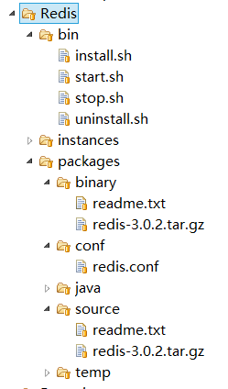

packages/source下存放的是未进行编译的redis源码安装包；packages/binary下存放的是已经编译后的redis二进制安装包。

该目录结构即为服务包的目录结构，最终开发完成的Redis服务需要打包成Redis.zip，如下图所示：

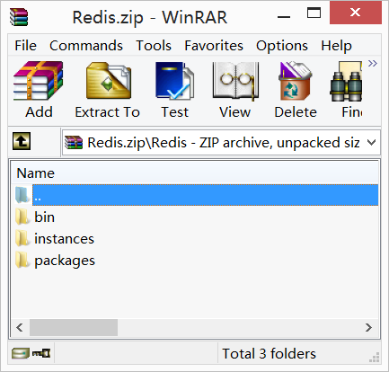

## 上线部署

上传至HTTP软件仓库下，如下图所示：

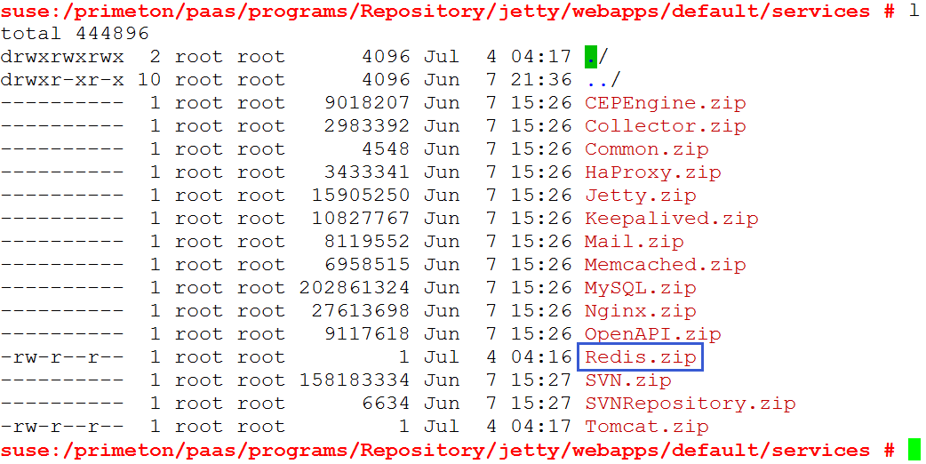

# 服务初始化SQL

## 服务定义

|  |
| --- |
| INSERT INTO `cld_service` (`SERVICE_NAME`, `SERVICE_DISPLAY_NAME`, `SERVICE_DESC`, `SERVICE_MODE`) VALUES ('Redis', 'Redis', 'Redis', 'PHYSICAL'); |

## 端口定义

|  |
| --- |
| INSERT INTO `cld_variable` (`VARIABLE_TYPE`, `VARIABLE_NAME`, `VARIABLE_VALUE`, `VARIABLE_DESC`) VALUES ('HOST', 'PORT_RANGE_Redis', '8200-8210', 'Redis服务端口段'); |

# 订单处理器扩展

## 接口说明

订单管理器接口：（查询，新增，修改，删除，处理等方法，通过OrderManagerFactory获取实例）

com.primeton.paas.manage.api.manager.IOrderManager

订单处理器接口：（通过扩展该接口实现不同订单类型的服务开通/销毁/变更/配置等处理；一般实现类集成他的抽象实现类即可）

com.primeton.paas.manage.api.manager.IOrderProcessor

抽象实现类：

com.primeton.paas.manage.api.impl.manager.AbstractOrderProcessor

|  |
| --- |
| /**  * Copyright © 2009 - 2015 Primeton. All Rights Reserved.  */  package com.primeton.paas.manage.api.manager;  import com.primeton.paas.manage.api.exception.OrderException;  import com.primeton.paas.manage.api.model.Order;  /**  * 订单处理器. <br>  *  * @author ZhongWen.Li (mailto:lizw@primeton.com)  *  */  public interface IOrderProcessor {    /**  * 处理器类型, 与订单类型映射. <br>  *  * @see com.primeton.paas.manage.api.model.Order#getOrderType()  *  * @return 处理器类型  */  String getType();  /**  * 处理订单. <br>  *  * @param order 订单  * @throws OrderException  */  void process(Order order) throws OrderException;    /**  * 仅仅处理某个订单项. <br>  *  * @param order 订单  * @param itemId 订单项标识  * @throws OrderException  */  void process(Order order, String itemId) throws OrderException;    } |

## Redis服务订单处理器示例

举例：处理创建Redis服务订单实现，参考下面代码：

|  |
| --- |
| /**  * Copyright © 2009 - 2015 Primeton. All Rights Reserved.  */  package com.primeton.paas.manage.api.impl.order;  import java.util.Date;  import java.util.List;  import org.gocom.cloud.common.logger.api.ILogger;  import com.primeton.paas.manage.api.cluster.RedisCluster;  import com.primeton.paas.manage.api.exception.ClusterException;  import com.primeton.paas.manage.api.exception.OrderException;  import com.primeton.paas.manage.api.exception.ServiceException;  import com.primeton.paas.manage.api.factory.ClusterManagerFactory;  import com.primeton.paas.manage.api.factory.ManageLoggerFactory;  import com.primeton.paas.manage.api.factory.ServiceManagerFactory;  import com.primeton.paas.manage.api.impl.manager.AbstractOrderProcessor;  import com.primeton.paas.manage.api.impl.util.ServiceRemoveUtil;  import com.primeton.paas.manage.api.impl.util.SystemVariables;  import com.primeton.paas.manage.api.manager.IClusterManager;  import com.primeton.paas.manage.api.manager.IRedisServiceManager;  import com.primeton.paas.manage.api.model.ICluster;  import com.primeton.paas.manage.api.model.IService;  import com.primeton.paas.manage.api.model.Order;  import com.primeton.paas.manage.api.model.OrderItem;  import com.primeton.paas.manage.api.model.OrderItemAttr;  import com.primeton.paas.manage.api.service.RedisService;  import com.primeton.paas.manage.api.util.StringUtil;  /**  * 订单处理器 : 创建简单的Redis服务集群及其服务实例. <br>  *  * @author ZhongWen.Li (mailto:lizw@primeton.com)  *  */  public class SingleCreateRedisOrderProcessor extends AbstractOrderProcessor {    private static ILogger logger = ManageLoggerFactory.getLogger(SingleCreateRedisOrderProcessor.class);    /**  * Type of Order. <br>  */  public static final String TYPE = "SingleCreateRedis";    private static IClusterManager clusterManager = ClusterManagerFactory.getManager(RedisService.TYPE);  private static IRedisServiceManager serviceManager = ServiceManagerFactory.getManager(RedisService.TYPE);  /* (non-Javadoc)  * @see com.primeton.paas.manage.api.manager.IOrderProcessor#getType()  */  public String getType() {  return TYPE;  }  /* (non-Javadoc)  * @see com.primeton.paas.manage.api.manager.IOrderProcessor#process(com.primeton.paas.manage.api.model.Order)  */  public void process(Order order) throws OrderException {  if (null == order) {  return;  }  OrderItem item = getItemByType(order, RedisService.TYPE);  if (null == item) {  List<OrderItem> items = order.getItemList();  if (null == items || items.isEmpty()) {  order = getOrderManager().getOrder(order.getOrderId());  items = order.getItemList();  }  item = (null == items || items.isEmpty()) ? null : items.get(0);  }  if (null == item) {  logger.warn("Order [" + order.getOrderType() + ", " + order.getOrderId() + "] none redis item.");  performOk(order);  return;  }  item.setItemStatus(OrderItem.ITEM_STATUS_PROCESSING);  item.setHandleTime(new Date());  getOrderManager().updateItem(item);    String displayName = getItemValue(item, OrderItemAttr.ATTR_DISPLAY_NAME, "redis service"); //$NON-NLS-1$  String packageId = getItemValue(item, OrderItemAttr.ATTR_HOSTPKG_ID); //$NON-NLS-1$  int clusterSize = getItemValue(item, OrderItemAttr.ATTR_CLUSTER_SIZE, 1); //$NON-NLS-1$  clusterSize = clusterSize < 1 ? 1 : clusterSize;  String isStandalone = getItemValue(item, OrderItemAttr.ATTR_IS_STANDALONE, "N"); //$NON-NLS-1$    if (StringUtil.isEmpty(packageId)) {  throw new OrderException("Create redis error, packageId is empty. Please check you order information.");  }    RedisCluster cluster = new RedisCluster();  cluster.setOwner(order.getOwner());  cluster.setName(displayName);  cluster.setMinSize(clusterSize);  cluster.setMaxSize(clusterSize);  cluster.setScope(ICluster.SCOPE_INNER);    ICluster redisCluster = null;  logger.info("Begin create redis cluster [" + displayName + "].");  try {  redisCluster = getClusterManager().create(cluster);  } catch (ClusterException e) {  logger.error("Create redis cluster [" + displayName + "] error", e);  throw new OrderException(e);  }    String redisClusterId = redisCluster.getId();  logger.info("End create redis cluster [" + redisClusterId + "].");    RedisService service = new RedisService();  service.setCreatedDate(new Date());  service.setCreatedBy(order.getHandler());  service.setOwner(order.getOwner());  service.setName(displayName);  service.setPackageId(packageId);  service.setScope(IService.SCOPE_INNER);  service.setStandalone("Y".equalsIgnoreCase(isStandalone)); //$NON-NLS-1$  service.setState(IService.STATE_NOT_RUNNING);    List<RedisService> services = null;  try {  services = getServiceManager().add(service, redisClusterId, clusterSize);  } catch (ServiceException e) {  if (SystemVariables.isCleanAfterHandleError()) {  logger.info("Begin clean redis cluster [" + redisClusterId + "].");  ServiceRemoveUtil.removeRedisCluster(redisClusterId);  }  throw new OrderException("Create redis service for cluster [" + redisClusterId +"] error.", e);  }    if (null == services || services.isEmpty()) {  if (SystemVariables.isCleanAfterHandleError()) {  logger.info("Begin remove redis cluster [" + redisClusterId + "].");  ServiceRemoveUtil.removeRedisCluster(redisClusterId);  }  throw new OrderException("Create redis service error [" + redisClusterId + "].");  }    logger.info("Begin start redis cluster [" + redisClusterId + "].");  try {  getClusterManager().start(redisClusterId);  } catch (ServiceException e) {  logger.error(e);  }    // 更新订单项状态  item.setItemStatus(OrderItem.ITEM_STATUS_SUCCEED);  item.setFinishTime(new Date());  getOrderManager().updateItem(item);    // 触发检查订单状态  performOk(order);  }  /* (non-Javadoc)  * @see com.primeton.paas.manage.api.manager.IOrderProcessor#process(com.primeton.paas.manage.api.model.Order, java.lang.String)  */  public void process(Order order, String itemId) throws OrderException {  if (null == order || StringUtil.isEmpty(itemId)) {  return;  }  // only one item  process(order);  }  /**  *  * @return IClusterManager of Redis  */  protected static IClusterManager getClusterManager() {  return clusterManager = (null == clusterManager)  ? ClusterManagerFactory.getManager(RedisService.TYPE)  : clusterManager;  }  /**  *  * @return  */  protected static IRedisServiceManager getServiceManager() {  return serviceManager = (null == serviceManager)  ? (IRedisServiceManager)ServiceManagerFactory.getManager(RedisService.TYPE)  : serviceManager;  }  } |

说明：集群模型定义与服务模型定义类似，参考上述代码。在META-INF/services 下配置ServiceLoader,新建或编辑com.primeton.paas.manage.api.manager.IOrderProcessor文件，添加扩展的订单处理器实现类。

# 门户页面开发

默认采用Jsery （REST风格）+ JSP + NUI 来开发页面，也可以使用其他技术，不做严格限制。

## CONSOLE-APP

### 菜单定义

菜单配置文件${WebContentRoot}/common/data/app-menu.txt，采用JSON格式配置，内容如下：

|  |
| --- |
| [  { id: "app", text: "自助服务平台"},  { id: "appOpen", text: "应用开通",pid: "app"},  { id: "myOrderMgr", pid: "appOpen", text: "我的订单", iconCls: "app_myOrder", url: "../app/open/order/myOrderMgr.jsp" },  { id: "myApplications", pid: "appOpen", text: "我的应用", iconCls: "app_myApp", url: "../app/open/application/myAppMgr.jsp" },  { id: "myServices", pid: "appOpen", text: "我的服务", iconCls: "app_myServices", url: "../app/open/service/myServicesMgr.jsp" },    { id: "appManage", text: "应用管理",pid: "app"},  { id: "listApplications_deploy", pid: "appManage", text: "应用部署", iconCls: "app_deployApp", url: "../app/mgr/deploy/listApplications.jsp" },  { id: "listApplications_control", pid: "appManage", text: "应用控制", iconCls: "app_controlApp", url: "../app/mgr/control/listApplications.jsp" } ,  { id: "appSetting", pid: "appManage", text: "应用设置", iconCls: "app_settingApp", url: "../app/mgr/setting/appSetting.jsp" } ,  { id: "appCert", pid: "appManage", text: "应用证书", iconCls: "app_certApp", url: "../app/mgr/cert/appCert.jsp" } ,      { id: "monitor", text: "应用监控",pid: "app"},  { id: "appMonitor", pid: "monitor", text: "监控状态", iconCls: "app_appMonitor", url: "../app/monitor/app/showAppMonitor.jsp" },  { id: "appLog", pid: "monitor", text: "日志查看", iconCls: "app_appLog", url: "../app/monitor/logs/appLog.jsp" },  { id: "appStretchStrategy", pid: "monitor", text: "伸缩策略", iconCls: "app_appStrategyConfig", url: "../app/monitor/stretch/appStrategyConfig.jsp" },  { id: "serviceAlarmStrategy", pid: "monitor", text: "服务监控告警", iconCls: "platform_appServiceMonitor", url: "../app/monitor/appservice/appServiceMonitorAndAlarm.jsp" },    { id: "mysql", text: "数据库管理",pid: "app"},  { id: "mySqlAdmin", pid: "mysql", text: "数据维护", iconCls: "app_mySqlAdmin", url: "../app/data/db/mySqlAdmin.jsp" },      { id: "person", text: "个人信息",pid: "app"},  { id: "updatePwd", pid: "person", text: "修改密码", iconCls: "app_updatePwd", url: "../app/account/update/updatePwd.jsp" },  { id: "myAccount", pid: "person", text: "资料维护", iconCls: "app_myAccount", url: "../app/account/info/myAccount.jsp" }    ] |

可以在这个配置文件中添加其他扩展的菜单。菜单的样式iconCls（图片）可以修改${WebContentRoot}/css/icon.css；格式如下：

|  |
| --- |
| *.default*  {  background:*url(../images/icons/default.png)* *no-repeat*;width:*16px*;height:*16px*;  }  *.app_deployApp*  {  background:*url(../images/icons/app_deployApp.png)* *no-repeat*;width:*16px*;height:*16px*;  } |

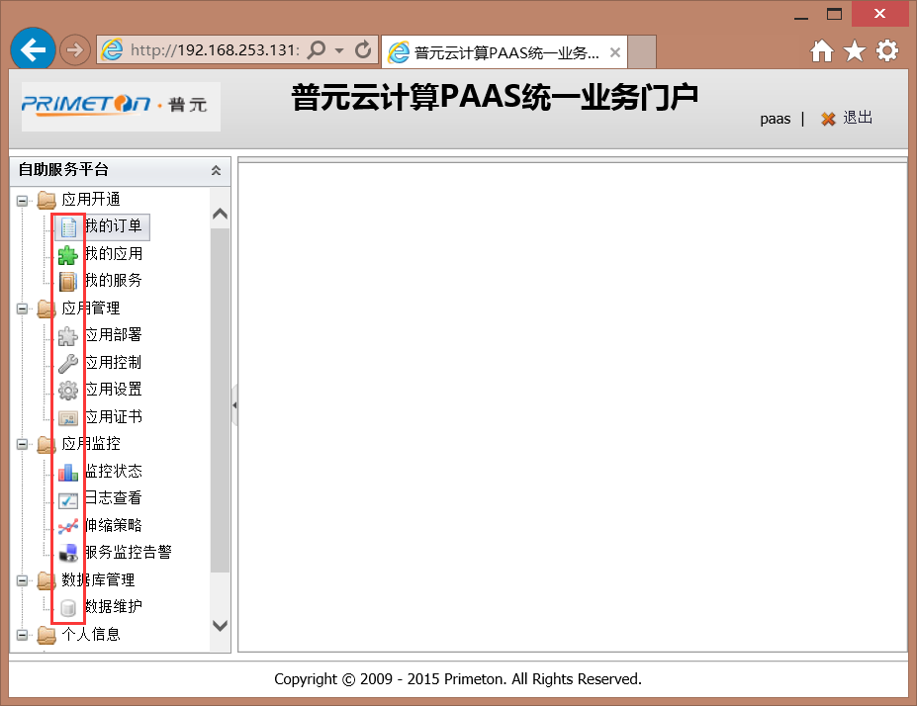

### 页面开发

一般展示个人的服务集群信息， 以及集群中的实例信息，提供创建服务向导；参考下面代码。

**展示Redis集群信息：**

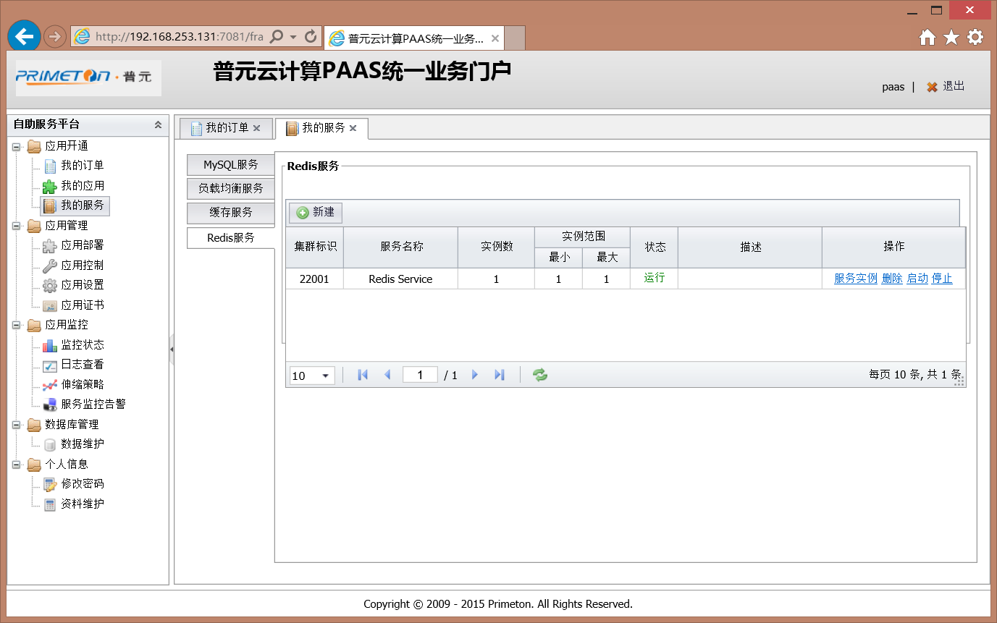

|  |
| --- |
| <%@page pageEncoding=*"UTF-8"* contentType=*"text/html; charset=UTF-8"* %>  <!DOCTYPE html PUBLIC "-//W3C//DTD XHTML 1.0 Transitional//EN" "http://www.w3.org/TR/xhtml1/DTD/xhtml1-transitional.dtd">  <html xmlns=*"http://www.w3.org/1999/xhtml"*>  <head>  <meta http-equiv=*"content-type"* content=*"text/html; charset=UTF-8"* />  <script src=*"*<%=request.getContextPath() %>*/common/nui/nui.js"* type=*"text/javascript"*></script>  <script src=*"*<%=request.getContextPath() %>*/common/cloud/dictEntry.js"* type=*"text/javascript"*></script>  <script src=*"*<%=request.getContextPath() %>*/common/cloud/common.js"* type=*"text/javascript"*></script>  </head>  <body style="height:*100%*">  <fieldset style="border:*solid 1px #aaa*;padding:*3px*;height:*45%*">  <legend ><b>Redis服务</b></legend>  <div id=*"datagrid"* class=*"nui-datagrid"* style="width:*100%*;height:*90%*;" allowResize=*"true"*  idField=*"id"* multiSelect=*"true"* url=*"*<%=request.getContextPath() %>*/srv/myService/listRedis"*>  <div property=*"columns"*>  <div field=*"id"* width=*"60"* headerAlign=*"center"* align =*"center"* allowSort=*"true"* >集群标识</div>  <div field=*"name"* width=*"120"* headerAlign=*"center"* align =*"center"* allowSort=*"true"*>服务名称</div>  <div field=*"attributes.size"* width=*"80"* headerAlign=*"center"* align =*"center"* allowSort=*"true"*>实例数</div>  <div header=*"实例范围"* headerAlign=*"center"* align =*"center"* >  <div property=*"columns"* headerAlign=*"center"* align =*"center"*>  <div field=*"minSize"* width=*"50"* headerAlign=*"center"* align =*"center"*>最小</div>  <div field=*"maxSize"* width=*"50"* headerAlign=*"center"* align =*"center"*>最大</div>  </div>  </div>    <div field=*"attributes.state"* width=*"50"* headerAlign=*"center"* align =*"center"* allowSort=*"true"* renderer=*"onSrvStatusRenderer"*>状态 </div>  <div field=*"desc"* width=*"150"* headerAlign=*"center"* align =*"center"* allowSort=*"true"* >描述 </div>  <div name=*"action"* width=*"150"* headerAlign=*"center"* align=*"center"* renderer=*"onDoActionRenderer"* cellStyle=*"padding:0;"*>操作</div>  </div>  </div>  </fieldset>  <script type=*"text/javascript"*>  // parse DOM  nui.parse();    **var** datagrid = nui.get("datagrid");  datagrid.load();    **function** onDoActionRenderer(e) {  **var** grid = e.sender;  **var** record = e.record;  **var** clusterId = record.id;  **var** type = record.type;  **var** state = record.attributes.status;  **if** (state == 1) {  **return** '<a href="javascript:detailsRow(\'' + clusterId + '\')">服务实例</a> '  + ' <a href="javascript:removeCluster(\'' + clusterId + '\'' + ',' + '\'' + type + '\')">删除</a> '  + ' <a href="javascript:restartCluster(\'' + clusterId+'\'' +','+'\''+type+'\''+','+'\''+state+ '\')">重启</a> '  + ' <a href="javascript:stopCluster(\'' + clusterId+'\'' +','+'\''+type+'\''+','+'\''+state+ '\')">停止</a> ';  } **else** **if** (state == 0) {  **return** '<a href="javascript:detailsRow(\'' + clusterId + '\')">服务实例</a> '  + ' <a href="javascript:removeCluster(\'' + clusterId + '\'' + ',' + '\''+ type + '\')">删除</a> '  + ' <a href="javascript:startCluster(\'' + clusterId+'\'' +','+'\''+type+'\''+','+'\''+state+ '\')">启动</a> '  + ' <a href="javascript:stopCluster(\'' + clusterId+'\'' +','+'\''+type+'\''+','+'\''+state+ '\')">停止</a> ';  }  **return** '<a href="javascript:detailsRow(\'' + clusterId + '\')">服务实例</a> '  + ' <a href="javascript:removeCluster(\'' + clusterId + '\'' + ',' + '\''+ type + '\')">删除</a> '  + ' <a href="javascript:startCluster(\'' + clusterId+'\'' +','+'\''+type+'\''+','+'\''+state+ '\')">启动</a> '  + ' <a href="javascript:stopCluster(\'' + clusterId+'\'' +','+'\''+type+'\''+','+'\''+state+ '\')">停止</a> ';;  }    **function** detailsRow(clusterId) {  window.location="redisServices.jsp?clusterId=" + clusterId;  }    **function** removeCluster(clusterId, type) {  **if** (!confirm("确定删除该集群及集群内所有服务?")) {  **return**;  }  $.ajax({  url : "<%=request.getContextPath() %>/srv/service/removeCluster",  data : {clusterId : clusterId, type : type},  type : "post",  success : **function** (text) {  },  error : **function** (jqXHR, textStatus, errorThrown) {  nui.alert("系统错误！请稍后重试！<br/>" + jqXHR.responseText);  }  });  nui.alert("集群删除订单已提交，请到订单管理查看处理结果！");  }    **function** createCluster() {  nui.open({  url: "<%=request.getContextPath() %>/app/open/service/createRedisService.jsp",  title: "新增Redis服务向导", width: 800, height: 250,  onload: **function** () {  //nothing  },  ondestroy: **function** (action) {  **if** (action == 'ok') {  datagrid.reload();  }  }  });  }    **function** remove(gName) {  **var** rows = nui.get(gName).getSelecteds();  **var** count = rows.length;  **if** (count != 1) {  nui.alert('请选中一条记录!');  **return**;  }  **var** row = rows[0];    **var** row = rows[0];  **if** (row.attributes.state == 2) {  nui.alert('此服务已经是移除状态!');  **return**;  }    **var** id = row.id;    nui.mask({  el: document.body,  cls: 'mini-mask-loading',  html: 'Loading...'  });    $.ajax({  // appName , @PathParam("appType") String appType  url: "<%=request.getContextPath() %>/srv/myService/removeService/" + id,  contentType: "application/json; charset=utf-8",  cache: **false**,  async: **false**,  success: **function** (text) {  **var** o = nui.decode(text);  **if** (o) {  nui.alert('提交移除申请成功!');  reload();  } **else** {  nui.alert('提交移除申请失败!');  }  nui.unmask(document.body);  }  });    }    **function** reload() {  datagrid.load();  }  </script>  </body>  </html> |

**Redis服务实例信息：**

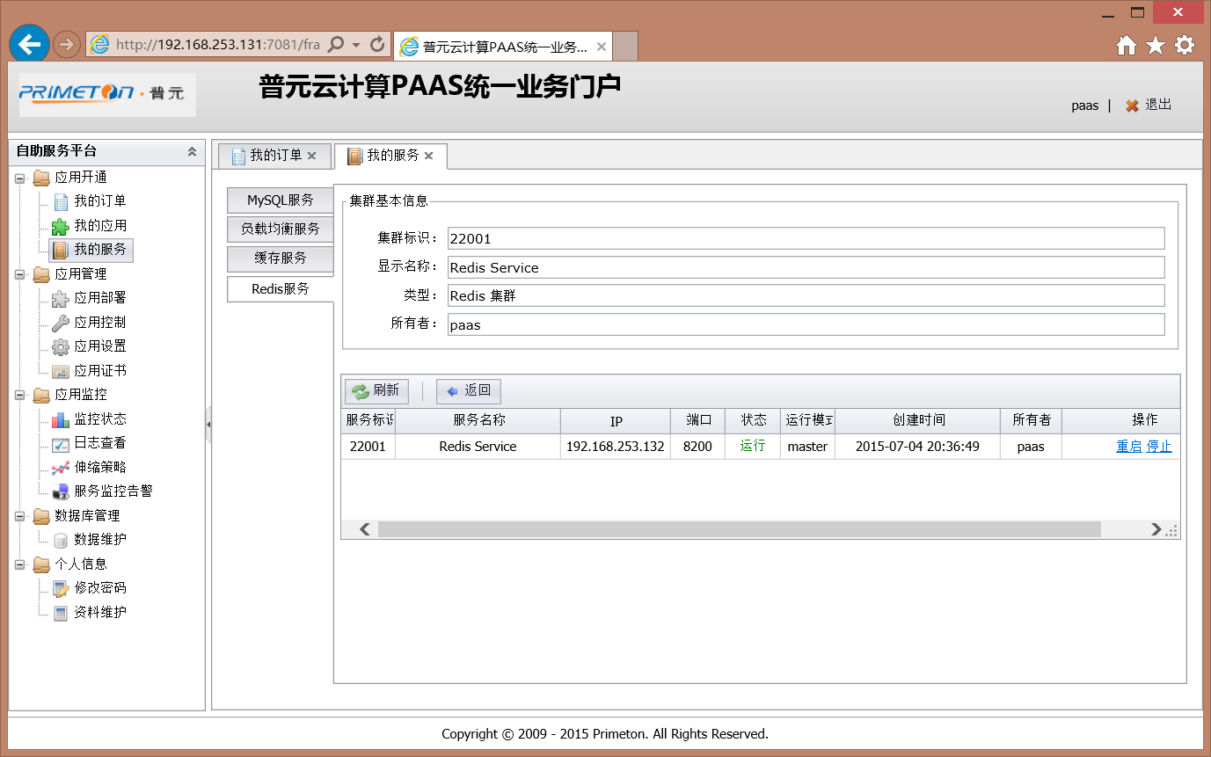

|  |
| --- |
| <%@page pageEncoding=*"UTF-8"* contentType=*"text/html; charset=UTF-8"*%>  <%@page import=*"com.primeton.paas.manage.api.service.RedisService"*%>  <%  String clusterId = request.getParameter("clusterId");  %>  <!DOCTYPE html PUBLIC "-//W3C//DTD XHTML 1.0 Transitional//EN" "http://www.w3.org/TR/xhtml1/DTD/xhtml1-transitional.dtd">  <html xmlns=*"http://www.w3.org/1999/xhtml"*>  <head>  <meta http-equiv=*"content-type"* content=*"text/html; charset=UTF-8"* />  <script src=*"*<%=request.getContextPath() %>*/common/nui/nui.js"* type=*"text/javascript"*></script>  <script src=*"*<%=request.getContextPath() %>*/common/cloud/dictEntry.js"* type=*"text/javascript"*></script>  <script src=*"*<%=request.getContextPath() %>*/common/cloud/common.js"* type=*"text/javascript"*></script>  <style type=*"text/css"*>  *.asLabel* *.nui-textbox-border***,**  *.asLabel* *.nui-textbox-input***,**  *.asLabel* *.nui-buttonedit-border***,**  *.asLabel* *.nui-buttonedit-input***,**  *.asLabel* *.nui-textboxlist-border*  {  border:*0*;background:*none*;cursor:*default*;  }  *.asLabel* *.nui-buttonedit-button***,**  *.asLabel* *.nui-textboxlist-close*  {  display:*none*;  }  *.asLabel* *.nui-textboxlist-item*  {  padding-right:*8px*;  }  </style>  <script type=*"text/javascript"*>  **var** datas = [{ id: 'true', text: '是'}  , { id: 'false', text: '否'}  ];  </script>  </head>  <body>  <form id=*"form1"* method=*"post"* action=*"*<%=request.getContextPath() %>*/srv/service/getRedisClusterDetail"*>  <fieldset style="border:*solid 1px #aaa*;padding:*3px*;">  <legend >集群基本信息</legend>  <div style="padding:*5px*;">  <table style="width:*100%*">  <tr>  <td style="width:*10%*;" align=*"right"*>集群标识：</td>  <td style="width:*80%*;">  <input name=*"id"* id=*"id"* class=*"nui-textbox asLabel"* width=*"100%"*/>  </td>  </tr>  <tr>  <td style="width:*10%*;" align=*"right"*>显示名称：</td>  <td style="width:*80%*;">  <input name=*"name"* class=*"nui-textbox asLabel"* width=*"100%"*/>  </td>  </tr>  <tr>  <td style="width:*10%*;" align=*"right"*>类型：</td>  <td style="width:*80%*;">  <input name=*"type"* class=*"nui-textbox asLabel"* width=*"100%"*/>  </td>  </tr>  <tr>  <td style="width:*10%*;" align=*"right"*>所有者：</td>  <td style="width:*80%*;">  <input name=*"owner"* class=*"nui-textbox asLabel"* width=*"100%"*/>  </td>  </tr>    </table>  </div>  </fieldset>  </form>  <br/>  <div style="width:*100%*;">  <div class=*"nui-toolbar"* style="border-bottom:*0*;padding:*0px*;">  <table style="width:*100%*;">  <tr>  <!--  <td style="width:100%;">  <a class="nui-button" iconCls="icon-add" onclick="increase()">新增实例</a><span class="separator"></span>  <a class="nui-button" iconCls="icon-remove" onclick="decrease()">移除实例</a>  </td>  -->  <td style="white-space:*nowrap*;">  <a class=*"nui-button"* iconCls=*"icon-reload"* onclick="reFresh()">刷新</a>  <span class=*"separator"*></span>  <a class=*"nui-button"* iconCls=*"icon-upgrade"* onclick="goBack()">返回</a>  </td>  </tr>  </table>  </div>  </div>  <div id=*"servicegrid"* class=*"nui-datagrid"* style="width:*100%*;height:*120px*" allowResize=*"true"*  idField=*"id"* multiSelect=*"true"* url=*"*<%=request.getContextPath() %>*/srv/service/redisService/*<%=clusterId %>*"* showPager=*"false"* onloaderror=*"onLoadErrorRenderer"*>  <div property=*"columns"*>  <!-- <div type="checkcolumn" ></div> -->  <div field=*"id"* width=*"50"* headerAlign=*"center"* align =*"center"* allowSort=*"false"* renderer=*"onActionRenderer"*>服务标识</div>  <div field=*"name"* width=*"150"* headerAlign=*"center"* align =*"center"* allowSort=*"false"*>服务名称</div>  <div field=*"ip"* width=*"100"* headerAlign=*"center"* align =*"center"* allowSort=*"false"*>IP</div>  <div field=*"port"* width=*"50"* headerAlign=*"center"* align =*"center"* allowSort=*"false"*>端口</div>  <div field=*"state"* width=*"50"* headerAlign=*"center"* align =*"center"* renderer=*"onServiceStateRenderer"*>状态</div>  <div field=*"attributes.runMode"* width=*"50"* headerAlign=*"center"* align =*"center"*>运行模式</div>  <div field=*"createdDate"* width=*"150"* headerAlign=*"center"* align =*"center"* allowSort=*"false"* renderer=*"onDateRenderer"*>创建时间</div>  <div field=*"owner"* width=*"100"* headerAlign=*"center"* align =*"center"* allowSort=*"false"*>所有者</div>  <div name=*"action"* width=*"150"* headerAlign=*"center"* align=*"center"* renderer=*"onServiceActionRenderer"* cellStyle=*"padding:0;"*>操作</div>  </div>  </div>  <script type=*"text/javascript"*>  nui.parse();    **var** grid = nui.get("servicegrid");  **var** form = **new** nui.Form("form1");  initForm();  grid.load();    **function** initForm() {  **var** clusterId = '<%=clusterId%>';  form.loading("操作中，请稍后 ...");  $.ajax({  url: "<%=request.getContextPath() %>/srv/service/getRedisClusterDetail/" + clusterId,  success: **function** (text) {  form.unmask();  **var** o = nui.decode(text);  o.data.type = o.data.type + " 集群";//**for** display  o.data.attributes.storageSize = o.data.attributes.storageSize + " G";  **if** (o.data.attributes.enableSession == ''  || o.data.attributes.enableSession == **null**) {  o.data.attributes.enableSession = **false**;  }  setNUIForm(form, **true**, **true**); // see common.js  form.setData(o.data);  form.setChanged(**false**);  },  error: **function** (jqXHR, textStatus, errorThrown) {  form.unmask();  nui.alert(jqXHR.responseText);  }  });  }    **function** reFresh() {  grid.reload();  }    **function** goBack() {  window.location = "myRedisClusters.jsp";  }    </script>  </body>  </html> |

**新建Redis服务向导：**

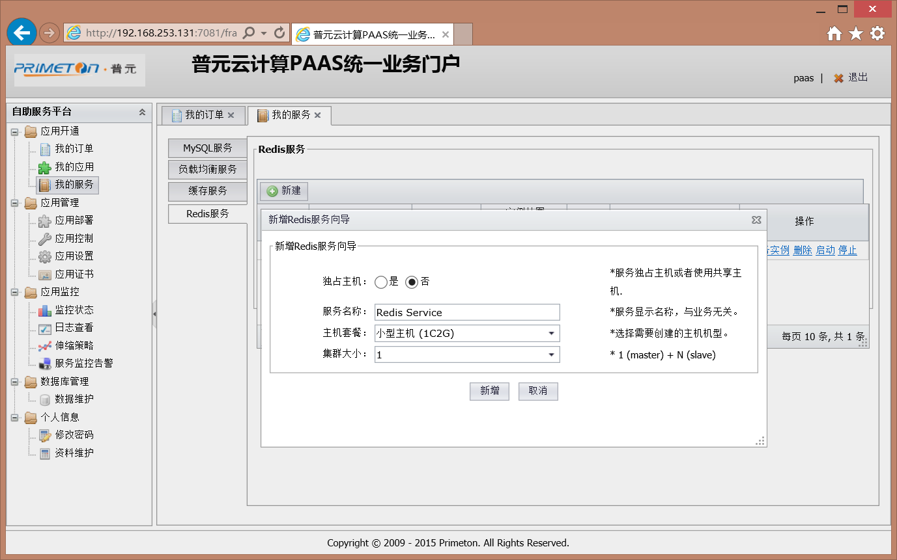

|  |
| --- |
| <%@page pageEncoding=*"UTF-8"* contentType=*"text/html; charset=UTF-8"* %>  <%@page import=*"java.util.List"*%>  <%@page import=*"java.util.ArrayList"*%>  <%@page import=*"java.util.Map"*%>  <%@page import=*"java.util.HashMap"*%>  <%@page import=*"net.sf.json.JSONObject"*%>  <%@page import=*"net.sf.json.JSONArray"*%>  <%@page import=*"com.primeton.paas.console.common.SystemVariable"*%>  <%@page import=*"com.primeton.paas.manage.api.model.OrderItemAttr"*%>  <%@page import=*"com.primeton.paas.manage.api.model.HostPackage"*%>  <%@page import=*"com.primeton.paas.manage.api.model.OrderItem"*%>  <%@page import=*"com.primeton.paas.manage.api.service.RedisService"*%>  <%  HostPackage[] hostpkgs = SystemVariable.getAllHostPackages();  List<Object> hostpkgsList = **new** ArrayList<Object>();  **for** (HostPackage st : hostpkgs) {  Map<String, Object> hostpkgsMap = **new** HashMap<String, Object>();  hostpkgsMap.put("id", st.getId());  hostpkgsMap.put("text", st.getName() + " ("  + st.getModel().getCoreCPU() + "C"  + st.getModel().getMemorySize() + "G" + ")");  hostpkgsList.add(hostpkgsMap);  }  Object hostpkgsData = JSONArray.fromObject(hostpkgsList);    **int** maxSize = SystemVariable.getMaxRedisSize();  maxSize = maxSize >= 1 ? maxSize : 5;  List<Object> sizeList = **new** ArrayList<Object>();  **for** (**int** i=1; i<=maxSize; i++) {  Map<String, Object> entry = **new** HashMap<String, Object>();  entry.put("id", String.valueOf(i));  entry.put("text", String.valueOf(i));  sizeList.add(entry);  }  Object sizeArrayData = JSONArray.fromObject(sizeList);  %>  <!DOCTYPE html PUBLIC "-//W3C//DTD XHTML 1.0 Transitional//EN" "http://www.w3.org/TR/xhtml1/DTD/xhtml1-transitional.dtd">  <html xmlns=*"http://www.w3.org/1999/xhtml"*>  <head>  <meta http-equiv=*"content-type"* content=*"text/html; charset=UTF-8"* />  <script src=*"*<%=request.getContextPath() %>*/common/nui/nui.js"* type=*"text/javascript"*></script>  <script src=*"*<%=request.getContextPath() %>*/common/cloud/dictEntry.js"* type=*"text/javascript"*></script>  </head>  <body>  <form id=*"form1"* method=*"post"* action=*"*<%=request.getContextPath() %>*/srv/service/createRedis"*>  <fieldset style="border:*solid 1px #aaa*;padding:*3px*;">  <legend >新增Redis服务向导</legend>  <div style="padding:*5px*;">  <input name=*"order.itemList[0].itemType"* value=*"*<%=RedisService.TYPE %>*"* class=*"nui-hidden"* />  <input name=*"order.orderType"* value=*"SingleCreateRedis"* class=*"nui-hidden"* /> <!-- 创建简单的Redis服务集群及其服务实例 -->  <table border=*"0"*>  <tr>  <td style="width:*20%*;" align=*"right"*>独占主机：</td>  <td style="width:*50%*;">  <input name=*"order.itemList[0].attrList[0].attrName"* value=*"*<%=OrderItemAttr.ATTR_IS_STANDALONE%>*"* class=*"nui-hidden"* />  <input name=*"order.itemList[0].attrList[0].attrValue"* class=*"nui-radiobuttonlist"* textField=*"text"* valueField=*"id"* value=*"N"* data=*" [{ id: 'Y', text: '是'}, { id: 'N', text: '否'}]"* onvalidation=*"onNullValidation"* width=*"80%"*/>  </td>  <td align=*"left"*>*服务独占主机或者使用共享主机.</td>  </tr>  <tr>  <td style="width:*15%*;" align=*"right"*>服务名称：</td>  <td style="width:*50%*;">  <input name=*"order.itemList[0].attrList[1].attrName"* value=*"*<%=OrderItemAttr.ATTR_DISPLAY_NAME%>*"* class=*"nui-hidden"* />  <input name=*"order.itemList[0].attrList[1].attrValue"* class=*"nui-textbox"* onvalidation=*"onNullValidation"* value=*"*<%=RedisService.TYPE %> *Service"* width=*"80%"*/>  </td>  <td align=*"left"*>*服务显示名称，与业务无关。</td>  </tr>  <tr>  <td style="width:*15%*;" align=*"right"*>主机套餐：</td>  <td style="width:*50%*;">  <input name=*"order.itemList[0].attrList[2].attrName"* value=*"*<%=OrderItemAttr.ATTR_HOSTPKG_ID%>*"* class=*"nui-hidden"* />  <input name=*"order.itemList[0].attrList[2].attrValue"* class=*"nui-combobox"* data=*'*<%=hostpkgsData %>*'* value=*"20130517J001"* width=*"80%"*/>  </td>  <td align=*"left"*>*选择需要创建的主机机型。</td>  </tr>  <tr>  <td style="width:*15%*;" align=*"right"*>集群大小：</td>  <td style="width:*50%*;">  <input name=*"order.itemList[0].attrList[3].attrName"* value=*"*<%=OrderItemAttr.ATTR_CLUSTER_SIZE%>*"* class=*"nui-hidden"* />  <input name=*"order.itemList[0].attrList[3].attrValue"* class=*"nui-combobox"* data=*'*<%=sizeArrayData %>*'* value=*"1"* width=*"80%"*/>  </td>  <td align=*"left"*>* 1 (master) + N (slave)</td>  </tr>  </table>  </div>  </fieldset>    <div style="text-align:*center*;padding:*10px*;">  <a class=*"nui-button"* style="width:*8%*; " onclick="onAdd">新增</a> &nbsp;  <a class=*"nui-button"* style="width:*8%*; " onclick="onCancel">取消</a>  </div>  </form>    <script type=*"text/javascript"*>  nui.parse();    **var** form = **new** nui.Form("form1");    **function** onNullValidation(e) {  **if** (!e.value) {  e.errorText = "不能为空！";  e.isValid = **false**;  }  }    **function** closeWindow(action) {  **if** (window.CloseOwnerWindow) {  **return** window.CloseOwnerWindow(action);  } **else** {  window.close();  }  }    **function** onAdd() {  **if** (!confirm("你确定要提交Redis服务创建申请？")) {  **return** **false**;  }  form.validate();  **if** (form.isValid() == **false**) {  **return**;  }    **var** data = form.getData().order;  **var** json = nui.encode(data);    $.ajax({  url: "<%=request.getContextPath() %>/srv/myService/createRedis",  contentType: "application/json; charset=utf-8",  data: json,  type: "PUT",  success: **function** (text) {  nui.alert("订单已提交，请到订单管理中查看处理结果！");  }  });  closeWindow("ok");  }    **function** onCancel(){  closeWindow("cancel");  }    </script>  </body>  </html> |

### MVC : Controller 开发

Jersey Rest风格开发，示例如下：

|  |
| --- |
| /**  *  * **@param** order  * **@return**  */  @Path("createRedis")  @PUT  @Produces(MediaType.***APPLICATION_JSON***)  @Consumes(MediaType.***APPLICATION_JSON***)  **public** Response createRedis(Order order) {  **if** (order != **null**) {  **if** (StringUtil.*isEmpty*(order.getOrderType())) {  order.setOrderType(SingleCreateRedisOrderProcessor.***TYPE***);  }  // 创建订单提交,但不自动审批,返回订单id  order = SrvApplyUtil.*submitOrder*(order, **false**);  }  Map<String, Object> result = **new** HashMap<String, Object>();  result.put("orderId", **null** == order ? **null** : order.getOrderId()); //$NON-NLS-1$  ResponseBuilder builder = Response.*ok*(result);  **return** builder.build();  } |

默认使用ConsoleResourceConfig注册了下面几个包，

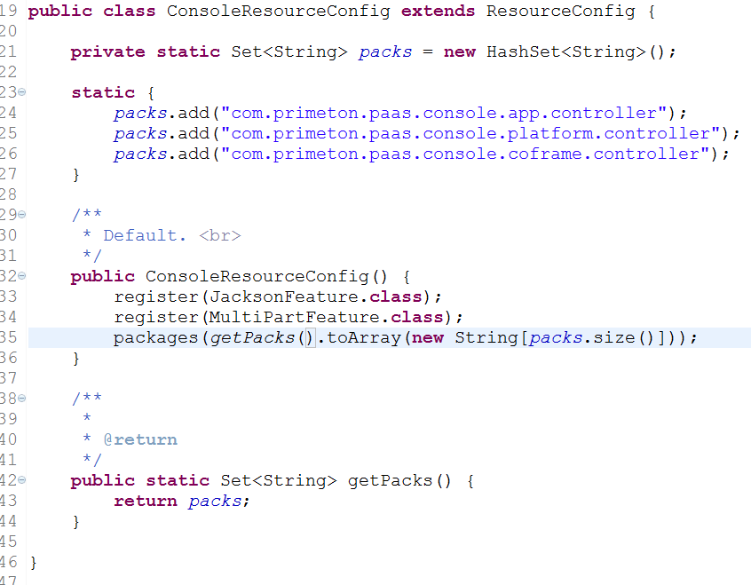

如果扩展的Controller在其他包中，则需要覆盖ConsoleResourceConfig或直接继承ResourceConfig并修改web.xml配置，如下图所示：

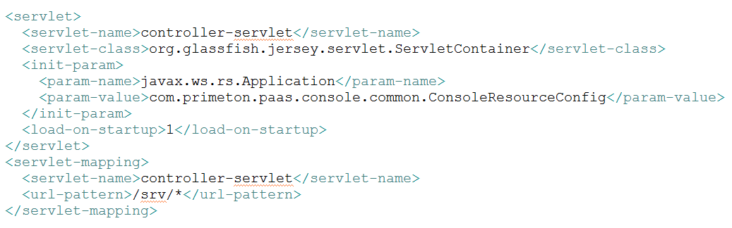

示例代码-1：

|  |
| --- |
| /**  * Copyright © 2009 - 2015 Primeton. All Rights Reserved.  */  package com.primeton.paas.console.common;  import java.util.HashSet;  import java.util.Set;  /**  * @author ZhongWen.Li (mailto:lizw@primeton.com)  *  */  public class NewResourceConfig extends ConsoleResourceConfig {  private static Set<String> newPacks = new HashSet<String>();    static {  newPacks.add("com.xxx.paas.app.controller");  newPacks.add("com.xxx.paas.platform.controller");  }    /**  * Default. <br>  */  public NewResourceConfig() {  super();  packages(newPacks.toArray(new String[newPacks.size()]));  }  } |

示例代码-2:

|  |
| --- |
| /**  * Copyright © 2009 - 2015 Primeton. All Rights Reserved.  */  package com.primeton.paas.console.common;  import java.util.HashSet;  import java.util.Set;  import org.glassfish.jersey.server.ResourceConfig;  /**  * @author ZhongWen.Li (mailto:lizw@primeton.com)  *  */  public class NewResourceConfig extends ResourceConfig {  private static Set<String> newPacks = new HashSet<String>();    static {  newPacks.add("com.xxx.paas.app.controller");  newPacks.add("com.xxx.paas.platform.controller");  }    /**  * Default. <br>  */  public NewResourceConfig() {  super();  packages(ConsoleResourceConfig.getPacks().toArray(  new String[ConsoleResourceConfig.getPacks().size()]));  packages(newPacks.toArray(new String[newPacks.size()]));  }  } |

## CONSOLE-PLATFORM

### 菜单定义

|  |
| --- |
| INSERT INTO cap_function (FUNC_ID, TENANT_ID, FUNC_NAME, FUNC_TYPE, FUNC_DESC, FUNC_ACTION, ISCHECK, ISMENU, CREATEUSER, CREATETIME) VALUES ('PAS_RedisMgr', 'default', 'Redis服务', 'page', 'Redis集群及服务管理', '../platform/srvmgr/redis/ClusterMgr.jsp', '1', '1', 'sysadmin', '2014-05-30 06:28:47'); |

|  |
| --- |
| INSERT INTO cap_menu (MENU_ID, TENANT_ID, MENU_CODE, MENU_NAME, LINK_TYPE, LINK_RES, LINK_ACTION, MENU_LEVEL, MENU_SEQ, ISLEAF, PARENT_MENU_ID, IMAGEPATH, EXPANDPATH, OPENMODE, CREATEUSER, CREATETIME) VALUES (284, 'default', 'PAS_1023_redis', 'Redis服务', 'function', 'PAS_RedisMgr', '../platform/srvmgr/redis/ClusterMgr.jsp', 2, '42.284.', '1', 42, 'platform_redisClusterMgr', null, '0', 'sysadmin', '2015-01-23 11:45:02'); |

|  |
| --- |
| INSERT INTO cap_resauth (TENANT_ID, PARTY_ID, PARTY_TYPE, RES_ID, RES_TYPE, RES_STATE, PARTY_SCOPE, CREATEUSER, CREATETIME) VALUES ('default', '102', 'role', 'PAS_RedisMgr', 'function', '1', '0', 'sysadmin', '2014-05-30 06:50:28'); |

### 页面开发

参考6.1.2章节。参考Console安装介质中的WAR。

### MVC : Controller 开发

参考6.1.3章节。