

This Report of Machine Learning Project
About
Guest Satisfaction Prediction

Prof: Dr. Dina Khattab

Level | Department | ID | Name
3 | Scientific Computing(SC) | 2022170006 | ابراهيم محمد ابراهيم احمد محمد | 1
3 | Scientific Computing(SC) | 2022170445 | منه حسن محمد حسن | 2
3 | Scientific Computing(SC) | 2022170185 | سعاد سعيد إبراهيم محمد | 3
3 | Scientific Computing(SC) | 2022170569 | رغد سامي زكي جوهر عسكر | 4
3 | Scientific Computing(SC) | 2022170302 | فاطمه الزهراء عاطف محمود | 5
3 | Scientific Computing(SC) | 2022170556 | حسام الدين احمد رزق خميس | 6

2025 – 2026
- Introduction
This report details the machine learning pipeline implemented by our team to predict guest satisfaction using the dataset GuestSatisfactionPrediction.csv. The pipeline includes data loading, exploration, cleaning, preprocessing, feature engineering, and encoding, preparing the data for model training.
- Data Loading and Initial Exploration
- Step: We read the dataset from GuestSatisfactionPrediction.csv using pandas and displayed basic details.
- Details:
  - Dataset dimensions: 8,724 rows and 69 columns.
  - Key columns include id, listing_url, name, summary, host_response_time, room_type, and review_scores_rating.
  - Methods used: data.shape, data.head(), data.columns, data.describe(), and data.info() to inspect structure, data types, and statistics.
- Purpose: Understand the dataset’s composition and identify initial preprocessing needs.
- Checking Duplicates
- Step: We checked for duplicate rows using data.duplicated().sum().
- Details: No duplicates were found (sum = 0).
- Purpose: Ensure data integrity by confirming no redundant entries.
- Handling Missing Values
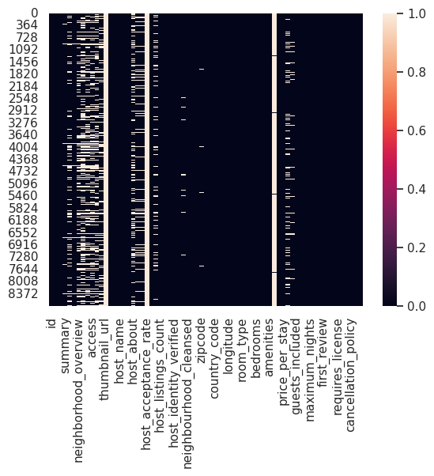
- Step: We identified null values with data.isnull().sum() and calculated the percentage of missing values for each column. A heatmap was drawn to visualize missing data (space reserved below).

- Details:
Columns with >80% missing values were dropped: thumbnail_url, host_acceptance_rate, square_feet.
Missing percentages guided further preprocessing decisions.
- Purpose: Assess and mitigate the impact of missing data.
- Data Cleaning
- Step: We dropped redundant or irrelevant columns:
  - name, host_name, id, listing_url, host_url, host_id, country_code (same as country), smart_location (same as city + state), street (same as city + state + country).
- Details: These columns were removed to simplify the dataset and focus on predictive features.
- Step: Cleaned specific columns:
  - Removed "$" from nightly_price, price_per_stay, security_deposit, cleaning_fee, extra_people.
  - Removed "%" from host_response_rate.
  - Converted first_review, last_review, host_since to days from the current date.
  - Removed "-" from zipcode.
- Purpose: Standardize data formats for numerical analysis.
- Imputing Missing Values
- Step: Filled missing values based on feature type:
- Numerical Columns: Missing values in numerical columns such as "beds", "bathrooms", "bedrooms", "cleaning_fee", "security_deposit", "host_total_listings_count", "host_listings_count", "host_response_rate", and "host_since" are filled with the median value of the respective column.
- Categorical Columns: Missing values in categorical columns like "host_response_time", "neighbourhood", "market", "host_location", "host_neighbourhood", "host_identity_verified", "host_has_profile_pic", and "host_is_superhost" are filled with the mode (most frequent value) of the respective column.
- Group-Based Imputation:
  - Missing values in the "zipcode" column are filled using the median value of the "zipcode" for the same "city".
  - Missing values in the "state" column are filled by extracting the relevant part from the "street" column.
- Purpose: Ensure a complete dataset while preserving relationships between features.
- Outlier Detection
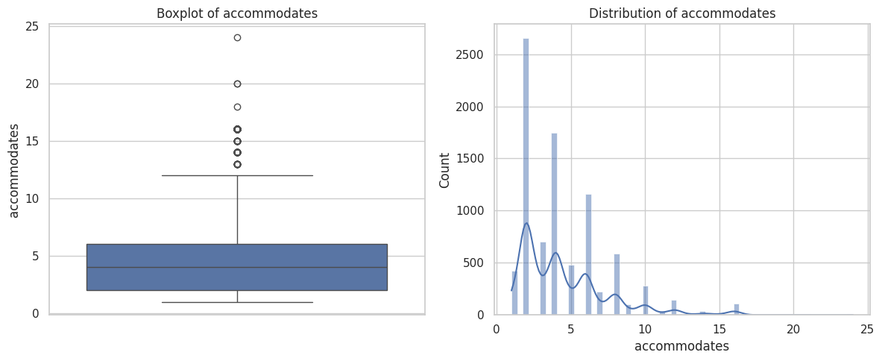
- Step: Drew boxplots and distribution plots for numerical features to check outliers, identified using the IQR method.

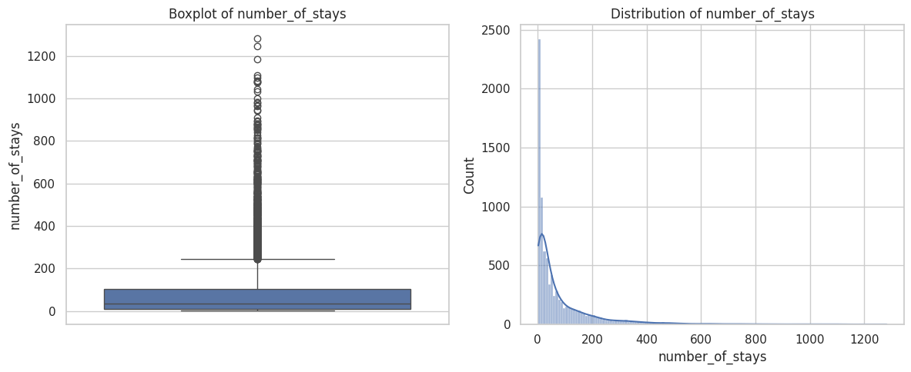

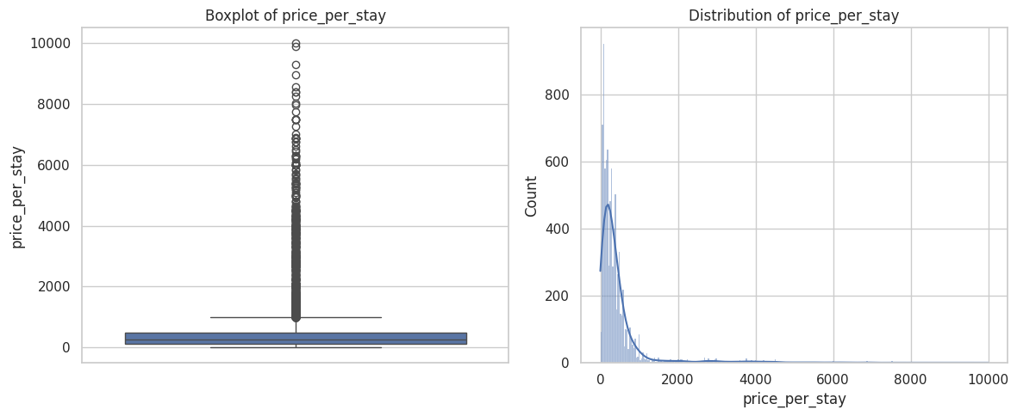

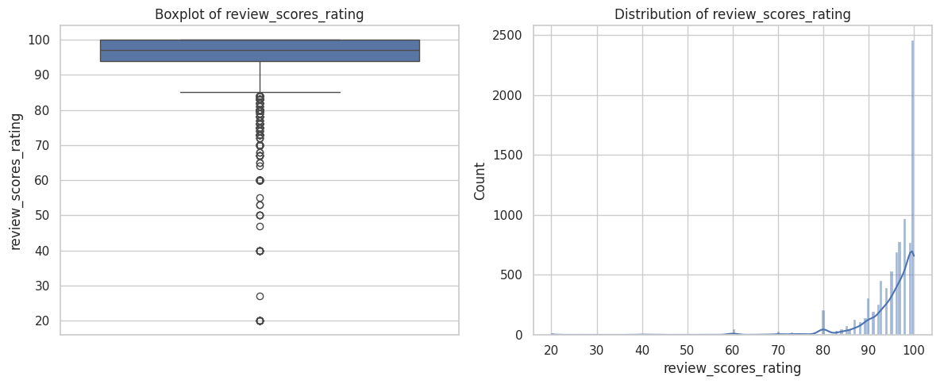

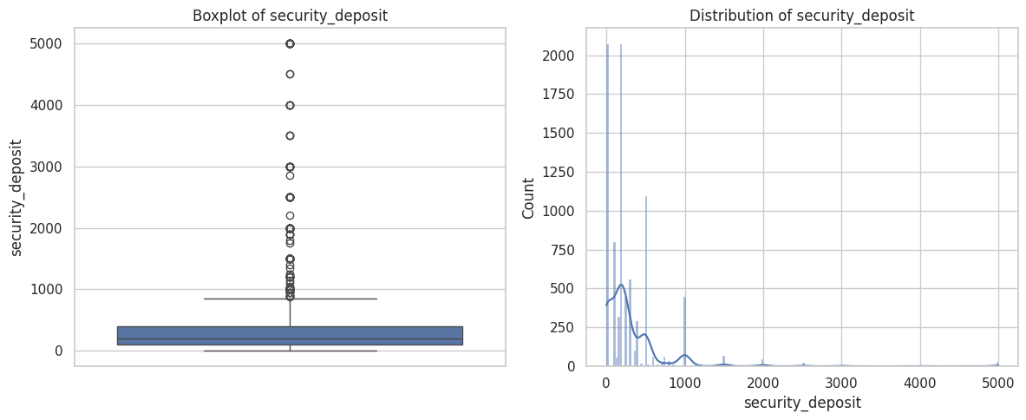

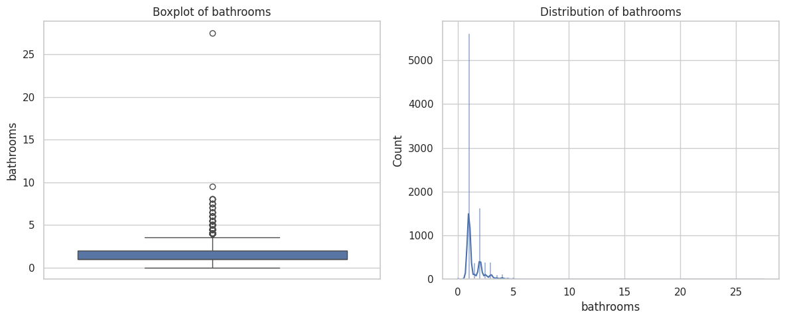

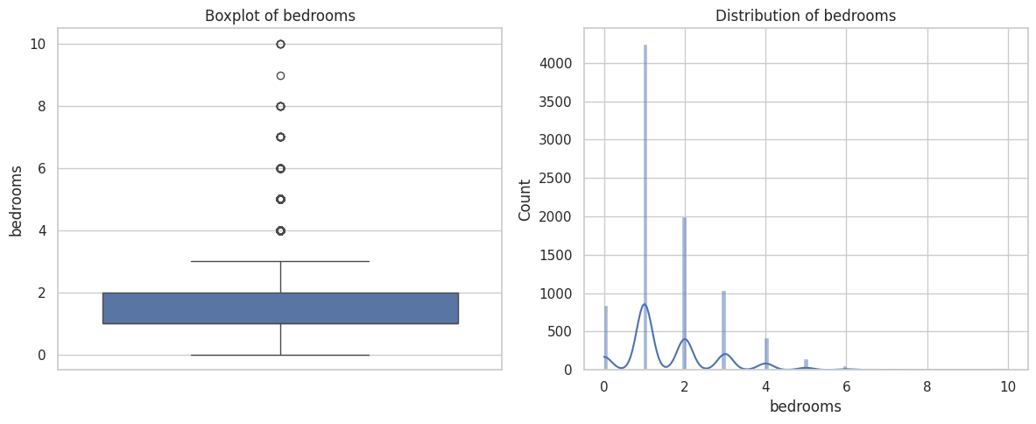

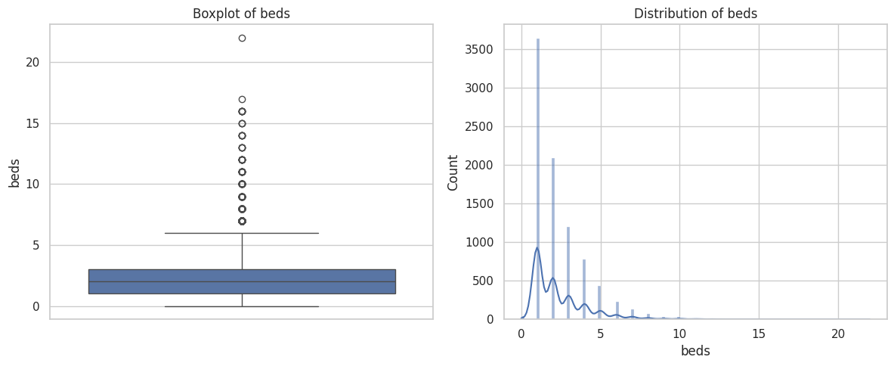

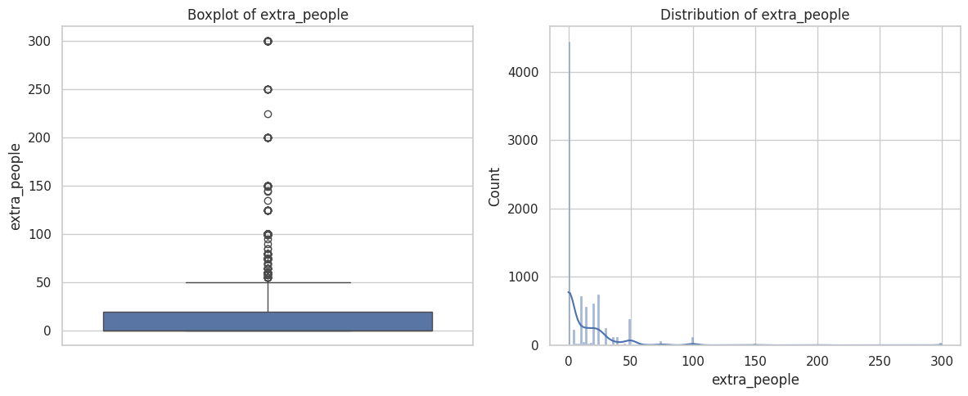

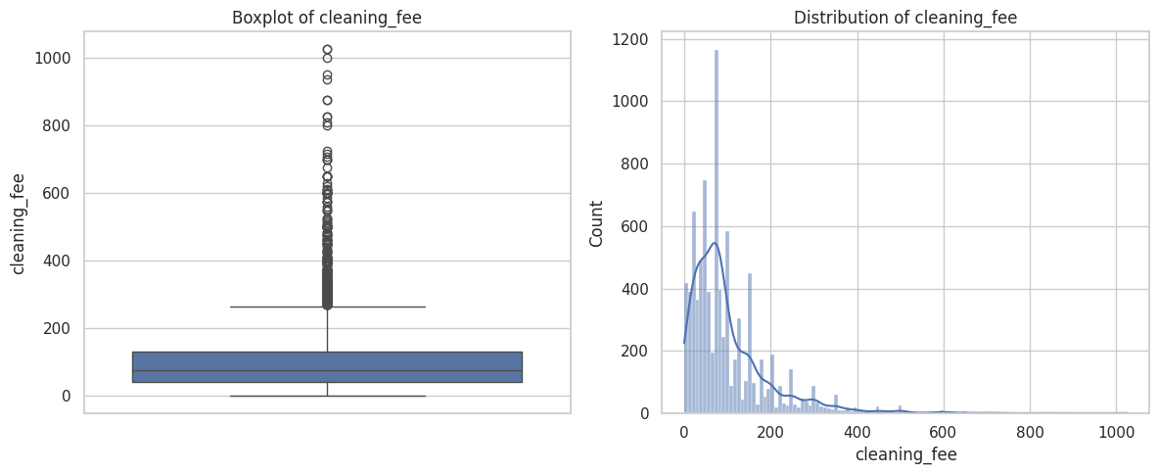

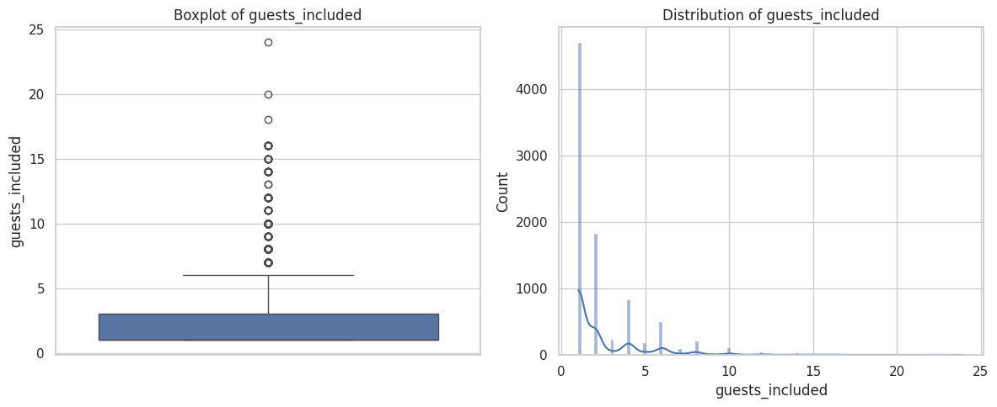

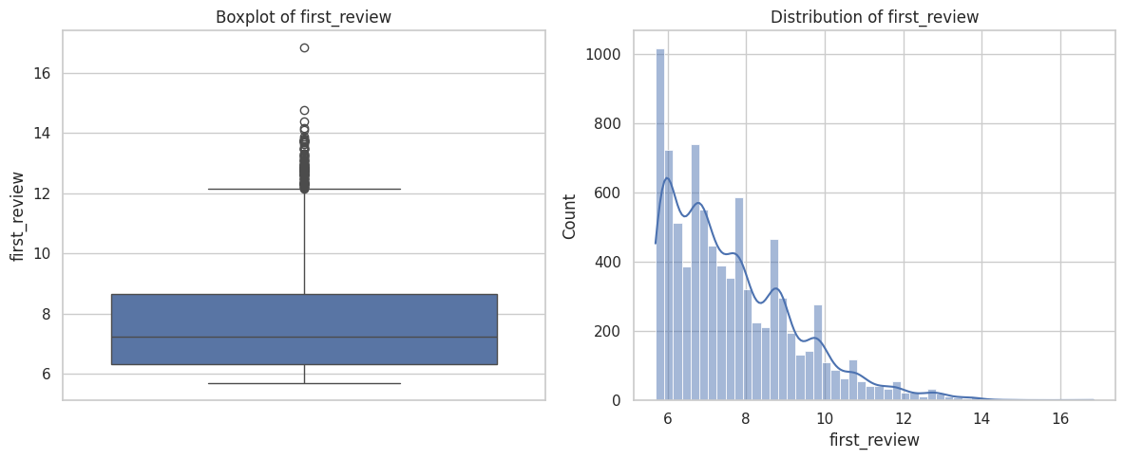

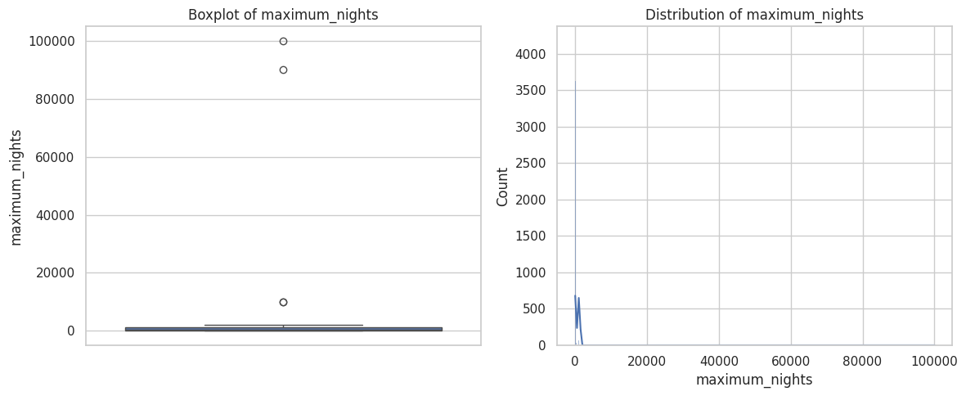

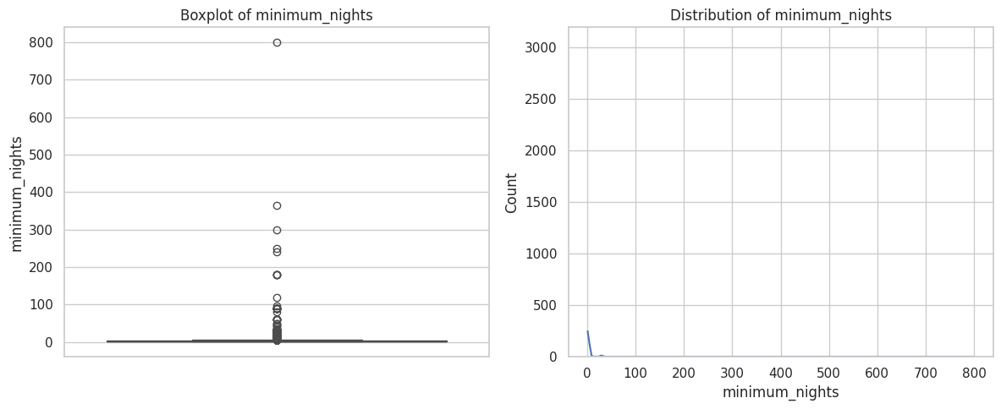

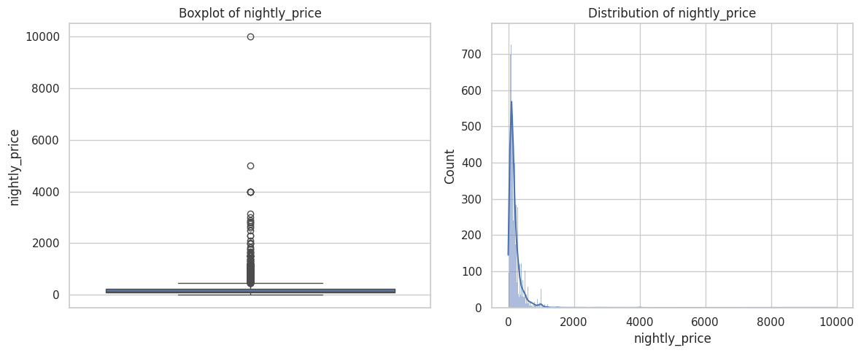

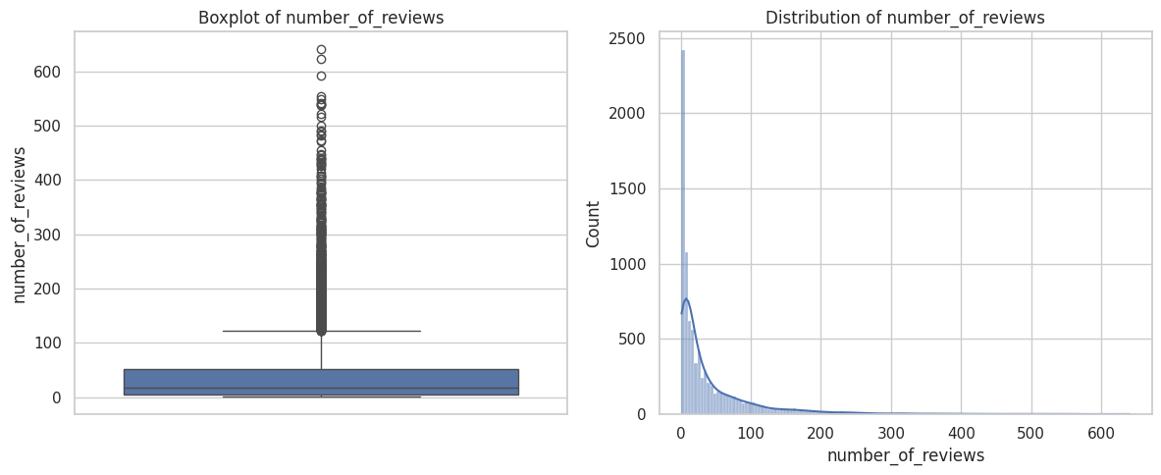

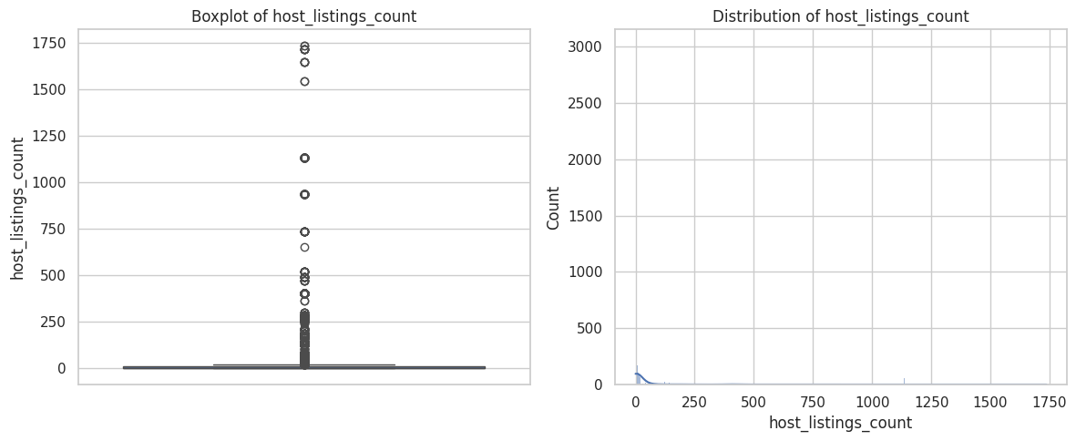

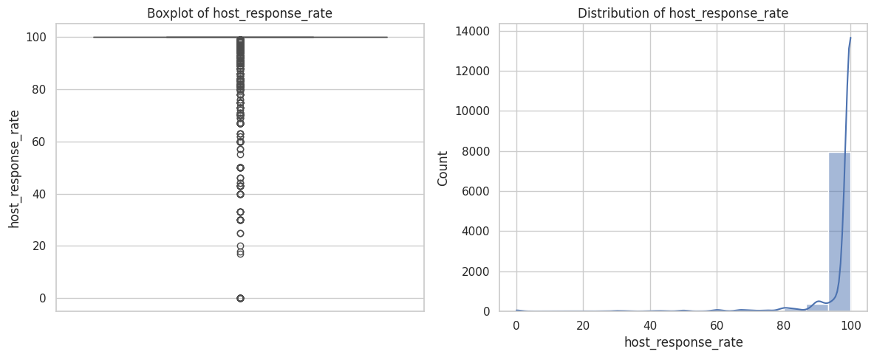

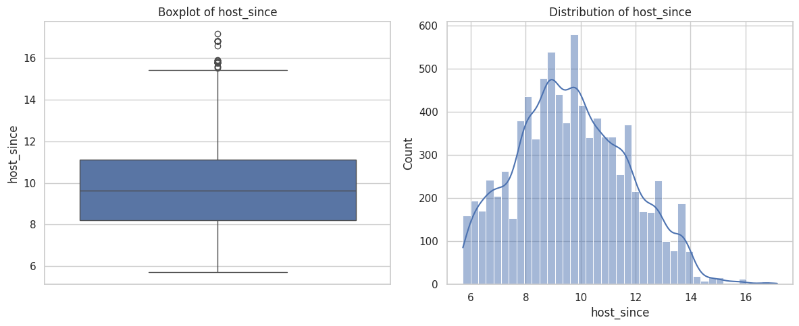

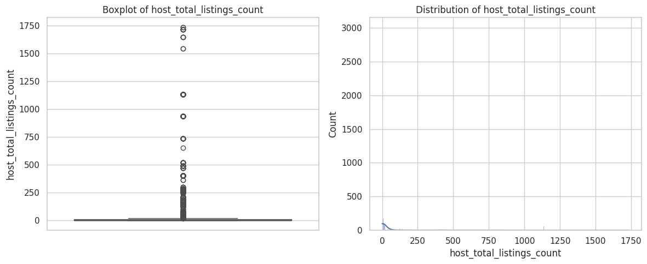

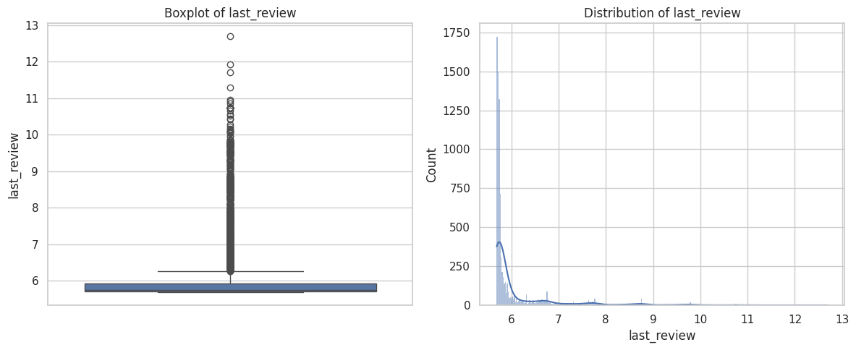

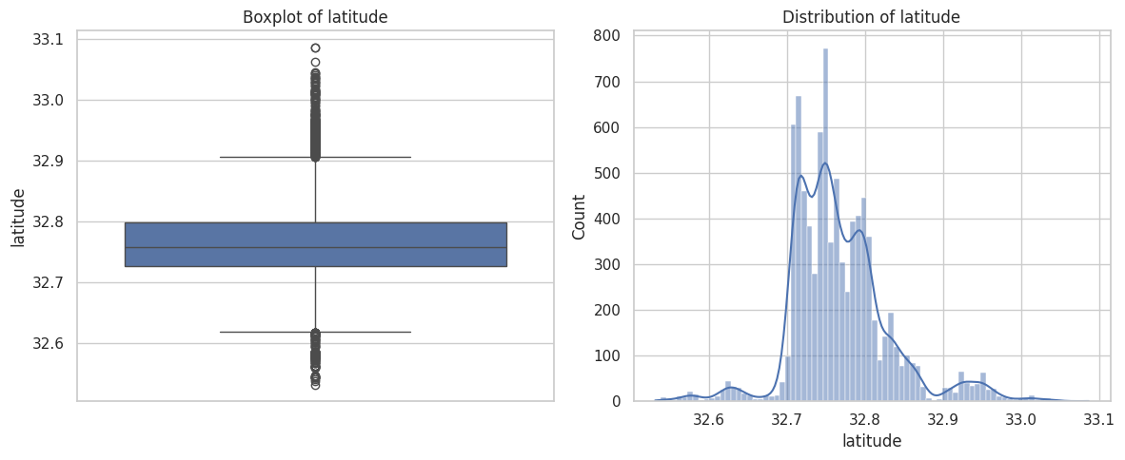

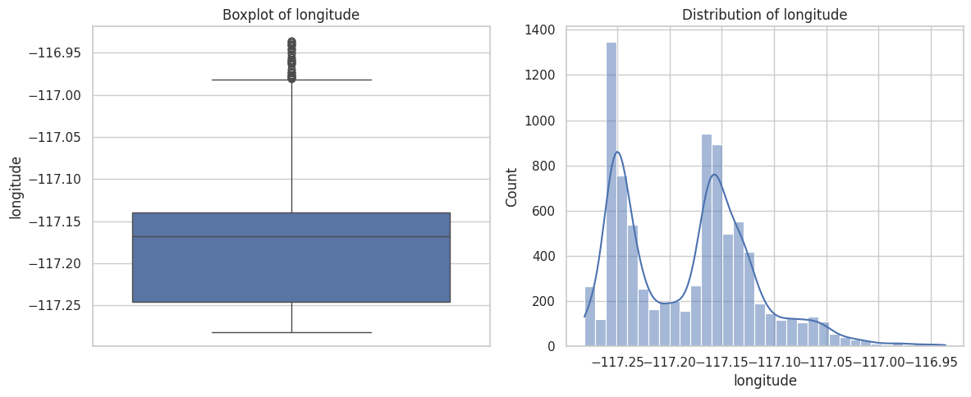

- Details: Visualizations helped detect anomalies in the data.
- Purpose: Prevent outliers from skewing model performance.
- Encoding Categorical Variables
- Step: Encoded categorical data:
  - Binary Encoding: Replaced 't'/'f' with 1/0 in host_is_superhost, host_has_profile_pic, host_identity_verified, is_location_exact, requires_license, instant_bookable, is_business_travel_ready, require_guest_profile_picture, require_guest_phone_verification.
  - Manual Mapping: Used dictionaries for country, host_response_time, room_type, bed_type, market, cancellation_policy.
    - Special Cases:
      - state: Standardized multiple unique values referring to the same place with a single code.
      - city: Used a lambda function to map variations in writing style (e.g., case differences) to a standard code.
  - Factorize Encoding: Applied to high-cardinality columns: host_neighbourhood, host_location, property_type, neighbourhood_cleansed, neighbourhood.
  - TF-IDF Encoding: Encoded text columns summary, space, description, neighborhood_overview, notes, transit, access, interaction, house_rules, host_about, amenities with max_features=500 to extract key words.
- Purpose: Transform categorical and text data into numerical formats for modeling.
- Feature Selection
- Step: Performed correlation analysis, visualized with a heatmap, and selected top features.
- Details: Identified highly correlated features for potential removal.
- Purpose: Reduce multicollinearity and enhance model performance.



- Conclusion
The pipeline prepares the dataset comprehensively for predicting guest satisfaction. It includes loading, cleaning, imputing, encoding, and feature selection. The cleaned and encoded dataset is now ready for training machine learning models, which will be the next step in our project.

