Light Pollution in Zeeland Report

Vayona Narekuli

May 14, 2024

UCR Data Center

Apprenticeship Spring 2024

# To what extent have protected “duisternisgebieden” (darkness areas) appointed in January 2019 limited light pollution in Zeeland?

# Introduction

The implementation of the Darkness Areas Act in 2019 marked a significant step in addressing the issue of light pollution in Zeeland. This legislation, aimed at designating specific areas for darkness preservation(reference to the areas), underscored a growing recognition of the adverse effects of excessive artificial illumination on both the environment and human health. However, despite its noble intentions, the effectiveness of this act in reducing light pollution remains a subject of inquiry.

Understanding and quantifying light pollution presents formidable challenges. Light and luminosity can be detected through various means, ranging from satellite observations to ground-level measurements. Factors such as the spectrum of visible light captured and the methodologies employed can significantly influence the assessment of light pollution levels. Hence, ascertaining the true impact of the Darkness Areas Act necessitates a nuanced approach that considers these complexities.

This investigation focuses on assessing the effectiveness of the 2019 Darkness Areas Law in reducing light pollution in Zeeland. Using NASA VIIRS satellite data, this research aims to offer practical insights into the impact of the legislation. However, it’s important to recognize the possible influence of external factors, such as the COVID-19 pandemic, which coincided with the law’s implementation. This study seeks to understand and identify the general patterns of light pollution across Zeeland as a whole as well as each darkness area, in an attempt to clarify the effect of the 2019 Darkness Areas Act.

# Data

This study relied on NASA VIIRS data, known as Black Marble Night Time Lights data[1], for evaluating light pollution in Zeeland. This data uses remote sensing techniques to detect artificial light in units of radiance, and calibrates for confounding variables such as moonlight. There are many alternative approaches to researching light pollution, One such approach involves deploying ground-based measuring devices strategically. Although this approach may necessitate specialized equipment and expertise, it provides a unique perspective on light pollution dynamics and can help validate findings derived from satellite observations. This study however will focus on Black Marble data in order to maintain consistency across years. Additionally, both raw and calibrated Black Marble data is updated daily, making it possible for the methods in this project to be used for future analysis.

However, it’s essential to acknowledge VIIRS’s limitations. Primarily designed to detect light sources near nadir, the dataset may not fully capture the extent of LED lighting, which often emits light at angles away from the vertical. Consequently, there’s a possibility that VIIRS underestimates the true level of light pollution in areas where LED lighting is prevalent.

In order to manage the NASA VIIRS Blackmarble raster data, this paper works mostly with the Blackmarbler package[2] as well as the lightpollutionNL package which was made alongside this research for the purposes of reproducibility and documentation. Additionally, the geodata package provides administrative borders for the Netherlands and the borders for the darknessareas themselves have been drawn with reference to information available in the Provincial Blaad, an official publication for Zeeland[3]. Duisternisgebieden (darkness areas) were appointed in Zeeland in January of 2019. This research will therefore focus on yearly composite mean radiance in the years 2015 to 2023.

# Methods

## Mapping

|  |
| --- |
|  |

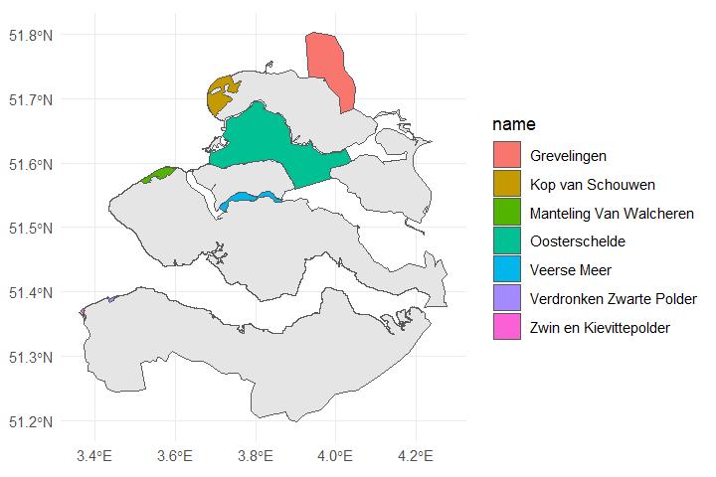

Figure 1 Darkness Areas in Zeeland

Figure 1 showcases the location of these 7 darkness areas in Zeeland, these designated darkness areas include water bodies as well as green forest areas.

Prior to investigating each darkness area separately however, first it would be interesting to investigate Zeeland as a whole to understand what kind of general patterns are present that may then have a further implications on the darknessareas specifically.

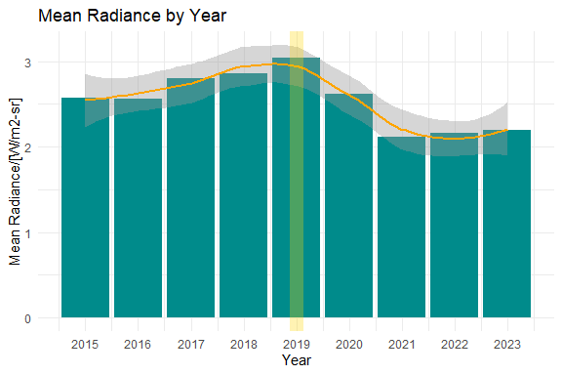

Figure 2 Zeeland Mean Radiance 2015 to 2023

Figure 2 shows a rise in mean nighttime radiance until its peak in 2019, with the yellow vertical line indicating the implementation of the darkness areas law, followed by a gradual decline until 2023. This suggests a possible effect of the light pollution reduction law implemented in 2019. However, the decline coincides with the onset of the COVID-19 pandemic in 2020. Further analysis is needed to determine whether the decrease is due to the law or the pandemic.

In order to rule out the COVID-19 pandemic as a confounding variable, the relationship between economic activity and light pollution in Zeeland will be examined. The reason for this is that economic activity serves as a reliable proxy for human mobility and outdoor lighting patterns, both of which are directly impacted by pandemic-related restrictions and behavioral changes [4]. Essentially, you would expect economic activity to reduce due to COVID and therefore light pollution to reduce also.

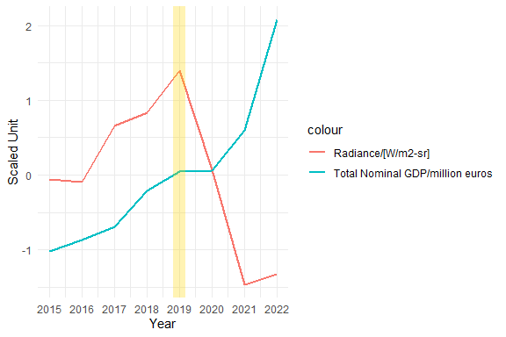

Figure 3 Radiance and Nominal GDP in 2015 to 2023[5]

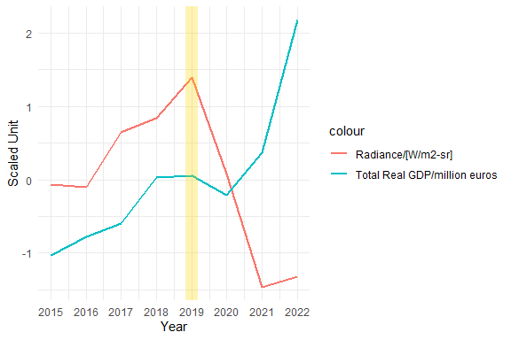

Figure 4 Radiance and Real GDP in 2015 to 2023[6]

Figures 3 and 4 illustrate the trends in light pollution radiance and total nominal GDP, or total real GDP in Zeeland from 2015 to 2023 in scaled standard units. The trends of nominal and real GDP are the same.

The graph shows a significant decline in light pollution radiance following the implementation of the darkness areas law in 2019. However, the total nominal GDP remains relatively stable throughout the period, suggesting that the reduction in light pollution is not correlated with a decrease in economic activity, such as the one observed during the COVID-19 pandemic. This implies that the decrease in light pollution was not necessarily due to the COVID-19 pandemic. This allows us to conclude that the effects of the darkness areas law measures are in fact being picked up, rather than the effects of the pandemic measures.

After ruling out the pandemic as a possible reason for the decrease in light pollution, the visible levels of light pollution in Zeeland as well as in the darkness areas specifically can be investigated.

### Darkness Areas in Zeeland

Unfortunately, radiance for large areas of water bodies such as Oosterschelde or Grevelingen is unavailable as it’s extremely difficult to discern radiance against the water reflections. Additionally, radiance values on water bodies are often so low they are indiscernible from general noise. Therefore, we will focus on the land and smaller water body areas.

#### Manteling Van Walcheren

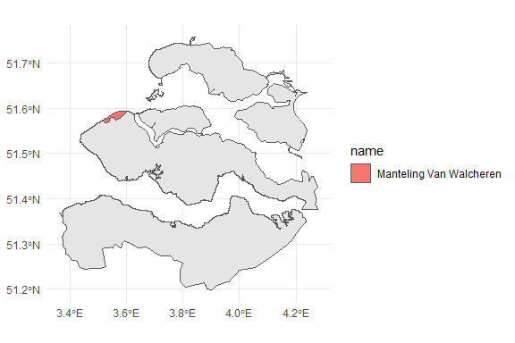

Figure 5 Manteling Van Walcheren

Manteling van Walcheren (Figure 5) is a darkness area present north of Oostkapelle and is a nature preserve with forest and beach areas.

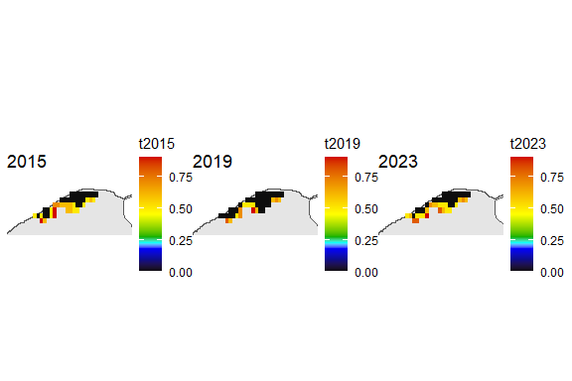

Figure 6 Manteling Van Walcheren 2015, 2019 and 2023

Figure 6 maps the radiance for this darkness area for the years of 2015, 2019 and 2023. It is clear that the radiance in 2015 was at its highest in both intensity and spread, and succesfully decreased in 2019 by a good amount. However, the radiance then seems to have increased in spread in 2023. This indicates that although the area is free of light sources itself, there is a good amount of light entering Manteling van Walcheren through diffusion from outside sources.

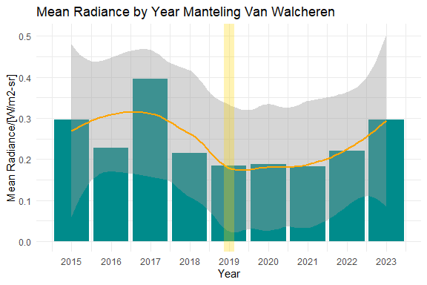

Figure 7 Manteling Van Walcheren Radiance 2015 to 2023

Based on the Figure 7 which showcases the mean radiance levels for Manteling van Walcheren specifically, it does seem that the radiance was significantly high prior to 2019, and it 2018 and 2019 it showed a drop. Additionally, it seems the radiance levels have slowly been increasing since 2022.

#### Kop van Schouwen

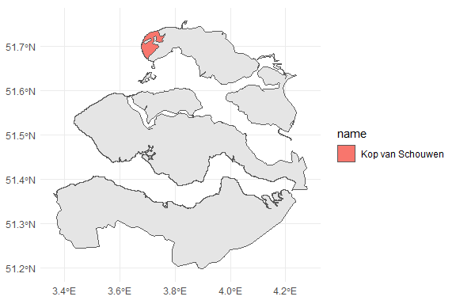

Figure 8 Kop van Schouwen

Kop van Schouwen (Figure 8) is a 4,400 hectare darkness area present in North Zeeland which consists of protected dune and forest areas [7].

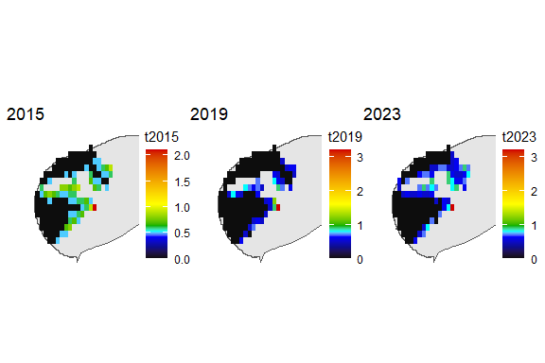

Figure 9 Kop van Schouwen 2015, 2019, 2023

As an important nature preserve that contains Zeeland’s largest forest, this area has quite low levels of light pollution in general. Whilst the radiance was at its highest in 2015, it has succesfully decreased.

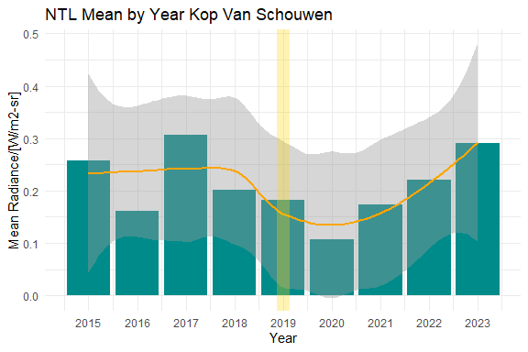

Figure 10 Kop van Schouwen Radiance 2015 to 2023

Figure 10 shows that Kop van Schouwen has quite low levels of Radiance with some spikes. Whilst the radiance levels reached an all time low in 2020, they have been steadily increasing since.

#### Veerse Meer

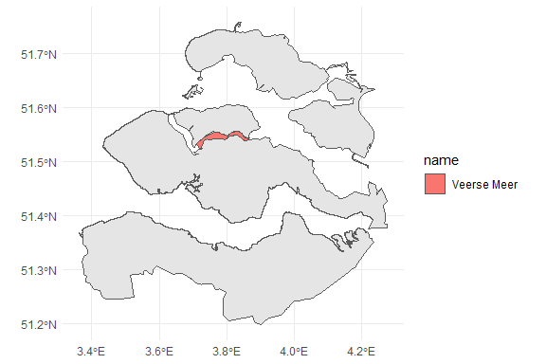

Figure 11 Veerse Meer

Figure 11 shows a protected section of the lake Veerse Meer which runs through central Zeeland.

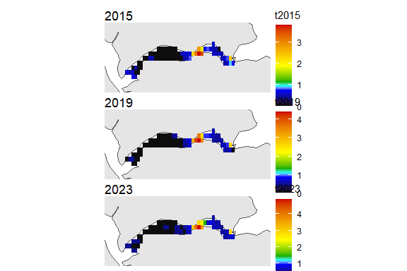

Figure 12 Veerse Meer 2015, 2019, 2023

Figure 12 shows the varied levels of light pollution in Veerse Meer, whilst one section is relatively light pollution free, the other has barely changed across the years. It is possible that the east area of Veerse Meer experiences more entry of light through diffusion from the banks, as it is a smaller area of water.

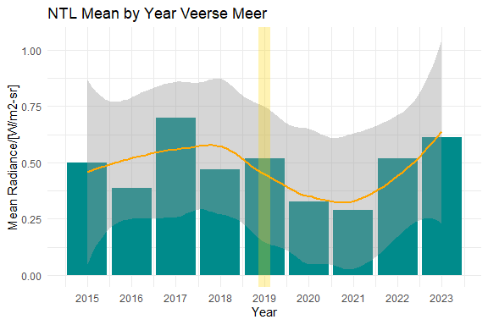

Figure 13 Veerse Meer Mean Radiance 2015 to 2023

Figure 13 is very interesting as it shows varying mean Radiances across the years, with significant drops and highs that show little pattern. Therefore, Veerse Meer has a high level of variance both spatially and temporally. This implies that the darkness areas law has not affected this darkness area significantly, and rather there are other factors at play.

#### South Zeeland: Verdronken Zwarte Polder, Zwin en Kievittepolder

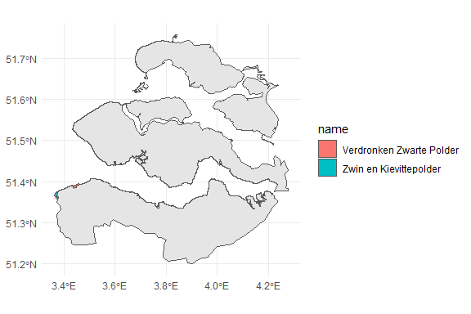

Figure 14 South Zeeland

Finally, the darkness areas in South Zeeland Verdronken Zwarte Polder and Zwin en Kievittepolder (Figure 14) are both green forest areas, and are the smallest designated darkness areas in Zeeland.

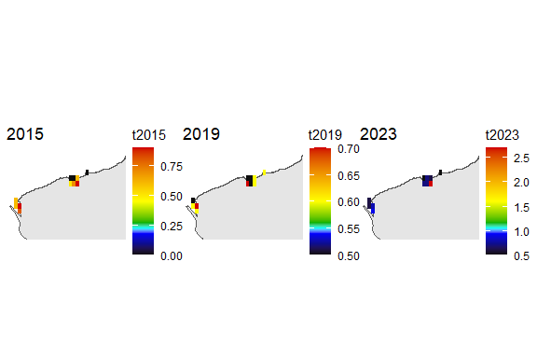

Figure 15 South Zeeland 2015, 2019 and 2023

Based on Figure 15, it seems that there is actually little darkness in these areas, and the values of radiance vary quite a lot.

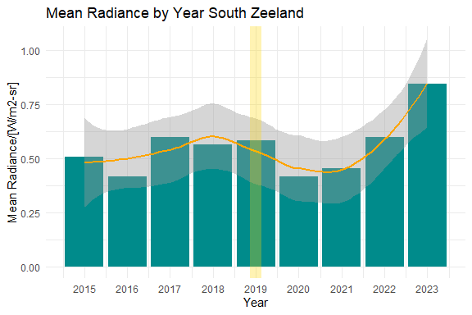

Figure 16 South Zeeland Mean Radiance 2015 to 2023

Unfortunately, Figure 16 shows very little change in radiance and in fact, there has been a rise in 2022, with the highest value of radiance across the past 8 years being in 2023. This however, could be attributed to the fact that because these darkness areas in South Zeeland are so small, they are extremely susceptible to incoming diffused light from external areas.

# Analysis

Based on the Radiance measures of the individual darkness areas, some patterns emerge that seem present across all darkness areas that are important to note. The underlying causes of these patterns can be points of further research in the future.

## Initial success of protection implementation

In most cases, it seems that the darkness areas law initially showed some success in decreasing light pollution between the years of 2019 and 2022. The most succesful decreases can be seen in Manteling van Walcheren (Figure 7) and Kop van Schouwen (Figure 10). The other darkness areas seem to show less of a decrease but still a discernible change. Veerse Meer had a decrease until 2021, and South Zeeland showed a decreased for only years 2020 and 2021.

## Increase in Radiance since 2022

Unfortunately, despite the initial success of the darkness areas law, there seems to be a pattern of increasing radiance since 2022. Based on the mappings created, it seems that this increase can be mainly attributed to the diffusion of light into darkness areas from external sources. In this case, South Zeeland and Veerse Meer suffered from the largest relative increase in these years.

## Size and Nature of the darkness area

There seems to be a noticeable difference in the behaviour of light pollution in darkness areas that mostly consist of forests, versus darkness areas that consist of water. Specifically, if you look at Veerse Meer shows different trends of radiance as compared to Manteling van Walcheren, the underlying reasons behind this behaviour would be an interesting point of further research.

Additionally, size of the area also makes a difference to how much light diffuses into the darkness area. As is visible in South Zeeland where light diffuses much more easily into the darkness area, versus in Kop van Schouwen where external light is not able to reach most of the darkness area, and remains at the edges.

# Conclusion

In summary, this research has identified patterns in Radiance present across Zeeland and in darkness areas on a large scale across the past 8 years, and more importantly has laid a technical foundation for further research into this topic, by making available data and data wrangling tools that simplify the research process significantly. This research has concluded that the implementation of the darkness areas law in Zeeland has unquestionably left a discernible mark on specific protected regions, operating independently from the effects of COVID-19. Therefore, despite the limitations of available data, it is safe to conclude that the darkness areas protection law itself has had effect on light pollution in Zeeland. Unfortunately, there remain some issues major issues, most notably the gradual resurgence of light pollution observed over the past two years, coupled with the persistent diffusion of light from external sources into designated dark zones. Veerse Meer and the darkness areas in South Zeeland seem to be the most vulnerable to these issues.

For future research, important points of focus can be to maintain regular monitoring of light pollution levels, and to focus on changes in radiance across smaller time frames such as by season and by month in an attempt to discern patterns on a smaller scale. Additionally, it would be interesting to investigate why light pollution has increased over the past 2 years specifically. Additionally, more ecological points of interest can be looked at for example, the impact of light pollution on the edges of darkness areas on local wildlife and foliage.

# Bibliography

CBS Statline. “Regional Key Figures; National Accounts ,” December 2023. <https://www.cbs.nl/en-gb/dossier/coronavirus-crisis-cbs-figures/economic-impact-of-covid-19>

Centraal Bureau voor de Statistiek. “Economic Impact of COVID-19.” CBS. Accessed May 2024. <https://www.cbs.nl/en-gb/dossier/coronavirus-crisis-cbs-figures/economic-impact-of-covid-19>

Provincie Zeeland. “Schouwen-Duiveland.” Visit, 2024. <https://zoek.officielebekendmakingen.nl/prb-2019-180.html>

Román, Miguel O., Zhuosen Wang, Qingsong Sun, Virginia Kalb, Steven D. Miller, Andrew Molthan, Lori Schultz, et al. “NASA’s Black Marble Nighttime Lights Product Suite.” Remote Sensing of Environment 210 (June 2018): 113–43. <https://doi.org/10.1016/j.rse.2018.03.017>

World Bank. “GDP Deflator Netherlands,” 2023. <https://data.worldbank.org/indicator/NY.GDP.DEFL.ZS>

Provincie Zeeland, 180 Provinciaal Blad § (2019)<https://zoek.officielebekendmakingen.nl/prb-2019-180.html>.

1. Miguel O. Román et al., “NASA’s Black Marble Nighttime Lights Product Suite,” Remote Sensing of Environment 210 (June 2018): 113–43, <https://doi.org/10.1016/j.rse.2018.03.017>
2. Marty R. Stefanini Vicente G., blackmarbler: Black Marble Data and Statistics. R package version 0.2.0, (2024), <https://worldbank.github.io/blackmarbler/>.
3. Provincie Zeeland, 180 Provinciaal Blad § (2019), <https://zoek.officielebekendmakingen.nl/prb-2019-180.html>
4. Centraal Bureau voor de Statistiek, “Economic Impact of COVID-19,” CBS, accessed May 2024, <https://www.cbs.nl/en-gb/dossier/coronavirus-crisis-cbs-figures/economic-impact-of-covid-19>
5. CBS Statline, “Regional Key Figures; National Accounts ,” December 2023 <https://opendata.cbs.nl/#/CBS/en/dataset/84432ENG/table>
6. World Bank. “GDP Deflator Netherlands,” 2023. <https://data.worldbank.org/indicator/NY.GDP.DEFL.ZS?locations=NL>
7. Provincie Zeeland, “Schouwen-Duiveland,” Visit, 2024. <https://www.zeeland.com/de-de/visit/inseln/schouwen-duiveland/was-schouwen-duiveland-so-besonders-macht>