Name:

MRN:

Room:

One-liner:

S:

**Con**: ◯ fever ◯ sweat ◯ chills ◯ weight△ ◯fatigue

**Eyes**: ◯ changes in vision

**ENT**: ◯ earaches ◯ allergies ◯ sinus ◯ sore throat

**Resp**: ◯ SOB ◯ chest pain ◯ cough

**Cardiac**: ◯ palpitations ◯ edema ◯ chest pain

**GI**: ◯ abdominal pain ◯N ◯V ◯D

**GU**: ◯ dysuria ◯ frequency ◯ urgency

**Skin**: ◯ rash ◯ dry skin

**Musculoskel**: ◯ myalgias ◯ arthalgias ◯ arthritis

**Psych**: ◯ depression ◯ anxiety ◯ sleep problems

**Neuro**: ◯ weakness ◯ dizziness

O:

**Vitals**: Temp: ( )

BP: ( )/( )

HR: ( )

RR: ( )

O2 Sat: % on

**I&O**:

**Weight:**

***Physical Exam***

**General**:

**HEENT**: ◯ PERRL

**Neck**: ◯ cervical lymphadenopathy ◯ neck supple

**Pulm**: ◯ CTA b/l ◯ rales ◯ rhonchi ◯ wheezing

◯ dullness to percussion

**CV**: ◯ RRR ◯ S1 S2 ◯ murmur

**GI**: ◯ abdomen soft ◯ non-tender ◯ non-distended

◯ organomegaly ◯ normal bowel sounds

**Ext**: ◯ warmth ◯ swelling ◯ erythema ◯ edema

◯ tenderness ◯ ulcers ◯ wounds ◯ +2 pulses

**Skin**: ◯ rash ◯ ecchymoses ◯ scars

**Musculoskel**: ◯ normal strength ◯ full ROM

**Neuro**: ◯ A&Ox3 ◯sensory/motor intact ◯ +2 reflex

**Labs**: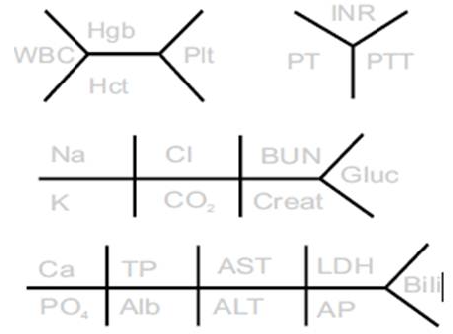

**Imaging:**

**Medications:**

A:

P: