TDST06 – Computer Networks

# Wireshark Lab : HTTP

# Assignment 1

# The basic HTTP GET/response interaction:

## Practical Questions :

1. **Is your browser running HTTP version 1.0 or 1.1? What version of HTTP is the server running?**

Both my computer and the server are running HTTP version 1.1, as it can be seen for example in the lines below:

Get request: (file Task A - Http Get, line 16)

Request Version: HTTP/1.1

Response: (file Task A - Response, line 14)

Response Version: HTTP/1.1

1. **What languages (if any) does your browser indicate that it can accept to the server? In the captured session, what other information (if any) does the browser provide the server with regarding the user/browser?**

My browser indicates that it accepts French and American English, as shown (file Task A - Http get, line 13).

Accept-Language: fr,fr-FR;q=0.8,en-US;q=0.5,en;q=0.3\r\n

Moreover, the browser provides information about which browser and which OS I’m using to the server. (file Task A - Http get, line 11):

User-Agent: Mozilla/5.0 (Windows NT 10.0; Win64; x64; rv:61.0) Gecko/20100101 Firefox/61.0\r\n

1. **What is the IP address of your computer? Of the gaia.cs.umass.edu server?**

My IP Address is the 192.168.1.9 and the server’s address is 128.119.245.12. (file Task A - Http get, line 2)

192.168.1.9 128.119.245.12

The source being my computer, and the destination the server since I request the page that the server is holding.

1. **What is the status code returned from the server to your browser?**

The status code returned is 200, which means the request has been successful. (file Task A - Response, line 15).

Status Code: 200

1. **When was the HTML file that you are retrieving last modified at the server?**

The HTML file retrieved has been modified on Tuesday the 4th of September at 05:59:01 GMT. (file Task A – Response)

Last-Modified: Tue, 04 Sep 2018 05:59:01 GMT

1. **How many bytes of content are being returned to your browser?**

128 bytes of content have been returned to my browser. (file Task A - Response, line 23) Content-Length: 128

1. **By inspecting the raw data in the "packet bytes" pane, do you see any http headers within the data that are not displayed in the "packet details" pane? If so, name one.**

There is no other header in the raw Data, because Wireshark already displays everything in the Details Pane.

## Paragraph:

In this section, it has been shown that when two host (a client and a server) interact, they exchange information to be identified which permits the server to give a adapted response to the client (such as the Language of the information, the client OS).

# The HTTP CONDITIONAL GET/response interaction

## Practice Questions:

1. **Inspect the contents of the first HTTP GET request from your browser to the server. Do you see an “IF-MODIFIED-SINCE” line in the HTTP GET?**

We cannot see the field IF-MODIFIED-SINCE.

1. **Inspect the contents of the server response. Did the server explicitly return the contents of the file? How can you tell?**

In the first GET the server responded with the text. In fact, it can be found in the Line-based text data field).

1. **Now inspect the contents of the second HTTP GET request from your browser to the server. Do you see an “IF-MODIFIED-SINCE:” line in the HTTP GET? If so, what information follows the “IF-MODIFIED-SINCE:” header?**

I see a “IF-MODIFIED-SINCE:” line in the second Http Get request. (file Task B – Http Get 1, line 24)

If-Modified-Since: Thu, 06 Sep 2018 05:59:01 GMT

1. **What is the HTTP status code and phrase returned from the server in response to this second HTTP GET? Did the server explicitly return the contents of the file? Explain.**

The HTTP Status Code responded is 304, and the phrase associated is Not Modified. (file Task B – Response 2, lines 15-17)

Status Code: 304

[Status Code Description: Not Modified]

Response Phrase: Not Modified

The server did not return explicitly the content of the file since there is no Line-based text data: text/html (10 lines) line in this response, even if there was on the first response. It has happened because when the second request has been done, it has been noticed the page wasn’t modified, and since it has cached it, there is no need to ask for the content again.

## Paragraph:

The IF-MODIFIED-SINCE field should be included if the page is cached in the browser. This is useful because then, the server doesn’t have to send explicitly the data to the client. It happens when the content hasn’t been modified since the date specified in the field. It saves times and bandwidth which can be very interesting with big files.

# Retrieving long documents:

## Practice Questions:

1. **How many HTTP GET request messages were sent by your browser?**

Only one HTTP GET request was sent by my browser.

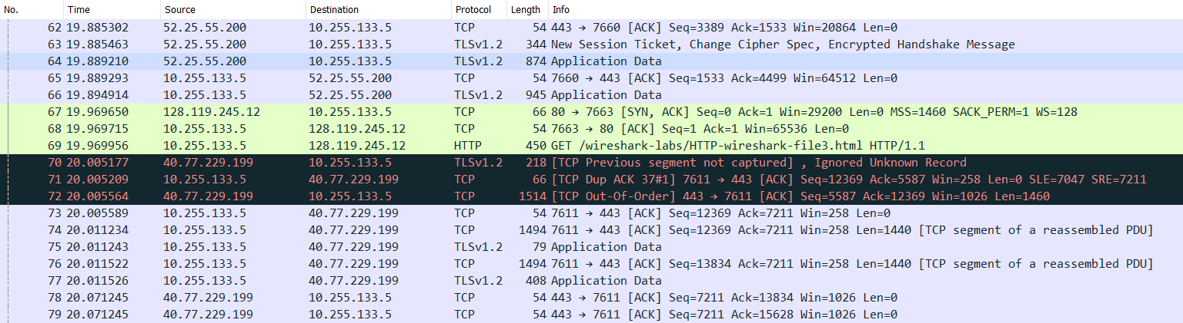

1. **How many data-containing TCP segments were needed to carry the single HTTP response?**

To carry the single HTTP response 4 TCP Segments were needed (3 single segments + 1 in the HTTP response).

1. **What is the status code and phrase associated with the response to the HTTP GET request?**

It has status code 200, with phrase OK.

1. **Is there any HTTP header information in the transmitted data associated with TCP segmentation? For this question you may want to think about at what layer each protocol operates, and how the protocols at the different layers interoperate.**

No there isn't, and it shouldn't. TCP layer operates one layer below HTTP. This means that during encapsulation, the newly generated TCP packet won't pass through the application layer and won't get an HTTP header.

## Paragraph:

The browser sends only one HTTP Request while there are 4 TCP requests because the file exceeds the MTU (1500 bytes). Thus, it must be split into chunks which in this case are 1460 bytes long.

# HTML Documents with Embedded Objects:

## Practice Questions:

1. **How many HTTP GET request messages were sent by your browser? To which Internet addresses were these GET requests sent?**

Four HTTP GET requests were done by the browser.

The requests were respectively sent to <http://gaia.cs.umass.edu/wireshark-labs/HTTP-wireshark-file4.html>, http://gaia.cs.umass.edu/pearson.png, <http://manic.cs.umass.edu/~kurose/cover_5th_ed.jpg>, <http://caite.cs.umass.edu/~kurose/cover_5th_ed.jpg>

1. **Can you tell whether your browser downloaded the two images serially, or whether they were downloaded from the two web sites in parallel? Explain.**

By looking at the trace given, we see we don’t need to get the response to the first request to throw a new one, so there are two GET in a row, and then we get the two responses. Hence, it is not serially but parallel.

## Paragraph:

Since there are many resources on a single page, the browser must send one HTTP request for each of those. If HTTP Persistence is used, it may happen that if two resources are on the same server, they can be sent over the same TCP response with wasting time and avoiding unnecessary communication.

# HTTP Authentication:

## Practice Questions:

1. **What is the server’s response (status code and phrase) in response to the initial HTTP GET message from your browser?**

The first request gets a 401 code and an Unauthorized message, because of the need for a password, whenever a password is inserted a new request is sent.

1. **When your browser sends the HTTP GET message for the second time, what new field is included in the HTTP GET message?**

In the second GET request, it sends a new field called Authorization, with the credentials in plain-text since the request is a simple HTTP request and not an encrypted one.

# Preparation for Assignment 2

1. **What does the "Connection: close" and "Connection: Keep-alive" header field imply in HTTP protocol? When should one be used over the other?**

The Connection header indicates whether the TCP connection has to be persistent or closed immediately after the response for the first resource (the webpage file). With keep-alive, we use the same TCP connection over and over for all the resources on the page, otherwise with the close field we would have to restart another TCP connection for every other resource (style.css, script.js,…) resulting in a waste of time. So we should use the keep-alive field whenever we have a page with a lot of resources to be downloaded.