Preparing Questions :

1. To send text and images over a socket, we will just fill the socket’s buffer with the data, and if it’s one is not enough, we loop to repeat this as long as we have data to send.
2. With HTTP:Keep Alive the connection is kept open. We have to figure out when the response is completed.

With HTTP:Close, the server closes the connection when the response is sent.

1. 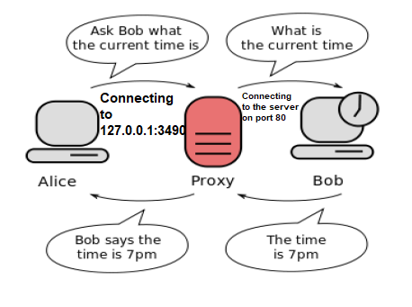
2. Proxy Server/Client algorithm:

Wait for request.

Parse HTTP GET

If URL not accepted:

Redirect

Else:

Send a new HTTP GET to the real server

Wait for response

If text content is acceptable:

Directly send the HTTP response to the client

Else:

Redirect the client