

INDUSTRIAL BAGS PH

Downtown Realty Investment, Inc. office address is Room No. 324 516 Quintin Paredes St., Barangay 289, Binondo, Manila, 1006

Tel: +639-27-737-2986. Landline: 0270015484

Re: FIBC offer Page: 1/3

Dear Mr/Ms. %{name}%,

We are pleased to offer as follows: 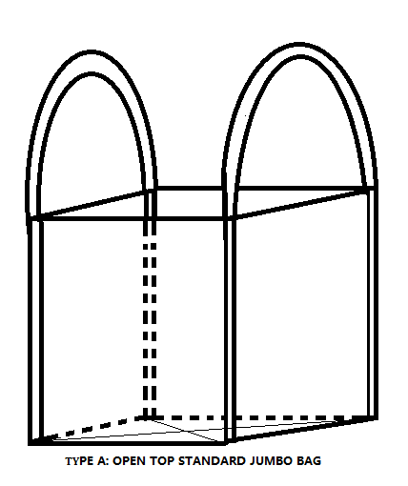

1. **Item: 1 tonner Bulk bag flexible intermediate bulk container.**

Material: UV stabilized woven polypropylene fabric

Size: 90cm x 90cm x 110cm

Type: A> Seamless body, Standard, bag weight 1.3kg

Lifting: 2 corner straps with bottom cross - 70mm width x 300mm loop

Type: B> Seamless body, duffel top, bag weight 1.6kg TYPE A: Standard Jumbo bag

Lifting: 2 corner straps with bottom cross - 70mm width x 300mm loop

Type: B> Seamless body, duffel top, 2 girdle, bag weight 1.65kg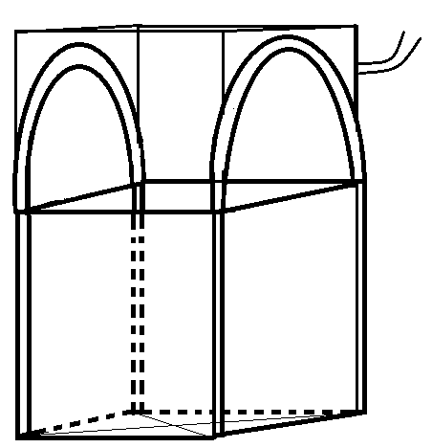

Lifting: 2 corner straps with bottom cross - 70mm width x 300mm loop

Color: White

SWL: 1000 kg safe working load

Print: None

Unit Price: A > ₱ 290.00

B > ₱ 336.00

C > ₱ 361.00 TYPE B: Duffel top closed bottom

Type chosen: %{type}% 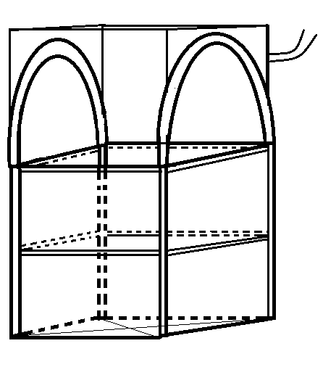

Quantity: %{quantity}%

**Total Price:** %{total_price}%**(Inclusive of delivery fee)**

Payment: Bank deposit before delivery dispatch

**Option 1:** 60% deposit fee 40% balance after dispatch.

**Option 2:** 100% deposit before dispatch.

Validity: Subject to reconfirmation after 15 days.

TYPE C: Duffel top with 2 girdle

*Vanessa Lee*

*Account’s manager*

**1.** **Open top Type A FIBC Ton bag**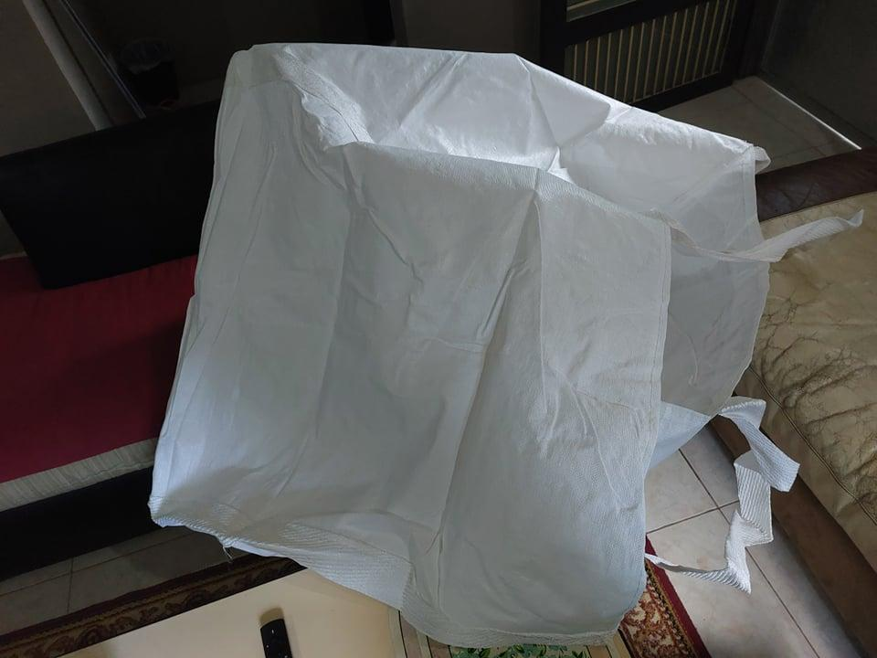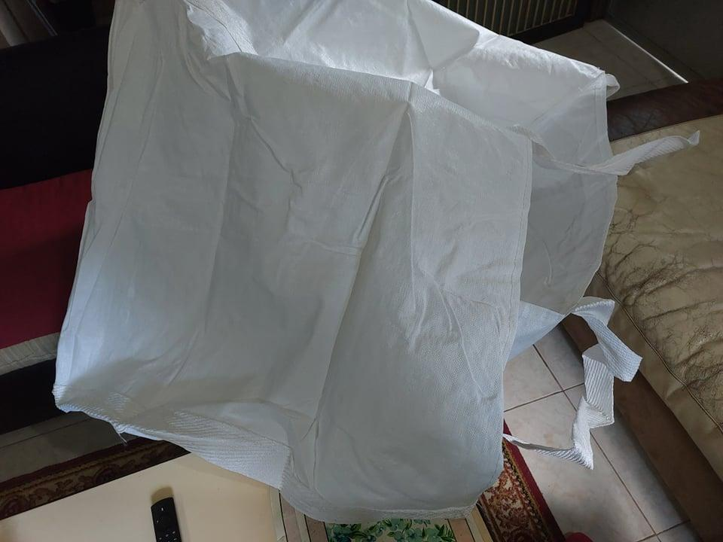

Actual side photo of our Type A Standard FIBC Bag

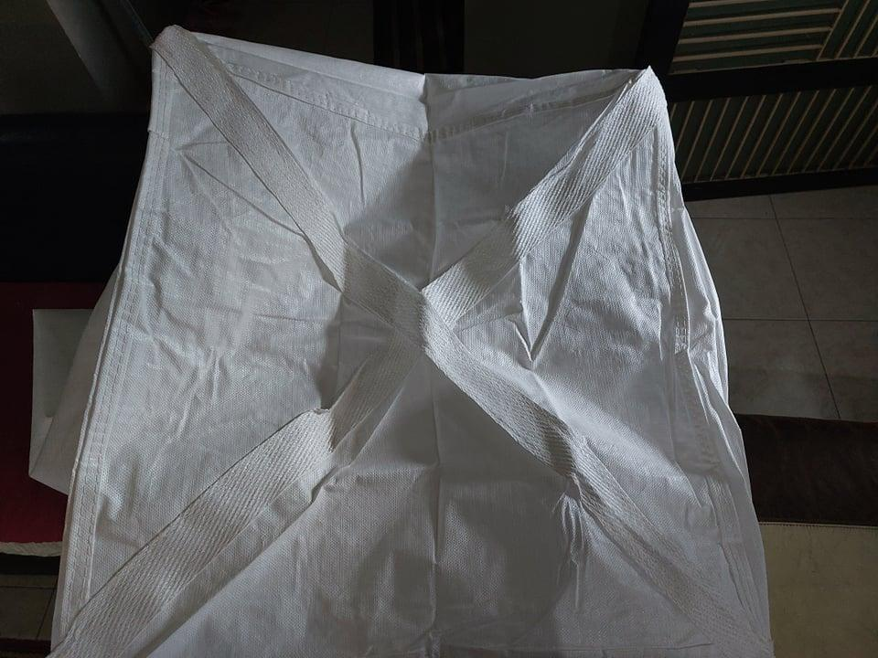

**

Actual photo of bottom stitched FIBC bag

**2.** **Duffel top Type B FIBC Ton bag**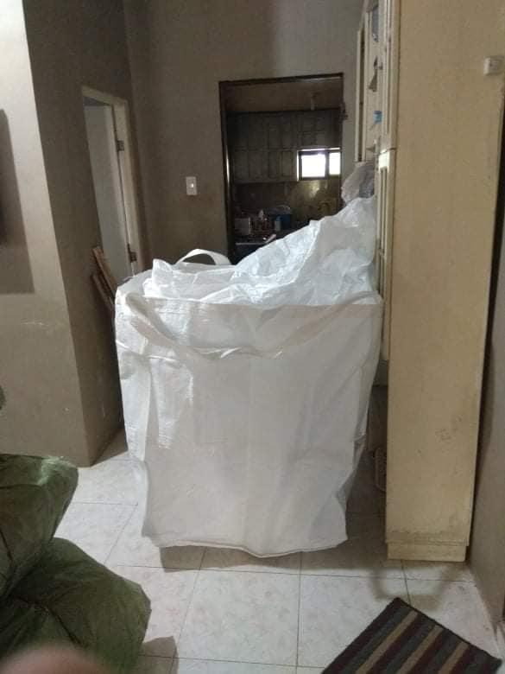

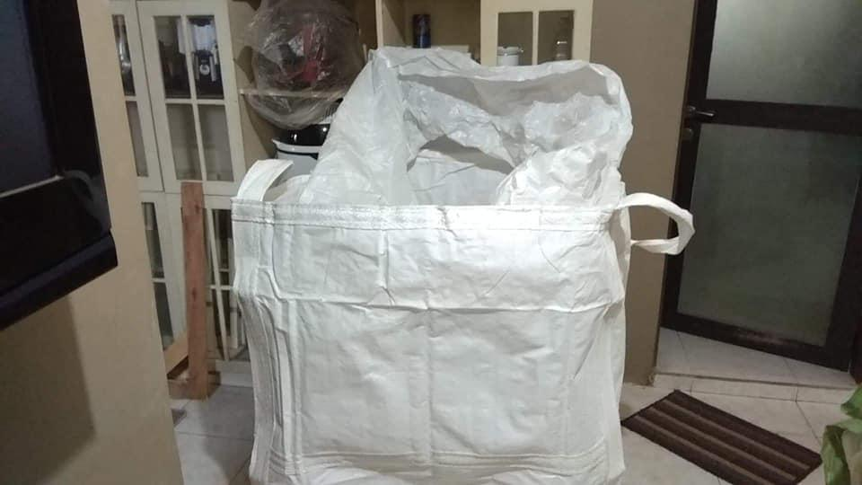

Actual Photo of Type B Duffel top bag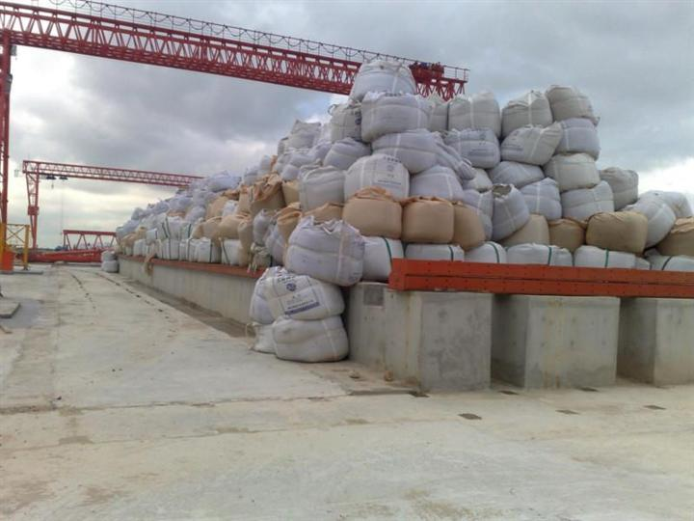

Actual demo of our FIBC Bag on site with other client

**3 Duffel top plus 2 girdle belt (type C)**

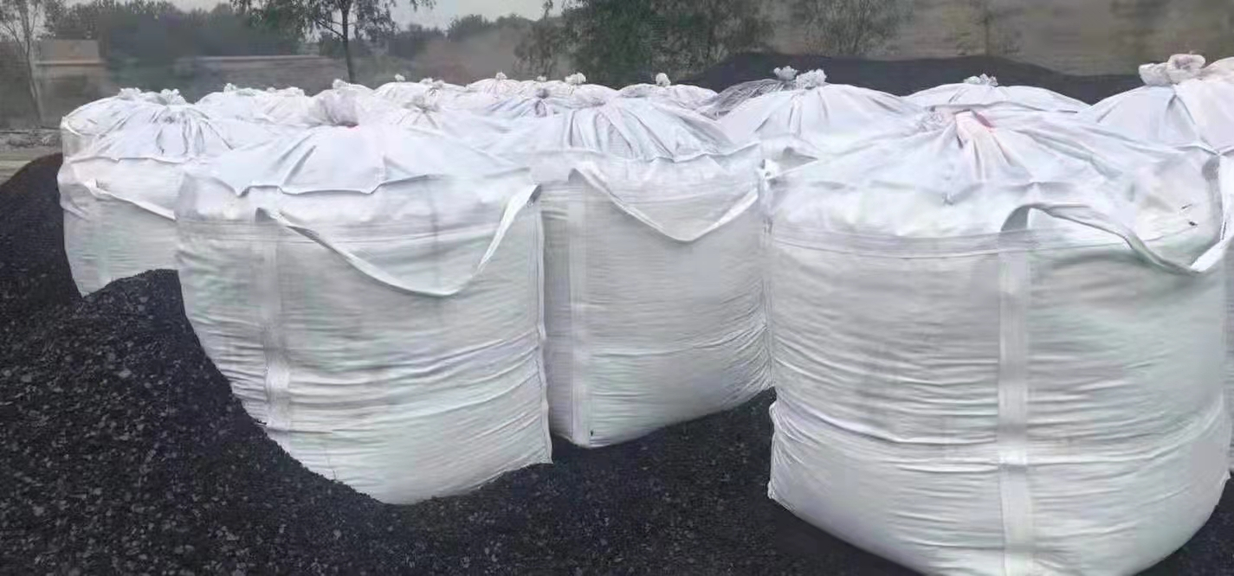

Actual demo of our FIBC Bag on site with other client