**树莓派开发文档笔记—基础配置**

1. **树莓派刷机**



1. **树莓派登录**
   1. **HDMI视频线 连接到显示器**
   2. **串口** 
      1. **设备破解**

**默认情况，树莓派的串口和蓝牙连接。**

**想办法断开蓝牙连接，把串口用来数据通信**

<https://blog.csdn.net/syjsxxjy/article/details/80774262>

1. **观看树莓派的启动过程，字符**
2. **串口登录树莓派**

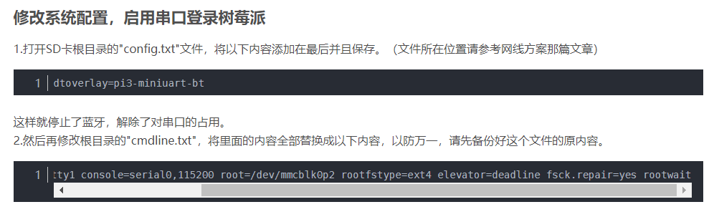

**2.2.2**

**默认账号：pi**

**默认密码：raspberry**

* 1. **通过网络登录树莓派**
     1. **让树莓派入网**

**修改**

<https://blog.csdn.net/qq_36760780/article/details/82016711>

sudo nano /etc/wpa_supplicant/wpa_supplicant.conf

network={

ssid="wifipig"

psk="123456789"

}

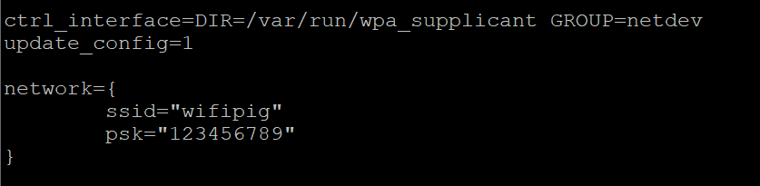

**是文档编辑器，已进入便可以编写。**

**Ctrl+o 保存，会有提示是否写入。我们按回车。Ctrl+x退出**

* + 1. **固定树莓派的ip地址**

**sudo nano /etc/rc.local**

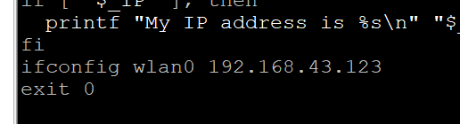

* + 1. **网络ssh方式登录树莓派**
       1. **打开ssh功能**
       2. **登录**
  1. **图形方式登录树莓派**

**sudo apt get install xrdp**

**windows用“远程桌面连接”自带软件登录**

1. **VIM更新到好用的版本**
   1. **默认的源是国外的，apt-get 安装的时候失败，我们更新成国内的源**
   2. <https://blog.csdn.net/Liu_959185/article/details/86636906>

deb http://mirrors.tuna.tsinghua.edu.cn/raspbian/raspbian/ stretch main contrib non-free rpi

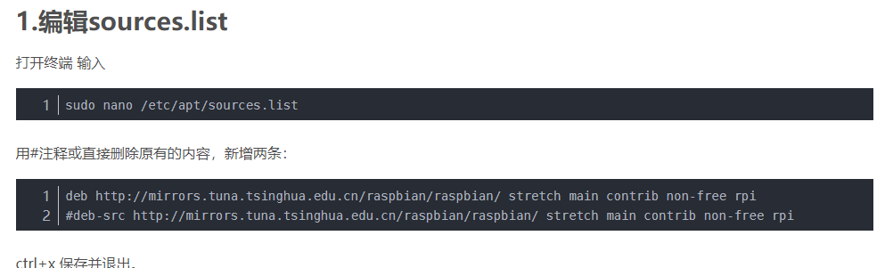

* 1. **sudo apt-get update更新源**
  2. **sudo apt-get install vim 安装新版vim**

1. **Gpio readall 查看树莓派引脚**
2. **树莓派摄像头命令**

**关闭视频：killall -TERM mjpg_streamer**

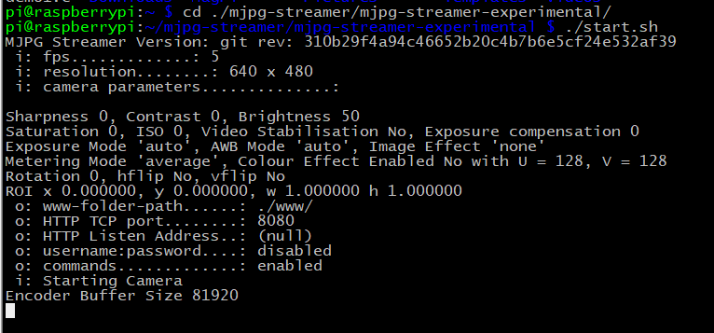

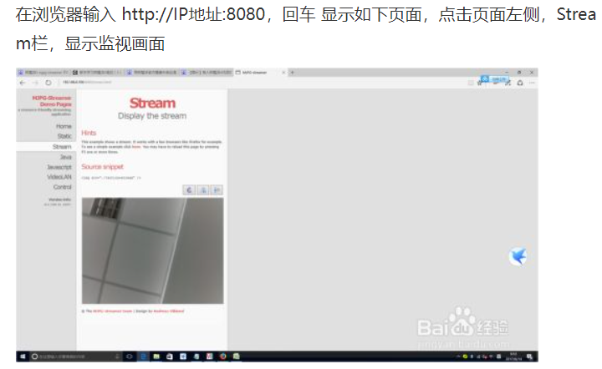

**编译：**

**gcc bathroomLight.c livingroomLight.c restaurantLight.c upstairLight.c fire.c voiceContrl.c socketContrl.c mainPro.c -lwiringPi -o test5**

**安装mjpg:**

1. **git clone <https://github.com/jacksonliam/mjpg-streamer.git>**
2. **cd mjpg-streamer/**
3. **cd mjpg-streamer-experimental/**
4. **make all**
5. **sudo apt-get install libjpeg8-dev**
6. **sudo apt-get install imagemagick**
7. **sudo apt-get install libv41-dev**
8. **sudo apt-get install cmake**

**./configure --prefix=$PWD/_install --host=arm-linux**

**编译：**

**gcc *.c -lwiringPi -lpthread -I ./../httpHandler/curl-7.71.1/_install/include/ -L ./../httpHandler/curl-7.71.1/_install/lib/ -lcurl -o hosepro**

**wc_otg.lpm_enable=0 kgdboc=ttyAMA0,115200 console=tty1 root=/dev/mmcblk0p2 rootfstype=ext4 elevator=deadline rootwait**

**dwc_otg.lpm_enable=0 console=tty1 console=serial0,115200 root=/dev/mmcblk0p2 rootfstype=ext4 elevator=deadline fsck.repair=yes rootwait**

**dwc_otg.lpm_enable=0 kgdboc=ttyAMA0,115200 console=tty1 root=/dev/mmcblk0p2 rootfstype=ext4 elevator=deadline rootwait**