CSI 102: MiniProject 01
Slot Machine
Anthony Cavallo
10.26.2025
I certify that this lab report is entirely my own work.

Introduction
In this mini project, the purpose was to create a simple slot machine game using Python. The program needed to include variables, loops, conditionals, lists, functions, and file handling. The player starts with a certain amount of money and can add money to the machine, change the bet, play the game, and cash out.

Methods
I created variables for the player’s balance, the machine’s balance, and the current bet. I also made a list of symbols for the slot machine reels. The program uses functions to organize the code, such as add_money(), change_bet(), play_game(), and cash_out_and_quit().
A while loop runs the main menu so the player can choose what to do. The random.choice() command is used to pick three symbols for the reels when the player chooses to play. The program checks how many symbols match and gives the correct payout.
When the player cashes out, the final balances are saved to a text file called slot_results.txt.

Results
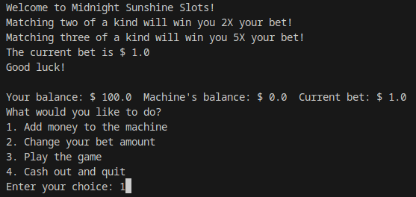

Discussion
This lab helped me review how loops, conditions, and functions work together in Python. It also gave me a better understanding of how to use user input to control a program in real time. The player movement task showed how logic can be applied to control position within limits, while the score calculation task showed how to perform different operations based on user choices. Both activities connected what I’ve learned in class to how programs can respond to player actions, similar to what happens in simple games.

Challenges
The hardest part was keeping track of the balances and making sure the program used the right variables when adding or subtracting money. I also learned that small mistakes in variable names can cause logic errors.

Conclusion
This project shows how simple games can be made using basic programming concepts. It helped me understand how loops, lists, and conditionals can all work together in one program. The program runs correctly and met all the requirements.

Appendix
Files included: slotMachine.py

