CSI 102: Lab 05
Dictionaries
Anthony Cavallo
10.14.2025
I certify that this lab report is entirely my own work.

Introduction
This lab focused on using dictionaries in Python to not just store data, but also use that data to have the end user receive outputs from it, such as correct answers in quizzes or word counts (foreshadowing). The primary goals were to: use both empty and filled in dictionaries, find out the code necessary to run both scenarios and be able to get a very good grasp on dictionaries as a whole.

Methods
Task 1: Word Counter
This program counts how many times each word appears in a block of text.
It first cleans up the text by making everything lowercase and removing punctuation, then splits the text into individual words, counts how often each one appears using a dictionary, and finally displays the results in alphabetical order.
Here’s a snippet of what the code looks like:
Step 1: Get and clean the text
Ask the user to type some text, then convert it all to lowercase and remove punctuation so words like “Word” and “word.” are treated the same.
Step 2: Split the text
Use .split() to separate the cleaned text into a list of individual words.
Step 3: Count each word
Use a dictionary (word_count) to store how many times each word appears.
Loop through the words. If a word already exists in the dictionary, add 1; otherwise, start it at 1.
Step 4: Display the results
Sort the words alphabetically and print each word with its count, then show a closing message.
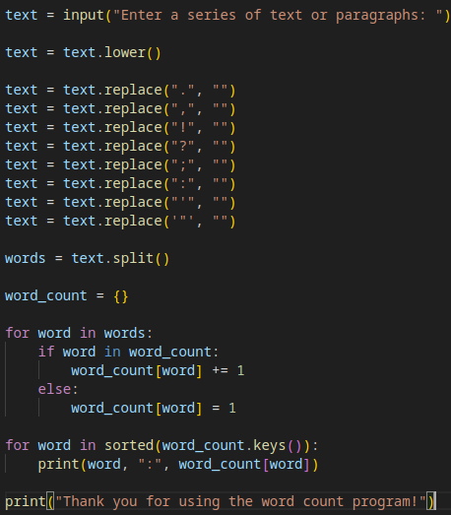
Task 2: Quiz
This program is a short quiz game that tests the user’s knowledge with four questions. It uses a dictionary to store each question and its correct answer, asks the user to respond to each one, and keeps track of how many answers are correct.
At the end, it shows the player’s total score and a message based on their performance.
Step 1: Create the quiz data
Make a dictionary called quiz where each question is a key and its correct answer is the value. This acts as the quiz’s database of questions and answers.
Step 2: Set up the score system
Start a variable score at 0 to keep track of how many questions the user answers correctly.
Step 3: Ask the questions
Use a for loop to go through each question in the dictionary.
Display the question, take the user’s input, and compare it to the correct answer (ignoring capitalization). If the answer is correct, add 1 to the score. If not, show the correct answer.
Step 4: Display the results
After all the questions are answered, show the user their total score and a message, either congratulating them for getting all correct or encouraging them to try again.

Results
Word Counter:
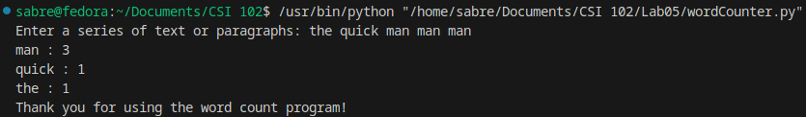
Quiz:
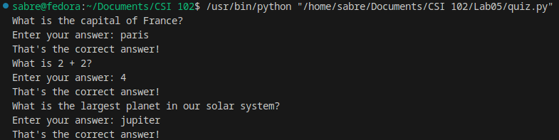

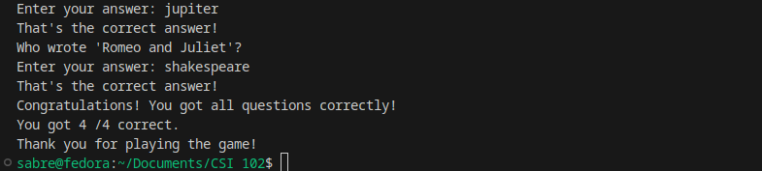
Discussion
This lab made me to recall the notes that I’ve taken on Python dictionaries, and allowed me to use the skills that I’ve learned into potential real world scenarios where dictionaries may prove useful. In fact, they’re really useful with the way that they’re more advanced than lists in a way, where they can hold a key and a value instead of just a key or just a value.

Challenges
One challenge was simply figuring out which commands to use for which scenario. I find myself struggling with whether to use a command and what parameters to set. The details are what screw me up, but I get the overall concept.

Conclusion
The lab successfully showed the power of dictionaries and it’s utility for quite a few scenarios and has enhanced my capabilities of using dictionaries in situations that call for them.

Appendix
Files included: quiz.py, wordCounter.py

