Verification and provenance auditing of an AI-drafted clinical rule base: executable invariants, a source-concordance protocol and a frozen laboratory-panel benchmark for an offline interpretation engine
Original research article. Revision R6 (2026-10-27), formatted for Computer Methods and Programs in Biomedicine. Research prototype — not approved or intended for clinical use.
Sobhan Bahrami^{a*}, Zhaleh Tahmasebinejad^{b,c}, Ehsan Bahrami Samani^{b}
ª Allameh Helli 10 High School (NODET), Tehran, Iran. ^{b} Statistics and Data Science Clinic, Faculty of Mathematical Sciences, Shahid Beheshti University, Tehran, Iran. ^{c} Department of Epidemiology and Biostatistics, Research Institute for Endocrine Sciences, Shahid Beheshti University of Medical Sciences, Tehran, Iran [affiliation wording to be confirmed by Z.T.].
\* Corresponding author: sobahramisamani@gmail.com · ORCID 0009-0004-6639-5081
Highlights
- Property-based invariants for a clinical rule engine, run on every release
- The invariants found a ranking defect that 353 hand-written vignettes had missed
- Frozen source-concordance protocol: 92% of sampled rules unverifiable by locator
- Untrained, traceable engine at recall@5 parity with an unnamed frontier LLM
- Engine-agnostic tools and protocol released; applicable to any analyte-rule base

Abstract
Background and Objective: Rule bases can now be drafted at scale with large language models, but rules uncheckable against their sources, and engines validated only on authors' vignettes, are not auditable. We evaluate three verification methods—executable invariants, a frozen source-concordance protocol and a hash-frozen one-shot benchmark—on Hemoglyph, an offline engine ranking a cited differential from a laboratory panel with 33,183 guideline-transcribed rules (99.2% AI-drafted) and no outcome training.
Methods: Property-based tests check invariants (determinism, unit and presentation invariance, monotonicity, absent-analyte and context) on randomised panels and, as a black box, on real panels given identically to engine and LLM. A protocol frozen before sampling labels 200 rules concordant, discordant or unresolvable against their locator. Under a hash-frozen analysis plan with two one-shot quarantine rounds, the engine was benchmarked on the eICU-CRD demo (2,314 ICU stays), 9,000 NHANES adults, 14,420 sepsis patients and external cohorts, with supervised baselines, ablation and a blinded comparison with an unnamed frontier LLM (400 stays).
Results: The invariant suite exposed a ranking defect missed by 353 adversarial vignettes. Of 200 audited rules, 92% (95% CI 87.4–95.1) were unresolvable from their locators and ≥7.5% (4.6–12.0) discordant. On the benchmark 60.8% (58.7–62.9) of clinician-listed ICU diagnoses appeared in the top five from laboratory values (prevalence baseline 51.3%). NHANES AUROCs reproduced across cycles (0.88–0.99; 2/485 healthy false assertions); sepsis prediction failed as pre-specified. Engine and LLM were at recall@5 parity (60.7% vs 59.6%, p = 0.54); the LLM led at rank 1 (κ 0.69). On identical perturbed panels SI units left the engine's top-5 unchanged in 40/40 versus 8/40 (LLM); a diagnosis was asserted without its defining analyte in 3/40 versus 14/40; the test also exposed an engine unit defect, since fixed. Ablation placed the result in 272 curated anchors and the syndrome layer, not the AI-drafted bulk.
Conclusions: Executable invariants and a frozen provenance audit are cheap, reproducible and informative—here unfavourably: provenance granularity, not rule count, limits auditability of AI-drafted rule bases. A traceable engine matched a frontier LLM on a blinded panel task and, unlike it, can be held to invariants. No clinical claim is made; code, rules, protocols and outputs are public.
Keywords: Clinical decision support; Knowledge base; Software verification; Provenance; Laboratory medicine; Large language models

1. Introduction
Roughly 70% of clinical decisions draw on laboratory results, yet interpretive comments accompany only a small fraction of reports, and post-analytical errors remain a leading source of diagnostic harm [1–3]. Rule-based interpretation embedded in laboratory information systems is transparent but narrow and hand-maintained [4,5]; supervised models need labelled data and cannot be audited clause by clause [6,7]; large language models (LLMs) interpret reports fluently but vary between runs, cannot run locally on commodity hardware without transmitting patient data, and misclassify values even when reference ranges are supplied [8–11].
Large language models have changed one part of this picture: a guideline-transcribed rule base that would once have taken a committee years can now be drafted in weeks. This creates a new software-engineering problem rather than solving an old one. An AI-drafted rule is a hypothesis about what a source says; nobody has read most of them; and the conventional validation of such engines—vignettes written by the same authors, a single institution, no comparator [12]—cannot detect either mistranscription or ranking defects. Mature diagnostic decision-support systems (Isabel, DXplain) have been compared with GPT-4-class models on 36–201 symptom cases [13–16], formal verification has been applied to the acquisition of guideline-derived knowledge models [17], and external-validation methodology for learned models is well developed [18]; but no method has been described for verifying a large AI-drafted laboratory rule base, and the public infrastructure for executable guideline knowledge has contracted: AHRQ CDS Connect went offline in April 2025 and a dated search found no openly licensed, machine-executable rule set for laboratory-panel interpretation (Supplementary Note 5).
This paper treats the rule base as software and asks how it can be verified. We contribute (i) a property-based test suite that states invariants any correct laboratory-interpretation engine must satisfy and checks them on randomised panels; (ii) a source-concordance protocol, frozen before sampling, that reports with explicit denominators whether a rule transcribes what its locator says; and (iii) a hash-frozen, one-shot, multi-dataset benchmark with a supervised baseline, an ablation and a blinded comparison against a frontier LLM, in which a failed quarantine round is reported rather than discarded. The invariant suite and the audit protocol are engine-agnostic—they require only that a rule be expressed as analyte, operator, threshold, unit, population gate and source locator—and are released as standalone tools. This paper does not claim that the engine is accurate; it claims that the engine is verifiable, and shows what verification finds. The object of study is Hemoglyph (analyse_gidlines.py, v7), an offline single-process engine with 33,183 guideline-transcribed rules, 99.2% of them AI-drafted by a non-clinician first author and none clinically audited. The engine is the same file that ships inside a proprietary desktop product owned by the first author; this interest is declared and motivated the frozen design. Only the inference engine fed with structured analyte–value pairs is evaluated; the optical-character-recognition front end is not. We make no claim of clinical validation.

2. Methods

2.1 Engine under study
Hemoglyph processes a panel in five stages (Fig. 1): normalisation (UCUM units, aliases, age/sex reference intervals, 100 derived indices); a rule layer over registry 14.1.0 (33,183 executable leaves, each a record with a machine-evaluable condition on at least one analyte, a population gate, an evidence role—diagnostic criterion weight 6, supportive or screening weight 3—a disease identifier and a source locator; release-by-release counts in Supplementary Table S10); an expert syndrome layer (~900 multi-analyte constellations with anchor strengths 0.95/0.88/0.80/0.72/0.45 and context predicates); fixed-weight fusion (0.35 rule engine, 0.25 Bayesian, 0.20 fuzzy, 0.10 knowledge graph, 0.10 risk models, set by judgement and never tuned on evaluation data; sensitivity in Table 1) with an expert floor (the fused score cannot fall below 0.90 × the rule-layer vote, so learned layers modulate but never veto a guideline rule); and ranking hygiene (causal attribution through a disease–finding explanation graph, covering-diagnosis suppression, KDIGO chronicity [19], ADA glycaemic criteria [20], UDMI acuity [21], maximum 25 entries). The Bayesian layer has 75 disease nodes with hand-coded priors and likelihood ratios from cited diagnostic-accuracy literature; no parameter was fitted to any patient record. Engine changes between releases (C1–C16) are dated in Supplementary Table S1; no version-control history exists for the development period, so "no change was outcome-fitted" is a documented process claim, not a verified one.

2.2 Knowledge-base construction and provenance
For each guideline source the first author prompted a general-purpose LLM with the source text or citation and a fixed JSON schema; returned records (analyte, operator, threshold, unit, population gate, evidence role, disease, locator) were accepted or rejected by automated audits only (schema validity, analyte in the 2,045-analyte feature registry, unit convertible, physiologically plausible threshold, no duplicate or contradiction, required context gate present, locator resolvable) and carry the status candidate_requires_specialist_validation. The 272 anchor rules were written or line-edited by hand from primary guideline text. No human read the bulk; we therefore call it AI-drafted and automatically audited. Locators were checked with registry_source_verify.py (Crossref resolution, HTTP reachability). Counts by release: 13.3.0, 33,230 rules/747 sources; 13.4.2, 33,170/781; 14.1.0, 33,183/785.

2.3 Verification method 1: executable invariants
A property-based suite (tests/test_properties.py; 25 tests) generates randomised panels and asserts: determinism (identical output on repeated runs); unit invariance (SI and conventional units yield the same ranking, tolerance 10⁻³); directional monotonicity (a more extreme value never lowers the probability of the finding it defines; 14 analyte–direction pairs); absent-analyte invariance (no syndrome asserted from an analyte that is not present); and context invariants (documented CKD never raises acute kidney injury; borderline flags behave as specified). The suite runs on every release in addition to 353 adversarial vignettes and a safety battery. It tests logical consistency, not clinical correctness: a mistranscribed threshold passes every invariant. Because the same properties can be stated for any reader, four were also run as a black-box benchmark with the engine and the LLM of Section 2.5 receiving identical real panels: 40 eICU panels in SI units (P2), the same 40 shuffled with five normal distractors (P3), 20 panels with creatinine at ×1.0/×1.5/×2.0 (P4), and 40 panels with the defining analyte of a criterion-met diagnosis removed (P5; an assertion at rank ≤ 5 without it counts as unsupported). Panels, scorer and metrics were committed before any reading; LLM readings were blind to labels and targets (eval/blackbox/).

2.4 Verification method 2: source-concordance audit
The protocol was frozen before sampling (eval/source_audit/PROTOCOL.md; seed 20261026). Sample: 100 of 272 curated anchors and 100 executable candidates (50 "eICU-relevant"—feature present in ≥ 50% of eICU first panels and disease in an evaluated label group—and 50 uniform from the rest), registry 14.1.0. Fields compared: analyte, operator/threshold with unit, population qualifier, disease attribution. Labels: CONCORDANT, DISCORDANT, UNRESOLVABLE, with the tie-break "when in doubt, unresolvable"; unresolvable is never counted as concordant. Sources were retrieved by the registry locator (curl, 20 s), with Crossref title and PubMed abstract as fall-back for paywalled DOIs and direct PDF retrieval for KDIGO guidelines. Rates are reported with two denominators (resolvable; all sampled) and Wilson 95% CIs. The rater was an AI agent under the first author's direction, declared as such (Section 3.2).

2.5 Verification method 3: frozen one-shot benchmark
An internal statistical analysis plan (Supplementary Note 1; 15 dated amendments) fixed metrics, label maps, thresholds and comparators; it was time-stamped and hash-frozen in the repository but not publicly registered, so we write "pre-specified", not "pre-registered". Before each quarantine round, code and registry were frozen with SHA-256 manifests and quarantine data were run once. Round 1 (MIMIC-IV demo; NHANES 2013–14; sepsis set B) used superiority criteria over the prior release; round 2 (NHANES 2015–16; sepsis set B2; healthy sweep with a new seed) used non-inferiority criteria specified before execution (Amendment 15: NHANES AUROC within 0.03 on six targets with ≤ 1% healthy false assertions; sepsis AUROC not more than 0.02 below; no new safety-battery failure).
Datasets and reference standards (Table 2; participant flow in Supplementary Table S3). eICU-CRD demo v2.0.1 [22]: 2,520 stays → 2,512 adults → 2,314 with ≥ 8 analytes in the first panel; reference = clinician problem list mapped by regular expressions to 31 groups (audit on 400 stays: precision 100%, sensitivity 98.3%; Supplementary Table S9). MIMIC-IV demo [23]: 235 admissions, ICD-10. NHANES 2013–14, 2015–16, 2017–18: 3,000 randomly sampled adults per cycle; references per ADA, KDIGO, WHO and ACG criteria and self-report. PhysioNet/CinC 2019 [24]: set A 4,871 patients (439 sepsis), set B 4,558 (268), set B2 4,991; Sepsis-3 onset. UCI thyroid0387 [25], UCI HCV [26], ILPD [27], 50 PMC case reports [28].
Metrics. Primary: flat recall@k of clinician-listed diagnoses (k = 3, 5, 10). Secondary: two-tier recall; panel-supported recall (labels whose first panel met a guideline criterion fixed in panel_supported_metric.py before scoring); per-group AUROC; screening AUROC and false-assertion rate in all-normal adults; sepsis AUROC; calibration (slope, intercept, ECE, Brier, decision curves before and after cross-fitted isotonic regression [29]); ablation of each component on the same 2,314 stays.
Comparators. B1, raw key-analyte threshold; B2, gradient boosting and logistic regression on the same analytes, five-fold out-of-fold; a prevalence-ranking baseline; and an unnamed frontier LLM run by the authors through the Arena.ai agent platform (2026-10-21 to 2026-10-25; n = 400), which routes among several frontier model families without exposing the model or version and offers no sampling controls—"unnamed frontier LLM" therefore denotes a capability tier, not a verified identity. The LLM received the identical panel, age and sex with a fixed prompt requesting ten ranked diagnoses, blinded to labels; 40 panels were re-read for test–retest and read with an alternative prompt; scoring used the same label map and script as the engine. Prompts, outputs and protocol are released (Supplementary Note 2).
Statistics. Labels are nested in stays (ICC 0.04); eICU proportions and paired differences use stay-cluster bootstrap (4,000 resamples) and the cluster-adjusted McNemar test [30,31]; Wilson intervals elsewhere; bootstrap or DeLong for AUROC; NHANES AUROCs additionally examination-weighted; Benjamini–Hochberg across per-group tests. Python 3.11/3.13, numpy, pandas, scikit-learn. Reporting follows TRIPOD+AI [32] adapted for an unfitted system (checklist in Supplementary Note 5.7). Post-freeze proposals (v8) were tested against the frozen artefacts and are described in Supplementary Note 9; no frozen number derives from them.

3. Results

3.1 Executable invariants
All 25 tests pass on the current engine (v8.2). On the frozen v7 the suite exposed one genuine defect that the 353 adversarial vignettes had not: a well-supported renal finding was capped beneath a presumptive explainer scoring below 0.80, so the leading renal probability fell as creatinine rose from 1.6 to 2.2 mg/dL. The fix applies an existing rule uniformly and passed the full gate (eICU recall@3/5/10 48.4/61.0/74.1% versus 47.9/60.8/74.1% for v7, inside the v7 confidence intervals). The frozen v7 numbers below are unchanged. The engine is deterministic (byte-identical output in 50/50 repeated stays), runs on one CPU core in ~1 s per panel and makes no network calls.

3.2 Source concordance
Of 200 rules sampled under the frozen protocol, only 16 could be resolved from the locators the registry provides: 15 were discordant—7 attribution errors among curated anchors (e.g. a hypernatraemia rule citing the hyponatraemia guideline) and 8 thresholds or definitions absent from an on-topic source (e.g. a candidate acute-kidney-injury "criterion" defined by a fixed creatinine > 1.1 mg/dL and attributed to KDIGO 2012, which defines AKI only by change from baseline)—and 1 concordant. The remaining 184 (92%, 95% CI 87.4–95.1) were unresolvable: 12 with no retrievable text, 55 with only a title or abstract, 46 citing only generic methodological standards (WHO essential diagnostics list, CLSI EP28/C59) that cannot contain a disease-specific threshold, and 71 organisation landing pages. Because an attribution error is visible from a title while concordance needs the full text, 15/16 is not an estimate of the registry's discordance rate; the defensible statements are that at least 7.5% (4.6–12.0) of sampled rules are demonstrably discordant and that the registry, as released, is not auditable rule-by-rule from its own locators. A separate provenance scan of all 785 sources resolved 112 DOIs via Crossref and reached 533 landing pages; 39 were unreachable, 34 lacked a locator, nine invalid DOIs were removed and 28 rules were flagged unverified_source (Supplementary Table S10, Fig. S1).
The audit is single-rater: the rater was an AI agent working under the first author's supervision, which is declared rather than hidden. The second-rater arm specified in the protocol did not yield a dataset that met the protocol's validity rule (a verdict must be supported by the verbatim source sentence) and is not reported; no inter-rater reliability is claimed, and the two figures above should be read as one declared rater's finding under a frozen protocol that anyone can re-run.

3.3 Frozen benchmark: quarantine outcome
Round 1 failed two primary criteria written as superiority over the prior release, because guideline-correctness changes (a single creatinine no longer asserts CKD) lowered CKD label recall. The criteria were re-specified as non-inferiority (Amendment 15, dated after round 1 and before any round-2 file was opened), six further correctness changes were implemented (v7) and round 2 met the new criteria (Fig. 2a; Supplementary Table S2). Because the criteria changed between rounds, round 2 is evidence of non-regression, not the confirmatory test originally planned. All results below are for frozen v7/14.1.0.

3.4 Intensive care (eICU-CRD demo)
In 2,314 adult ICU stays from 186 US hospitals, from the first panel with ≥ 8 analytes and no clinical text, 47.9% (stay-clustered 95% CI 45.8–50.0) of 2,432 clinician-listed, laboratory-relevant diagnoses appeared in the top 3, 60.8% (58.7–62.9) in the top 5 and 74.1% (72.2–76.0) in the top 10 of the flat differential (Table 3); 275 further labels lacked the key analyte. Precision@5 was 14.2% (13.3–15.2), F1@5 23.1% and NDCG@5 56.5% (54.1–58.8) against an incomplete problem list. Recall@5 was 88.1% for acute myocardial infarction, 82.8% for heart failure, 83.0% for anaemia and 77.5% for acute kidney injury, but 49.1% for sepsis, 45.1% for diabetes and 35.8% for CKD. A prevalence-ranking baseline reached recall@5 51.3% and NDCG@5 39.0% and overtook the engine at k = 10 (76.8% vs 74.1%); the engine's contribution is ordering, not coverage (Supplementary Table S11). Automated criterion matching of the 10,380 top-5 assertions found 14.2% on the problem list, 54.8% uncoded but criterion-positive in the same panel, 12.6% criterion-negative—the closest available estimate of false positives—and 18.4% in groups without a single-analyte criterion.
The reference standard bounds these metrics (Fig. 2b): of 2,707 label targets, 541 belonged to groups with no single laboratory criterion, 275 lacked the key analyte and 431 were contradicted by the first panel (e.g. hypokalaemia coded with potassium 4.1 mmol/L after repletion). Among the 1,460 labels whose first panel met the guideline criterion—a secondary metric defined after the ceiling was observed—flat recall was 29.6/62.5/78.0/91.8% at k = 1/3/5/10 (Supplementary Fig. S3). Supervised models trained on the labels (Fig. 3) exceeded the untrained engine only in outcome-defined groups without a laboratory signature (sepsis AUROC 0.82 vs 0.68; GI bleeding 0.85 vs 0.75; alcohol withdrawal 0.80 vs 0.54) and were matched or beaten in nine guideline-defined groups; a raw key-analyte threshold matched the engine for single-analyte groups.

3.5 Component ablation
Two components carry the signal (Table 1; Supplementary Table S12): removing the rule-engine vote cost 12.1 points of flat recall@5 (−14.4 to −9.8) and removing the syndrome layer 9.5 points (−11.1 to −7.9). The Bayesian network contributed 1.3 points; the other layers and any fusion-weight profile changed recall by ≤ 1.4 points. Restricting the registry to the 272 curated anchors (32,911 AI-drafted rules off) lowered recall@5 by 0.9 points (−2.1 to +0.2) with the syndrome layer on and 3.1 points with it off. The headline therefore rests on the hand-curated components—the ones not yet independently audited—and registry scale is not claimed as a merit.

3.6 Community survey, external cohorts and the pre-specified negative result
In 3,000 NHANES adults per cycle, unweighted AUROCs reproduced across the development cycle (2017–18) and the two quarantine cycles (2013–14, 2015–16): diabetes 0.946/0.938/0.924, CKD 0.959/0.968/0.962, anaemia 0.972/0.994/0.983, hyperuricaemia 0.943/0.958/0.955, hypercholesterolaemia 0.905/0.883/0.886, ALT elevation 0.872/0.880/0.877 (Fig. 4; Table 4). These laboratory-defined labels overlap the inputs; against self-reported physician diagnosis AUROC was 0.90–0.92 for diabetes and 0.75–0.82 for kidney disease. Among guideline-healthy adults the engine asserted a disease in 2/485 (0.4%). External cohorts (UCI thyroid 0.979/0.798, HCV 0.925, ILPD 0.704, MIMIC-IV demo top-5 47.5%, PMC case reports 26% specific/68% syndrome) are in Table 4 and Supplementary Note 10. In PhysioNet/CinC 2019 the engine's sepsis score discriminated Sepsis-3 onset with AUROC 0.600, 0.610 and 0.588 in sets A, B and B2 versus 0.691, 0.712 and 0.679 for a supervised logistic model on the same features (Fig. 5); Hemoglyph is not a sepsis predictor, and the engine was not tuned to the task afterwards. Raw scores were uncalibrated (pooled AUROC 0.797; Fig. 7); subgroup, unit-invariance and perturbation results are in Supplementary Note 11.

3.7 Blinded comparison with an unnamed frontier LLM
On 400 stays (291 with scorable labels; 596 labels), recall@5—the pre-specified primary comparison—was 60.7% (56.5–65.0) for Hemoglyph versus 59.6% (55.3–63.6) for the LLM, difference +1.2 points (−2.5 to +5.1; cluster-adjusted McNemar p = 0.54). The LLM was better at rank 1 (28.2% vs 24.0%, p = 0.013) and rank 3 (50.8% vs 47.0%, p = 0.041); the engine at rank 10 (72.0% vs 65.1%, p = 0.0002) and left fewer labels absent (21.8% vs 34.9%); mean reciprocal rank 0.391 vs 0.408 (Fig. 6; Table 5). On 40 panels re-read by the LLM, top-5 agreement with its own first reading was κ 0.69; the engine's was 1.00. An earlier comparison against engine v5.1 had favoured Hemoglyph; re-scoring against frozen v7 reduced it to parity (Supplementary Fig. S6).

3.8 Black-box property conformance on identical perturbed panels
Table 6 reports four properties run on both systems. Re-expressing 40 panels in SI units left the engine's top-5 set identical in 40/40 (mean Jaccard 1.00) and the LLM's in 8/40 (0.72); shuffling order and adding distractors, 35/40 (0.96) versus 10/40 (0.73). The LLM figures are measured against its first reading from an earlier session and therefore include its test–retest variability (κ 0.69); the engine's are deterministic. The first engine run gave 36/40 on SI units, and all four discrepancies traced to one defect the in-process suite had not reached: a record mirrored under a legacy internal identifier kept its reported unit, so a normal bilirubin of 9 µmol/L was compared with an 8 mg/dL panic threshold, raising a false critical alert and a spurious cholestasis entry. The fix (v8.2) has a regression test that fails before and passes after it; the frozen v7 numbers are untouched. On the creatinine ladder the engine violated monotonicity in 2/20 stays at the ×2.0 step (logged, not changed); the LLM's 0/20 is not blind because the ladder step was visible to it. After removal of the defining analyte, the target diagnosis remained at rank ≤ 5 in 3/40 engine and 14/40 LLM panels; restricted post hoc to the 29 panels with no redundant analyte left, 1/29 versus 4/29. In the earlier blinded NHANES test (40 guideline-healthy adults), the engine asserted no disease and the LLM four (Table 6; Supplementary Note 13).

4. Discussion
Three methods were applied to an AI-drafted clinical rule base, and each produced information that conventional validation had not. The invariant suite found a monotonicity defect that 353 adversarial vignettes missed, and its black-box variant on real SI-unit panels found a unit-handling defect in a legacy alias path that the in-process suite did not reach; the frozen concordance protocol showed that the rule base, as released, cannot be audited from its own locators and that at least 7.5% of sampled rules are demonstrably discordant; and the frozen benchmark showed an untrained, fully traceable engine at recall@5 parity with a frontier LLM while a prevalence baseline reached 51%—so the engine's measurable contribution is ordering (NDCG@5 56.5% vs 39.0%) and per-stay specificity, not coverage. Each method is cheap—minutes for the suite, two rater-days for the audit, public data and released scripts for the benchmark—and reproducible from the repository.
The methodological lesson is about where verification stops. Executable invariants are a genuine advantage of a rule engine over an LLM: they can be stated, run on every release and violated only visibly; on identical panels the engine held unit and presentation invariance where the LLM's output changed in most panels (Section 3.8), and the same test found two engine defects—which is the point: a violated invariant is a bug report with a reproducer, whereas an LLM's changed answer is not actionable. But they establish logical consistency, not correctness—a mistranscribed threshold passes every invariant—and the concordance audit shows why correctness is hard to reach: the limiting factor was not rater effort but locator granularity. Organisation-level URLs and generic standards make 92% of rules uncheckable, and where checking was possible the error was usually attribution, which a title reveals and a transcription audit therefore over-samples. Any audit protocol for such rule bases should therefore require the verbatim source sentence for every verdict, and any registry intended to be auditable should carry section- or table-level locators; both are planned for release 15 together with re-sourcing or retirement of the 46 sampled candidates whose only citation is a generic standard and correction of the five curated-anchor attribution errors found. Concordance remains necessary, not sufficient: an independent clinical audit is the next step and is outside this paper. Both tools transfer without change to any rule base whose records carry analyte, operator, threshold, unit, population and locator—including rule sets generated by retrieval-augmented LLM pipelines—and the benchmark scripts run unchanged on the credentialed full eICU and MIMIC-IV releases.
The benchmark numbers measure the reference standard at least as much as the engine; three observations locate the ceiling. First, the labels: a quarter of admission-level problem-list entries were not inferable from the first panel at all, and the panel-supported subset is recovered at 78.0% (k = 5) and 91.8% (k = 10). Second, the comparators: supervised models trained on the labels themselves did not exceed 0.82 AUROC for outcome-defined groups and a prevalence-ranking baseline overtakes any method at k = 10, so no laboratory-only system can score much higher on this reference. Third, the "false positives": of the 85.8% of top-5 assertions not on the problem list, 54.8% satisfy the group's laboratory criterion in the same panel and only 12.6% are criterion-negative—the coded precision of 14.2% is a lower bound and 69.0% an upper bound. Where the engine genuinely loses (sepsis, bleeding, withdrawal, CKD without a second creatinine) the label is an outcome learned from hidden correlates or needs longitudinal data—an argument for hybrid designs; part of the loss was chosen, since withdrawing single-creatinine CKD assertions to comply with KDIGO cost three points of recall@5. The ablation locates the result in the rule vote and the curated syndrome constellations, written by a non-clinician from guideline criteria; the 33,000-rule bulk adds one to three points, so Hemoglyph is guideline-transcribed, not guideline-derived. The contribution of such an engine is therefore not accuracy beyond what the reference permits but a property no LLM and no trained model offers: every output carries a rule identifier, threshold and source, runs offline in about one second without a GPU, and can be verified by executable invariants before release. Our design also addresses criticisms of recent LLM benchmarks—unstable metrics, leakage and post-hoc selection [28,33]: releases were frozen with manifests, quarantine data were run once, the failed round and the weakened criteria are disclosed, and the LLM's test–retest variability (κ 0.69) exceeded the between-system difference. Compared with Isabel and DXplain [13–16,34], this study isolates laboratory-only reasoning on more than 20,000 encounters and releases its knowledge base under an open licence. The output design (a rule identifier and source for every entry) is consistent with the transparency principle of the FDA's January 2026 clinical-decision-support guidance; no regulatory claim is made.

4.1 Limitations
No clinician audited the rules or adjudicated outputs; the concordance audit is single-rater, by a declared AI agent, without inter-rater reliability. The components that carry the result were written by a non-clinician first author; 34 sources lack a locator; Bayesian priors are hand-coded without a per-value citation table; no version-control history exists for the development period. Only the open demo subsets of eICU and MIMIC-IV were used, with admission-level problem lists and ICD codes as reference standards. The LLM comparison is an author-run self-baseline through a platform that does not disclose the model, with two prompts, no retrieval augmentation and no clinician adjudication, and the model's training data may include the public eICU demo. Quarantine criteria were weakened after round 1; the panel-supported metric is post hoc; NHANES laboratory-defined labels overlap the inputs; raw scores are uncalibrated; external cohorts are small; the OCR front end was not evaluated; Iranian populations and non-English laboratory conventions were not evaluated. The first author is a secondary-school student with a financial interest in the commercial product, and the system, including 99.2% of the rules, was developed with AI-agent assistance. Hemoglyph is a research prototype with no regulatory clearance.

5. Conclusion
Executable invariants, a frozen source-concordance protocol and a hash-frozen one-shot benchmark are three low-cost, reproducible methods for verifying an AI-drafted clinical rule base. A rule engine whose every output carries a rule identifier, threshold and source can be audited in ways a language model cannot, and its measured recall is bounded by the reference standard rather than by the method. Applied to Hemoglyph they found a defect that vignettes had missed, showed that provenance granularity rather than rule count limits auditability, and placed an untrained, traceable engine at parity with a frontier LLM on a blinded laboratory-panel task close to the ceiling the reference standard allows. The limits—an unaudited rule base, outcome-defined syndromes, uncalibrated scores—are stated so that they can be measured and closed.

Acknowledgements and declarations
Ethics statement. All data are from public, de-identified research datasets released under their own data-use agreements (eICU-CRD demo, MIMIC-IV demo, PhysioNet/CinC 2019, NHANES, UCI and ILPD repositories, PMC case reports). No patient was recruited, no identifiable information was accessed and no intervention was performed; under the Iranian National Ethical Guidelines for Biomedical Research and the terms of the source repositories, secondary analysis of such data does not require ethics-committee approval or informed consent, and none was sought.
Funding. This research did not receive any specific grant from funding agencies in the public, commercial, or not-for-profit sectors.
Declaration of competing interest. S.B. designed and wrote the Hemoglyph software, owns the proprietary desktop application and would benefit from its commercial distribution; this is a financial interest in a favourable evaluation, which the pre-specified one-shot design and released evaluation scripts are intended to constrain. The engine source, registries and evaluation code are open. Z.T. and E.B.S. declare no competing interests. No funding was received.
Declaration of generative AI and AI-assisted technologies. During the preparation of this work the authors used AI-assisted tools in three declared ways: (i) the rule registry was drafted with AI assistance from guideline text and filtered by automated consistency audits (99.2% of records; stated throughout); (ii) an AI coding agent assisted with evaluation scripts, figure generation (data visualisations derived from the released outputs by reproducible code) and the blinded LLM arm under the first author's direction; (iii) the single-rater source-concordance audit was performed by an AI agent under a frozen protocol. All analyses were specified in the statistical analysis plan and are reproducible from the released code. After using these tools, the authors reviewed and edited the content as needed and take full responsibility for the content of the published article. No AI tool is listed as an author.
CRediT authorship contribution statement. Sobhan Bahrami: Conceptualization, Methodology, Software, Validation, Formal analysis, Investigation, Data curation, Writing – original draft, Writing – review & editing, Visualization, Project administration. Zhaleh Tahmasebinejad: Methodology (statistical analysis plan), Validation (review of the quarantine reporting), Writing – review & editing. Ehsan Bahrami Samani: Methodology (statistical supervision), Supervision, Writing – review & editing. All authors approved the final version. (Contributions of Z.T. and E.B.S. to be confirmed by them before submission.)
Data and code availability. eICU-CRD demo (physionet.org/files/eicu-crd-demo/2.0.1/), MIMIC-IV demo, PhysioNet/CinC 2019 (physionet.org/files/challenge-2019/1.0.0/training/), NHANES (wwwn.cdc.gov/nchs/nhanes), UCI and ILPD repositories are public. Per-stay outputs, label maps, LLM prompts and outputs are provided as Supplementary Data. Engine and evaluation scripts (AGPL-3.0-or-later) and the rule registries (CC BY-SA 4.0) are public on GitHub (github.com/sobahramisamani-droid); the frozen v7/14.1.0 snapshot with freeze manifests, per-stay outputs and reproduce.sh will be archived on Zenodo with a DOI before publication. Hardware used for all timings: 2 vCPU Intel Xeon 2.60 GHz, 2 GB RAM, Linux 6.1, Python 3.13.
Software availability. Hemoglyph engine analyse_gidlines.py (Python ≥ 3.11; dependencies numpy, pandas, brotli; no GPU; ~1 s per panel on one CPU core), the property-based test suite tests/test_properties.py (pytest + hypothesis-style random panels), the audit protocol and sampling script eval/source_audit/, and all evaluation scripts are available at github.com/sobahramisamani-droid under AGPL-3.0-or-later; rule registries under CC BY-SA 4.0. The frozen v7/14.1.0 snapshot with SHA-256 manifests will be archived on Zenodo with a DOI before publication.

References
[1] Plebani M. The detection and prevention of errors in laboratory medicine. Ann Clin Biochem 2010;47:101–110.
[2] Hallworth MJ, et al. Current evidence and future perspectives on the effective practice of patient-centered laboratory medicine. Clin Chem 2015;61:589–599.
[3] Epner PL, Gans JE, Graber ML. When diagnostic testing leads to harm. BMJ Qual Saf 2013;22:ii6–ii10.
[4] Vasikaran S, et al. Interpretative commenting. Clin Biochem Rev 2008;29(Suppl 1):S99–S103.
[5] Sutton RT, et al. An overview of clinical decision support systems: benefits, risks, and strategies for success. npj Digit Med 2020;3:17.
[6] Rank N, et al. Deep-learning-based real-time prediction of acute kidney injury outperforms human predictive performance. npj Digit Med 2020;3:139.
[7] Amjad H, Hussain Z, Hasan M, Ul Hassan M. Machine learning-based models for screening of anemia and leukemia using features of complete blood count reports. Sci Rep 2025;15:33333.
[8] Cadamuro J, et al. Potentials and pitfalls of ChatGPT and natural-language artificial intelligence models for the understanding of laboratory medicine test results. Clin Chem Lab Med 2023;61:1158–1166.
[9] Kurstjens S, et al. Accuracy of large language models in answering laboratory medicine questions. Clin Chem Lab Med 2024.
[10] Hager P, et al. Evaluation and mitigation of the limitations of large language models in clinical decision-making. Nat Med 2024;30:2613–2622.
[11] Savage T, et al. Diagnostic reasoning prompts reveal the potential for large language model interpretability in medicine. npj Digit Med 2024;7:20.
[12] Laposata M, Dighe A. "Pre-pre" and "post-post" analytical error. Clin Chem Lab Med 2007;45:712–719.
[13] Bridges JM. Computerized diagnostic decision support systems – a comparative performance study of Isabel Pro vs. ChatGPT4. Diagnosis (Berl) 2024;11:250–258.
[14] Bridges JM, Jiang X, Ige M, Toyobo O. Computerized diagnostic decision support systems—Isabel Pro versus ChatGPT-4 part II. JAMIA Open 2025;8:ooaf048. doi:10.1093/jamiaopen/ooaf048.
[15] Feldman MJ, Hoffer EP, Conley JJ, et al. Dedicated AI expert system vs generative AI with large language model for clinical diagnoses. JAMA Netw Open 2025;8:e2512994. doi:10.1001/jamanetworkopen.2025.12994.
[16] Shea YF, et al. Use of GPT-4 to analyze medical records of patients with extensive investigations and delayed diagnosis. JAMA Netw Open 2023;6:e2325000.
[17] Hussain M, Afzal M, Malik KM, et al. Acquiring guideline-enabled data driven clinical knowledge model using formally verified refined knowledge acquisition method. Comput Methods Programs Biomed 2020;197:105701. doi:10.1016/j.cmpb.2020.105701.
[18] Cabitza F, Campagner A, Soares F, et al. The importance of being external. Methodological insights for the external validation of machine learning models in medicine. Comput Methods Programs Biomed 2021;208:106288. doi:10.1016/j.cmpb.2021.106288.
[19] KDIGO 2024 Clinical Practice Guideline for CKD. Kidney Int 2024;105:S117–S314.
[20] American Diabetes Association. Standards of Care in Diabetes—2024. Diabetes Care 2024;47(Suppl 1).
[21] Thygesen K, et al. Fourth universal definition of myocardial infarction. Eur Heart J 2019;40:237–269.
[22] Pollard TJ, et al. The eICU Collaborative Research Database. Sci Data 2018;5:180178.
[23] Johnson AEW, et al. MIMIC-IV, a freely accessible electronic health record dataset. Sci Data 2023;10:1.
[24] Reyna MA, et al. Early prediction of sepsis from clinical data: the PhysioNet/Computing in Cardiology Challenge 2019. Crit Care Med 2020;48:210–217.
[25] Quinlan JR. Thyroid disease data set (thyroid0387). UCI Machine Learning Repository.
[26] Hoffmann G, et al. Using machine learning techniques to generate laboratory diagnostic pathways—a case study. J Lab Precis Med 2018;3:58.
[27] Ramana BV, et al. A critical study of selected classification algorithms for liver disease diagnosis. Int J Database Manag Syst 2011;3:101–114.
[28] Bhasuran B, et al. Preliminary analysis of the impact of lab results on large language model generated differential diagnoses. npj Digit Med 2025;8:159.
[29] Vickers AJ, Elkin EB. Decision curve analysis. Med Decis Making 2006;26:565–574.
[30] Durkalski VL, Palesch YY, Lipsitz SR, Rust PF. Analysis of clustered matched-pair data. Stat Med 2003;22:2417–2428.
[31] Obuchowski NA. On the comparison of correlated proportions for clustered data. Stat Med 1998;17:1495–1507.
[32] Collins GS, et al. TRIPOD+AI statement. BMJ 2024;385:e078378.
[33] Agrawal M, Chen IY, Gulamali F, Joshi S. The evaluation illusion of large language models in medicine. npj Digit Med 2025;8:600. doi:10.1038/s41746-025-01963-x.
[34] Bond WF, et al. Differential diagnosis generators: an evaluation of currently available computer programs. J Gen Intern Med 2012;27:213–219.

Figure legends
Fig. 1 | Architecture. Panel, age/sex and optional context → UCUM normalisation and derived indices → rule layer (33,183 guideline rules) → expert syndrome layer → fusion → ranking hygiene (causal attribution, chronicity, UDMI) → two-tier cited differential.
Fig. 2 | Pre-specification workflow and the reference-standard ceiling. (a) SAP, freezes and the two one-shot quarantine rounds, including the failed round. (b) Decomposition of 2,707 eICU label targets and recall on the 1,460 panel-supported labels for the product release, v7 and the registry-off ablation.
Fig. 3 | Untrained engine versus supervised models on identical inputs (eICU). Per-group AUROC of Hemoglyph, five-fold out-of-fold gradient boosting and logistic regression.
Fig. 4 | NHANES screening across three independent cycles. AUROC per task for the development cycle (2017–18, frozen-v7 re-run) and quarantine cycles (2013–14, 2015–16), n = 3,000 each; y-axis truncated at 0.5 (chance level) to resolve differences of 0.01–0.05.
Fig. 5 | Sepsis: a pre-specified negative result. Engine versus supervised logistic AUROC in prediction and concurrent frames across sets A, B and B2.
Fig. 6 | Blinded LLM comparison (400 stays, 596 labels), frozen engine v7. Per-group recall@5 and recall@k curves for Hemoglyph and the unnamed frontier LLM model.
Fig. 7 | Calibration and decision curves (eICU, engine v7). Reliability diagrams before and after cross-fitted isotonic recalibration and decision curves for the five largest groups.

Tables
Table 1 | Component ablation of the frozen engine v7 (2,314 eICU stays; the 28 `unverified_source` rules are a subset of the 33,183 executable rules).
Arm | flat @3 | flat @5 | flat @10 | Δ flat @5 (95% CI) | two-tier @5 | Δ two-tier @5 (95% CI) | mean AUROC (24 groups)
full v7 (reference) | 47.9 | 60.8 | 74.1 | — | 71.9 | — | 0.767
rule-engine vote off (registry + syndrome votes) | 34.7 | 48.7 | 67.0 | −12.1 (−14.4 to −9.8) | 57.6 | −14.3 (−16.3 to −12.4) | 0.664
expert syndrome layer off (registry intact) | 39.5 | 51.3 | 68.3 | −9.5 (−11.1 to −7.9) | 66.0 | −6.0 (−7.3 to −4.6) | 0.751
registry restricted to 272 curated anchor rules (32,911 AI-drafted rules off) | 46.8 | 59.9 | 72.5 | −0.9 (−2.1 to +0.2) | 68.9 | −3.0 (−4.0 to −2.1) | 0.732
anchor rules only and expert syndrome layer off (2 × 2 cell) | 38.0 | 48.2 | 68.1 | −12.6 (−14.5 to −10.6) | 60.9 | −11.1 (−12.7 to −9.4) | 0.708
Bayesian-network layer off | 47.5 | 59.5 | 69.9 | −1.3 (−2.0 to −0.6) | 68.2 | −3.7 (−4.8 to −2.7) | 0.757
uniform fusion weights (0.20 × 5) | 47.5 | 59.4 | 73.1 | −1.4 (−2.1 to −0.7) | 72.2 | +0.3 (−0.2 to +0.8) | 0.767
rule-heavy fusion weights (0.55 / 0.15 / 0.15 / 0.075 / 0.075) | 48.2 | 60.8 | 74.0 | −0.0 (−0.6 to +0.5) | 71.8 | −0.2 (−0.7 to +0.4) | 0.762
rule-light fusion weights (0.20 / 0.30 / 0.25 / 0.125 / 0.125) | 47.6 | 59.7 | 73.3 | −1.1 (−1.8 to −0.3) | 72.2 | +0.3 (−0.2 to +0.8) | 0.767
discord shrinkage and single-source discount off | 47.7 | 60.4 | 73.5 | −0.4 (−1.0 to +0.2) | 71.7 | −0.2 (−0.7 to +0.3) | 0.766
Dempster instead of Yager combination | 47.6 | 60.7 | 74.0 | −0.1 (−0.3 to +0.1) | 71.9 | −0.0 (−0.2 to +0.1) | 0.765
fuzzy layer off | 47.9 | 61.1 | 73.8 | +0.3 (−0.1 to +0.8) | 71.8 | −0.1 (−0.4 to +0.2) | 0.764
knowledge-graph layer off | 48.3 | 60.9 | 74.3 | +0.1 (−0.3 to +0.6) | 72.2 | +0.3 (−0.1 to +0.8) | 0.765
risk-model layer off | 47.9 | 60.8 | 74.1 | +0.0 (+0.0 to +0.0) | 71.9 | +0.0 (+0.0 to +0.0) | 0.765
28 unverified_source rules off | 47.9 | 60.8 | 74.1 | +0.0 (+0.0 to +0.0) | 71.9 | +0.0 (+0.0 to +0.0) | 0.765

Arm definitions (full definitions and environment switches in Supplementary Note 3 / eval/ablation/run_ablation.py): rule-engine vote off removes the rule_engine channel from fusion, through which both registry rules and expert-syndrome constellations vote, so it is a superset of syndrome layer off, which silences only the ~900 constellations while registry rules remain; anchor-only keeps the 272 curated rules and the syndrome layer. The mean AUROC column covers the 24 laboratory-detectable groups with ≥ 5 listed stays and a group score; the multiplicity analysis covers all 29 groups with ≥ 10 coded labels, including five without a single-analyte criterion.
Table 2 | Data sources, reference standards and roles.
Dataset | Setting | Reference standard | Role | n evaluated
eICU-CRD demo v2.0.1 | 186 US ICUs | clinician problem list → 31 groups | development and per-release gate | 2,314 stays; 2,432 labels
MIMIC-IV demo | US tertiary hospital | ICD-10 codes | quarantine 1 | 235 admissions; 507 pairs
NHANES 2017–18 (J) | US community survey | guideline criteria; self-report | development | 3,000 adults
NHANES 2013–14 (H) | idem | idem | quarantine 1 | 3,000
NHANES 2015–16 (I) | idem | idem | quarantine 2 | 3,000 (healthy subset 79)
PhysioNet/CinC 2019 A / B / B2 | US ICU hourly records | Sepsis-3 onset | pre-specified single target; B, B2 quarantine | 4,871 / 4,558 / 4,991 patients
UCI thyroid0387 | referral laboratory | expert comment | external | 7,743 records with TSH; 6,932 scored (655 / 195 / 6,082) + 811 other classes
UCI HCV | donors and hepatology clinic | clinical category | external | 615
ILPD | Andhra Pradesh, India | liver-patient status | external | 583
PMC-Patients | published case reports | published diagnosis | external anchor | 50
Synthetic healthy panels | generated | all-normal | safety | 1,000 per seed

Table 3 | eICU-CRD demo (n = 2,314 stays), laboratory values only: recall of clinician-listed diagnoses by release.
Release | flat @3 | flat @5 | flat @10 | two-tier @5 | panel-supported @5 / @10 (n = 1,460) | two-tier panel-supported @5 / @10
13.4.2 (product) | 49.3 | 63.7 | 76.9 | — | 81.6 / 95.1 | —
14.1.0 + v6 | 48.5 | 60.8 | 74.1 | 71.7 | 78.0 / 91.8 | 88.9 / 97.2
14.1.0 + v7 (frozen) | 47.9 | 60.8 | 74.1 | 71.9 | 78.0 / 91.8 | 89.2 / 97.2

CIs for the v7 row are stay-clustered (top-3 45.8–50.0; top-5 58.7–62.9; top-10 72.2–76.0). The historical registry-off ablation on engine v5.3 (first submission) is moved to Supplementary Table S12b; the ablations that belong to the evaluated release are those of Table 1. All scores in this table are rank-based and uncalibrated; after cross-fitted isotonic recalibration within eICU the pooled ECE fell from 0.162 to 0.003 and the Brier score from 0.117 to 0.040 without changing any rank, so recall values are unaffected. The shipped product displays ranks and evidence states, not probabilities, and applies no calibration map.
Table 4 | External and quarantine datasets, engine v7.
Dataset / task | Metric | Value (95% CI)
NHANES J / H / I: diabetes | AUROC | 0.946 / 0.938 / 0.924
NHANES J / H / I: CKD | AUROC | 0.959 / 0.968 / 0.962
NHANES J / H / I: anaemia | AUROC | 0.972 / 0.994 / 0.983
NHANES J / H / I: iron deficiency | AUROC | 0.989 / – / 0.972
NHANES J / H / I: hyperuricaemia | AUROC | 0.943 / 0.958 / 0.955
NHANES J / H / I: hypercholesterolaemia | AUROC | 0.905 / 0.883 / 0.886
NHANES J / H / I: ALT elevation (ACG sex-specific) | AUROC | 0.872 / 0.880 / 0.877
NHANES J / H / I: self-reported diabetes | AUROC | 0.919 / 0.914 / 0.898
NHANES J / H / I: self-reported kidney disease | AUROC | 0.816 / 0.748 / 0.799
NHANES H/I/J healthy adults | false assertions | 1/246, 0/79, 1/160 (2/485)
UCI thyroid0387 (9,172 records → 7,743 with TSH and non-excluded class; 811 in other classes not scored, Supplementary Table S13): hypothyroidism 655 vs 6,082 / hyperthyroidism 195 vs 6,082 | AUROC | 0.979 (0.974–0.983) / 0.798 (0.783–0.814)
UCI HCV (615 = 533 donors, 7 suspect donors excluded from both tasks, 75 with liver disease): any liver disease 75 vs 533 / cirrhosis 30 vs 578 | AUROC | 0.925 (0.881–0.962) / 0.909 (0.837–0.969)
ILPD: liver patient (416 vs 167) | AUROC | 0.704 (0.661–0.747)
MIMIC-IV demo (v6, one-shot quarantine 1 / v7 post-hoc re-run) | recall @5 / @10 | 47.9 / 61.7% / 47.5 / 62.1%
PMC case reports, manual labs: specific / syndrome | top-5 | 26% / 68%
Sepsis set B2 prediction / concurrent (labs + vitals) | AUROC | 0.588 (0.559–0.616) / 0.635 (0.597–0.673); logistic 0.679 / 0.726

Table 5 | Blinded comparison with an unnamed frontier LLM (agent platform, model not disclosed), 400 eICU stays, 596 labels. The historical v5.1 comparison from the first submission is in Supplementary Figure S (superseded).
Metric | Hemoglyph v7 (flat) | LLM | Difference (95% CI) | Cluster-adjusted p
recall@1 | 24.0% (20.6–27.7) | 28.2% (24.6–32.0) | −4.2 pp (−7.5 to −0.9) | 0.013
recall@3 | 47.0% (42.6–51.5) | 50.8% (46.5–55.1) | −3.9 pp (−7.4 to −0.3) | 0.041
recall@5 (primary) | 60.7% (56.5–65.0) | 59.6% (55.3–63.6) | +1.2 pp (−2.5 to +5.1) | 0.54
recall@10 | 72.0% (67.9–75.8) | 65.1% (60.8–69.3) | +6.9 pp (+3.3 to +10.5) | 0.0002
MRR | 0.391 | 0.408 | −0.017 (−0.043 to +0.008) | —
label absent from list | 21.8% | 34.9%
two-tier recall@5 (secondary, post hoc) | 69.8% (65.7–73.7) | 59.6% | +10.2 pp (+6.7 to +13.9) | < 0.0001
test–retest / alternative prompt (40 panels) | deterministic | 85.7% agreement, κ 0.69 / 83.5–89.0%
critical values flagged (50 stays; shared safety floor, non-discriminating) | 39/39 (91–100%) | 39/39 (91–100%)

Table 6 | Black-box property conformance: engine and LLM on identical perturbed panels (eICU stays from the 400 already read blind; healthy-adult row from the earlier NHANES blinded test). Engine = working release (v8.2; first-run v8.1 values in parentheses where they differ). LLM top-5 agreement is measured against its own first reading from a different session and therefore includes test–retest variability (κ 0.69).
Property (n) | Engine | LLM
P2 SI units: top-5 identical / mean Jaccard (40) | 40/40 / 1.00 (v8.1: 36/40 / 0.98) | 8/40 / 0.72
P3 shuffled order + 5 normal distractors (40) | 35/40 / 0.96 | 10/40 / 0.73
P4 creatinine ×1.0/×1.5/×2.0: renal rank falls at any step (20 ladders) | 2/20 | 0/20 (ladder step visible to the reader)
P5 target still at rank ≤ 5 after its defining analyte removed (40) | 3/40 | 14/40
P5 restricted to panels with no redundant analyte left (29; post hoc) | 1/29 | 4/29
Guideline-healthy adults with a disease asserted at p ≥ 0.5 (40; NHANES 2017–18, blinded) | 0/40 | 4/40

Supplementary information
Notes: Note 1 SAP and amendments; Table S1 engine change log C1–C16 with sources; Table S2 quarantine criteria and outcomes (rounds 1 and 2); Note 2 LLM comparison protocol; Table S3 participant flow and baseline characteristics; Note 3 fusion/Theory-of-Evidence algorithm and consistency identities; Table S4 subgroup recall; Table S5 next-test utility (engine v5.3, superseded metric); Tables S6–S6c calibration, recalibration, decision curves, multiplicity and panel-size sensitivity; Table S7 survey-weighted NHANES AUROC; Table S8 per-group calibration; Table S9 label-mapping audit (400 stays); Table S10 registry count reconciliation; Table S11 precision/F1/NDCG, alert burden, per-group PPV and prevalence baseline; Table S12 fusion-weight sensitivity; Table S12b historical comparisons (superseded); Table S13 participant flow for the UCI cohorts; Table S15 open vs proprietary components; Table S16 sepsis companion model; Note 4 regression gate; Note 5 definitions, audits and completed TRIPOD+AI checklist; Note 6 version manifest; Note 7 evidence triage of twelve proposals; Note 8 source-concordance audit; Notes 9–12 material moved from the main text; Note 13 black-box property-conformance benchmark (engine and LLM on identical perturbed panels); Fig. S1 provenance audit; Fig. S2 per-release eICU metrics; Fig. S3 per-group panel-supported recall; Fig. S4 per-group calibration; Fig. S5 context-echo analysis; Fig. S6 historical LLM comparison vs engine v5.1; Fig. S7 participant flow; Data 1 per-stay outputs and LLM prompts/outputs.

Supplementary Note 9 — Post-freeze development version (v8); moved verbatim from the main text
Engine v8 (2026-10-26) differs from the frozen v7 in three presentation- or index-level additions—MELD/MELD-Na (Kamath 2001; Kim 2008; OPTN formula with sodium clamped to 125–137 mmol/L and creatinine capped at 4 mg/dL; computed only when bilirubin > 2 mg/dL or INR > 1.5) and the platelet-to-lymphocyte ratio as derived patterns with supports = [], and a confidence_band/concise field on each differential entry (bands ≥ 0.70 high, 0.60–0.69 moderate, 0.50–0.59 low, otherwise consider; descriptive, calibrated on the development set only). The gate exists because MELD was derived in, and is calibrated for, patients with established hepatic dysfunction; computed on a panel with normal bilirubin and INR it reduces to a creatinine term and would mislabel isolated kidney injury as liver prognosis. The remaining difference is registry 14.2.0, which re-sources 28 rules (9 source records) with Crossref-resolved DOIs and changes no rule logic, threshold, weight or executable flag (eval/registry_patches/patch_14_2_0.py). The sepsis companion (eval/sepsis_ml/sepsis_risk_module.py) uses the same three PhysioNet/CinC 2019 subsets as the engine evaluation (set A 4,871 patients for training; sets B 4,558 and B2 4,991 held out; Table 2); features are listed in the script; the logistic model is class-balanced L2 (C = 0.05); the gradient-boosting reference uses depth ≤ 4, ≤ 15 leaves, ≥ 300 samples per leaf, L2 = 5 and early stopping on 15% of set A. The alert threshold for the utility score was chosen on set A over a grid of score quantiles. Disclosure: the boosting hyper-parameters were tightened once after a first evaluation on set B showed over-fitting (training AUROC 0.997, set B 0.719); set B2 was not opened until the final configuration. Patient-level AUROC uses the maximum score over hours before the shifted label for septic patients and over all hours for non-septic patients; horizon AUROC compares the score exactly h hours before onset with a random hour of each non-septic patient. The v8 gate (eval/results/gate_v8/) repeats the v7 gate (three vignette batteries, 1,000-panel healthy sweep, 755-pair perturbation battery, unit tests, eICU labs-only run) with a pre-stated non-inferiority margin of 0.5 recall points.
Engine v8.1 (2026-10-26) added a property-based test suite (determinism, unit invariance, directional monotonicity for 14 analyte–direction pairs, absent-analyte and context invariants), fixed the one defect it exposed (the final finding-demotion pass capped a well-supported finding beneath a presumptive explainer scoring < 0.80; the existing rule that a weak explainer organises but does not lower a finding is now applied uniformly) and added a reporting-only measurement-uncertainty layer (biological-variation-based probability that a value truly lies outside its reference limit; no effect on any score). Its development gate reproduced every safety-battery result; eICU flat recall@3/5/10 was 48.4/61.0/74.1% versus 47.9/60.8/74.1% for v8, a difference inside the v7 confidence intervals and reported as parity.

Supplementary Note 10 — External cohorts and case reports; moved verbatim from the main text
On the UCI thyroid referral set (6,932 scored records) AUROC was 0.979 (0.974–0.983) for hypothyroidism and 0.798 (0.783–0.814) for hyperthyroidism; on the HCV cohort (n = 615) 0.925 (0.881–0.962) for any liver disease and 0.909 (0.837–0.969) for cirrhosis; on ILPD (n = 583) 0.704 (0.661–0.747). In MIMIC-IV demo (235 admissions, ICD-coded) top-5/10 recall was 47.9/61.7% for v6 in quarantine round 1 and 47.5/62.1% for the post-hoc v7 re-run. On 50 PMC case reports given only the laboratory paragraph, the specific diagnosis was in the top-5 in 26% and the correct syndrome in 68% (automatic parsing: 10% and 44%) (Table 4).

Supplementary Note 11 — Calibration, subgroups and robustness; moved verbatim from the main text
Pooled over 52,689 stay–group units, AUROC was 0.797 but raw scores were over-confident: calibration slope 0.25, ECE 0.162, Brier 0.117 (Fig. 7). Split-half cross-fitted isotonic recalibration reduced ECE to 0.003 within eICU—evidence that ranks are recalibrable, not a transferable calibration. Raw scores are therefore ranks, not probabilities. Twenty-seven of 29 groups with ≥10 labels had AUROC above 0.5 after Benjamini–Hochberg adjustment (exceptions: malnutrition, hypocalcaemia). Recall@5 was 62.3% in men and 58.5% in women, 58–64% across age bands and 59–61% across the three largest ethnicity strata (Supplementary Table S4); three strata in one US dataset do not support a fairness claim. The engine contains no race or ethnicity term, and its optional ethnicity field is parsed but never read. The release passed the non-regression gate: 689/689 unit tests, 352/353 adversarial vignettes (alcoholic pancreatitis ranked second behind alcohol-use disorder, deliberately not patched), 753/755 perturbation pairs (both failures are replicates of one thiazide-hyponatraemia vignette under 3% noise) and the SI/conventional unit-twin battery (Supplementary Note 4).

Supplementary Note 12 — Full-length Methods and Results text of revision R5 (verbatim; condensed in the main text for length — superseded where it differs from the main text)

R5 Methods

2.1 Engine
Hemoglyph (analyse_gidlines.py [sic—historical file name], v7) processes a panel in five stages: normalisation (UCUM units, aliases, age/sex reference intervals, 100 derived indices); a rule layer over registry 14.1.0 (33,183 executable leaves, where a leaf is one registry record with a machine-evaluable condition on at least one analyte, a disease identifier and an executable: true flag—retired, template and empty-expression records are kept for provenance but never evaluated—a count that moved from 34,005 in release 13.1.0 through 33,230 (13.3.0), 33,170 (13.4.2) and 33,178 (14.0.0) as 1,307 rules were retired and 485 guideline-sourced rules were added, Supplementary Table S10; each with analyte conditions, population gates, evidence role—diagnostic criterion weight 6, supportive or screening weight 3—disease identifier and source); an expert syndrome layer (~900 constellations with anchor strengths 0.95/0.88/0.80/0.72/0.45, operators absent/between/neg/present and context predicates for pregnancy, age, sex, medication, condition, family history and encounter); fixed-weight fusion (weights 0.35 rule engine, 0.25 Bayesian, 0.20 fuzzy, 0.10 knowledge graph, 0.10 risk models, set by the first author as a judgement that explicit criteria should dominate, with four context profiles, e.g. toxicology 0.55 for rules; no weight was derived from or tuned on any evaluation dataset, and Table 1 reports the sensitivity to them) with an expert floor (the fused score of a diagnosis cannot fall below 0.90 × the rule-layer vote, so that the four other layers can modulate but never veto a guideline rule). The Bayesian layer has 75 disease nodes with hand-coded prevalence priors (constants or age bands, e.g. type 2 diabetes 0.08, CKD 0.10) and hand-coded likelihood ratios for 68 of them, taken from diagnostic-accuracy literature cited in code comments (e.g. lipase ≥ 3 × ULN, LR+ 18 for acute pancreatitis); none is estimated from data, so the engine remains untrained in the sense that no parameter was fitted to any patient record; and ranking hygiene (causal attribution via a disease–finding explanation graph, covering-diagnosis suppression of explained findings, KDIGO chronicity [17], ADA glycaemic criteria [18], UDMI acuity [19], maximum 25 entries). Engine changes between releases (C1–C16) are listed with dates in Supplementary Table S1; none was fitted to outcome data and no rule was written for a specific missed case. This is supported by the dated change log and by the fact that every change is expressed as a guideline citation plus a synthetic vignette rather than a parameter value; no version-control history exists for the development period, so the statement cannot be audited by commit diff and is offered as a documented process claim, not a verified one.

2.2 Knowledge base construction and provenance
'AI assistance' means the following. For each guideline source the first author prompted a general-purpose LLM with the source text or citation and a fixed JSON schema; the model returned candidate rule records (analyte, operator, threshold, unit, population gate, evidence role, disease identifier, source locator). These records were not individually edited by a human: they were accepted or rejected by automated audits (schema validity, analyte exists in the 2,045-analyte feature registry, unit convertible, threshold within physiological range, no duplicate or contradictory record, context gate present where the guideline requires one, source locator resolvable) and carry the status candidate_requires_specialist_validation. The 272 anchor rules were written or line-edited by hand by the first author from the primary guideline text and carry higher weight; the 13 demoted anchors and all rules retired between releases were removed by rule-level review of defect reports, not by outcome data. No record of the proportion of candidate rules that a human read exists, and we therefore describe the bulk as AI-drafted and automatically audited, not human-reviewed. Sources: KDIGO, ADA, WHO, ACC/AHA, EASL, ATA, ESC, CLSI, Tietz and others listed in the registry. Source locators were verified with registry_source_verify.py (Crossref resolution, HTTP reachability). Counts by release: 13.3.0, 33,230 rules/747 sources; 13.4.2, 33,170/781; 14.1.0, 33,183/785.

2.3 Pre-specification, freezes and quarantine
The SAP (Supplementary Note 1) fixed metrics, label maps, thresholds and comparators; 15 amendments are dated and justified. Freezes v14 and v15 recorded SHA-256 manifests. Quarantine round 1 (MIMIC-IV demo; NHANES 2013–14; sepsis set B) used superiority criteria and failed; round 2 (NHANES 2015–16; sepsis set B2; healthy sweep with a new seed) used non-inferiority criteria specified before execution and passed. Two data-loader defects discovered during round 2 (string patient identifiers; a dropped derived NHANES variable) were fixed before scoring without touching the engine and are documented.

2.4 Datasets and reference standards
Data sources, reference standards and their roles are summarised in Table 2. eICU-CRD demo v2.0.1 [20]: 2,520 stays → 2,512 adults → 2,314 with ≥ 8 analytes in the first panel; reference = clinician problem list mapped by regular expressions to 31 groups (audit on 400 stays: precision 100%, sensitivity 98.3%; per-group values in Supplementary Table S9). MIMIC-IV demo [21]: 235 admissions, ICD-10 reference. NHANES 2013–14, 2015–16, 2017–18: 3,000 randomly sampled adults per cycle with biochemistry and CBC; references per ADA, KDIGO, WHO and ACG criteria and self-reported diagnoses. PhysioNet/CinC 2019 [22]: set A 4,871 patients (439 sepsis), set B 4,558 (268), set B2 4,991; Sepsis-3 onset label; the post-hoc concurrent analysis (labs and vitals within ±6 h of onset) used 247 cases and 600 dwell-time-matched controls drawn from set B2 only, which is why Table 3 reports it for B2 alone. UCI thyroid0387 [23], UCI HCV [24], ILPD [25], PMC-Patients 50 case reports [26]. Participant flow in Supplementary Table S3.

2.5 Metrics
Primary: flat recall@k of clinician-listed diagnoses (k = 3, 5, 10). Secondary: two-tier recall; panel-supported recall (labels whose first panel met a guideline criterion fixed in panel_supported_metric.py before scoring; groups without a single criterion excluded); per-group AUROC of the group score. Screening: AUROC and false-assertion rate in all-normal adults. Sepsis: AUROC of the sepsis-group score. Calibration: calibration slope and intercept, ECE (10 equal-frequency bins), Brier with cluster-bootstrap CI, log-loss and decision curves before and after cross-fitted isotonic regression [27]. Ablation: the frozen engine with one component disabled or altered per arm (each of five fusion layers, syndrome layer, registry, anchor-only registry, unverified_source rules removed, fusion-weight and shrinkage settings), scored on the same 2,314 stays.

2.6 Comparators
B1, raw key-analyte threshold; B2, gradient boosting and logistic regression trained on the same analytes, five-fold out-of-fold; registry-off ablation; LLM: an unnamed frontier model run by the authors through a chat interface on 2026-10-21 (n = 60), 2026-10-22 (n = 100) and 2026-10-23 (n = 240), re-read 2026-10-24 and alternative prompt 2026-10-25; the interface exposes no temperature or sampling parameters, so these are the provider defaults; the LLM was accessed through the Arena.ai agent platform, which routes requests among several frontier model families (including GPT, Claude and Gemini) and does not expose the specific model or version to the user; 'unnamed frontier LLM' therefore denotes a capability tier, not a verified identity, and the comparison cannot be reproduced against a named model version—a limitation stated in the Discussion; blinded to labels, with a fixed prompt requesting ten ranked diagnoses from the identical panel, age and sex; 40 panels re-read for test–retest and read with an alternative prompt; scoring against the frozen engine v7 by the same label map and script. Prompts, outputs and the full protocol are released (Supplementary Note 2).

2.7 Post-freeze development version (v8)
After the freeze, twelve review-driven improvement proposals were tested against the frozen artefacts before any code was changed; the procedure, the four supported and eight refuted proposals, and the resulting development version v8 are described in Supplementary Note 9. No frozen number in this paper derives from v8.

2.8 Source-concordance audit
Protocol frozen before sampling (eval/source_audit/PROTOCOL.md). Seed 20261026; 100 of 272 curated anchors and 100 executable candidates (50 "eICU-relevant": feature present in ≥ 50% of eICU first panels and disease in an evaluated label group; 50 uniform from the rest), registry 14.1.0. Fields compared: analyte, operator/threshold with unit, population qualifier, disease attribution. Labels CONCORDANT / DISCORDANT / UNRESOLVABLE with the tie-break "when in doubt, unresolvable"; unresolvable is never counted as concordant. Sources were retrieved by the registry locator (curl, 20 s), with Crossref title and PubMed abstract as fall-back for paywalled DOIs and direct PDF retrieval for KDIGO guidelines. Rates are reported with two denominators (resolvable and all sampled) and Wilson 95% CIs. The rater was an AI agent under the first author's supervision (declared); the protocol's second-rater arm did not yield a valid dataset under the quotation rule and no inter-rater reliability is claimed.

2.9 Statistics and software
Labels are nested in stays (ICC 0.04); eICU proportions and paired differences use stay-cluster bootstrap (4,000 resamples) and the cluster-adjusted McNemar test [28,29]; Wilson intervals elsewhere; 1,000-sample bootstrap or DeLong for AUROC; NHANES AUROCs additionally weighted by examination weights; Benjamini–Hochberg across per-group tests. Python 3.11/3.13, numpy, pandas, scikit-learn. Reporting follows TRIPOD+AI [30], adapted for a system that is not fitted to data (model-training items answered "not applicable" with justification), with the DECIDE-AI early-stage items consulted for the Limitations; the completed checklist is Supplementary Note 5.7.

R5 Results

3.1 System and knowledge base
The architecture (Fig. 1; Section 2.1) was frozen as engine v7 with registry 14.1.0 (33,183 executable rules: 272 hand-curated anchors and 32,911 AI-drafted, unaudited candidates from 785 guideline sources; ~900 curated syndrome constellations). The engine is deterministic (byte-identical output in 50/50 repeated stays), runs on one CPU core in ~1 s per panel and makes no network calls. Open and proprietary components are tabulated in Supplementary Table S15; only the open components were evaluated.
The registry was constructed with AI assistance from guideline text and filtered by automated consistency audits; it has not been audited rule-by-rule by clinicians, so the per-rule error rate is unknown. Each output entry displays its rule's status and evidence tier as machine-readable fields. A provenance audit resolved 112 DOIs via Crossref and reached 533 landing pages; 39 sources were unreachable from our sandbox, 34 lacked a locator, nine invalid DOIs were removed and 28 rules were flagged unverified_source (Supplementary Table S10, Fig. S1).

3.2 Pre-specification, freezes and quarantine
Evaluation followed an internal statistical analysis plan with 15 dated amendments (Supplementary Note 1), time-stamped and hash-frozen inside the repository but not publicly registered; we therefore write 'pre-specified', not 'pre-registered'. Before each quarantine round, code and registry were frozen with a SHA-256 manifest, and quarantine data were run once (the MIMIC-IV demo re-run with v7 is the labelled exception). Round 1 (MIMIC-IV demo, NHANES 2013–14, PhysioNet sepsis set B) failed two primary criteria written as superiority over the prior release, because guideline-correctness changes (a single creatinine no longer asserts chronic kidney disease) lowered CKD label recall. We report that failure, re-specified the criteria as non-inferiority (Amendment 15, dated after Round 1 and before any Round-2 file was opened: NHANES AUROC within 0.03 on six targets with ≤1% healthy false assertions; sepsis AUROC not more than 0.02 below; no new safety-battery failure), implemented six further correctness changes (v7) and ran Round 2 (NHANES 2015–16, sepsis set B2, new healthy sweep), which met them (Fig. 2a; Supplementary Table S2). Because the criteria changed between rounds, Round 2 is supportive evidence of non-regression, not the confirmatory test originally planned. All results below are for frozen v7/14.1.0 unless stated.

3.3 Intensive care (eICU-CRD demo)
In 2,314 adult ICU stays from 186 US hospitals, using the first panel with ≥8 analytes and no clinical text, 47.9% (stay-clustered 95% CI 45.8–50.0) of 2,432 clinician-listed, laboratory-relevant diagnoses appeared in the top-3, 60.8% (58.7–62.9) in the top-5 and 74.1% (72.2–76.0) in the top-10 of the flat differential (Table 4); a further 275 coded labels lacked the key analyte and are reported as 'analyte missing'. Raising the analyte threshold to ≥25 changed top-5 recall by ≤1 point. Counting either tier, top-5 recall was 71.9%. Precision@5 was 14.2% (13.3–15.2), F1@5 23.1% and NDCG@5 56.5% (54.1–58.8) against an incomplete problem list (lower bounds). Recall@5 was 88.1% for acute myocardial infarction, 82.8% for heart failure, 83.0% for anaemia and 77.5% for acute kidney injury, but 49.1% for sepsis, 45.1% for diabetes and 35.8% for CKD.
A prevalence-ranking baseline (most frequent groups whose key analyte is present) reached recall@5 51.3% and NDCG@5 39.0%; at k = 10 its recall (76.8%) exceeded the engine's 74.1%, so the engine's advantage is ranking, not coverage (Supplementary Table S11). Automated laboratory-criterion matching of the 10,380 top-5 assertions (fixed single-analyte criteria written before scoring, not clinician adjudication) found 14.2% on the problem list, 54.8% not coded but satisfying the group's laboratory criterion in the same panel, 12.6% criterion-negative—the closest available estimate of true false positives—and 18.4% in groups without a single-analyte criterion. Precision@5 therefore lies between 14.2% and 69.0%; whether the uncoded criterion-positive findings were clinically useful cannot be judged without a clinician.
The reference standard bounds these metrics (Fig. 2b). Of 2,707 label targets, 541 belonged to groups with no single laboratory criterion, 275 lacked the key analyte and 431 were contradicted by the first panel (e.g. hypokalaemia coded with potassium 4.1 mmol/L after repletion). Among the 1,460 labels whose first panel met the guideline criterion—a secondary metric whose thresholds were fixed before scoring but whose definition followed observation of the ceiling—flat recall was 29.6/62.5/78.0/91.8% at k = 1/3/5/10 (Supplementary Fig. S3).
Three comparators used identical inputs (Fig. 3). A raw key-analyte threshold matched or exceeded the engine's AUROC for single-analyte groups (hyperkalaemia 0.96 vs 0.92; anaemia 0.83 vs 0.78), as expected for findings that are definitions. Gradient boosting and logistic regression trained on the labels (five-fold out-of-fold) exceeded the untrained engine only in outcome-defined groups without a laboratory signature—sepsis (0.82 vs 0.68), GI bleeding (0.85 vs 0.75), alcohol withdrawal (0.80 vs 0.54)—and were matched or beaten in nine guideline-defined groups (CKD 0.79 vs 0.81; hyponatraemia 0.85 vs 0.89; cirrhosis 0.83 vs 0.87). Adding documented history and medications raised recall@5 by 0.9 points for labels not named in the history (n = 2,467) but by 23.3 points for labels already named (n = 240); the context arm mainly echoes documentation and is reported only in the Supplement.

3.4 Component ablation
Two components carry the signal (Table 1; Supplementary Table S12). Removing the rule-engine vote cost 12.1 points of flat recall@5 (−14.4 to −9.8) and removing the expert syndrome layer cost 9.5 points (−11.1 to −7.9). The Bayesian network contributed 1.3 points; the fuzzy, knowledge-graph and risk-model layers and the fusion refinements each lay within ±0.5 points; uniform fusion weights cost 1.4 points and rule-heavy or rule-light weights changed recall by ≤1.1 points, so the hand-set weights are not a hidden tuning knob. Restricting the registry to the 272 curated anchors (32,911 AI-drafted rules off) lowered flat recall@5 by 0.9 points (−2.1 to +0.2) with the syndrome layer on and by 3.1 points with it off; the syndrome layer contributed 9.5 points with the full registry and 11.7 with anchors only. The AI-drafted bulk is therefore partly redundant with the syndrome layer rather than inert, but the headline rests on the curated anchors and syndrome constellations—the components not yet independently audited—and registry scale is not claimed as a merit.

3.5 Community survey: three independent NHANES cycles
In 3,000 adults per cycle, unweighted AUROCs reproduced across the development cycle (2017–18) and the two quarantine cycles (2013–14, 2015–16): diabetes 0.946/0.938/0.924, CKD 0.959/0.968/0.962, anaemia 0.972/0.994/0.983, iron deficiency 0.989/–/0.972, hyperuricaemia 0.943/0.958/0.955, hypercholesterolaemia 0.905/0.883/0.886 and ALT elevation 0.872/0.880/0.877 (Fig. 4; Table 3). A correction: the previous version quoted 0.721 for ALT in 2017–18; that value came from registry 14.0.0, not the frozen v7. These laboratory-defined labels overlap the inputs and test criterion recognition; against self-reported physician diagnosis, AUROC was 0.90–0.92 for diabetes and 0.75–0.82 for kidney disease. Examination weights changed laboratory-defined AUROCs by ≤0.015 but lowered self-reported kidney disease in 2017–18 from 0.816 to 0.744 (Supplementary Table S7). Among guideline-healthy adults (30-analyte filter, Supplementary Note 5), the engine asserted a disease in 1/160, 1/246 and 0/79 (2/485, 0.4%); because the filter covers 30 analytes, this is a lower bound on false assertions. Separately, 0/1,000 synthetic guideline-normal panels produced a disease (a regression check, not evidence).

3.6 External cohorts and case reports
On the UCI thyroid referral set AUROC was 0.979 (0.974–0.983) for hypothyroidism and 0.798 (0.783–0.814) for hyperthyroidism; on the HCV cohort 0.925 (0.881–0.962) for any liver disease; on ILPD 0.704 (0.661–0.747); in the MIMIC-IV demo top-5/10 recall was 47.5/62.1% (v7 re-run); on 50 PMC case reports the specific diagnosis was in the top five in 26% and the correct syndrome in 68% (Table 3; full results in Supplementary Note 10).

3.7 Pre-specified negative result: sepsis
In PhysioNet/CinC 2019, the engine's sepsis score from first-24-h laboratory values discriminated Sepsis-3 onset with AUROC 0.600 (0.575–0.625) in set A, 0.610 (0.583–0.640) in quarantine set B and 0.588 (0.559–0.616) in set B2, versus 0.691, 0.712 and 0.679 for a supervised logistic model on the same features (Fig. 5). Guideline-sourced SIRS/qSOFA rules added afterwards (Amendment 15; developed on A, validated once on B2) added about 0.04 AUROC and are labelled post hoc. Hemoglyph is not a sepsis predictor.

3.8 Blinded comparison with an unnamed frontier LLM
On 400 stays (291 with scorable labels; 596 labels) an unnamed frontier LLM, accessed through an agent platform that does not disclose the model, received the identical panel, age and sex and returned ten ranked diagnoses, blinded to labels (Supplementary Note 2). Recall@5—the pre-specified primary comparison—was 60.7% (56.5–65.0) for Hemoglyph versus 59.6% (55.3–63.6), difference +1.2 points (−2.5 to +5.1; cluster-adjusted McNemar p = 0.54). The LLM was better at rank 1 (28.2% vs 24.0%, p = 0.013) and rank 3 (50.8% vs 47.0%, p = 0.041); the engine at rank 10 (72.0% vs 65.1%, p = 0.0002) and left fewer labels absent (21.8% vs 34.9%); mean reciprocal rank 0.391 vs 0.408 (Fig. 6; Table 5). Crediting either engine tier—a post-hoc metric with no LLM counterpart—gave 69.8% vs 59.6%. An earlier comparison with engine v5.1 had favoured Hemoglyph (64.4%, p = 0.009); the v7 correctness changes removed that advantage. The engine led for GI bleeding (84 vs 50%), diabetes (50 vs 37%) and hypokalaemia (59 vs 41%); the LLM for metabolic acidosis (79 vs 50%), hyperkalaemia (90 vs 70%) and DKA (83 vs 73%). On 40 re-read panels the LLM's agreement with itself was 85.7% (κ = 0.69) and its recall@5 varied by ±5 points across reads and prompts—more than the engine–LLM difference. Both flagged 39/39 CAP critical values in 50 stays, a shared safety floor.

3.9 Calibration, subgroups and robustness
Raw scores were uncalibrated (pooled AUROC 0.797; reliability and decision curves before and after cross-fitted isotonic regression in Fig. 7); subgroup recall by age, sex and unit type, unit-invariance and perturbation results are given in Supplementary Note 11 and Table S4.

3.10 Verification: executable invariants and source concordance
Two further checks were added after the freeze; neither alters a frozen number. First, a property-based test suite
(tests/test_properties.py, engine v8.1) states invariants that any correct laboratory-interpretation engine must satisfy
and checks them on randomised panels rather than hand-written vignettes: determinism (identical output on repeated runs),
unit invariance (SI and conventional units give the same ranking, tolerance 10⁻³), directional monotonicity (a more extreme
value never lowers the probability of the finding it defines; 14 analyte–direction pairs including creatinine, glucose up and
down, potassium up and down, sodium up and down, haemoglobin, ALT, bicarbonate, leukocytes up and down, platelets),
absent-analyte invariance (a syndrome is never asserted from an analyte that is not present) and context invariants
(documented CKD never raises acute kidney injury; borderline-value flags behave as specified). All 21 tests pass. The suite
exposed one genuine defect that the 353 adversarial vignettes had not: a well-supported renal finding was capped beneath a
presumptive explainer scoring below 0.80, so the leading renal probability fell as creatinine rose from 1.6 to 2.2 mg/dL; the
fix applies an existing rule uniformly and passed the full gate (eICU 48.4/61.0/74.1% versus 47.9/60.8/74.1%, inside the v7
confidence intervals). These tests establish logical consistency, not clinical correctness: a mistranscribed threshold passes
every invariant.
Second, a source-concordance audit asked whether the rule transcribes what its cited source says (Methods; Supplementary
Note 8). Of 200 rules sampled under a frozen protocol (100 curated anchors, 100 candidates), only 16 could be resolved from
the locators the registry provides: 15 were discordant (7 attribution errors among curated anchors, such as a hypernatraemia
rule citing the hyponatraemia guideline, and 8 thresholds or definitions absent from an on-topic source, including a
candidate AKI "criterion" defined by a fixed creatinine > 1.1 mg/dL and attributed to KDIGO 2012, which defines AKI only by
change from baseline) and 1 concordant. The remaining 184 (92%, 95% CI 87.4–95.1) were unresolvable—12 with no retrievable
text, 55 with only a title or abstract, 46 citing only generic methodological standards (WHO essential diagnostics list, CLSI
EP28/C59) that cannot contain a disease-specific threshold, and 71 landing pages. Because an attribution error is visible from
a title while concordance needs the full text, the 15/16 ratio is not an estimate of the registry's discordance rate; the
defensible statements are that at least 7.5% (4.6–12.0) of sampled rules are demonstrably discordant and that the registry,
as released, is not auditable rule-by-rule from its own locators. The audit was performed by a single declared rater (an AI agent under the first author's direction); the protocol's second-rater arm did not yield a valid dataset and is not reported. No inter-rater reliability is therefore claimed for the audit, and its two figures (92% unverifiable, ≥ 7.5% discordant) should be read as one rater's finding under a frozen protocol that anyone can re-run.

R5 Discussion
A guideline-transcribed rule engine with no training data recovered 61% of clinician-listed ICU diagnoses in five suggestions from laboratory values alone (78% on the post-hoc panel-supported subset), reproduced screening AUROCs across three NHANES cycles while asserting disease in at most one adult per healthy cohort, and was statistically indistinguishable from an unnamed frontier LLM on the pre-specified metric, with the LLM stronger at rank 1 and the engine at coverage. Its advantages are determinism, local execution and traceability to a cited rule, not accuracy. It failed, as pre-specified, to predict sepsis.
Five findings shape how these numbers should be read. First, the ~60% ceiling is largely a property of the reference standard: a quarter of admission-level labels were not inferable from the first panel, and a supervised model trained on the labels themselves did not exceed 0.82 AUROC for outcome-defined groups. The panel-supported metric was defined after the ceiling was observed and is structurally optimistic; we present it alongside, not instead of, the flat metric. Second, the untrained engine matched supervised models wherever a guideline definition exists and lost wherever the label is an outcome (sepsis, bleeding, withdrawal) learned from hidden correlates—the expected division of labour between knowledge and learning, which argues for hybrid rather than replacement designs. Third, the LLM and the engine make different errors: differences are small where a single analyte defines the label (renal impairment 83% vs 81%) and large where a multi-analyte pattern must be assembled or where the LLM prefers a broader term; the LLM's test–retest variability exceeded the between-system difference. Fourth, the ablation locates the result in the rule-engine vote and the curated syndrome constellations, written by a non-clinician first author from guideline criteria and not independently validated; the 33,000-rule registry adds one to three points. We therefore describe Hemoglyph as guideline-transcribed rather than guideline-derived: the result is what such a transcription achieves, not what the guidelines themselves would achieve. The expert floor (fused score ≥0.90 × rule vote) means the learned layers can modulate but not veto a rule—a deliberate bias towards explicit criteria that trades the possibility of a learned layer correcting a wrong rule for the guarantee that every surfaced diagnosis is traceable to one. Fifth, a prevalence-ranking baseline reaches recall@5 of 51% and overtakes the engine at k = 10; the engine's measurable contribution is ordering (NDCG@5 56.5% vs 39.0%; recall@3 47.9% vs 36.1%) and per-stay specificity (precision@5 14.2% vs 10.8%), and precision against an incomplete problem list remains low in absolute terms.
Our design addresses criticisms levelled at recent LLM benchmarks—unstable metrics, leakage and post-hoc selection [26,31]. Releases were frozen with manifests; quarantine data were run once; a failed round is reported with its original criteria and the subsequent weakening to non-inferiority is disclosed; the post-hoc sepsis additions are labelled. The cost of correctness is visible: moving from the product release to v7 cost three points of flat recall, almost entirely because a single creatinine no longer asserts CKD and a normal leukocyte count no longer yields a syndrome; our first submission reported superiority over the LLM against an earlier engine version, and re-scoring against the frozen release reduced that to parity. Compared with Isabel and DXplain, which take symptoms and have been evaluated on 36–201 cases [13–16,32], this study isolates laboratory-only reasoning on more than 20,000 real encounters and releases its knowledge base under an open licence at a time when the main public executable-guideline repository has been withdrawn. Because the rules were AI-drafted, open release is a precondition for—not a substitute for—expert audit; every leaf carries a source locator, so a clinician can accept, amend or reject a rule and the change is versioned.
Where might such an engine be used? Not as an autonomous diagnostician. Its natural positions are the post-analytical step of a laboratory information system—interpretive comments and critical-pattern alerts generated locally—and a reproducible, auditable baseline against which LLM-based interpretation can be measured. The two architectures could be combined: a language model to extract and normalise free-text results (the step at which our automatic parser lost half the PMC cases) and a rule engine to reason over them. We chose laboratory-only inputs as the primary arm because documented history inflates recall mainly by echoing the diagnosis already written down (+23 points for labels named in the history versus +1 otherwise). We did not tune the engine to the sepsis task after the pre-specified result because an outcome-fitted rule would have been a supervised model in disguise.
Post-freeze proposals were tested against the frozen artefacts before any code changed (Section 2.7; Supplementary Notes 7 and 9); a separate supervised sepsis companion reached held-out AUROC 0.654/0.631 versus the engine's 0.610/0.588. The verification results reframe what this paper can claim. Executable invariants are a genuine methodological advantage of a rule engine over an LLM—they can be stated, run on every release and violated only visibly—and they found a defect that vignettes had missed. The source-concordance audit, however, shows the limit of such verification: the registry's locators are organisation-level URLs and generic standards, so most rules cannot be checked against their source at all, and where they could be checked the error was usually one of attribution. Concordance is a necessary, not sufficient, condition for validity—a rule can quote its source exactly and still encode an outdated threshold—so an independent clinical audit remains the essential next step, and section-level locators are a precondition for it. Consequent registry actions (planned for release 15, none altering the frozen v7 results): section- or table-level locators for every source, re-sourcing or retirement of the 46 sampled candidates—and the class they represent—whose only citation is a generic methodological standard, and correction of the five curated-anchor attribution errors identified. The output design (a rule identifier and source citation for every entry) is consistent with the transparency principle of Criterion 4 of the FDA's January 2026 clinical-decision-support guidance; determining regulatory status is outside the scope of this paper and no claim about it is made. None of these post-freeze versions (v8, v8.1) has been through a quarantine round, and no frozen number here derives from them.
What would change the evidence level? A rule audit by independent clinicians on a random sample with inter-rater agreement; the credentialed full eICU and MIMIC-IV releases, on which the released scripts run unchanged; and a clinician-in-the-loop crossover study measuring accuracy, time and automation bias, for which a protocol has been drafted. Until then, the claims of this paper are bounded to retrospective, laboratory-only performance.

4.1 Limitations
The knowledge base has not been audited rule-by-rule by clinicians, and the non-clinical source-concordance audit reported here shows that 92% of sampled rules cannot even be checked against their cited source from the locator provided, while at least 7.5% are demonstrably discordant; the components that carry the result—272 anchor rules and ~900 syndrome constellations—were written by a non-clinician first author; 34 sources lack a locator; the Bayesian priors are hand-coded without a per-value citation table. No version-control history exists for the development period, so the claim that no change was outcome-fitted rests on the dated change log. Only the open demo subsets of eICU and MIMIC-IV were used; the reference standards are admission-level problem lists and ICD codes, not adjudicated panel-level diagnoses. The LLM comparison is an author-run self-baseline through an agent platform that does not disclose the model, so it is not reproducible against a named model; it used two prompts, no retrieval augmentation and no clinician adjudication, and the model's training data may include the public eICU demo. The quarantine criteria were weakened after round 1 failed; the panel-supported metric is post hoc; the OCR front end was not evaluated; laboratory-defined NHANES labels overlap the inputs; raw scores are uncalibrated; the external cohorts are small and ILPD discrimination was modest. No clinician-in-the-loop evaluation was performed. Iranian populations and non-English laboratory conventions were not evaluated. The first author is a secondary-school student with a financial interest in the commercial product, and the system, including 99.2% of the rules, was developed with AI-agent assistance. Hemoglyph is a research prototype with no regulatory clearance.

Figures
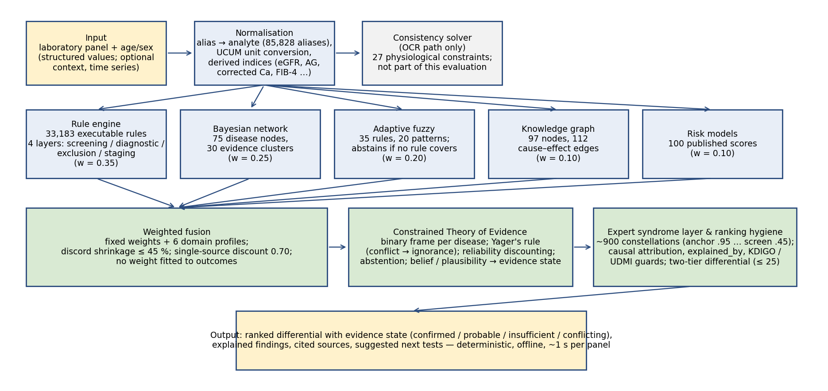
Fig. 1 | Architecture. Panel, age/sex and optional context → UCUM normalisation and derived indices → rule layer (33,183 guideline rules) → expert syndrome layer → fusion → ranking hygiene (causal attribution, chronicity, UDMI) → two-tier cited differential.

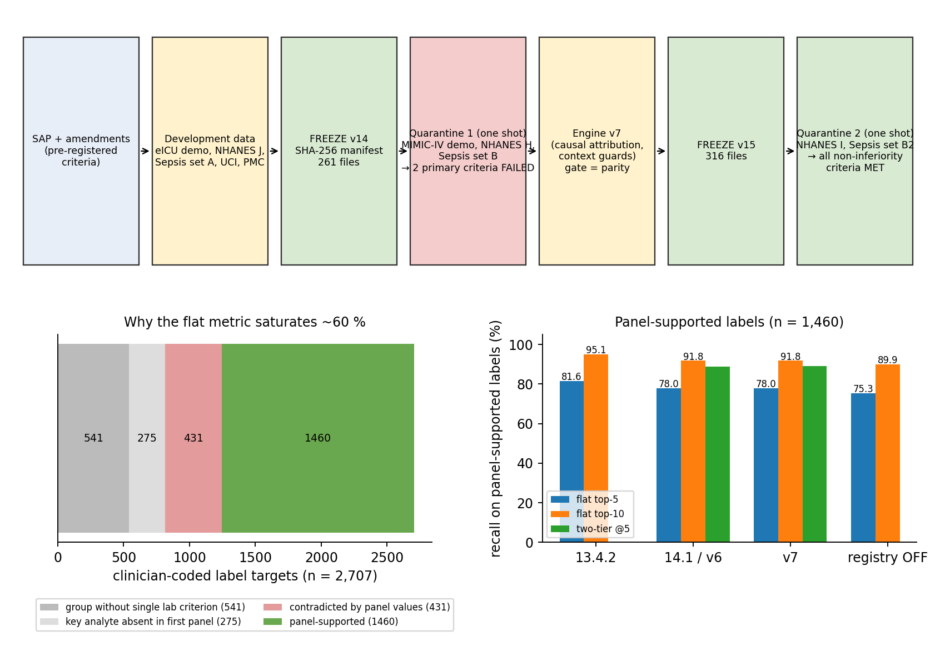
Fig. 2 | Pre-specification workflow and the reference-standard ceiling. (a) SAP, freezes and the two one-shot quarantine rounds, including the failed round. (b) Decomposition of 2,707 eICU label targets and recall on the 1,460 panel-supported labels for the product release, v7 and the registry-off ablation.

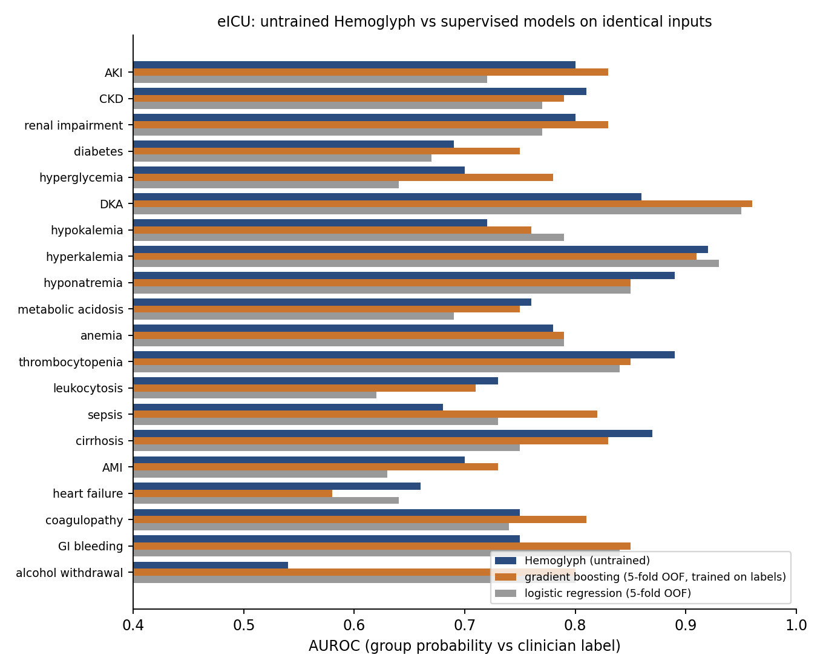
Fig. 3 | Untrained engine versus supervised models on identical inputs (eICU). Per-group AUROC of Hemoglyph, five-fold out-of-fold gradient boosting and logistic regression.

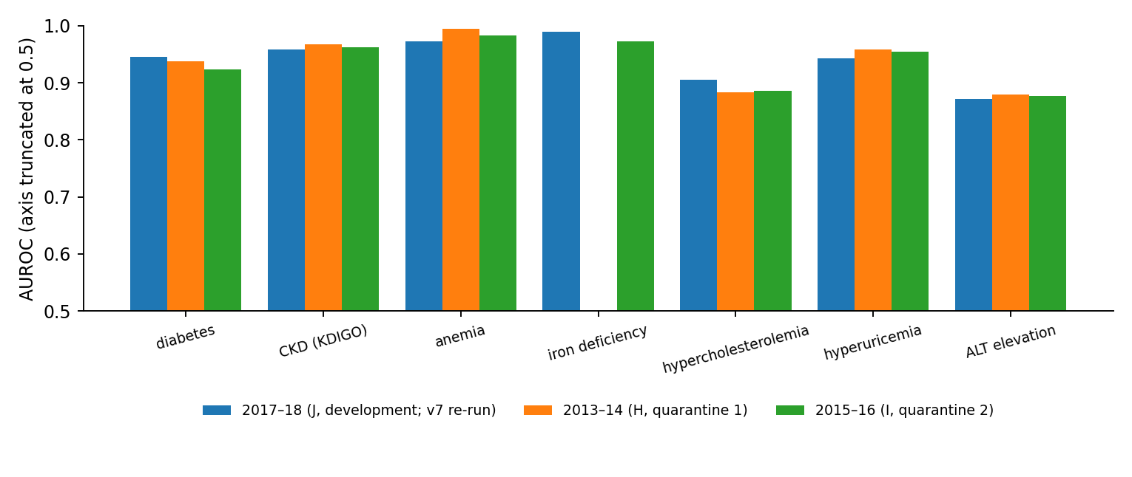
Fig. 4 | NHANES screening across three independent cycles. AUROC per task for the development cycle (2017–18, frozen-v7 re-run) and quarantine cycles (2013–14, 2015–16), n = 3,000 each; y-axis truncated at 0.5 (chance level) to resolve differences of 0.01–0.05.

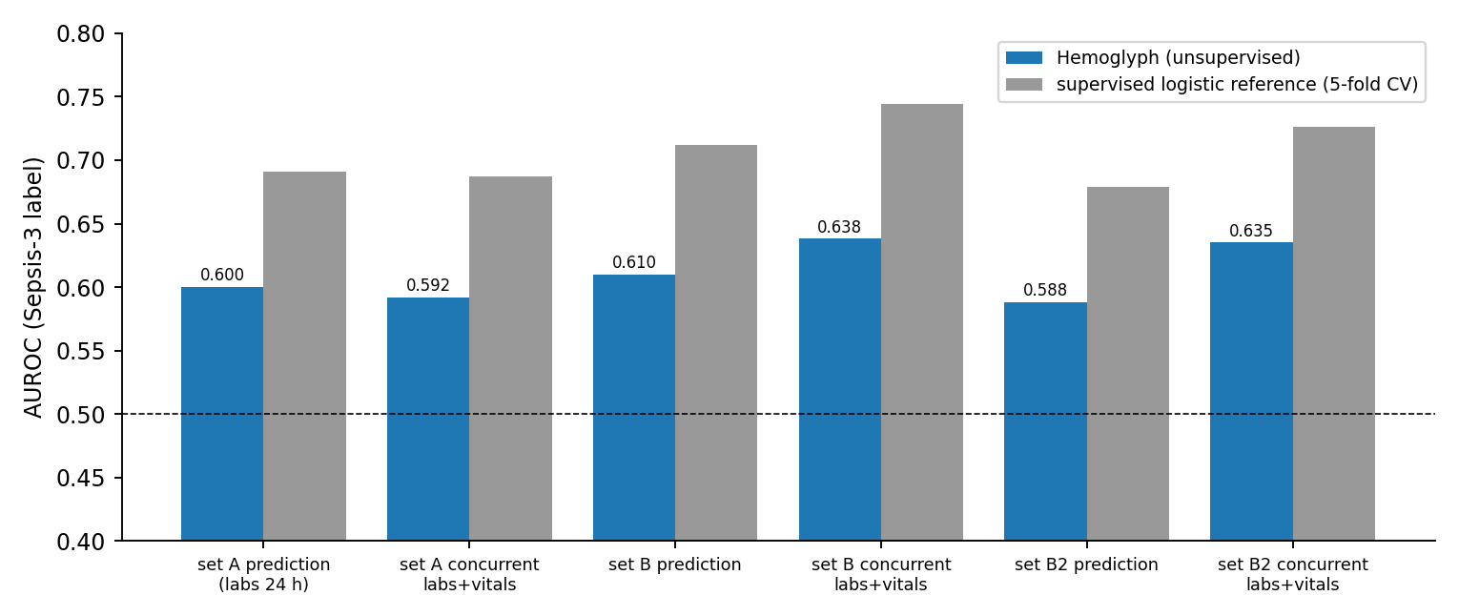
Fig. 5 | Sepsis: a pre-specified negative result. Engine versus supervised logistic AUROC in prediction and concurrent frames across sets A, B and B2.

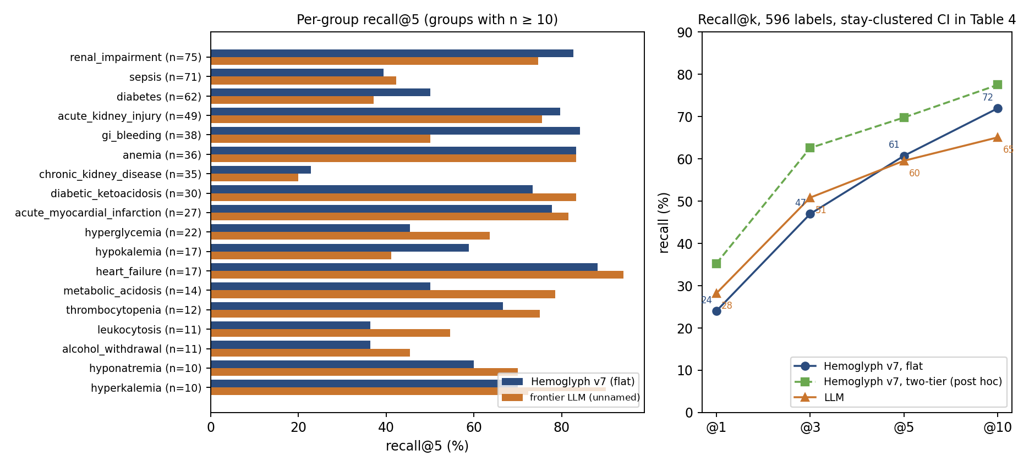
Fig. 6 | Blinded LLM comparison (400 stays, 596 labels), frozen engine v7. Per-group recall@5 and recall@k curves for Hemoglyph and the unnamed frontier LLM model.

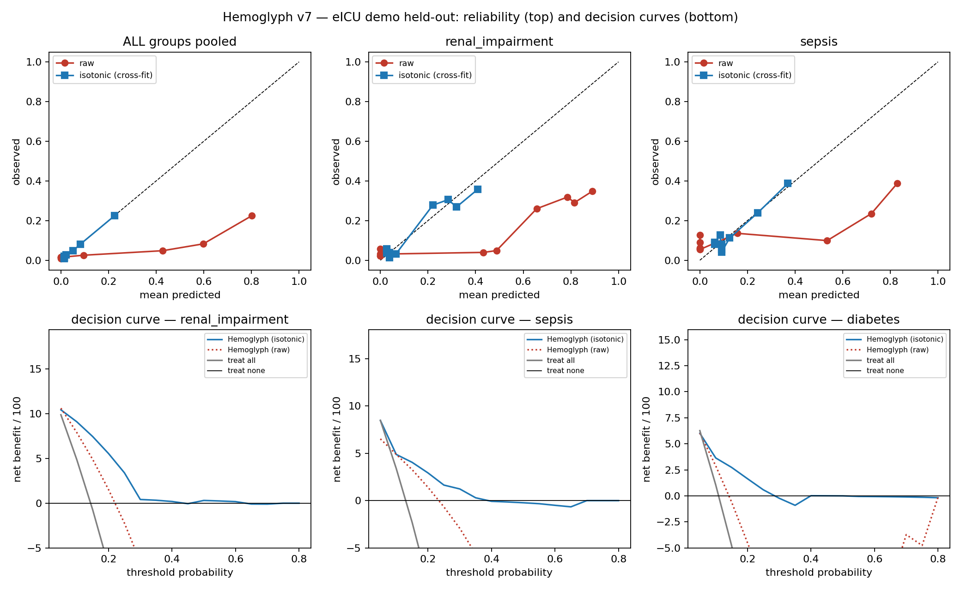
Fig. 7 | Calibration and decision curves (eICU, engine v7). Reliability diagrams before and after cross-fitted isotonic recalibration and decision curves for the five largest groups.

