SOFTWARE DEVELOPMENT PLAN
LEADS - Lead generation Engine for Automated Discovery System
1. PROJECT DETAILS
Project Title: LEADS
Start Date: Monday, April 27, 2026
End Date: Monday, April 26, 2027
Duration: 1 Year
Development Methodology: Agile
Project Manager: Muhammad Soban

Project Scope:
LEADS is a web-based real estate platform built for the Pakistani market that covers everything happening in the pre-transaction phase, from market intelligence to active lead generation and listing management. The platform serves real estate agents, investors and internal administrators, while external buyers interact with properties through a centralized listing hub where every user must first verify their identity via a two-step OTP process. The market intelligence system continuously scrapes Zameen.com, OLX Pakistan, Graana.com and Ilaan.com using Scrapy, Playwright and parallel proxy-assigned Celery workers, cleaning raw records to calculate listing velocity, days on market and price movements before sending a computed demand score to GPT-4o mini to generate actionable trend recommendations. When a target property is selected, the platform handles seller outreach via user-approved WhatsApp messages, collects structured property details through automated forms and passes the input to an LLM to generate fair market valuations, highlight hot features, correct categories and write enhanced listing descriptions. To connect with potential buyers, LEADS executes a second targeted scraping pass, drafts approved WhatsApp outreach campaigns, monitors replies through webhooks, automatically classifies positive responses as warm leads and generates follow-up drafts for agent handover. Once approved, listings publish to LEADS' verified listing management hub, enabling buyers to filter properties, save favorites, set alerts and contact sellers directly. LEADS operates strictly as a pre-transaction tool, avoiding payment processing, legal documentation or financial intermediation and launches exclusively in Pakistan in English.

Project Objectives:
• BO-1 (Market Demand Scoring): The system will calculate market demand scores for property categories in different Pakistani cities by continuously reading scraped listing data and finding listing velocity, average days on market, and price trends, and then it will generate easy trend recommendations using an AI model.
• BO-2 (Targeted Multi-Agent Scraping): The system will run targeted multi-agent scraping runs across four major Pakistani property platforms which are Zameen.com, OLX Pakistan, Graana.com, and Ilaan.com using Scrapy and Playwright with rotating proxy IPs so the target platforms do not block our requests.
• BO-3 (AI Seller Outreach): When an agent selects a property lead, the system will draft a personalized WhatsApp outreach message and terms summary for the agent to review and approve before sending it to the seller.
• BO-4 (Digital Property Forms): The system will deliver category-specific digital forms over WhatsApp for houses, flats, shops, plots, and plazas so the seller can submit all required property details in one simple submission without long messaging back and forth.
• BO-5 (Two-Stage LLM Property Analysis): The system will send the submitted form data to an LLM like Google Gemini or GPT-4o mini to estimate fair market value, find key selling features, flag any problems, verify property category, and generate a good listing description.
• BO-6 (Buyer Outreach & Intent Scoring): The system will run a second scraping pass using the verified property details to find active buyers on competing platforms, rank them using a machine learning lead scoring model, and draft a WhatsApp campaign for user review.
• BO-7 (Webhook Warm Lead Detection): The system will listen to incoming WhatsApp replies using a webhook, classify each reply as hot, warm, or cold, send warm leads to the seller dashboard, and write an automatic follow-up draft for the agent to review.
• BO-8 (Verified Property Listing Hub): Confirmed and AI-improved listings will be published on the LEADS listing discovery hub where verified buyers can search properties using fast Meilisearch filters and view locations on Google Maps.
• BO-9 (Admin Control Panel): The system will give administrators full control over scraper schedules, proxy pools, API keys, scoring model weights, user accounts, and audit logs through a dedicated admin panel.
• BO-10 (Dual-OTP User Verification): All registered users must verify both their email address and phone number through time-limited OTP before using platform features so that anonymous spam and fake listings are stopped.

2. WBS - WORK BREAKDOWN STRUCTURE
ID | Task Name | Start | Finish | Resource Names
1 | SCOPE AND PLANNING
1.1 | Competitor Analysis | Mon 4/27/26 | Wed 4/29/26 | Mamoon Tahir, Muhammad Soban
1.2 | Requirements Gathering | Thu 4/30/26 | Thu 5/7/26 | Mamoon Tahir, Muhammad Soban
1.3 | Scope Document Writing | Fri 5/8/26 | Wed 5/13/26 | Mamoon Tahir, Muhammad Soban
1.4 | Scope Submitted | Wed 5/13/26 | Wed 5/13/26 | Dr. Tehseen Riaz Abbasi, Mamoon Tahir, Muhammad Soban
2 | SYSTEM DESIGN
2.1 | Database Schema Design | Thu 5/14/26 | Fri 5/22/26 | Muhammad Soban
2.2 | System Architecture and API design | Mon 5/25/26 | Tue 6/2/26 | Mamoon Tahir, Muhammad Soban
2.3 | Lead-scoring model and NLP reply-classification architecture planning | Wed 6/3/26 | Tue 6/9/26 | Mamoon Tahir
2.4 | UI/UX wireframes | Wed 6/10/26 | Tue 6/23/26 | Mamoon Tahir, Muhammad Soban
2.5 | Design Phase Complete | Tue 6/23/26 | Tue 6/23/26 | Dr. Tehseen Riaz Abbasi, Mamoon Tahir, Muhammad Soban
3 | SOFTWARE REQUIREMENT SPECIFICATION (SRS)
3.1 | Functional Requirements Documentation | Wed 6/24/26 | Tue 6/30/26 | Mamoon Tahir, Muhammad Soban
3.2 | Non Functional Requirements Documentation | Wed 7/1/26 | Fri 7/3/26 | Mamoon Tahir, Muhammad Soban
3.3 | Usecase Diagrams and Descriptions | Mon 7/6/26 | Tue 7/14/26 | Mamoon Tahir, Muhammad Soban
3.4 | UML Diagrams | Wed 7/15/26 | Thu 7/23/26 | Mamoon Tahir, Muhammad Soban
3.5 | SRS Review and Finalization | Fri 7/24/26 | Mon 7/27/26 | Dr. Tehseen Riaz Abbasi, Mamoon Tahir, Muhammad Soban
3.6 | SRS Complete | Mon 7/27/26 | Mon 7/27/26 | Dr. Tehseen Riaz Abbasi
4 | SOFTWARE DESIGN SPECIFICATION (SDS)
4.1 | Architecture and Component Design Documentation | Tue 7/28/26 | Thu 7/30/26 | Mamoon Tahir, Muhammad Soban
4.2 | ER Diagram and Design Documentation | Fri 7/31/26 | Wed 8/11/26 | Mamoon Tahir, Muhammad Soban
4.3 | UML Diagrams | Wed 8/12/26 | Wed 8/18/26 | Mamoon Tahir, Muhammad Soban
4.4 | SDS Review and Finalization | Wed 8/19/26 | Thu 8/20/26 | Dr. Tehseen Riaz Abbasi,  Mamoon Tahir, Muhammad Soban
4.5 | SDS Complete | Thu 8/20/26 | Thu 8/20/26 | Dr. Tehseen Riaz Abbasi
5 | DEVELOPMENT
5.1 | Environment Setup | Fri 8/21/26 | Mon 8/24/26 | Muhammad Soban
5.2 | M01 - User Authentication | Tue 8/25/26 | Wed 9/2/26 | Muhammad Soban
5.3 | M02 - Market Intelligence Engine | Thu 9/3/26 | Mon 9/14/26 | Muhammad Soban
5.4 | M03 - Scraping Engine - Scrapy Spiders | Tue 9/15/26 | Thu 9/24/26 | Muhammad Soban
5.5 | M03 - Scraping Engine - Playwright Spiders | Fri 9/25/26 | Tue 10/6/26 | Muhammad Soban
5.6 | Scraping and Market Intelligence Complete | Tue 10/6/26 | Tue 10/6/26 | Dr. Tehseen Riaz Abbasi
5.7 | M04 - Seller Outreach Agent | Wed 10/7/26 | Thu 10/15/26 | Mamoon Tahir
5.8 | M05 - Seller Form System | Fri 10/16/26 | Mon 10/26/26 | Mamoon Tahir
5.9 | M06 - AI Property Analyser (two stage LLM chain) | Tue 10/27/26 | Thu 11/5/26 | Mamoon Tahir
5.10 | M07 Buyer Outreach - Lead Scoring model (feature engineering, scikit-learn training, cross validation) | Fri 11/6/26 | Thu 11/19/26 | Mamoon Tahir
5.11 | M07 Buyer Outreach - Campaign dispatch + webhook reply NLP classification | Fri 11/20/26 | Thu 12/3/26 | Mamoon Tahir
5.12 | Seller Side Pipeline Complete | Thu 12/3/26 | Thu 12/3/26 | Dr. Tehseen Riaz Abbasi
5.13 | M08 - Listing Management System - publish pipeline, SSR listing pages, Meilisearch indexing | Fri 12/4/26 | Mon 12/14/26 | Muhammad Soban
5.14 | M08 - Listing Management System - Buyer Discovery UI (filters, bookmarks, saved searches, contact routing) | Tue 12/15/26 | Wed 12/23/26 | Muhammad Soban
5.15 | M09 - Seller Dashboard (deal/lead summary, activity chart, revenue tracking) | Thu 12/24/26 | Thu 12/31/26 | Mamoon Tahir
5.16 | M10 - Admin Control Panel (scrapers, proxies, API keys, scoring weights, user management, audit log) | Fri 1/1/27 | Tue 1/12/27 | Muhammad Soban
5.17 | M11 - Campaign Dashboard | Wed 1/13/27 | Wed 1/20/27 | Muhammad Soban
5.18 | M12 - Profile and Settings | Thu 1/21/27 | Wed 1/27/27 | Mamoon Tahir
5.19 | Core Modules Development Complete | Wed 1/27/27 | Wed 1/27/27 | Dr. Tehseen Riaz Abbasi
5.20 | Integration of all 10 modules into a unified system | Thu 1/28/27 | Fri 2/5/27 | Mamoon Tahir, Muhammad Soban
5.21 | End-to-end pipeline testing | Mon 2/8/27 | Thu 2/11/27 | Mamoon Tahir, Muhammad Soban
5.22 | 100% Working Product Complete | Thu 2/11/27 | Thu 2/11/27 | Dr. Tehseen Riaz Abbasi
6 | TESTING
6.1 | Unit test cases for all modules | Fri 2/12/27 | Wed 2/17/27 | Mamoon Tahir, Muhammad Soban
6.2 | Integration test plan (end-to-end pipeline) | Thu 2/18/27 | Tue 2/23/27 | Mamoon Tahir, Muhammad Soban
6.3 | Test results documentation and traceability matrix | Wed 2/24/27 | Fri 2/26/27 | Mamoon Tahir, Muhammad Soban
6.4 | Testing Document Complete | Fri 2/26/27 | Fri 2/26/27 | Dr. Tehseen Riaz Abbasi
7 | FINAL REVIEW AND DELIVERY
7.1 | Lead Scoring and reply-classification model evaluation and retraining on live scraped data | Mon 3/1/27 | Fri 3/5/27 | Mamoon Tahir, Muhammad Soban
7.2 | Performance optimization | Mon 3/8/27 | Fri 3/12/27 | Mamoon Tahir, Muhammad Soban
7.3 | Security Review | Mon 3/15/27 | Fri 3/19/27 | Mamoon Tahir, Muhammad Soban
7.4 | User Acceptance Testing | Mon 3/22/27 | Mon 3/29/27 | Mamoon Tahir, Muhammad Soban
7.5 | Bug fixing and final polishing based on UAT feedback | Tue 3/30/27 | Fri 4/2/27 | Mamoon Tahir, Muhammad Soban
7.6 | Final Report Writing | Mon 4/5/27 | Tue 4/13/27 | Mamoon Tahir, Muhammad Soban
7.7 | Final Presentation Preparation | Wed 4/14/27 | Thu 4/22/27 | Dr. Tehseen Riaz Abbasi,  Mamoon Tahir, Muhammad Soban
7.8 | Plagiarism Check | Fri 4/23/27 | Fri 4/23/27 | Mamoon Tahir, Muhammad Soban
7.9 | Final Evaluation and Presentation | Mon 4/26/27 | Mon 4/26/27 | Mamoon Tahir, Muhammad Soban
7.10 | Project Complete | Mon 4/26/27 | Mon 4/26/27 | Dr. Tehseen Riaz Abbasi,  Mamoon Tahir, Muhammad Soban

4. GANTT CHART
l report writing, plagiarism checking, and final evaluation presentation.
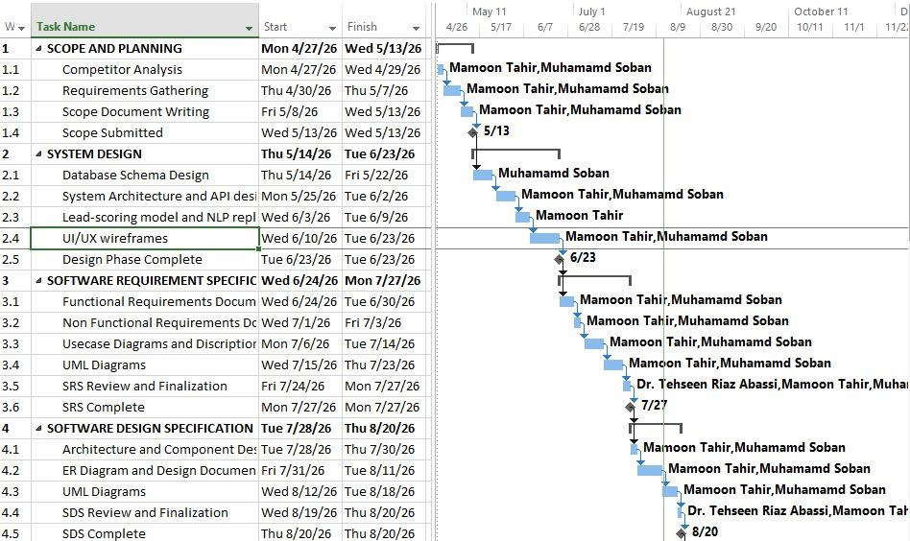
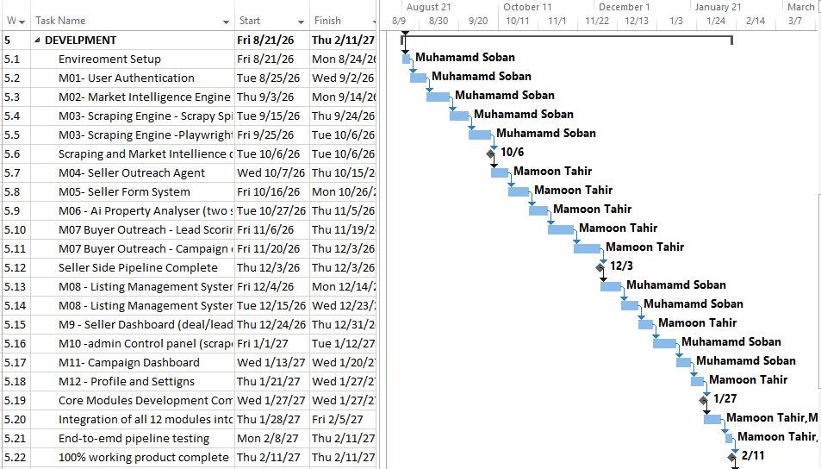
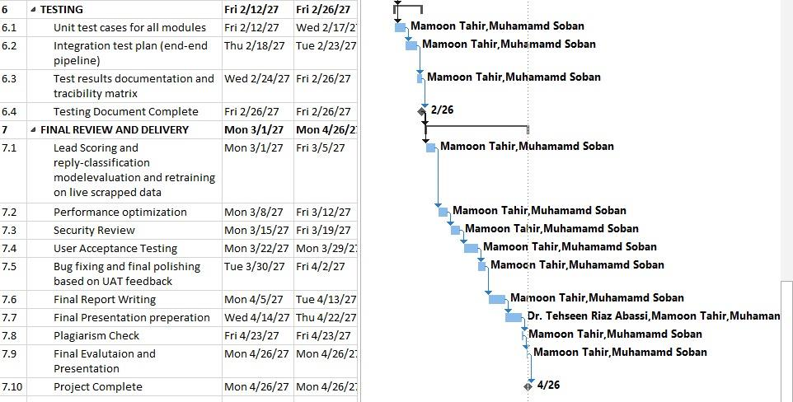

5. NETWORK DIAGRAM
Below is the Activity On Node (AON) network diagram for LEADS. Each box represents a distinct project activity with its activity identifier, task title, and duration in working days. The critical path is shown in the diagram and connects all activities where any delay will directly delay the final completion of the project.

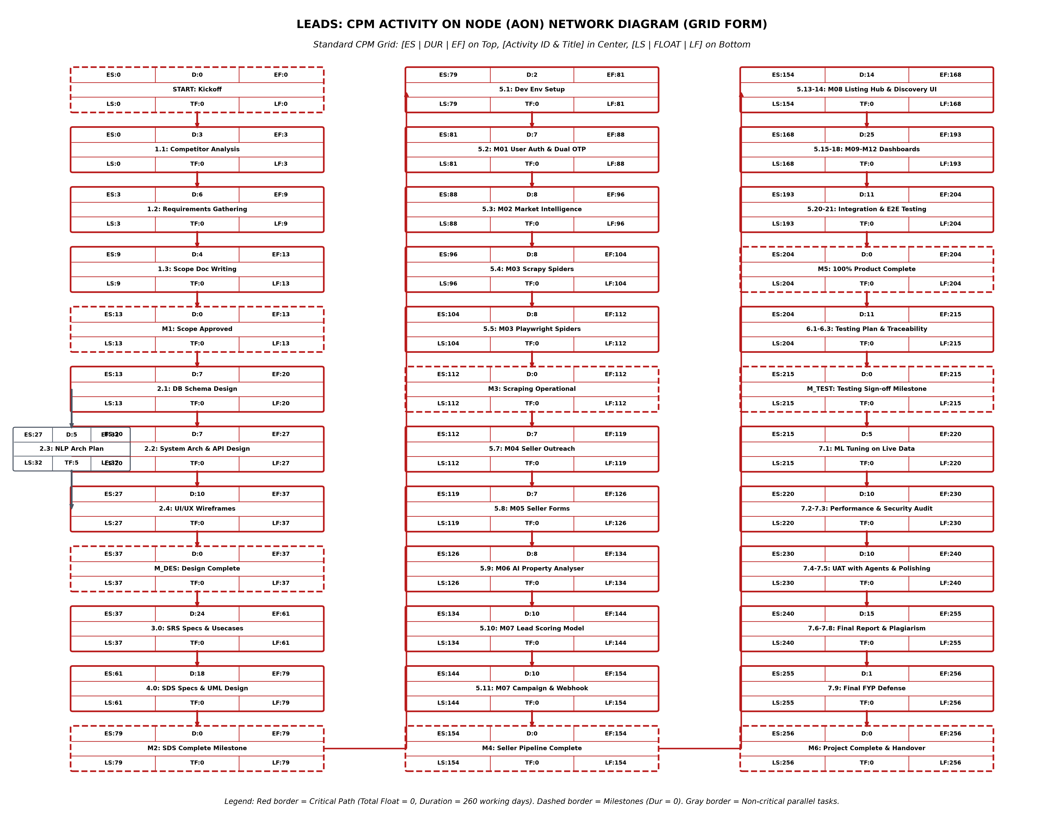
Figure 5.1: Activity On Node (AON) Network Diagram for LEADS

6. COST MANAGEMENT
The table below shows the complete project cost estimate structured in standard Excel format. It includes human resources, software licenses and cloud APIs, hosting infrastructure, quality assurance, deployment, and a 10% contingency reserve for unexpected price rises or API usage increases.
S.No | Cost Category | Item Description | Quantity | Unit Rate (PKR) | Total Cost (PKR) | Formula
1.1 | Human Resources | Lead Full-Stack & Systems Engineer (Muhammad Soban) | 12 Months | 120,000 | 1,440,000 | =D2*E2
1.2 | Human Resources | AI/ML & Data Pipeline Engineer (Mamoon Tahir) | 12 Months | 120,000 | 1,440,000 | =D3*E3
1.4 | Human Resources | UI/UX & Quality Assurance Specialist (Contractor) | 3 Months | 60,000 | 180,000 | =D5*E5
 | Subtotal: Human Resources | Sum of Human Resource Personnel Costs |  |  | 3,540,000 | =SUM(F2:F5)
2.1 | Software / Licenses | Google Gemini 2.0 Flash API (Listing generation & trends) | 12 Months | 15,000 | 180,000 | =D7*E7
2.2 | Software / Licenses | OpenAI API (GPT-4o mini backup & sentiment analysis) | 12 Months | 10,000 | 120,000 | =D8*E8
2.3 | Software / Licenses | WhatsApp Cloud API (Outreach campaigns & OTP messages) | 15,000 Msgs | 12 | 180,000 | =D9*E9
2.4 | Software / Licenses | SendGrid Email Delivery Service (Transaction OTP & alerts) | 12 Months | 5,000 | 60,000 | =D10*E10
2.5 | Software / Licenses | Domain Name (.com / .pk) and SSL Certificate | 1 Year | 10,000 | 10,000 | =D11*E11
 | Subtotal: Software / Licenses | Sum of Software and API Licenses |  |  | 550,000 | =SUM(F7:F11)
3.1 | Hardware / Cloud | High-Performance Cloud VPS (Ubuntu 8 vCPUs, 16GB RAM) | 12 Months | 25,000 | 300,000 | =D13*E13
3.2 | Hardware / Cloud | Managed Database Hosting (PostgreSQL 17 + MongoDB) | 12 Months | 18,000 | 216,000 | =D14*E14
3.3 | Hardware / Cloud | Rotating Residential & Datacenter Proxy Network Pool | 12 Months | 20,000 | 240,000 | =D15*E15
3.4 | Hardware / Cloud | Development Workstation Amortization & Local Storage | 2 Units | 50,000 | 100,000 | =D16*E16
 | Subtotal: Hardware / Cloud | Sum of Hardware and Cloud Infrastructure |  |  | 856,000 | =SUM(F13:F16)
5.1 | Deployment | Production Setup, Reverse Proxy & Meilisearch Deployment | 1 Service | 50,000 | 50,000 | =D22*E22
5.2 | Deployment | Staging Environment VPS Hosting | 6 Months | 10,000 | 60,000 | =D23*E23
5.3 | Deployment | Production Monitoring & Sentry Log Services | 12 Months | 6,000 | 72,000 | =D24*E24
 | Subtotal: Deployment | Sum of Deployment and Hosting Operations |  |  | 182,000 | =SUM(F22:F24)
 | SUBTOTAL (BASE EXPENDITURE) | Sum of All Five Operational Cost Categories |  |  | 5,311,000 | =F6+F12+F17+F21+F25
 | TOTAL PROJECT BUDGET | Grand Total with 10% Contingency Reserve |  |  | 5,842,100 | =F26+F27

8. TOOLS AND TECHNOLOGIES
The table below lists all the tools, programming languages, libraries, and frameworks used in building LEADS, along with their versions and justification.
Category | Tool / Technology | Version | Rationale
Frontend | Next.js | 16+ | App Router architecture with Server-Side Rendering so public property listing pages can be indexed by search engines.
Frontend | React.js | 19.2 | Component-based library for building interactive and reusable user interfaces across all three portals.
Frontend | Tailwind CSS | 4+ | Utility-first CSS framework for fast, consistent, and responsive styling on mobile and desktop screens.
Frontend | TypeScript | 5.7+ | Provides static type checking and reduces runtime bugs across frontend components and API routes.
Backend | Python | 3.13+ | Primary backend language used for web scraping spiders, data analysis, and machine learning models.
Backend | FastAPI | 0.115+ | High-speed asynchronous Python framework for handling concurrent scraping triggers and AI requests.
Backend | Django + DRF | 5.1+ / 3.15+ | Provides structured relational data management, built-in security, and admin interface.
Backend | Celery | 5.4+ | Distributed task queue used to run scraping spiders and WhatsApp outreach campaigns in the background.
Backend | Redis | 7.4+ | In-memory message broker for Celery queues and high-speed application cache.
Backend | Scrapy | 2.12+ | Fast web scraping framework with built-in support for throttling and proxy rotation.
Backend | Playwright | 1.50+ | Automates headless Chromium browsers to scrape JavaScript-heavy listing portals like Zameen and Graana.
Database | PostgreSQL | 17+ | Relational database used with Prisma ORM to store users, listings, campaigns, leads, and audit logs safely.
Database | MongoDB | Latest | Document database used to store millions of unstructured raw scraped listing records and price histories.
Database | Meilisearch | 1.5+ | Fast open-source search engine providing typo-tolerant instant property search and filtering for buyers.
AI & ML | Google Gemini API | 2.0 Flash | Generates fair market valuations, extracts key property features, and writes listing descriptions.
AI & ML | OpenAI API | GPT-4o mini | Used for buyer intent scoring, sentiment classification, and backup listing description generation.
AI & ML | scikit-learn | 1.6+ | Builds, trains, and runs the composite lead scoring model to rank buyer leads.
AI & ML | Hugging Face Transformers | 4.47+ | Pre-trained NLP models used to analyze listing text and classify buyer chat replies.
Communication | WhatsApp Cloud API | v21+ | Sends automated outreach messages, delivers digital property forms, and receives replies via webhook.
Communication | SendGrid API | Latest | Sends transactional email OTP verification codes and user account alerts.
Design | Figma | Latest | Used for designing interactive UI/UX wireframes and mockups for all three user portals.
Design | Draw.io / Mermaid | Latest | Used for drawing system architecture, ER diagrams, and Activity on Node network diagrams.
Version Control | Git & GitHub | Latest | Monorepo code repository, branch management, pull request code reviews, and automated CI/CD workflows.
Project Management | GitHub Projects / Jira | Latest | Sprint planning, user story tracking, task backlog grooming, and milestone monitoring.
Testing | Pytest | Latest | Unit and integration testing for Python backend endpoints, scraping spiders, and ML models.
Testing | Playwright Test | Latest | End-to-end automated browser testing for user registration, login, and form submission.
Testing | Postman | Latest | API endpoint testing, request validation, and webhook payload simulation.
Deployment | Docker & Docker Compose | 27+ | Containerization to keep local development, staging, and production environments consistent.
Deployment | Nginx | Latest | Reverse proxy server, SSL/TLS termination, rate limiting, and static asset serving.
Deployment | Ubuntu Linux VPS | 24.04 LTS | Cloud virtual private server hosting all Docker containers with static public IP.

