PROJECT REPORT
(Project Term Sep-Nov, 2016)

PIZZA DELIVERY MANAGEMENT SYSTEM

Submitted By

NAME OF STUDENT: Saurabh Tiwari Registration Number: 11505728

SECTION: K1504 GROUP: 2

NAME OF STUDENT: Sandeep Gandhi Registration Number: 11505606

SECTION: K1504 GROUP: 2

NAME OF STUDENT: Srikar Nikanj Registration Number: 11505251

SECTION: K1504 GROUP: 2

Course Code: INT 213

Under the Guidance of
(Mr. Jaspreet Singh, Assistant Professor)

School of Computer Science and Engineering



DECLARATION
We hereby declare that the mini project work entitled “Pizza Delivery Management” is an authentic record of our work carried out in B. Tech degree in Computer Science and Engineering from Lovely Professional University, Phagwara, under the guidance of Mr. Jaspreet Singh, during September to November 2016. All the information furnished in this mini project report is based on our own intensive work and is genuine.

Name of Student: Saurabh Tiwari
Registration Number:11505728
Roll No: B50

Name of Student: Sandeep Gandhi
Registration Number: 11505606
Roll No:B40

Name of Student: Srikar Nikanj
Registration Number: 11505251
Roll No:B30

INDEX

Acknowledgement…………………………………………………………………………………... i

1. Introduction of the Project……………………………………………..……………………… 1
2. Problem Statement………………………………………………………………………………. 2
3. Feasibility Analysis of the Project…………………………………………………………… 3
4. Basic Requirements of Project……………………………………………………………….. 4
5.ScreenshotsOfProject........................................................................................6-9
6.GanttChart……………………………………………………………………………………......... 10
7. Current Status of the Project………………………………………………………………… 11
8. Limitations of the Project………….……………………….………………………………… 12
9. Bibliography……………………………………………………………………………………….. 13

ACKNOWLEDGEMENT

We take this opportunity to present my votes of thanks to all those guideposts who really acted as lightening pillars to enlighten our way throughout this project that has led to successful and satisfactory completion of this study.

We are really grateful to Dimple mam for providing us with an opportunity to undertake this project and providing us with all the facilities. We are highly thankful to mam for her active support, valuable time and advice, whole-hearted guidance, sincere cooperation and pains-taking involvement during the study and in completing the assignment of preparing the said project within the time stipulated.

Lastly, we are thankful to all those, particularly the various friends, who have been instrumental in creating proper, healthy and conductive environment and including new and fresh innovative ideas for us during the project, without their help, it would have been extremely difficult for us to prepare the project in a time bound framework.

Introduction of the Project
.
Online Pizza ordering system is a web based application which enables customers to order their pizzas online for home delivery or pick up from the pizzeria.
There are a variety of food items available on this planet. Each country has its own kind of dishes to offer. But if we pick a food item which is loved by all the people on this planet, then pizza will be a clear winner in it.

Problem Statement

The main problem wass to develop a secure, efficient and reliable Application that should not be easy to destroy and that allows to perform all type of operations either ordering the pizza or cancelling the pizza. The application must be strong enough for operating these commands.

Feasibility Analysis of the Project

The Project is developed using Python programming language and hence requires a Python-2.7.5 GUI tool & Tkinter for working.
Economic Feasibility:-
The software being developed is economic with respect to commuters. It is cost effective in the sense that it has eliminated the manual work and now we can simply convert base of number through app. The software is also time effective because it contains minimum errors and is highly accurate as the data is required.

Technical Feasibility:-
The technical requirement for the system is economic and it does not use any other
additional hardware and software.

Behavioral Feasibility:-
The software is quite easy to use and learn due to its simple but attractive interface. User doesn’t require any special training for using this software.

Basic Requirements of The Project

Interpreter:
Python-2.7.5
Operating System:
Windows
Hardware:
Basic hardware configurations

SCREENSHOTS OF THE PROJECT

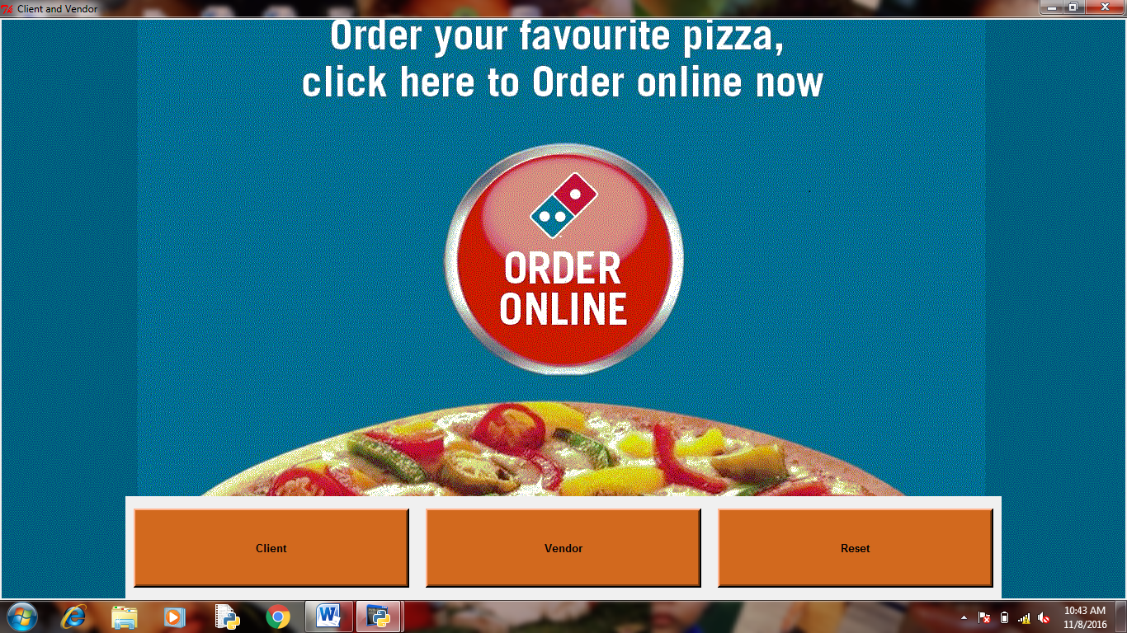

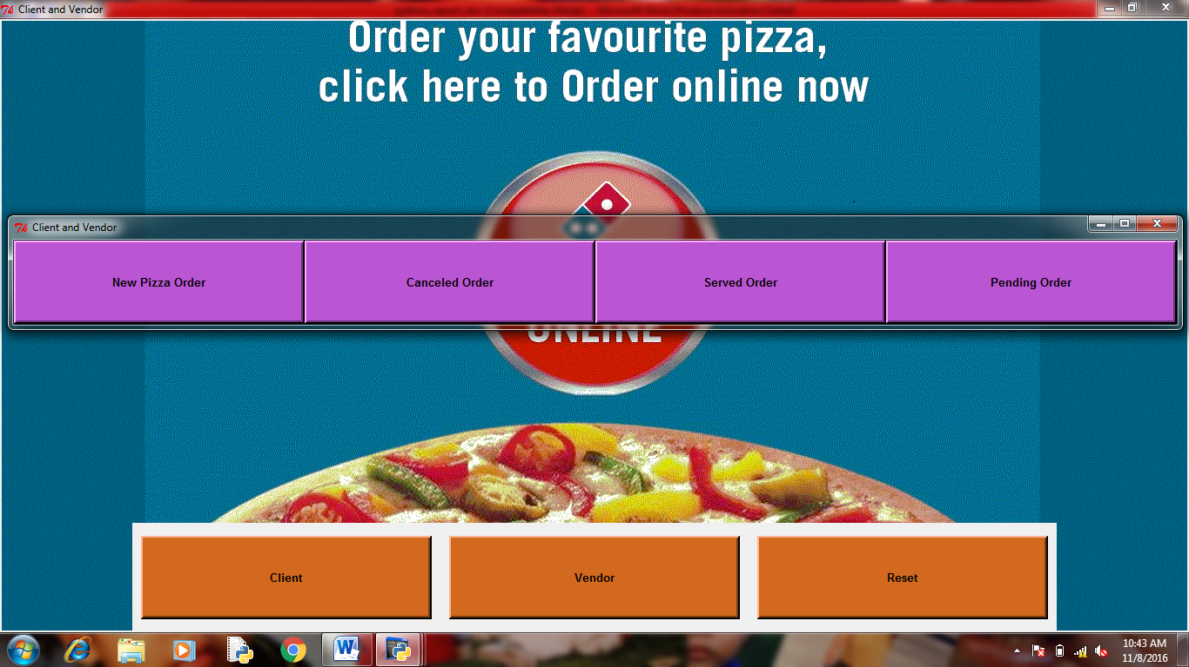

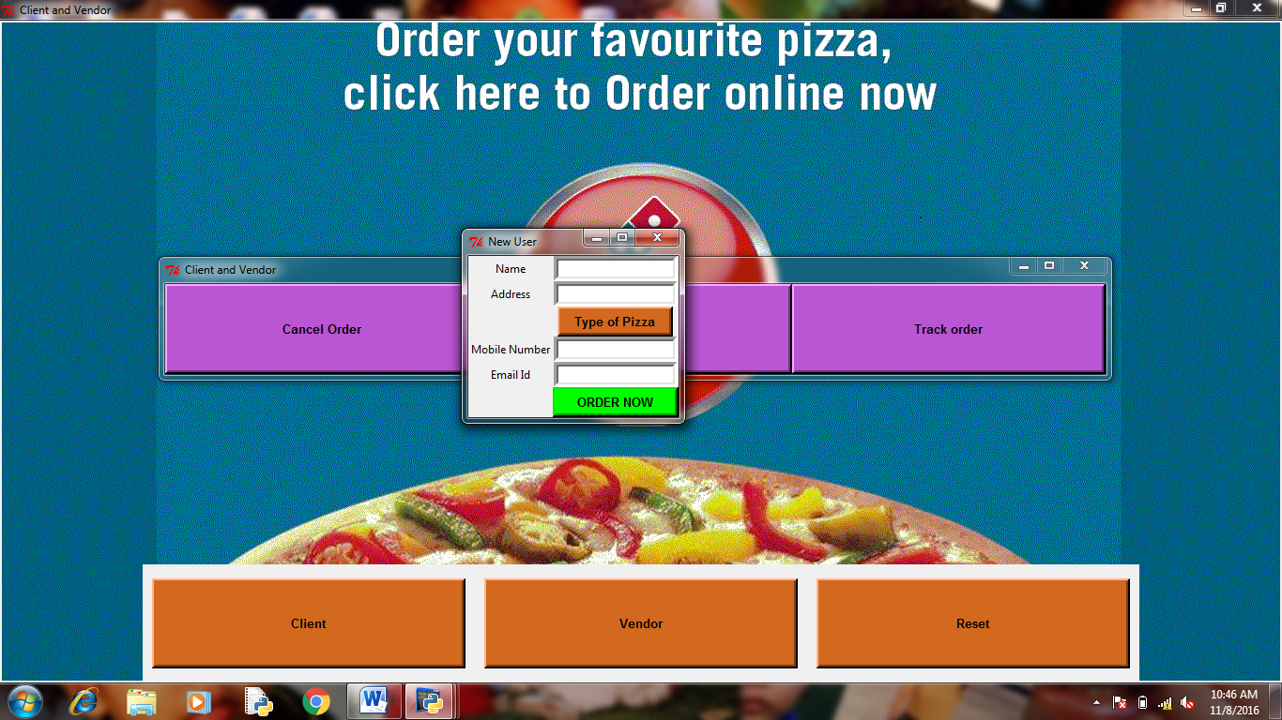

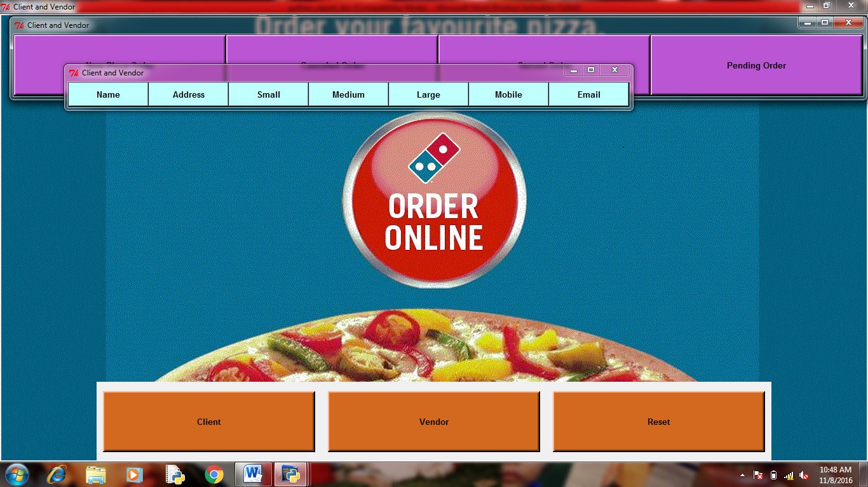

GANTT CHART
Planning of the project

Logic development for Codes

Coding and Module development
GUI development
Testing and debugging

Progress | 7-sep-16 to 11-sep-16 | 12-sep-16 to 19-sep-16 | 21-sep-16 to 24-sep-16 | 5-oct-16 to 21-oct-16 | 23-oct-16 to 29-oct-16

CURRENT STATUS OF PROGRAM
The project has been completed on the logical level. All the modules are working properly. The program has been tested thoroughly and all the bugs have been removed. Basic GUI for this project has also been developed. The project is quite efficient and produces accurate results.

BIBLIOGRAPHY

Book:
- Learning Python by AllenDowney,Jeffery Elkner and Chris Meyers, Edition-I

Websites:
1. http://www.pythonfiddle.com/python-logic-gates/
- https://www.tutorialspoint.com/python/python_gui_programming .htm.

