**PUBLIC HEALTH AWARENESS**

**TEAM MEMBER**

REGISTER NUMBER:412621243048

NAME: SOBANA K S

# Phase-1 Document Submission

**Objectives:**

To define specific objectives for analyzing public health awareness campaign data, such as measuring audience reach, awareness levels, and campaign impact.

**Data Collection:**

To identify the sources and methods for collecting campaign data, including engagement metrics, audience demographics, and awareness surveys.

**Visualization Strategy:**

To plan how to visualize the insights using IBM Cognos to create informative dashboards and reports.

**Code Integration:**

To decide which aspects of the analysis can be enhanced using code, such as data cleaning, transformation, and statistical analysis.

**Dataset Link:** <https://www.kaggle.com/datasets/osmi/mental-health-in-tech-survey>

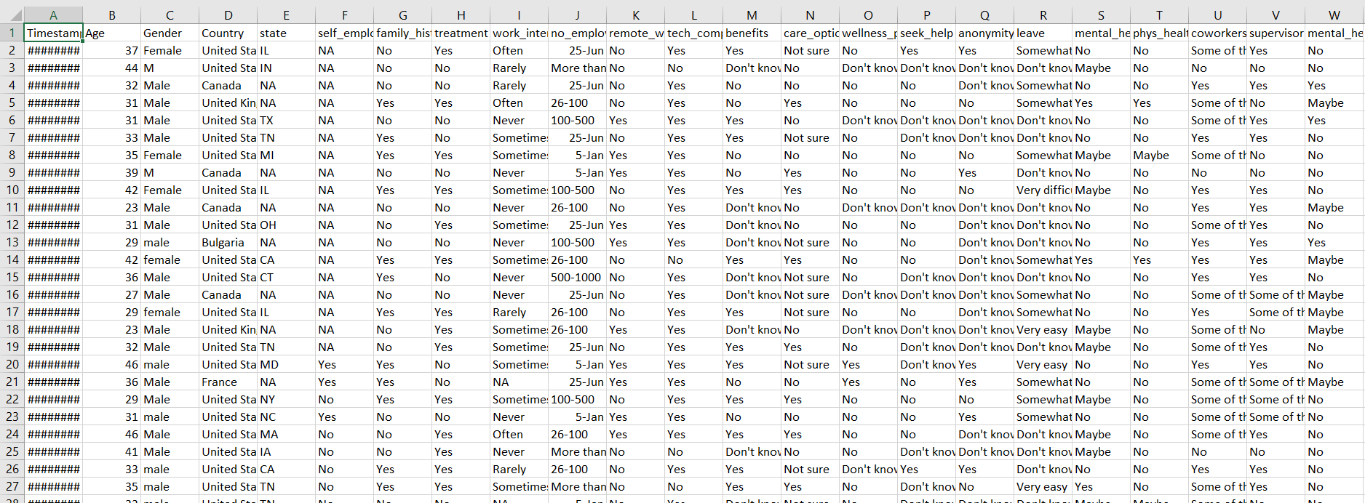

**PYTHON PROGRAM:**

import numpy as np

import pandas as pd

import matplotlib.pyplot as plt

from sklearn.preprocessing import StandardScaler

from sklearn.model_selection import train_test_split

import tensorflow as tf

data = pd.read_csv('../input/mental-health-in-tech-survey/survey.csv')

data

data.isna().sum()

data.isna().mean()

data = data.drop('comments', axis=1)

data = data.drop('state', axis=1)

data['self_employed'].unique()

data['self_employed'].mode()

data['self_employed'] = data['self_employed'].fillna('No')

data['work_interfere'].unique()

data['work_interfere'].mode()

data['work_interfere'] = data['work_interfere'].fillna('Sometimes')

data

{column: len(data[column].unique()) for column in data.select_dtypes('object').columns}

{column: list(data[column].unique()) for column in data.select_dtypes('object').columns}

def encode_gender(x):

if x.lower()[0] == 'f':

return 0

elif x.lower()[0] == 'm':

return 1

else:

return 2

data['Gender'] = data['Gender'].apply(encode_gender)

target = 'treatment'

binary_features = [

'self_employed',

'family_history',

'remote_work',

'tech_company',

'obs_consequence'

]

ordinal_features = [

'work_interfere',

'no_employees'

]

nominal_features = [

'Country',

'benefits',

'care_options',

'wellness_program',

'seek_help',

'anonymity',

'leave',

'mental_health_consequence',

'phys_health_consequence',

'coworkers',

'supervisor',

'mental_health_interview',

'phys_health_interview',

'mental_vs_physical'

]

def binary_encode(df, columns, positive_values):

df = df.copy()

for column, positive_value in zip(columns, positive_values):

df[column] = df[column].apply(lambda x: 1 if x == positive_value else 0)

return df

def ordinal_encode(df, columns, orderings):

df = df.copy()

for column, ordering in zip(columns, orderings):

df[column] = df[column].apply(lambda x: ordering.index(x))

return df

def onehot_encode(df, columns, prefixes):

df = df.copy()

for column, prefix in zip(columns, prefixes):

dummies = pd.get_dummies(df[column], prefix)

df = pd.concat([df, dummies], axis=1)

df = df.drop(column, axis=1)

return df

binary_positive_values = ['Yes' for feature in binary_features]

ordinal_orderings = [

['Never', 'Rarely', 'Sometimes', 'Often'],

['1-5', '6-25', '26-100', '100-500', '500-1000', 'More than 1000']

]

nominal_prefixes = [

'co',

're',

'be',

'ca',

'we',

'se',

'an',

'le',

'mc',

'ph',

'cw',

'su',

'mi',

'pi',

'mp'

]

data = binary_encode(

data,

columns=binary_features,

positive_values=binary_positive_values

)

data = ordinal_encode(

data,

columns=ordinal_features,

orderings=ordinal_orderings

)

data = onehot_encode(

data,

columns=nominal_features,

prefixes=nominal_prefixes

)

data

data = binary_encode(data, columns=['treatment'], positive_values=['Yes'])

data

print("Remaining non-numeric columns:", len(data.select_dtypes('object').columns))

{column: len(data[column].unique()) for column in data.select_dtypes('object').columns}

data = data.drop('Timestamp', axis=1)

print("Remaining non-numeric columns:", len(data.select_dtypes('object').columns))

print("Remaining missing values:", data.isna().sum().sum())

y = data['treatment'].copy()

X = data.drop('treatment', axis=1).copy()

scaler = StandardScaler()

X = scaler.fit_transform(X)

X_train, X_test, y_train, y_test = train_test_split(X, y, train_size=0.7, random_state=100)

X.shape

print("Class Distribution (Positive to Negative): {:.1f}% / {:.1f}%".format(y_train.mean() * 100, (1 - y_train.mean()) * 100))

inputs = tf.keras.Input(shape=(X.shape[1],))

x = tf.keras.layers.Dense(1024, activation='relu')(inputs)

x = tf.keras.layers.Dense(1024, activation='relu')(x)

outputs = tf.keras.layers.Dense(1, activation='sigmoid')(x)

model = tf.keras.Model(inputs, outputs)

model.compile(

optimizer='adam',

loss='binary_crossentropy',

metrics=[

'accuracy',

tf.keras.metrics.AUC(name='auc')

]

)

batch_size = 64

epochs = 50

history = model.fit(

X_train,

y_train,

validation_split=0.2,

batch_size=batch_size,

epochs=epochs,

callbacks=[

tf.keras.callbacks.ReduceLROnPlateau()

]

)

plt.figure(figsize=(12, 6))

plt.plot(range(epochs), history.history['accuracy'], label="Training Accuracy")

plt.plot(range(epochs), history.history['val_accuracy'], label="Validation Accuracy")

plt.xlabel("Epoch")

plt.ylabel("Accuracy")

plt.legend()

plt.title("Accuracy Over Time")

plt.show()

model.evaluate(X_test, y_test)

OUTPUT:

