**PUBLIC HEALTH AWARENESS**

**TEAM MEMBER**

REGISTER NUMBER: 412621243048

NAME: SOBANA K S

# **Phase-2 INNOVATION** Document Submission

**Title:** Leveraging Advanced Machine Learning Techniques for PUBLIC HEALTH AWARENESS

**INTRODUCTION**

Mental health is a critical public health issue, with millions of people worldwide affected by mental health conditions. However, many people do not seek treatment for their mental health problems, due to several barriers, such as stigma, lack of awareness, and financial constraints.

Machine learning and data analytics can address these challenges and improve public health awareness of mental health.

**Dataset Link:** <https://www.kaggle.com/datasets/osmi/mental-health-in-tech-survey>

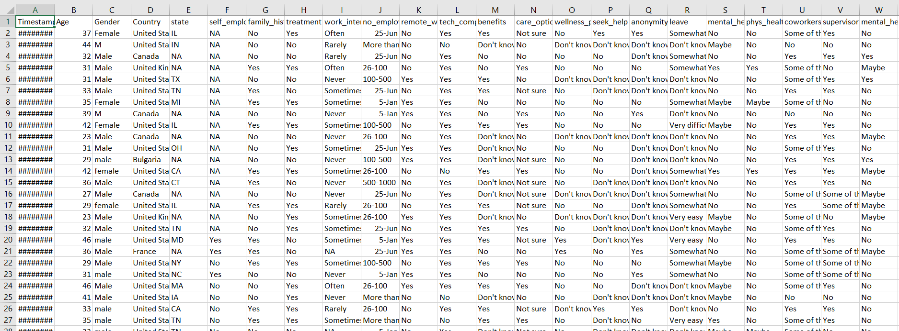

**Innovation**

The main innovation in this approach is using a machine learning model to predict whether a person is at risk of developing a mental health condition. This is a challenging task, as there is no single factor that determines whether a person will develop a mental health condition. However, machine learning models can learn complex relationships between different factors and make accurate predictions.

Another innovative aspect of this approach is the use of data analytics to identify the factors that are associated with seeking treatment for mental health. This can help to develop public health campaigns that are targeted to the people who need them most.

**Step-by-step innovation**

This Step-by-step approach to using machine learning and data analytics to improve public health awareness of mental health:

**Data extraction:**

Extract data from relevant sources, such as public health surveys, medical records, and social media data.

**Data cleaning:**

Clean the data by removing errors and inconsistencies.

**Feature engineering:**

Create new features by combining existing features or transforming them in new ways.

**Model training:**

Train a machine learning model to predict whether a person is at risk of developing a mental health condition.

**Model evaluation:**

Evaluate the model's performance on a held-out test set.

**Deployment:**

Deploy the model to production so that it can be used to make predictions for new data.

**Conclusion:**

This step-by-step approach to using machine learning and data analytics to improve public health awareness of mental health has several benefits:

* It can help to identify people who are at risk of developing mental health problems so that they can be provided with early intervention and support.
* It can also help identify the factors associated with seeking mental health treatment so that public health campaigns can be targeted to the people who need them most.
* This approach is data-driven, so it can be used to track the progress of public health initiatives over time and identify areas where improvement is needed.