**PUBLIC HEALTH AWARENESS**

**TEAM MEMBER**

REGISTER NUMBER:412621243048

NAME: SOBANA K S

# **Phase-3 Document Submission**

**Phase 3:Development Part 1:**

Title: Data Preprocessing For PUBLIC HEALTH AWARENESS

**1. Data Collection:**

Identify reliable sources for COVID-19 vaccine data. These sources can include government health agencies, research institutions, or reputable datasets from organizations like the World Health Organization (WHO) and the Centers for Disease Control and Prevention (CDC).

**2. Data Retrieval:**

Ensure that the data includes relevant attributes such as date, location (country/region), vaccine types, doses administered, and population statistics.

**3. Data Cleaning:**

Clean the dataset to ensure it is in a usable format. This may involve:

Handling missing data by imputation or removal.

Removing duplicates and irrelevant columns.

Standardizing date formats and column names.

Correcting any inconsistencies or errors in the data.

**4. Data Transformation:**

Depending on the research questions and analysis you plan to perform, you may need to create new variables or aggregate data at different levels (e.g., daily, weekly, or by country/region).

**5. Data Exploration:**

Conduct initial exploratory data analysis (EDA) to understand the characteristics of the dataset. You can create summary statistics, visualizations, and plots to gain insights into the data.

**6. Data Integration:**

If you have data from multiple sources, you may need to integrate them into a single dataset for a comprehensive analysis.

**7. Data Validation:**

Check the data for any anomalies, outliers, or inconsistencies. It's essential to ensure the data is accurate and reliable.

**8. Data Preprocessing:**

Depending on your specific analysis, you may need to perform additional preprocessing steps such as normalization, scaling, or encoding categorical variables.

**9. Data Splitting:**

If you plan to perform predictive modeling or machine learning, split the data into training and testing sets.

**10. Data Documentation:**

Document the data collection and preprocessing steps. This documentation is essential for transparency and reproducibility.

**Dataset Link:** <https://www.kaggle.com/datasets/osmi/mental-health-in-tech-survey>

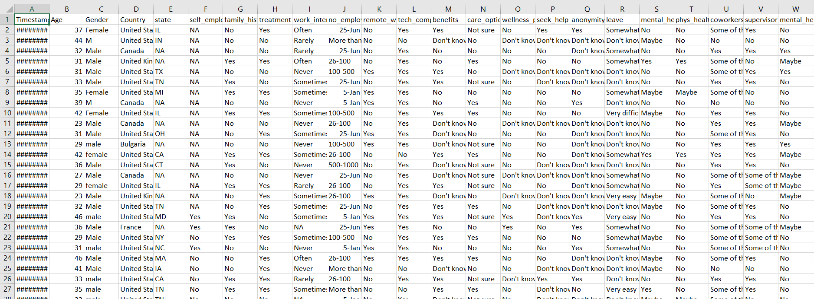

**PYTHON PROGRAM:**

import numpy as np

import pandas as pd

import matplotlib.pyplot as plt

from sklearn.preprocessing import StandardScaler

from sklearn.model_selection import train_test_split

import tensorflow as tf

data = pd.read_csv('../input/mental-health-in-tech-survey/survey.csv')

data

data.isna().sum()

data.isna().mean()

data = data.drop('comments', axis=1)

data = data.drop('state', axis=1)

data['self_employed'].unique()

data['self_employed'].mode()

data['self_employed'] = data['self_employed'].fillna('No')

data['work_interfere'].unique()

data['work_interfere'].mode()

data['work_interfere'] = data['work_interfere'].fillna('Sometimes')

data

{column: len(data[column].unique()) for column in data.select_dtypes('object').columns}

{column: list(data[column].unique()) for column in data.select_dtypes('object').columns}

def encode_gender(x):

if x.lower()[0] == 'f':

return 0

elif x.lower()[0] == 'm':

return 1

else:

return 2

data['Gender'] = data['Gender'].apply(encode_gender)

target = 'treatment'

binary_features = [

'self_employed',

'family_history',

'remote_work',

'tech_company',

'obs_consequence'

]

ordinal_features = [

'work_interfere',

'no_employees'

]

nominal_features = [

'Country',

'benefits',

'care_options',

'wellness_program',

'seek_help',

'anonymity',

'leave',

'mental_health_consequence',

'phys_health_consequence',

'coworkers',

'supervisor',

'mental_health_interview',

'phys_health_interview',

'mental_vs_physical'

]

def binary_encode(df, columns, positive_values):

df = df.copy()

for column, positive_value in zip(columns, positive_values):

df[column] = df[column].apply(lambda x: 1 if x == positive_value else 0)

return df

def ordinal_encode(df, columns, orderings):

df = df.copy()

for column, ordering in zip(columns, orderings):

df[column] = df[column].apply(lambda x: ordering.index(x))

return df

def onehot_encode(df, columns, prefixes):

df = df.copy()

for column, prefix in zip(columns, prefixes):

dummies = pd.get_dummies(df[column], prefix)

df = pd.concat([df, dummies], axis=1)

df = df.drop(column, axis=1)

return df

binary_positive_values = ['Yes' for feature in binary_features]

ordinal_orderings = [

['Never', 'Rarely', 'Sometimes', 'Often'],

['1-5', '6-25', '26-100', '100-500', '500-1000', 'More than 1000']

]

nominal_prefixes = [

'co',

're',

'be',

'ca',

'we',

'se',

'an',

'le',

'mc',

'ph',

'cw',

'su',

'mi',

'pi',

'mp'

]

data = binary_encode(

data,

columns=binary_features,

positive_values=binary_positive_values

)

data = ordinal_encode(

data,

columns=ordinal_features,

orderings=ordinal_orderings

)

data = onehot_encode(

data,

columns=nominal_features,

prefixes=nominal_prefixes

)

data

data = binary_encode(data, columns=['treatment'], positive_values=['Yes'])

data

print("Remaining non-numeric columns:", len(data.select_dtypes('object').columns))

{column: len(data[column].unique()) for column in data.select_dtypes('object').columns}

data = data.drop('Timestamp', axis=1)

print("Remaining non-numeric columns:", len(data.select_dtypes('object').columns))

print("Remaining missing values:", data.isna().sum().sum())

y = data['treatment'].copy()

X = data.drop('treatment', axis=1).copy()

scaler = StandardScaler()

X = scaler.fit_transform(X)

X_train, X_test, y_train, y_test = train_test_split(X, y, train_size=0.7, random_state=100)

X.shape

print("Class Distribution (Positive to Negative): {:.1f}% / {:.1f}%".format(y_train.mean() * 100, (1 - y_train.mean()) * 100))

inputs = tf.keras.Input(shape=(X.shape[1],))

x = tf.keras.layers.Dense(1024, activation='relu')(inputs)

x = tf.keras.layers.Dense(1024, activation='relu')(x)

outputs = tf.keras.layers.Dense(1, activation='sigmoid')(x)

model = tf.keras.Model(inputs, outputs)

model.compile(

optimizer='adam',

loss='binary_crossentropy',

metrics=[

'accuracy',

tf.keras.metrics.AUC(name='auc')

]

)

batch_size = 64

epochs = 50

history = model.fit(

X_train,

y_train,

validation_split=0.2,

batch_size=batch_size,

epochs=epochs,

callbacks=[

tf.keras.callbacks.ReduceLROnPlateau()

]

)

plt.figure(figsize=(12, 6))

plt.plot(range(epochs), history.history['accuracy'], label="Training Accuracy")

plt.plot(range(epochs), history.history['val_accuracy'], label="Validation Accuracy")

plt.xlabel("Epoch")

plt.ylabel("Accuracy")

plt.legend()

plt.title("Accuracy Over Time")

plt.show()

model.evaluate(X_test, y_test)

**OUTPUT:**

