Internationally recognized  UET Graduates are Eligible To Work globally As It is Associated To Washington Accord. Programs Offered In Computer Science Department Are Recognized By Washington Accord  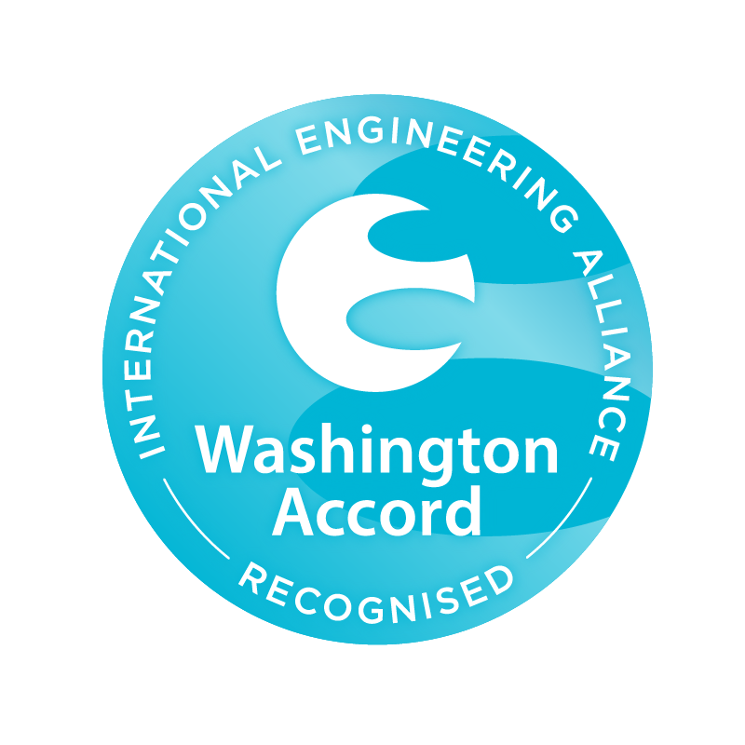 |  | 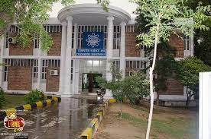  Visit Us Online:  lms.uet.edu.pk  cse.uet.edu.pk  uet.acm@gmail.com | j |  | 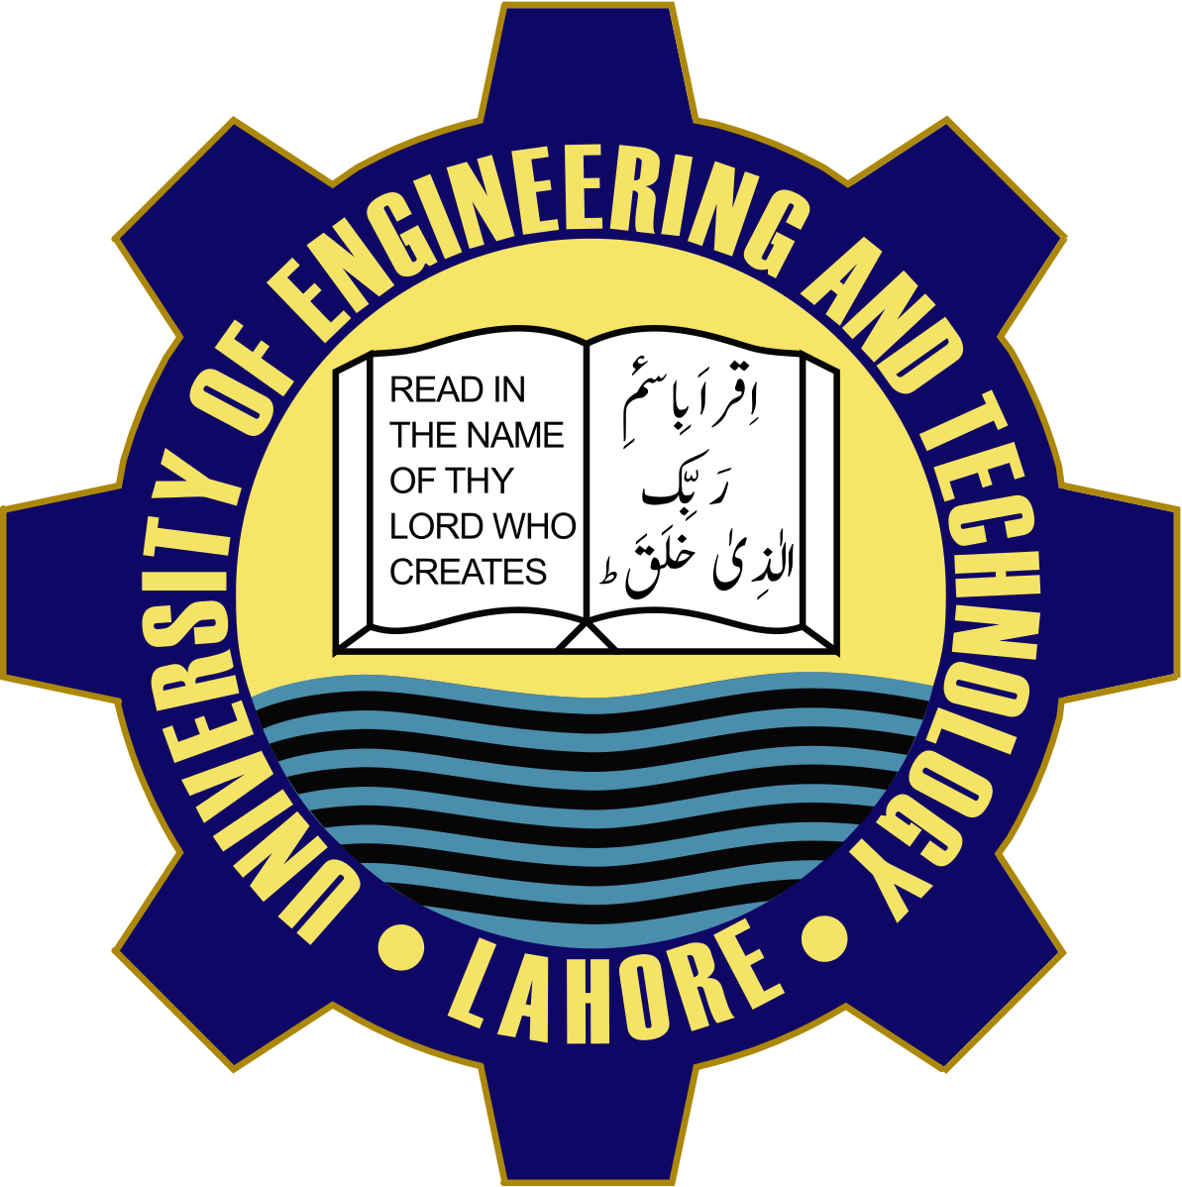  Department of computer science and engineering ,UET Lahore 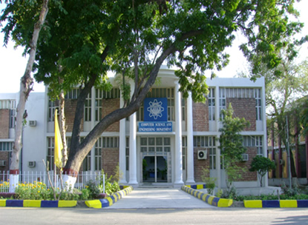

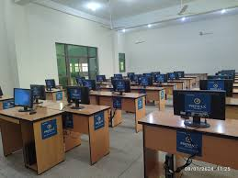  Courses Offered  - BSC computer Engineering  - BSc computer Science  - MSc computer Science  - MSc Computer Engineering  Careers  - Software Development  - Network & Computer System Administrator’s  - Computer Network & Architects | The science of Today is the technology of Tomorrow  Edward Teller  Technical Society  UET ACM is one of the most celebrated scientific society which is actively participated in different events in collaboration with ICOSST (KICS)  - IEEE UET Society  - COMPUTER CLUB  - IET SOCIETY  Computer Facilities  Computer cell is providing complete facilities with advance internet services to whole universities | Dean: Prof. Dr. Suhail Aftab qurashi  Chairman: Prof. Dr.  Muhammad Shehbaz  Contact Us  UET Admissions 042-9902916  Registrar: 042-99029227  Deputy Registrar:042-9902909  Assistance Registrar: 042-99029417

