Tata Group Data Visualisation
Forage Virtual Experience Programme
Online Retail Dataset – Power BI Dashboard & Insights
Dataset Period: 2010 – 2011

1. Project Overview
This project was completed as part of the Tata Group Data Visualisation virtual experience programme on Forage. The objective was to analyse an online retail dataset and build an interactive Power BI dashboard that provides actionable insights for business leadership — specifically a CEO and CMO.
Rather than only answering the given problem statement, a full Power BI dashboard was proactively built before framing business questions. This approach provided a deeper understanding of the data and helped anticipate the kind of questions senior leadership would ask.

2. Tools & Dataset

2.1 Tools Used
- Power BI Desktop – Data cleaning, transformation, and dashboard building
- Microsoft Excel – Source dataset (Online Retail.xlsx)

2.2 Dataset Information
- Source: UCI Machine Learning Repository
- Period: December 2010 to December 2011
- Reference: Daqing Chen, Sai Liang Sain, and Kun Guo – Data mining for the online retail industry, Journal of Database Marketing and Customer Strategy Management, Vol. 19, No. 3, pp. 197-208, 2012

2.3 Dataset Columns
Column | Description
InvoiceNo | Unique invoice number for each transaction
StockCode | Unique product or item code
Description | Name and description of the product
Quantity | Number of units purchased per transaction
InvoiceDate | Date and time of the transaction
UnitPrice | Price per unit of the product
CustomerID | Unique identifier for each customer
Country | Country where the customer is located

3. Data Cleaning & Transformation (Power BI)
All transformations were performed in Power Query Editor inside Power BI Desktop.
Step 1 – InvoiceNo: Extract numeric values only
- Some invoice numbers contained non-numeric characters and empty spaces
- Extracted the last 6 characters to retain only numeric invoice numbers
- This ensured clean and consistent invoice identification
Step 2 – StockCode: Changed data type to Text
- StockCode contained a mix of numeric and alphanumeric values
- For example, 14302 and 14302E are two distinct products
- Changing to Text type preserved these distinctions and prevented numeric misinterpretation
Step 3 – Quantity: Replaced negative values with zero
- Some rows had negative quantities representing returns or data entry errors
- Replaced all negative values with 0 to avoid distorting revenue and quantity calculations
Step 4 – Description: Removed empty rows
- Rows with null or blank descriptions were removed to maintain data quality
Step 5 – CustomerID: Removed empty rows
- Transactions without a CustomerID were removed as customer-level analysis required a valid ID
Step 6 – InvoiceDate: Removed empty rows
- Rows with missing invoice dates were removed to enable accurate time-based analysis
Step 7 – StockCode: Removed empty rows
- Rows with blank StockCodes were removed to avoid unidentified product records
Step 8 – Date Column: Extracted time intelligence columns
From the InvoiceDate column, the following new columns were extracted:
New Column | Purpose
Year | Filter and compare data across 2010 and 2011
Month Name | Display month labels on charts
Month Number | Sort months chronologically (1 to 12)
Quarter | Group data into Q1 through Q4
Day Name | Analyse revenue by day of the week
Week of Month | Understand intra-month purchase patterns
Week Number | Weekly trend analysis
Note: Month Number and Week Number were extracted specifically to enable correct chronological sorting in visuals, since Power BI sorts text values alphabetically by default.

4. Dashboard Structure

4.1 Page 1 – Revenue & Time Analysis
- Monthly Revenue – Horizontal bar chart showing revenue by month
- Revenue by Week of Month – Bar chart for intra-month purchase patterns
- Revenue by Quarter – Area chart showing quarterly progression
- Revenue by Day Name – Bar chart showing which days generate most revenue
- Revenue by Hour – Line chart showing peak purchasing hours throughout the day
- Total Revenue KPI Card – Single value card showing overall revenue
- Year Slicer – Filter to view data by 2010 and 2011 individually

4.2 Page 2 – Country, Product & Customer Analysis
- Orders by Country – Bar chart showing order volume per country
- Revenue by Country – Bar chart showing revenue contribution per country
- Top 10 Revenue by Product Description – Horizontal bar chart of best performing products
- Customers by Year – Pie chart showing the 2010 versus 2011 customer split
- KPI Cards – Revenue, Orders, Customers, and Quantity Sold

4.3 Dashboard Screenshots
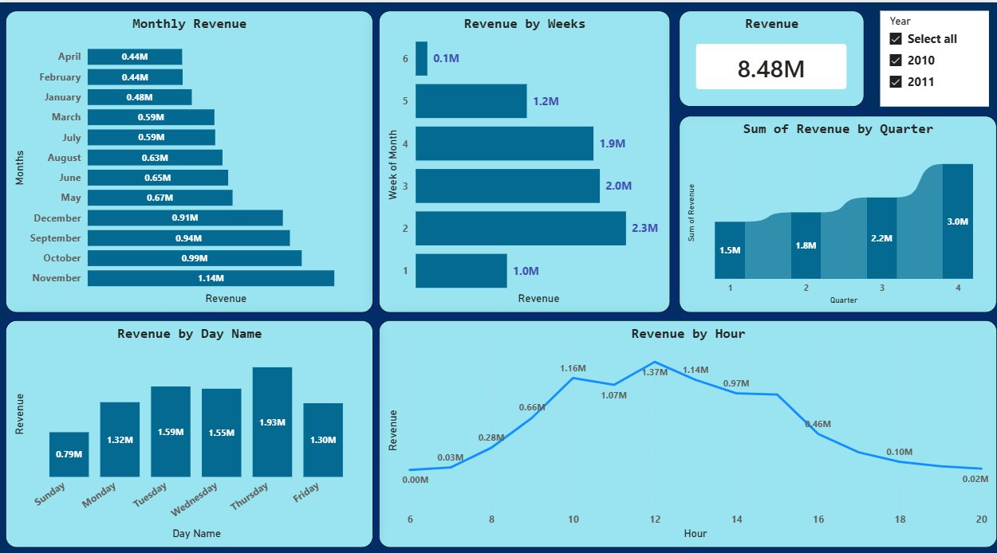
Page 1 – Revenue & Time Analysis
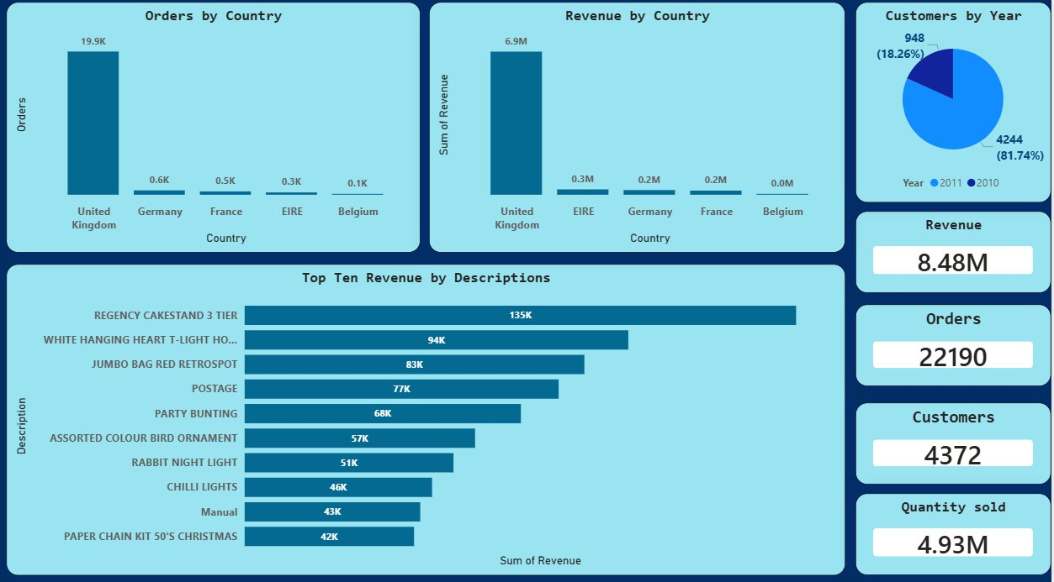
Page 2 – Country, Product & Customer Analysis

5. Key Performance Indicators
Metric | Value
Total Revenue | £8.48M
Total Orders | 22,190
Total Customers | 4,372
Total Quantity Sold | 4.93M

6. Data Insights

6.1 Monthly Revenue
Month | Revenue
November | £1.14M
October | £0.99M
September | £0.94M
December | £0.91M
May | £0.67M
June | £0.65M
August | £0.63M
March | £0.59M
July | £0.59M
January | £0.48M
February | £0.44M
April | £0.44M
- Highest month: November at £1.14M
- Lowest months: April and February both at £0.44M
- Strong Q4 demand driven by holiday shopping season

6.2 Revenue by Quarter
Quarter | Revenue
Q1 | £1.5M
Q2 | £1.8M
Q3 | £2.2M
Q4 | £3.0M
- Q4 is the strongest quarter at £3.0M, accounting for approximately 35% of total annual revenue
- Clear upward progression from Q1 through to Q4

6.3 Revenue by Week of Month
Week of Month | Revenue
Week 1 | £1.0M
Week 2 | £2.3M
Week 3 | £2.0M
Week 4 | £1.9M
Week 5 | £1.2M
Week 6 | £0.1M
- Week 2 drives the highest revenue at £2.3M
- Week 1 is the slowest at £1.0M

6.4 Revenue by Day of Week
Day | Revenue
Thursday | £1.93M
Tuesday | £1.59M
Wednesday | £1.55M
Monday | £1.32M
Friday | £1.30M
Sunday | £0.79M
- Thursday is the strongest day at £1.93M
- Sunday is the weakest day at £0.79M
- Weekdays significantly outperform the weekend

6.5 Revenue by Hour
Hour | Revenue
6 AM | £0.00M
8 AM | £0.03M
9 AM | £0.28M
10 AM | £1.16M
11 AM | £0.66M
12 PM | £1.37M
1 PM | £1.14M
2 PM | £1.07M
3 PM | £0.97M
4 PM | £0.46M
5 PM | £0.10M
6 PM | £0.02M
- Revenue peaks at 12 PM with £1.37M
- The 10 AM to 2 PM window generates the majority of daily revenue
- Near-zero transactions after 6 PM indicating business-hours purchase behaviour

6.6 Orders & Revenue by Country
Country | Orders | Revenue
United Kingdom | ~19,900 | £6.9M
Germany | ~600 | £0.2M
France | ~500 | £0.3M
EIRE (Ireland) | ~300 | £0.3M
Belgium | ~100 | £0.0M
- United Kingdom dominates with £6.9M revenue and approximately 19,900 orders
- UK accounts for approximately 81% of total revenue
- Germany, France, EIRE, and Belgium are present but contribute minimally

6.7 Top 10 Products by Revenue
Rank | Product Description | Revenue
1 | Regency Cakestand 3 Tier | £135K
2 | White Hanging Heart T-Light Holder | £94K
3 | Jumbo Bag Red Retrospot | £83K
4 | Postage | £77K
5 | Party Bunting | £68K
6 | Assorted Colour Bird Ornament | £57K
7 | Rabbit Night Light | £51K
8 | Chilli Lights | £46K
9 | Manual | £43K
10 | Paper Chain Kit 50s Christmas | £42K
- Regency Cakestand 3 Tier is the top revenue product at £135K
- Top 3 products contribute significantly more than the rest of the top 10

6.8 Customers by Year
Year | Customers | Share
2010 | 948 | 18.26%
2011 | 4,244 | 81.74%
- Customer base grew from 948 in 2010 to 4,244 in 2011
- Nearly 4.5x growth in customers in a single year

7. How to Run
- Download the Online_Retail.xlsx dataset from the UCI repository or Forage resources
- Open tatadataanalysis.pbix in Power BI Desktop
- If prompted, update the data source path to your local copy of the Excel file
- Refresh the data and explore the dashboard

Built independently as part of the Tata Group Forage Virtual Experience Programme.
Dashboard designed and developed in Power BI with custom data transformations in Power Query.

