PROJECT DOCUMENTATION
India Startup Ecosystem
Power BI Dashboard | DPIIT Recognized Startups 2016–2025

1. Objective
Analyze the growth, geographic distribution, and sectoral composition of DPIIT-recognized startups across India from 2016 to 2025, and present findings through an interactive Power BI dashboard built on real government data.

2. Data Source
Attribute | Details
Portal | Dataful.in — dataful.in/datasets/15737/
Original Source | DPIIT / data.gov.in (Government of India)
Dataset Title | Year, State and Industry wise Startups Recognized by DPIIT
Snapshot | As of April 2026
Format | CSV — 9,932 rows × 4 columns
Grain | One row per (year, state, industry) combination with aggregate count
Coverage | 2016–2025 · 36 States/UTs · 56 Industries

Per DPIIT definition: a startup must be less than 10 years old from incorporation and must not have exceeded ₹100 crore turnover in any financial year.

3. Data Cleaning & Preparation (Power Query)
- Loaded CSV into Power BI via Power Query Editor
- Verified data types: year as Whole Number, state and industry as Text, count as Whole Number
- Confirmed no null or blank values in any column
- Dataset is pre-aggregated by DPIIT — no deduplication required

4. Dashboard Structure

Persistent Elements (All Pages)
Element | Description
Filter Dropdowns (Top Row) | Industry, State, Year — cross-filter enabled across all pages
KPI Cards (Right Panel) | Total Startups (207,134) · Industries (56) · States (36)
Bookmark Navigation (Left Panel) | States · Industry · Year · % By Year
Filter Toggle (Top Right) | Clear-all icon for resetting slicers

Page 1 — Year wise Startups
Visual: Area chart | X-axis: Year · Y-axis: Startup count
Insight: Steep upward curve from 502 (2016) to 49,430 (2025) — a 98× increase over ten years. The 2025 spike is the sharpest single-year jump in the dataset.

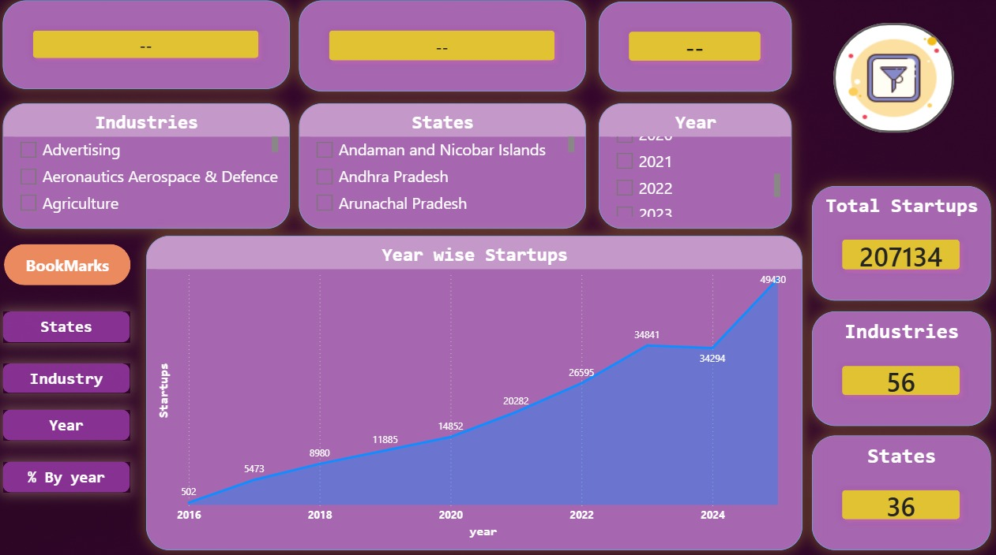
Year wise Startups (Area Chart)

Page 2 — % Improvement by Year
Visual: Column bar chart | Metric: Each year's startups as % of cumulative 207,134 total
Insight: 2025 alone accounts for 23.86% of all startups ever recognized, compared to 0.24% in 2016 — showing accelerating concentration in recent years.

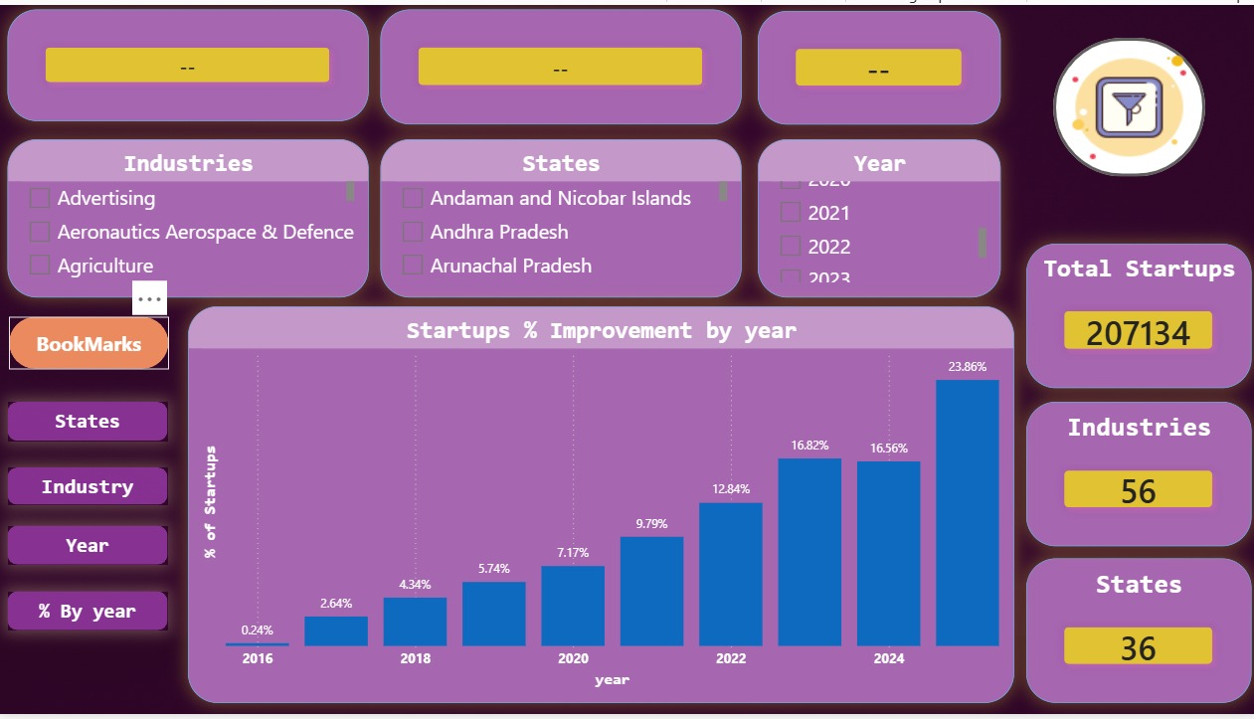
% Improvement by Year (Column Bar Chart)

Page 3 — State wise Startups
Visual: Horizontal bar chart (descending by startup count)
Insight: Maharashtra leads with 36K — ahead of Karnataka, which many assume to be the top state. Top 5 states account for approximately 57% of all recognized startups.

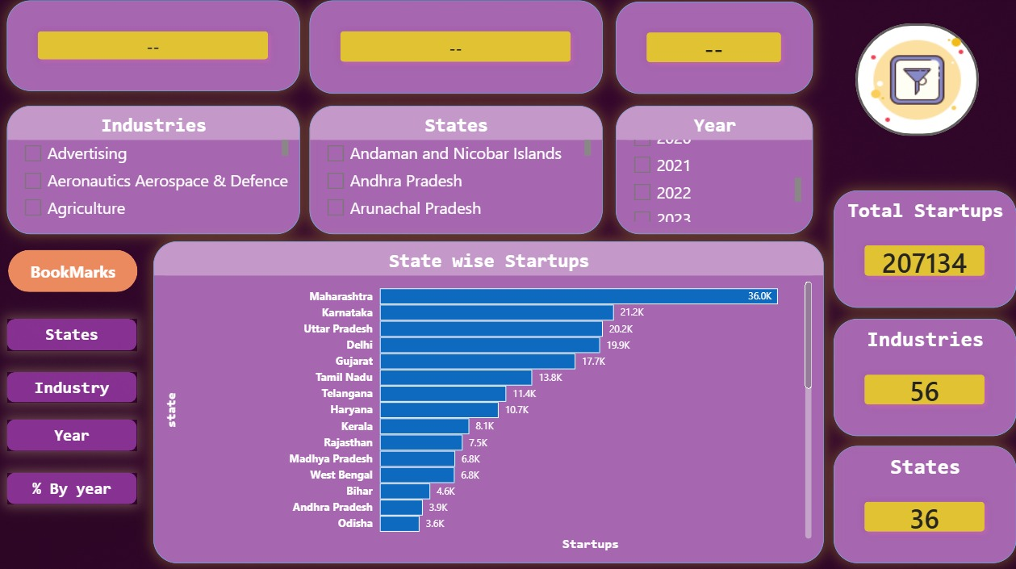
State wise Startups (Horizontal Bar Chart)

Page 4 — Industry wise Startups
Visual: Horizontal bar chart (descending by startup count)
Insight: IT Services leads by a significant margin, but Agriculture and Education in the top 5 confirm that Bharat-focused innovation is real — the ecosystem is broader than just tech.

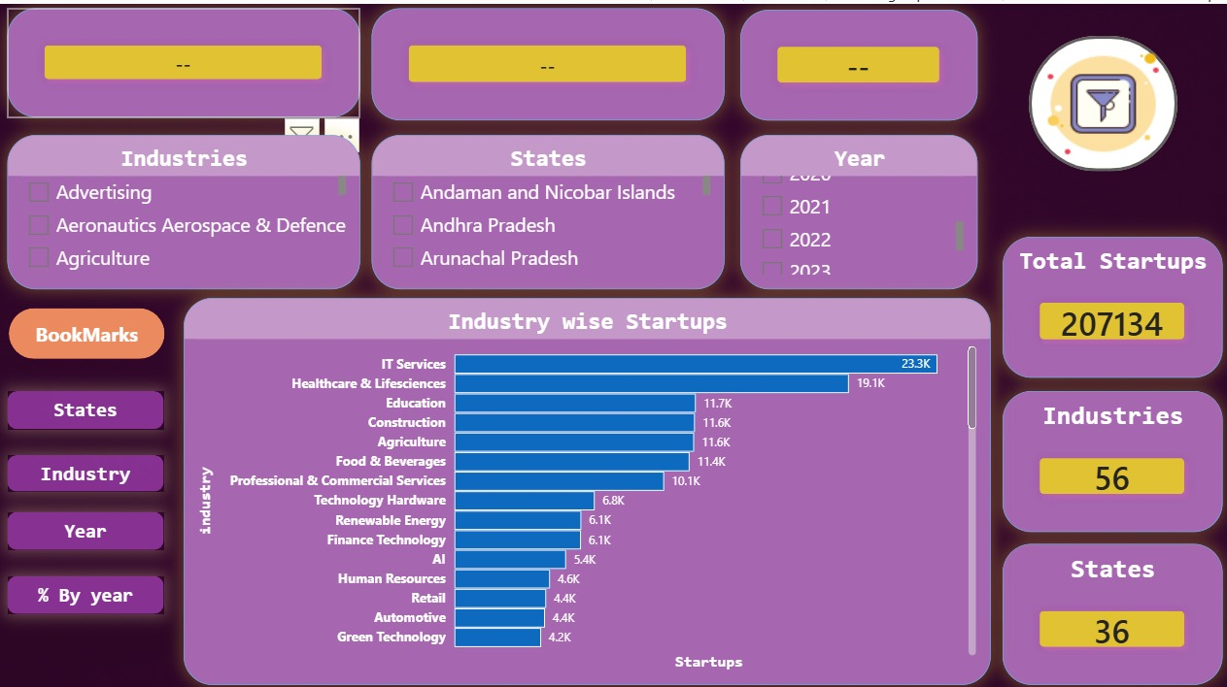
Industry wise Startups (Horizontal Bar Chart)

5. Key Findings
# | Finding | Data Point
1 | Total recognized startups across all years | 207,134
2 | Peak single year | 2025 — 49,430 startups (23.86% of all-time)
3 | Baseline year | 2016 — 502 startups (0.24% of all-time)
4 | Overall 10-year growth | 98× increase from 2016 to 2025
5 | Top state | Maharashtra (36K) — ahead of Karnataka (21.2K)
6 | Top industry | IT Services (23.3K)
7 | Notable sector finding | Agriculture ranks #5 — nearly tied with Education and Construction
8 | COVID-year resilience | 2020 still saw 25% YoY growth — policy momentum held through the pandemic
9 | Geographic concentration | Top 5 states account for ~57% of all startups
10 | Industry breadth | 56 distinct industries — not a purely tech-driven ecosystem

6. Limitations
- Covers only DPIIT-recognized startups — informal or unregistered ventures are excluded
- No data on funding rounds, valuations, or startup shutdown rates
- The 2025 figure reflects an April 2026 snapshot — not a complete calendar year
- State data does not break down to city level (no Bangalore vs. Pune granularity)

7. Tools Used
Tool | Purpose
Microsoft Power BI Desktop | Data visualization and dashboard development
Power Query (M) | Data loading, column renaming, and type verification
Dataful.in | Data discovery and dataset access (originally DPIIT / data.gov.in)

8. Dashboard Design Notes
- Color palette: purple and gold, consistent across all four pages for brand cohesion
- Navigation uses Power BI Bookmarks for seamless page switching without browser-style tabs
- Slicers (Industry, State, Year) are cross-filter enabled selecting one filters all visuals simultaneously
- KPI cards on the right panel persist across all pages, giving the viewer a constant anchor on the headline numbers
- Charts are sorted descending by count for instant visual ranking

