Installing and Using the LPC3250 NOR Flash Loader

- Unzip LPC3250NORFlashLoader.zip file into a folder.
- Verify serial cable is connected between the Phy3250 board and the PC. No specific setup is required in the Phy3250 board, except for the UART5 port (bottom connector) which should work correctly.
- Start the Loader.exe application.

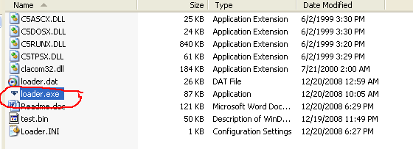

- Change default COM port (if necessary) using Setup -> Port menu:

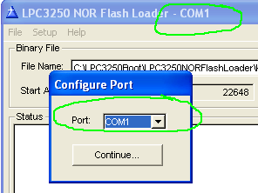

- Select the binary image ( *.bin ) to be burned into the NOR Flash.

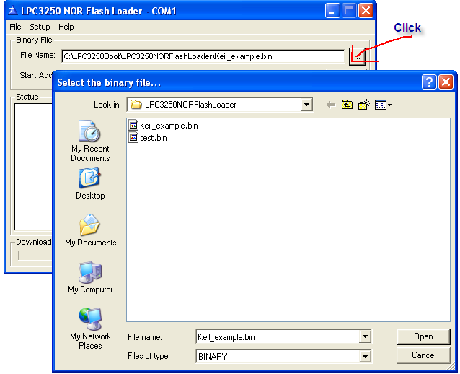

- Use the Include Validation Word? check according your needs (it’s needed in order to boot from NOR flash).
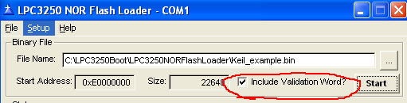

- Press the Start button. The Status window shows the following:

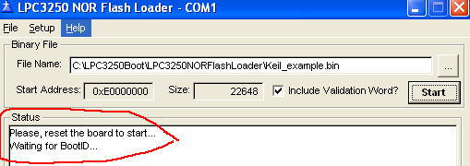

- Reset the Phy3250 board. The downloading process should start. When finish, a specific message should appear in the Status window. A progress bar shows the download progress. If an error arises, the Status window will show an error message.
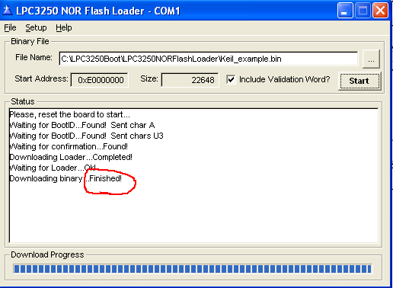

- A Test.bin image file is provided in order to test the loader application. This image contains a specific patterns ( 0x00, 0x01, 0x02, … , 0x0E, 0x0F ) which is repeated through the whole file (51200 bytes). After downloading this image, a Debugger with JTAG can be used in order to verify this pattern is burned in the NOR Flash, starting at 0xE0000000 (or 0xE0000004 if the Include Validation Word? check was used).

