GDOU-B-11-112
广东海洋大学学生实验报告书（学生用表）
实验名称 | 实验七 |  | 课程名称 | 程序设计基础实验 |  |  | 课程号 |  | 321116120
学院（系） | 数学与计算机学院 |  | 专 业 | 软件工程 |  |  | 班 级 |  | 1244
学生姓名 | 陈伟生 | 学号 | 202411701404 |  | 实验地点 | 钟海楼04004 |  | 日期 |  | 2024年12月20日
实验七 多态性
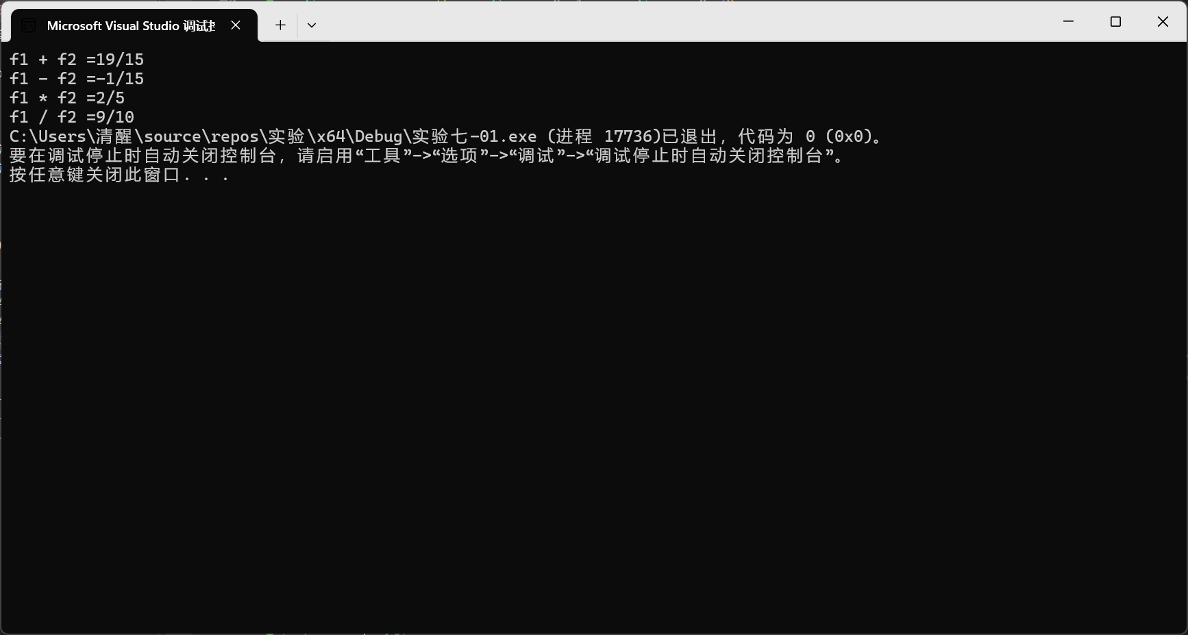
#include<iostream>
using namespace std;
class Fraction {
private:
int numerator;//分子
int denominator;// 分母
public:
Fraction(int a, int b);
Fraction() :numerator(0), denominator(0) {};
Fraction(Fraction& t);
void display();
friend Fraction operator+(const Fraction& t1, const Fraction& t2);
friend Fraction operator-(const Fraction& t1, const Fraction& t2);
friend Fraction operator*(const Fraction& t1, const Fraction& t2);
friend Fraction operator/(const Fraction& t1, const Fraction& t2);
};
Fraction::Fraction(int a, int b)
{
if (b == 0)
{
cout << "分母不能为0" << endl;
return;
}
numerator = a;
denominator = b;
}
Fraction::Fraction(Fraction& t)
{
numerator = t.numerator;
denominator = t.denominator;
}
void Fraction::display()
{
cout << numerator << "/" << denominator;
}
Fraction operator+(const Fraction& t1, const Fraction& t2)
{
int m_denominator = t1.denominator * t2.denominator;
int m_numerator = t1.numerator * t2.denominator + t2.numerator * t1.denominator;
Fraction temp(m_numerator, m_denominator);
return temp;
}
Fraction operator-(const Fraction& t1, const Fraction& t2)
{
int m_denominator = t1.denominator * t2.denominator;
int m_numerator = t1.numerator * t2.denominator - t2.numerator * t1.denominator;
Fraction temp(m_numerator, m_denominator);
return temp;
}
Fraction operator*(const Fraction& t1, const Fraction& t2)
{
int m_denominator = t1.denominator * t2.denominator;
int m_numerator = t1.numerator * t2.numerator;
// 把得到的结果约分到最简
int t = 1;
for (int i = 1; i <= m_numerator && i <= m_denominator; i++)
{
if (m_numerator % i == 0 && m_denominator % i == 0)
{
t = i;
}
}
m_numerator /= t;
m_denominator /= t;
Fraction temp(m_numerator, m_denominator);
return temp;
}
Fraction operator/(const Fraction& t1, const Fraction& t2)
{
int m_denominator = t1.denominator * t2.numerator;
int m_numerator = t1.numerator * t2.denominator;
// 把得到的结果约分到最简
int t = 1;
for (int i = 1; i <= m_numerator && i <= m_denominator; i++)
{
if (m_numerator % i == 0 && m_denominator % i == 0)
{
t = i;
}
}
m_numerator /= t;
m_denominator /= t;
Fraction temp(m_numerator, m_denominator);
return temp;
}
int main()
{
Fraction f1(3, 5), f2(2, 3), f3;
f3 = f1 + f2;
cout << "f1 + f2 =";
f3.display();
cout << endl;
f3 = f1 - f2;
cout << "f1 - f2 =";
f3.display();
cout << endl;
f3 = f1 * f2;
cout << "f1 * f2 =";
f3.display();
cout << endl;
f3 = f1 / f2;
cout << "f1 / f2 =";
f3.display();
return 0;
}
（4）约分时候忘记判断哪个是比较小的数，导致错误。修改for循环里的条件判断。成功约分
（5）对问题分析再仔细点

