MongoDB Tutoring

1. **The introduction of MongoDB**
   1. **What is MongoDB?**

MongoDB is a database based on distributed file storage, written by C++ and is designed to provide scalable high-performance data storage soluations for WEB application. MongoDB is a high-performance, open source and modeless document database.

The official definition for yourself is a bridge between Key-value storage (high performance and high expansion) and traditional RDBMS (rich query and function).

* 1. **The docment and BSON in MongoDB**

In MongoDB, data are stored as BSON, for example:

{

name: “ruizhi”,

age: “23”,

groups: [“art”, “game”]

}

The basic unit of data in MongoDB is called a Document, it is the core concept of MongoDB, which is composed by multiple keys and values placed together in an order. They are corresponding to the rows in the database.

Data in MongoDB are stored as the form of BSON(Binary-JSON). BSON

(Binary Serialized Document Format) is a binary json-like storage format. It is just like JSON and supports embedded document objects and array objects, but BSON has some data types that JSON does not have, such as Date and BinData types.

1. **CRUD operation in MongoDB**
   1. **Insert documents in MongoDB**

In the database, data insertion is the most basic operation. In MongoDB, use the db.collection.insert (document) statement to insert the document, as shown below:

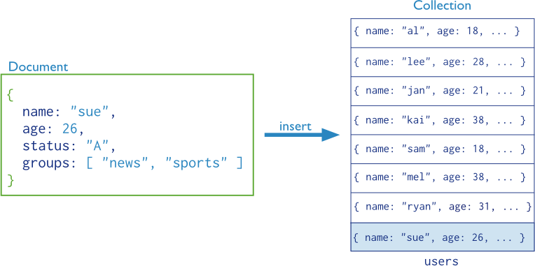

Document is document data, and collection is a collection of document data.For example: all user information is stored in the user’s collection, each user information is a user document, insert data:

db.users.insert(user);

If the collection exists, the document will be added to the collection directory. If the collection does not exist, the database will first create the collection and then save the document.

* 1. **Insert many documents in MongoDB**

The insert statement can not only insert a single document, but also insert multiple documents at once. When inserting multiple documents, the parameter of the insert command is an array, and the array elements are documents in BSON format. Multiple documents can be placed in an array, inserting multiple data at once, for example:

db.users.insert([{name: "tommy"},{name: "tommy"}])

* 1. **MongoDB query and projection**

In MongoDB, the query points to a specific set of documents, the query sets conditions, and specifies the documents that MongoDB needs to return; the query can also contain a projection that specifies the returned fields.

As shown in the figure below, a query condition and a sorting modification are specified during the query process.

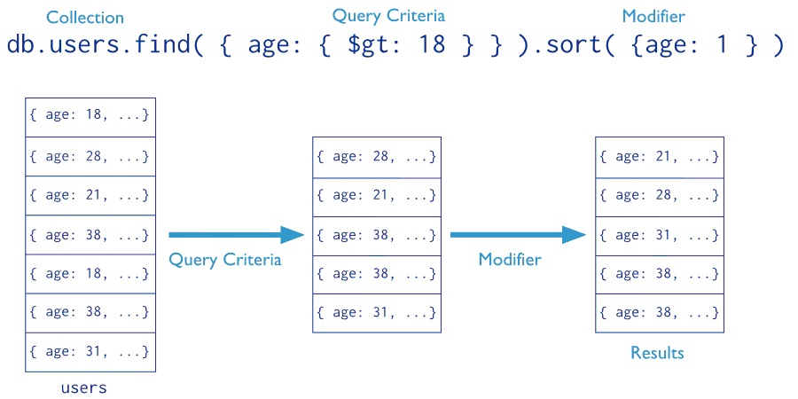

In relational databases, projection refers to the screening of columns. Similarly, in MongoDB, projection refers to the screening of object attributes that appear in the result set.

* 1. **MongoDB's find () method**

Use the find command when querying and retrieving data in MongoDB. The method of use is as follows:

db.collection.find (criteria, projection);

The find command has two optional parameters, criterion is the query condition, and projection is the returned field. If no condition database is passed, all documents in the collection will be returned.

