AI-Powered Test Automation Across the Full Lifecycle
Requirement to Result — Proof of Concept Outcome
Prepared for: Management / Leadership
Prepared by: QA Automation Team
Date: September 2026
Status: PoC Complete — Validated

1. Executive Summary
We set out to answer one question: can AI meaningfully speed up and simplify web application testing? The Proof of Concept confirms it can.
We built a general-purpose automation framework using Kiro (AI) and Playwright that turns a requirement into a working, self-maintaining automated test in minutes instead of days. It covers the entire testing lifecycle — from reading the requirement, through test case creation, code generation, and execution, to publishing results back to the source system.
The framework integrates with both Jira + Zephyr Scale and Azure DevOps, so teams keep their existing tools with no change to the automation engine. To prove it works on a hard problem, we validated it on Salesforce Experience Cloud, one of the most complex platforms to automate.
Result: a 100% pass rate and roughly a 95% reduction in automation effort.

2. Business Value at a Glance
Outcome | Detail
100% pass rate | Every test confirmed by creating a real record in the application
~95% less effort | Automating a user story dropped from 1–2 days to about 6–10 minutes
Self-healing | The framework repairs broken locators automatically when the UI changes
Dual ALM support | Runs end-to-end from both Jira and Azure DevOps
Application-agnostic | Works on virtually any web application, proven on the hardest case

3. The Problem
Traditional test automation is slow and fragile, regardless of the application:
- Manual test authoring takes 1–2 days per user story.
- Locators break with every UI change, and fixing them consumes most of the automation effort.
- Complex modern applications (single-page apps, Shadow DOM, iframes) defeat standard tooling.
- Getting from a requirement to a working test involves multiple manual handoffs across several tools.
These challenges apply to any modern web application — customer portals, banking and insurance platforms, e-commerce, and enterprise systems alike.

4. The Solution — A Complete, AI-Driven Lifecycle
The framework acts as an AI automation engineer that runs the full process end to end:
- Reads the requirement — from a Jira User Story, an Azure DevOps Work Item, or a document.
- Creates test cases — in Zephyr Scale (Jira) or as linked Test Case work items (Azure DevOps).
- Generates detailed test steps — as business-readable Gherkin scenarios.
- Discovers elements on the live application — AI navigates the real app and verifies each element by interacting with it.
- Generates Playwright automation code — following the industry-standard Page Object Model.
- Executes the tests — verifying success by creating a real record in the application.
- Publishes results back — to Jira or Azure DevOps, including screenshots on failure.
This delivers complete traceability from requirement to result with minimal manual effort.

5. Key Innovation — Self-Healing Locators
The breakthrough is that the framework does not guess how to find elements. It navigates the live application, inspects the real page (including Shadow DOM and iframes), and confirms each locator by actually using it.
When the UI changes and a locator breaks, the framework re-inspects the live page and repairs itself — dramatically reducing the maintenance burden that normally dominates automation work.
Traditional Approach | Our Approach
Guess locators from developer tools | AI interacts with the live page
Struggles with Shadow DOM and complex apps | Handles Shadow DOM, iframes, dynamic content
Breaks on UI changes | Self-heals by re-inspecting
Manual fixes needed | Automatically finds working alternatives

6. Proof of Value — Salesforce Case Study
We deliberately chose Salesforce Experience Cloud because it represents a worst-case difficulty for automation: deeply nested Shadow DOM, dynamic dependent form fields, custom dropdowns with no accessible text, and constant background network activity.
Business workflows automated end-to-end:
Scenario | Source | Status
Incident Creation | Jira ticket | Passing
Certificate of Insurance Request | Jira ticket | Passing
Expense Request | Document | Passing
Request Assessments | Document | Passing
Facilities Request | Document | Passing
Security Exception Request | Jira ticket | Passing
The takeaway: if the framework handles Salesforce, it can handle virtually any web application.

7. Business Impact
Activity | Traditional | AI-Driven | Improvement
Understand requirement | 30 min | seconds | ~99%
Create test cases | 2 hours | seconds | ~99%
Discover locators | 4 hours | ~3 min | ~98%
Build automation | 4 hours | ~1 min | ~99%
Heal a broken locator | 1–4 hours | ~2 min | ~97%
Total per user story | 1–2 days | 6–10 min | ~95%

8. Architecture Overview
The diagrams below illustrate how the framework turns a requirement into a verified, self-healing automated test across the full lifecycle, and how a single engine serves both Jira and Azure DevOps.
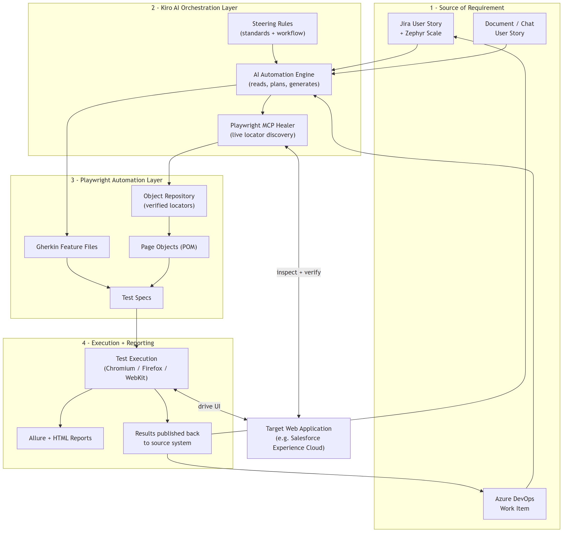
Figure 1 — System Architecture (four layers)
Figure 2 — End-to-End Process (Requirement to Result)
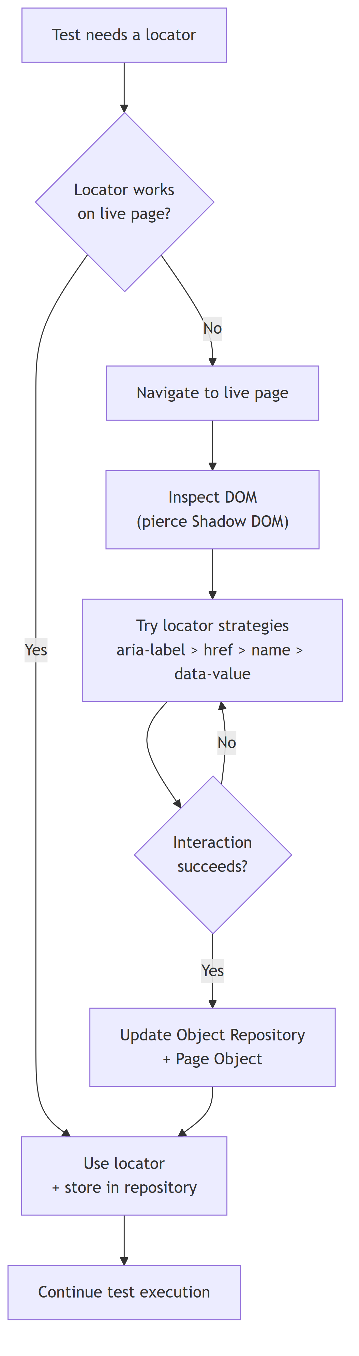
Figure 3 — Self-Healing Locator Flow
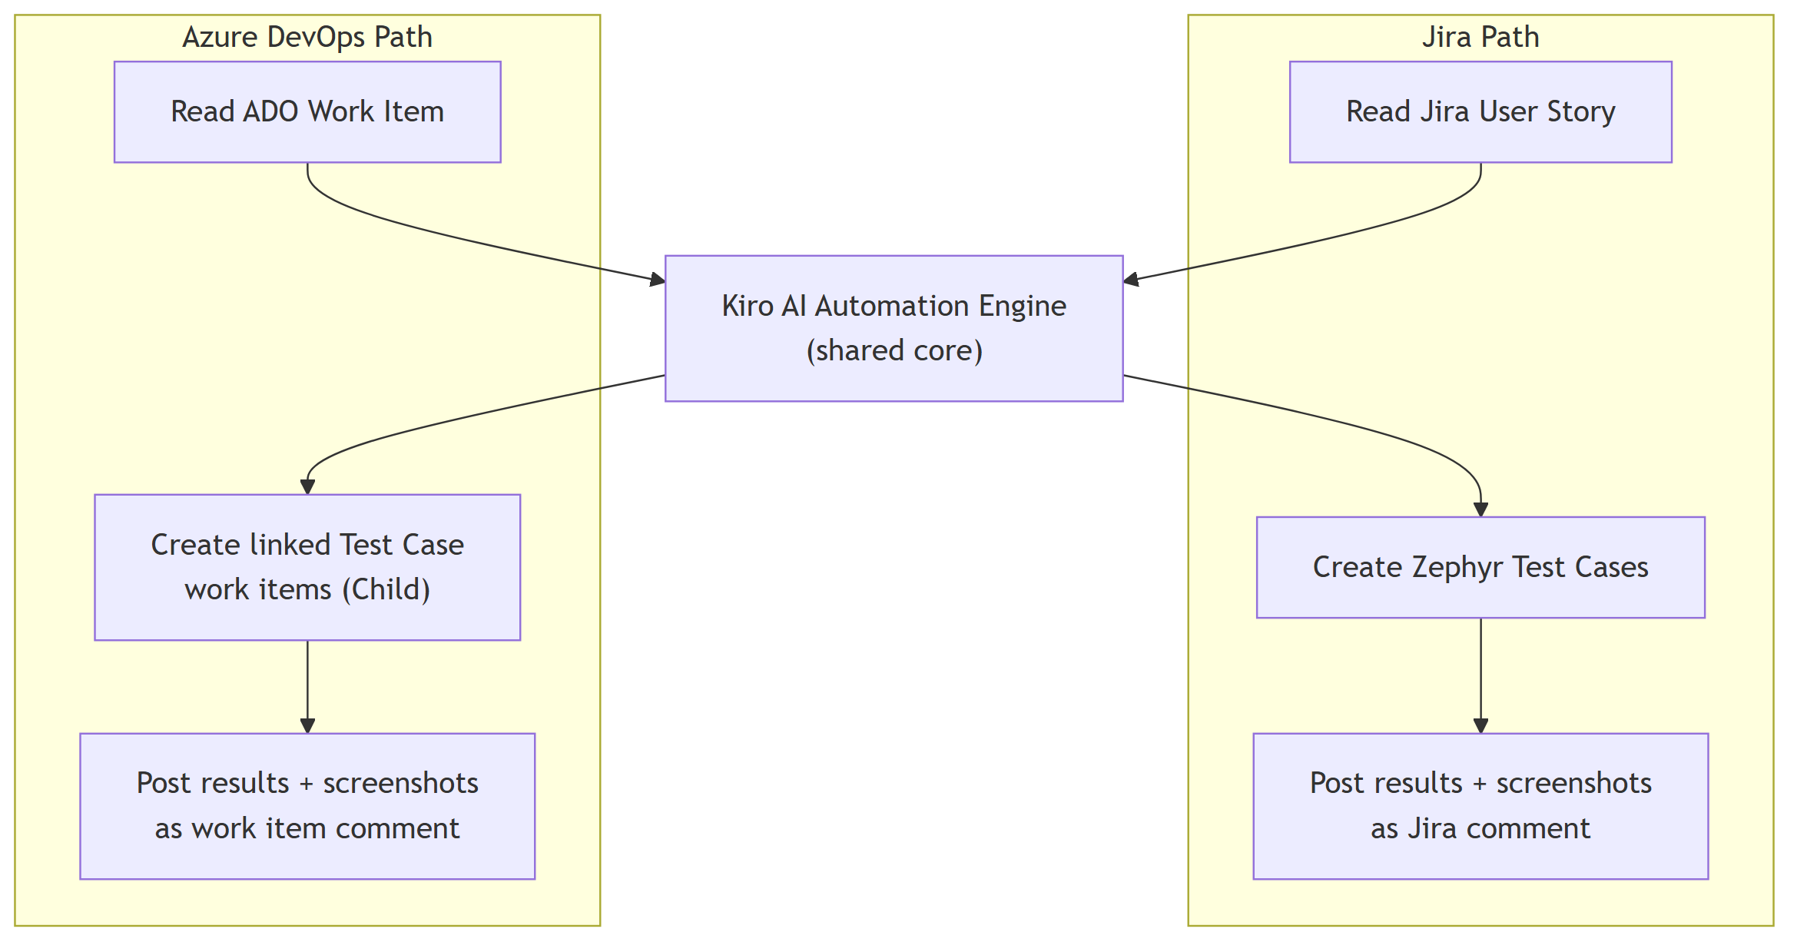
Figure 4 — Dual ALM Integration (Jira and Azure DevOps)
Figure 5 — Technology Stack

9. Demonstrations Delivered
The framework was presented in two sessions:
- TechExchange — internal technical showcase.
- WestPoint — client demonstration.
Both demonstrated the complete requirement-to-result flow on a live application.

10. Next Steps
The framework is ready to extend to additional applications and modules. Planned enhancements:
- API test automation integration.
- SQL / database validation integration.

11. Conclusion
This PoC demonstrates a reusable, general-purpose framework that automates the entire testing lifecycle for any web application. The Salesforce case study proves it handles even the most challenging environments. The efficiency gains — a 100% pass rate and roughly 95% less effort — translate directly into faster delivery, lower maintenance cost, and higher confidence in quality.

