1. **Save User with Valid Input**

**Input Payload:**

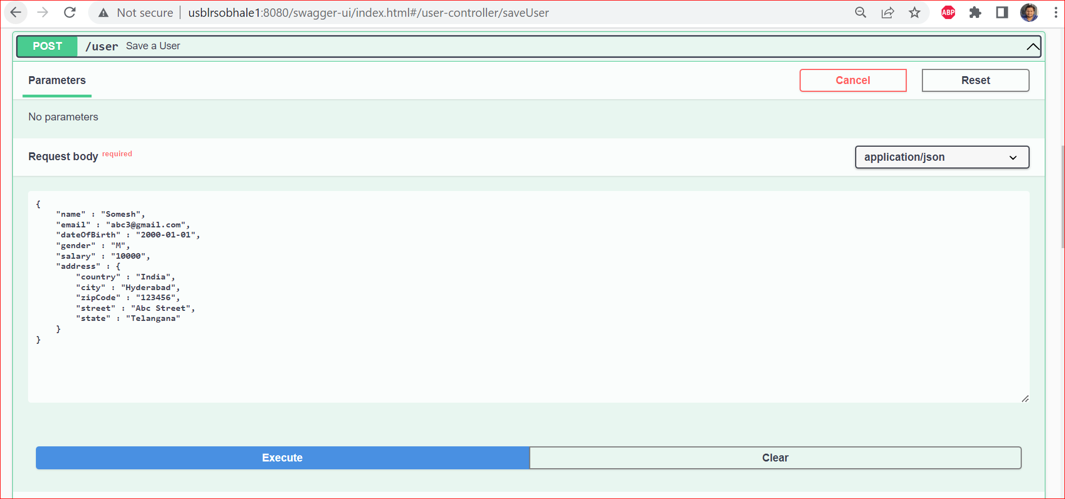

**Output:**

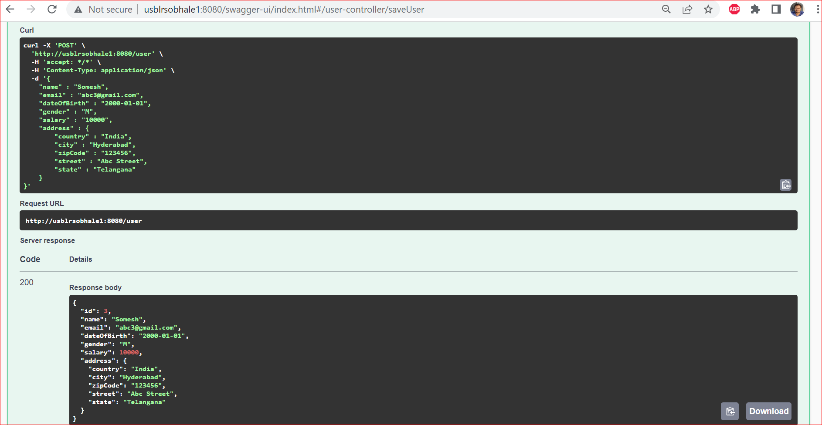

1. **Try to Save User with Invalid Date Of Birth (Less Than 18 Years of Age till date)**

**Input Payload:**

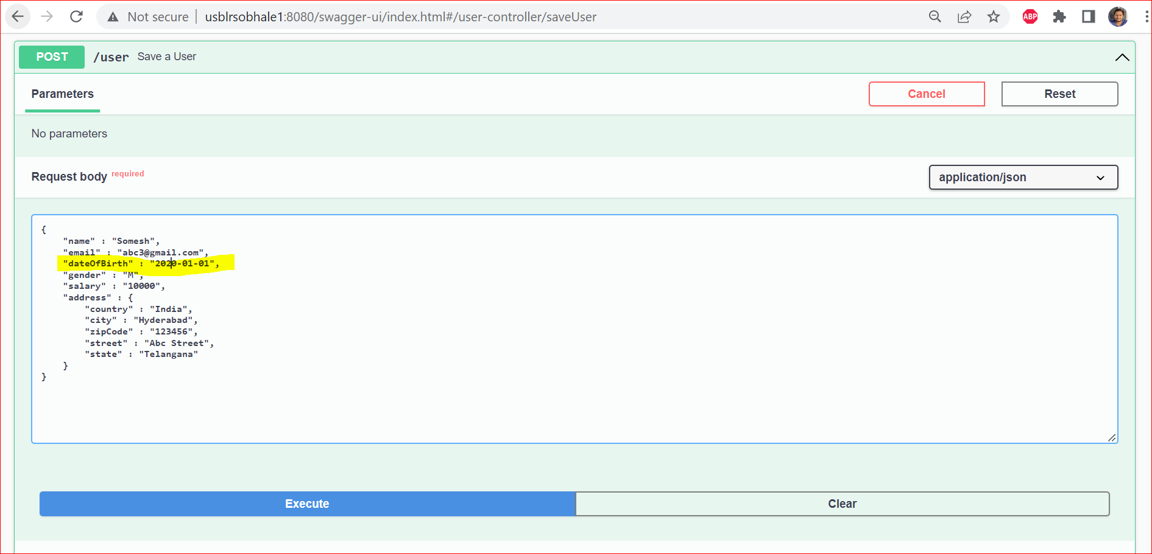

**Output with Error Response:**

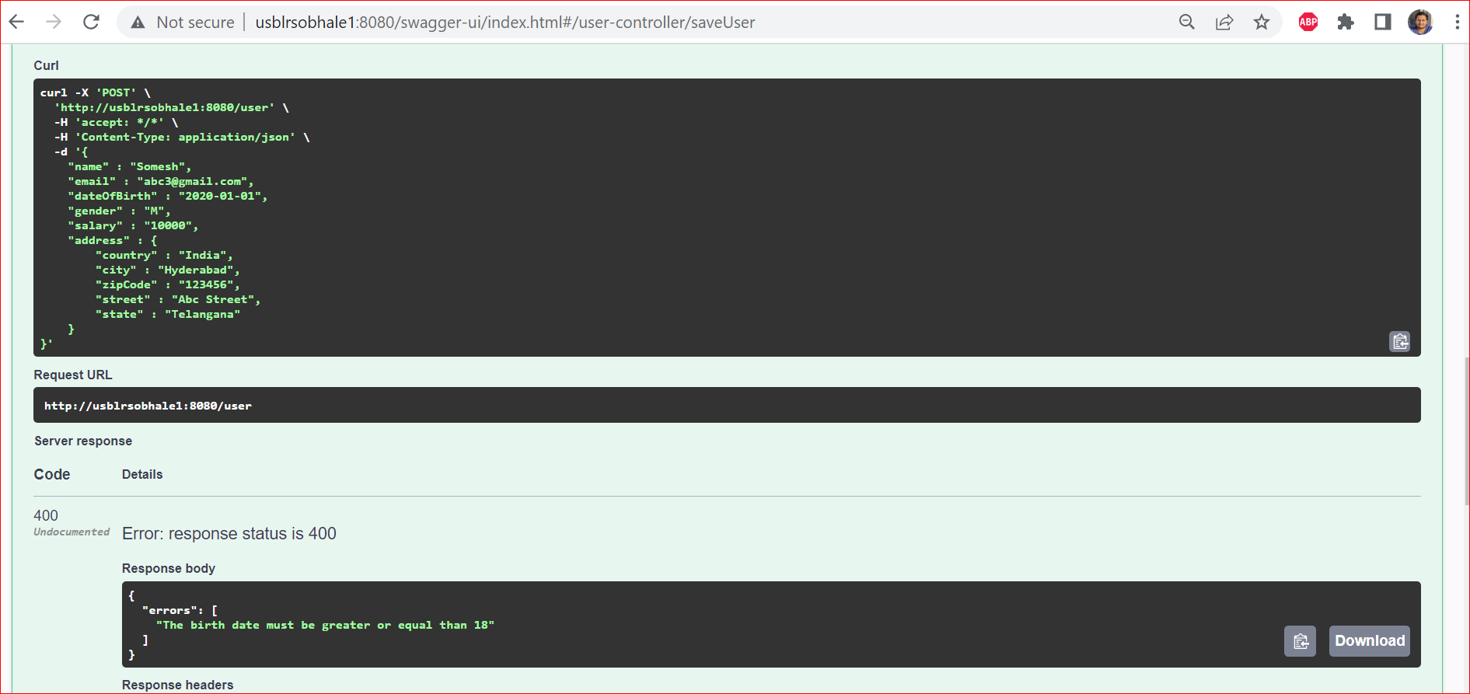

1. **Try to save user with Invalid Salary (negative Salary):**

**Input Payload:**

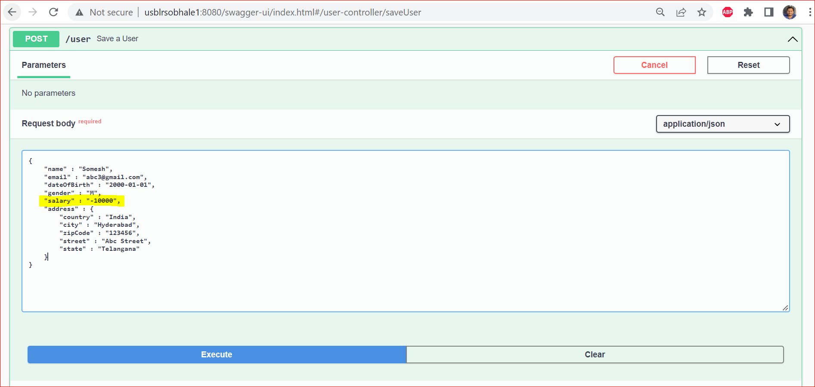

**Output with Error:**

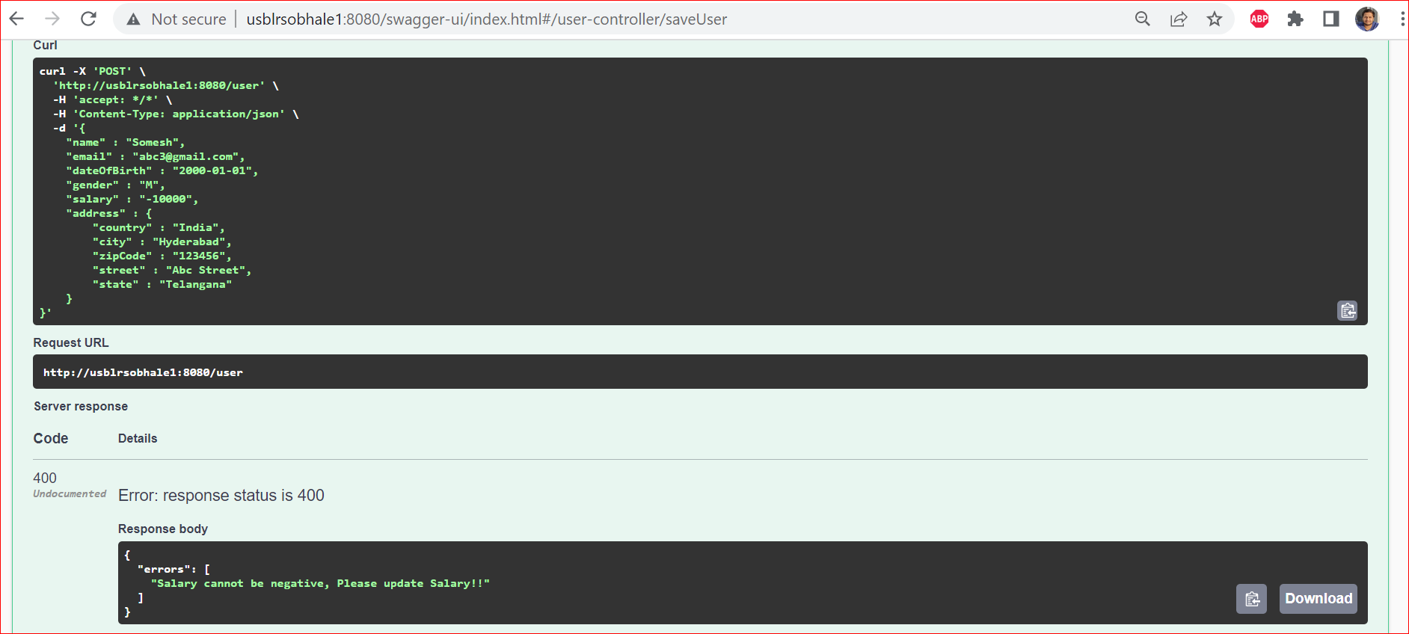

1. **Try to save user with invalid DOB and invalid Salary:**

**Input Payload:**

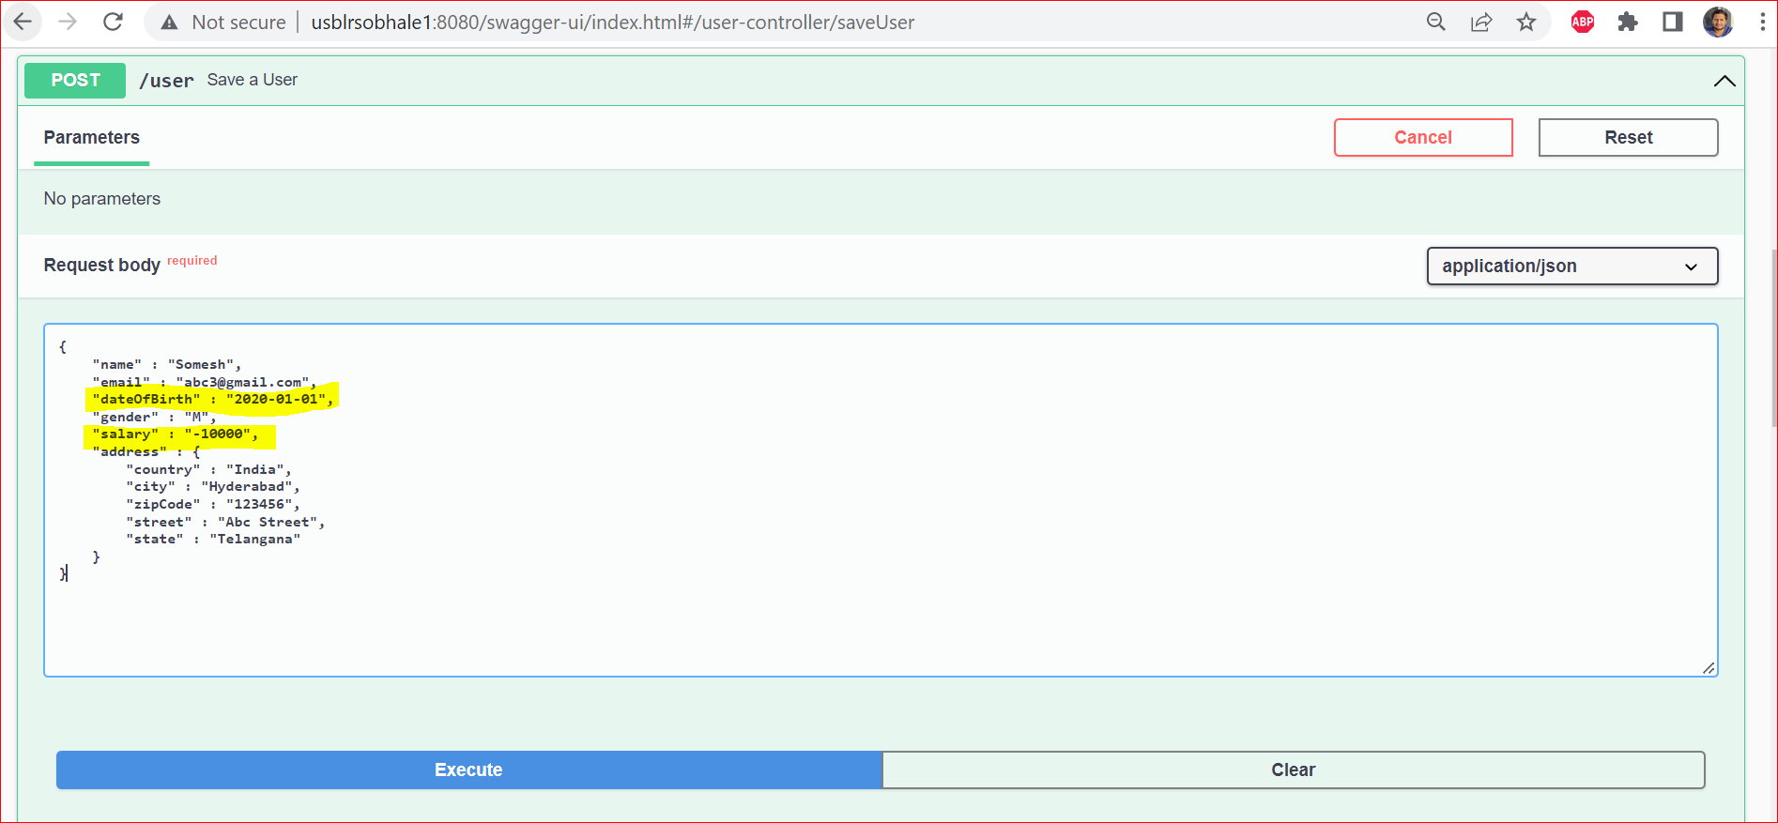

**Output:**

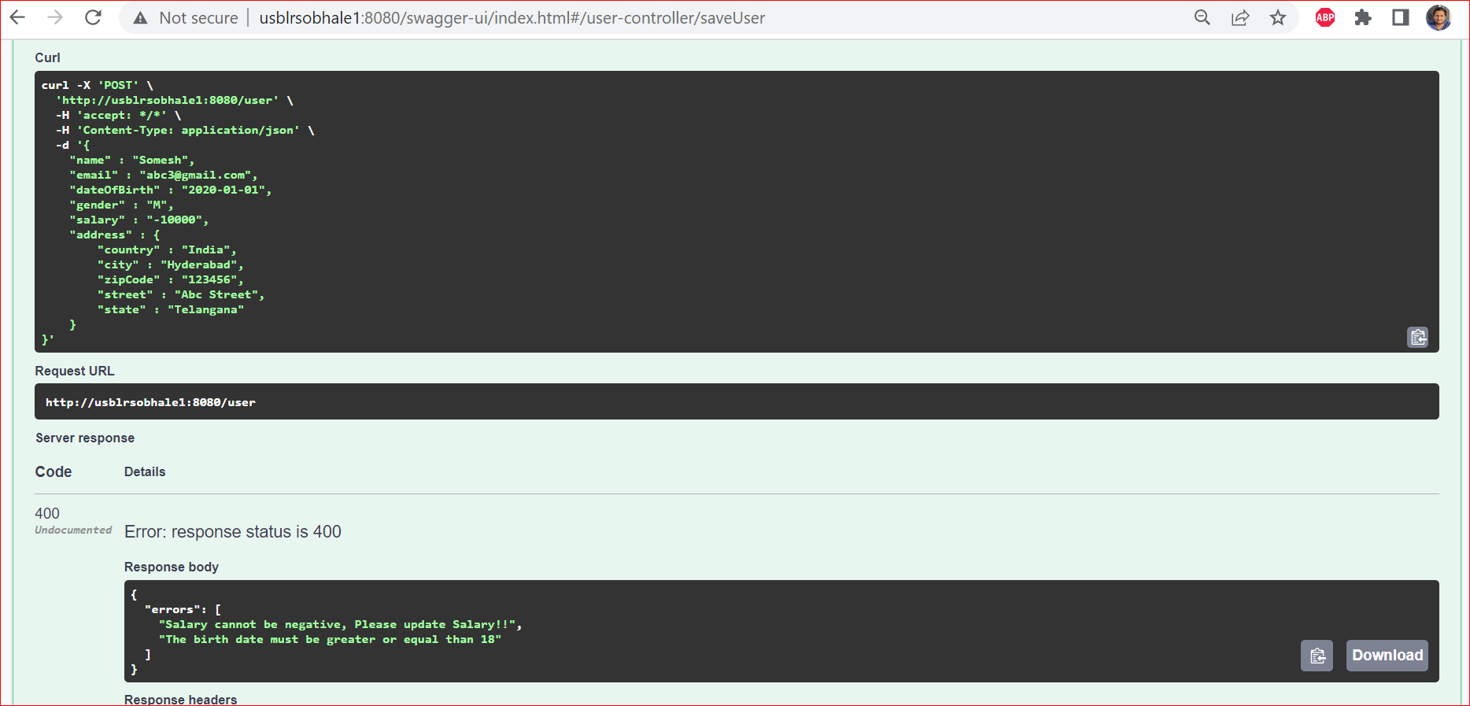

**GitHub Push to remote repo Screenshot:**

