Euler’s Number Mathematical constant

An irrational number represented by the letter e, Euler's number is 2.71828..., where the digits go on forever in a series that never ends or repeats (similar to pi). Euler's number is used in everything from explaining exponential growth to radioactive decay.
Like p(3.14) number

Formula
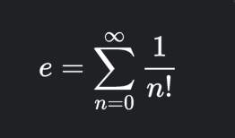

a property of Euler’s number is its exponential function is a derivative to ifself which is convenient for exponential and logarithm function

e = 2.71

now we wanna calculate a compound interest with python and euler's number
A = P x (1+r/n)^{nt}

for example :

note = all of these numbers are random and just replaced

150 (1+40/13)^{12*2} = 9.3


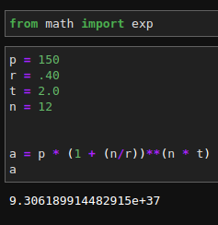

you also can check the python file = 1.ipynb

